1. Create SageMaker Notebook Instance

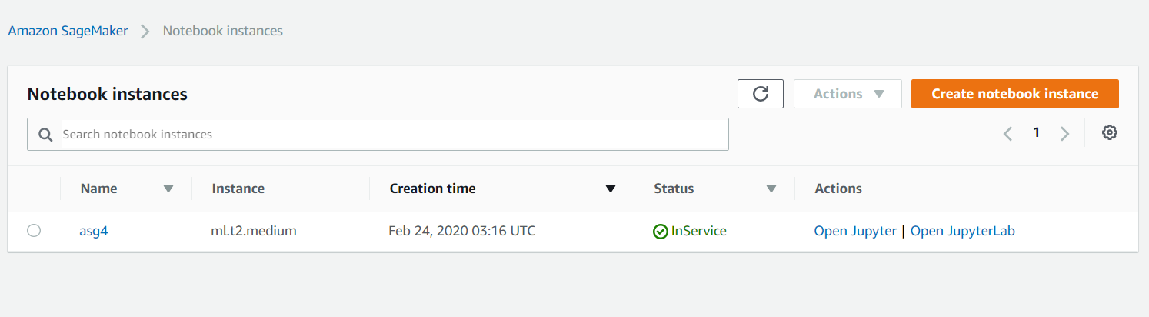

1. Using SageMaker Jupyter terminal to run the sentiment_training.py file

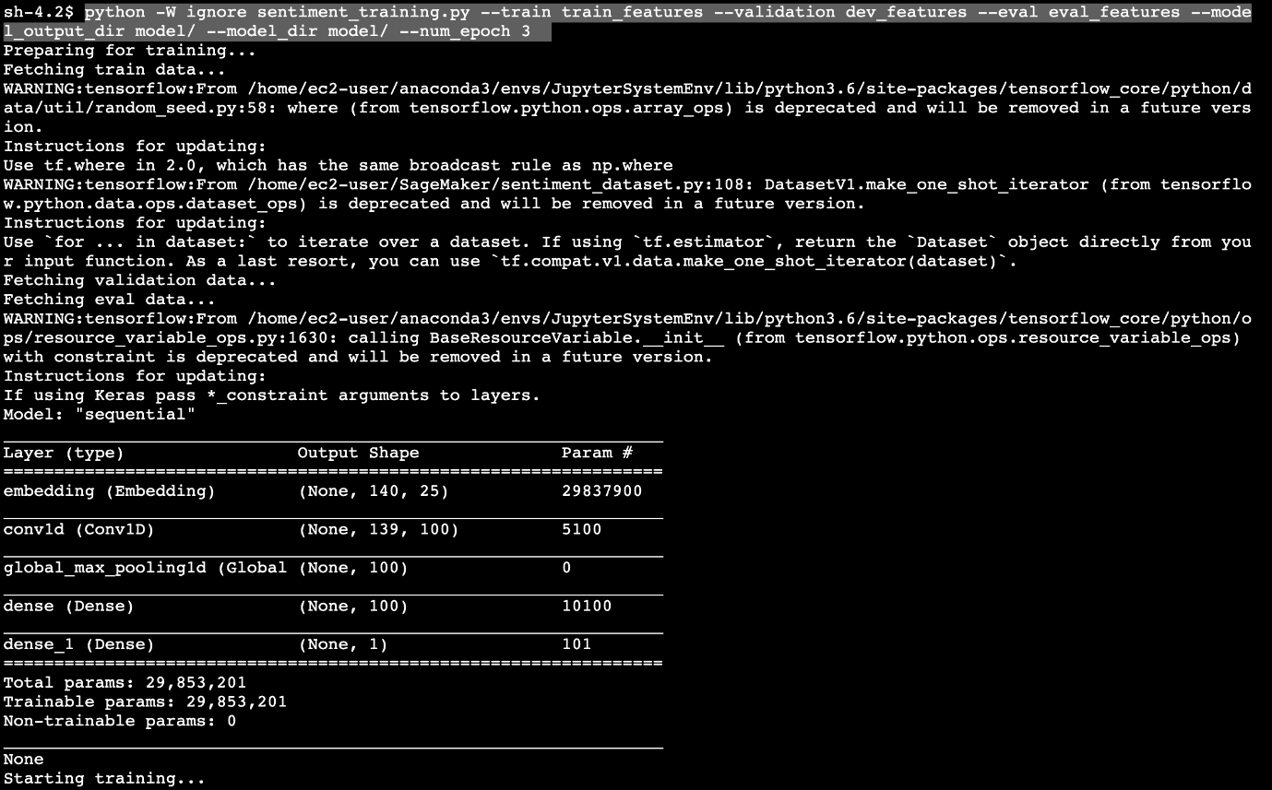

1. Model Running

