问题二 跨维度数据融合与广义标度律
物理纠偏、硬指标验证与工程化接口报告
本问在 B1--B10 附件和问题一接口上建立同时包含参数规模 N、数据量 D、质量变量和 17 域配比的标度律。所有 B 表 val_loss 均保留其 Pythia/Cerebras 原生验证集口径；The Pile Loss 与 B 表不直接混算。本文先纠正 Q_score 的物理方向，再给出结构化验证、边际技术替代率和跨语料桥接的可识别性边界。

1 结论摘要
B1 不是普通随机样本，而是 8 个 N 乘 147 个 D 的完整无重复解析网格。格点均值解释 Loss 方差 100%，留一 N 的结构化检验均保持极高 R²，因此应表述为“解析网格流形下的无偏参数精确辨识”，不能把 R²=1.0000 当作独立外部泛化证据。
B6--B8 的 Q_score 是噪声缺陷率：原始相关 r=0.6067，扣除 B1 的 N-D 基线后与 Loss 残差的相关 r=0.6661；全部 2090 条观测的质量方向为正。Q_quality=1-Q_score 与 |Q-1| 在 [0,1] 上只是同一保号仿射变换，不能翻转偏导。因此主模型改为 L=c+A N^-alpha+B D^-beta+gamma Q_score^theta，其中 gamma、theta>0，等价地对 Q_quality 的偏导严格为负。选择该形式的首要依据是物理正确性，不追求 R² 人为提升。
B2 的绝对 Loss 通过同域五折仿射重标定后再评价，B4/B5 主要报告排序保序性。跨语料桥接 L_Pile=u L_Pythia+v 已提出并检验，但 High 层只有 7/75 条真正同模型同验证集配对，区间很宽，结论是“假设可检验但当前定量识别不足”，而不是预设拒绝。

2 数据边界与接口
item | source | used_as
B1 | real Pythia log | complete analytical N-D grid; structured diagnostics
B2 | Cerebras | external ranking plus affine recalibration
B3 | interpolated trajectories | same-family validation
B4/B5 | cross-family/literature | ranking validation
B6-B8 | native Q_score experiments | physical asymmetric defect-rate effect
B9/B10 | estimated large-scale tables | scenario sensitivity only
A interface | Question 1 bridge | Q_bar(p), ILR substitution and conditional second-order effects
B9/B10 明确定位为超百亿参数外推的情景敏感性工具，不作为独立实验验证。问题一接口中的 Q_star、Q_bar(p) 和 ILR 替代向量仅作为场景输入；A 与 B 的质量量表和验证集不同，不能直接把 A1 的 Q_star 当作 B6--B8 的 Q_score。

3 B1 经典标度律与网格识别
经典模型为 L=c+A N^-alpha+B D^-beta。B1 含 1176 行，8 个参数规模和 147 个数据规模，恰好填满 8×147 网格且 (N,D) 无重复。按 (N,D) 分组计算格点均值得到 group-mean R²=1.000000；该结果说明生成结构被精确辨识，而不是新增数据上的泛化保证。
parameter | value
c | 1.689767
A | 0.354014
B | 1.240287
alpha | 0.339957
beta | 0.279876
n_rows | n_N | n_D | expected_cartesian | unique_pairs | complete_unique_grid | group_mean_r2
1176 | 8 | 147 | 1176 | 1176 | True | 1.000000
holdout_scheme | r2 | mae | rmse | n | note
group_by_(N,D) | 1.000000 | 0.000105 | 0.000147 | 1176 | reported deterministic grid diagnostic; no random external data
holdout_N | r2 | mae | rmse | n
0.070542 | 0.999999 | 0.000169 | 0.000220 | 147.000000
0.162405 | 0.999999 | 0.000137 | 0.000182 | 147.000000
0.409009 | 1.000000 | 0.000108 | 0.000135 | 147.000000
1.040867 | 1.000000 | 0.000109 | 0.000155 | 147.000000
1.416184 | 1.000000 | 0.000100 | 0.000132 | 147.000000
2.782831 | 1.000000 | 0.000082 | 0.000114 | 147.000000
6.861040 | 1.000000 | 0.000083 | 0.000135 | 147.000000
11.965825 | 1.000000 | 0.000076 | 0.000102 | 147.000000
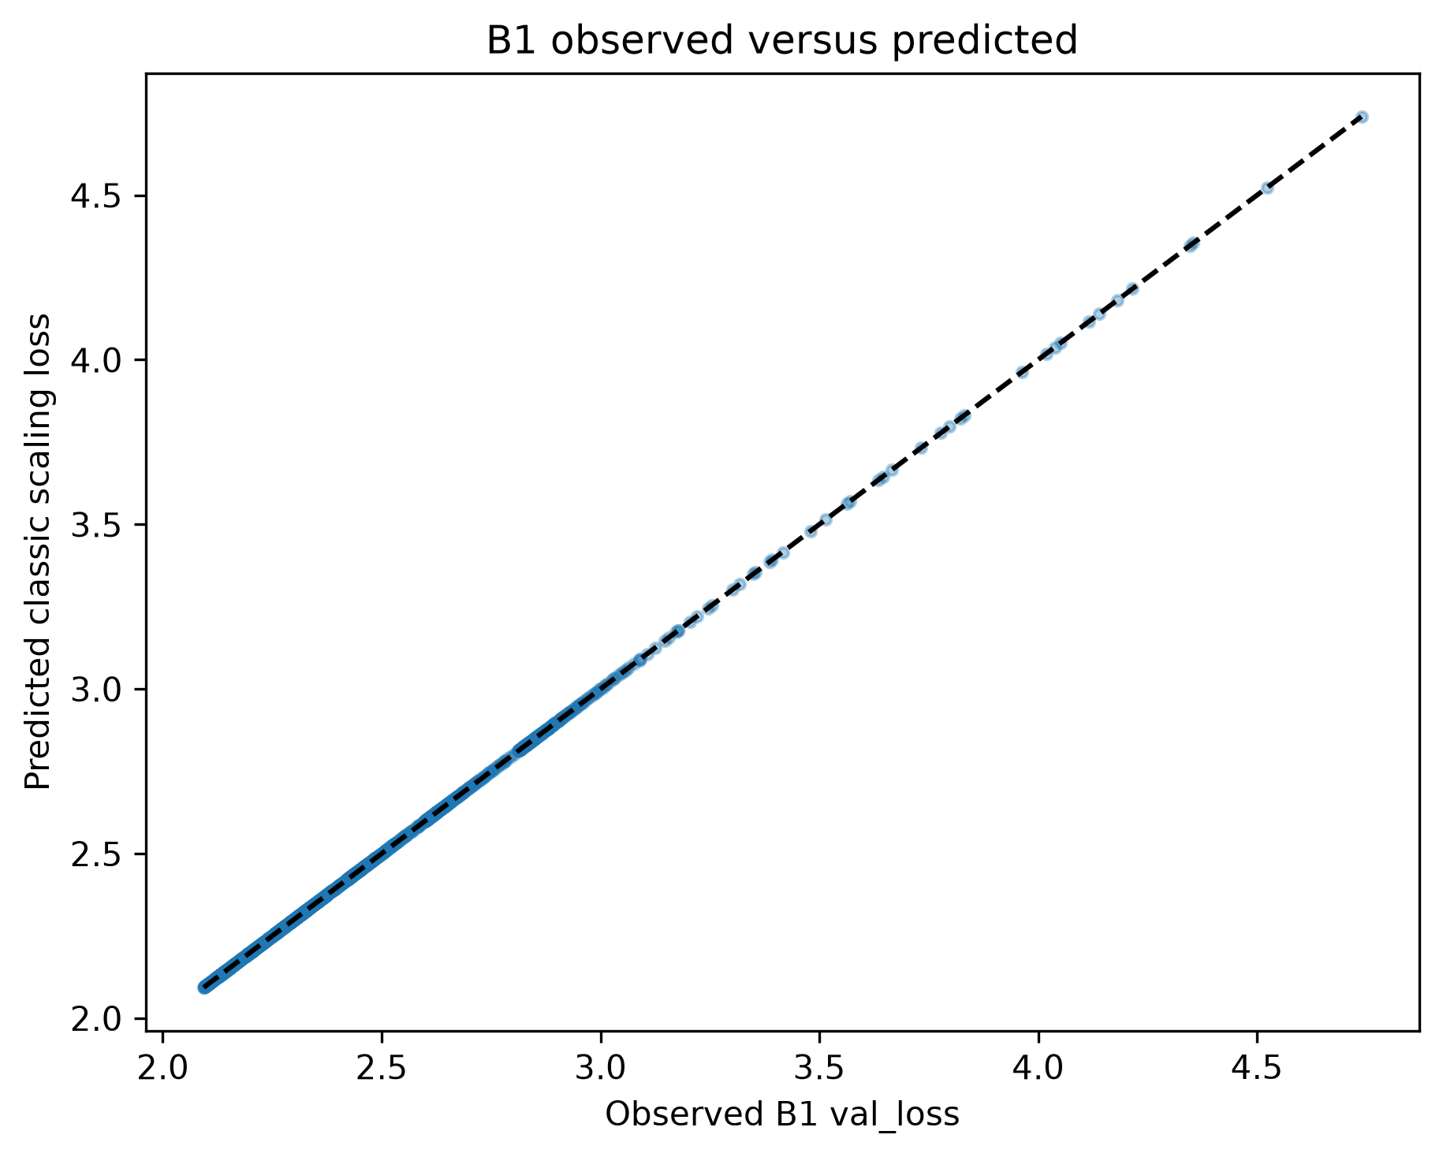
图 1 B1 观测值与经典标度律预测值
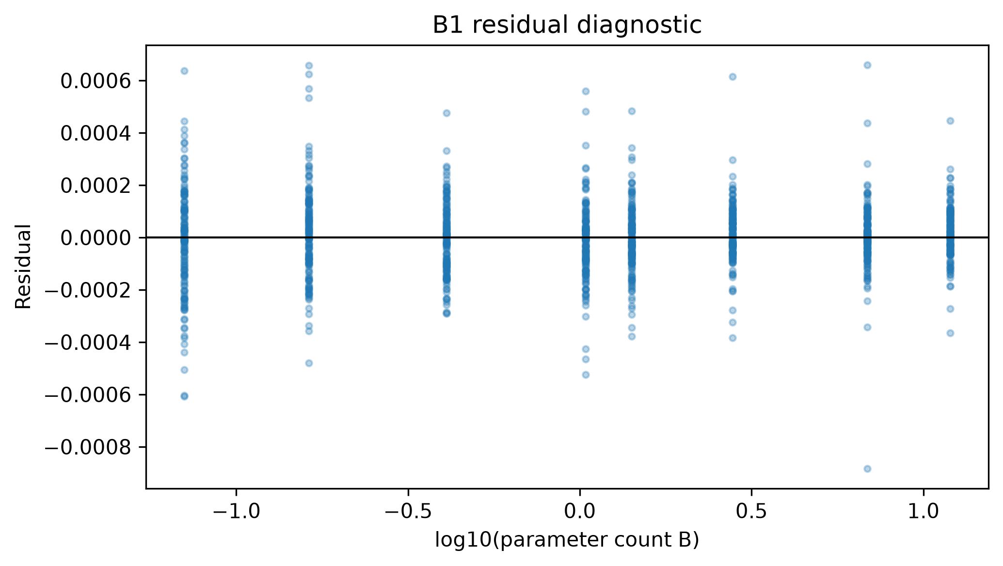
图 2 B1 残差诊断

4 B2--B5 验证与重标定
dataset | data_status | n | r2 | mae | rmse | spearman
B2_Cerebras | semi_external_real_family | 1029 | -5.07279 | 1.17844 | 1.24308 | 0.78810
B4_cross_family | real_cross_family | 57 | 0.60451 | 0.22727 | 0.29267 | 0.98298
B5_published | real_literature | 44 | 0.73057 | 0.17072 | 0.19759 | 0.95881
fold | n | slope | intercept | dataset | data_status | r2 | mae | rmse | spearman
1 | 206 | 1.57820 | -0.13268 | B2_affine_calibrated | 5fold_affine_recalibration | 0.40362 | 0.27740 | 0.42788 | 0.78920
2 | 206 | 1.58641 | -0.15671 | B2_affine_calibrated | 5fold_affine_recalibration | 0.50585 | 0.25777 | 0.35680 | 0.77885
3 | 206 | 1.64455 | -0.28406 | B2_affine_calibrated | 5fold_affine_recalibration | 0.36002 | 0.25663 | 0.37550 | 0.76187
4 | 206 | 1.58562 | -0.14320 | B2_affine_calibrated | 5fold_affine_recalibration | 0.50061 | 0.23132 | 0.33489 | 0.80123
5 | 205 | 1.58529 | -0.14648 | B2_affine_calibrated | 5fold_affine_recalibration | 0.45426 | 0.24757 | 0.37636 | 0.81164
trajectory | dataset | data_status | n | r2 | mae | rmse | spearman
pythia_0.070542B_trajectory | pythia_0.070542B_trajectory | interpolated_trajectory | 500 | 0.99995 | 0.00287 | 0.00383 | 0.99998
pythia_0.162405B_trajectory | pythia_0.162405B_trajectory | interpolated_trajectory | 500 | 0.99995 | 0.00296 | 0.00393 | 0.99999
pythia_0.409009B_trajectory | pythia_0.409009B_trajectory | interpolated_trajectory | 500 | 0.99995 | 0.00289 | 0.00386 | 0.99999
pythia_1.040867B_trajectory | pythia_1.040867B_trajectory | interpolated_trajectory | 500 | 0.99996 | 0.00272 | 0.00357 | 0.99998
pythia_1.416184B_trajectory | pythia_1.416184B_trajectory | interpolated_trajectory | 500 | 0.99995 | 0.00300 | 0.00397 | 0.99999
pythia_11.965825B_trajectory | pythia_11.965825B_trajectory | interpolated_trajectory | 500 | 0.99995 | 0.00300 | 0.00391 | 0.99998
pythia_2.782831B_trajectory | pythia_2.782831B_trajectory | interpolated_trajectory | 500 | 0.99995 | 0.00286 | 0.00378 | 0.99998
pythia_6.86104B_trajectory | pythia_6.86104B_trajectory | interpolated_trajectory | 500 | 0.99995 | 0.00291 | 0.00380 | 0.99998
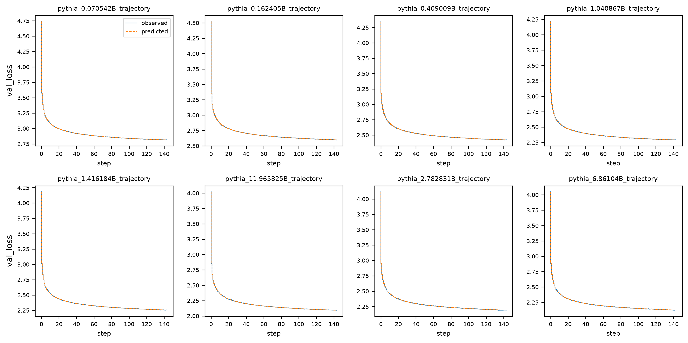
图 3 B3 八条轨迹，实线为观测、虚线为预测
B2 原始绝对 Loss 受模型族和验证集偏移影响，仿射重标定只作为同一外部数据集内的校准诊断；B4/B5 的排序相关性比绝对 R² 更稳定。因此可迁移的是相对排序和趋势，不能把 B1 截距直接当成所有模型族的共同标尺。

5 Qscore 物理纠偏与低端饱和
线性中心化模型和其镜像形式的预测值完全相同，镜像并不能改变偏导符号。下表逐行给出两种写法的 R²、MAE 和最大预测差，数值相同且预测差为机器精度量级；因此不能把 Q_quality=1-Q_score 或 |Q_score-1| 当作物理纠偏。主模型采用 q_defect=Q_score、q_quality=1-q_defect：L=c+A N^-alpha+B D^-beta+gamma q_defect^theta。于是 ∂L/∂q_defect=gamma theta q_defect^(theta-1)>0，∂L/∂q_quality<0；当 q_quality→1 时缺陷项趋于零，退化为经典 N-D 标度律。alpha、beta 围绕 B1 的 0.339957、0.279878 采用惩罚项松弛，lambda 取 0、0.1、1、10。
lambda | c | A | B | gamma | alpha | beta | theta | alpha_minus_B1 | beta_minus_B1 | r2 | mae
0.000000 | -7.302010 | 1.392151 | 7.118718 | 1.653806 | 0.132025 | 0.010000 | 0.865499 | -0.207932 | -0.269876 | 0.601225 | 0.384528
0.100000 | -7.301682 | 1.391798 | 7.118728 | 1.653808 | 0.132064 | 0.010000 | 0.865496 | -0.207893 | -0.269876 | 0.601225 | 0.384526
1.000000 | -7.298852 | 1.388740 | 7.118817 | 1.653818 | 0.132404 | 0.010000 | 0.865477 | -0.207553 | -0.269876 | 0.601225 | 0.384508
10.000000 | -7.271610 | 1.359225 | 7.119696 | 1.653926 | 0.135766 | 0.010000 | 0.865287 | -0.204192 | -0.269876 | 0.601220 | 0.384332

form | r2 | mae | max_abs_prediction_difference_vs_centered
centered Q_score | 0.591198953 | 0.364949943 | 0.000000000
mirrored |Q_score-1| = 1-Q_score | 0.591198953 | 0.364949943 | 0.000000000
quantity | pearson_r | n
raw Q_score vs val_loss | 0.606699 | 2090
Q_score vs loss residual after B1 N-D | 0.666110 | 2090
dL/dQ_score grid minimum | 0.978229 | 2090
dL/dQ_score grid maximum | 2.118461 | 2090
dL/dQ_score positive share | 1.000000 | 2090
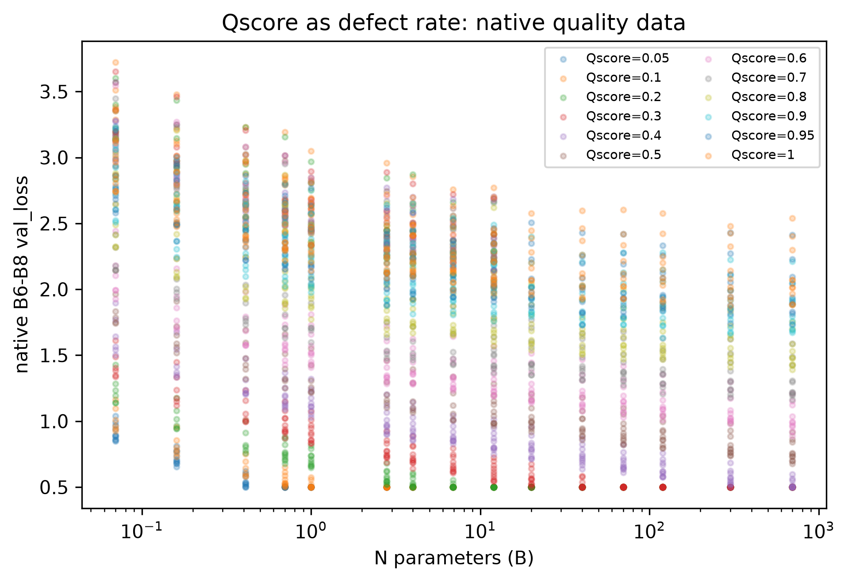
图 4 原生 Qscore 缺陷率与验证 Loss
低端敏感性检验共得到 138 个 Qscore=0.05/0.10 的 (N,D) 配对，其中 106 对 Loss 完全相等（76.8%）。例如 N=0.07、D=5 时两点分别为 1.0401 和 1.1624；N=1.0、D≥100 时两点均为 0.5000。该结果说明低端存在与规模相关的截断/饱和机制，不能把局部反常解释为质量方向翻转。
N_params_B | D_tokens_B | 0.05 | 0.1 | equal_loss
0.0700 | 5 | 1.0401 | 1.1624 | False
0.0700 | 20 | 0.9701 | 1.0960 | False
0.0700 | 100 | 0.8910 | 1.0093 | False
0.0700 | 500 | 0.8610 | 0.9621 | False
0.0700 | 1000 | 0.8471 | 0.9414 | False
0.0700 | 2000 | 0.8539 | 0.9243 | False
0.1600 | 5 | 0.8104 | 0.9548 | False
0.1600 | 20 | 0.7755 | 0.8548 | False
0.1600 | 100 | 0.7109 | 0.8001 | False
0.1600 | 500 | 0.6974 | 0.7769 | False
0.1600 | 1000 | 0.6787 | 0.7577 | False
0.1600 | 2000 | 0.6532 | 0.7317 | False

6 MRTS 与统一广义标度律
将问题一的 16 维 ILR 坐标记为 z(p)，把逐域或宏观质量项写入统一形式：L_d(N,D,q,p)=c_d+A_d N^-alpha_d+B_d D^-beta_d+gamma_d q^theta+t_d^T z(p)+Delta_d^(2)。其中 Delta^(2) 是固定单纯形约束下的二阶非加性增量，系数语义为相对替代，不是绝对增加。
全微分满足 dL=(∂L/∂lnN)dlnN+(∂L/∂lnD)dlnD+(∂L/∂q)dq+sum_i(∂L/∂p_i)dp_i=0，且 sum_i dp_i=0。质量提升令 dq<0，保持 Loss 不变时 ΔlnN=-(∂L/∂q·Δq)/(∂L/∂lnN)<0，ΔN%=(exp(ΔlnN)-1)×100%，N_equiv=N_base exp(ΔlnN)。
quantity | min | Q1 | median | Q3 | max
dL_dQ_quality | -1.648453 | -1.648453 | -1.648453 | -1.648453 | -1.648453
dL_dlnN | -0.261210 | -0.213712 | -0.179248 | -0.156051 | -0.132372
elasticity_N | -0.126509 | -0.122688 | -0.120113 | -0.116325 | -0.096431
delta_ln_N | -1.245316 | -1.059187 | -0.920030 | -0.773511 | -0.631082
delta_N_percent | -71.214995 | -65.272222 | -60.142293 | -53.824043 | -46.798441
N_equiv_B | 0.037529 | 0.158394 | 0.488260 | 1.287022 | 3.444363
表中为完整 N-D 网格的中位数和四分位区间，避免用单点替代整体波动。当前非对称拟合在 q_quality=0.65、质量提升 0.1 的基准下给出参数替代区间；这是一种局部情景计算，不应外推为跨验证集的因果结论。
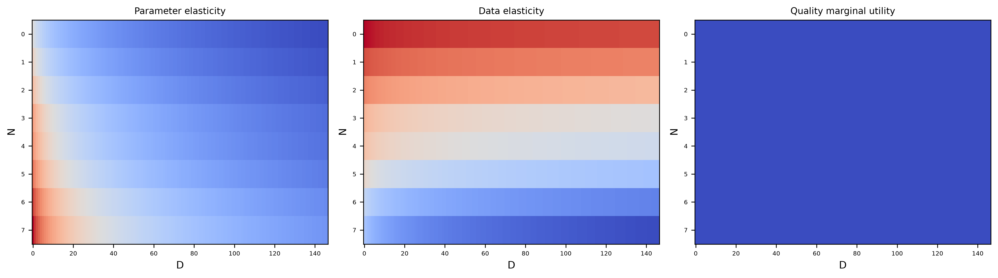
图 5 参数弹性、数据弹性与有效质量边际效用的 1×3 网格

7 17 域配比与二阶非加性
宏观质量泛函为 Q_bar(p)=sum_i p_i Q_i_star。配比使用单纯形闭合和 16 维 ILR，提升某域必然从其他域替代。问题一接口传入的 65 条 Top-5 记录全部来自 independent test quadratic model，是二次模型的条件预测，不是实验观测。
domain | Q_star | t_first_order | Q_status
arxiv | 0.73234 | -0.11019 | observed
freelaw | 0.54253 | -0.17512 | median_imputed_no_document_quality
nih_exporter | 0.54253 | -0.63196 | median_imputed_no_document_quality
pubmed_central | 0.54253 | -0.16983 | median_imputed_no_document_quality
wikipedia_en | 0.54253 | 0.12386 | median_imputed_no_document_quality
dm_mathematics | 0.54253 | 0.23555 | median_imputed_no_document_quality
github | 0.40575 | 0.18960 | observed
philpapers | 0.54253 | -0.37999 | median_imputed_no_document_quality
stackexchange | 0.54253 | -0.24947 | observed
enron_emails | 0.54253 | -0.98501 | median_imputed_no_document_quality
gutenberg_pg_19 | 0.54253 | 0.07413 | median_imputed_no_document_quality
pile_cc | 0.54253 | 0.89479 | median_imputed_no_document_quality
ubuntu_irc | 0.54253 | -0.32578 | median_imputed_no_document_quality
europarl | 0.54253 | 1.25206 | median_imputed_no_document_quality
hackernews | 0.54253 | -0.43634 | median_imputed_no_document_quality
pubmed_abstracts | 0.54253 | 0.29399 | median_imputed_no_document_quality
uspto_backgrounds | 0.54253 | 0.39971 | median_imputed_no_document_quality
n_effects | positive_share | min | median | max | effect_source | interpretation
65 | 0.55385 | -0.11806 | 0.02499 | 0.24866 | independent test quadratic model | model-conditional nonadditive increment; not an experimental causal interaction
65 条非加性增量的正号占比为 55.4%，中位数约 0.025，符号近乎混合。因此本文使用“模型条件非加性增量”和“条件替代效应”，不拔高为因果协同或互补机制。

8 跨语料仿射桥接
提出可检验的跨语料假设 L_Pile=u L_Pythia+v，并分别在全部、High 和 Medium 层估计。High 层只有 7 条，占 75 条的 9.3%，且均为同一模型同一验证集的终检点；因此其 u 的置信区间较宽，当前只能给出不可稳定识别的定量证据。
tier | n | u | v | r2 | F | p_value | ci_width_u | identifiability
all | 75 | -20.41688 | 62.96091 | 0.26012 | 25.66402 | 0.00000 | 16.06437 | descriptive
High | 7 | -0.88166 | 7.67165 | 0.15798 | 0.93810 | 0.37725 | 4.67994 | weak; High tier is 7/75
Medium | 68 | -19.18461 | 61.43368 | 0.25250 | 22.29420 | 0.00001 | 16.22446 | descriptive

9 大规模外推与 A18 脱敏
dataset | data_status | n | r2 | mae | rmse | spearman
B9_B10_large | estimated_large_scale | 128 | 0.99999 | 0.00059 | 0.00107 | 0.99999
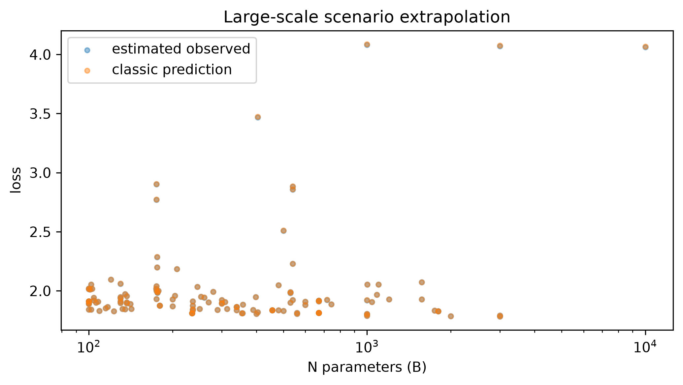
图 6 B9/B10 超百亿规模情景外推
A18 仅用于技术性定性例证，覆盖 17 个域；每域只保留域名、3 个关键词、样本量和平均字符数，不保留任何连续原文。该表不能计算 Q，也不能构造冲突标签。
domain | keyword_1 | keyword_2 | keyword_3 | sample_rows | mean_text_chars
arxiv | abstract | latex | formula | 1719 | 47031.4
dm_mathematics | problem | equation | remainder | 1922 | 8194.0
enron_emails | email | forwarded | approval | 1010 | 1618.6
europarl | debate | motion | translation | 157 | 51662.9
freelaw | statute | court | jurisdiction | 5100 | 15762.0
github | repository | code | license | 15117 | 5178.7
gutenberg_pg_19 | novel | chapter | character | 79 | 381179.6
hackernews | technology | comment | startup | 944 | 5180.6
nih_exporter | research | grant | biomedical | 1884 | 2081.3
philpapers | philosophy | argument | citation | 67 | 73524.1
pile_cc | web | document | crawl | 18191 | 4523.0
pubmed_abstracts | abstract | clinical | study | 29895 | 1330.5
pubmed_central | case | method | result | 2629 | 31268.0
stackexchange | question | answer | code | 30378 | 2171.4
ubuntu_irc | chat | package | debugging | 16 | 225242.8
uspto_backgrounds | patent | claim | invention | 11415 | 4139.5
wikipedia_en | encyclopedia | reference | topic | 17511 | 2964.6

10 复现与结论
复现命令为 $env:PYTHONPATH='src'; .venv\Scripts\python.exe -m f_question.q2，再运行 bundled Python 的 build_q2_docx.py。结论：B1 网格被精确识别；Qscore 按缺陷率建模；B2 需重标定；跨语料桥接暂不可稳定识别；二阶配比项仅作条件非加性；B9/B10 仅支持情景分析。

