数学建模 F 题第一问
语料质量评分与配比到验证损失建模完整报告
数据版本：A1–A18；主分析输出目录：outputs/q1

报告摘要
本报告将第一问的质量评分、冲突识别、配比建模、外推诊断和跨问接口统一在一份文档中。质量分使用 A1 全局经验 CDF 映射，始终满足 Q∈(0,1]；配比先闭合到单纯形，再做乘性零值替换和 16 维 Helmert ILR；13 个 The Pile 验证域分别建模，未对原始 Loss 做算术平均。
主要结论：同尺度 1M→1M 的逐域建模有效，独立检验宏平均 R² 约 0.889（指数模型），而绝对 Loss 无法跨尺度迁移；秩在跨尺度上仍较稳定。质量分的冲突惩罚是无监督的定义型敏感性评分，因没有文档级 Q 与配方级 Loss 配对，不能宣称其带来监督增益。A12–A15 的估算数据表现出高度规则的乘性标度结构，应作为估算机制诊断而非实验结果。

一 研究目标与总体流程
第一问包含三个相互连接但口径不同的任务：其一，从 22 个质量信号得到文档级 Q 和域级质量概况；其二，识别不同质量维度之间的冲突并构造可解释的惩罚评分；其三，在配比数据上使用成分数据分析，把 17 域配比映射为各验证域 Loss。完整流程为：方向统一 → A1 ECDF 标定 → 组内聚合与赋权 → 域内冲突诊断 → 配比闭合与 ILR → 逐 Loss 域训练/CV/独立检验 → 跨尺度和估算机制诊断 → 导出第二问接口。

二 质量分定义与结果

研究目标与结论
第一问分为语料质量评价、质量冲突识别、配比到验证损失建模三部分。主分析遵守三个口径：质量分 Q 属于 (0,1]；配比先闭合到单纯形再做 ILR；13 个验证域 Loss 各自建模，不对原始 Loss 求算术平均。
1. A1 质量信号样本共 51,230 条，覆盖 7 个域。等权组分 Q 保持有界，域级 bootstrap 区间见下表。
2. 13 个 The Pile 验证域分别拟合。1M 同尺度线性 Ridge 基线宏平均 R²=0.7641，逐域 Spearman 中位数=0.8854，13 个域中 13 个 R² 为正。
3. 1M 训练到 60M 测试的宏平均 R²=-7.967、Spearman 中位数=0.8861；到 1B 的宏平均 R²=-606.186、Spearman 中位数=0.8809。绝对 Loss 不具跨尺度迁移性，配比排序信号相对稳定。
4. 同尺度检验是预先指定的模型形式比较集；模型形式与惩罚参数均通过训练集 CV 逐域选择。
5. 逐域 CV 选型中，data_mixing_exponential 在 11/13 个域获选；所选模型的独立同尺度测试宏平均 R²=0.8896，13 域中正 R² 数=13。详细逐域选择表见 selected_model_by_domain.csv。

质量分定义
每个原始指标依题意统一方向，经 A1 参考经验 CDF 映射到 (0,1]。多类别分类器先 softmax 后取期望，二分类取正类概率，单元素 fineweb_edu 列表直接取值。指标按语义归为 edu、read、reason、clean、struct 五组，组内缺失值可用指标均值聚合，组间按权重求和：
Q_i=\sum_g \omega_g Q_{ig},\quad Q_i\in(0,1],\quad \sum_g\omega_g=1.
等权用于主口径；CRITIC 和熵权仅为无监督敏感性对照。监督式 Meta-rater 权重不从无配对数据中拟合：A16 只映射 6/17 配方域，且配方实验没有文档级质量标签，无法将域差异与质量效应分开。A2/A3 全量与 A1 对应域部分重合，因此同时报告全量域级 Q 及按 id 去重后的非重叠结果；两者使用冻结的 A1 指标经验 CDF 标尺。

域级质量分和区间
domain | n | Q_equal_mean | Q_CI_low | Q_CI_high | Q_length_weighted
arxiv | 1419 | 0.7323 | 0.7293 | 0.7353 | 0.7304
book | 171 | 0.5811 | 0.5656 | 0.5973 | 0.5970
commoncrawl | 9640 | 0.5661 | 0.5637 | 0.5686 | 0.5865
stackexchange | 10000 | 0.5425 | 0.5409 | 0.5442 | 0.5683
c4 | 10000 | 0.5236 | 0.5207 | 0.5266 | 0.5851
wikipedia | 10000 | 0.4389 | 0.4364 | 0.4416 | 0.5522
github | 10000 | 0.4057 | 0.4039 | 0.4076 | 0.4633

三套权重
group | equal | CRITIC | entropy
edu | 0.2000 | 0.2432 | 0.3081
read | 0.2000 | 0.2139 | 0.2341
reason | 0.2000 | 0.2277 | 0.2292
clean | 0.2000 | 0.1720 | 0.1388
struct | 0.2000 | 0.1433 | 0.0898

长度加权仅作为文档贡献口径敏感性分析，见 q_length_weighting_comparison.csv，不改变文档等权主分析。

全量扩展集域级 Q 与排序稳定性
下表报告 A2/arxiv、A3/github 全量记录，以及剔除与 A1 重合记录后的域级 Q。各分数仍在 (0,1]，CI 为文档 bootstrap 区间。
dataset | domain | n | Q_mean | Q_CI_low | Q_CI_high
A1 | arxiv | 1419 | 0.7323 | 0.7293 | 0.7353
A1 | book | 171 | 0.5811 | 0.5656 | 0.5973
A1 | c4 | 10000 | 0.5236 | 0.5207 | 0.5266
A1 | commoncrawl | 9640 | 0.5661 | 0.5637 | 0.5686
A1 | github | 10000 | 0.4057 | 0.4039 | 0.4076
A1 | stackexchange | 10000 | 0.5425 | 0.5409 | 0.5442
A1 | wikipedia | 10000 | 0.4389 | 0.4364 | 0.4416
A2_full | arxiv | 17523 | 0.7314 | 0.7305 | 0.7323
A2_nonoverlap | arxiv | 16104 | 0.7313 | 0.7303 | 0.7322
A3_full | github | 203752 | 0.4050 | 0.4045 | 0.4054
A3_nonoverlap | github | 193752 | 0.4049 | 0.4045 | 0.4053

与 A1 对应域的量表差值比较：
domain | extension | weighting | A1_n | extension_n | A1_Q_mean | extension_Q_mean | difference_extension_minus_A1
arxiv | A2_full | equal | 1419 | 17523 | 0.7323 | 0.7314 | -0.0010
arxiv | A2_full | critic | 1419 | 17523 | 0.7632 | 0.7618 | -0.0014
arxiv | A2_full | entropy | 1419 | 17523 | 0.7900 | 0.7881 | -0.0020
arxiv | A2_full | length | 1419 | 17523 | 0.7304 | 0.7296 | -0.0007
arxiv | A2_nonoverlap | equal | 1419 | 16104 | 0.7323 | 0.7313 | -0.0011
arxiv | A2_nonoverlap | critic | 1419 | 16104 | 0.7632 | 0.7616 | -0.0015
arxiv | A2_nonoverlap | entropy | 1419 | 16104 | 0.7900 | 0.7879 | -0.0021
arxiv | A2_nonoverlap | length | 1419 | 16104 | 0.7304 | 0.7296 | -0.0008
github | A3_full | equal | 10000 | 203752 | 0.4057 | 0.4050 | -0.0008
github | A3_full | critic | 10000 | 203752 | 0.4101 | 0.4094 | -0.0006
github | A3_full | entropy | 10000 | 203752 | 0.4107 | 0.4103 | -0.0004
github | A3_full | length | 10000 | 203752 | 0.4633 | 0.4649 | 0.0016
github | A3_nonoverlap | equal | 10000 | 193752 | 0.4057 | 0.4049 | -0.0008
github | A3_nonoverlap | critic | 10000 | 193752 | 0.4101 | 0.4094 | -0.0007
github | A3_nonoverlap | entropy | 10000 | 193752 | 0.4107 | 0.4103 | -0.0004
github | A3_nonoverlap | length | 10000 | 193752 | 0.4633 | 0.4650 | 0.0017

权重和长度口径变化下的域排名稳定性：
dataset | comparison | n_domains | spearman_rank | max_absolute_rank_shift | domain_order_equal
A1 | critic_vs_equal | 7 | 1.0000 | 0.0000 | True
A1 | entropy_vs_equal | 7 | 0.9643 | 1.0000 | False
A1 | length_vs_equal | 7 | 0.9643 | 1.0000 | False
A2_full | critic_vs_equal | 1 |  | 0.0000 | True
A2_full | entropy_vs_equal | 1 |  | 0.0000 | True
A2_full | length_vs_equal | 1 |  | 0.0000 | True
A2_nonoverlap | critic_vs_equal | 1 |  | 0.0000 | True
A2_nonoverlap | entropy_vs_equal | 1 |  | 0.0000 | True
A2_nonoverlap | length_vs_equal | 1 |  | 0.0000 | True
A3_full | critic_vs_equal | 1 |  | 0.0000 | True
A3_full | entropy_vs_equal | 1 |  | 0.0000 | True
A3_full | length_vs_equal | 1 |  | 0.0000 | True
A3_nonoverlap | critic_vs_equal | 1 |  | 0.0000 | True
A3_nonoverlap | entropy_vs_equal | 1 |  | 0.0000 | True
A3_nonoverlap | length_vs_equal | 1 |  | 0.0000 | True

A1 的 7 个域中，CRITIC 排名与等权完全一致；熵权和长度加权的 Spearman 均为 0.964，最大只移动 1 位。A2/A3 每个扩展文件仅覆盖一个域，因此其域间排序相关不适用；表中空 Spearman 表示样本域数为 1，不是缺失计算。

冲突识别
先在每个域内对每个质量组按文档计算经验分位，再定义冲突：至少一个组达到上阈值，且另一个组低于下阈值。报告阈值 (P70,P30)、(P75,P25)、(P80,P20)、(P90,P10) 的逐域冲突率；完整曲线见 conflict_threshold_sensitivity.csv。域内标准化避免把域先验错判为文档内冲突。
综合评价使用定义型惩罚分 Q_i^*={clip}(Q_i-\lambda C_i,\epsilon,1)，其中 C_i 为五组域内秩相对中位秩的平均绝对偏差归一化值。它只表达评分者对冲突的规范性折减，不是由 Loss 监督拟合的消解器；附件无文档 Q 与配方 Loss 配对，故惩罚是否提升 Loss 预测不可识别，不能称作实证增益。
扩展集 P75/P25 冲突率：
dataset | records | conflicts | conflict_rate
A1 | 51230 | 20463 | 0.4255
A2_full | 17523 | 9403 | 0.5366
A2_nonoverlap | 16104 | 8624 | 0.5355
A3_full | 203752 | 97621 | 0.4791
A3_nonoverlap | 193752 | 92745 | 0.4787

主要组对 (P75/P25，按各数据集前列组合)：
dataset | domain | group_a | group_b | count | pair_rate_all | share_of_conflict_pairs | upper_quantile | lower_quantile
A1 | github | edu | struct | 1961 | 0.1961 | 0.1721 | 0.7500 | 0.2500
A1 | github | reason | struct | 1780 | 0.1780 | 0.1562 | 0.7500 | 0.2500
A1 | github | read | struct | 1619 | 0.1619 | 0.1421 | 0.7500 | 0.2500
A2_full | arxiv | edu | reason | 3511 | 0.2004 | 0.1640 | 0.7500 | 0.2500
A2_full | arxiv | reason | clean | 3274 | 0.1868 | 0.1529 | 0.7500 | 0.2500
A2_full | arxiv | read | reason | 2460 | 0.1404 | 0.1149 | 0.7500 | 0.2500
A2_nonoverlap | arxiv | edu | reason | 3207 | 0.1991 | 0.1635 | 0.7500 | 0.2500
A2_nonoverlap | arxiv | reason | clean | 2995 | 0.1860 | 0.1527 | 0.7500 | 0.2500
A2_nonoverlap | arxiv | read | reason | 2256 | 0.1401 | 0.1150 | 0.7500 | 0.2500
A3_full | github | edu | struct | 38299 | 0.1880 | 0.1677 | 0.7500 | 0.2500
A3_full | github | reason | struct | 36264 | 0.1780 | 0.1588 | 0.7500 | 0.2500
A3_full | github | read | struct | 33256 | 0.1632 | 0.1456 | 0.7500 | 0.2500
A3_nonoverlap | github | edu | struct | 36332 | 0.1875 | 0.1675 | 0.7500 | 0.2500
A3_nonoverlap | github | reason | struct | 34479 | 0.1780 | 0.1589 | 0.7500 | 0.2500
A3_nonoverlap | github | read | struct | 31627 | 0.1632 | 0.1458 | 0.7500 | 0.2500

冲突惩罚的 λ 敏感性结果：
lambda | Q_mean | Q_min | Q_max | spearman_vs_unpenalized | mean_rank_shift | loss_cv_delta | interpretation
0.0000 | 0.5017 | 0.0968 | 0.9120 | 1.0000 | 0.0000 |  | descriptive Q re-ranking; document Q and mixture Loss have no paired observations
0.1000 | 0.4663 | 0.0919 | 0.9071 | 0.9962 | 964.8493 |  | descriptive Q re-ranking; document Q and mixture Loss have no paired observations
0.2500 | 0.4133 | 0.0798 | 0.8997 | 0.9768 | 2391.6611 |  | descriptive Q re-ranking; document Q and mixture Loss have no paired observations
0.5000 | 0.3248 | 0.0000 | 0.8874 | 0.9130 | 4661.1199 |  | descriptive Q re-ranking; document Q and mixture Loss have no paired observations
1.0000 | 0.1684 | 0.0000 | 0.8628 | 0.7410 | 8121.3789 |  | descriptive Q re-ranking; document Q and mixture Loss have no paired observations

分类器域偏移诊断将 ModernBERT、FineWeb-Edu 与 Qurater 聚合为 G_{model}，将结构统计聚合为 G_{struct}，并用 G_{noise}=1-ad_en 表示清洁方向。以下表格给出 arxiv 与 stackexchange 的离差和共现率；这是跨域失配的风险证据，缺少人工广告真值时不能直接命名为“误判率”。因此支持对广告信号做门控或降权，不支持无条件删除文档。
domain | G_model_mean | G_noise_mean | G_model_minus_global | G_noise_minus_global | model_high_ad_high_rate
arxiv | 0.8816 | 0.0105 | 0.3816 | -0.0706 | 0.5152
stackexchange | 0.5837 | 0.0104 | 0.0837 | -0.0706 | 0.1658

判断：冲突在 A1、A2、A3 扩展样本均普遍存在，且教育组与其他组的冲突在各扩展样本中占据重要位置，因此“存在跨维度冲突”的主要结论成立。主导组对并不完全稳定：A1 与 A3 为 edu–struct（占比约 0.152、0.168），A2 转为 edu–reason（约 0.164）；因此 arxiv 扩展集的冲突结构不能概括为与 A1/A3 相同。

配比到 Loss
给定配方原始比例 p，先按行闭合 p_j <- p_j / sum(p)，再将零值乘性替换为 δ 并重新闭合，使用 Helmert 正交基得到 16 维 ILR 坐标 z。线性 Ridge 基线为：
L_d = \beta_{0d} + z^T\beta_d + \epsilon_d,\qquad d=1,\ldots,13.
每个域单独 5 折 CV 选择 Ridge 惩罚强度。17 个组成只有 16 个自由度；ILR 系数是对数对比，任一域比例上升必从其他域替代而来，因此系数表达相对替代效应，不是绝对边际效应。4 个无对应 Loss 的组成仍会通过闭合与基准对比影响系数。
δ 敏感性、单纯形行和误差、逐域测试指标、模型形式比较和系数语义表均单独导出。交互模型用 ILR 的平方项和两两交互，共 152 个二阶设计项，并用 CV Ridge 收缩。独立检验配方上另计算固定份额联合替代：仅取训练集中平均占比最高的 8 个组成域作为有数据支持的分析范围，从一个来源域各转移 5 个百分点到两个目标域，对照两个单独转移效应之和；非加性差值描述二次模型中的组合关联，不是全 17 域无差别的因果结论。

独立同尺度测试上的模型比较
model | macro_R2 | median_domain_Spearman | domains_R2_positive
data_mixing_exponential | 0.8688 | 0.9682 | 13
linear_ridge | 0.7641 | 0.8854 | 13
quadratic_interaction_ridge | 0.8628 | 0.9399 | 13

独立检验集上的联合替代非加性效应按 Loss 域分别汇总；13 个域的绝对差值不跨域排序：
loss_domain | evaluated_combinations | median_abs_nonadditive_delta | median_sign_consistency
metric/the_pile_arxiv_val_loss | 168 | 0.0367 | 0.8889
metric/the_pile_dm_mathematics_val_loss | 168 | 0.0432 | 0.9583
metric/the_pile_freelaw_val_loss | 168 | 0.0253 | 0.9243
metric/the_pile_github_val_loss | 168 | 0.0362 | 0.9118
metric/the_pile_gutenberg_pg_19_val_loss | 168 | 0.0151 | 0.9045
metric/the_pile_hackernews_val_loss | 168 | 0.0101 | 0.9388
metric/the_pile_pile_cc_val_loss | 168 | 0.0132 | 0.8117
metric/the_pile_pubmed_abstracts_val_loss | 168 | 0.0204 | 0.8367
metric/the_pile_pubmed_central_val_loss | 168 | 0.0259 | 0.9077
metric/the_pile_stackexchange_val_loss | 168 | 0.0279 | 0.8947
metric/the_pile_ubuntu_irc_val_loss | 168 | 0.0329 | 0.9538
metric/the_pile_uspto_backgrounds_val_loss | 168 | 0.0187 | 0.8571
metric/the_pile_wikipedia_en_val_loss | 168 | 0.0199 | 0.8684

各 Loss 域内平均绝对非加性差值最大的组合（仅在域内定位）：
loss_domain | donor_domain | recipient_1 | recipient_2 | transfer_each | n_test_recipes | mean_nonadditive_delta_loss | median_nonadditive_delta_loss | mean_absolute_nonadditive_delta_loss | sign_consistency | interpretation
metric/the_pile_arxiv_val_loss | github | stackexchange | arxiv | 0.0500 | 77 | 0.1661 | 0.0554 | 0.1775 | 0.8701 | quadratic-model non-additivity; conditional association, not causal synergy
metric/the_pile_dm_mathematics_val_loss | arxiv | freelaw | pubmed_central | 0.0500 | 65 | -0.1181 | -0.0614 | 0.1182 | 0.9846 | quadratic-model non-additivity; conditional association, not causal synergy
metric/the_pile_freelaw_val_loss | arxiv | freelaw | pile_cc | 0.0500 | 65 | 0.0823 | 0.0320 | 0.0833 | 0.9385 | quadratic-model non-additivity; conditional association, not causal synergy
metric/the_pile_github_val_loss | pile_cc | stackexchange | github | 0.0500 | 68 | 0.2487 | 0.0868 | 0.2522 | 0.8676 | quadratic-model non-additivity; conditional association, not causal synergy
metric/the_pile_gutenberg_pg_19_val_loss | uspto_backgrounds | wikipedia_en | github | 0.0500 | 59 | -0.0334 | -0.0160 | 0.0334 | 1.0000 | quadratic-model non-additivity; conditional association, not causal synergy
metric/the_pile_hackernews_val_loss | arxiv | freelaw | pubmed_central | 0.0500 | 65 | -0.0261 | -0.0166 | 0.0263 | 0.9846 | quadratic-model non-additivity; conditional association, not causal synergy
metric/the_pile_pile_cc_val_loss | github | wikipedia_en | pile_cc | 0.0500 | 77 | 0.0592 | 0.0280 | 0.0610 | 0.8442 | quadratic-model non-additivity; conditional association, not causal synergy
metric/the_pile_pubmed_abstracts_val_loss | freelaw | wikipedia_en | github | 0.0500 | 47 | -0.0452 | -0.0259 | 0.0452 | 1.0000 | quadratic-model non-additivity; conditional association, not causal synergy
metric/the_pile_pubmed_central_val_loss | pubmed_central | wikipedia_en | uspto_backgrounds | 0.0500 | 81 | 0.0775 | 0.0458 | 0.0775 | 1.0000 | quadratic-model non-additivity; conditional association, not causal synergy
metric/the_pile_stackexchange_val_loss | pile_cc | stackexchange | github | 0.0500 | 68 | 0.1919 | 0.0670 | 0.1939 | 0.8824 | quadratic-model non-additivity; conditional association, not causal synergy
metric/the_pile_ubuntu_irc_val_loss | arxiv | freelaw | pubmed_central | 0.0500 | 65 | -0.0716 | -0.0388 | 0.0719 | 0.9538 | quadratic-model non-additivity; conditional association, not causal synergy
metric/the_pile_uspto_backgrounds_val_loss | uspto_backgrounds | wikipedia_en | github | 0.0500 | 59 | 0.0185 | 0.0055 | 0.0582 | 0.6102 | quadratic-model non-additivity; conditional association, not causal synergy
metric/the_pile_wikipedia_en_val_loss | github | wikipedia_en | pile_cc | 0.0500 | 77 | 0.1299 | 0.0689 | 0.1319 | 0.8571 | quadratic-model non-additivity; conditional association, not causal synergy

跨尺度检查
绝对误差与排序相关分别报告，不将不同尺度的 Loss 做混合均值。跨尺度检验用于界定适用范围，而不是模型升级的调参集。
对 A12–A15 的共用 63 个配方，逐域 1M 对估算 10B/70B 的 Spearman 中位数分别为 0.623 / 0.492；先逐域 z 标准化再等权合成后的排序相关为 -0.749 / -0.793。该证据提示配方相对排序具有一定保持性，但估算数据不提供跨尺度绝对 Loss 校准。

按附录编号的固定指数模型评估
为直接对应附录 A，以下补充实验固定使用 Data Mixing Laws 指数式 L_d=c_d+k_d\exp(t_d^T p)：A4–A5 的 1M 配比与 Loss 成对用于训练，域内正则强度沿用 A4–A5 内部五折 CV 结果；A6–A11 分别评估 1M、60M、1B，A12–A15 分别评估估算 10B、70B。每个尺度独立列出逐域 R^2 与 MAE，再报告 13 域指标的算术均值（先逐域计算指标，不合并原始 Loss）。误差放大倍数定义为同域 MAE 相对 A6–A7 同尺度检验 MAE 的比值，再取域中位数。
appendix_pair | scale | data_status | domains_evaluated | recipe_count | mean_domain_r2 | median_domain_r2 | mean_domain_mae | median_domain_mae | mean_domain_rmse | mean_domain_spearman | median_domain_error_amplification | exact_recipe_overlap_with_A4_A5
A10-A11 | 1B | observed cross-scale | 13 | 64 | -549.3750 | -403.0339 | 2.8322 | 2.6998 | 2.8593 | 0.9037 | 17.4731 | 0
A12-A13 | 10B | estimated cross-scale | 13 | 63 | -237.4910 | -232.6527 | 3.5749 | 3.5609 | 3.6215 | 0.5798 | 21.9602 | 63
A14-A15 | 70B | estimated cross-scale | 13 | 63 | -386.7915 | -373.0903 | 3.9578 | 3.9445 | 4.0060 | 0.4958 | 24.3010 | 63
A6-A7 | 1M | observed held-out | 13 | 256 | 0.8688 | 0.8996 | 0.2193 | 0.1581 | 0.2680 | 0.9492 | 1.0000 | 0
A8-A9 | 60M | observed cross-scale | 13 | 256 | -7.5202 | -8.0918 | 1.4894 | 1.3714 | 1.5223 | 0.9449 | 8.5605 | 0

appendix_split_exponential_metrics_by_domain.csv 给出 13 域完整结果，appendix_split_exponential_predictions.csv.gz 保存逐配方预测，图见 fig_appendix_split_exponential_eval.png。A6–A11 是未出现在 A4–A5 的新配方，可用于检验；A12–A15 的 63 个配方则与训练表配方逐行重复，因此这些数字只衡量固定配方的估算跨尺度偏差，不能作为独立配方外推精度或实验验证。A8–A11 也是不同模型规模的实测 Loss，明显的绝对误差放大说明 1M Loss 标度不可直接迁移；排序相关与绝对误差应分开解释。

A12–A15 标度生成机制反演
对 63 个共同配方逐域计算 \gamma=-\log(L_N/L_{1M})/\log(N/1M)，并对三尺度的 \log L 做乘性标度拟合。估算表中逐域结果、相关置信区间和真实 1M→60M 对照见 scaling_est_reverse_engineering.csv 与 scaling_est_gamma_by_recipe.csv，图见 fig_est_gamma_coupling.png。估算数据的 gamma(10B) 与 gamma(70B) 高度一致，但与初始 Loss 的相关性按域差异明显；汇总相关是域-配方池化的描述性统计，不能视为独立样本。真实 1M→60M 对照未复现统一的高正相关，因此现有数据不支持“必然存在 r>0.90 的人工耦合”这一强断言；可以确认的是估算三点几乎严格落在乘性曲线上（估算域内中位 log-fit R²=1.0000），应将其作为估算机制特征而非实验规律。

数据边界与可识别性
- A12–A15 是估算数据；10B 与 70B 使用同一组配方 id，不作为独立实验结果。
- A12–A15 与 A4–A5 的 63 个配方配置逐行相同；固定指数式在其上的评估是估算 Loss 的尺度诊断，不是新配方外推检验。
- A2/A3 含有 A1 对应域记录，报告将全量结果用于题目要求的扩展对照，并另列去重非重叠估计；A2/A3 是扩展抽样而非独立外部验证。
- A17 域摘要用于域先验。A18 原始文本样例覆盖 17 个域，以下仅作定性构念核验；A18 不含 22 项质量信号，不能验证数值 Q，也不能作为冲突标签。
domain | sample_text_excerpt
arxiv | --- abstract: 'The role of the spatial structure of a turbulent flow in enhancing particle collision rates in suspensions is an open question. We show and quantify, as a function of particle inertia, the correlation between the multiscale structures of turbulence and particle collisions: Straining zones contribute predominantly to rapid head-on collisions co
dm_mathematics | b be o(-2). Suppose -1 = -2*i + 2*z - 23, -3*i - 5*z = b. What is the remainder when 8/6*(-306)/i is divided by 12? 10 What is the remainder when -4*(-4 - -1) - -1 is divided by 5? 3 Suppose y + 7 - 19 = 0. What is the remainder when 21 is divided by y? 9 Suppose 0 = -3*k + 4 + 8. Suppose 2*x - 7*x - c = -115, -2*c = 0. Suppose 4*z - 40 = -2*s, -40 = -5*z +
enron_emails | pls print this email also. thanks df ---------------------- Forwarded by Drew Fossum/ET&S/Enron on 03/20/2001 04:37 PM --------------------------- From: Michael P Moran/ENRON@enronXgate on 03/20/2001 02:08 PM To: Rod Hayslett/ENRON@enronXgate cc: Drew Fossum/ET&S/Enron@ENRON Subject: RE: ETS Approval Authorization Policy I think one area that needs to be cla
europarl | Ramy kwalifikacji dla uczenia się przez całe życie (debata) Przewodniczący Następnym punktem porządku obrad jest sprawozdanie Mario Mantovaniego, w imieniu Komisji Zatrudnienia i Spraw Socjalnych, w sprawie wniosku dotyczącego zalecenia Parlamentu Europejskiego i Rady w sprawie ustanowienia europejskich ram kwalifikacji dla uczenia się przez całe życie - C6-
freelaw | 720 N.W.2d 716 (2006) 2006 WI App 132 Linda T. PETERSON, Plaintiff-Appellant, v. CORNERSTONE PROPERTY DEVELOPMENT, LLC, Defendant-Respondent. No. 2004AP3358. Court of Appeals of Wisconsin. June 13, 2006. On behalf of the plaintiff-appellant, the cause was submitted on the briefs of Jordan B. Reich of Kohner, Mann & Kailas, S.C., of Milwaukee, with oral argum
github | grammar Poly; options { output=AST; language=ObjC; } tokens { MULT; } // imaginary token poly: term ('+'^ term)* ; term: INT ID -> ^(MULT[@"*"] INT ID) \ | INT exp -> ^(MULT[@"*"] INT exp) \ | exp \ | INT \ | ID ; exp : ID '^'^ INT ; ID returns [NSString *value] : 'a'..'z'+ ; INT returns [NSString *value] : '0'..'9'+ ; WS : (' '\ | '\t'\ | '\r'\ | '\n')+ { $channel=HIDDEN; }
gutenberg_pg_19 | Produced by Jason Isbell, Stacy Brown Thellend and the Online Distributed Proofreading Team at http://www.pgdp.net Merged with an earlier text produced by Juliet Sutherland, Thomas Hutchinson and the Online Distributed Proofreading Team [Illustration] TALES OF DARING AND DANGER. [Illustration] [Illustration: SIGHTING THE WRECK OF THE STEAMER.] TALES OF DARIN
hackernews | How Freud’s Only Visit to America Made Him Hate the US for the Rest of His Life - protomyth http://mentalfloss.com/article/501060/man-buys-two-metric-tons-lego-bricks-sorts-them-machine-learning ====== Fricken Might wanna try posting this again, you're linking to a story about the guy who built a crazy Lego sorting machine. ~~~ Zuider The submitter linked to
nih_exporter | Potassium channels in the renal cortical collecting tubule (CCT) play an important role in potassium (K) secretion by the kidney and help to maintain the body's overall K balance. In this nephron segment, potassium secretion rates depend on both the apical membrane K permeability and the electrochemical driving forces for K across the apical membrane. The ap
philpapers | S.Ph. Essays and Explorations 1.2 25 "Part of that force that always wills the evil and always produces the good" On a Devilish Incoherence Peter Baumann When Mephisto was asked by Faust, "Well now, who are you then?" ("Nun gut, wer bist Du denn?"), he gave the well-known answer, "Part of that force that always wills the evil and always produces the good" ("
pile_cc | Mud Hens pitcher Evan Reed charged with sexual assault Mud Hens pitcher Evan Reed was charged July 30 with sexual assault related to a March incident in Detroit when he was a member of the Detroit Tigers. Evan Reed Reed, 28, was charged with two counts of criminal sexual conduct for alleged committing “an act of penetration through force or coercion” when he
pubmed_abstracts | One-year follow-up of patients treated for dental fear: effects of cognitive therapy, applied relaxation, and nitrous oxide sedation. The effects of dental fear treatments were assessed in a 1-year follow-up study. Sixty-two patients had finished a controlled study in which they were randomly allocated to nitrous oxide sedation (NO), cognitive therapy (CT),
pubmed_central | Background {#Sec1} ========== The clinical importance of lumbar disc degeneration as measured on MRI remains controversial and uncertain. This may in part be due to the challenges in accurately and reproducibly measuring disc degeneration. Most studies investigating disc degeneration use a subjective assessment which categorize discs into different levels of
stackexchange | Q: Show message dialog Is it possible to display a QML dialog when the user hits a button in a QML window? Example: When the user clicks in the menu bar on Help -> About the About dialog should be displayed: import QtQuick 2.12 import QtQuick.Layouts 1.12 import QtQuick.Window 2.12 import QtQuick.Controls 2.12 import "components" ApplicationWindow { id: wind
ubuntu_irc | #ubuntu-design 2012-06-19 <warp10> Hi all guys! <warp10> Is this picture available in higher resolution somehwere? --> http://www.ubuntu.com/sites/www.ubuntu.com/files/active/02_ubuntu/U_business/desktop-release-nov-2011.png #ubuntu-design 2012-06-21 <c3sso> hello. does somebody know why the themes from .themes aren not shown in appearance panel ? #ubuntu-de
uspto_backgrounds | The invention relates to an expansion joint for part of a railway track disposed on a foundation which has a stock rail with a stock rail head, web and foot and a tongue movable with respect to and along said stock rail, upon which tongue at least one fastening means acts to press it onto the head of the stock rail. In known expansion joints, also designated
wikipedia_en | Roman Catholic Diocese of Tambacounda The Roman Catholic Diocese of Tambacounda () is a diocese located in the city of Tambacounda in the Ecclesiastical province of Dakar in Senegal. History August 13, 1970: Established as Apostolic Prefecture of Tambacounda from the Diocese of Kaolack and Diocese of Saint-Louis du Sénégal April 17, 1989: Promoted as Diocese

- 附件 A Loss 是 The Pile 验证集交叉熵；附件 B Pythia val_loss 是另一验证集的口径。没有共同样本或同模型、同检查点的配对 Loss，仿射/单调桥接不能从当前附件识别。附件 A Q 与 B 的 Q_score 也没有同文档配对，故不拟合重标定关系。本报告结果不作为第二问接口的已校准数值。
- A12–A15 的逐域排序与域内标准化等权汇总见 estimated_loss_ranking_reversal_summary.csv；任何跨域合成均先在域内标准化，原始 13 域算术均值不作排序结论或模型因变量。

输出文件
逐域完整数据表、敏感性 CSV、模型指标、残差与预测散点图、域 Q 分布图，以及按附录编号补充的指数模型逐域结果和误差放大图均在 outputs/q1/。图中汇总散点只对每个域分别标准化后叠合，未平均原始 Loss。
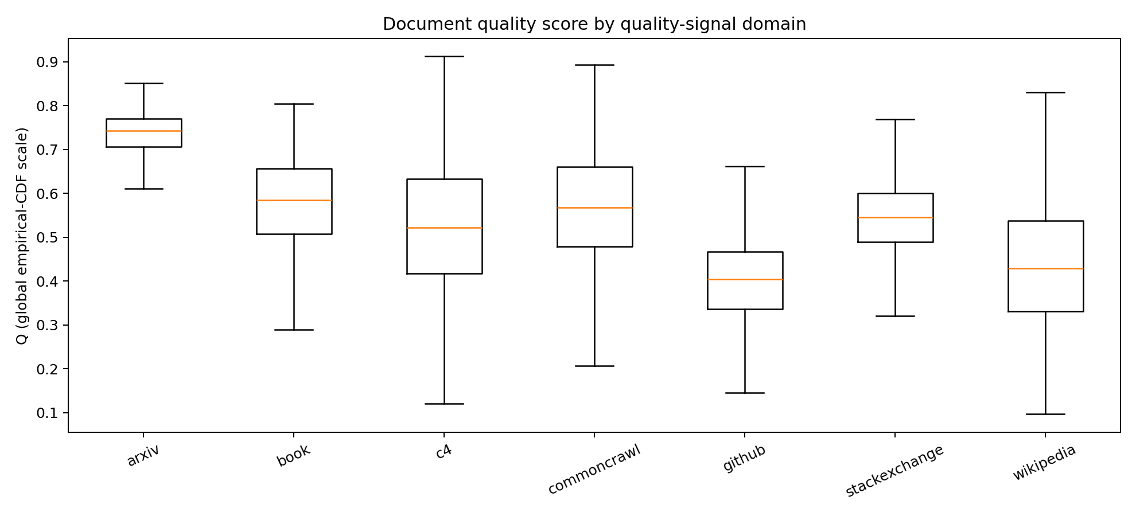
图 1 七个抽样域的文档质量分分布。
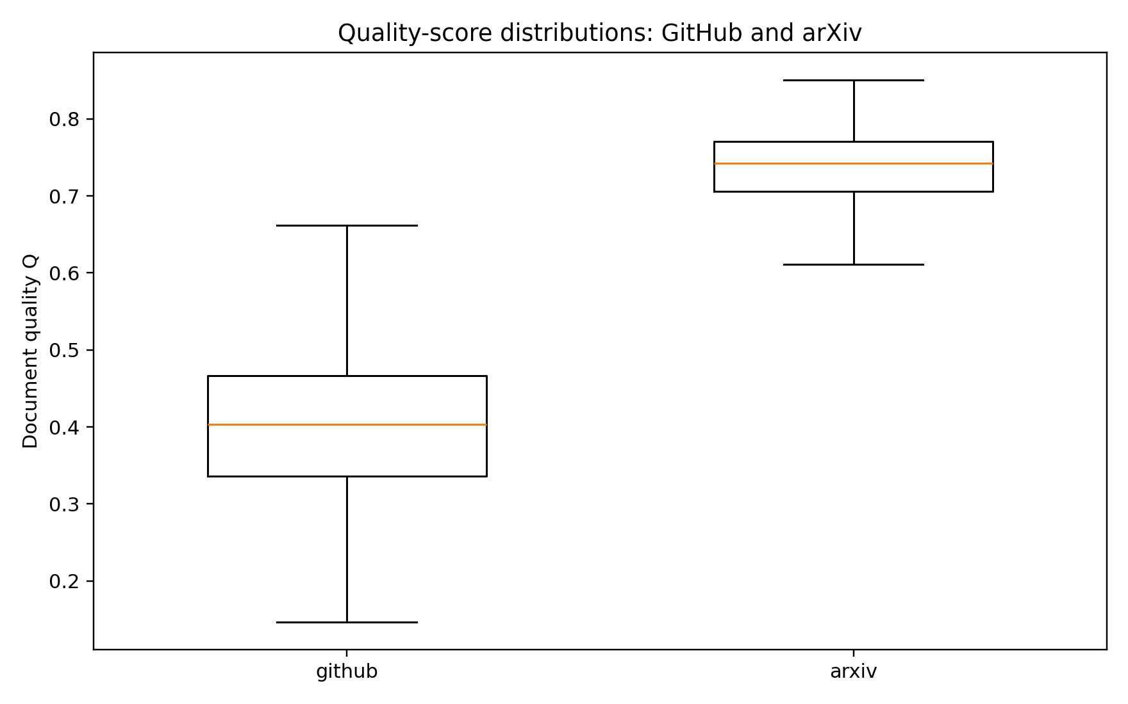
图 2 github 与 arxiv 的质量分对比，显示明显的域间水平差异。

三 补充实证与机制解释
下面汇总补充报告中的估算数据、冲突机制、分类器域偏移、组合效应和 A17/A18 证据。数值表保留原始分析口径，所有估算结果均明确标注为估算或描述性诊断。

A12–A15：估算外推排序
A12–A15 中 10B 与 70B 均有 63 个相同配方、13 个域完整 Loss。以下结果按 index 对齐；它们是估算数据诊断，不是独立实验。跨域合成先分别对每个域做 z 标准化，再对域 z 分数等权平均；不使用原始 Loss 算术均值作为结论。
comparison | n_recipes | spearman | kendall_tau | best_recipe_a | best_recipe_b | data_status
10B vs 70B; mean within-domain z-score composite | 63.0000 | 0.9942 | 0.9447 | 32.0000 | 32.0000 | estimated; equal-domain standardized composite is descriptive only, not a response
1M vs 10b; mean within-domain z-score composite | 63.0000 | -0.7490 | -0.5678 | 56.0000 | 32.0000 | 1M observed vs estimated; equal-domain standardized composite is descriptive only
1M vs 70b; mean within-domain z-score composite | 63.0000 | -0.7931 | -0.6129 | 56.0000 | 32.0000 | 1M observed vs estimated; equal-domain standardized composite is descriptive only

逐域对照 1M 观测训练 Loss 与估算 Loss：
domain | scale | n_shared_recipes | spearman_1m_vs_estimated | kendall_tau | pairwise_rank_reversal_fraction | best_recipe_1m | best_recipe_estimated | best_recipe_same | worst_recipe_1m | worst_recipe_estimated | data_status
arxiv | 10b | 63.0000 | 0.8665 | 0.6979 | 0.1510 | 45.0000 | 45.0000 | True | 47.0000 | 47.0000 | estimated; shared recipe ids; not independent experiment
dm_mathematics | 10b | 63.0000 | 0.8292 | 0.6477 | 0.1761 | 35.0000 | 35.0000 | True | 32.0000 | 23.0000 | estimated; shared recipe ids; not independent experiment
freelaw | 10b | 63.0000 | 0.7527 | 0.5791 | 0.2104 | 11.0000 | 32.0000 | False | 9.0000 | 36.0000 | estimated; shared recipe ids; not independent experiment
github | 10b | 63.0000 | 0.8077 | 0.6160 | 0.1920 | 41.0000 | 51.0000 | False | 29.0000 | 7.0000 | estimated; shared recipe ids; not independent experiment
gutenberg_pg_19 | 10b | 63.0000 | 0.4222 | 0.2934 | 0.3533 | 31.0000 | 29.0000 | False | 9.0000 | 62.0000 | estimated; shared recipe ids; not independent experiment
hackernews | 10b | 63.0000 | 0.0191 | 0.0097 | 0.4951 | 61.0000 | 47.0000 | False | 9.0000 | 16.0000 | estimated; shared recipe ids; not independent experiment
pile_cc | 10b | 63.0000 | 0.0959 | 0.0753 | 0.4624 | 57.0000 | 32.0000 | False | 9.0000 | 16.0000 | estimated; shared recipe ids; not independent experiment
pubmed_abstracts | 10b | 63.0000 | 0.4102 | 0.2883 | 0.3559 | 63.0000 | 9.0000 | False | 33.0000 | 17.0000 | estimated; shared recipe ids; not independent experiment
pubmed_central | 10b | 63.0000 | 0.7608 | 0.5627 | 0.2186 | 9.0000 | 9.0000 | True | 32.0000 | 17.0000 | estimated; shared recipe ids; not independent experiment
stackexchange | 10b | 63.0000 | 0.6385 | 0.4456 | 0.2772 | 25.0000 | 51.0000 | False | 29.0000 | 27.0000 | estimated; shared recipe ids; not independent experiment
ubuntu_irc | 10b | 63.0000 | 0.6227 | 0.4347 | 0.2826 | 23.0000 | 47.0000 | False | 9.0000 | 37.0000 | estimated; shared recipe ids; not independent experiment
uspto_backgrounds | 10b | 63.0000 | 0.4512 | 0.3237 | 0.3382 | 29.0000 | 29.0000 | True | 34.0000 | 36.0000 | estimated; shared recipe ids; not independent experiment
wikipedia_en | 10b | 63.0000 | 0.3286 | 0.2372 | 0.3814 | 10.0000 | 47.0000 | False | 34.0000 | 36.0000 | estimated; shared recipe ids; not independent experiment
arxiv | 70b | 63.0000 | 0.8086 | 0.6365 | 0.1818 | 45.0000 | 45.0000 | True | 47.0000 | 47.0000 | estimated; shared recipe ids; not independent experiment
dm_mathematics | 70b | 63.0000 | 0.8103 | 0.6119 | 0.1941 | 35.0000 | 35.0000 | True | 32.0000 | 23.0000 | estimated; shared recipe ids; not independent experiment
freelaw | 70b | 63.0000 | 0.6798 | 0.5136 | 0.2432 | 11.0000 | 32.0000 | False | 9.0000 | 36.0000 | estimated; shared recipe ids; not independent experiment
github | 70b | 63.0000 | 0.7099 | 0.5228 | 0.2386 | 41.0000 | 51.0000 | False | 29.0000 | 7.0000 | estimated; shared recipe ids; not independent experiment
gutenberg_pg_19 | 70b | 63.0000 | 0.3315 | 0.2299 | 0.3850 | 31.0000 | 29.0000 | False | 9.0000 | 62.0000 | estimated; shared recipe ids; not independent experiment
hackernews | 70b | 63.0000 | -0.0900 | -0.0630 | 0.5315 | 61.0000 | 47.0000 | False | 9.0000 | 16.0000 | estimated; shared recipe ids; not independent experiment
pile_cc | 70b | 63.0000 | 0.0380 | 0.0343 | 0.4828 | 57.0000 | 32.0000 | False | 9.0000 | 16.0000 | estimated; shared recipe ids; not independent experiment
pubmed_abstracts | 70b | 63.0000 | 0.2877 | 0.2084 | 0.3958 | 63.0000 | 9.0000 | False | 33.0000 | 16.0000 | estimated; shared recipe ids; not independent experiment
pubmed_central | 70b | 63.0000 | 0.6474 | 0.4634 | 0.2683 | 9.0000 | 9.0000 | True | 32.0000 | 17.0000 | estimated; shared recipe ids; not independent experiment
stackexchange | 70b | 63.0000 | 0.4921 | 0.3186 | 0.3407 | 25.0000 | 51.0000 | False | 29.0000 | 27.0000 | estimated; shared recipe ids; not independent experiment
ubuntu_irc | 70b | 63.0000 | 0.4981 | 0.3442 | 0.3279 | 23.0000 | 47.0000 | False | 9.0000 | 37.0000 | estimated; shared recipe ids; not independent experiment
uspto_backgrounds | 70b | 63.0000 | 0.3780 | 0.2720 | 0.3640 | 29.0000 | 29.0000 | True | 34.0000 | 36.0000 | estimated; shared recipe ids; not independent experiment
wikipedia_en | 70b | 63.0000 | 0.2375 | 0.1685 | 0.4158 | 10.0000 | 47.0000 | False | 34.0000 | 36.0000 | estimated; shared recipe ids; not independent experiment

1M 与 10B、1M 与 70B 的逐域 Spearman 中位数分别为 0.623、0.492；A12–A15 内部 10B/70B 域内排序 Spearman 中位数为 0.991。经域内标准化后的 1M/10B、1M/70B 配方综合排序 Spearman 分别为 -0.749、-0.793。这些估算结果仅说明跨尺度配方排序关联，不能解释为绝对 Loss 的跨尺度迁移。

A12–A15 标度生成机制反演
逐域计算 gamma=-log(L_N/L_1M)/log(N/1M)，并对三尺度 log Loss 做乘性拟合。估算 gamma(10B) 与 gamma(70B) 的池化相关为 0.9997；估算域内中位 log-fit R² 为 1.0000。与 1M 初始 Loss 的相关未达到 r>0.90 的人工耦合判据，真实 1M→60M 对照也未复现统一高正相关。池化统计是域-配方描述性诊断，不是独立样本推断。

冲突、成因与惩罚
冲突在每个来源域内分别计算五组分数的经验秩：至少一组处于上分位且另一组处于下分位即定义为冲突。组对表统计高低分共现次数；这是描述性构成，不作因果解释。
A1 阈值敏感性汇总：
upper_quantile | total_conflicts | mean_domain_rate | n | weighted_rate
0.7000 | 26296.0000 | 0.5391 | 51230.0000 | 0.5133
0.7500 | 20463.0000 | 0.4255 | 51230.0000 | 0.3994
0.8000 | 14582.0000 | 0.3050 | 51230.0000 | 0.2846
0.9000 | 4273.0000 | 0.0909 | 51230.0000 | 0.0834

抽样集与扩展集在 P75/P25 下的复核：
dataset | records | mean_domain_conflict_rate
A1 | 51230.0000 | 0.4255
A2_full | 17523.0000 | 0.5366
A2_nonoverlap | 16104.0000 | 0.5355
A3_full | 203752.0000 | 0.4791
A3_nonoverlap | 193752.0000 | 0.4787

冲突组对的前列组合（按数据集）：
dataset | group_a | group_b | pair_count | share
A1 | edu | struct | 7086.0000 | 0.1516
A1 | read | struct | 6042.0000 | 0.1293
A1 | reason | struct | 5691.0000 | 0.1218
A1 | edu | clean | 5440.0000 | 0.1164
A1 | clean | struct | 4735.0000 | 0.1013
A2_full | edu | reason | 3511.0000 | 0.1640
A2_full | reason | clean | 3274.0000 | 0.1529
A2_full | read | reason | 2460.0000 | 0.1149
A2_full | reason | struct | 2304.0000 | 0.1076
A2_full | edu | struct | 2125.0000 | 0.0993
A2_nonoverlap | edu | reason | 3207.0000 | 0.1635
A2_nonoverlap | reason | clean | 2995.0000 | 0.1527
A2_nonoverlap | read | reason | 2256.0000 | 0.1150
A2_nonoverlap | reason | struct | 2109.0000 | 0.1075
A2_nonoverlap | edu | struct | 1933.0000 | 0.0985
A3_full | edu | struct | 38299.0000 | 0.1677
A3_full | reason | struct | 36264.0000 | 0.1588
A3_full | read | struct | 33256.0000 | 0.1456
A3_full | clean | struct | 24433.0000 | 0.1070
A3_full | read | clean | 22472.0000 | 0.0984
A3_nonoverlap | edu | struct | 36332.0000 | 0.1675
A3_nonoverlap | reason | struct | 34479.0000 | 0.1589
A3_nonoverlap | read | struct | 31627.0000 | 0.1458
A3_nonoverlap | clean | struct | 23202.0000 | 0.1069
A3_nonoverlap | read | clean | 21338.0000 | 0.0984

题目示例的定向检验：域内教育价值组处于 P75 以上且原始广告概率处于 P75 以上（即清洁度方向不利）的共现率。
dataset | records | edu_high_ad_high_n | mean_domain_rate | weighted_rate
A1 | 51230.0000 | 3976.0000 | 0.0769 | 0.0776
A2_full | 17523.0000 | 888.0000 | 0.0507 | 0.0507
A2_nonoverlap | 16104.0000 | 822.0000 | 0.0510 | 0.0510
A3_full | 203752.0000 | 12609.0000 | 0.0619 | 0.0619
A3_nonoverlap | 193752.0000 | 11994.0000 | 0.0619 | 0.0619

分类器域偏移诊断把 ModernBERT/FineWeb-Edu/Qurater 合成为 G_model，把结构统计合成为 G_struct，并以 G_noise=1-ad_en 表示清洁方向。目标域结果如下；无人工广告真值，因此这是假阳性风险证据而非误判率。
domain | G_model_mean | G_noise_mean | G_model_minus_global | G_noise_minus_global | model_high_ad_high_rate
arxiv | 0.8816 | 0.0105 | 0.3816 | -0.0706 | 0.5152
stackexchange | 0.5837 | 0.0104 | 0.0837 | -0.0706 | 0.1658

综合评分敏感性定义为 Q*=clip(Q_equal-λC, ε, 1)，其中 C 是五组域内经验秩相对中位秩的平均绝对偏差（映射至 [0,1]）。
lambda | Q_mean | Q_min | Q_max | spearman_vs_unpenalized | mean_rank_shift | loss_cv_delta | interpretation
0.0000 | 0.5017 | 0.0968 | 0.9120 | 1.0000 | 0.0000 |  | descriptive Q re-ranking; document Q and mixture Loss have no paired observations
0.1000 | 0.4663 | 0.0919 | 0.9071 | 0.9962 | 964.8493 |  | descriptive Q re-ranking; document Q and mixture Loss have no paired observations
0.2500 | 0.4133 | 0.0798 | 0.8997 | 0.9768 | 2391.6611 |  | descriptive Q re-ranking; document Q and mixture Loss have no paired observations
0.5000 | 0.3248 | 0.0000 | 0.8874 | 0.9130 | 4661.1199 |  | descriptive Q re-ranking; document Q and mixture Loss have no paired observations
1.0000 | 0.1684 | 0.0000 | 0.8628 | 0.7410 | 8121.3789 |  | descriptive Q re-ranking; document Q and mixture Loss have no paired observations

现有附件没有将文档级 Q 与配方级 13 域 Loss 配对的观测。因此 λ 表只评估 Q 的范围和排序变化；Loss CV 增益不可识别，不能据此宣称惩罚改善了模型。若以冲突率作为惩罚也属于定义型评分而非监督消解。论文主 Q 保留 λ=0，惩罚分作为敏感性评分。

17 域配比效应解读
指数式为 L_d=c_d+k_d exp(Σ_j t_dj p_j)，并约束 Σ_j t_dj=0。配比从域 k 转移到域 j 时，log(L_d-c_d) 的局部变化率是 t_dj-t_dk，是明确的相对替代对比。
各 Loss 域中模型内最强和最弱的替代方向（关联解释）：
loss_domain | gain_domain | replaced_domain | delta_log_excess_loss_per_unit_share | interpretation | direction
metric/the_pile_arxiv_val_loss | arxiv | enron_emails | -31.2329 | increase gain_domain share by replacing replaced_domain share; conditional association | lower predicted excess Loss
metric/the_pile_dm_mathematics_val_loss | dm_mathematics | pubmed_abstracts | -22.5135 | increase gain_domain share by replacing replaced_domain share; conditional association | lower predicted excess Loss
metric/the_pile_freelaw_val_loss | freelaw | github | -28.3491 | increase gain_domain share by replacing replaced_domain share; conditional association | lower predicted excess Loss
metric/the_pile_github_val_loss | github | uspto_backgrounds | -22.1354 | increase gain_domain share by replacing replaced_domain share; conditional association | lower predicted excess Loss
metric/the_pile_gutenberg_pg_19_val_loss | gutenberg_pg_19 | uspto_backgrounds | -22.4096 | increase gain_domain share by replacing replaced_domain share; conditional association | lower predicted excess Loss
metric/the_pile_hackernews_val_loss | hackernews | uspto_backgrounds | -21.8974 | increase gain_domain share by replacing replaced_domain share; conditional association | lower predicted excess Loss
metric/the_pile_pile_cc_val_loss | pile_cc | uspto_backgrounds | -7.7153 | increase gain_domain share by replacing replaced_domain share; conditional association | lower predicted excess Loss
metric/the_pile_pubmed_abstracts_val_loss | pubmed_abstracts | uspto_backgrounds | -18.4323 | increase gain_domain share by replacing replaced_domain share; conditional association | lower predicted excess Loss
metric/the_pile_pubmed_central_val_loss | pubmed_central | enron_emails | -25.0546 | increase gain_domain share by replacing replaced_domain share; conditional association | lower predicted excess Loss
metric/the_pile_stackexchange_val_loss | stackexchange | gutenberg_pg_19 | -22.3439 | increase gain_domain share by replacing replaced_domain share; conditional association | lower predicted excess Loss
metric/the_pile_ubuntu_irc_val_loss | ubuntu_irc | pubmed_abstracts | -21.9118 | increase gain_domain share by replacing replaced_domain share; conditional association | lower predicted excess Loss
metric/the_pile_uspto_backgrounds_val_loss | nih_exporter | github | -1.7765 | increase gain_domain share by replacing replaced_domain share; conditional association | lower predicted excess Loss
metric/the_pile_wikipedia_en_val_loss | wikipedia_en | github | -21.0174 | increase gain_domain share by replacing replaced_domain share; conditional association | lower predicted excess Loss
metric/the_pile_arxiv_val_loss | enron_emails | europarl | 4.8689 | increase gain_domain share by replacing replaced_domain share; conditional association | higher predicted excess Loss
metric/the_pile_dm_mathematics_val_loss | freelaw | dm_mathematics | 22.5370 | increase gain_domain share by replacing replaced_domain share; conditional association | higher predicted excess Loss
metric/the_pile_freelaw_val_loss | arxiv | freelaw | 28.2843 | increase gain_domain share by replacing replaced_domain share; conditional association | higher predicted excess Loss
metric/the_pile_github_val_loss | pubmed_central | github | 22.2627 | increase gain_domain share by replacing replaced_domain share; conditional association | higher predicted excess Loss
metric/the_pile_gutenberg_pg_19_val_loss | arxiv | gutenberg_pg_19 | 22.4630 | increase gain_domain share by replacing replaced_domain share; conditional association | higher predicted excess Loss
metric/the_pile_hackernews_val_loss | pubmed_central | hackernews | 22.0242 | increase gain_domain share by replacing replaced_domain share; conditional association | higher predicted excess Loss
metric/the_pile_pile_cc_val_loss | github | pile_cc | 8.0777 | increase gain_domain share by replacing replaced_domain share; conditional association | higher predicted excess Loss
metric/the_pile_pubmed_abstracts_val_loss | enron_emails | pubmed_abstracts | 20.4571 | increase gain_domain share by replacing replaced_domain share; conditional association | higher predicted excess Loss
metric/the_pile_pubmed_central_val_loss | freelaw | pubmed_central | 24.7845 | increase gain_domain share by replacing replaced_domain share; conditional association | higher predicted excess Loss
metric/the_pile_stackexchange_val_loss | freelaw | stackexchange | 22.4775 | increase gain_domain share by replacing replaced_domain share; conditional association | higher predicted excess Loss
metric/the_pile_ubuntu_irc_val_loss | pubmed_central | ubuntu_irc | 21.9937 | increase gain_domain share by replacing replaced_domain share; conditional association | higher predicted excess Loss
metric/the_pile_uspto_backgrounds_val_loss | github | uspto_backgrounds | 19.7188 | increase gain_domain share by replacing replaced_domain share; conditional association | higher predicted excess Loss
metric/the_pile_wikipedia_en_val_loss | arxiv | wikipedia_en | 20.8182 | increase gain_domain share by replacing replaced_domain share; conditional association | higher predicted excess Loss

该指数模型的线性预测项没有配比交互项，所以可估计替代效应，不能检验域对协同/互补；声称互补需要另加交互并通过独立检验集验证。下面的 t 汇总仅作跨域描述，不能代替逐 Loss 域系数。
mixture_domain | mean_t | median_t | positive_loss_domains | negative_loss_domains
enron_emails | -0.9850 | -1.2560 | 5.0000 | 8.0000
nih_exporter | -0.6320 | 0.0755 | 7.0000 | 6.0000
hackernews | -0.4363 | 1.2485 | 10.0000 | 3.0000
philpapers | -0.3800 | -0.3688 | 6.0000 | 7.0000
ubuntu_irc | -0.3258 | 1.3155 | 12.0000 | 1.0000
stackexchange | -0.2495 | 1.7673 | 11.0000 | 2.0000
freelaw | -0.1751 | 2.0982 | 12.0000 | 1.0000
pubmed_central | -0.1698 | 2.0446 | 11.0000 | 2.0000
arxiv | -0.1102 | 2.0979 | 12.0000 | 1.0000
gutenberg_pg_19 | 0.0741 | 1.8270 | 12.0000 | 1.0000
wikipedia_en | 0.1239 | 1.8165 | 11.0000 | 2.0000
github | 0.1896 | 2.0654 | 11.0000 | 2.0000
dm_mathematics | 0.2356 | 2.0850 | 12.0000 | 1.0000
pubmed_abstracts | 0.2940 | 2.0191 | 12.0000 | 1.0000
uspto_backgrounds | 0.3997 | 2.0330 | 12.0000 | 1.0000
pile_cc | 0.8948 | 1.6760 | 12.0000 | 1.0000
europarl | 1.2521 | 1.3849 | 13.0000 | 0.0000

nih_exporter、enron_emails、europarl、philpapers 无直接验证 Loss 列，其 t 仅表示它们进入混合比例后对其他有观测域 Loss 的替代关系，不是对该域自身质量的预测。

A17/A18 与指标规范
A17 regmix_domain_summary.csv 已导出为域样本量、平均文本长度的先验表。A18 regmix_domain_sample.jsonl.xz 已做全量域覆盖和条数核验，可为论文提供原始文本定性例证；该文件不含 22 项质量信号，不能用来计算 Q 或量化冲突。
domain | sample_rows | mean_text_chars | quality_indicators_present | permitted_use
arxiv | 1719.0000 | 47031.4444 | False | domain coverage and qualitative text examples only; cannot calculate Q/conflicts
dm_mathematics | 1922.0000 | 8194.0000 | False | domain coverage and qualitative text examples only; cannot calculate Q/conflicts
enron_emails | 1010.0000 | 1618.6327 | False | domain coverage and qualitative text examples only; cannot calculate Q/conflicts
europarl | 157.0000 | 51662.8662 | False | domain coverage and qualitative text examples only; cannot calculate Q/conflicts
freelaw | 5100.0000 | 15762.0020 | False | domain coverage and qualitative text examples only; cannot calculate Q/conflicts
github | 15117.0000 | 5178.6776 | False | domain coverage and qualitative text examples only; cannot calculate Q/conflicts
gutenberg_pg_19 | 79.0000 | 381179.5949 | False | domain coverage and qualitative text examples only; cannot calculate Q/conflicts
hackernews | 944.0000 | 5180.6049 | False | domain coverage and qualitative text examples only; cannot calculate Q/conflicts
nih_exporter | 1884.0000 | 2081.3524 | False | domain coverage and qualitative text examples only; cannot calculate Q/conflicts
philpapers | 67.0000 | 73524.0746 | False | domain coverage and qualitative text examples only; cannot calculate Q/conflicts
pile_cc | 18191.0000 | 4523.0303 | False | domain coverage and qualitative text examples only; cannot calculate Q/conflicts
pubmed_abstracts | 29895.0000 | 1330.4512 | False | domain coverage and qualitative text examples only; cannot calculate Q/conflicts
pubmed_central | 2629.0000 | 31267.9490 | False | domain coverage and qualitative text examples only; cannot calculate Q/conflicts
stackexchange | 30378.0000 | 2171.3960 | False | domain coverage and qualitative text examples only; cannot calculate Q/conflicts
ubuntu_irc | 16.0000 | 225242.7500 | False | domain coverage and qualitative text examples only; cannot calculate Q/conflicts
uspto_backgrounds | 11415.0000 | 4139.5155 | False | domain coverage and qualitative text examples only; cannot calculate Q/conflicts
wikipedia_en | 17511.0000 | 2964.6163 | False | domain coverage and qualitative text examples only; cannot calculate Q/conflicts

A18 原始文本示例覆盖全部 17 域（仅示意领域文本差异，不作为评分或冲突证据）：
domain | sample_text_excerpt | interpretation_boundary
arxiv | --- abstract: 'The role of the spatial structure of a turbulent flow in enhancing particle collision rates in suspensions is an open question. We show and quantify, as a function of particle inertia, the correlation between the multiscale structures of turbulence and particle collisions: Straining zones contribute predominantly to rapid head-on collisions co | illustrative source text only; not a quality label or conflict case
dm_mathematics | b be o(-2). Suppose -1 = -2*i + 2*z - 23, -3*i - 5*z = b. What is the remainder when 8/6*(-306)/i is divided by 12? 10 What is the remainder when -4*(-4 - -1) - -1 is divided by 5? 3 Suppose y + 7 - 19 = 0. What is the remainder when 21 is divided by y? 9 Suppose 0 = -3*k + 4 + 8. Suppose 2*x - 7*x - c = -115, -2*c = 0. Suppose 4*z - 40 = -2*s, -40 = -5*z + | illustrative source text only; not a quality label or conflict case
enron_emails | pls print this email also. thanks df ---------------------- Forwarded by Drew Fossum/ET&S/Enron on 03/20/2001 04:37 PM --------------------------- From: Michael P Moran/ENRON@enronXgate on 03/20/2001 02:08 PM To: Rod Hayslett/ENRON@enronXgate cc: Drew Fossum/ET&S/Enron@ENRON Subject: RE: ETS Approval Authorization Policy I think one area that needs to be cla | illustrative source text only; not a quality label or conflict case
europarl | Ramy kwalifikacji dla uczenia się przez całe życie (debata) Przewodniczący Następnym punktem porządku obrad jest sprawozdanie Mario Mantovaniego, w imieniu Komisji Zatrudnienia i Spraw Socjalnych, w sprawie wniosku dotyczącego zalecenia Parlamentu Europejskiego i Rady w sprawie ustanowienia europejskich ram kwalifikacji dla uczenia się przez całe życie - C6- | illustrative source text only; not a quality label or conflict case
freelaw | 720 N.W.2d 716 (2006) 2006 WI App 132 Linda T. PETERSON, Plaintiff-Appellant, v. CORNERSTONE PROPERTY DEVELOPMENT, LLC, Defendant-Respondent. No. 2004AP3358. Court of Appeals of Wisconsin. June 13, 2006. On behalf of the plaintiff-appellant, the cause was submitted on the briefs of Jordan B. Reich of Kohner, Mann & Kailas, S.C., of Milwaukee, with oral argum | illustrative source text only; not a quality label or conflict case
github | grammar Poly; options { output=AST; language=ObjC; } tokens { MULT; } // imaginary token poly: term ('+'^ term)* ; term: INT ID -> ^(MULT[@"*"] INT ID) \ | INT exp -> ^(MULT[@"*"] INT exp) \ | exp \ | INT \ | ID ; exp : ID '^'^ INT ; ID returns [NSString *value] : 'a'..'z'+ ; INT returns [NSString *value] : '0'..'9'+ ; WS : (' '\ | '\t'\ | '\r'\ | '\n')+ { $channel=HIDDEN; } | illustrative source text only; not a quality label or conflict case
gutenberg_pg_19 | Produced by Jason Isbell, Stacy Brown Thellend and the Online Distributed Proofreading Team at http://www.pgdp.net Merged with an earlier text produced by Juliet Sutherland, Thomas Hutchinson and the Online Distributed Proofreading Team [Illustration] TALES OF DARING AND DANGER. [Illustration] [Illustration: SIGHTING THE WRECK OF THE STEAMER.] TALES OF DARIN | illustrative source text only; not a quality label or conflict case
hackernews | How Freud’s Only Visit to America Made Him Hate the US for the Rest of His Life - protomyth http://mentalfloss.com/article/501060/man-buys-two-metric-tons-lego-bricks-sorts-them-machine-learning ====== Fricken Might wanna try posting this again, you're linking to a story about the guy who built a crazy Lego sorting machine. ~~~ Zuider The submitter linked to | illustrative source text only; not a quality label or conflict case
nih_exporter | Potassium channels in the renal cortical collecting tubule (CCT) play an important role in potassium (K) secretion by the kidney and help to maintain the body's overall K balance. In this nephron segment, potassium secretion rates depend on both the apical membrane K permeability and the electrochemical driving forces for K across the apical membrane. The ap | illustrative source text only; not a quality label or conflict case
philpapers | S.Ph. Essays and Explorations 1.2 25 "Part of that force that always wills the evil and always produces the good" On a Devilish Incoherence Peter Baumann When Mephisto was asked by Faust, "Well now, who are you then?" ("Nun gut, wer bist Du denn?"), he gave the well-known answer, "Part of that force that always wills the evil and always produces the good" (" | illustrative source text only; not a quality label or conflict case
pile_cc | Mud Hens pitcher Evan Reed charged with sexual assault Mud Hens pitcher Evan Reed was charged July 30 with sexual assault related to a March incident in Detroit when he was a member of the Detroit Tigers. Evan Reed Reed, 28, was charged with two counts of criminal sexual conduct for alleged committing “an act of penetration through force or coercion” when he | illustrative source text only; not a quality label or conflict case
pubmed_abstracts | One-year follow-up of patients treated for dental fear: effects of cognitive therapy, applied relaxation, and nitrous oxide sedation. The effects of dental fear treatments were assessed in a 1-year follow-up study. Sixty-two patients had finished a controlled study in which they were randomly allocated to nitrous oxide sedation (NO), cognitive therapy (CT), | illustrative source text only; not a quality label or conflict case
pubmed_central | Background {#Sec1} ========== The clinical importance of lumbar disc degeneration as measured on MRI remains controversial and uncertain. This may in part be due to the challenges in accurately and reproducibly measuring disc degeneration. Most studies investigating disc degeneration use a subjective assessment which categorize discs into different levels of | illustrative source text only; not a quality label or conflict case
stackexchange | Q: Show message dialog Is it possible to display a QML dialog when the user hits a button in a QML window? Example: When the user clicks in the menu bar on Help -> About the About dialog should be displayed: import QtQuick 2.12 import QtQuick.Layouts 1.12 import QtQuick.Window 2.12 import QtQuick.Controls 2.12 import "components" ApplicationWindow { id: wind | illustrative source text only; not a quality label or conflict case
ubuntu_irc | #ubuntu-design 2012-06-19 <warp10> Hi all guys! <warp10> Is this picture available in higher resolution somehwere? --> http://www.ubuntu.com/sites/www.ubuntu.com/files/active/02_ubuntu/U_business/desktop-release-nov-2011.png #ubuntu-design 2012-06-21 <c3sso> hello. does somebody know why the themes from .themes aren not shown in appearance panel ? #ubuntu-de | illustrative source text only; not a quality label or conflict case
uspto_backgrounds | The invention relates to an expansion joint for part of a railway track disposed on a foundation which has a stock rail with a stock rail head, web and foot and a tongue movable with respect to and along said stock rail, upon which tongue at least one fastening means acts to press it onto the head of the stock rail. In known expansion joints, also designated | illustrative source text only; not a quality label or conflict case
wikipedia_en | Roman Catholic Diocese of Tambacounda The Roman Catholic Diocese of Tambacounda () is a diocese located in the city of Tambacounda in the Ecclesiastical province of Dakar in Senegal. History August 13, 1970: Established as Apostolic Prefecture of Tambacounda from the Diocese of Kaolack and Diocese of Saint-Louis du Sénégal April 17, 1989: Promoted as Diocese | illustrative source text only; not a quality label or conflict case

22 个指标的方向、变换、分组及是否进入 Q 已规范化输出在 quality_indicator_protocol_22.csv。

解释边界
A12–A15 是共用配方的估算结果；A2/A3 与 A1 样本重叠部分须剔除后才可作扩展复核。跨域冲突组对不等于因果机制；配方系数只在给定混合比例空间、给定 Loss 域和模型形式下解释。

二阶组合效应
独立检验配方中，对来源域分别向两个目标域各转移 5 个百分点。分析限于训练集平均占比最高的 8 个组成域。非加性量为联合预测变化减去两项单独变化之和；它刻画二次 Ridge 的条件关联，不是因果协同。不同 Loss 域的绝对量纲不同，因此逐域汇总，不跨域按效应大小排序。
loss_domain | evaluated_combinations | median_abs_nonadditive_delta | median_sign_consistency
metric/the_pile_arxiv_val_loss | 168.0000 | 0.0367 | 0.8889
metric/the_pile_dm_mathematics_val_loss | 168.0000 | 0.0432 | 0.9583
metric/the_pile_freelaw_val_loss | 168.0000 | 0.0253 | 0.9243
metric/the_pile_github_val_loss | 168.0000 | 0.0362 | 0.9118
metric/the_pile_gutenberg_pg_19_val_loss | 168.0000 | 0.0151 | 0.9045
metric/the_pile_hackernews_val_loss | 168.0000 | 0.0101 | 0.9388
metric/the_pile_pile_cc_val_loss | 168.0000 | 0.0132 | 0.8117
metric/the_pile_pubmed_abstracts_val_loss | 168.0000 | 0.0204 | 0.8367
metric/the_pile_pubmed_central_val_loss | 168.0000 | 0.0259 | 0.9077
metric/the_pile_stackexchange_val_loss | 168.0000 | 0.0279 | 0.8947
metric/the_pile_ubuntu_irc_val_loss | 168.0000 | 0.0329 | 0.9538
metric/the_pile_uspto_backgrounds_val_loss | 168.0000 | 0.0187 | 0.8571
metric/the_pile_wikipedia_en_val_loss | 168.0000 | 0.0199 | 0.8684

各 Loss 域内平均绝对非加性差值最大的组合：
loss_domain | donor_domain | recipient_1 | recipient_2 | transfer_each | n_test_recipes | mean_nonadditive_delta_loss | median_nonadditive_delta_loss | mean_absolute_nonadditive_delta_loss | sign_consistency | interpretation
metric/the_pile_arxiv_val_loss | github | stackexchange | arxiv | 0.0500 | 77.0000 | 0.1661 | 0.0554 | 0.1775 | 0.8701 | quadratic-model non-additivity; conditional association, not causal synergy
metric/the_pile_dm_mathematics_val_loss | arxiv | freelaw | pubmed_central | 0.0500 | 65.0000 | -0.1181 | -0.0614 | 0.1182 | 0.9846 | quadratic-model non-additivity; conditional association, not causal synergy
metric/the_pile_freelaw_val_loss | arxiv | freelaw | pile_cc | 0.0500 | 65.0000 | 0.0823 | 0.0320 | 0.0833 | 0.9385 | quadratic-model non-additivity; conditional association, not causal synergy
metric/the_pile_github_val_loss | pile_cc | stackexchange | github | 0.0500 | 68.0000 | 0.2487 | 0.0868 | 0.2522 | 0.8676 | quadratic-model non-additivity; conditional association, not causal synergy
metric/the_pile_gutenberg_pg_19_val_loss | uspto_backgrounds | wikipedia_en | github | 0.0500 | 59.0000 | -0.0334 | -0.0160 | 0.0334 | 1.0000 | quadratic-model non-additivity; conditional association, not causal synergy
metric/the_pile_hackernews_val_loss | arxiv | freelaw | pubmed_central | 0.0500 | 65.0000 | -0.0261 | -0.0166 | 0.0263 | 0.9846 | quadratic-model non-additivity; conditional association, not causal synergy
metric/the_pile_pile_cc_val_loss | github | wikipedia_en | pile_cc | 0.0500 | 77.0000 | 0.0592 | 0.0280 | 0.0610 | 0.8442 | quadratic-model non-additivity; conditional association, not causal synergy
metric/the_pile_pubmed_abstracts_val_loss | freelaw | wikipedia_en | github | 0.0500 | 47.0000 | -0.0452 | -0.0259 | 0.0452 | 1.0000 | quadratic-model non-additivity; conditional association, not causal synergy
metric/the_pile_pubmed_central_val_loss | pubmed_central | wikipedia_en | uspto_backgrounds | 0.0500 | 81.0000 | 0.0775 | 0.0458 | 0.0775 | 1.0000 | quadratic-model non-additivity; conditional association, not causal synergy
metric/the_pile_stackexchange_val_loss | pile_cc | stackexchange | github | 0.0500 | 68.0000 | 0.1919 | 0.0670 | 0.1939 | 0.8824 | quadratic-model non-additivity; conditional association, not causal synergy
metric/the_pile_ubuntu_irc_val_loss | arxiv | freelaw | pubmed_central | 0.0500 | 65.0000 | -0.0716 | -0.0388 | 0.0719 | 0.9538 | quadratic-model non-additivity; conditional association, not causal synergy
metric/the_pile_uspto_backgrounds_val_loss | uspto_backgrounds | wikipedia_en | github | 0.0500 | 59.0000 | 0.0185 | 0.0055 | 0.0582 | 0.6102 | quadratic-model non-additivity; conditional association, not causal synergy
metric/the_pile_wikipedia_en_val_loss | github | wikipedia_en | pile_cc | 0.0500 | 77.0000 | 0.1299 | 0.0689 | 0.1319 | 0.8571 | quadratic-model non-additivity; conditional association, not causal synergy

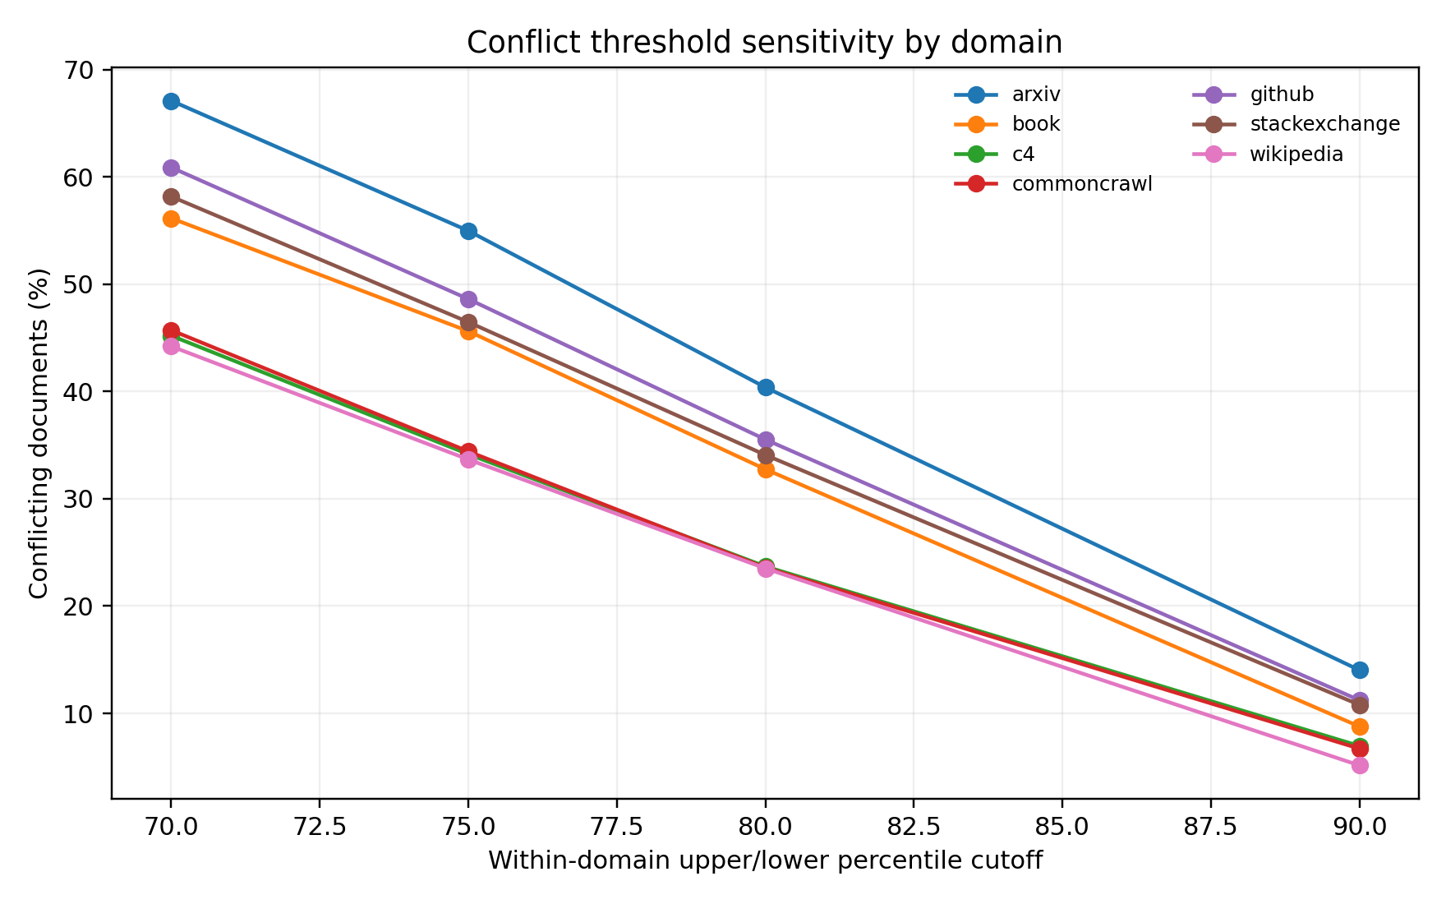
图 3 冲突阈值敏感性曲线。阈值越严格，冲突率越低；主口径采用域内 P75/P25。
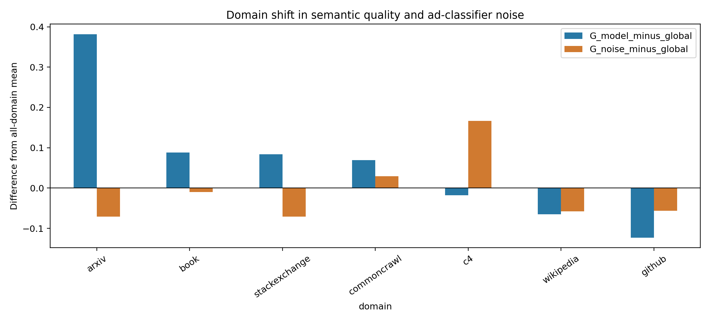
图 4 arxiv 与 stackexchange 的分类器域偏移诊断。
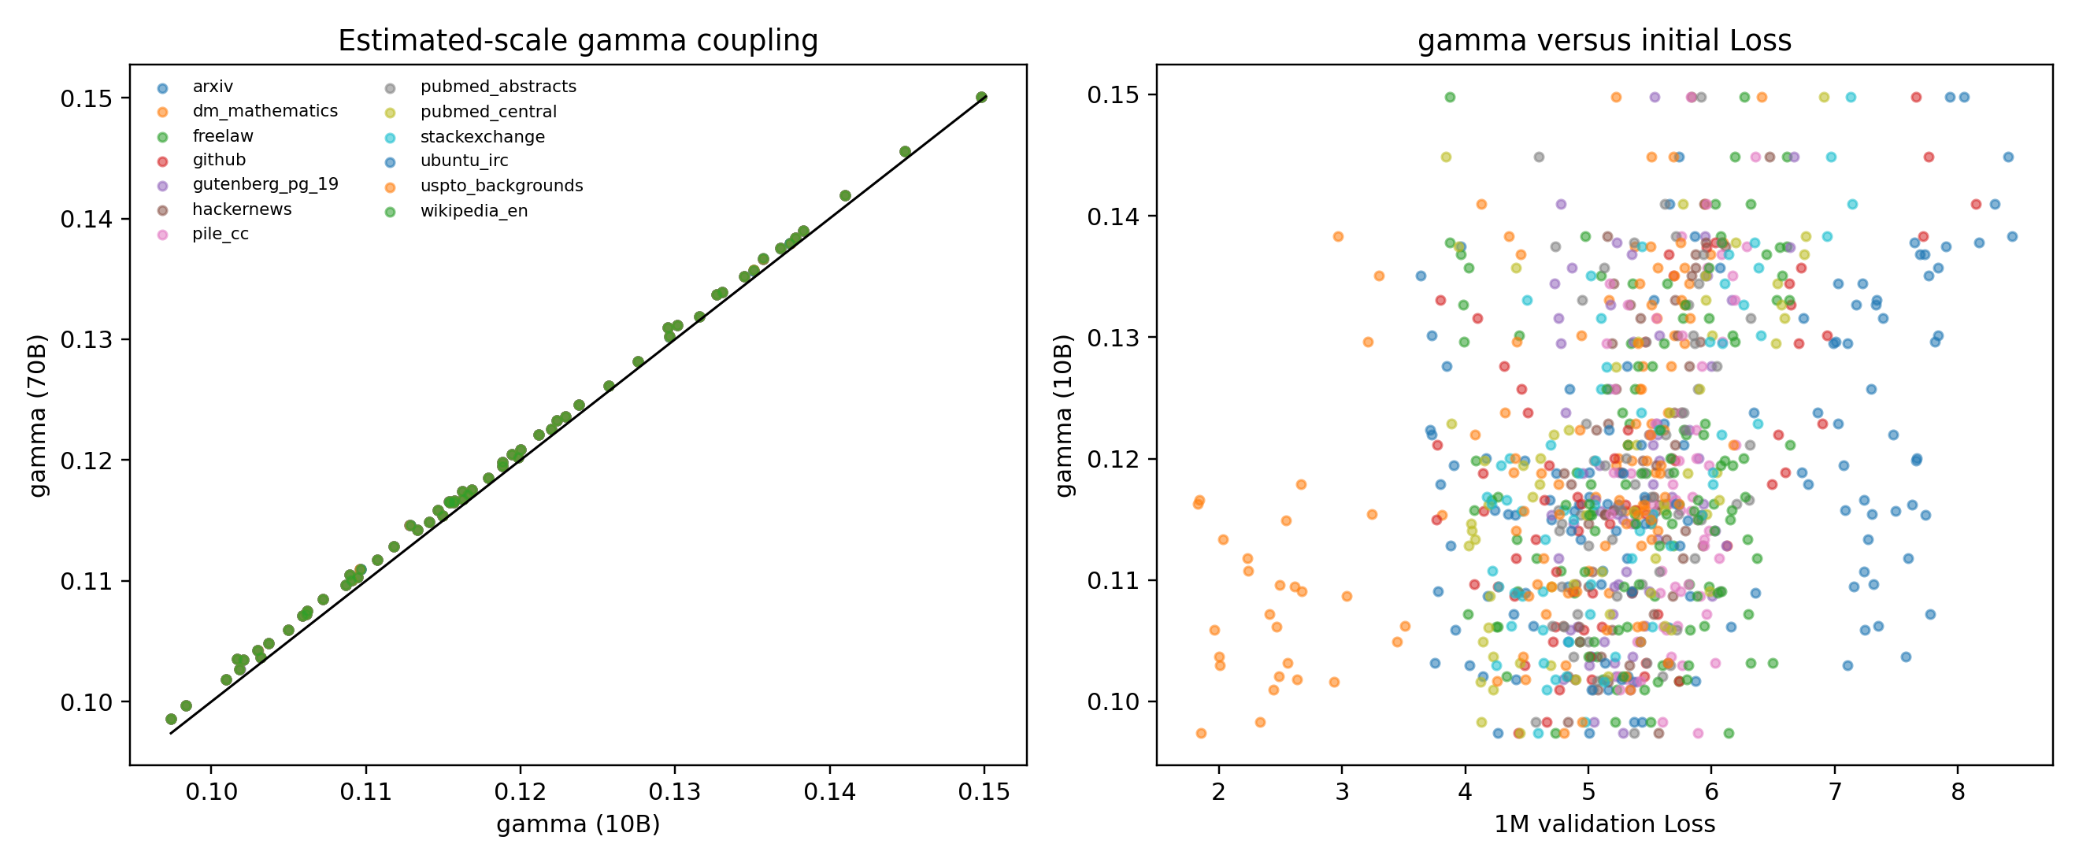
图 5 A12–A15 估算标度指数 gamma 的耦合关系。
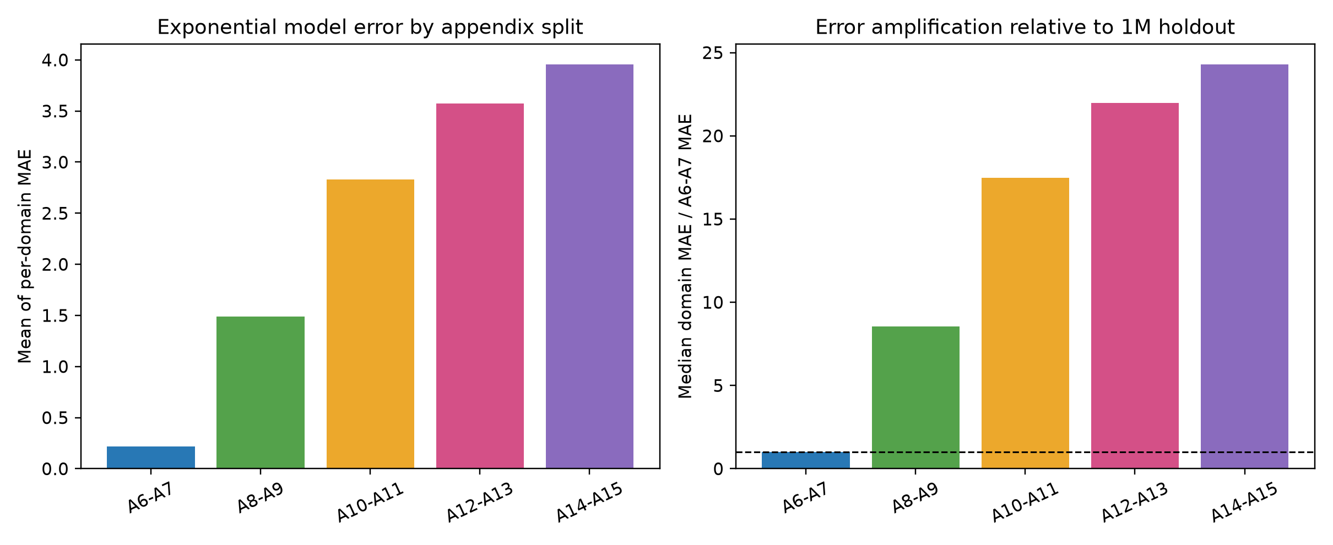
图 6 按附录 A 编号划分的固定指数模型跨集合误差与相对放大倍数。
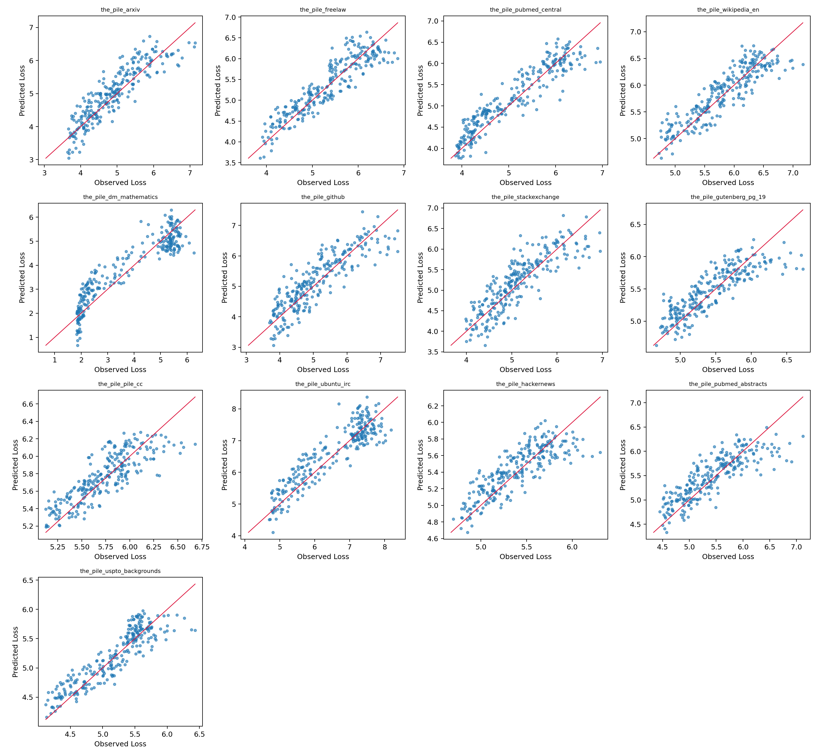
图 7 各验证域独立 Loss 的预测值与实测值。
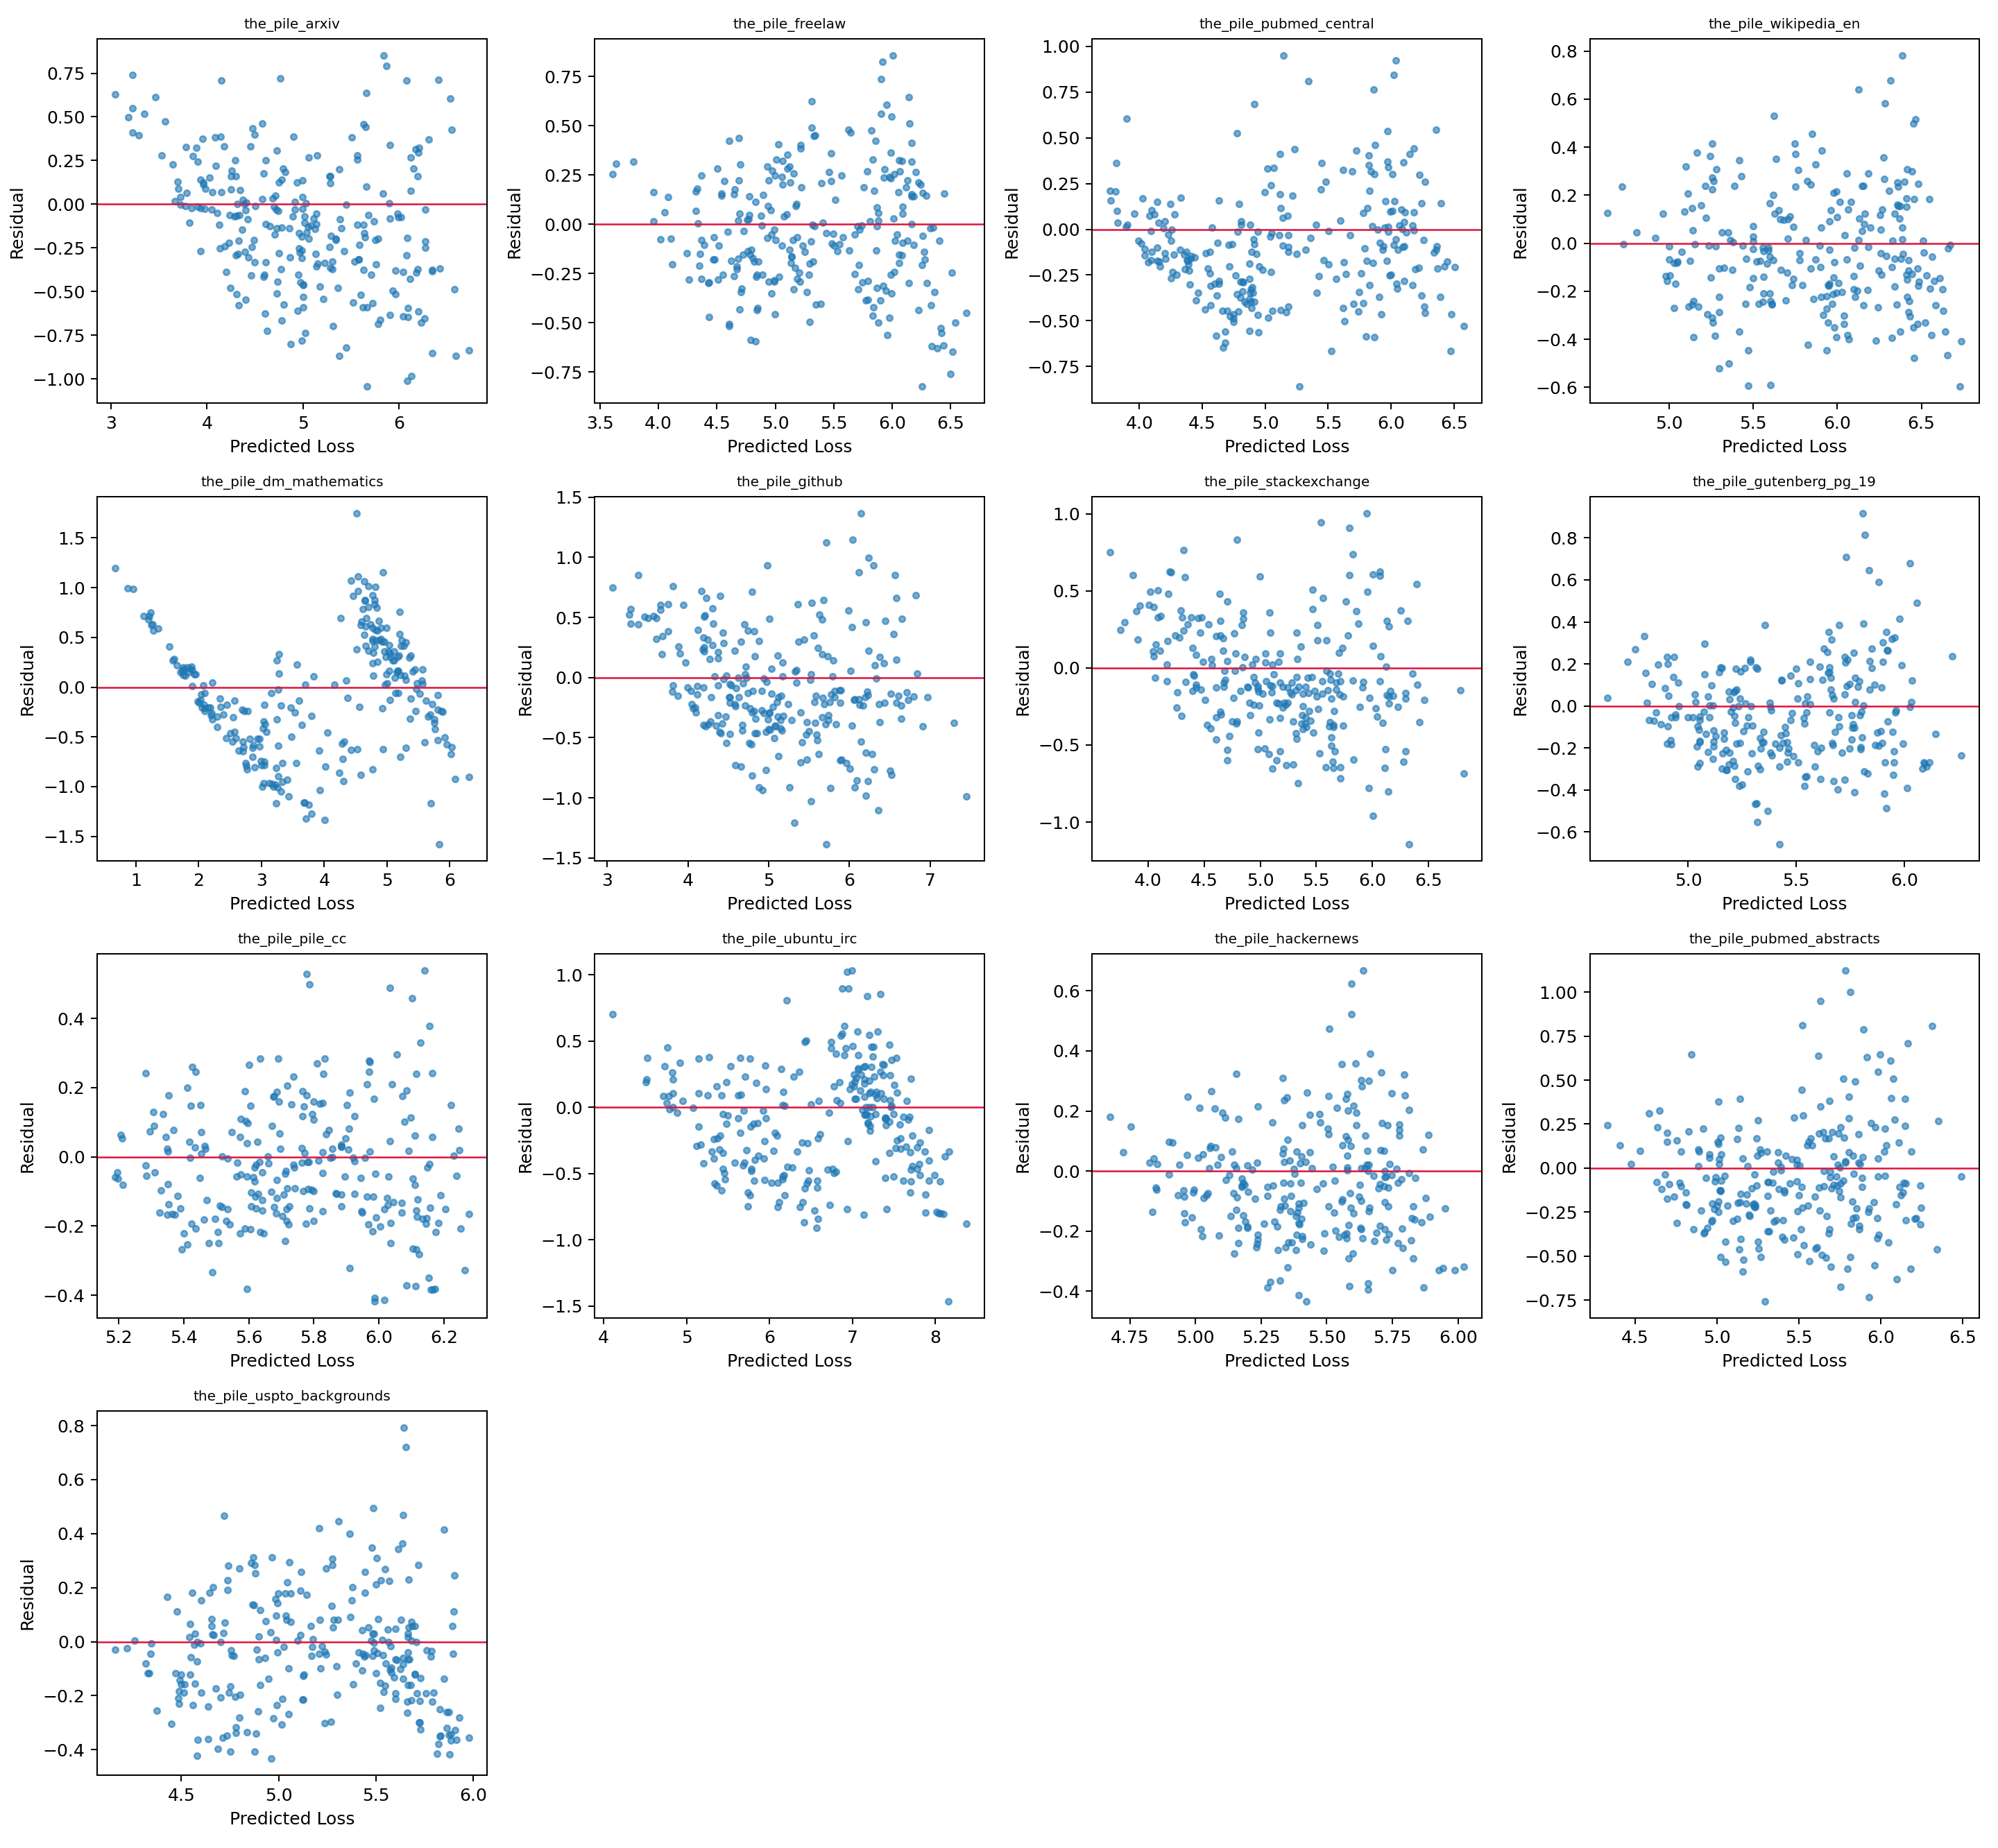
图 8 各验证域独立模型残差。
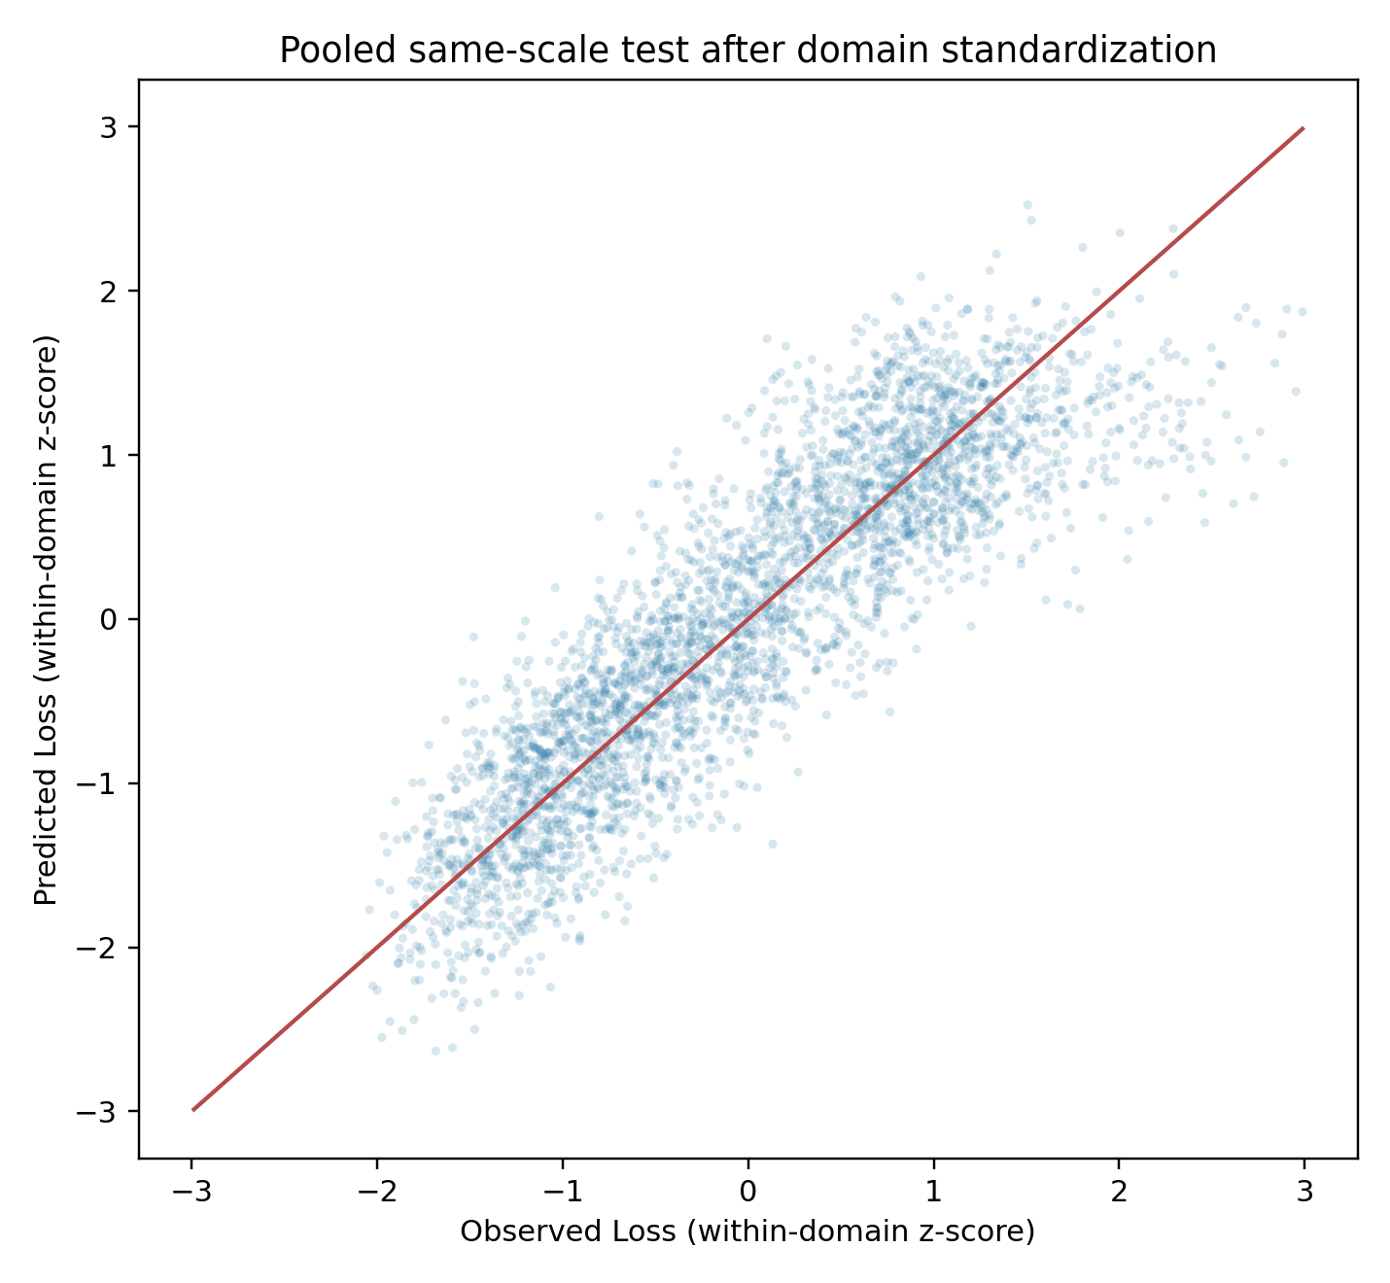
图 9 域内标准化后的跨尺度排序诊断。

四 结果图与数据文件索引
图 1–9 已嵌入本报告。为便于复核，原始表格和模型系数仍以 CSV/JSON 保存在 outputs/q1。关键文件包括：q_domain_summary.csv、q_domain_summary_A1_A2_A3_all.csv、quality_weight_comparison.csv、conflict_threshold_by_population.csv、conflict_pair_decomposition.csv、conflict_penalty_sensitivity.csv、model_form_comparison.csv、loss_metrics_by_domain_and_scale.csv、appendix_split_exponential_metrics_by_domain.csv、appendix_split_exponential_metrics_summary.csv、data_mixing_law_coefficients.csv、mixture_joint_transfer_effects.csv、scaling_est_reverse_engineering.csv、conflict_classifier_domain_shift.csv、q2_input_interface_bundle.json。

五 最终结论与边界
质量分应理解为冻结在 A1 经验分布上的相对质量刻度，不能直接与附件 B 的 Q_score 混用；跨附件 Loss 也必须经过桥接，不能把 The Pile 验证 Loss 与 Pythia 自有 val_loss 当作同一量尺。配比系数表示相对替代：提高一个域的比例必然从其他域挪出份额。四个没有直接 Loss 列的域只通过闭合和替代关系间接进入系数，不能解读为它们自身的直接预测效果。A12–A15 共用同一批 63 个配方，A2/A3 与 A1 存在完全重合的子抽样关系，均不应当被当作独立外部实验。
在独立同尺度检验上，指数模型优于线性基线；二次交互模型提供组合非加性诊断，但组合效应属于模型条件关联而非因果协同。跨尺度检验表明绝对 Loss 不可迁移，而域内排序仍保留，因此第二问应采用明确的桥接映射和尺度分层报告。
按附录编号的补充评估使用 A4–A5 训练、A6–A11 实测检验，并将 A12–A15 作为估算尺度诊断单列。A12–A15 的 63 个组成配方与训练配方逐行重复，因此其误差不能解释为独立配方外推能力。

