**Homework1:**

**1.1: P13----9, 15, 17,23,27, 33,43.**

**9.**

**a)** Sharks have not been spotted near the shore.

**b)** Swimming at the New Jersey shore is allowed, and sharks have been spotted near the shore.

**c)** Swimming at the New Jersey shore is not allowed, or sharks have been spotted near the shore.

**d)** If swimming at the New Jersey shore is allowed, then sharks have not been spotted near the shore.

**e)** If sharks have not been spotted near the shore, then swimming at the New Jersey shore is allowed.

**f)** If swimming at the New Jersey shore is not allowed, then sharks have not been spotted near the shore.

**g)** Swimming at the New Jersey shore is allowed if and only if sharks have not been spotted near the shore.

**h)** Swimming at the New Jersey shore is not allowed, and either swimming at the New Jersey shore is allowed or sharks have not been spotted near the shore.

**15.**

**a)** r∧￢p **b)** ￢p∧q∧r **c)** r →(q ↔￢p) **d)** ￢q∧￢p ∧r  **e)** (q→(￢r ∧￢p))∧￢((￢r ∧￢p)→q)

**f)** (p ∧ r) → ￢q

**17. a)** False **b)** True **c)** True **d)** True

**23.**

**a)** If the wind blows from the northeast, then it snows.

**b)** If it stays warm for a week, then the apple trees will bloom.

**c)** If the Pistons win the championship, then they beat the Lakers.

**d)** If you get to the top of Long’s Peak, then you must have walked 8 miles.

**e)** If you are world-famous, then you will get tenure as a professor.

**f)** If you drive more than 400 miles, then you will need to buy gasoline.

**g)** If your guarantee is good, then you must have bought your CD player less than 90 days ago.

**h)** If the water is not too cold, then Jan will go swimming.

**27. a)** Converse: “I will ski tomorrow only if it snows today.” Contrapositive: “If I do not ski tomorrow, then it will not have snowed today.” Inverse: “If it does not snow today, then I will not ski tomorrow.”

**b)** Converse: “If I come to class, then there will be a quiz.” Contrapositive: “If I do not come to class, then there will not be a quiz.” Inverse: “If there is not going to be a quiz, then I don’t come to class.”

**c)** Converse: “A positive integer is a prime if it has no divisors other than 1 and itself.” Contrapositive: “If a positive integer has a divisor other than 1 and itself, then it is not prime.” Inverse: “If a positive integer is not prime, then it has a divisor other than 1 and itself.”

**33.** For parts (a), (b), (c), (d), and (f) we have this table.

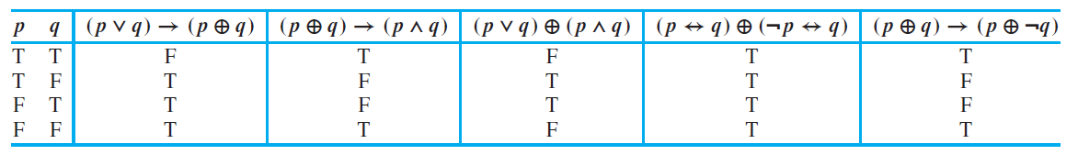

For part (e) we have this table.

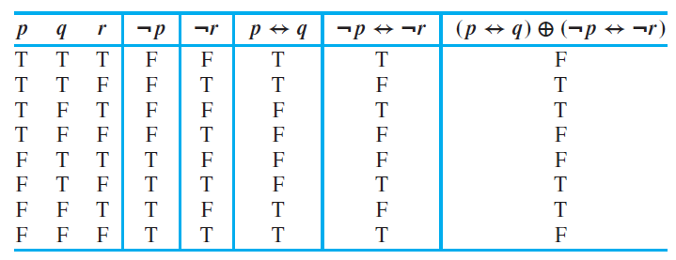

**43.**

**a)** Bitwise *OR* is 111 1111; bitwise*AND* is 000 0000; bitwise*XOR* is 111 1111.

**b)** Bitwise*OR* is 1111 1010; bitwise *AND* is 1010 0000; bitwise *XOR* is 0101 1010.

**c)** Bitwise *OR* is 10 0111 1001; bitwise *AND* is 00 0100 0000; bitwise *XOR* is 10 0011 1001.

**d)** Bitwise *OR* is 11 1111 1111; bitwise *AND* is 00 0000 0000; bitwise *XOR* is 11 1111 1111.

**1.2: P22----3, 7, 9, 17, 23, 33**

**3.** g → (r ∧ (￢m) ∧ (￢b))

**7.** a) q →p b) q ∧￢p c) q →p d) ￢q →￢p

**9.** Not consistent

**17.** If the first professor did not want coffee, then he would know that the answer to the hostess’s question was “no.” Therefore the hostess and the remaining professors know that the first professor did want coffee. Similarly, the second professor must want coffee. When the third professor said “no,” the hostess knows that the third professor does not want coffee.

**23.** A is a knave and B is a knight.

**33.** In order of decreasing salary: Fred, Maggie, Janice

**1.3: P34----7, 9, 25, 31, 41,57**

**7.**

**a)** Jan is not rich, or Jan is not happy.

**b)** Carlos will not bicycle tomorrow, and Carlos will not run tomorrow.

**c)** Mei does not walk to class, and Mei does not take the bus to class.

**d)** Ibrahim is not smart, or Ibrahim is not hard working.

**9.**

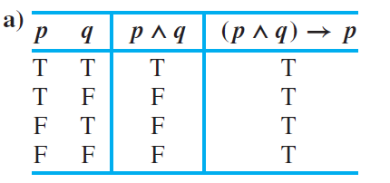

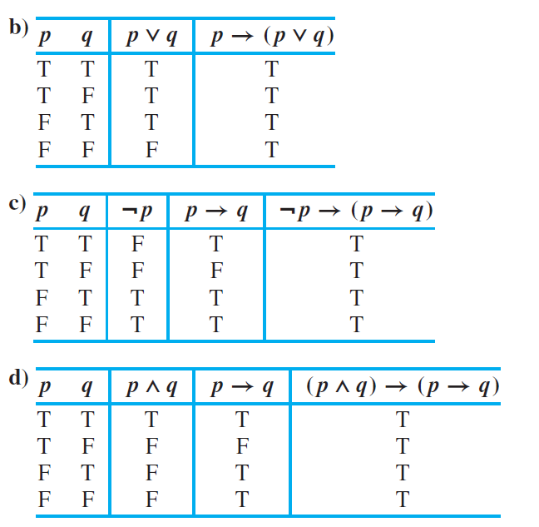

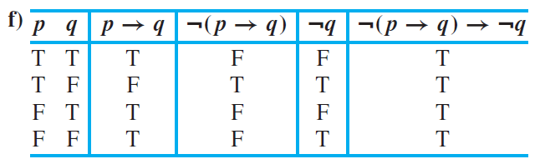

25. For (p → r) ∨ (q → r) to be false, both of the two conditional statements must be false, which happens exactly when r is false and both p and q are true. But this is precisely the case in which p ∧ q is true and r is false, which is precisely when (p ∧ q) → r is false. Because the two propositions are false in exactly the same situations, they are logically equivalent.

31. These are not logically equivalent because when p, q, and r are all false, (p → q) → r is false, but p → (q → r) is true.

41. (p ∧ q ∧ ￢r) ∨ (p ∧ ￢q ∧ r) ∨ (￢p ∧ q ∧ r)

**57.** If the database is open, then either the system is in its initial state or the monitor is put in a closed state.

**1.4: P53----5, 7, 13,17, 23, 35, 45,53**

**5.**

**a)** There is a student who spends more than 5 hours every weekday in class.

**b)** Every student spends more than 5 hours every weekday in class.

**c)** There is a student who does not spend more than 5 hours every weekday in class.

**d)** No student spends more than 5 hours every weekday in class.

**7.**

**a)** Every comedian is funny.

**b)** Every person is a funny comedian.

**c)** There exists a person such that if she or he is a comedian, then she or he is funny.

**d)** Some comedians are funny.

**13. a)** T **b)** T **c)** T **d)** T

17.

**a)** P(0) ∨ P(1) ∨ P(2) ∨ P(3) ∨ P(4)

**b)**  P(0)∧P(1)∧P(2)∧P(3)∧P(4)

**c)** ￢P(0)∨￢P(1)∨￢P(2) ∨ ￢P(3) ∨ ￢P(4)

**d)** ￢P(0) ∧ ￢P(1) ∧￢P(2) ∧￢P(3) ∧ ￢P(4)

**e)** ￢(P (0) ∨ P(1) ∨ P(2) ∨P(3) ∨ P(4))

**f)** ￢(P (0) ∧ P(1) ∧ P(2) ∧ P(3) ∧ P(4))

**23.** Let C(x) be the propositional function “x is in your class.”

**a)** ∃xH(x) and ∃x(C(x) ∧ H(x)), where H(x) is “x can speak Hindi”

**b)** ∀xF(x) and ∀x(C(x) → F(x)), where F(x) is “x is friendly”

**c)** ∃x￢B(x) and ∃x(C(x)∧￢B(x)), where B(x) is “x was born in California”

**d)** ∃xM(x) and ∃x(C(x)∧M(x)), where M(x) is “x has been in a movie”

**e)** ∀x￢L(x) and ∀x(C(x) → ￢L(x)), where L(x) is “x has taken a course in logic programming”

35.

**a)** There is no counterexample.

**b)** x =0

**c)** x =2

45. Both statements are true precisely when at least one of P(x) and Q(x) is true for at least one value of x in the domain.

**53. a)** True **b)** False, unless the domain consists of just one element **c)** True

**1.5: P64----3,9,15, 25,31,39**

**3.**

**a)** There is some student in your class who has sent a message to some student in your class.

**b)** There is some student in your class who has sent a message to every student in your class.

**c)** Every student in your class has sent a message to at least one student in your class.

**d)** There is a student in your class who has been sent a message by every student in your class.

**e)** Every student in your class has been sent a message from at least one student in your class.

**f)** Every student in the class has sent a message to every student in the class.

9.

**a)** ∀xL(x, Jerry)

**b)** ∀x∃yL(x, y)

**c)** ∃y∀xL(x, y)

**d)** ∀x∃y￢L(x, y)

**e)** ∃x￢L(Lydia, x)

**f)** ∃x∀y￢L(y, x)

**g)** ∃x(∀yL(y, x) ∧ ∀z((∀wL(w, z)) →z = x))

**h)** ∃x∃y(x ≠ y ∧ L(Lynn, x) ∧ L(Lynn, y) ∧ ∀z(L(Lynn, z) → (z = x ∨z=y)))

**i)** ∀xL(x, x)

**j)** ∃x ∀ y(L(x,y) ↔ x = y)

**15.**

**a)** ∀xP(x), where P(x) is “x needs a course in discrete mathematics” and the domain consists of all computer science students

**b)** ∃xP(x), where P(x) is “x owns a personal computer” and the domain consists of all students in this class

**c)** ∀x∃yP(x, y), where P(x, y) is “x has taken y,” the domain for x consists of all students in this class, and the domain for y consists of all computer science classes

**d)** ∃x∃yP(x, y), where P(x, y) and domains are the same as in part (c)

**e)** ∀x∀yP(x, y), where P(x, y) is “x has been in y,” the domain for x consists of all students in this class, and the domain for y consists of all buildings on campus

**f)** ∃x∃y∀z(P(z, y) → Q(x, z)), where P(z, y) is “z is in y” and Q(x, z) is “x has been in z”; the domain for x consists of all students in the class, the domain for y consists of all buildings on campus, and the domain of z consists of all rooms.

**g)** ∀x∀y∃z(P(z, y) ∧ Q(x, z)), with same environment as in part (f)

**25.** a) There is a multiplicative identity for the real numbers.

b) The product of two negative real numbers is always a positive real number.

c) There exist real numbers x and y such that x2 exceeds y but x is less than y.

d) The real numbers are closed under the operation of addition.

**31.**

a) ∃x∀y∃z￢T(x, y, z)

b) ∃x∀y￢P(x, y) ∧ ∃x∀y ￢ Q(x, y)

c) ∃x∀y(￢P(x, y)∨∀z￢R(x, y, z))

d) ∃x∀y(P(x, y)∧￢Q(x, y))

**39.**

a) x = 2, y = −2 b) x = −4 c) x = 17, y = −1

**1.6: P78----5, 11, 15, 17, 27**

5. Let w be “Randy works hard,” let d be “Randy is a dull boy,” and let j be “Randy will get the job.” The hypotheses are w,w→d, and d →￢j . Using modus ponens and the first two hypotheses, d follows. Using modus ponens and the last hypothesis, ￢j , which is the desired conclusion, “Randy will not get the job,” follows.

**11.** Suppose that *p*1*, p*2*, . . . , pn* are true. We want to establish that *q* → *r* is true. If *q* is false, then we are done, vacuously. Otherwise, *q* is true, so by the validity of the given argument form (that whenever *p*1*, p*2*, . . . , pn, q* are true, then *r* must be true), we know that *r* is true.

**15.**

**a)** Correct, using universal instantiation and modus ponens

**b)** Invalid; fallacy of affirming the conclusion

**c)** Invalid; fallacy of denying the hypothesis

**d)** Correct, using universal instantiation and modus tollens

**17.** We know that *some x* exists that makes *H(x)* true, but we cannot conclude that Lola is one such *x*.

**27.**

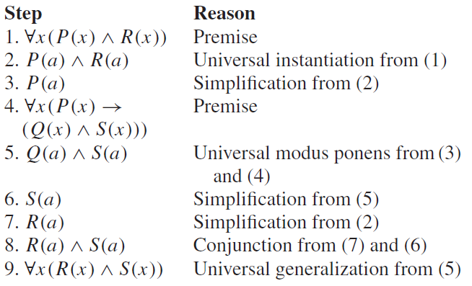

**1.7: P91----7, 15, 25, 37**

**7.** Because *n* is odd, we can write *n* = 2*k* + 1 for some integer *k*. Then *(k*+1*)*2−*k*2 = *k*2+2*k*+1−*k*2 = 2*k*+1 = *n*.

**15.** Assume that it is not true that *x* ≥ 1 or *y* ≥ 1. Then*x <* 1 and*y <* 1. Adding these two inequalities, we obtain *x* +*y <* 2, which is the negation of *x*+*y* ≥ 2.

**25.** Suppose by way of contradiction that *a/b* is a rational root, where *a* and *b* are integers and this fraction is in lowest terms (that is, *a* and *b* have no common divisor greater than 1). Plug this proposed root into the equation to obtain *a*3*/b*3 + *a/b* + 1 = 0. Multiply through by *b*3 to obtain *a*3 + *ab*2 + *b*3 = 0. If *a* and *b* are both odd, then the left-hand side is the sum of three odd numbers and therefore must be odd. If *a* is odd and *b* is even, then the left-hand side is odd + even + even, which is again odd. Similarly, if *a* is even and *b* is odd, then the left-hand side is even + even + odd, which is again odd. Because the fraction *a/b* is in simplest terms, it cannot happen that both *a* and *b* are even. Thus in all cases, the left-hand side is odd, and therefore cannot equal 0. This contradiction shows that no such root exists.

**37.** Suppose that *p*1 → *p*4 → *p*2 → *p*5 → *p*3 → *p*1. To prove that one of these propositions implies any of the others, just use hypothetical syllogism repeatedly.

1.8: P108---3, 9, 17

**3.** If *x* ≤ *y*, then max*(x, y)* + min*(x, y)* = *y* + *x* = *x* + *y*. If *x* ≥ *y*, then max*(x, y)* + min*(x, y)* = *x* + *y*. Because these are the only two cases, the equality always holds.

**9.** 10,001, 10,002, *. . . ,* 10,100 are all nonsquares, because 1002 = 10*,*000 and 1012 = 10*,*201; constructive.

**17.** The equation |*a* − *c*| = |*b* − *c*| is equivalent to the disjunction of two equations: *a* − *c* = *b* − *c* or *a* − *c* = −*b* + *c*. The first of these is equivalent to *a* = *b*, which contradicts the assumptions made in this problem, so the original equation is equivalent to *a* − *c* = −*b* + *c*. By adding *b* + *c* to both sides and dividing by 2, we see that this equation is equivalent to *c* = *(a* + *b)/*2. Thus, there is a unique solution. Furthermore, this *c* is an integer, because the sum of the odd integers *a* and *b* is even.