Homework2:

2.1: P125---7,11,19,23,43,

7. a) Yes b) No c) Yes d) No e) No f) No

11. a) True b) True c) False d) True e) True f) False

19. a) 1 b) 1 c) 2 d) 3

23. a) 8 b) 16 c) 2

43. a) {−1, 0, 1} b) Z−{0, 1} c) ∅

2.2: P136---3,13,19,27,29,51,53

**3. a)** {0*,*1*,*2*,*3*,*4*,*5*,*6} **b)** {3} **c)** {1*,* 2*,* 4*,*5} **d)** {0*,* 6}

**13.** Suppose *x* ∈ *A* ∩ *(A* ∪ *B)*. Then *x* ∈ *A* and *x* ∈ *A* ∪ *B* by the definition of intersection. Because *x* ∈ *A*, we have proved that the left-hand side is a subset of the righthand side. Conversely, let *x* ∈ *A*. Then by the definition of union, *x* ∈ *A* ∪ *B* as well. Therefore *x* ∈ *A* ∩ *(A* ∪ *B)* by the definition of intersection, so the right-hand side is a subset of the left-hand side.

19. 

**27. a)** The double-shaded portion is the desired set.

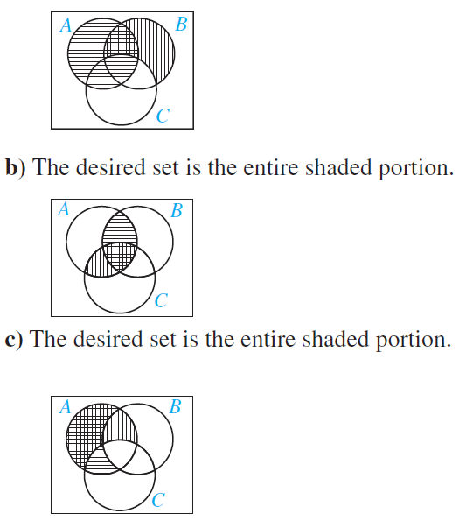

29.

**51. a) Z**, {−1, 0, 1} **b) Z** − {0}, ∅ **c) R**, [−1, 1] **d)** [1,∞), ∅

**53. a)** {1, 2, 3, 4, 7, 8, 9, 10} **b)** {2, 4, 5, 6, 7} **c)** {1, 10}

2.3: P152---3,9,15,31,43,65,73

**3. a)** Not a function **b)** A function **c)** Not a function

**9. a)** 1 **b)** 0 **c)** 0 **d)** −1 **e)** 3 **f)** −1 **g)** 2 **h)** 1

**15. a)** Onto **b)** Not onto **c)** Onto **d)** Not onto **e)** Onto

**31. a)** *f (S)* = {0*,* 1*,* 3} **b)** *f (S)* = {0*,* 1*,* 3*,* 5*,* 8} **c)** *f (S)* = {0*,* 8*,* 16*,* 40} **d)** *f (S)* = {1*,* 12*,* 33*,* 65}

43. 

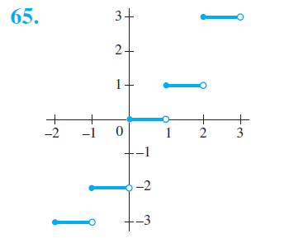

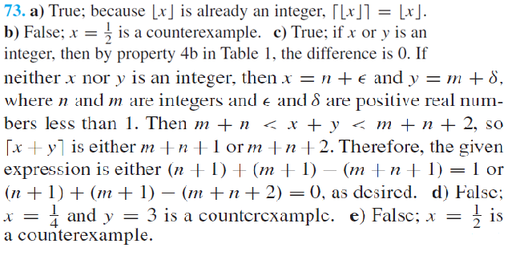

**2.4: P167---3, 9,19,23,33**

**3. a)** *a*0 = 2*, a*1 = 3*,a*2 =5*, a*3 =9 **b)** *a*0 = 1*, a*1 =4*, a*2 =27*, a*3 = 256

**c)** *a*0 = 0, *a*1 = 0, *a*2 = 1, *a*3 = 1 **d)** *a*0 = 0, *a*1 = 1, *a*2 = 2*, a*3 = 3

**9. a)** 2*,* 12*,* 72*,* 432*,* 2592 **b)** 2*,* 4*,* 16*,* 256*,* 65*,*536 **c)** 1*,* 2*,* 5*,* 11*,* 26 **d)** 1*,* 1*,* 6*,* 27*,* 204

**e)** 1*,* 2*,* 0*,* 1*,* 3

**19. a)** *an* =3*an*−1 **b)** 5,904,900

**23.** *B(k)* = [1+*(*0*.*07*/*12*)*]*B(k* −1*)*−100, with *B(*0*)* = 5000

**33. a)** 21 **b)** 78 **c)** 18 **d)** 18

2.5: P176---1,11,19

**1. a)** Countably infinite, −1*,* −2*,* −3*,* −4*, . . .* **b)** Countably infinite, 0*,* 2*,* −2*,* 4*,* −4*, . . .*

**c)** Countably infinite, 99*,* 98*,* 97*, . . .* **d)** Uncountable **e)** Finite

**f)** Countably infinite,0*,* 7*,*−7*,* 14*,*−14*, . . .*

11.



**19.**We are given bijections *f* from *A* to *B* and *g* from *C* to *D*. Then the function from *A* × *C* to *B* × *D* that sends *(a, c)* to *(f (a), g(c))* is a bijection.

2.6: P184--15,29

