**SCION Earth Evolution Model V1.1**

***Guidebook***

By Benjamin J. W. Mills // b.mills@leeds.ac.uk // @bjwmills // www.bjwmills.com

**Contents.**

* Model overview
* Model versions
* Files in this package
* System requirements
* Running the model and viewing output
* Sensitivity analysis

**Model overview.**

SCION is a ‘Spatial Continuous Integration’ global biogeochemical model that runs over geological timescales. It runs forwards in time and computes the Earth’s major elemental cycles of carbon, oxygen, sulfur, phosphorus and nitrogen. It makes estimates for the composition of the atmosphere and oceans, as well as the surface climate. It also predicts the values of a suite of geochemical tracers to aid in hypothesis testing. SCION is a ‘predictive’ model in which the boundary conditions are set by tectonic reconstructions and the timing of evolutionary events, and the surface chemistry and climate are an emergent property. Thus, while there are some encouraging correlations, the model climate and chemistry during the Phanerozoic Eon is not completely accurate. The model is a descendent (a *scion*, if you will) of previous approaches to model global biogeochemistry and climate over long timescales (Figure 1).

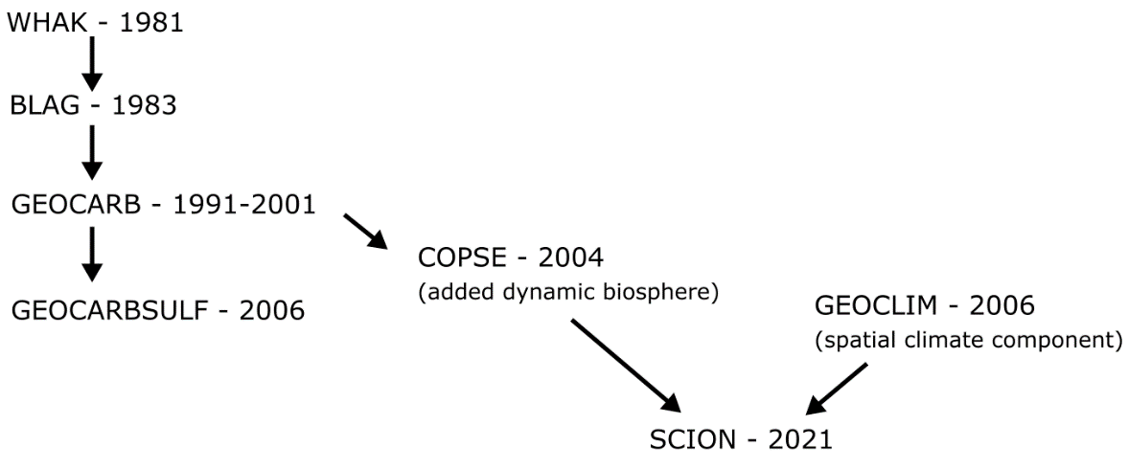

*Figure 1: SCION family tree.*

This document provides information on running and editing the model code and visualising output. For the model derivation and history of long-term global biogeochemical models it is recommended to read the above publications as a minimum. Details are in the bibliography at the end of this document.

**Model versions**

V1.1: Current model version.

* Improved the gridding of the FOAM climate model dataset, this fixed an issue where a small number of coastal squares were not represented due to different resolutions of topography and climatology files. This mainly fixed issues with the 15 Ma climate model dataset, which was omitted from the initial model, but is now used.
* Fixed a minor bug inherited from COPSE in which the ridge CO2 input was not taken into account separately in the carbon isotope mass balance. This makes no noticeable difference in the Phanerozoic but could have important implications should the model be extended to the Early Earth.

V1.0:

* Version published in Mills et al., 2021 and first model iteration

**Files in this package.**

|  |  |
| --- | --- |
| SCION_initialise.m | This script sets parameter values, loads forcings, initialises the solver, and then calls the plotting scripts. Call this function to begin a single model run. |
| SCION_equations.m | This script contains the model flux and reservoir calculations, it is called by the solver. Do not run directly. |
| SCION_plot_fluxes.m | This script plots the model fluxes. It is called by the initialise script. |
| SCION_plot_worldgraphic.m | This script plots the model 2D fields. It is called by the initialise script. |
| SCION_sens.m | Call this script to begin a sensitivity analysis. |
| SION_plot_sens.m | This script plots the fluxes from the sensitivity analysis. It is called by the sens script. |
| data | Folder containing geochemical data to which the model is compared. |
| documentation | Folder containing documentation – i.e. this guidebook in editable form. |
| forcings | Folder containing model forcing files. |

*Table 1. Model files*

**System requirements.**

The SCION model runs in MATLAB and requires this software to run. It was mostly developed in version R2018a but should run in all newer versions and probably many older ones. SCION is designed to run on a workstation computer and should run on any MATLAB compatible operating system. Single runs use one processor core and the sensitivity analysis uses all available cores simultaneously so overall compute time roughly scales with core count. A high CPU core count is therefore preferable. A single model run takes around 10 seconds. The model has not been adapted for use on computing clusters.

Current MATLAB package requirements: (V1.1)

* Mapping toolbox (topographic slope calculations)
* interp1qr.m (fast linear interpolation)
* tight_subplot.m (for plotting)
* M_Map plotting package (for plotting: https://www.eoas.ubc.ca/~rich/map.html)

**Running the model and viewing output.**

Single model runs are computed by calling the SCION_initialise script from the MATLAB command line. Calling SCION_initialise(0) runs the model and plots all output.   
Calling SCION_initialise(-1) runs model and plots only fluxes for brevity.   
Calling SCION_initialise(-2) runs model for fixed present day forcings, use to check the present day steady state if modifying the model. Note that due to constant supply of carbon from the mantle and conversion to organic C, crustal organic C increases throughout all model runs.  
  
The initialise script calls the MATLAB built-in solver ODE15s, which is targeted at the equations file.

Below is an example of the console output during a successful run.

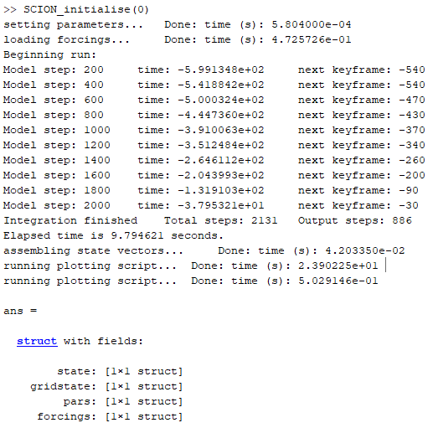

The output structure will be called ‘ans’ unless assigned a different name by typing e.g. myrun = SCION_initialise(0). The structure contains four fields which show the bulk fluxes (state), the gridded spatial values (gridstate), the model fixed parameters for that run (pars) and the forcings for that run (forcings). The model does not save output automatically.

If run with the (0) argument the model will produce the spatial maps shown in figure 2, defined at each ‘keyframe’ point, alongside the bulk flux plots shown in figure 3, which are plotted against the geochemical data compilation. If run with the (-1) argument the spatial fields will not be plotted.

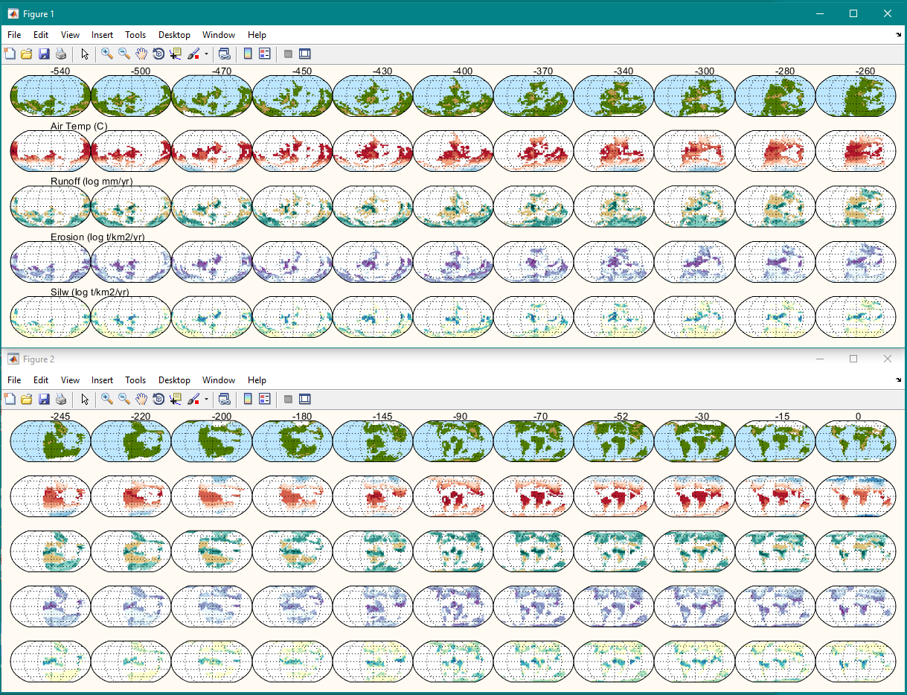

*Figure 2. Model spatial fields for default Phanerozoic run.*

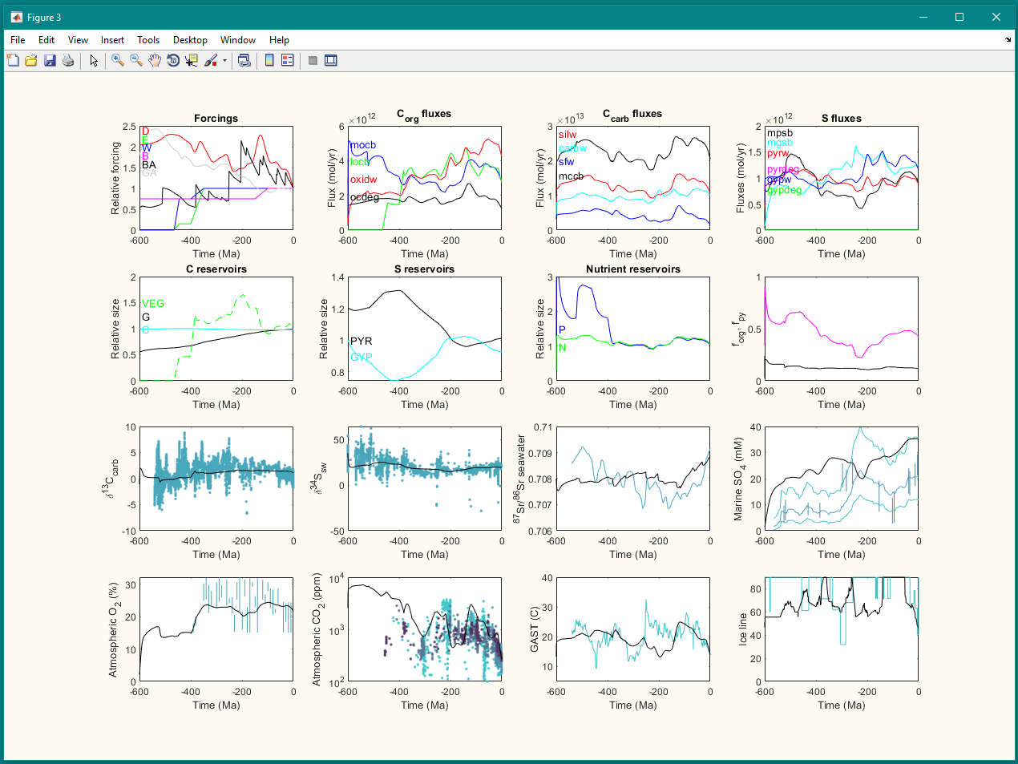

*Figure 3. Model fluxes for default Phanerozoic run.*

**Sensitivity analysis**

To run a sensitivity analysis, call SCION_sens. Edit the sens script to change the number of sensitivity runs and gridding of the results. Sensitivity parameters are included within the initialise and equations scripts. Running on a 4-core CPU looks like this:

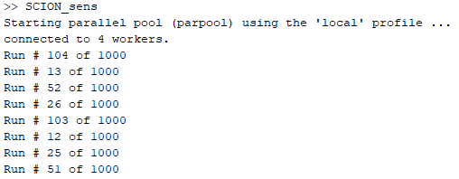

The model will update on run numbers complete. It is advised to estimate how long the analysis will take by multiplying the single model compute time on your system by the sensitivity ensemble size divided by your core count. All data plotted is saved temporarily to the workspace. The default sensitivity analysis does not save gridded data, or data that is not plotted in the sensitivity figure in order to save memory. This can be altered in the equations file. Figure 4 shows the default sensitivity plot.

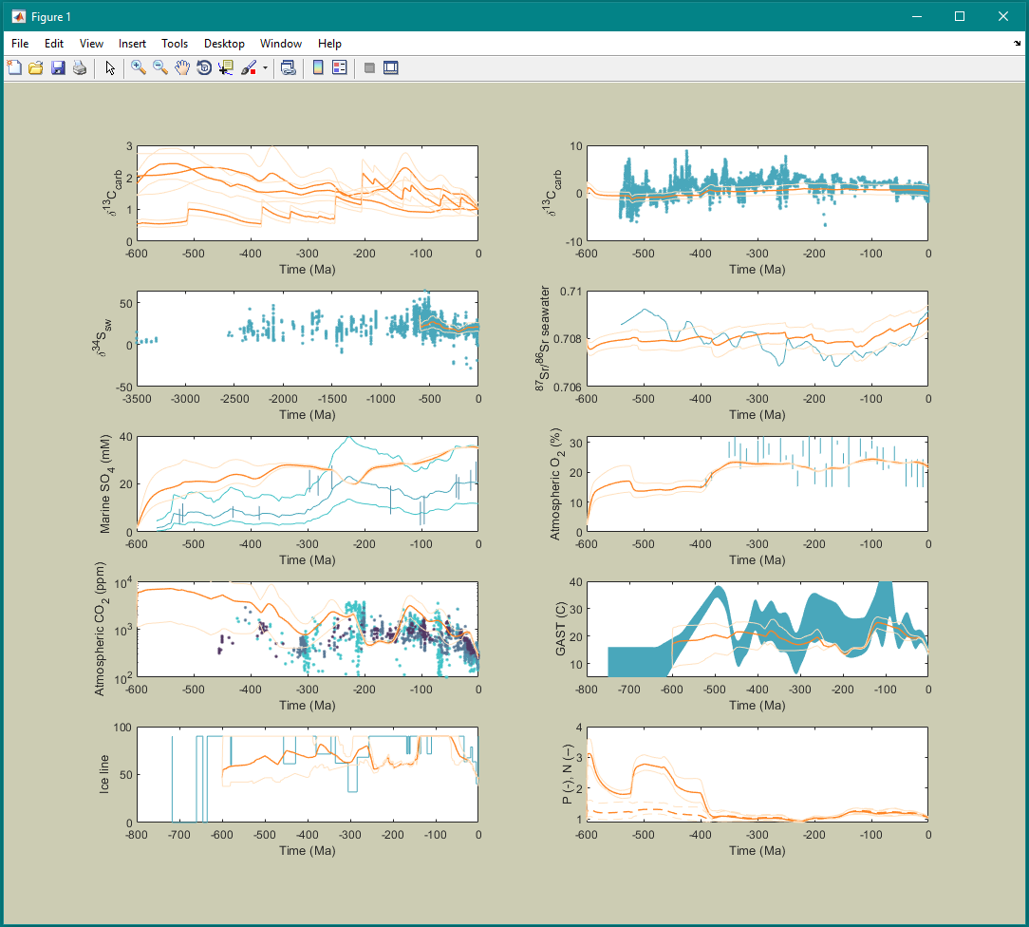

*Figure 4. Model sensitivity plot for default Phanerozoic run.*

**Bibliography**

Below are the key model papers mentioned in the SCION family tree.

WHAK:

Walker, J. C. G., Hays, P. B. & Kasting, J. F. A negative feedback mechanism for the long-term stabilization of Earth's surface temperature. *Journal of Geophysical Research* 86, 9776-9782 (1981).

BLAG:

Berner, R. A., Lasaga, A. C. & Garrels, R. M. The carbonate-silicate geochemical cycle and its effect on atmospheric carbon dioxide over the past 100 million years. *American Journal of Science* 283, 641-683 (1983).

GEOCARB:

Berner, R. A. A model for atmospheric CO2 over Phanerozoic time. *American Journal of Science* 291, 339-376 (1991).

Berner, R. A. GEOCARBSULF: A combined model for Phanerozoic atmospheric O2 and CO2. *Geochimica et Cosmochimica Acta* 70, 5653-5664 (2006).

COPSE:

Bergman, N. M., Lenton, T. M. & Watson, A. J. COPSE: A new model of biogeochemical cycling over Phanerozoic time. *American Journal of Science* 304, 397-437 (2004).

Lenton, T. M., Daines, S. J. & Mills, B. J. W. COPSE reloaded: An improved model of biogeochemical cycling over Phanerozoic time. *Earth-Sci. Rev.* 178, 1-28 (2018).

Tostevin, R. & Mills, B. J. W. Reconciling proxy records and models of Earth's oxygenation during the Neoproterozoic and Palaeozoic. *Interface Focus* 10, 20190137 (2020).

GEOCLIM:

Donnadieu, Y., Goddéris, Y., Pierrehumbert, R., Dromart, G., Fluteau, F., Jacob, R. A GEOCLIM simulation of climatic and biogeochemical consequences of Pangea breakup. *Geochemistry, Geophysics, Geosystems* 7 (2006).

Goddéris, Y., Donnadieu, Y., Le Hir, G., Lefebvre, V. & Nardin, E. The role of palaeogeography in the Phanerozoic history of atmospheric CO2 and climate. *Earth-Sci. Rev.* 128, 122-138 (2014).

SCION:

Mills, B. J. W., Donnadieu, Y. & Goddéris, Y. Spatial continuous integration of Phanerozoic global biogeochemistry and climate. *Gondwana Research*, doi:10.1016/j.gr.2021.02.011 (2021).