Compare the EORA results with the WIOD

This comparison aims to identify potential small errors in our data processing. I only pick the data in 2005 from two database and choose the countries that included in both databases for the comparison.

# Water use

The two present a similar pattern, though some small differences (relatively large difference in the data for India). And the data magnitude of EORA is about two times of the WIOD data.

Questions: No water-related data for Taiwan in EORA?

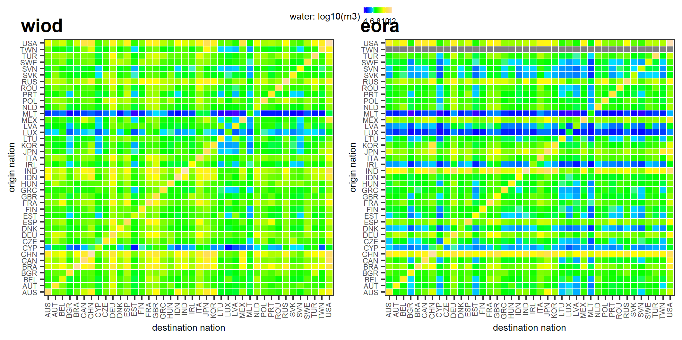

# CO2

Similar pattern. The flow from KOR to CHN was larger in EORA than that in WIOD.

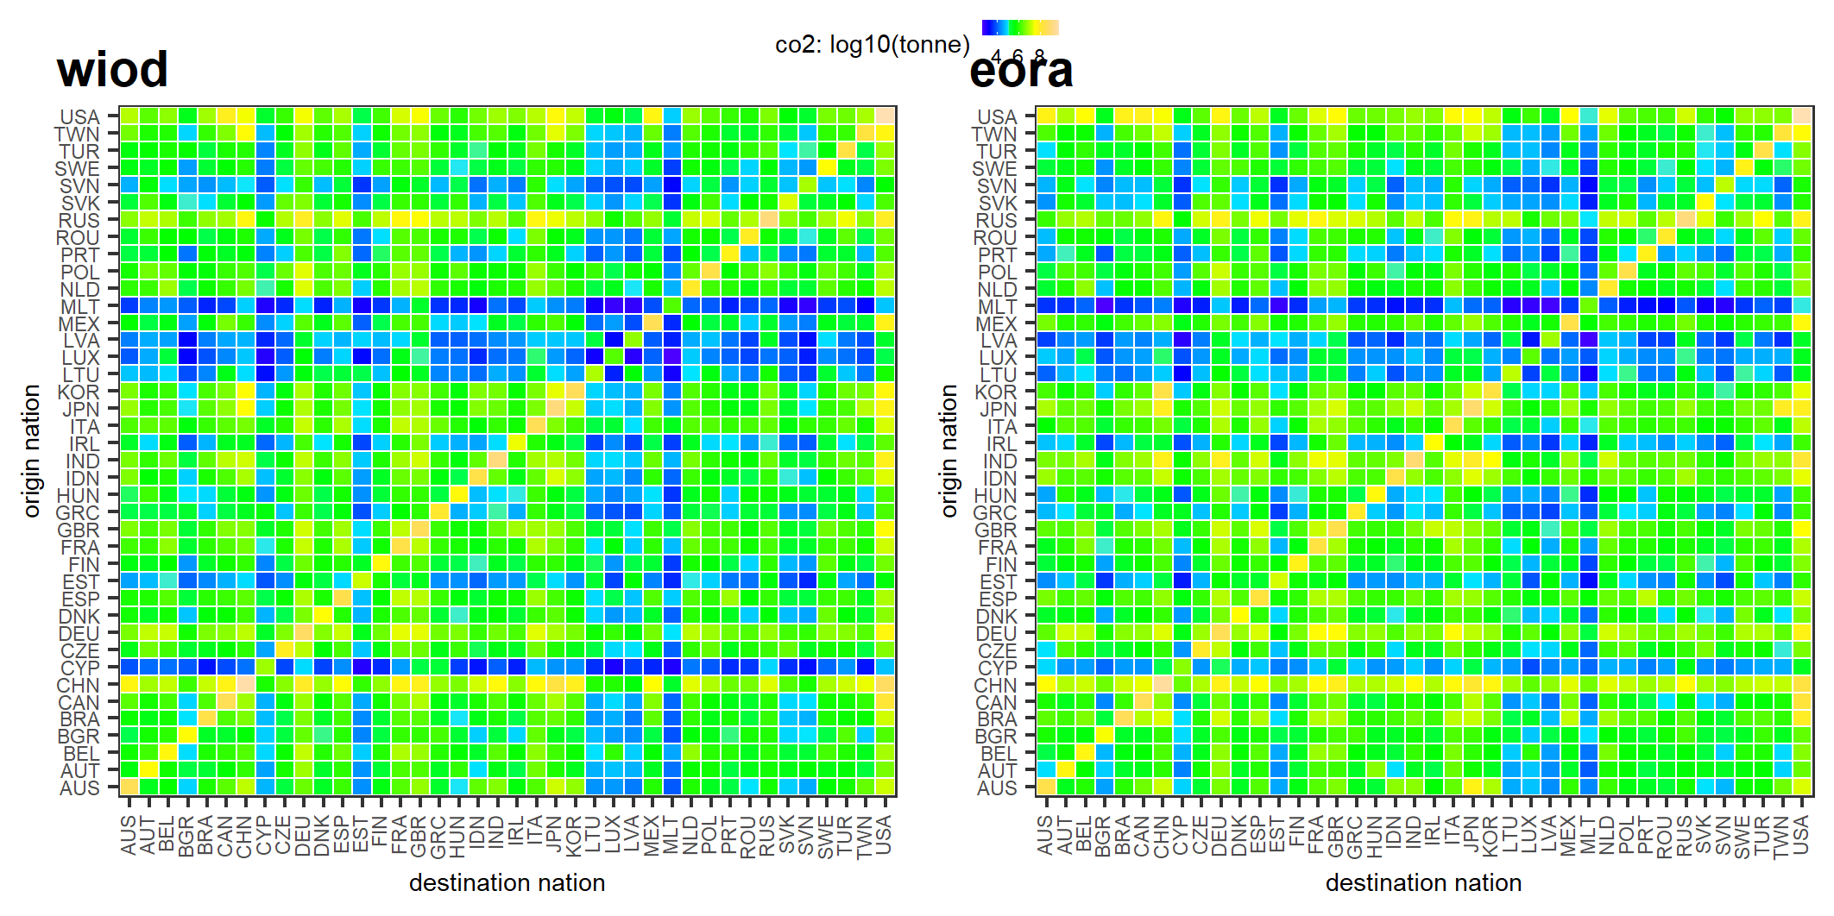

# Total energy

The patterns look similar, but there is a huge difference in the magnitude – the value from EORA is around 26789 times of WIOD data.

The pattern of total energy is similar to that of CO2, and this should be correct, as both data sources show the same pattern.

