# Basics of Compressed Sensing

## The Compressed Sensing Model

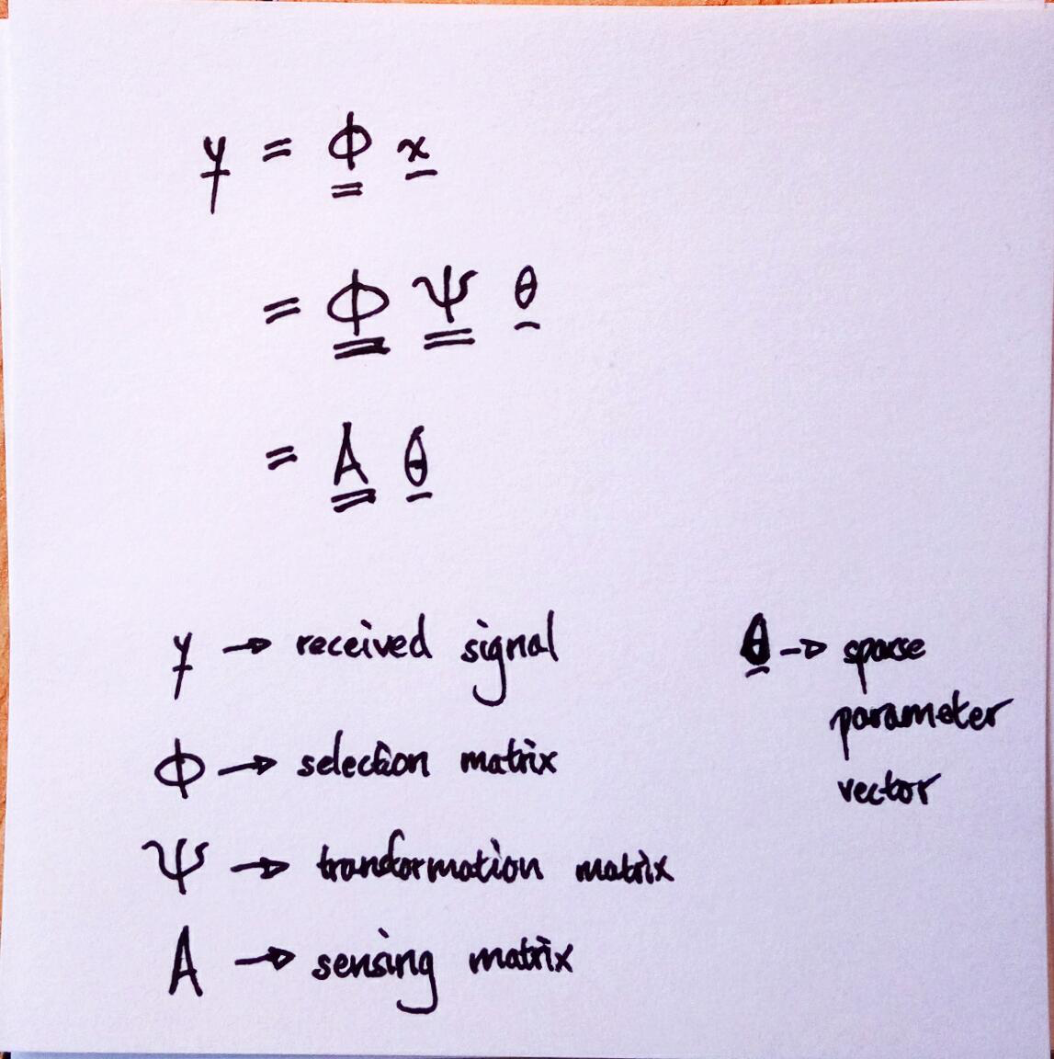

## Criteria for Successful Reconstruction

### Coherence

Equations for coherence, ...

Restricted Isotropy Property

# Compressed Sensing Formulation of MC-MIMO System

## The Sparse Parameter Space

## Linearizing Signal and Parameter Space

## The Sensing Matrix

# Coherence and Sidelobe Level

## General Relationship for DOA Estimation

## Special case of MC-MIMO