WeRateDogs Twitter Archive

- Act Report

**Insights:**

* Q1: Which dog has highest retweet counts?
  + 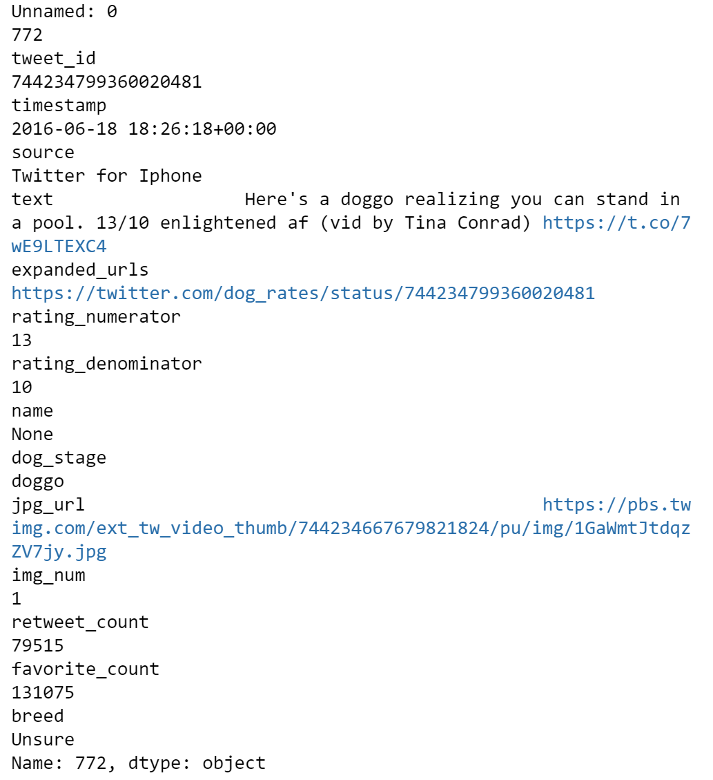
  + The dog has highest retweet counts. Its stage is doggo. The pose retweeted 79515 times and received 131075 favorite counts.
* Q2: Which dog receive most favorite counts?
  + 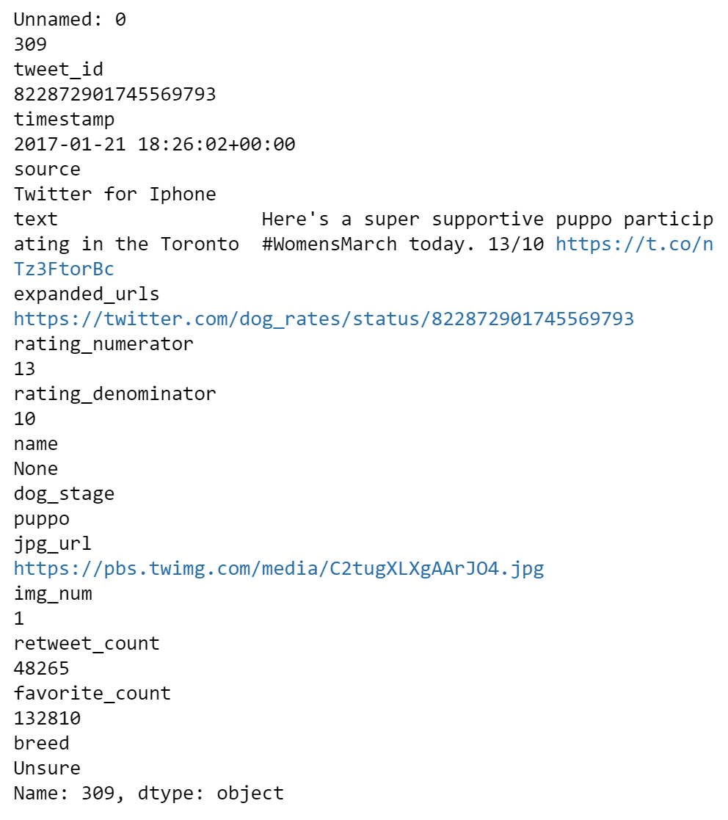
  + The dog has most favorite counts, its stage is puppo. The pose retweeted 48265 times and received 132810 favorite counts.
* Q3: What way do users most use to log in WeRateDog?
  + 98% of the WeRateDog users like to use Twitter through iPhone. Only few people use Twitter web and TweetDeck. So, for Twitter, they could mainly focus on the phone serve users.
* Q4: What is the relation between retweet counts and favorite counts?
  + The mean of retweet counts is 27775.6, the mean of favorite counts is 8925.8. And the the favorite counts are as three times as many as the retweet counts. It means that people would always thump up for a pose, but they might not retweet it.

**Visualization:**

* #1. What is the most popular dog breed?
  + 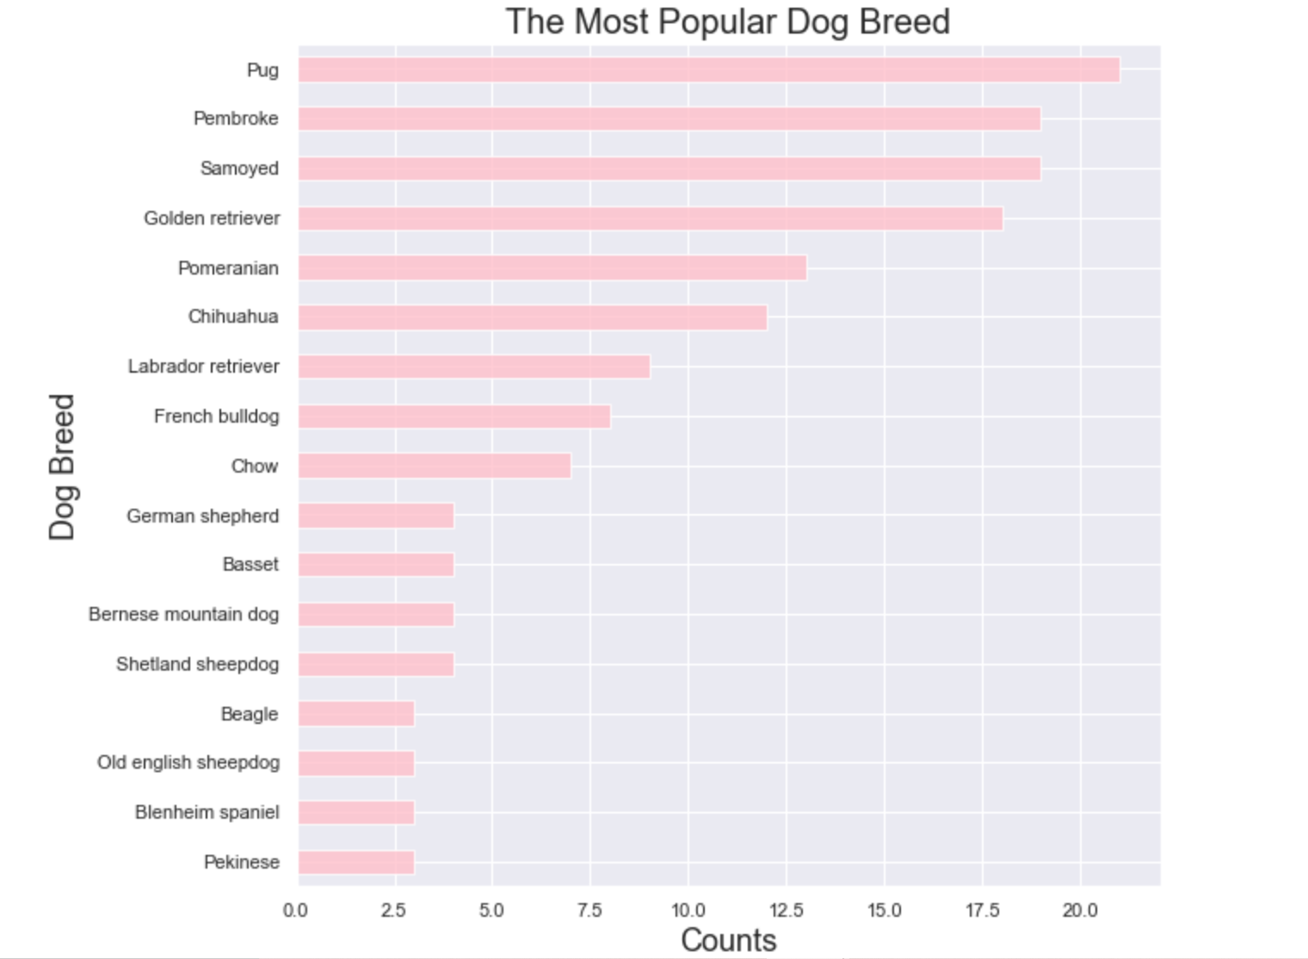
  + Through this chart, the most popular dog breed is Pug with 21 counts. The second popular dog breeds are Pembroke and Samoyed with 19 counts. The third is Golden retriever with 18 counts. The dog breed has 50 categories in total.
* #2. What is the proportion of dog stages? And what's the relation between favorite counts and its dog stage?
  + 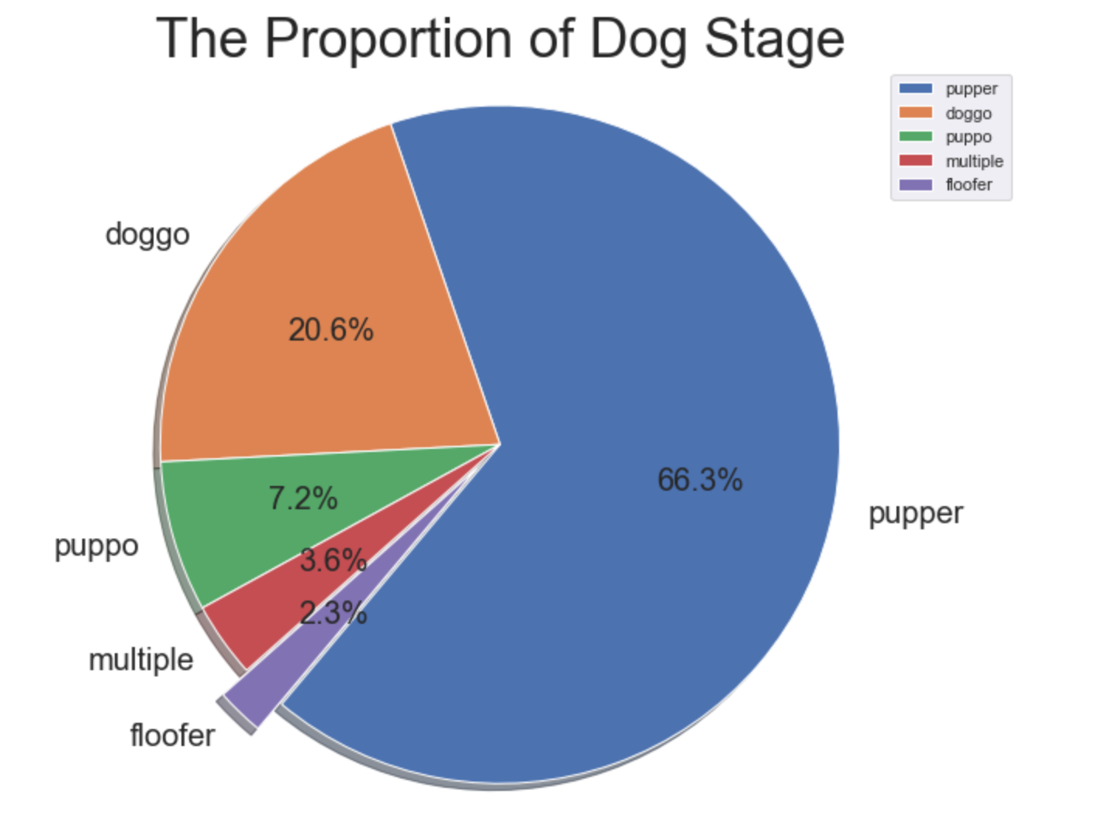
  + 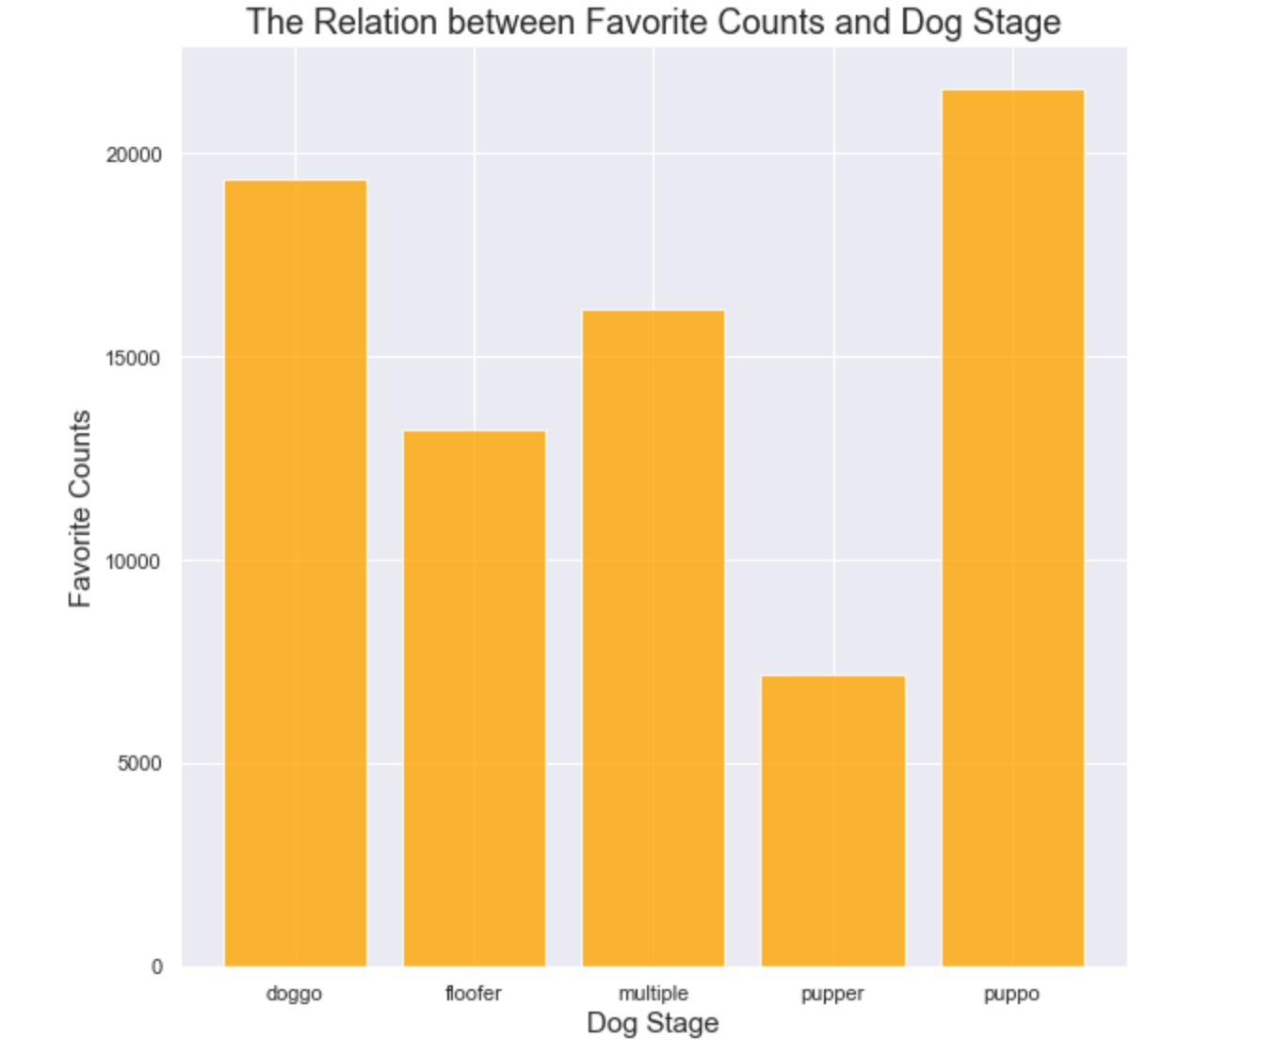
  + Based on the pie chart, the largest proportion of dog stage is pupper accounting for 66.3%, and the less of it is floofer with 2.3%. But from the bar chart, the pupper receives less favorite counts. The dog stage which gets most of favorite counts is puppo, puppo is only 7.2% of all dog stage. The floofer receives average 13206 favorite counts which is the second largest proportion of receiving favorite counts. So, the relation between favorite counts and dog stage number has not positive relationship.