Weather Trend Report

1. **Introduction**

The goal of this report is to show the similarities and differences between global temperature trends and San Francisco temperature trends through a line chart by using the skills in SQL and Excel. Eight other American big cities are also shown on the line graph for reference including Las Vegas, Los Angeles, Seattle, Denver, New York, Phoenix, Washington, Omaha. The data was recorded from 1858 to 2012.

1. **Preparation**
   * Using **SQL to extract** the global temperature data and other American cities temperature data from the database, then export to CSV.

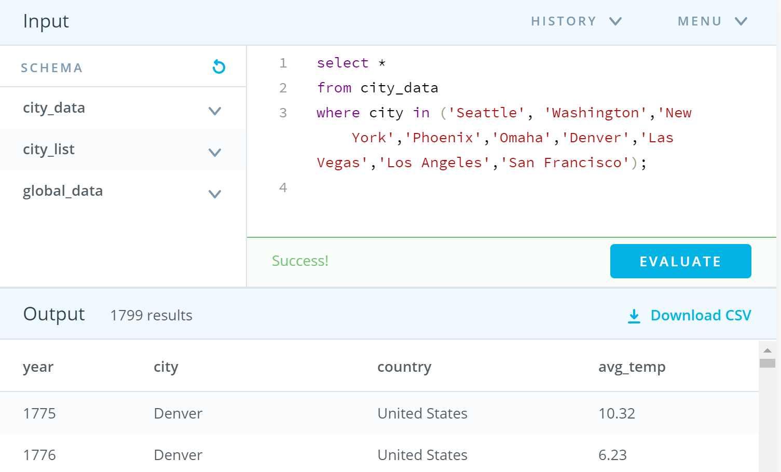

* + Aiming to smooth data, calculating **every ten years’ temperature averages as moving averages** instead of using every year’s temperature averages data in Spreadsheets.
  + To bring out the temperature contrast between San Francisco and Global, many cities’ data would be used as control groups.

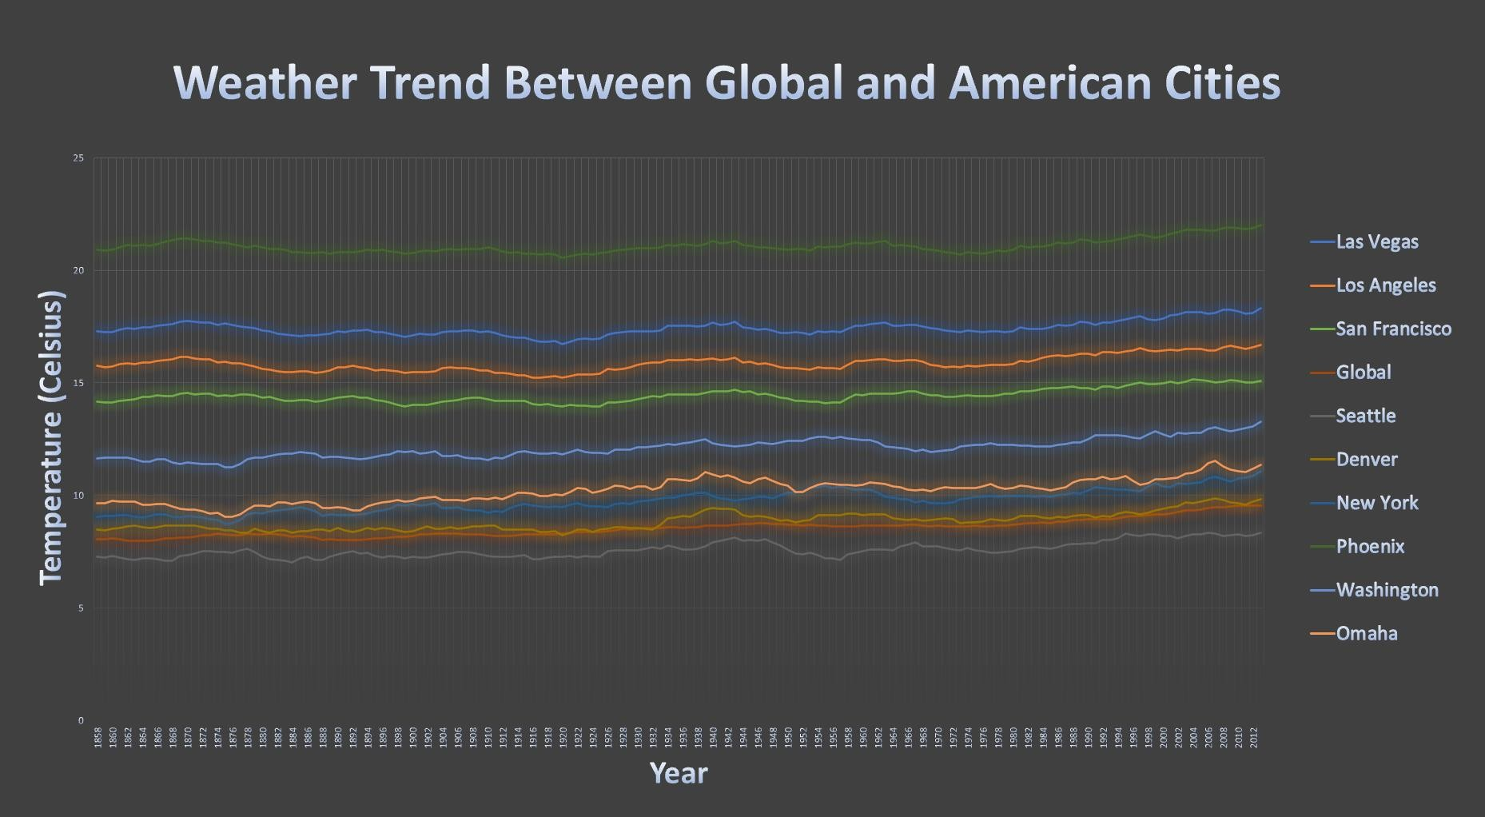

1. **Graph Analysis**
   * As the graph is shown, the hottest city was Phoenix which average temperature floats at 21 degrees Celsius, the coolest one was Seattle which average temperature fluctuated around 7 degrees Celsius. So, the average temperature of San Francisco was approximately 14 degrees Celsius in the middle of them.
   * Starting from the first highest average temperature of Phoenix, the second hottest place was Las Vegas around 17 degrees Celsius, the third warmest city was Los Angeles which was 1 degree Celsius lower than Las Vegas.
   * From 1858 to 2012, the global average temperature was 6 degrees Celsius lower than the San Francisco’s.
   * The global average temperature trend was close to Denver’s.
   * Overall, all cities’ average temperature trends have a slight increasement in the year of 2012 compared to 1858.
2. **Conclusion**

From the data analysis on the line graph, it visualized the continuous average temperature data trends from time to time. It is an effective way for environmental scientists to observe the changes in temperature trends in different locations. As shown in the chart, San Francisco is a nice place to live with its abundance of warm weather, not much hot and cold. Besides, the overall trend of all cities grew marginally over a few hundred years. It demonstrated the fact of global warming. Protecting the environment is a crucial task as a human being.