**深 圳 大 学 实 验 报 告**

**课程名称：­ 随机信号处理**

**实验项目名称： 交易游戏中的随机处理过程**

**学院： 电子与信息工程学院**

**专业： 电子信息工程**

**指导教师： 孙维泽**

**报告人： 陈应权 学号：2022280297**

**班级： 06**

**实验时间： 2024年3月1日——2024年4月8日**

**实验报告提交时间： 2024年4月11日**

**教务处制**

Description of format:

* Use Times New Roman, 12 pt, single column, single line spacing.
* When inserting figures and tables, title of the figures and tables must be included.
* Do not change ‘1、Purposes of the experiment’ and ‘2、Design task and detail requirement’.

**1、Purposes of the experiment**

1. Use Matlab to show some commonly used distribution of random variables.
2. Use correct equations (Bayes’ theorem) to design a strategy for the games in ‘3. Advance’ and ‘4. Extra’.
3. Analyze the results and draw reasonable conclusions

**2、Design task and detail requirement**

See ‘Appendix 1 – Task and requirement for experimental report 1.doc’.

**3、The result and Analysis**

* **Part 1:** submit your programs only.
* **Part 2:**

Please submit your program file(s) that/those can generate the eight figures.

Please note that a figure should be with a title.

1. **Your result figures**

1)Plot the PDF of Rayleigh distribution

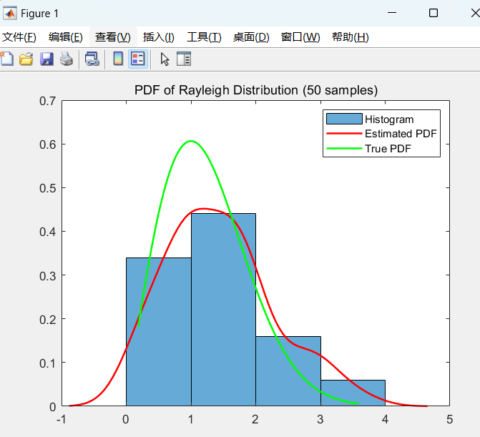

PDF of Rayleigh Distribution (50 samples)

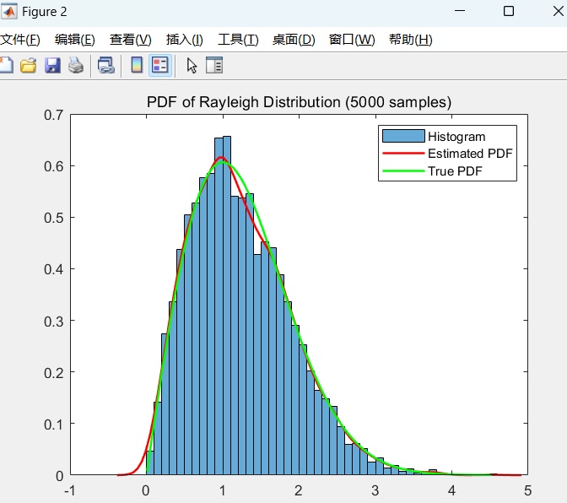

PDF of Rayleigh Distribution (5000 samples)

2) Plot the PDF of Poisson distribution

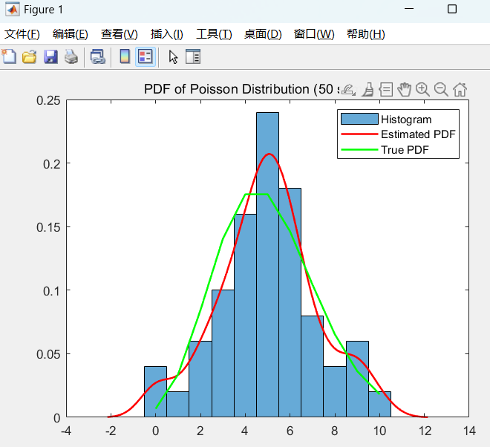

PDF of Poisson Distribution (50 samples)

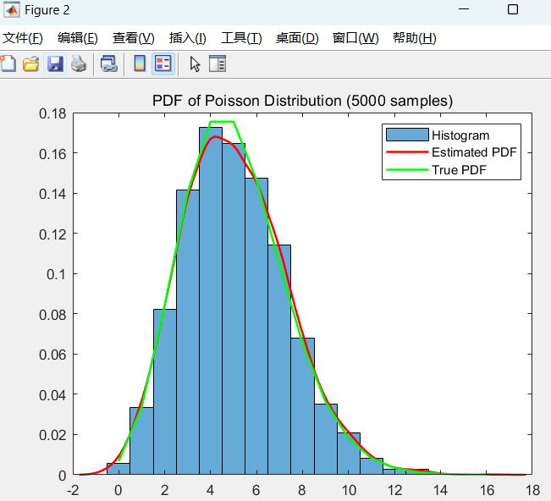

PDF of Poisson Distribution (5000 samples)

3) Plot the PDF of Uniform distribution

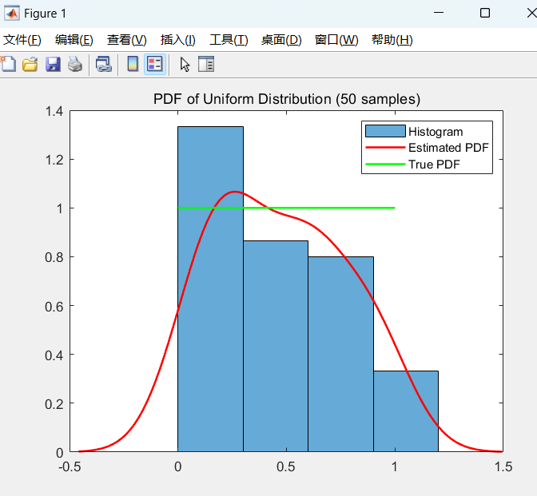

PDF of Uniform Distribution (50 samples)

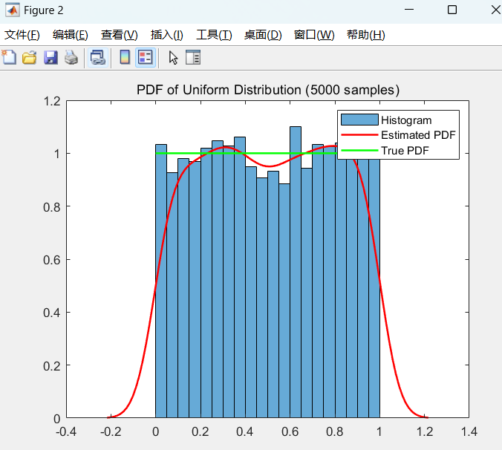

PDF of Uniform Distribution (5000 samples)

4) Plot the PDF of Exponential distribution

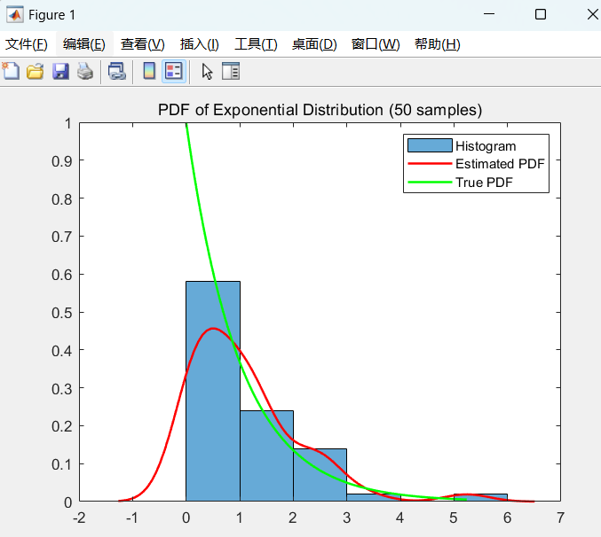

PDF of Exponential Distribution (50 samples)

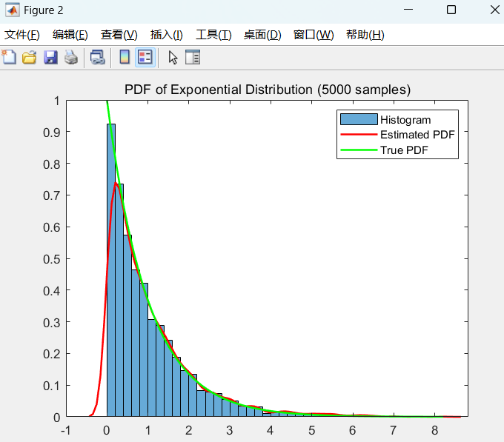

PDF of Exponential Distribution (5000 samples)

1. **Your analysis**

**1) Rayleigh Distribution:**

**a)** Characteristics:

The Rayleigh distribution is a continuous probability distribution used to model the magnitude of vectors in two-dimensional space, especially in radar signal processing and wireless communications. It is positively skewed, with most of the data concentrated near zero.

**b)Differences in 50 and 5000 random numbers:**

With 50 samples, the estimated PDF may be more irregular and show less resemblance to the true PDF. The histogram may have peaks and valleys, deviating from the smooth shape of the expected Rayleigh distribution.

With 5000 samples, the estimated PDF becomes smoother and more closely matches the true PDF. The histogram is also smoother and aligns well with the true PDF.

**2) Poisson Distribution:**

**a**) Characteristics:

The Poisson distribution is a discrete probability distribution that models the number of events occurring in a fixed interval of time or space. It is often used to model rare events and has a mean and variance equal to the rate parameter (λ).

**b) Differences in 50 and 5000 random numbers:**

With 50 samples, the estimated PDF may be less smooth, showing more variability in comparison to the true PDF. The histogram may have higher fluctuations due to the small sample size.

With 5000 samples, the estimated PDF is more consistent and closely matches the true PDF. The histogram will have a smoother shape and better alignment with the true PDF.

**3) Uniform Distribution:**

**a)** Characteristics:

The Uniform distribution is a continuous distribution where all values within a specified range have an equal probability of occurring. It is flat across the entire range of values.

**b) Differences in 50 and 5000 random numbers:**

With 50 samples, the estimated PDF may have fluctuations and may not appear perfectly flat due to the small sample size. The histogram may not be as smooth as expected.

With 5000 samples, the estimated PDF is much smoother and aligns closely with the true PDF. The histogram will appear more uniform and evenly distributed across the range.

**4) Exponential Distribution:**

a) Characteristics:

The Exponential distribution is a continuous distribution commonly used to model the time between events in a process with a constant rate (λ). It is positively skewed, with most of the data concentrated near zero.

**b) Differences in 50 and 5000 random numbers:**

With 50 samples, the estimated PDF may be less smooth and deviate from the true PDF due to the small sample size. The histogram may have variations and may not follow the expected shape.

With 5000 samples, the estimated PDF closely matches the true PDF. The histogram becomes smoother and aligns well with the true PDF.

* **Part 3:Advance**

1. **Your program, and the flow chart of your program**

Main function:

1) Initialization: The code begins by initializing some parameters, including the number of independent runs (N_runs) and the number of trades in each run (N_trades), as well as an array to store the total returns for each run.

2) Independent Runs:

The code performs 500 independent runs, each consisting of the following steps:

Randomly generates the counterparty's probability of betrayal to simulate the randomness of the counterparty's behavior.

Randomly generates the counterparty's behavior records (trust or betray) for the previous 10 rounds of trading to estimate the counterparty's betrayal rate.

In each run, simulates the trading process between the counterparty and the user over 10 rounds of trades. Based on the counterparty's behavior records from the previous 10 rounds, the user can adjust their trading strategy.

In each trade, calculates the current trade's return based on the user's strategy and the counterparty's actual actions and accumulates the return to the total return.

At the end of each independent run, stores the total return of the run.

3) Calculation and Visualization: Finally, the code calculates the average return, standard deviation, maximum return, and minimum return across all runs. Then, it uses this data to plot a histogram and a probability density function (PDF) of the total returns and adds a red line representing a return of zero in the graph.

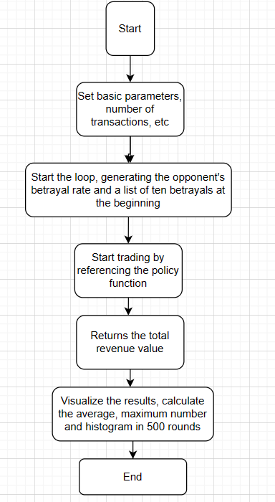

**Strategy function:**

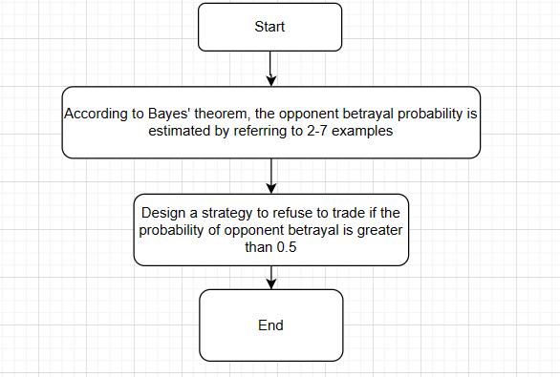

1. **Explain the reason of your strategy?**

According to lesson 2 example 7:

Example $7:$ Let $p=P\left(H\right)$ represent the probability of betray. For a given action, a-priori $p$ can possess any value in the interval (0,1). In the absence of any additional information, we may assume the a-priori pdf $f_{P}\left(p\right)$ to be a uniform distribution in interval (0,1). Now suppose we actually perform an experiment of trade $n$ times, and $k$ betray actions are observed. This is new information. How can we update $f_{P}\left(p\right)?$

Solution: Let $A=$“ $k$ betray actions in $n$ specific trades”. Since these trade result in a specific sequence,

$P(A|P=p)=p^{k}q^{n-k},$

and using (2-7) we get

$$P\left(A\right)=\int_{0}^{1}{P}\left(A|P=p\right)f_{P}\left(p\right)dp=\int_{0}^{1}{p^{k}}{\left(1-p\right)}^{n-k} dp=\frac{\left(n-k\right)! k!}{\left(n+1\right)!}.$$

· The a-posteriori(后验) pdf $f_{P|A}\left(p|A\right)$ represents the updated information

$$\begin{aligned}&\text{given the event }A,\text{and from (2-6)} \\ &f_{P|A}(p|A)=\frac{P(A|P=p)f_{P}(p)}{P(A)}=\frac{(n+1)!}{(n-k)!k!}p^{k}q^{n-k},0<p<1\text{(2-8)}\end{aligned}$$

Let B= “betray occurring in the (n+1)th trades, given that k betray actions have occurred in n trades “

Clearly $P\left(B|P=p\right)=p$, and from (2-7):

$$P\left(B\right)=\int_{0}^{1}{P}\left(B|P=p\right)f_{P}\left(p|A\right)dp.$$

(2-9) · Notice that unlike (2-7), we have used the a-posteriori pdf in (2-9) to reflect our knowledge about the experiment already performed. write (2-8) in (2-9), we get

$$P\left(B\right)=\int_{0}^{1}{p}⋅\frac{\left(n+1\right)!}{\left(n-k\right)! k!}p^{k}q^{n-k}dp=\frac{k+1}{n+2}.$$

In our experiment, n = 10 , k = sum of betray.

So, We calculated the probability of our opponent betraying us.

If the probability is greater than 0.5, then he is very likely to betray us, so we choose to refuse trade. That's where my strategy comes in.

1. **Results and analysis**

Results:

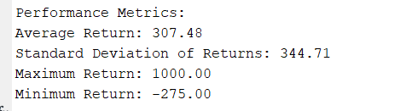

The average and variance of returns and so on

You can see that in our 500 rounds of trading, the average return is about 307. This is a very objective benefit. Why do you say that? Let's calculate the average expectation at 0.5.

That is 10*0.5-5*0.5=2.5,2.5*100=250。Of course, this is only a rough estimate, but it is enough to illustrate the success of our strategy

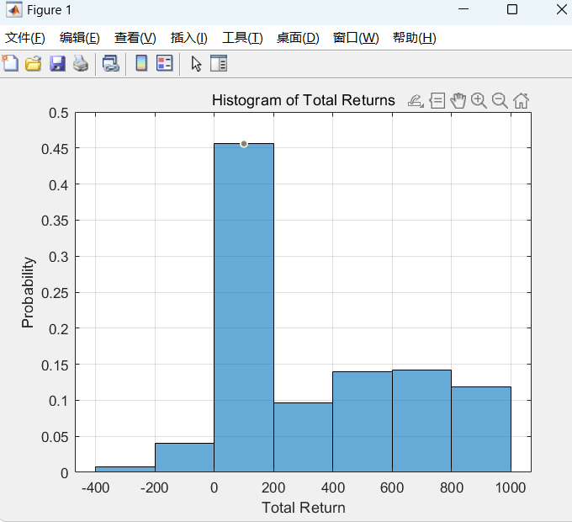

Histogram of Total returns

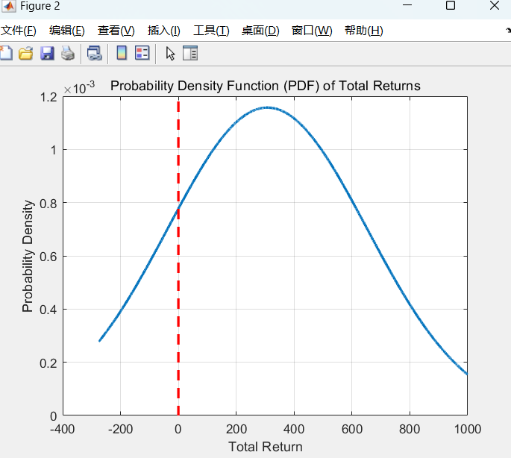

Probabaility density function of total returns

Through these two charts, we can intuitively find that we are making profits most of the time, and we can see that the main concentration is around 300

* **Part 4:Extra**

1. **Your program, and the flow chart of your program**

Main fuction:

1) Initialization:

independent_run is the number of independent runs, set to 200.

independent_run_list is a list used to store the return of each independent run.

2)Independent Run:

The code loops 200 times, each loop representing one independent run.

In each independent run, the counterparty's betrayal probability is randomly generated and uniformly distributed between 0.4 and 0.8.

The code then simulates the counterparty's behavior (trust or betray) in 100 trades to calculate how many times the counterparty betrayed.

Then, based on the counterparty's betrayal probability, the counterparty's action in the current trade is generated.

Next, the function strategy_extra(friends_betrayals) determines the trading strategy.

Based on your trading strategy and the counterparty's action, the return of the current trade is calculated:

If both trust, 10 points are added to the return.

If you trust and the counterparty betrays, 5 points are subtracted from the return.

If you reject the trade, the return remains 0.

The current trade's return is added to the independent_run_list to record the total return for each independent run.

3)Calculation and Decision:

The code calculates the total return, the number of times the return is -5, 0, and 10.

The randomly selected profit is calculated as follows: in 200 independent runs, each trade has a 50% chance of rejecting the trade. The remaining 50% of trades consist of a 40% chance of both trusting and 60% chance of you trusting while the counterparty betrays. The total expected return is calculated based on these probabilities and returns.

If the total return is greater than the randomly selected profit, and the number of times the return is 10 is greater than the times the return is -5, it is considered a success; otherwise, it is a failure.

4)Results Output:

Finally, the code outputs the total return and plots a pie chart showing the proportion of returns of -5, 0, and 10.

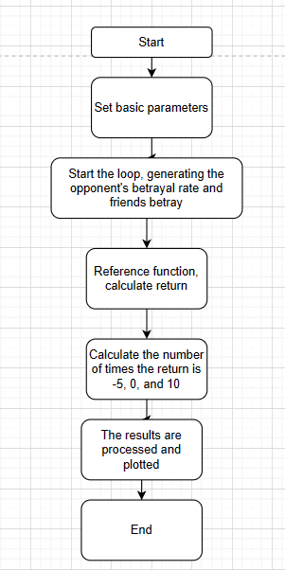

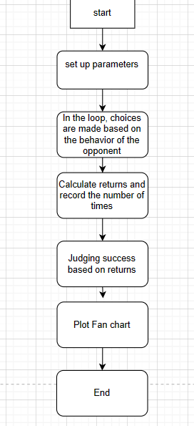

flow chart of main function

1. **The reason of your strategy**

According to Example 8: An unknown random phase $θ$ is uniformly n~ $N\left(0,σ^{2}\right)$. Determine $f\left(\vec{θ}|\vec{r}\right)$. Solution: Initially almost nothing about the r.v $θ$ is known,

so that we assume its a-priori pdf to be uniform in the interval $\left(0,2π\right).$

* In the equation $r= + n, $we can think of $n$ as $θ$ and n are reasonable is reasonable to assume that $θ$ and $n$ are independent. In that case

$$f\left(r|θ=θ\right)∼N\left(θ,σ^{2}\right)$$

since it is given that $Θ=θ$ is a constant, $r=θ+n$ posteriori pdf of $θ$ given $r$

behaves like n. Using (3-4) can gives the aposteriori pdf of $θ$ given r

$$\begin{aligned}that f_{θ}(θ)=1/2πandf(r|θ)=\frac{1}{\sqrt{2π}σ}e^{-\frac{(r-θ)^{2}}{2σ^{2}}}: \\ f(θ|r)=\frac{f(r|θ)f_{θ}(θ)}{\int_{0}^{2π}{ }f(r|θ)f_{θ}(θ)dθ} \\ =\frac{\frac{1}{\sqrt{2π}σ}e^{-(r-θ)^{2}/2σ^{2}}\frac{1}{2π}}{\int_{0}^{2π}{ }\frac{1}{\sqrt{2π}σ}e^{-(r-θ)^{2}/2σ^{2}}\frac{1}{2π}dθ} \\ θ)^{2}/2σ^{2} \\ 0<θ<2π, \\ Whereϕ(r)=\frac{1}{\int_{0}^{2π}{ }e^{-(r-θ)^{2}/2σ^{2}}dθ}\end{aligned}$$

$f\left(θ|r\right)$ $=ϕ\left(r\right)e^{-{\left(θ-r\right)}^{2}/2σ^{2}},0<θ<2π$, Where $ϕ\left(r\right)$ $=\frac{1}{\int_{0}^{2π}{e^{-{\left(r-θ\right)}^{2}/2σ^{2}}}dθ}$

· Notice that the knowledge about the observation $r$ is reflected in the a-posteriori pdf of $θ$ in Fig.3.1 (b). It is no longer flat as the a-priori pdf in Fig. 3.1 (a), and it shows higher probabilities in the neighborhood of $θ=r.$

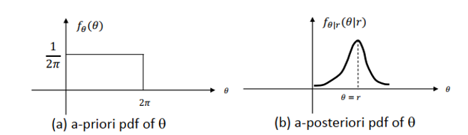

1. **Results and analysis, together with: What indicator/indicators is/are used for evaluation? Explain it/them.**

Result of program:

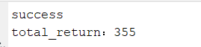

As you can see, the end result is success, and the payoff is 355

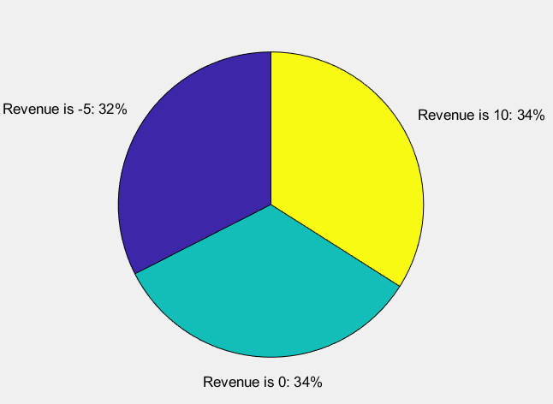

Plot of fan chart

Indicators Used for Evaluation:

a) Total Return: This is the overall profit or loss achieved across all independent runs. A higher total return indicates better performance.

b) Return Frequencies: The number of times each type of return (-5, 0, or 10) occurred is used to understand the distribution of outcomes and the strategy's reliability in achieving positive returns.

c) Randomly Selected Profit: This is a threshold value calculated based on the probabilities of each type of return (-5, 0, or 10) occurring. It is used to assess whether the total return is satisfactory.

d) Success or Failure: By comparing the total return and the return frequencies to certain criteria (as explained in the "Success or Failure" section above), the code determines whether the strategy is successful or not.

**4、Conclusion**

In conclusion, the experiments covered a wide range of statistical concepts and applications, from understanding various probability distributions to designing and evaluating strategies in a trading game based on Bayesian inference.

Probability Distributions: The first part of the experiment involved plotting Rayleigh, Poisson, Uniform, and Exponential distributions. By comparing the true and estimated probability density functions (pdf) alongside histograms, it was possible to gain a better understanding of each distribution's characteristics and how they vary with different sample sizes. This analysis is fundamental for working with statistical data and making inferences.

Trading Game with Bayesian Inference: The second part of the experiment focused on applying Bayesian inference to a trading game scenario. By designing strategies and estimating the counterparty's probability of betrayal based on prior actions and data from friends, participants had the opportunity to apply Bayesian reasoning to a practical decision-making situation. The game tested the participant's ability to optimize returns while minimizing risks.

Evaluation and Strategy: Evaluating the strategies involved analyzing the total returns and defining criteria for success or failure. Participants were required to explain their reasoning and approach, which tested their understanding of probability and decision theory.

What I learn from this experiment:

In this experiment, I gained several valuable insights into different aspects of statistics and decision-making:

Understanding Probability Distributions: The experiment involved plotting and analyzing several common probability distributions, such as Rayleigh, Poisson, Uniform, and Exponential distributions. This deepened my understanding of each distribution's characteristics, including their shapes and parameters, and how they behave with different sample sizes. This knowledge is essential for interpreting statistical data and modeling real-world phenomena.

Bayesian Inference in Decision-Making: The experiment applied Bayesian reasoning to a trading game scenario, which helped me understand how to use prior information and observed data to update beliefs and make decisions. This included estimating the counterparty's probability of betrayal based on their previous actions and data from friends. This approach is useful for making informed decisions under uncertainty.

Strategy Design and Evaluation: I learned how to design and evaluate strategies in a trading game context. This involved balancing risk and reward while maximizing returns. I also had the opportunity to define criteria for success and failure, allowing me to critically assess the effectiveness of different strategies.

Statistical Evaluation Methods: The experiment taught me how to use statistical metrics such as total returns, averages, and standard deviations to evaluate the performance of strategies. This skill is valuable for assessing outcomes in various decision-making scenarios.

|  |
| --- |
| 指导教师批阅意见：  成绩评定：  指导教师签字：  年 月 日 |
| 备注： |

注：1、报告内的项目或内容设置，可根据实际情况加以调整和补充。

2、教师批改学生实验报告时间应在学生提交实验报告时间后10日内。