深圳大学考试答题纸
二○二三～二○二四学年度第 二 学期 2024年5月10日
课程编号 | 2801000049 | 课序号 |  |  |  | 课程名称 |  | 机器学习 |  | 主讲教师 | 麦晓春 | 评分
学 号 | 2022280297 |  | 姓名 |  | 陈应权 |  | 专业年级 |  | 22电信文华

The method used to solve the problem involves the following steps:

- Data Preparation:
The input data consists of a list of tuples, where each tuple contains the name and position of an individual.

- Algorithm Design:
- The algorithm iterates through each individual in the input list.
- For each individual, it calculates the absolute differences between their position and the positions of all other individuals.
- The algorithm then sorts these absolute differences and selects the five individuals with the closest positions as friends for the current individual.
- The friends are stored in a dictionary where the key is the individual's name and the value is a list of their five closest friends.
- Visualization:
- Matplotlib library is used for visualization.
- Individuals are plotted on the x-axis based on their positions.
- Each individual is represented as a point on the plot, and their name is labeled at their respective position.
- Connections (lines) are drawn between each individual and their five closest friends, forming a tree-like structure.
- Testing and Validation:
- The algorithm is tested with sample data to ensure that it correctly identifies each individual's five closest friends.
- Visualization results are validated to ensure they accurately represent the relationships between individuals based on their positions.
Results:
The array of friend with position
For each person has his own five friends
{'Alice': ['Amy', 'Laoda', 'Bob', 'Charlie', 'Meisii'], 'Bob': ['Laoda', 'Amy', 'Alice', 'David', 'Charlie'], 'Charlie': ['Meisii', 'Alice', 'Amy', 'Laoda', 'Bob'], 'David': ['Bob', 'Eve', 'Laoda', 'Amy', 'Alice'], 'Eve': ['David', 'Bob', 'Laoda', 'Amy', 'Alice'], 'Amy': ['Alice', 'Laoda', 'Bob', 'Charlie', 'David'], 'Laoda': ['Bob', 'Amy', 'Alice', 'David', 'Charlie'], 'Meisii': ['Charlie', 'Alice', 'Amy', 'Laoda', 'Bob']}.
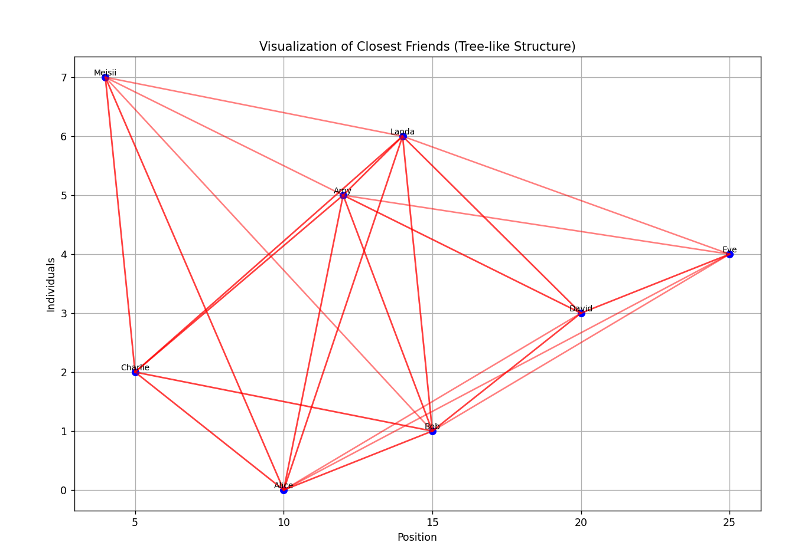
Visual result
The horizontal axis is where everyone is, the vertical axis is where they were when they entered the data, and then each dot represents each person, with a name next to it, and finally each person connects five lines pointing to their friend

