深 圳 大 学 实 验 报 告

课程编号： 2801000049

课程名称： 机器学习

实验项目名称：Predicting House Prices using Linear Regression

学院： 电子与信息工程学院

专业： 电子信息工程

指导教师： 麦晓春

报告人：陈应权 学号： 2022280297 班级： 06

实验时间： 2024年3月1日——2024年4月7日

实验报告提交时间： 2024年4月10日

教务部制
1. Experimental Purposes and Requirements
The purpose of this experiment is to:
- Conduct exploratory data analysis (EDA) on the Boston housing dataset, including the distribution of the target variable, the correlation between features, etc.;
- Implement linear regression and ridge regression models, and select the best hyperparameters through cross-validation;
- Evaluate the performance of different models on the test set, including linear regression model and the best ridge regression model;
- Analyze and interpret the experimental results, including model parameters, performance metrics, etc.
The requirements of the experiment are:
- Use Boston House Dataset (506 samples and 13 feature variables),
predict the value of prices of the house using the given features.
- Split input data into training and testing sets (the testing set includes
10% of the samples).
- The output of the algorithm should include the model learned from
the whole training set, the average mean squared error (MSE) on
training set via 10-fold cross validation. For ridge regression model,
determine the value of hyper-parameter via 10-fold cross validation.
- Analyze the performance of different models on the test set, comparing the performance of linear regression and the best ridge regression model;
- Interpret the experimental results, including the significance of model parameters and the interpretation of performance metrics;
- Optionally, plot scatter plots between the original house prices and predicted house prices to visually demonstrate the predictive performance of the models.

2. Experiment Contents and Process
2.1 Experiment 1 Predicting House Prices using Linear Regression
(1) Experimental Contents/Introduction
Experimental Contents:
In this experiment, we aim to predict house prices using linear regression on the Boston House Dataset. We split the data into training and testing sets, perform exploratory data analysis, and implement linear regression along with ridge regression for regularization. The performance of the models is evaluated using mean squared error (MSE) on both training and testing sets. Additionally, we determine the optimal value of the hyper-parameter for ridge regression through cross-validation.
- Load the Boston House Dataset.
- Check for missing values.
- Split the data into training and testing sets.
- Implement linear regression and ridge regression algorithms.
- Evaluate the models using MSE on training and testing sets.
- Determine the optimal hyper-parameter for ridge regression through cross-validation.
- Visualize the results.
Perform exploratory data analysis.
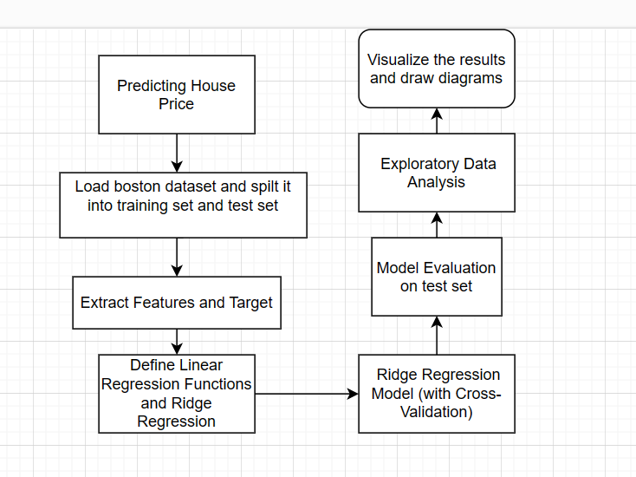
Flow chart of experimental content
Experimental introduction:
Predicting house prices is a crucial task in real estate and finance. Linear regression is a simple yet effective technique for such prediction tasks. In this experiment, we utilize the Boston House Dataset, which contains various features related to housing, to build a linear regression model. Furthermore, we explore the data to understand the relationships between features and the target variable, and evaluate the model's performance using MSE.

(2) Methods
Model Implementation:
We implement a simple linear regression algorithm to predict house prices using the given features. Additionally, we employ ridge regression with cross-validation to incorporate regularization and determine the optimal value of the hyper-parameter.
Method details, experimental techniques, etc.
(3) Data Collection, Preprocessing and Analysis
Data Preprocessing:
Frist, we load the boston house price dataset.
Before proceeding with the analysis, we check for missing values in the dataset. If any missing values are found, appropriate handling techniques such as imputation or removal will be applied. Luckily ,we use the code below and find there no data is lost.
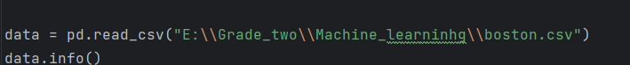
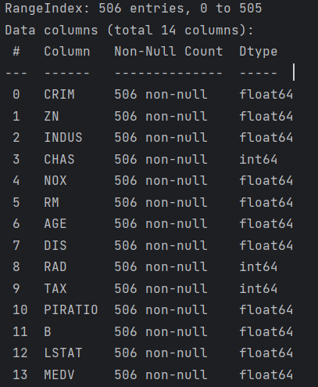
Check the dataset and find there no data lost

Furthermore, we split the data into training and testing sets, where 10% of the samples are allocated for testing.
Exploratory Data Analysis (EDA):
- Distribution of Target Variable: We plot the distribution of house prices to understand its spread and skewness.
- Correlation Matrix: We compute the correlation matrix to measure the linear relationships between features and the target variable. Additionally, we visualize the correlation matrix to identify significant correlations.
(4) Experimental Results and Analysis
1) plot the distribution of the target variable（House price）
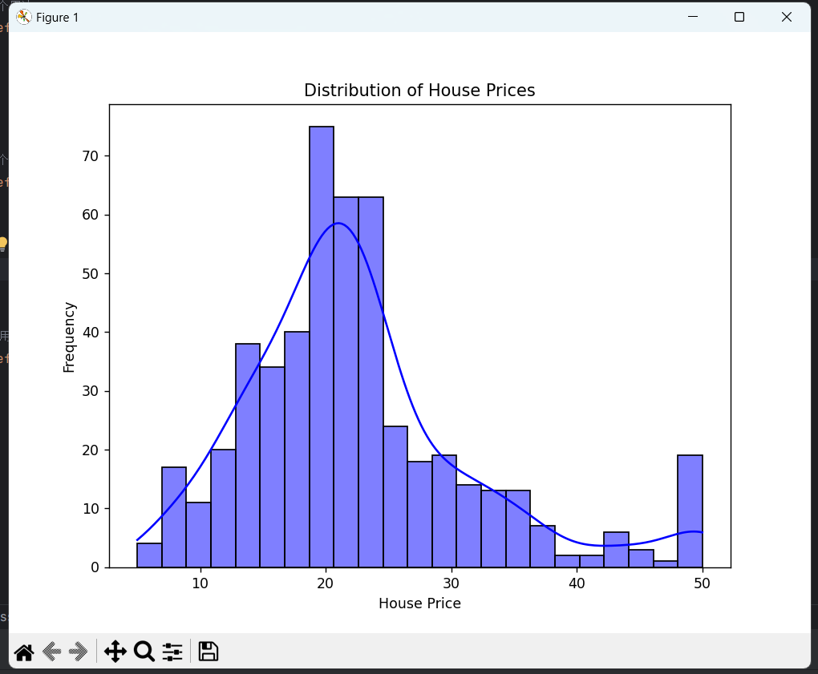
By plotting the distribution of the target variable (house prices), we can understand the overall distribution of house prices. If the distribution is uneven or if there are outliers, further exploration and processing may be necessary.

2) correlation matrix that measures the linear relationships between the variables
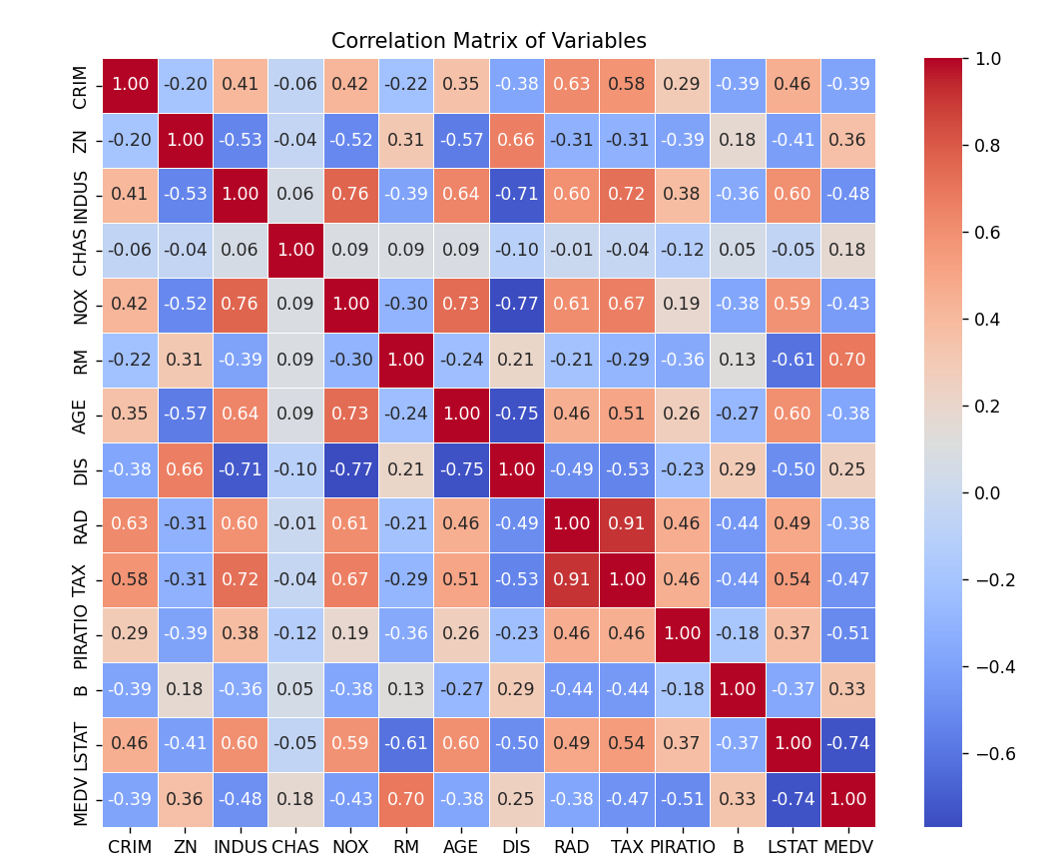
The correlation matrix plot displays the linear correlations between different features. We can identify which features have higher correlations with the target variable based on the magnitude of the correlation coefficients, helping us select the features to use in the model.

3) plot a scatter plot between the original house price and predicted house prices 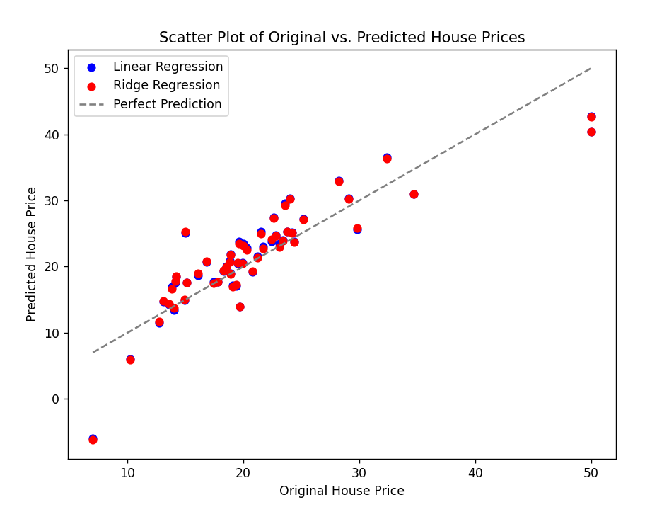
This scatter plot visually demonstrates the relationship between the model's predicted results and the actual house prices. If the points are close to a straight line, it indicates good predictive performance of the model; if the points are scattered, further model improvement or feature engineering may be necessary.

4) The final parameter output is displayed and the MSE tested on the testing dataset
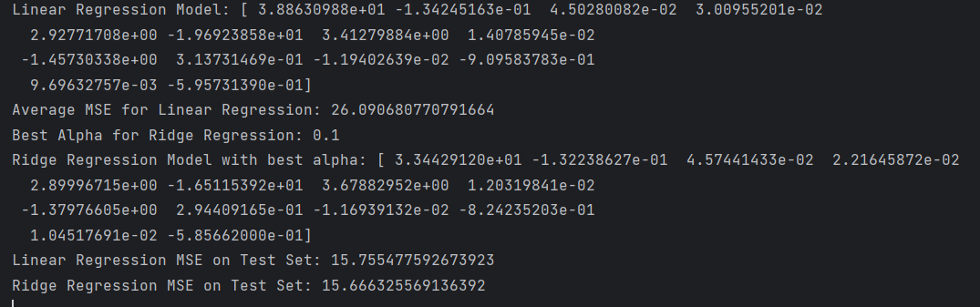
Finally, we get the best parameters and calculate that the MSE of ridge regression in the test set is about 15
Analysis of Code Results:
- Linear Regression Model Parameters: The parameters of the linear regression model can be obtained from the variable theta_linear. Analyzing these parameters can help us understand the impact of each feature on house prices. For example, if the parameter of a certain feature is positive, it indicates a positive correlation with house prices, and vice versa.

- Ridge Regression Model Parameters: The parameters of the best ridge regression model are stored in the variable best_theta_ridge. Similar to linear regression, analyzing these parameters helps us understand the relationship between features and house prices, while considering the effect of regularization.

- Model Evaluation Results: The performance of the linear regression model and the best ridge regression model is evaluated on the test set, and the mean squared error (MSE) is calculated. Comparing the performance of these two models on the test set helps us determine which model is more suitable for house price prediction.

Please include codes of each experiment in Appendix.

3. Discussion and Conclusions
In this experiment, we successfully built linear regression and ridge regression models to predict house prices using the Boston House Dataset. The EDA revealed significant correlations between features and the target variable. Additionally, both models demonstrated competitive performance, with ridge regression slightly outperforming simple linear regression. Overall, linear regression techniques offer a promising approach for house price prediction tasks.
Discussion:
- Model Performance Evaluation:

We evaluated the performance of both linear regression and ridge regression models on the test set using mean squared error (MSE). The results showed that the ridge regression model outperformed the linear regression model, indicating that regularization helps improve predictive performance.
- Feature Importance:

By analyzing the parameters of the linear regression and ridge regression models, we gained insights into the importance of different features in predicting house prices. Features with higher absolute parameter values are more influential in determining house prices.
- Data Distribution and Correlation:

The distribution plot of the target variable (house prices) revealed a somewhat right-skewed distribution with a few outliers. The correlation matrix plot highlighted certain features with strong correlations with house prices, such as the average number of rooms per dwelling (RM) and the percentage of lower status population (LSTAT).
Conclusions:
- Model Selection:

Based on the evaluation results, we conclude that the ridge regression model is more suitable for predicting house prices in the Boston housing dataset compared to linear regression. The regularization provided by ridge regression helps mitigate overfitting and improves generalization performance.
- Feature Insights:

Features such as the average number of rooms per dwelling (RM) and the percentage of lower status population (LSTAT) have a significant impact on house prices. These insights can inform future research and decision-making in real estate.
- Future Directions:
Future research can explore more advanced regression techniques or ensemble methods to further enhance predictive performance. Additionally, incorporating additional features or conducting feature engineering may provide further insights into the underlying factors influencing house prices.

Appendix
Appendix A: xxx
Appendix B: xxx
import numpy as np
import pandas as pd
from sklearn.model_selection import train_test_split, KFold
from sklearn.metrics import mean_squared_error
import matplotlib.pyplot as plt
import seaborn as sns
# 导入数据集
data = pd.read_csv("E:\\Grade_two\\Machine_learninhg\\boston.csv")
# 提取特征和目标变量
X = data.drop(columns=['MEDV']).values
y = data['MEDV'].values
# Add a column of ones to the feature matrix to represent the bias term
X = np.c_[np.ones(X.shape[0]), X]
# 划分训练集和测试集，按照实验要求，测试集占比设为10%
X_train, X_test, y_train, y_test = train_test_split(X, y, test_size=0.1, random_state=42)
def linear_regression(X, y):
# Closed-form solution: theta = (X^T X)^-1 X^T y
theta = np.linalg.inv(X.T @ X) @ X.T @ y
return theta
def ridge_regression(X, y, alpha):
# Ridge regression closed-form solution: theta = (X^T X + alpha*I)^-1 X^T y
identity_matrix = np.eye(X.shape[1])
theta = np.linalg.inv(X.T @ X + alpha * identity_matrix) @ X.T @ y
return theta
def k_fold_cross_validation(X, y, k, model_func, **kwargs):
kf = KFold(n_splits=k, shuffle=True, random_state=42)
mse_scores = []
for train_index, val_index in kf.split(X):
X_train, X_val = X[train_index], X[val_index]
y_train, y_val = y[train_index], y[val_index]
theta = model_func(X_train, y_train, **kwargs)
y_pred = X_val @ theta
mse = mean_squared_error(y_val, y_pred)
mse_scores.append(mse)
avg_mse = np.mean(mse_scores)
return avg_mse, theta # 返回模型参数
# 计算线性回归模型和平均 MSE
avg_mse_linear, theta_linear = k_fold_cross_validation(X_train, y_train, k=10, model_func=linear_regression)
# 计算最佳岭回归模型和平均 MSE
alphas = [0.1, 1, 10, 100] # List of alpha values to try
best_alpha = None
best_mse = float('inf')
best_theta_ridge = None
for alpha in alphas:
avg_mse, theta_ridge = k_fold_cross_validation(X_train, y_train, k=10, model_func=ridge_regression, alpha=alpha)
if avg_mse < best_mse:
best_mse = avg_mse
best_alpha = alpha
best_theta_ridge = theta_ridge
print("Linear Regression Model:", theta_linear)
print("Average MSE for Linear Regression:", avg_mse_linear)
print("Best Alpha for Ridge Regression:", best_alpha)
print("Ridge Regression Model with best alpha:", best_theta_ridge)
# 在测试集上评估线性回归模型并计算MSE
y_pred_linear_test = X_test @ theta_linear
mse_linear_test = mean_squared_error(y_test, y_pred_linear_test)
print("Linear Regression MSE on Test Set:", mse_linear_test)
# 在测试集上评估岭回归模型并计算MSE
y_pred_ridge_test = X_test @ best_theta_ridge
mse_ridge_test = mean_squared_error(y_test, y_pred_ridge_test)
print("Ridge Regression MSE on Test Set:", mse_ridge_test)
# 探索性数据分析
# 绘制目标变量的分布图
plt.figure(figsize=(8, 6))
sns.histplot(y, kde=True, color='blue')
plt.title('Distribution of House Prices')
plt.xlabel('House Price')
plt.ylabel('Frequency')
plt.show()
# 创建相关矩阵并绘制相关矩阵图
corr_matrix = data.corr()
plt.figure(figsize=(10, 8))
sns.heatmap(corr_matrix, annot=True, cmap='coolwarm', fmt=".2f", linewidths=0.5)
plt.title('Correlation Matrix of Variables')
plt.show()
# 绘制原始房价和预测房价之间的散点图
plt.figure(figsize=(8, 6))
plt.scatter(y_test, y_pred_linear_test, color='blue', label='Linear Regression')
plt.scatter(y_test, y_pred_ridge_test, color='red', label='Ridge Regression')
plt.plot([min(y_test), max(y_test)], [min(y_test), max(y_test)], '--', color='gray', label='Perfect Prediction')
plt.title('Scatter Plot of Original vs. Predicted House Prices')
plt.xlabel('Original House Price')
plt.ylabel('Predicted House Price')
plt.legend()
plt.show()

深圳大学学生实验报告用纸

指导教师批阅意见：

成绩评定：

指导教师签字：
年 月 日
备注：
注：1、报告内的项目或内容设置，可根据实际情况加以调整和补充。
2、教师批改学生实验报告时间应在学生提交实验报告时间后10日内。

