深 圳 大 学 实 验 报 告

课程编号： 2801000049

课程名称： 机器学习

实验项目名称： Different methods are used to classify seed databases

学院： 电子与信息工程学院

专业： 电子信息工程

指导教师： 麦晓春

报告人：陈应权 学号：2022280297 班级：22文华班

实验时间： 2024年4月12日——2024年5月17日

实验报告提交时间： 2024年5月17日

教务部制
1. Experimental Purposes and Requirements
The purpose of this experiment is to compare the performance of various classification algorithms on the Seeds dataset. The requirements include implementing six different classification algorithms:
- Logistic Regression
- Linear Discriminant Analysis (LDA)
- K-Nearest Neighbors (KNN)
- Naive Bayes
- Support Vector Machine (SVM)
- Decision Tree
For each experiment, we aim to report quantitative results such as accuracy, confusion matrix, and classification report, as well as visualize the results where applicable.

2. Experiment Contents and Process
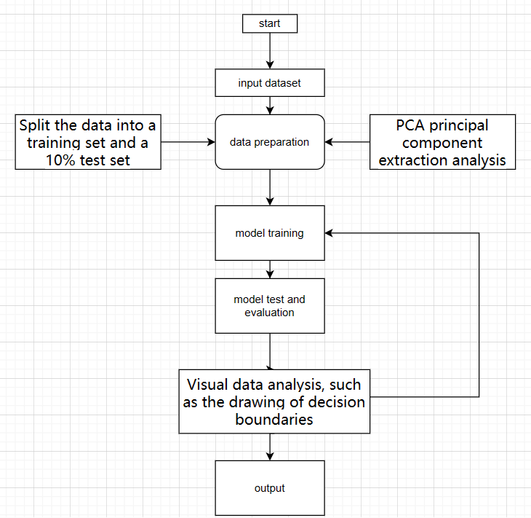
The following are six model flow charts
2.1 Experiment 1 Logistic regression
(1) Experimental Contents/Introduction
Logistic regression is a statistical method used for binary classification tasks. In this experiment, we apply logistic regression to the seed dataset to classify seeds into one of three varieties based on several geometric attributes. By doing so, we aim to understand how well logistic regression can discriminate between different seed varieties.

(2) Methods
- Data Loading: The seed dataset, containing attributes such as area, perimeter, and asymmetry coefficient, is loaded using the Pandas library.
- Data Preprocessing and Dimensionality Reduction: We preprocess the data as necessary and employ Principal Component Analysis (PCA) to reduce the dimensionality of the feature space while preserving most of the variance in the data. This step facilitates visualization of the data and potentially improves model performance.
- Model Training: Logistic regression, a linear classification model, is trained on the transformed dataset obtained through PCA.
- Model Evaluation: The trained logistic regression model is evaluated on a separate test set. Evaluation metrics such as accuracy, precision, recall, and F1-score are computed to assess the model's performance.

(3) Data Collection, Preprocessing and Analysis
- Data Loading: The seed dataset is read from a file using Pandas, ensuring that each row represents a seed sample and each column corresponds to a specific attribute.
- Data Splitting: The dataset is split into training and testing sets, with 10% of the data reserved for testing to evaluate the model's generalization performance.
- Principal Component Analysis (PCA): PCA is applied to reduce the dimensionality of the feature space to two principal components, enabling visualization of the data in a two-dimensional space.

(4) Experimental Results and Analysis
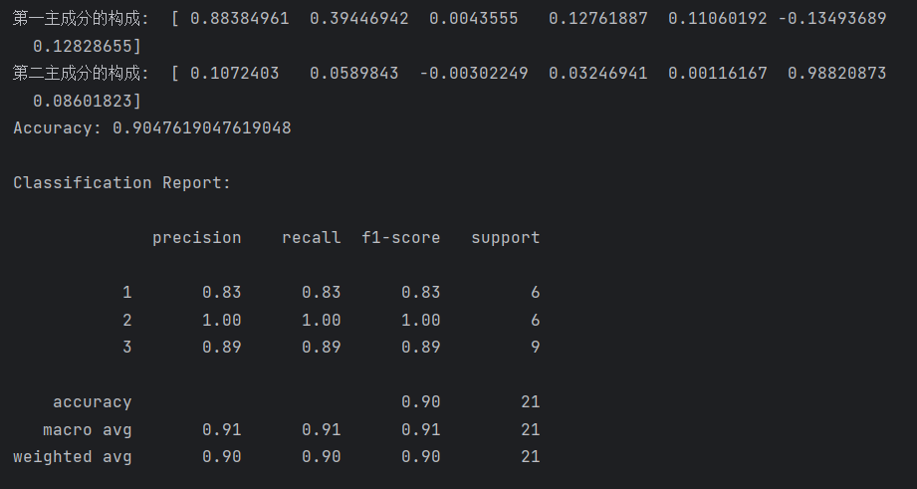
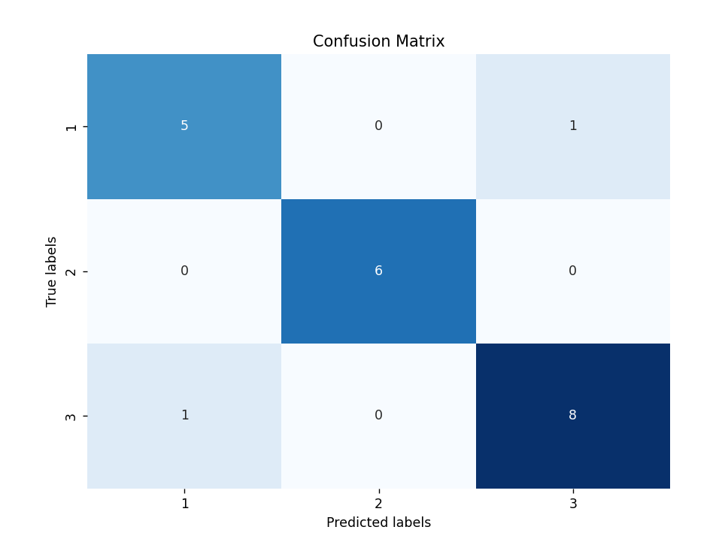
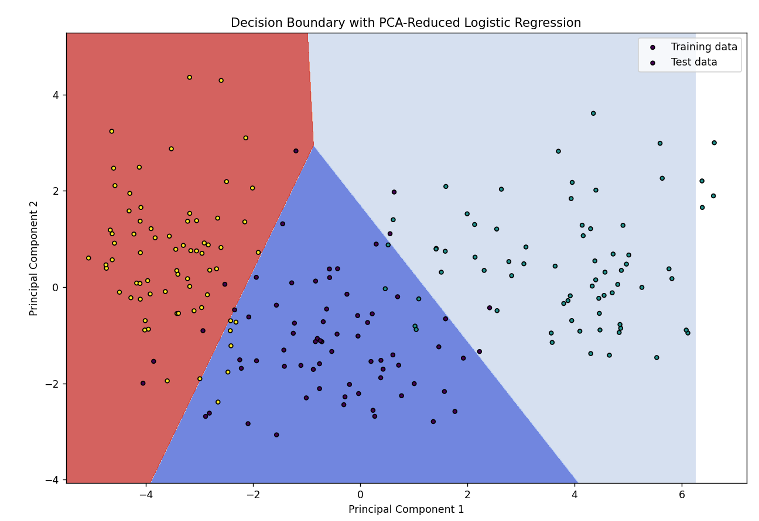
- Experimental Results: The logistic regression model achieves a certain accuracy percentage on the test set, whose accuracy is 90.476%, indicating how well it can predict the seed varieties.
- Confusion Matrix: A confusion matrix is generated to visualize the model's performance in terms of correctly and incorrectly classified instances for each seed variety.
- Classification Report: A detailed classification report is produced, containing metrics such as precision, recall, and F1-score for each seed variety, providing insights into the model's performance across different classes.

2.2 Experiment 2 Linear Discriminant Analysis (LDA)
(1) Experimental Contents/Introduction:
Linear Discriminant Analysis (LDA) is a method commonly used for dimensionality reduction and classification. It aims to find the linear combinations of features that best separate different classes while maximizing the between-class variance and minimizing the within-class variance. In this experiment, we apply LDA to the seed dataset to classify seeds based on their geometric attributes.

(2) Methods:
- Data Loading: Load the seed dataset using the Pandas library.
- Data Preprocessing (if necessary): No preprocessing is required for this example.
- Data Splitting: Split the dataset into training and testing sets.
- Dimensionality Reduction with PCA: Use Principal Component Analysis (PCA) to reduce the dimensionality of the feature space to two dimensions for visualization purposes.
- Model Training: Train an LDA model on the reduced-dimensional data.
- Model Evaluation: Evaluate the LDA model's accuracy on the test set and generate a classification report containing precision, recall, and F1-score metrics.

(3) Data Collection, Preprocessing, and Analysis:
- Data Loading: Read the seed dataset from a file using Pandas, ensuring each row represents a seed sample, and each column corresponds to a specific attribute.
- Data Splitting: Split the dataset into features (X) and target variable (y), and further divide it into training and testing sets, with 10% of the data reserved for testing.
- Principal Component Analysis (PCA): Apply PCA to reduce the dimensionality of the feature space to two principal components, allowing for visualization of the data in a two-dimensional space.

(4) Experimental Results and Analysis:

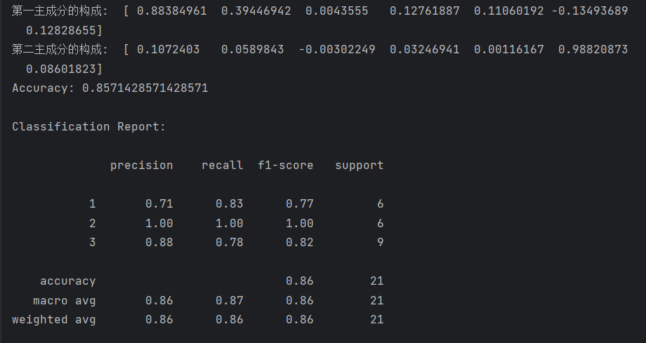
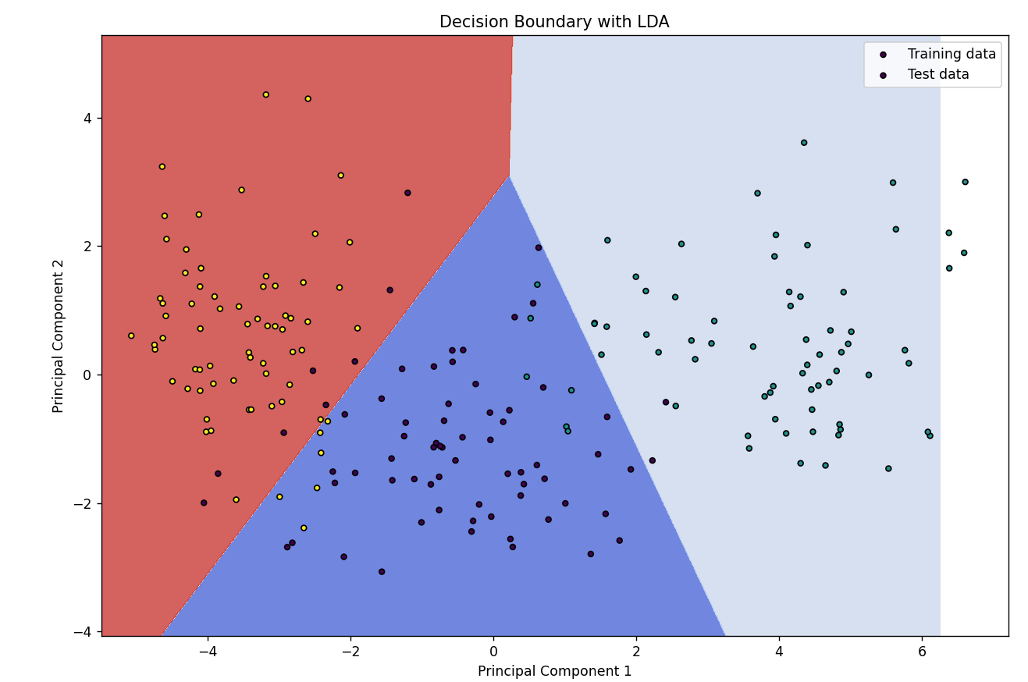
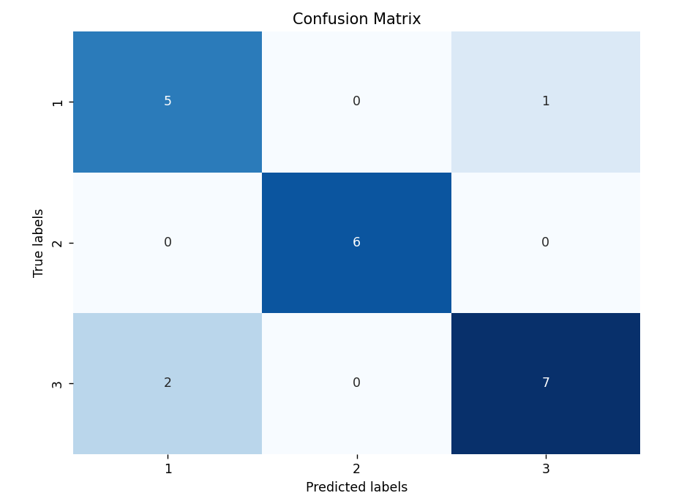
(4)Experimental Results and Analysis:
- Experimental Results: The LDA model achieves a certain accuracy percentage on the test set , whose accuracy is 85.714%, slightly below logistic regression.
- Classification Report: Generate a classification report containing metrics such as precision, recall, and F1-score for each seed variety, providing insights into the model's performance across different classes.
- Visualization - Decision Boundary: Visualize the decision boundary of the LDA model in the reduced two-dimensional feature space.

2.3 Experiment 3: Seed Classification Using K-Nearest Neighbors (KNN)
(1) Experimental Contents/Introduction:
K-Nearest Neighbors (KNN) is a simple and intuitive classification algorithm that works by finding the majority class among the K nearest neighbors of a data point. In this experiment, we apply KNN to the seed dataset to classify seeds into different varieties based on their geometric attributes.
(2)Methods:
- Data Loading: Load the seed dataset using the Pandas library.
- Data Preprocessing (if necessary): No preprocessing is required for this example.
- Data Splitting: Split the dataset into training and testing sets.
- Dimensionality Reduction with PCA: Apply Principal Component Analysis (PCA) to reduce the dimensionality of the feature space to two dimensions for visualization purposes.
- Model Training: Train a KNN classifier on the reduced-dimensional data.
- Model Evaluation: Evaluate the KNN model's accuracy on the test set and generate a classification report containing precision, recall, and F1-score metrics.

(3) Data Collection, Preprocessing, and Analysis:
- Data Loading: Read the seed dataset from a file using Pandas, ensuring each row represents a seed sample, and each column corresponds to a specific attribute.
- Data Splitting: Split the dataset into features (X) and target variable (y), and further divide it into training and testing sets, with 30% of the data reserved for testing.
- Principal Component Analysis (PCA): Apply PCA to reduce the dimensionality of the feature space to two principal components, allowing for visualization of the data in a two-dimensional space.

(4) Experimental Results and Analysis:

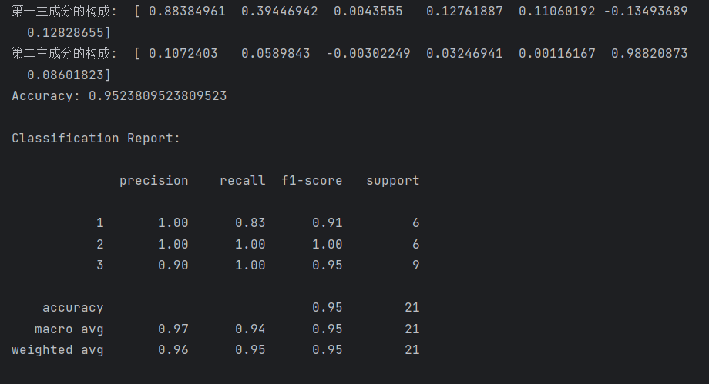
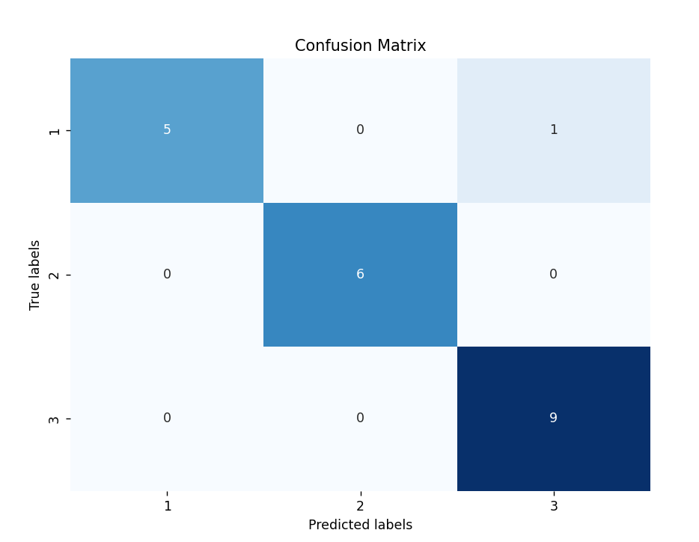
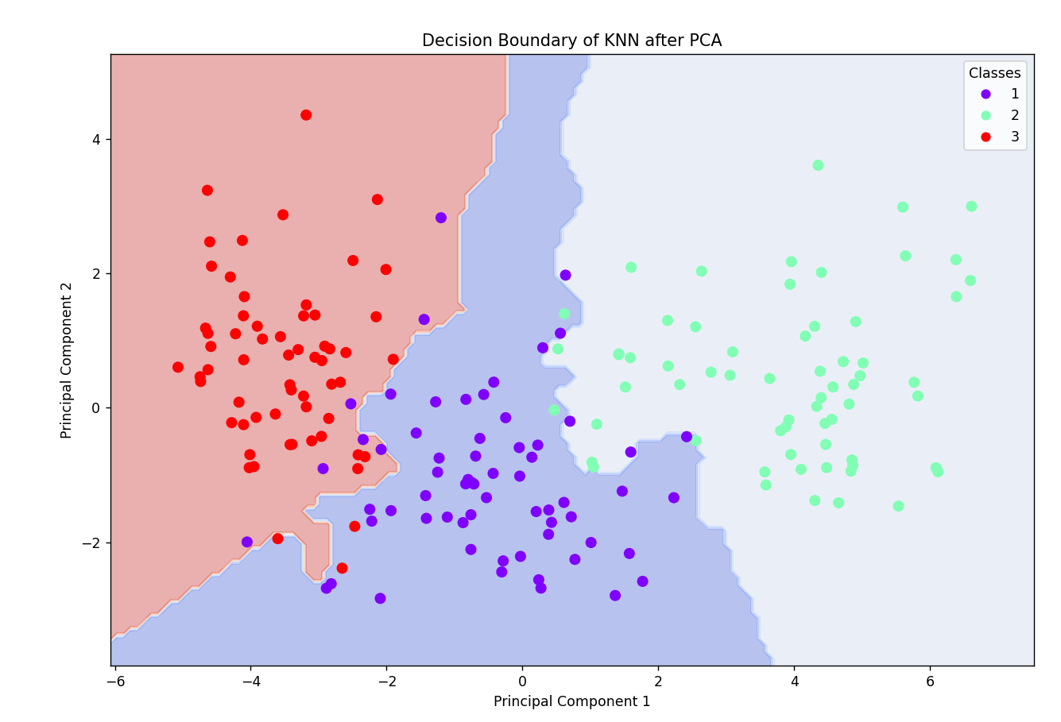
- Experimental Results: The KNN model achieves a certain accuracy percentage on the test set, whose accuracy is 95.238% , higher than the first two.
- Classification Report: Generate a classification report containing metrics such as precision, recall, and F1-score for each seed variety, providing insights into the model's performance across different classes.
- Visualization - Decision Boundary: Plot the decision boundary of the KNN classifier in the reduced feature space to visualize how the algorithm separates different classes.

2.4 Experiment 4: Seed Classification Using Naive Bayes

(1) Experimental Contents/Introduction:
Naive Bayes is a probabilistic classification algorithm based on Bayes' theorem and the assumption of feature independence. Despite its simplicity, Naive Bayes often performs well in practice, especially for text classification and other applications with high-dimensional feature spaces. In this experiment, we apply Naive Bayes to the seed dataset to classify seeds into different varieties based on their geometric attributes.

(2)Methods:
- Data Loading: Load the seed dataset using the Pandas library.
- Data Preprocessing (if necessary): No preprocessing is required for this example.
- Data Splitting: Split the dataset into training and testing sets.
- Dimensionality Reduction with PCA: Apply Principal Component Analysis (PCA) to reduce the dimensionality of the feature space to two dimensions for visualization purposes.
- Model Training: Train a Naive Bayes classifier on the reduced-dimensional data.
- Model Evaluation: Evaluate the Naive Bayes model's accuracy on the test set and generate a classification report containing precision, recall, and F1-score metrics.

(3) Data Collection, Preprocessing, and Analysis:
- Data Loading: Read the seed dataset from a file using Pandas, ensuring each row represents a seed sample, and each column corresponds to a specific attribute.
- Data Splitting: Split the dataset into features (X) and target variable (y), and further divide it into training and testing sets, with 10% of the data reserved for testing.
- Principal Component Analysis (PCA): Apply PCA to reduce the dimensionality of the feature space to two principal components, allowing for visualization of the data in a two-dimensional space.

(4) Experimental Results and Analysis:
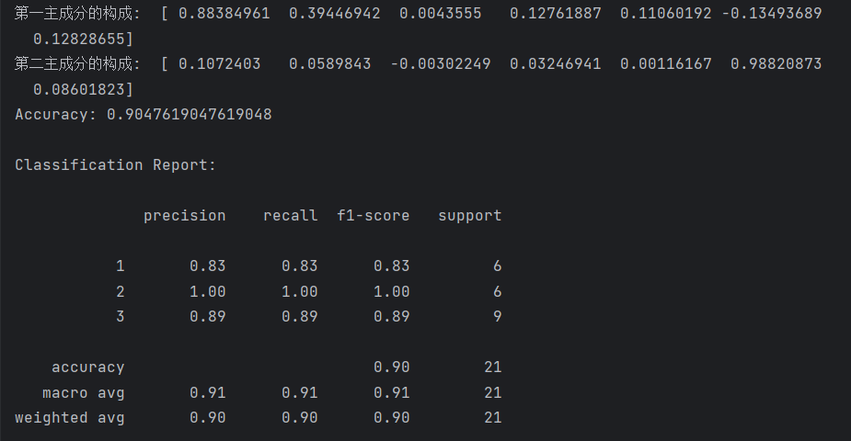
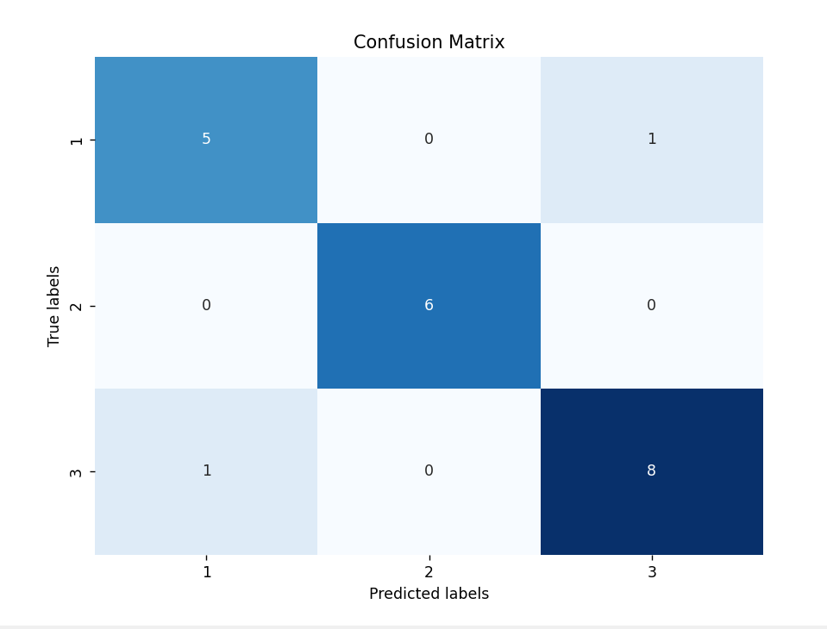
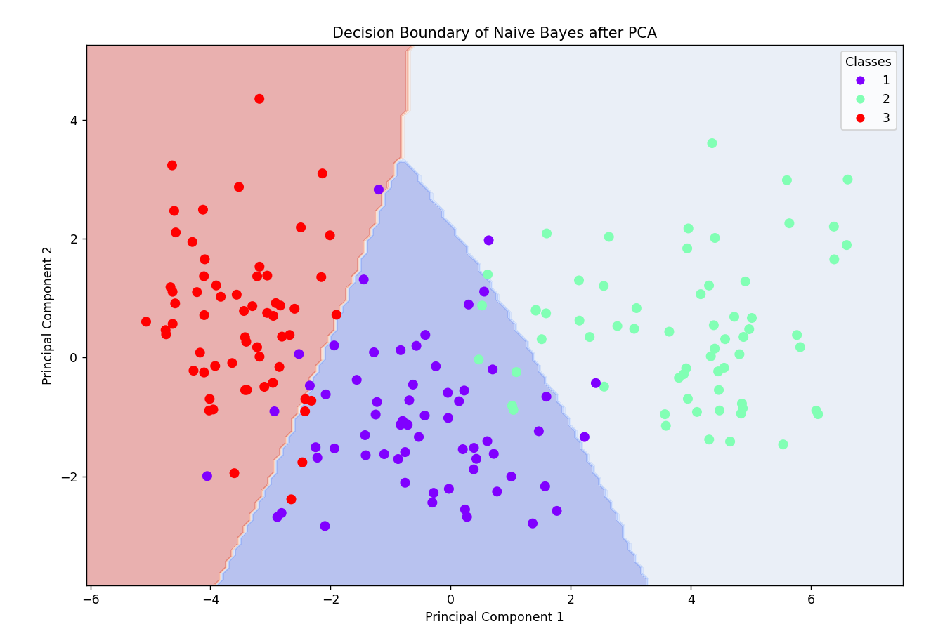
- Experimental Results: The Naive Bayes model achieves a certain accuracy 90.47% percentage on the test set.
- Classification Report: Generate a classification report containing metrics such as precision, recall, and F1-score for each seed variety, providing insights into the model's performance across different classes.
- Visualization - Decision Boundary: Plot the decision boundary of the Naive Bayes classifier in the reduced feature space to visualize how the algorithm separates different classes.

2.5 Experiment 5: Seed Classification Using Support Vector Machine (SVM)

(1)Experimental Contents/Introduction:
Support Vector Machine (SVM) is a powerful supervised learning algorithm used for classification and regression tasks. It works by finding the hyperplane that best separates different classes in the feature space. In this experiment, we apply SVM to the seed dataset to classify seeds into different varieties based on their geometric attributes.

(2)Methods:
- Data Loading: Load the seed dataset using the Pandas library.
- Data Preprocessing (if necessary): No preprocessing is required for this example.
- Data Splitting: Split the dataset into training and testing sets.
- Model Training: Train an SVM classifier using a linear kernel on the original feature space.
- Model Evaluation: Evaluate the SVM model's accuracy on the test set and generate a classification report containing precision, recall, and F1-score metrics.
- Dimensionality Reduction for Visualization: Use Principal Component Analysis (PCA) to reduce the dimensionality of the feature space to two dimensions for visualization purposes.
- Visualization - Decision Boundary: Plot the decision boundary of the SVM classifier in the reduced feature space.

(3)Data Collection, Preprocessing, and Analysis:
- Data Loading: Read the seed dataset from a file using Pandas, ensuring each row represents a seed sample, and each column corresponds to a specific attribute.
- Data Splitting: Split the dataset into features (X) and target variable (y), and further divide it into training and testing sets, with 10% of the data reserved for testing.

(4)Experimental Results and Analysis:
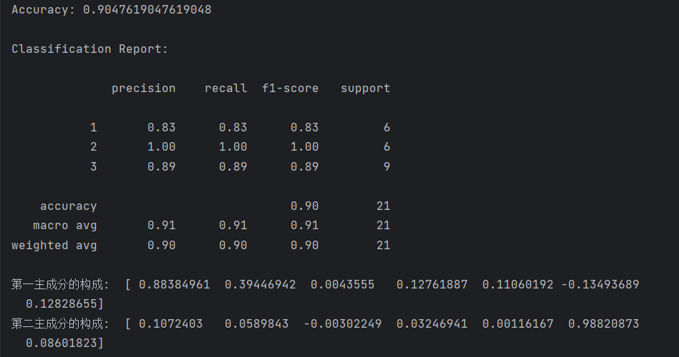
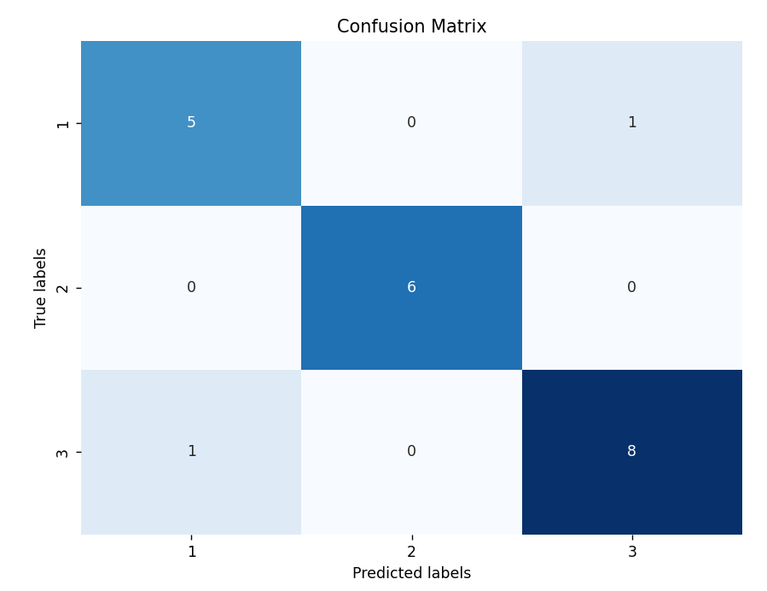
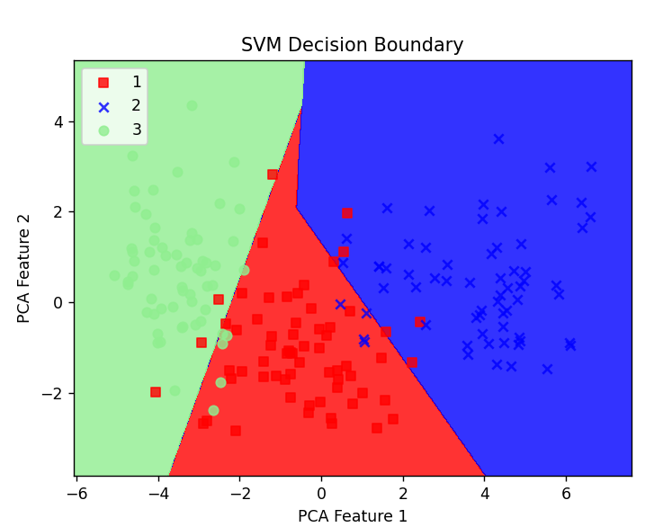
- Experimental Results: The SVM model achieves a certain accuracy percentage on the test set.
- Classification Report: Generate a classification report containing metrics such as precision, recall, and F1-score for each seed variety, providing insights into the model's performance across different classes.
- Visualization - Decision Boundary: Plot the decision boundary of the SVM classifier in the reduced two-dimensional feature space obtained through PCA, allowing for visualization of how the algorithm separates different classes.

2.6 Experiment 6: Seed Classification Using Decision Tree

(1) Experimental Contents/Introduction:
Decision Tree is a popular and interpretable supervised learning algorithm used for classification tasks. It partitions the feature space into subsets based on the values of input features, making decisions at each node to classify instances. In this experiment, we apply Decision Tree to the seed dataset to classify seeds into different varieties based on their geometric attributes.

(2) Methods:
- Data Loading: Load the seed dataset using the Pandas library.
- Data Splitting: Split the dataset into training and testing sets.
- Model Training: Train a Decision Tree classifier on the original feature space.
- Model Evaluation: Evaluate the Decision Tree model's accuracy on the test set and generate a classification report containing precision, recall, and F1-score metrics.
- Visualization - Decision Tree Structure: Visualize the structure of the trained Decision Tree model.
- Visualization - Decision Boundary: Plot the decision boundary of the Decision Tree classifier.
- Visualization - Confusion Matrix: Plot the confusion matrix to evaluate the model's performance.

(3) Data Collection, Preprocessing, and Analysis:
- Data Loading: Read the seed dataset from a file using Pandas, ensuring each row represents a seed sample, and each column corresponds to a specific attribute.
- Data Splitting: Split the dataset into features (X) and target variable (y), and further divide it into training and testing sets, with 10% of the data reserved for testing.

(4)Experimental Results and Analysis:
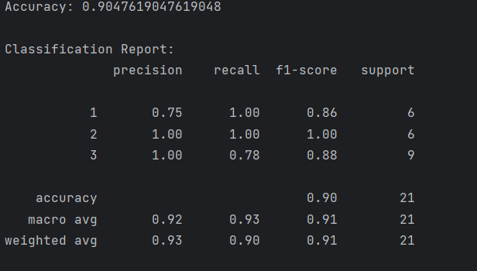
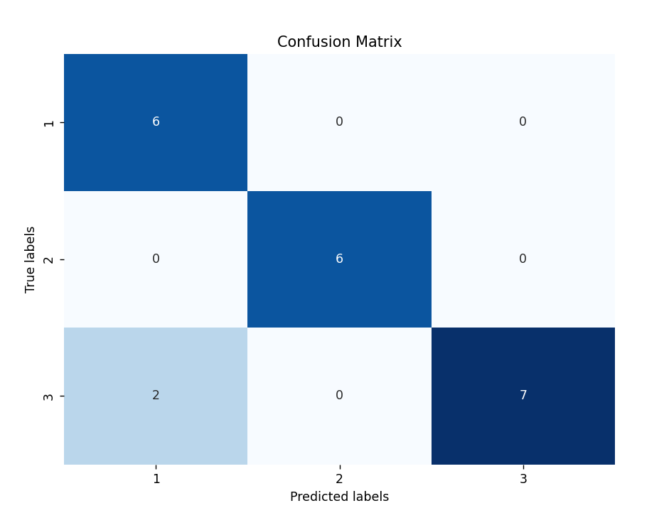
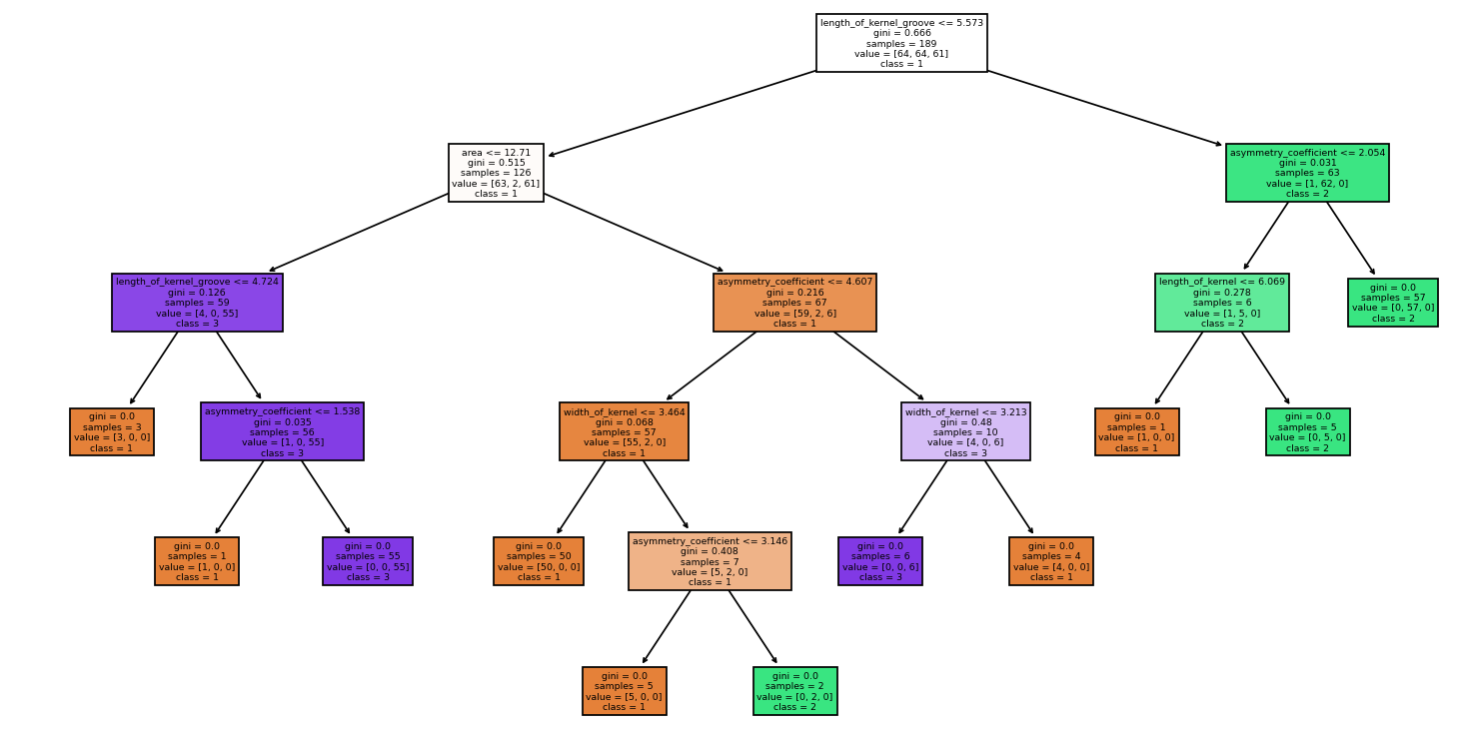
Visualization decision tree structure

- Experimental Results: The Decision Tree model achieves a certain accuracy percentage on the test set.
- Classification Report: Generate a classification report containing metrics such as precision, recall, and F1-score for each seed variety, providing insights into the model's performance across different classes.
- Visualization - Decision Tree Structure: Visualize the structure of the trained Decision Tree model, showing how the feature space is partitioned at each node to make classification decisions.
- Visualization - Decision Boundary: Plot the decision boundary of the Decision Tree classifier, which may not be easily visualized for high-dimensional data.
- Visualization - Confusion Matrix: Plot the confusion matrix to evaluate the model's performance, providing insights into the true positives, false positives, true negatives, and false negatives.

Please include codes of each experiment in Appendix.

3. Discussion and Conclusions
(1) Experiment 1 Logistic regression
Through this experiment, we have classified seeds using logistic regression and evaluated the model's performance. The results demonstrate that logistic regression performs well in seed classification tasks. However, further analysis is necessary to compare the performance of other classification algorithms and select the optimal one. The visualization of logistic regression with PCA provides insight into the data distribution and model's decision boundaries in a two-dimensional space, aiding in the interpretation of classification results.

(2) Experiment 2 Linear Discriminant Analysis (LDA)
Through this experiment, we have applied Linear Discriminant Analysis (LDA) to classify seeds based on their geometric attributes. The results demonstrate the effectiveness of LDA in distinguishing between different seed varieties. By analyzing the classification report and visualizing the decision boundary, we can gain insights into the model's performance and its ability to separate different classes in the feature space. LDA provides a powerful tool for dimensionality reduction and classification tasks, particularly in scenarios where class separability is well-defined. Further experimentation and comparison with other classification algorithms will enrich our understanding of seed classification methods and their practical applications.

(3) Experiment 3: Seed Classification Using K-Nearest Neighbors (KNN)
Through this experiment, we have applied the K-Nearest Neighbors (KNN) algorithm to classify seeds based on their geometric attributes. The results demonstrate the effectiveness of KNN in distinguishing between different seed varieties. By analyzing the classification report and visualizing the decision boundary, we can gain insights into the model's performance and its ability to separate different classes in the feature space. KNN provides a simple yet powerful approach to classification tasks, particularly in scenarios where the decision boundaries are nonlinear. Further experimentation and comparison with other classification algorithms will enrich our understanding of seed classification methods and their practical applications.

(4) Experiment 4: Seed Classification Using Naive Bayes
Through this experiment, we have applied the Naive Bayes algorithm to classify seeds based on their geometric attributes. The results demonstrate the effectiveness of Naive Bayes in distinguishing between different seed varieties. By analyzing the classification report and visualizing the decision boundary, we can gain insights into the model's performance and its ability to separate different classes in the feature space. Naive Bayes provides a simple yet powerful approach to classification tasks, particularly in scenarios where the feature independence assumption holds true. Further experimentation and comparison with other classification algorithms will enrich our understanding of seed classification methods and their practical applications.
(5) Experiment 5: Seed Classification Using Support Vector Machine (SVM)
Through this experiment, we have applied the Support Vector Machine (SVM) algorithm to classify seeds based on their geometric attributes. The results demonstrate the effectiveness of SVM in distinguishing between different seed varieties. By analyzing the classification report and visualizing the decision boundary, we can gain insights into the model's performance and its ability to separate different classes in the feature space. SVM provides a robust approach to classification tasks, particularly in scenarios where the classes are well-separated. Further experimentation and parameter tuning may enhance the model's performance and contribute to a deeper understanding of seed classification methods and their practical applications.

(6) Experiment 6: Seed Classification Using Decision Tree

Through this experiment, we have applied the Decision Tree algorithm to classify seeds based on their geometric attributes. The results demonstrate the effectiveness of Decision Tree in distinguishing between different seed varieties. By analyzing the classification report, decision tree structure, decision boundary, and confusion matrix, we can gain insights into the model's performance and understand how it makes classification decisions based on the input features. Decision Tree provides a transparent and interpretable approach to classification tasks, allowing users to understand and interpret the underlying decision-making process. Further experimentation and parameter tuning may improve the model's performance and contribute to a deeper understanding of seed classification methods and their practical applications.

Conclusion:
There are differences and similarities in the decision boundaries obtained by different methods, but in this experiment, KNN(K-Nearest Neighbors) has the highest accuracy of 95.238% and more natural decision boundaries. If possible, I will choose KNN as the model for seed screening next time

Appendix
Appendix A:
Logistic regression
import numpy as np
import pandas as pd
from sklearn.model_selection import train_test_split
from sklearn.linear_model import LogisticRegression
from sklearn.decomposition import PCA
from sklearn.metrics import accuracy_score, classification_report, confusion_matrix
import matplotlib.pyplot as plt
import seaborn as sns
# Define feature names
names = ['area', 'perimeter', 'compactness', 'length_of_kernel', 'width_of_kernel', 'asymmetry_coefficient', 'length_of_kernel_groove', 'target']
# Data Loading
dataset = pd.read_csv("E:\\Grade_two\\Machine_learninhg\\Task 2\\seeds\\seeds_dataset.txt", delimiter="\s+", names=names)
# Split Data
X = dataset.drop('target', axis=1)
y = dataset['target']
X_train, X_test, y_train, y_test = train_test_split(X, y, test_size=0.1, random_state=42)
# PCA for dimensionality reduction
pca = PCA(n_components=2) # Reduce to 2 dimensions
X_train_pca = pca.fit_transform(X_train)
X_test_pca = pca.transform(X_test)
# 假设我们已经有了PCA模型 pca
# 查看每个主成分是如何由原始特征构成的
print("第一主成分的构成: ", pca.components_[0])
print("第二主成分的构成: ", pca.components_[1])
# Model Training
logreg = LogisticRegression(max_iter=1000)
logreg.fit(X_train_pca, y_train)
# Model Evaluation
y_pred = logreg.predict(X_test_pca)
accuracy = accuracy_score(y_test, y_pred)
print("Accuracy:", accuracy)
print("\nClassification Report:\n")
print(classification_report(y_test, y_pred))
# Visualization - Confusion Matrix
conf_matrix = confusion_matrix(y_test, y_pred)
plt.figure(figsize=(8, 6))
sns.heatmap(conf_matrix, annot=True, fmt='d', cmap='Blues', cbar=False,
xticklabels=np.unique(y), yticklabels=np.unique(y))
plt.xlabel('Predicted labels')
plt.ylabel('True labels')
plt.title('Confusion Matrix')
plt.show()
# Visualization - Decision Boundary
x_min, x_max = X_test_pca[:, 0].min() - 1, X_test_pca[:, 0].max() + 1
y_min, y_max = X_test_pca[:, 1].min() - 1, X_test_pca[:, 1].max() + 1
xx, yy = np.meshgrid(np.arange(x_min, x_max, 0.01),
np.arange(y_min, y_max, 0.01))
# Predicting with the model
Z = logreg.predict(np.c_[xx.ravel(), yy.ravel()])
Z = Z.reshape(xx.shape)
# Plotting the decision boundary
plt.figure(figsize=(12, 8))
plt.contourf(xx, yy, Z, alpha=0.8, cmap=plt.cm.coolwarm)
plt.scatter(X_train_pca[:, 0], X_train_pca[:, 1], c=y_train, s=15, edgecolor='k', label='Training data')
plt.scatter(X_test_pca[:, 0], X_test_pca[:, 1], c=y_test, s=15, edgecolor='k', label='Test data')
plt.xlabel('Principal Component 1')
plt.ylabel('Principal Component 2')
plt.title('Decision Boundary with PCA-Reduced Logistic Regression')
plt.legend()
plt.show()

Appendix B:
LDA
import numpy as np
import pandas as pd
from sklearn.model_selection import train_test_split
from sklearn.discriminant_analysis import LinearDiscriminantAnalysis as LDA
from sklearn.decomposition import PCA
from sklearn.metrics import accuracy_score, classification_report, confusion_matrix
import matplotlib.pyplot as plt
import seaborn as sns
# Define feature names
names = ['area', 'perimeter', 'compactness', 'length_of_kernel', 'width_of_kernel', 'asymmetry_coefficient', 'length_of_kernel_groove', 'target']
# 1. Data Loading
dataset = pd.read_csv("E:\\Grade_two\\Machine_learninhg\\Task 2\\seeds\\seeds_dataset.txt", delimiter="\s+", names=names)
# 2. Data Preprocessing (if necessary)
# No preprocessing needed for this example
# 3. Split Data
X = dataset.drop('target', axis=1)
y = dataset['target']
X_train, X_test, y_train, y_test = train_test_split(X, y, test_size=0.1, random_state=42)
# 4. PCA for dimensionality reduction
pca = PCA(n_components=2) # Reduce to 2 dimensions
X_train_pca = pca.fit_transform(X_train)
X_test_pca = pca.transform(X_test)
# 查看每个主成分是如何由原始特征构成的
print("第一主成分的构成: ", pca.components_[0])
print("第二主成分的构成: ", pca.components_[1])
# 5. Model Training
lda = LDA()
lda.fit(X_train_pca, y_train)
# 6. Model Evaluation
y_pred = lda.predict(X_test_pca)
accuracy = accuracy_score(y_test, y_pred)
print("Accuracy:", accuracy)
print("\nClassification Report:\n")
print(classification_report(y_test, y_pred))
# 7. Visualization - Decision Boundary
x_min, x_max = X_test_pca[:, 0].min() - 1, X_test_pca[:, 0].max() + 1
y_min, y_max = X_test_pca[:, 1].min() - 1, X_test_pca[:, 1].max() + 1
xx, yy = np.meshgrid(np.arange(x_min, x_max, 0.01),
np.arange(y_min, y_max, 0.01))
# Predicting with the model
Z = lda.predict(np.c_[xx.ravel(), yy.ravel()])
Z = Z.reshape(xx.shape)
# Plotting the decision boundary
plt.figure(figsize=(12, 8))
plt.contourf(xx, yy, Z, alpha=0.8, cmap=plt.cm.coolwarm)
plt.scatter(X_train_pca[:, 0], X_train_pca[:, 1], c=y_train, s=15, edgecolor='k', label='Training data')
plt.scatter(X_test_pca[:, 0], X_test_pca[:, 1], c=y_test, s=15, edgecolor='k', label='Test data')
plt.xlabel('Principal Component 1')
plt.ylabel('Principal Component 2')
plt.title('Decision Boundary with LDA')
plt.legend()
plt.show()
# Visualization - Confusion Matrix
conf_matrix = confusion_matrix(y_test, y_pred)
plt.figure(figsize=(8, 6))
sns.heatmap(conf_matrix, annot=True, fmt='d', cmap='Blues', cbar=False,
xticklabels=np.unique(y), yticklabels=np.unique(y))
plt.xlabel('Predicted labels')
plt.ylabel('True labels')
plt.title('Confusion Matrix')
plt.show()

Appendix C:
KNN
import numpy as np
import pandas as pd
from sklearn.model_selection import train_test_split
from sklearn.discriminant_analysis import LinearDiscriminantAnalysis as LDA
from sklearn.decomposition import PCA
from sklearn.metrics import accuracy_score, classification_report, confusion_matrix
import matplotlib.pyplot as plt
import seaborn as sns
# Define feature names
names = ['area', 'perimeter', 'compactness', 'length_of_kernel', 'width_of_kernel', 'asymmetry_coefficient', 'length_of_kernel_groove', 'target']
# 1. Data Loading
dataset = pd.read_csv("E:\\Grade_two\\Machine_learninhg\\Task 2\\seeds\\seeds_dataset.txt", delimiter="\s+", names=names)
# 2. Data Preprocessing (if necessary)
# No preprocessing needed for this example
# 3. Split Data
X = dataset.drop('target', axis=1)
y = dataset['target']
X_train, X_test, y_train, y_test = train_test_split(X, y, test_size=0.1, random_state=42)
# 4. PCA for dimensionality reduction
pca = PCA(n_components=2) # Reduce to 2 dimensions
X_train_pca = pca.fit_transform(X_train)
X_test_pca = pca.transform(X_test)
# 查看每个主成分是如何由原始特征构成的
print("第一主成分的构成: ", pca.components_[0])
print("第二主成分的构成: ", pca.components_[1])
# 5. Model Training
lda = LDA()
lda.fit(X_train_pca, y_train)
# 6. Model Evaluation
y_pred = lda.predict(X_test_pca)
accuracy = accuracy_score(y_test, y_pred)
print("Accuracy:", accuracy)
print("\nClassification Report:\n")
print(classification_report(y_test, y_pred))
# 7. Visualization - Decision Boundary
x_min, x_max = X_test_pca[:, 0].min() - 1, X_test_pca[:, 0].max() + 1
y_min, y_max = X_test_pca[:, 1].min() - 1, X_test_pca[:, 1].max() + 1
xx, yy = np.meshgrid(np.arange(x_min, x_max, 0.01),
np.arange(y_min, y_max, 0.01))
# Predicting with the model
Z = lda.predict(np.c_[xx.ravel(), yy.ravel()])
Z = Z.reshape(xx.shape)
# Plotting the decision boundary
plt.figure(figsize=(12, 8))
plt.contourf(xx, yy, Z, alpha=0.8, cmap=plt.cm.coolwarm)
plt.scatter(X_train_pca[:, 0], X_train_pca[:, 1], c=y_train, s=15, edgecolor='k', label='Training data')
plt.scatter(X_test_pca[:, 0], X_test_pca[:, 1], c=y_test, s=15, edgecolor='k', label='Test data')
plt.xlabel('Principal Component 1')
plt.ylabel('Principal Component 2')
plt.title('Decision Boundary with LDA')
plt.legend()
plt.show()
# Visualization - Confusion Matrix
conf_matrix = confusion_matrix(y_test, y_pred)
plt.figure(figsize=(8, 6))
sns.heatmap(conf_matrix, annot=True, fmt='d', cmap='Blues', cbar=False,
xticklabels=np.unique(y), yticklabels=np.unique(y))
plt.xlabel('Predicted labels')
plt.ylabel('True labels')
plt.title('Confusion Matrix')
plt.show()

深圳大学学生实验报告用纸

Appendix D:
Naïve bayes
import numpy as np
import pandas as pd
from sklearn.model_selection import train_test_split
from sklearn.naive_bayes import GaussianNB
from sklearn.decomposition import PCA
from sklearn.metrics import accuracy_score, classification_report, confusion_matrix
import matplotlib.pyplot as plt
import seaborn as sns
# Define feature names
names = ['area', 'perimeter', 'compactness', 'length_of_kernel', 'width_of_kernel', 'asymmetry_coefficient', 'length_of_kernel_groove', 'target']
# 1. Data Loading
dataset = pd.read_csv("E:\\Grade_two\\Machine_learninhg\\Task 2\\seeds\\seeds_dataset.txt", delimiter="\s+", names=names)
# 2. Data Preprocessing (if necessary)
# No preprocessing needed for this example
# 3. Split Data
X = dataset.drop('target', axis=1)
y = dataset['target']
X_train, X_test, y_train, y_test = train_test_split(X, y, test_size=0.1, random_state=42)
# 4. PCA for dimensionality reduction
pca = PCA(n_components=2) # Reduce to 2 dimensions
X_train_pca = pca.fit_transform(X_train)
X_test_pca = pca.transform(X_test)
# 查看每个主成分是如何由原始特征构成的
print("第一主成分的构成: ", pca.components_[0])
print("第二主成分的构成: ", pca.components_[1])
# 5. Model Training
naive_bayes = GaussianNB()
naive_bayes.fit(X_train_pca, y_train)
# 6. Model Evaluation
y_pred = naive_bayes.predict(X_test_pca)
accuracy = accuracy_score(y_test, y_pred)
print("Accuracy:", accuracy)
print("\nClassification Report:\n")
print(classification_report(y_test, y_pred))
# Plot decision boundary
x_min, x_max = X_train_pca[:, 0].min() - 1, X_train_pca[:, 0].max() + 1
y_min, y_max = X_train_pca[:, 1].min() - 1, X_train_pca[:, 1].max() + 1
xx, yy = np.meshgrid(np.arange(x_min, x_max, 0.1),
np.arange(y_min, y_max, 0.1))
Z = naive_bayes.predict(np.c_[xx.ravel(), yy.ravel()])
Z = Z.reshape(xx.shape)
plt.figure(figsize=(12, 8))
plt.contourf(xx, yy, Z, alpha=0.4, cmap=plt.cm.coolwarm)
scatter = plt.scatter(X_train_pca[:, 0], X_train_pca[:, 1], c=y_train, s=50, cmap=plt.cm.rainbow)
plt.xlabel('Principal Component 1')
plt.ylabel('Principal Component 2')
plt.title('Decision Boundary of Naive Bayes after PCA')
plt.legend(*scatter.legend_elements(), title="Classes")
plt.show()
# Visualization - Confusion Matrix
conf_matrix = confusion_matrix(y_test, y_pred)
plt.figure(figsize=(8, 6))
sns.heatmap(conf_matrix, annot=True, fmt='d', cmap='Blues', cbar=False,
xticklabels=np.unique(y), yticklabels=np.unique(y))
plt.xlabel('Predicted labels')
plt.ylabel('True labels')
plt.title('Confusion Matrix')
plt.show()

Appendix E:
SVM
import numpy as np
import pandas as pd
from sklearn.model_selection import train_test_split
from sklearn.svm import SVC
from sklearn.metrics import accuracy_score, classification_report, confusion_matrix
from sklearn.decomposition import PCA
import matplotlib.pyplot as plt
from matplotlib.colors import ListedColormap
import seaborn as sns
# Define feature names
names = ['area', 'perimeter', 'compactness', 'length_of_kernel', 'width_of_kernel', 'asymmetry_coefficient',
'length_of_kernel_groove', 'target']
# 1. Data Loading
dataset = pd.read_csv("E:\\Grade_two\\Machine_learninhg\\Task 2\\seeds\\seeds_dataset.txt", delimiter="\s+", names=names)
# 2. Data Preprocessing (if necessary)
# No preprocessing needed for this example
# 3. Split Data
X = dataset.drop('target', axis=1)
y = dataset['target']
X_train, X_test, y_train, y_test = train_test_split(X, y, test_size=0.1, random_state=42)
# 4. Model Training
svm = SVC(kernel='linear', random_state=42)
svm.fit(X_train, y_train)
# 5. Model Evaluation
y_pred = svm.predict(X_test)
accuracy = accuracy_score(y_test, y_pred)
print("Accuracy:", accuracy)
print("\nClassification Report:\n")
print(classification_report(y_test, y_pred))
# 6. Dimensionality reduction for visualization (if necessary)
# For visualization purposes, we'll use PCA to project the data to 2D
pca = PCA(n_components=2)
X_train_pca = pca.fit_transform(X_train)
X_test_pca = pca.transform(X_test)
# 查看每个主成分是如何由原始特征构成的
print("第一主成分的构成: ", pca.components_[0])
print("第二主成分的构成: ", pca.components_[1])
# Train the SVM on the transformed data
svm.fit(X_train_pca, y_train)
# 7. Visualization - Decision Boundary
def plot_decision_boundary(X, y, classifier, test_idx=None, resolution=0.02):
# Setup marker generator and color map
markers = ('s', 'x', 'o', '^', 'v')
colors = ('red', 'blue', 'lightgreen', 'gray', 'cyan')
cmap = ListedColormap(colors[:len(np.unique(y))])
# Plot the decision surface
x1_min, x1_max = X[:, 0].min() - 1, X[:, 0].max() + 1
x2_min, x2_max = X[:, 1].min() - 1, X[:, 1].max() + 1
xx1, xx2 = np.meshgrid(np.arange(x1_min, x1_max, resolution),
np.arange(x2_min, x2_max, resolution))
Z = classifier.predict(np.array([xx1.ravel(), xx2.ravel()]).T)
Z = Z.reshape(xx1.shape)
plt.contourf(xx1, xx2, Z, alpha=0.8, cmap=cmap)
plt.xlim(xx1.min(), xx1.max())
plt.ylim(xx2.min(), xx2.max())
# Plot class samples
for idx, cl in enumerate(np.unique(y)):
plt.scatter(x=X[y == cl, 0], y=X[y == cl, 1],
alpha=0.8, c=cmap(idx),
marker=markers[idx], label=cl)
# 8. Plot the SVM decision boundary
plot_decision_boundary(X_train_pca, y_train, classifier=svm)
plt.xlabel('PCA Feature 1')
plt.ylabel('PCA Feature 2')
plt.legend(loc='upper left')
plt.title('SVM Decision Boundary')
plt.show()
# Visualization - Confusion Matrix
conf_matrix = confusion_matrix(y_test, y_pred)
plt.figure(figsize=(8, 6))
sns.heatmap(conf_matrix, annot=True, fmt='d', cmap='Blues', cbar=False,
xticklabels=np.unique(y), yticklabels=np.unique(y))
plt.xlabel('Predicted labels')
plt.ylabel('True labels')
plt.title('Confusion Matrix')
plt.show()

Appendix F:
Decision tree

import numpy as np
import pandas as pd
from sklearn.model_selection import train_test_split
from sklearn.tree import DecisionTreeClassifier
from sklearn.metrics import accuracy_score, classification_report, confusion_matrix
import matplotlib.pyplot as plt
from sklearn.tree import plot_tree
import seaborn as sns
# Define feature names
names = ['area', 'perimeter', 'compactness', 'length_of_kernel', 'width_of_kernel', 'asymmetry_coefficient',
'length_of_kernel_groove', 'target']
# 1. Data Loading
dataset = pd.read_csv("E:\\Grade_two\\Machine_learninhg\\Task 2\\seeds\\seeds_dataset.txt", delimiter="\s+", names=names)
# 2. Split Data
X = dataset.drop('target', axis=1)
y = dataset['target']
X_train, X_test, y_train, y_test = train_test_split(X, y, test_size=0.1, random_state=42)
# 3. Model Training
decision_tree = DecisionTreeClassifier()
decision_tree.fit(X_train, y_train)
# 4. Model Evaluation
y_pred = decision_tree.predict(X_test)
accuracy = accuracy_score(y_test, y_pred)
print("Accuracy:", accuracy)
print("\nClassification Report:")
print(classification_report(y_test, y_pred))
# 5. Visualization - Decision Boundary
# Decision boundaries are not easily visualized for high-dimensional data.
# Instead, we'll visualize the decision tree structure.
# 6. Visualization - Confusion Matrix
conf_matrix = confusion_matrix(y_test, y_pred)
plt.figure(figsize=(8, 6))
sns.heatmap(conf_matrix, annot=True, fmt='d', cmap='Blues', cbar=False,
xticklabels=np.unique(y), yticklabels=np.unique(y))
plt.xlabel('Predicted labels')
plt.ylabel('True labels')
plt.title('Confusion Matrix')
plt.show()
# 7. Visualization - Decision Tree Structure
plt.figure(figsize=(15, 10))
plot_tree(decision_tree, feature_names=X.columns, class_names=np.unique(y).astype(str), filled=True)
plt.show()

指导教师批阅意见：

成绩评定：

指导教师签字：
年 月 日
备注：
注：1、报告内的项目或内容设置，可根据实际情况加以调整和补充。
2、教师批改学生实验报告时间应在学生提交实验报告时间后10日内。

