深 圳 大 学 实 验 报 告

课程编号： 2801000049

课程名称： 机器学习

实验项目名称：Explore the different effects of K-means and DBScan in clustering

学院： 电子与信息工程学院

专业： 电子与信息工程

指导教师： 麦晓春

报告人：陈应权 学号：2022280297 班级： 22文华班

实验时间： 2024年5月24日——2024年6月7日

实验报告提交时间： 2024年6月1日

教务部制
1. Experimental Purposes and Requirements
- Understand and learn the characteristics of datasets:
By loading five different datasets, including noisy circles, noisy moons, blobs, anisotropic data, and no-structure data, learners can understand the characteristics and structures of different types of data.

- Master data visualization techniques:
By drawing scatterplots to visualize the datasets, learners can intuitively observe the data distribution and features, thus gaining a better understanding of the data.

- Understand and apply K-means clustering algorithm:
By applying the K-means clustering algorithm separately on all datasets, learners can grasp the principles and applications of the algorithm, and evaluate its effectiveness through visualizing the clustering results.

- Understand and apply DBSCAN clustering algorithm:
By applying the DBSCAN clustering algorithm separately on all datasets and adjusting the parameter eps to fit different datasets, learners can comprehend the principles of the algorithm, methods for parameter adjustment, its applicability to different datasets, and evaluate its effectiveness through visualizing the clustering results.

2. Experiment Contents and Process
2.1 Experiment 1 Explore the different effects of K-means and DBScan in clustering
(1) Experimental Contents/Introduction

In this experiment, we aim to explore and analyze the characteristics of different datasets and evaluate the performance of two popular clustering algorithms: K-means and DBSCAN. The experiment consists of the following key components:

- Dataset Loading:
We start by loading five distinct datasets: noisy circles, noisy moons, blobs, anisotropic data, and no-structure data. Each dataset exhibits unique characteristics and challenges for clustering algorithms.

- Data Visualization:
To gain insights into the structure and distribution of the datasets, we employ data visualization techniques such as scatterplots. Visualizing the data helps us understand its inherent patterns and complexities.

- K-means Clustering:
We apply the K-means clustering algorithm to each dataset separately. By clustering the data into predetermined clusters, we aim to identify meaningful groupings and assess the algorithm's performance.

- DBSCAN Clustering:
Next, we utilize the DBSCAN clustering algorithm on each dataset individually. DBSCAN is known for its ability to identify clusters of arbitrary shapes and handle noise effectively. We adjust the parameter eps to adapt to the varying densities and structures present in different datasets.

- Evaluation and Analysis:
Finally, we visualize the clustering results obtained from both K-means and DBSCAN algorithms. Through visual inspection and possibly quantitative evaluation metrics, we analyze the effectiveness of each algorithm in clustering the datasets.

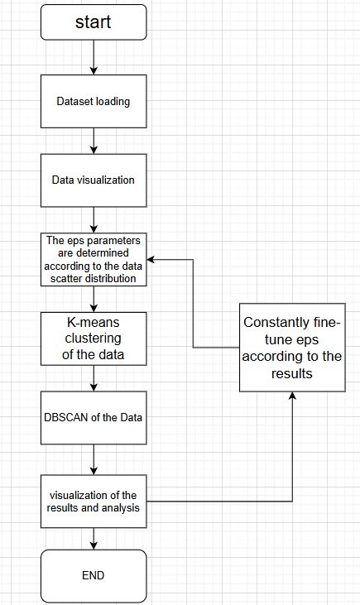
Experimental process flow chart

(2) Methods
Method details, experimental techniques, etc.
In this section, we detail the methods employed in our experiments, including experimental techniques and procedures.
- Data Loading: We load five datasets from external text files using the load_dataset function. These datasets include noisy_circles.txt, noisy_moons.txt, blobs.txt, aniso.txt, and no_structure.txt.
- Visualization: We visualize the loaded datasets using scatterplots generated by the visualize_dataset function. This step helps us understand the structure and distribution of data points in each dataset.
- K-means Clustering: We apply K-means clustering separately to each dataset using the kmeans_clustering function. K-means clustering partitions the data into a predetermined number of clusters based on similarity between data points. We experiment with different numbers of clusters for each dataset.
- DBSCAN Clustering: DBSCAN (Density-Based Spatial Clustering of Applications with Noise) clustering is performed on each dataset using the dbscan_clustering function. DBSCAN is a density-based clustering algorithm that identifies clusters based on the density of data points. We adjust the eps parameter for each dataset to control the neighborhood size for cluster identification.
- Parameter Tuning: For both K-means and DBSCAN, we adjust parameters such as the number of clusters (n_clusters for K-means) and the neighborhood size (eps for DBSCAN) to explore their effects on clustering results.
- Visualization of Results: We visualize the clustering results obtained from both K-means and DBSCAN methods for each dataset. This allows us to assess the quality of clustering and compare the performance of the two algorithms.
Through these methods, we aim to gain insights into the behavior and effectiveness of K-means and DBSCAN clustering algorithms on different types of datasets, thereby facilitating a comparative analysis of their performance.

(3) Data Collection, Preprocessing and Analysis

This section outlines the steps involved in data collection, preprocessing, and analysis for our clustering experiments.
- Data Collection: We collected our datasets from external text files. These datasets include noisy_circles.txt, noisy_moons.txt, blobs.txt, aniso.txt, and no_structure.txt. Each dataset contains two-dimensional data points.
- Data Preprocessing: Before clustering, we preprocess the datasets to ensure consistency and compatibility with the algorithms. This involves loading the data using the load_dataset function and standardizing it using StandardScaler to ensure that all features have a mean of 0 and a standard deviation of 1. Standardization helps in improving the performance of clustering algorithms.
- Data Analysis: After preprocessing, we analyze the datasets by visualizing them using scatterplots generated by the visualize_dataset function. Visualization provides insights into the distribution and structure of the data, which helps in selecting appropriate clustering algorithms and parameters.
- Clustering Algorithm Selection: Based on the characteristics of the datasets observed during analysis, we choose two clustering algorithms: K-means and DBSCAN. K-means is chosen for its simplicity and efficiency, while DBSCAN is selected for its ability to handle datasets with irregular shapes and varying densities.
- Parameter Tuning: For K-means clustering, we experiment with different numbers of clusters (n_clusters) for each dataset. For DBSCAN clustering, we adjust the eps parameter, which determines the maximum distance between two samples for them to be considered as in the same neighborhood, based on the dataset's characteristics.

Through these steps, we ensure that our datasets are properly prepared for clustering analysis, and we select appropriate algorithms and parameters to perform meaningful clustering. This sets the stage for further experimentation and evaluation of the clustering results.
(4) Experimental Results and Analysis

- The scatterplots of datasets:
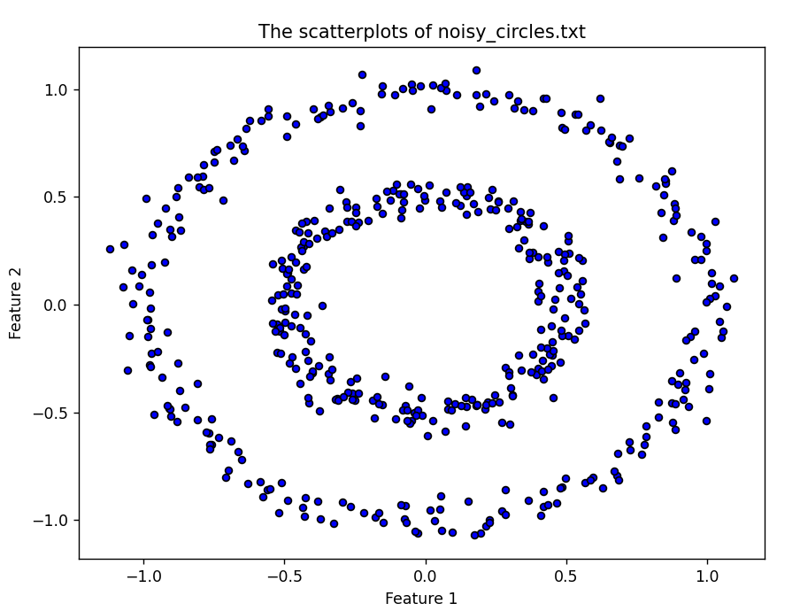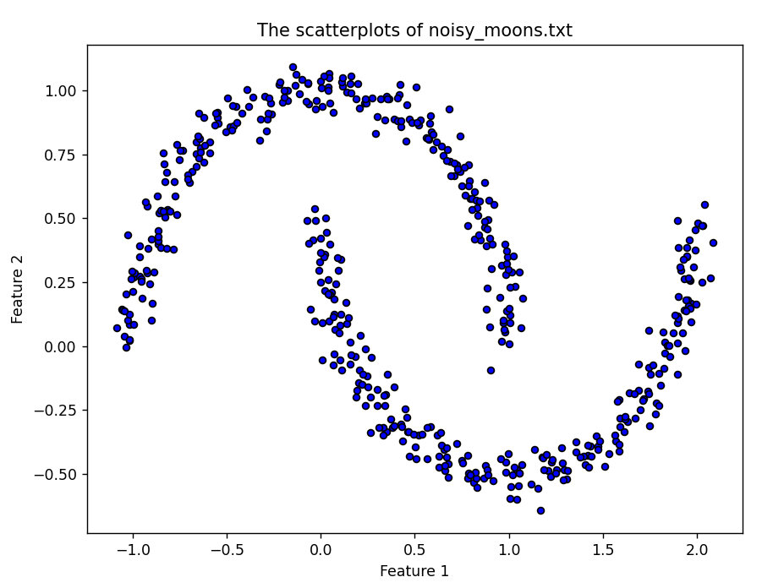
The scatterplots of noisy_circles The scatterplots of noisy_moons
Circular scatter distribution: It can be seen that there should be two categories, the inner circle one, the outer circle one.
Lunar scatter distribution: It can also be seen that there should be two categories, and the two moons are one category each

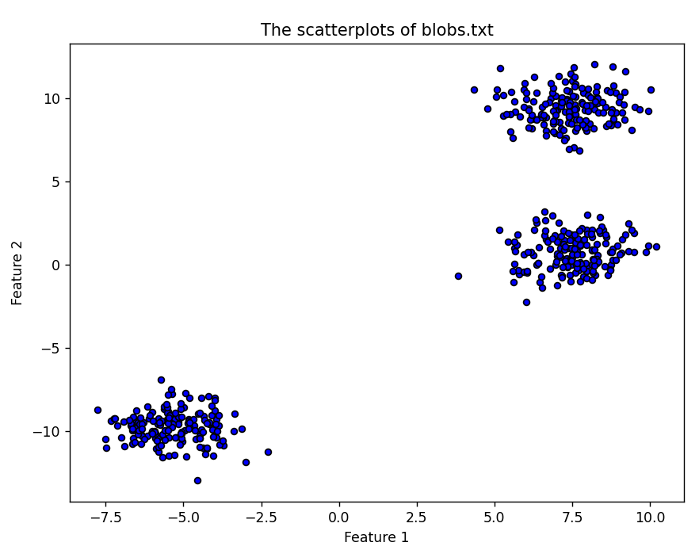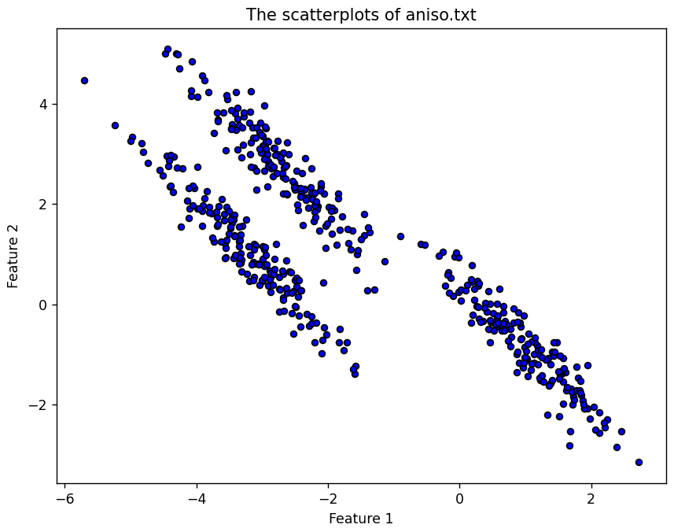
The scatterplots of blobs The scatterplots of aniso
Blobs scatter distribution: it can be seen that there are three types of blobs, separated by three clusters for each different category.

Aniso scatter distribution: It can be seen that there should also be three categories, three adjacent bars corresponding to different three categories
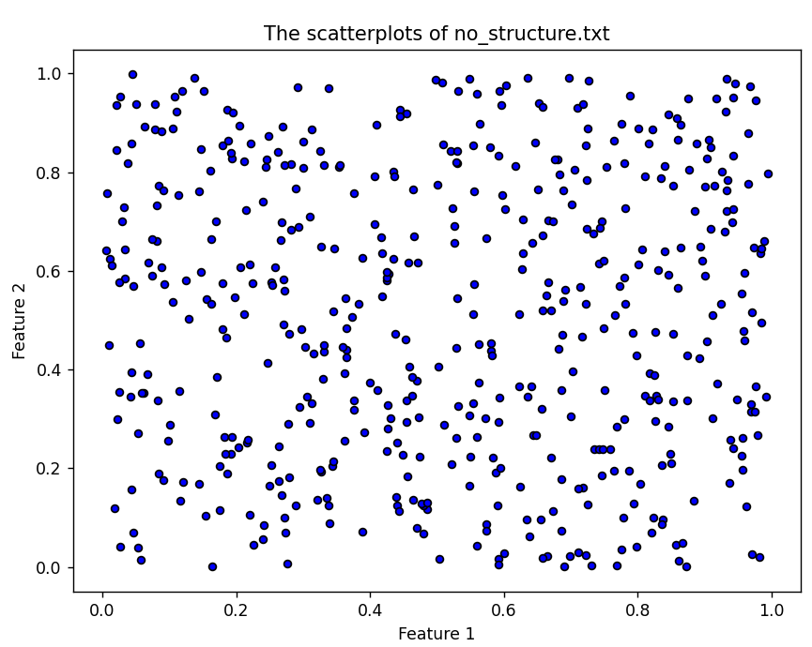
The scatterplots of no_structure
Evenly distributed scatter chart: Because it is too uniform, there is no obvious category, just like a scattering of sand.

By observing the distribution of the scatter plot, we can roughly know the distribution of the scatter and how many classes should be divided for KNN clustering. For example, there should be two categories in The scatterplots of noisy circles.

- K_means_clustering results
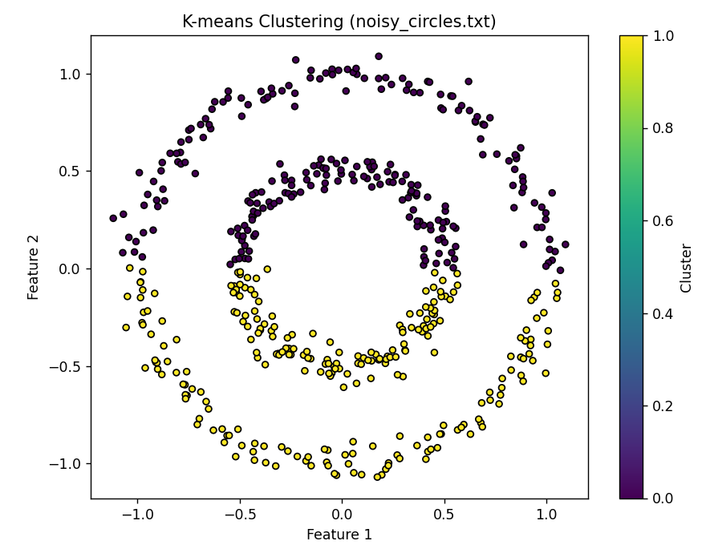
K-means Clustering for noisy_circle

It can be found that k-means clustering does not achieve clustering well, it divides the top half into one class, and the bottom half into another class
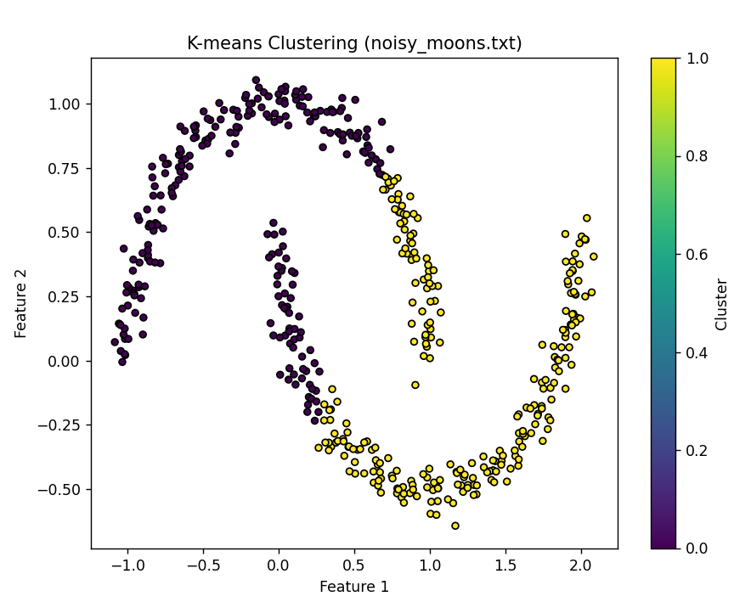
K-means Clustering for noisy_moons

It can be found that k-means clustering does not achieve clustering well, it divides the upper left half into one class, and the lower right half into another class

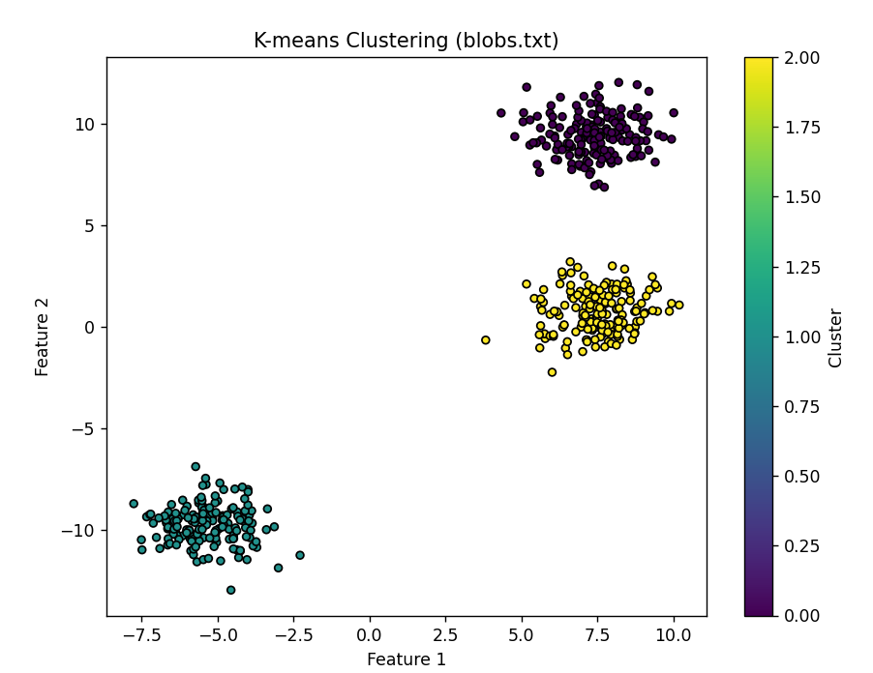
K-means Clustering for noisy_blobs

Blobs scatter distribution: As can be seen, k-means divides these scatter points into three categories well, even if several noise points are far from the class center, it still assigns them to the nearest class center.The noise is not recognized very well.

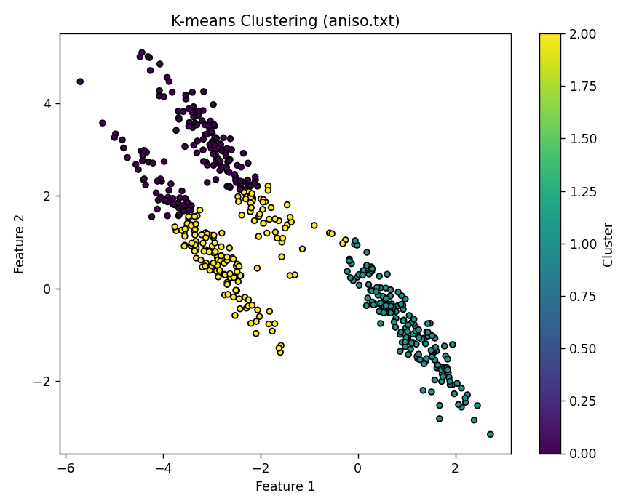
K-means Clustering for noisy_aniso

aniso scatter distribution: It can be seen that k-means is not able to classify correctly.
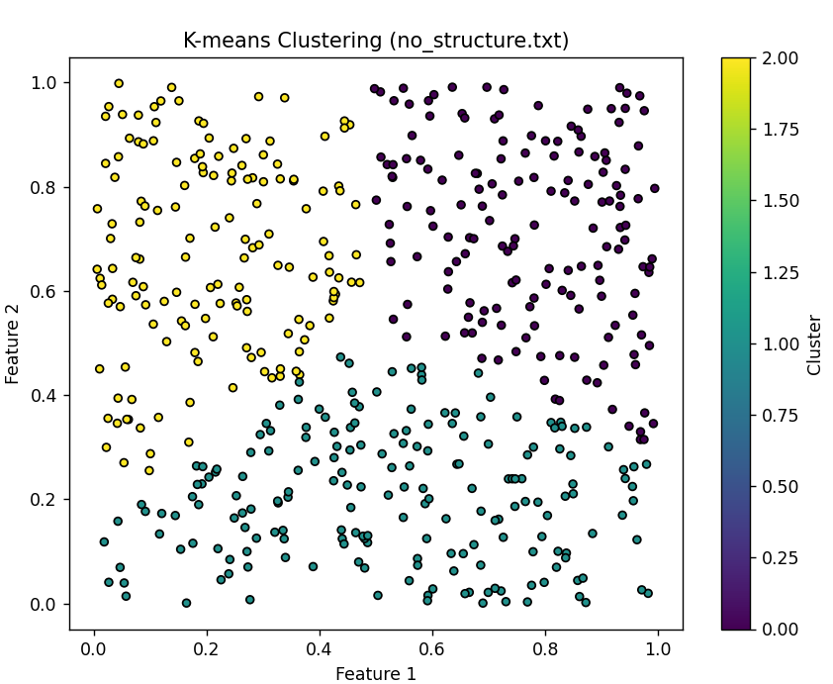
k-means Clustering for noisy_no_structure

Uniform scatter distribution: As can be seen, even if the scatter does not have obvious category characteristics, since the number of classes entered into the classification is 3, k-means divides it into three parts

- The dbscan_clustering results
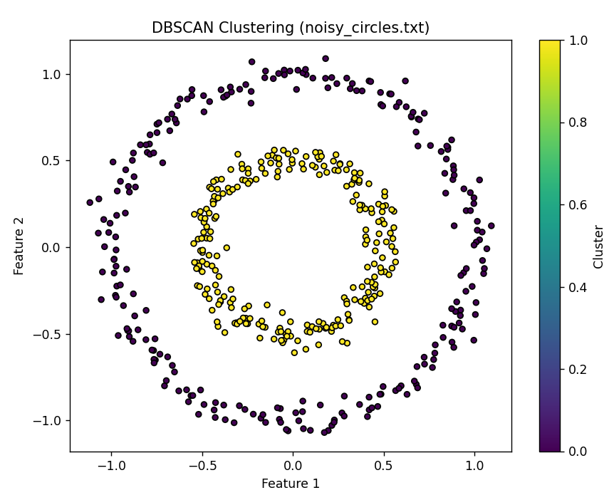
DBSCAN Clustering for noisy_circle with eps=0.2

Circular ring-scatter distribution: You can see that DBSCAN correctly divides them into two categories.

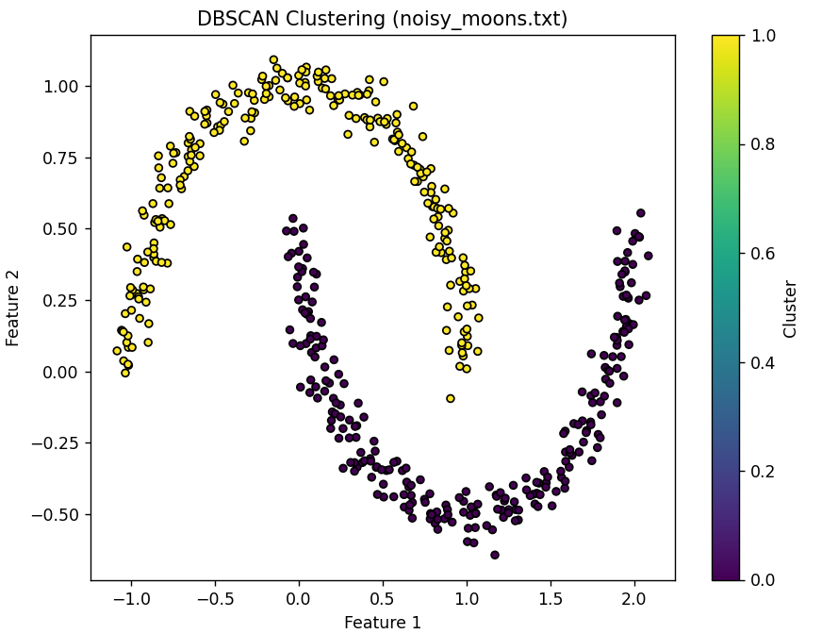
DBSCAN Clustering for noisy_moons with eps=0.3

Moon-shaped scatter distributions :DBSCAN does a good job of dividing them into two categories.
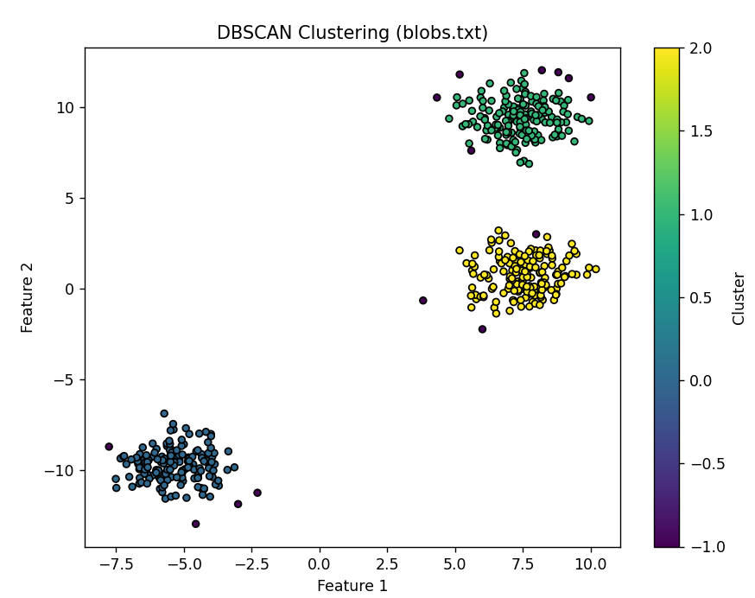
DBSCAN Clustering for noisy_blobs with eps=0.6

blobs Scatter distribution :DBSCAN handles classification well, and unlike k-means, DBSCAN is also able to find outliers and noise.

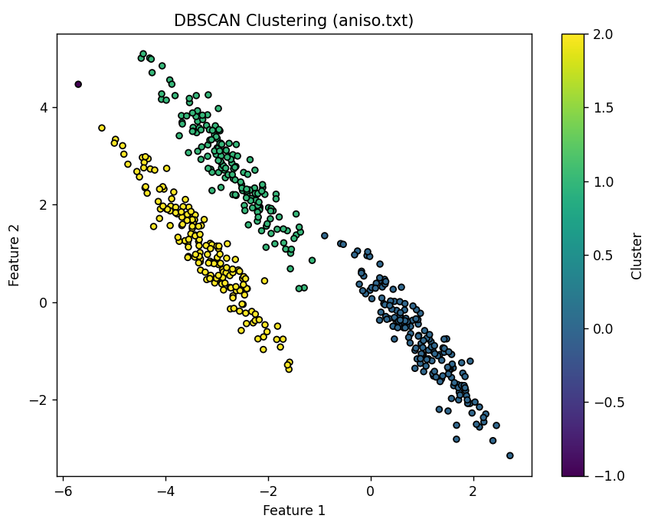
DBSCAN Clustering for noisy_aniso with eps=0.5

aniso Scatter distribution :DBSCAN handles classification well, and unlike k-means, DBSCAN is also able to find outliers and noise.

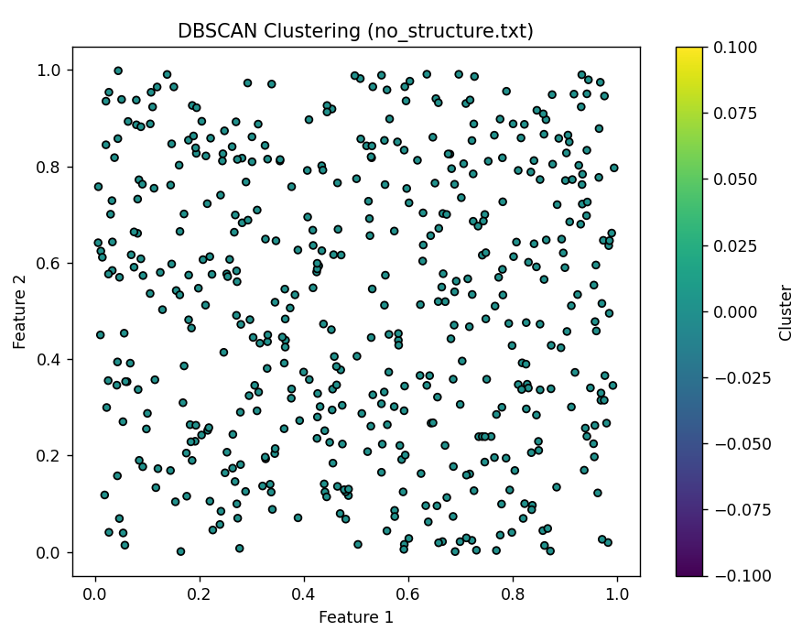
DBSCAN Clustering for noisy_no_structure with eps=0.2

Uniform scatter distribution without structure :DBSCAN cannot solve this kind of problem, basically because DBSCAB is classified according to density, the density of uniform distribution is more uniform, there is no special category structure, DBS will classify it into the same category. Even if the eps is as small as 0.06, different categories will appear, but this is meaningless. As shown below

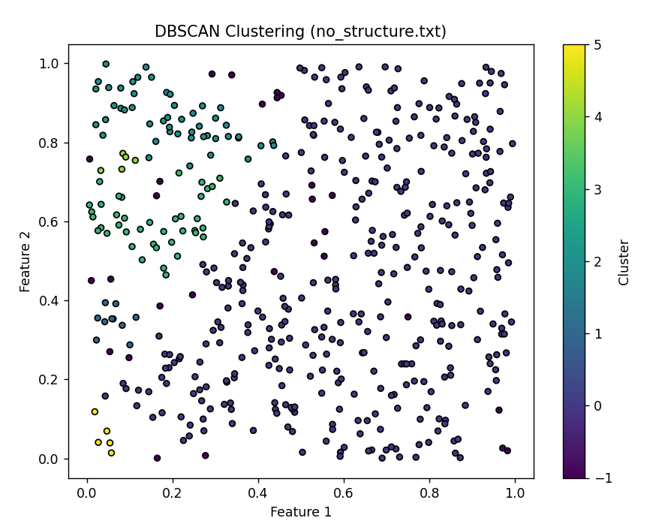
DBSCAN Clustering for noisy_no_structure with eps=0.06

3. Discussion and Conclusions
3.1 Discussion
In this experiment, we explored and analyzed the application effects of the K-means and DBSCAN clustering algorithms on different datasets. Through the experiment, we found that each algorithm has its unique strengths and limitations.
- The K-means clustering algorithm performed well on the blobs and no_structure dataset, correctly categorizing the data points into three categories. Despite some noise points being far from the class centers, the algorithm still assigned them to the nearest class centers. However, when dealing with noisy_circle, noisy_moons, and noisy_aniso datasets, the K-means algorithm failed to identify the true categories of the data points. The main reason is that the K-means algorithm relies on the concept of class centers and its performance is limited when dealing with non-spherical or non-uniformly distributed datasets.
- The DBSCAN clustering algorithm showed excellent performance when dealing with datasets of arbitrary shapes and densities. On the noisy_circle, noisy_moons, and noisy_blobs datasets, DBSCAN was able to correctly identify the categories of the data points and effectively handle noise and outliers. The advantage of DBSCAN is that it does not require a predetermined number of categories and can adapt to variations in the local density of the data. However, when dealing with the noisy_no_structure dataset, due to the uniform distribution of data points without obvious category structures, DBSCAN could not effectively perform clustering.
3.2 Conclusions
In summary, we can draw the following conclusions from the experiment:
- The K-means algorithm is suitable for spherical or uniformly distributed datasets and requires a predetermined number of categories. It is simple and efficient but may not perform well when dealing with complex shapes or datasets with noise.
- The DBSCAN algorithm is suitable for datasets with arbitrary shapes and densities, especially when the dataset contains noise and outliers. It does not require a predetermined number of categories and can identify local density variations in the data. However, it may not effectively cluster when dealing with uniformly distributed datasets without obvious structural features.
- In practical applications, choosing the appropriate clustering algorithm requires considering the characteristics of the dataset and the goals of clustering. For different datasets, it may be necessary to try multiple algorithms and adjust parameters to achieve the best clustering results.
- The selection of clustering algorithms and parameter tuning is crucial for the quality of clustering results. Through visualization and quantitative evaluation, we can better understand the performance of different algorithms on specific datasets and make appropriate choices.
Through this experiment, we have not only mastered the principles and applications of the K-means and DBSCAN clustering algorithms but also learned how to choose the appropriate clustering method based on the characteristics of the dataset and perform effective parameter adjustment and result evaluation.

Appendix
Appendix A: Clustering
import numpy as np
import matplotlib.pyplot as plt
from sklearn.datasets import make_moons, make_circles, make_blobs
from sklearn.cluster import KMeans, DBSCAN
from sklearn.preprocessing import StandardScaler
# Function to load dataset from file
def load_dataset(filename):
data = np.loadtxt(filename)
return data
# Function to visualize scatterplots
def visualize_dataset(X, title):
plt.figure(figsize=(8, 6))
plt.scatter(X[:, 0], X[:, 1], c='b', s=20, edgecolor='k')
plt.title("The scatterplots of "+ title)
plt.xlabel('Feature 1')
plt.ylabel('Feature 2')
plt.show()
# Function to apply K-means clustering and visualize results
def kmeans_clustering(X, n_clusters, title):
kmeans = KMeans(n_clusters=n_clusters,n_init=10)
kmeans.fit(X)
labels = kmeans.labels_
plt.figure(figsize=(8, 6))
plt.scatter(X[:, 0], X[:, 1], c=labels, s=20, cmap='viridis', edgecolor='k')
plt.title(f'K-means Clustering ({title})')
plt.xlabel('Feature 1')
plt.ylabel('Feature 2')
plt.colorbar(label='Cluster')
plt.show()
# Function to apply DBSCAN clustering and visualize results
def dbscan_clustering(X, eps, title):
dbscan = DBSCAN(eps=eps)
dbscan.fit(X)
labels = dbscan.labels_
plt.figure(figsize=(8, 6))
plt.scatter(X[:, 0], X[:, 1], c=labels, s=20, cmap='viridis', edgecolor='k')
plt.title(f'DBSCAN Clustering ({title})')
plt.xlabel('Feature 1')
plt.ylabel('Feature 2')
plt.colorbar(label='Cluster')
plt.show()
# Load datasets
datasets = ['noisy_circles.txt', 'noisy_moons.txt', 'blobs.txt', 'aniso.txt', 'no_structure.txt']
X_datasets = []
for dataset in datasets:
X = load_dataset(dataset)
X_datasets.append(X)
# Visualize datasets
for i, X in enumerate(X_datasets):
visualize_dataset(X, datasets[i])
# Apply K-means clustering and visualize results
n_clusters = [2, 2, 3, 3, 3]
for i, X in enumerate(X_datasets):
kmeans_clustering(X, n_clusters[i], datasets[i])
# Apply DBSCAN clustering and visualize results with different eps values
eps_values = [0.2, 0.3, 0.6, 0.5, 0.2 ] # Adjust eps values for each dataset
for i, X in enumerate(X_datasets):
dbscan_clustering(X, eps_values[i], datasets[i])

深圳大学学生实验报告用纸

指导教师批阅意见：

成绩评定：

指导教师签字：
年 月 日
备注：
注：1、报告内的项目或内容设置，可根据实际情况加以调整和补充。
2、教师批改学生实验报告时间应在学生提交实验报告时间后10日内。

