深 圳 大 学 实 验 报 告

课程编号： 2801000049

课程名称： 机器学习

实验项目名称：Non-negative matrix decomposition clustering

学院： 电子与信息工程学院

专业： 电子信息工程

指导教师： 麦晓春

报告人：陈应权 学号：2022280297 班级：22文华

实验时间： 2024年6月14日——2024年6月28日

实验报告提交时间： 2024年6月28日

教务部制
1. Experimental Purposes and Requirements
- Experimental Purposes:
The purpose of this experiment is to explore the clustering of grain varieties using Non-Negative Matrix Factorization (NMF) and evaluate the clustering quality using Silhouette coefficients. The experiment aims to achieve the following requirements.

- Experimental Requirements:
- Data Loading and Preparation:
  - Load the dataset named seeds.csv, ensuring it contains sufficient feature data and information about grain varieties.
  - Extract and transform the data into a format suitable for machine learning algorithms.
- Non-Negative Matrix Factorization (NMF):
  - Utilize sklearn.decomposition.NMF for matrix factorization.
  - Set parameters for the factorization process including rank and number of iterations.
  - Perform multiple runs of NMF to assess stability and consistency of results.
- Clustering Analysis:
  - Apply the components obtained from NMF (e.g., matrix W) for clustering analysis.
  - Evaluate clustering results primarily using silhouette scores to assess clustering quality.
- Result Interpretation and Visualization:
  - Create a contingency table to show how different grain varieties distribute across clusters.
  - Use visualization tools such as matplotlib to plot a line graph showing silhouette scores over iterations, annotating the best score corresponding to the optimal iteration.
- Experiment Documentation and Analysis:
  - Transform the clustering results corresponding to the best Silhouette score into a DataFrame.
  - Create a crosstabulation (using pd.crosstab) that shows how each grain variety is distributed across the clusters identified by the best clustering result.
Through these experimental steps, the goal is to analyze how grain varieties cluster based on their features, leveraging NMF for dimensionality reduction and clustering, and using Silhouette coefficients to quantify and compare clustering quality across multiple iterations. This experiment provides insights into the clustering patterns of grain varieties, facilitating further exploration and understanding in agricultural and biological research contexts.

2. Experiment Contents and Process
2.1 Experiment 1
(1) Experimental Contents/Introduction
Introduction
The experiment focuses on exploring the clustering patterns of different grain varieties using Non-Negative Matrix Factorization (NMF) coupled with clustering analysis. Grain varieties such as Canadian wheat, Kama wheat, and Rosa wheat are analyzed based on their feature data to understand how they naturally group together.
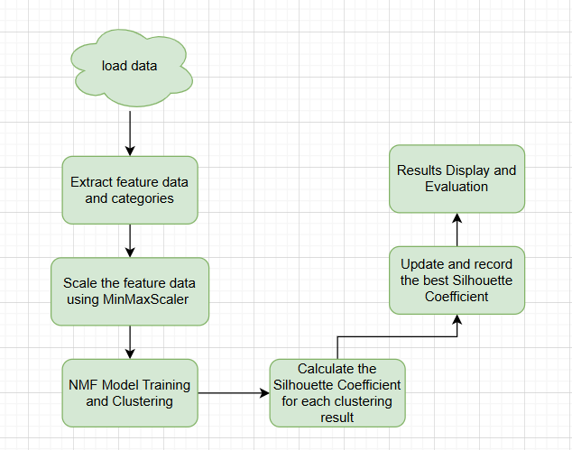
The flowchart of the experiment content
Flowchart Description
- Data Loading and Preprocessing
  - Load the dataset from a CSV file.
  - Extract feature data and categories (assuming the last column is the category).
  - Scale the feature data using MinMaxScaler to ensure non-negative values.
- NMF Model Training and Clustering
  - Initialize variables to store the best results and scores.
  - For each iteration:
    - Fit the data using the NMF model and compute the transformed W matrix.
    - Determine the most relevant NMF component (topic) for each sample based on the maximum value in the W matrix.
    - Calculate the Silhouette Coefficient for each clustering result.
    - Update and record the best Silhouette Coefficient and corresponding clustering result.
- Results Display and Evaluation
  - Print the Silhouette Coefficient for each run.
  - Plot the Silhouette Coefficients for different NMF initializations and annotate the best score.
  - Create a cross-tabulation of varieties and the best clustering results.
  - Print the best Silhouette Coefficient as the final evaluation metric.

(2) Methods
Method details, experimental techniques, etc.
- Dataset Loading and Preparation:
- Load the dataset seeds.csv which includes information about grain varieties and their features.
- Extract grain variety labels and feature data, transforming the feature data into a numpy array format suitable for machine learning.
- Non-Negative Matrix Factorization (NMF):
- Implement NMF using sklearn.decomposition.NMF to decompose the feature matrix into non-negative factors.
- Configure NMF with a fixed rank of 3 to extract latent features that represent the underlying structure of the grain varieties dataset.
- Repeat the NMF process 20 times (repeat_times) to assess variability in clustering results and ensure robustness.
- Clustering Evaluation:
- Utilize Silhouette coefficients as a measure of clustering quality.
- Calculate Silhouette scores for each clustering result derived from NMF.
- Plot a line graph to visualize how Silhouette scores vary across different iterations of NMF, identifying and labeling the iteration with the highest score as the optimal clustering result.
- Data Visualization and Analysis:
- Transform the clustering results corresponding to the best Silhouette score into a DataFrame.
- Use pd.crosstab to create a contingency table that illustrates how grain varieties are distributed across the identified clusters.
- Interpret the crosstab results to gain insights into the natural groupings of grain varieties based on their features.

(3) Data Collection, Preprocessing and Analysis
- Data Collection
The experiment utilizes the dataset seeds.csv, which contains comprehensive information about different grain varieties. Each entry in the dataset includes numeric features that characterize various attributes of the grains.
- Data Preprocessing
- Loading the Dataset:
  - Load the dataset seeds.csv using pandas to facilitate data manipulation and analysis.
- Feature Extraction:
  - Extract the grain variety labels and feature data from the dataset.
  - Ensure the data is in a structured format suitable for subsequent machine learning tasks.
- Transforming Data into Numpy Array:
  - Convert the extracted feature data into a numpy array. This transformation is essential for compatibility with machine learning libraries like scikit-learn.

- Data Analysis
- Non-Negative Matrix Factorization (NMF):
  - Apply NMF to decompose the feature matrix into two non-negative matrices (W and H).
  - Set the rank of NMF to 3, aiming to identify latent features that represent underlying patterns in the grain varieties dataset.
- Multiple Iterations of NMF:
  - Perform NMF multiple times (specified by repeat_times) to explore variability in clustering results.
  - This iterative process helps assess the stability and consistency of clustering patterns derived from NMF.
- Clustering Evaluation:
  - Evaluate clustering quality using Silhouette coefficients.
  - Calculate Silhouette scores for each clustering result obtained from NMF.
  - Silhouette scores provide insights into the compactness and separation of clusters, aiding in the identification of the optimal clustering configuration.
- Visualization and Interpretation:
  - Visualize the variation in Silhouette scores across different iterations of NMF using matplotlib.
  - Identify and annotate the iteration with the highest Silhouette score as the best clustering result.
  - Transform the clustering results corresponding to the best Silhouette score into a structured DataFrame.

- Crosstabulation:
  - Use pd.crosstab to create a contingency table that showcases how grain varieties are distributed across clusters identified by the best NMF clustering result.
  - Analyze the crosstab results to interpret and understand the natural groupings of grain varieties based on their feature similarities.

(4) Experimental Results and Analysis

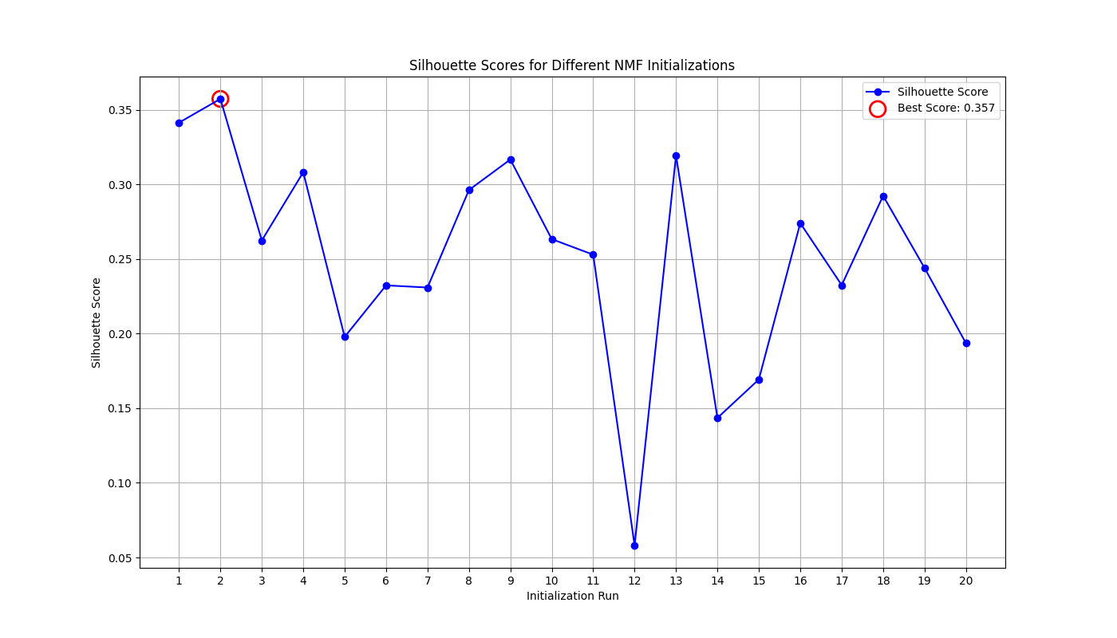
Silhouette Scores for NMF Clustering

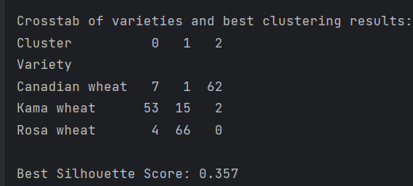
The varieties and the best clustering results
Variety Cluster | 0 | 1 | 2
Canadian wheat | 7 | 1 | 62
Kama wheat | 53 | 15 | 2
Rosa wheat | 4 | 66 | 0
The results show the distribution of different grain varieties in clusters and the variation of Silhouette scores with NMF iterations. Here is a specific analysis of the results:
- Silhouette Scores: Silhouette scores, which range from -1 to 1, measure the compactness and separation of clusters. A higher Silhouette score indicates better clustering results. In the experiment, a line graph of Silhouette scores varying with the number of iterations is plotted to identify the iteration with the highest score, representing the optimal clustering result.
- Cluster Distribution: According to the provided table, we can see the distribution of different grain varieties in different clusters. For example, Canadian wheat is distributed with 62 samples in cluster 2 and 7 samples in cluster 0; Kama wheat has 53 samples in cluster 0 and 15 samples in cluster 1; For rose, the classification of the largest sample is in cluster 1
- Cluster Stability Assessment: By performing NMF 20 times, we assessed the stability of the clustering results. Although Silhouette scores fluctuated across different iterations, the Silhouette score of the optimal clustering result remained at a high level, indicating that the clustering results are relatively stable.

Please include codes of each experiment in Appendix.
3. Discussion and Conclusions
Discussion
- Application of NMF:
  - Non-Negative Matrix Factorization, as an effective dimensionality reduction and clustering method, successfully revealed the intrinsic structure among grain varieties in this experiment. Through NMF, we were able to transform high-dimensional feature data into low-dimensional latent features, which helps to better understand the natural grouping of grain varieties.
- Importance of Silhouette Scores:
  - Silhouette scores played a crucial role as an important measure of clustering quality in this experiment. By observing the changes in Silhouette scores, we were able to identify the optimal clustering configuration, resulting in more accurate clustering results.
- Interpretation of Clustering Results:
  - The distribution of clustering results provides us with an intuitive understanding of the similarity in features among grain varieties. For example, the high concentration of certain varieties in specific clusters may indicate a high degree of similarity in certain features.

Conclusion
This experiment successfully clustered grain varieties through Non-Negative Matrix Factorization (NMF) and evaluated the clustering through Silhouette scores. The results indicate that NMF is an effective clustering method that can reveal the intrinsic connections between grain varieties. By multiple iterations and evaluation of Silhouette scores, we determined the optimal clustering results, providing valuable insights for further agricultural and biological research.

Appendix
Appendix A: non-negative matrix decomposition
import pandas as pd
import numpy as np
import matplotlib.pyplot as plt
from sklearn.decomposition import NMF
from sklearn.metrics import silhouette_score
from sklearn.preprocessing import MinMaxScaler
# Step 1: Load the dataset
df = pd.read_csv(r"E:\Grade_two\Machine_learninhg\Task 4 - matrix factorization\seeds.csv")
# Step 2: Extract the grain variety and the feature data
varieties = df.iloc[:, -1] # Assuming the last column is the variety
features = df.iloc[:, :-1].values # All columns except the last one
# Step 3: Scale the feature data to be non-negative
scaler = MinMaxScaler()
features_scaled = scaler.fit_transform(features)
# Initialize variables for storing the best results
best_silhouette_score = -1
best_clustering_result = None
silhouette_scores = []
all_clustering_results = []
# Step 4: Run NMF and calculate Silhouette coefficients
for i in range(20):
nmf = NMF(n_components=3, init='random', random_state=i, max_iter=1000, beta_loss="frobenius")
W = nmf.fit_transform(features_scaled)
# Find the most relevant NMF component to which each sample belongs
cluster_labels = np.argmax(W, axis=1)
# Calculate Silhouette coefficient
silhouette_avg = silhouette_score(features_scaled, cluster_labels)
silhouette_scores.append(silhouette_avg)
all_clustering_results.append(cluster_labels)
# Update best score and clustering result
if silhouette_avg > best_silhouette_score:
best_silhouette_score = silhouette_avg
best_clustering_result = cluster_labels
# Print the silhouette scores
print("\nSilhouette scores for each run:")
for idx, score in enumerate(silhouette_scores):
print(f"Run {idx + 1}: {score:.3f}")
# Step 5: Plot Silhouette scores
plt.figure(figsize=(14, 8))
plt.plot(range(1, 21), silhouette_scores, marker='o', linestyle='-', color='b', label='Silhouette Score')
plt.title('Silhouette Scores for Different NMF Initializations')
plt.xlabel('Initialization Run')
plt.ylabel('Silhouette Score')
plt.scatter(np.argmax(silhouette_scores) + 1, best_silhouette_score, s=200, color='none', edgecolor='r', linewidth=2, label=f'Best Score: {best_silhouette_score:.3f}')
plt.legend()
plt.grid(True)
plt.xticks(range(1, 21))
plt.show()
# Step 6: Create a crosstab of the varieties and the best clustering results
best_clustering_df = pd.DataFrame({'Variety': varieties, 'Cluster': best_clustering_result})
crosstab = pd.crosstab(best_clustering_df['Variety'], best_clustering_df['Cluster'])
# Display the crosstab
print("\nCrosstab of varieties and best clustering results:")
print(crosstab)
# Step 7: Evaluate the best clustering result using Silhouette Score
print(f'\nBest Silhouette Score: {best_silhouette_score:.3f}')

Appendix B: xxx
深圳大学学生实验报告用纸

指导教师批阅意见：

成绩评定：

指导教师签字：
年 月 日
备注：
注：1、报告内的项目或内容设置，可根据实际情况加以调整和补充。
2、教师批改学生实验报告时间应在学生提交实验报告时间后10日内。

