Yingting Xiao GPU Raytracer

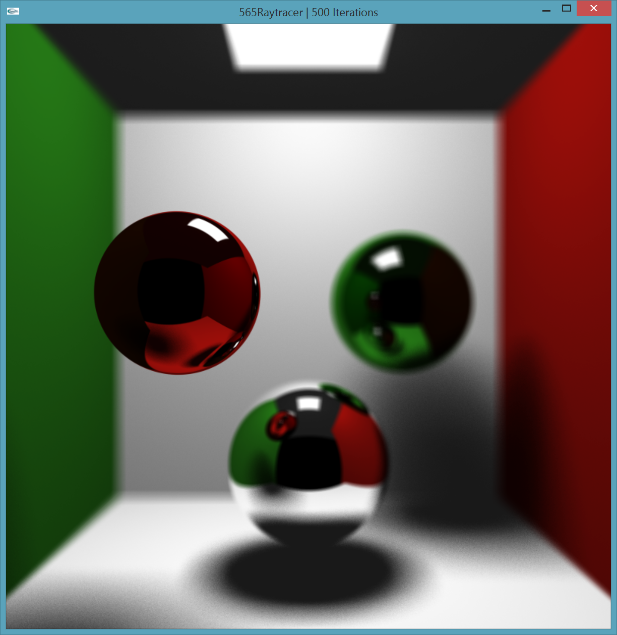

Features I’ve implemented:

* All required features
* Reflection
* Specular highlights
* Soft shadows and area lights
* Anti-aliasing
* Depth of field
* Interactive camera (A-left, D-right, W-up, S-down, Z-forward, X-backward)
* Refraction (not Fresnel so doesn’t look that good…)

Additional screenshots (can also be found in the screenshots folder):

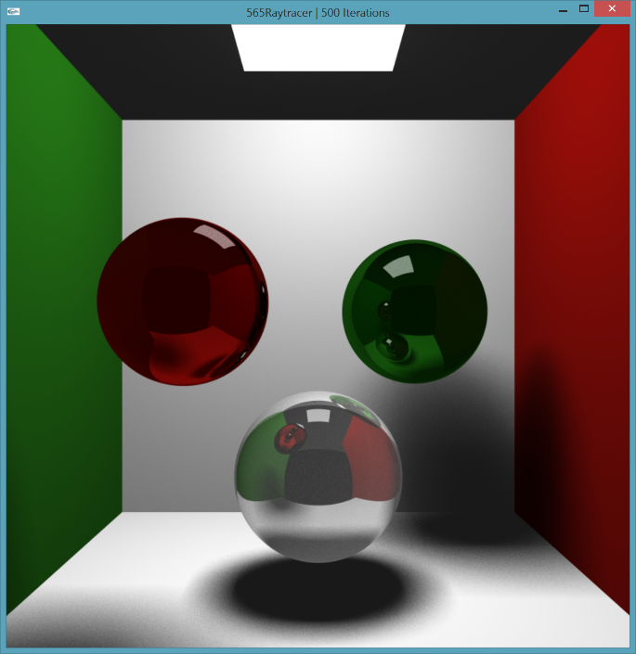 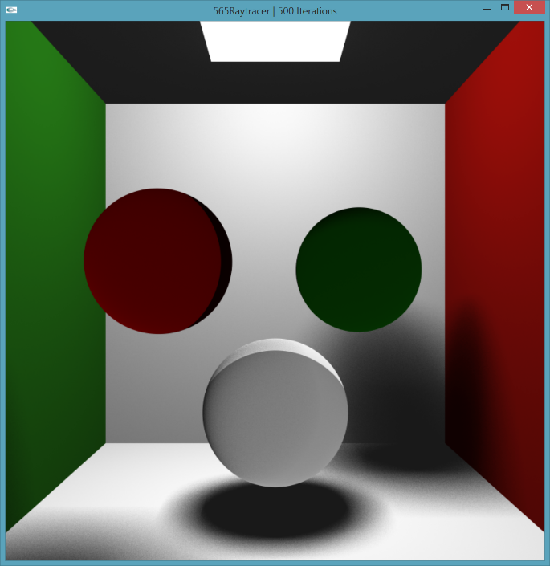

Reflection + refraction Refraction

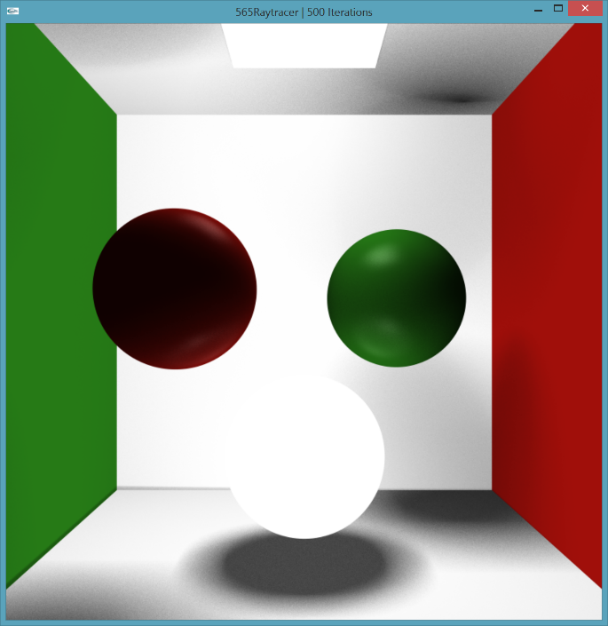 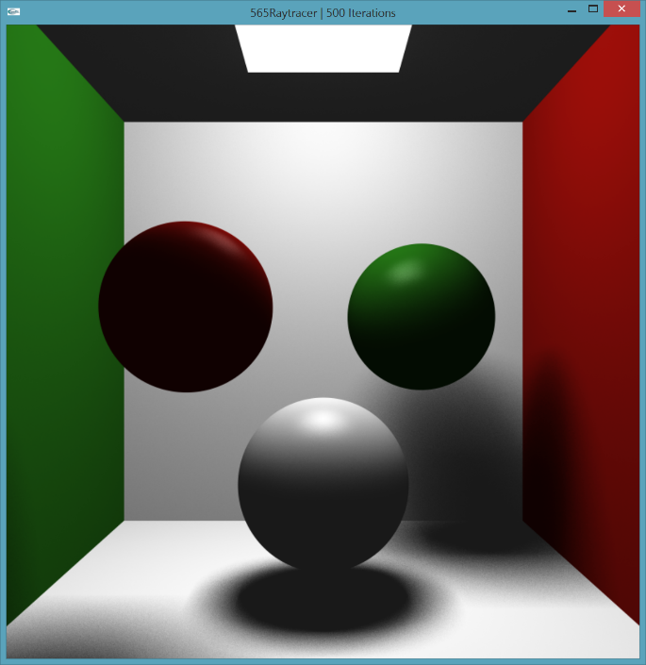

Multiple lights Specular highlights

Screen recording:

<https://vimeo.com/75074121>

Performance evaluation:

(I used 3rd-party code: fps.h, fps.cpp, clock.h, timer.h for Fps tracking)

|  |  |  |  |  |  |  |
| --- | --- | --- | --- | --- | --- | --- |
| # lights | reflection | refraction | DOF | antialiasing | tileSize | fps |
| 1 | yes | no | yes | yes | 1 | 0.4 |
| 1 | yes | no | yes | yes | 2 | 2.5 |
| 1 | yes | no | yes | yes | 4 | 9.5 |
| 1 | yes | no | yes | yes | 8 | 26 |
| 1 | yes | no | yes | yes | 16 | 24 |
| 1 | yes | no | yes | yes | 32 | 20 |
| 1 | yes | no | no | yes | 8 | 26 |
| 1 | yes | no | yes | no | 8 | 26 |
| 1 | yes | yes | yes | yes | 8 | 23 |
| 1 | no | no | yes | yes | 8 | 30 |
| 2 | yes | no | yes | yes | 8 | 18 |
| 2 | no | no | yes | yes | 8 | 20 |