《6天搞定英语所有语法》



# 《6天搞定英语所有语法》

《6天搞定英语所有语法》



### 语法是什么？

如果把英语比作一串项链，

单词就是珍珠，语法就是链子，口语就是包装盒！

《6天搞定英语所有语法》



### 为什么要学语法？

* 学语法是学好英语的必经之路
* 学语法是让我们能够真正看懂英文，而不是凭感觉

《6天搞定英语所有语法》



### 如何快速掌握语法？

* + 不要纠结于各种概念与定义
  + 从整体和本质上把握语法

《6天搞定英语所有语法》



《6天搞定英语所有语法》

一．五大基本概念

二．五大基本句型

三．并列句的起源与本质

四．名词性从句的起源与本质

五．形容词性从句（定语从句）的起源与本质

六．副词性从句（状语从句）的起源与本质

《6天搞定英语所有语法》



七、长难句必杀技一 ——“左二右六原则” 八、长难句必杀技二 ——“悬挂结构”

九、那些年我们经历过的痛——“15个最常见介词的深层次含义”十、四大特殊句型：强调句；倒装句；虚拟语气；独立主格

十一、宇哥时态轴——一条数学轴破解16种时态的秘密

《6天搞定英语所有语法》



### 一．五大基本概念

《6天搞定英语所有语法》



### 一．五大基本概念

《6天搞定英语所有语法》



### 什么叫做主语？

《6天搞定英语所有语法》



宇哥定义： 放在谓语动词之前的成分就叫做主语。

① I love you.

② To see is to believe.

③ The flower smells great.

④ Being able to love you is the happiest thing in this world.

《6天搞定英语所有语法》



### 什么叫做谓语？

《6天搞定英语所有语法》



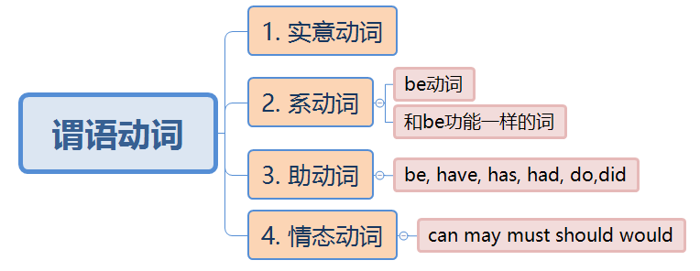宇哥定义： 谓语就是动词，动词主要分为 实意动词 和 系动词。

① I love you.

② To see is to believe.

③ The flower smells great.

④ Being able to love you is the happiest thing in this world.

《6天搞定英语所有语法》



### 什么叫做宾语？

《6天搞定英语所有语法》



宇哥定义： 放在实意动词之后的成分就叫做宾语

① I love you.

② To see is to believe.

③ The flower smells great.

④ Being able to love you is the happiest thing in this world.

问： 以上哪个句子中含有宾语？

《6天搞定英语所有语法》



### 什么叫做表语？

《6天搞定英语所有语法》



宇哥定义： 放在系动词之后的成分就叫做表语

① I love you.

② To see is to believe.

③ The flower smells great.

④ Being able to love you is the happiest thing in this world.

问： 以上哪个句子中含有表语？

《6天搞定英语所有语法》



### 什么叫做宾补？

《6天搞定英语所有语法》



宇哥定义： 补充说明宾语的成分就叫做宾补。

* I find you beautiful
* I consider him a liar.
* I hear her singing.

小技巧：

如果宾语和宾语之后成分加be动词后能够构成一个逻辑完整的句子，

则宾语之后的成分为宾补。

《6天搞定英语所有语法》



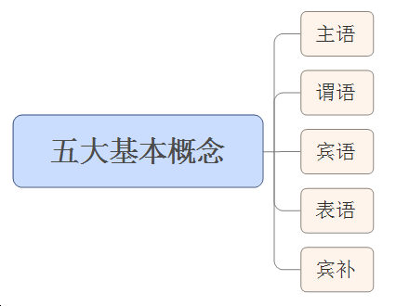

《6天搞定英语所有语法》



### 二．五大基本句型

《6天搞定英语所有语法》



* + 主+谓 eg：I arrived. / The rain stopped.
  + 主+谓+宾 eg: I love you.
  + 主+谓+宾+宾 eg: My mum bought me a drink.
  + 主+谓+宾+宾补 eg: I find you beautiful.
  + 主+系+表 eg：I am good/ a student.

《6天搞定英语所有语法》





重要结论：

1. 五大简单基本句型是万句之源；
2. 一个句子的主干有且仅有一个谓语动词。

《6天搞定英语所有语法》

* 教科书定义：

什么是状语？

说明地点、时间、原因、目的、结果、条件、方向、程度、方式和伴 随状况等的句子成分叫做状语。



* 宇哥定义：

除去五大基本概念和形容词（定语）剩下的成分就是状语。

《6天搞定英语所有语法》



1. 主+谓

① He cried.

② The bus stopped.

③ It is raining ~~now~~.

④ We have worked ~~for 5 days~~.

⑤ Dark clouds hung ~~overhead~~.

《6天搞定英语所有语法》



1. 主+谓

~~⑥ Gradually~~ a smile appeared ~~on her face.~~

⑦ He is smiling ~~all over his face.~~

⑧ I did ~~well~~ ~~in English~~.

⑨ He talked ~~loudly~~ ~~in the classroom~~ ~~yesterday~~.

《6天搞定英语所有语法》



1. 主+谓+宾

① I love you.

② People ~~all over the world~~ speak English.

③ He did not know what to say.

④ He practice speaking English ~~every day~~.

⑤ He is having dinner ~~at home~~ ~~now.~~

《6天搞定英语所有语法》



1. 主+谓+宾+宾

① He lent *me some money*.

② She ordered *herself a new dress*.

③ She cooked *her husband a delicious meal*.

④ I showed *him my pictures*.

⑤ He showed *me how to run the machine*.

《6天搞定英语所有语法》



1. 主+谓+宾 +宾补

① He asked me *to lend him some money.*

② Our teacher encourages us *to do more reading.*

③ I heard someone *calling for help.*

④ We saw her *entering the room.*

⑤ His father named him *Dongming*.

《6天搞定英语所有语法》



1. 主+谓+宾 +宾补

⑥ Let the fresh air *in.*

⑦ We saw him *out.*

⑧ He kept his hands *behind his back*.

⑨ I want your homework *done* on time.

⑩ I’ll have my bike *repaired*.

⑪ They painted their boat *white*.

《6天搞定英语所有语法》



1. 主+系+表

① His advice *proved* right.

② The shop *stays* open till 8 o’clock.

③ The machine *went* wrong.

④ All these efforts *seem* in vain.

⑤ The room soon *became* crowded.

《6天搞定英语所有语法》



1. 主+系+表

⑥ The days *are getting* longer and longer.

⑦ He *fell* ill yesterday.

⑧ Trees *turn* green in spring.

⑨ What you said *sounds* great.

⑩ He tasted the food, and the food *tasted* delicious.

⑪ The book still *lies* open on the desk.

《6天搞定英语所有语法》



### 三. 并列句的起源与本质

 《6天搞定英语所有语法》



“你人很好，但是我不爱你”

###### You are nice. I don't love you.

如果用一句话怎么说呢？

《6天搞定英语所有语法》



简单句**+**并列连词**+**简单句

**You are nice but I don't love you.**

《6天搞定英语所有语法》



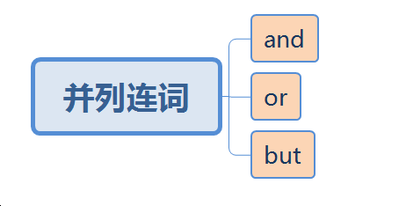

* + He helped me and I helped him.
  + You can watch TV or you can do exercise.
  + You are nice but I don't love you.

《6天搞定英语所有语法》



### 四. 名词性从句的起源与本质

《6天搞定英语所有语法》



### 为什么会出现名词性从句？

《6天搞定英语所有语法》



翻译：姚明很高.

**Yaoming is tall.**

翻译："姚明很高是一个事实"

**It is a fact that Yaoming is tall.**

不能用It is...这种结构该如何表达呢？

《6天搞定英语所有语法》



“姚明很高” **Yaoming is tall.** “姚明很高是一个事实” **A is a fact.** 变化规则： **that**+陈述句=一个名词

**that Yaoming is tall= A**

因此这里应该填入：

**That Yaoming is tall is a fact.**

“一个句子做了名词的功能就叫做名词性从句”

《6天搞定英语所有语法》



陈述句： **Yaoming is tall.**

变化规则： that + 陈述句 = 名词

1. 姚明很高是一个事实。

**That Yaoming is tall is a fact. →**主语从句

1. 我们知道姚明很高。

**We know** （**that**） **Yaoming is tall →**宾语从句

1. 我的观点是姚明很高。

**My opinoin is that Yaoming is tall. →**表语从句

1. 姚明很高这个观点是正确的。

**The opinon that Yaoming is tall is right. →**同位语从句

《6天搞定英语所有语法》



一般疑问句： **Will you come to Beijing tomorrow?**

变化规则： if/whether + 疑问句的陈述语序 = 名词

1. 你明天是否来北京对我来说很重要。

**Whether you will come to BJ tomorrow is important to me. →**主语从句

1. 我想知道你明天是否来北京。

**I want to know if/whether you will come to BJ tomorrow. →**宾语从句

1. 我的问题是你明天是否来北京。

**My question is whether you will come to BJ tomorrow. →**表语从句

1. 你明天是否来北京这个问题让我很烦心。

**The question whether you will come to BJ tomorrow bothers me. →**同位语从句

《6天搞定英语所有语法》



特殊疑问句： **Why are you so clever?**

变化规则： 陈述语序的特殊疑问句= 名词

* 1. 你为什么这么聪明是一个迷。

**Why you are so clever is a mystery. →**主语从句

* 1. 我们不知道你为什么这么聪明。

**We don’t know why you are so clever →**宾语从句

* 1. 我问题是你为什么这么聪明。

**My question is why you are so clever →**表语从句

* 1. 你为什么这么聪明这个问题让我感兴趣。

**The question why you are so clever interests me . →**同位语从句

《6天搞定英语所有语法》



特殊疑问词大汇总

英文中共有8个特殊疑问词：

**what which who whose when where why how**

What is it ? Which one do you like?

Who is the man? Whose car is it? When do you get up? Where do you live?

Why do you come here? How did you get here?

《6天搞定英语所有语法》



同位语从句知识点补充

1. 在句子中遇到“抽象名词”时，应条件反射地想到后面可能跟了同位语 从句，常跟同位语从句的抽象名词有：

belief (信念), fact (事实), idea(主意), problem(问题), information(消息), conclusion( 结 论 ), decision( 决 定 ), news( 新 闻 ), thought( 想 法 ), explanation(解释)等

1. 当同位语从句充当主语过长时，同位语从句和它所修饰的名词常常隔开。

An **idea** came to her **that she could solve the problem in another way.**

她想到她可以用另外一种方法解决问题。

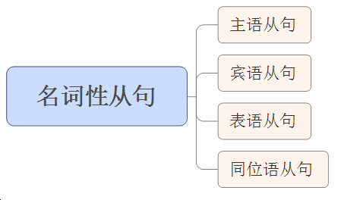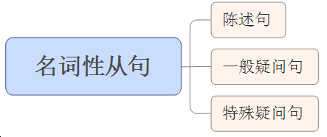 《6天搞定英语所有语法》



《6天搞定英语所有语法》

巩固练习



下列句子的主干属于五大基本句型的哪一个？（直接用序号即可）

* 1. What he does is important. （ ）
  2. I don’t like what he does every day. （ ）
  3. This is what he does every day. （ ）
  4. I don’t know the fact that he is a teacher. （ ）

《6天搞定英语所有语法》

巩固练习



下列句子的主干属于五大基本句型的哪一个？（直接用序号即可）

1. What he does is important. （ 5 ）
2. I don’t like what he does every day. （ 2 ）
3. This is what he does every day. （ 5 ）
4. I don’t know the fact that he is a teacher. （ 2 ）

《6天搞定英语所有语法》

巩固练习



下列句子的主干属于五大基本句型的哪一个？

1. I wonder who will teach us. （ ）
2. Mr. Wang asked whose book that was. （ ）
3. The news that we won the game is exciting. （ ）
4. You can do what you think is right. （ ）

《6天搞定英语所有语法》

巩固练习



下列句子的主干属于五大基本句型的哪一个？

1. I wonder who will teach us. （ 2 ）
2. Mr. Wang asked whose book that was. （ 2 ）
3. The news that we won the game is exciting. （ 5 ）
4. You can do what you think is right. （ 2 ）

《6天搞定英语所有语法》

巩固练习



下列句子的主干属于五大基本句型的哪一个？

1. Whoever smokes here will be punished. （ ）
2. Whatever you say is of no use now. （ ）
3. You can take whatever you like. （ ）
4. Whatever he likes will be given to him. （ ）

《6天搞定英语所有语法》

巩固练习



下列句子的主干属于五大基本句型的哪一个？

1. Whoever smokes here will be punished. （ 1 ）
2. Whatever you say is of no use now. （ 5 ）
3. You can take whatever you like. （ 2 ）
4. Whatever he likes will be given to him. （ 2 ）

《6天搞定英语所有语法》

巩固练习



下列句子的主干属于五大基本句型的哪一个？

1. Lily wanted to know if her grandma liked the handbag.（ ）
2. It all depends on whether she likes the boss or not. （ ）
3. None of us knows where these new parts can be bought. （ ）
4. I have heard that he will come tomorrow. （ ）

《6天搞定英语所有语法》

巩固练习



下列句子的主干属于五大基本句型的哪一个？

1. Lily wanted to know if her grandma liked the handbag.（ 2 ）
2. It all depends on whether she likes the boss or not. （ 2 ）
3. None of us knows where these new parts can be bought. （ 2 ）
4. I have heard that he will come tomorrow. （ 2 ）

《6天搞定英语所有语法》

巩固练习



下列句子的主干属于五大基本句型的哪一个？

1. His brother asks when he will go to the library. （ ）
2. I don’t know what he wants to buy. （ ）
3. Can you tell me who we are going to meet? （ ）
4. Could you tell us which gate we have to go to? （ ）

《6天搞定英语所有语法》

巩固练习



下列句子的主干属于五大基本句型的哪一个？

1. His brother asks when he will go to the library. （ 2 ）
2. I don’t know what he wants to buy. （ 2 ）
3. Can you tell me who we are going to meet? （ 3 ）
4. Could you tell us which gate we have to go to? （ 3 ）

《6天搞定英语所有语法》

巩固练习



下列句子的主干属于五大基本句型的哪一个？

1. Could you please tell me how you use the new panel? （ ）
2. Could you tell us how much it costs to fly to Hainan? （ ）
3. Could you tell us how often you go abroad for a holiday? （ ）
4. Could you tell us how long the meeting will last? （ ）

《6天搞定英语所有语法》

巩固练习



下列句子的主干属于五大基本句型的哪一个？

1. Could you please tell me how you use the new panel? （ 3 ）
2. Could you tell us how much it costs to fly to Hainan? （ 3 ）
3. Could you tell us how often you go abroad for a holiday? （3 ）
4. Could you tell us how long the meeting will last? （ 3 ）

《6天搞定英语所有语法》

巩固练习



下列句子的主干属于五大基本句型的哪一个？

1. I don’t know how far it is to the cinema . （ ）
2. Please tell us how many students there are in your school （ ）
3. Can you tell us how old his brother is? （ ）
4. Please tell us how soon you will be ready. （ ）

《6天搞定英语所有语法》

巩固练习



下列句子的主干属于五大基本句型的哪一个？

1. I don’t know how far it is to the cinema . （ 2 ）
2. Please tell us how many students there are in your school.（ 3 ）
3. Can you tell us how old his brother is? （ 3 ）
4. Please tell us how soon you will be ready. （ 3 ）

《6天搞定英语所有语法》

注意事项



表达人的个人心情时常常用的句型的主干我们是比较难理解的，如：

* 1. I’m afraid (that) he won’t pass the exam .
  2. We are sure that he will be successful soon.
  3. I am glad that you come to see me.

这一类句子当做固定句型记忆即可。

《6天搞定英语所有语法》



### 五. 形容词性从句的起源与本质

—— 定语从句详解

《6天搞定英语所有语法》



### 为什么会出现形容词性从句？

《6天搞定英语所有语法》



我喜欢那个女孩。

I like that girl.

我喜欢那个漂亮的女孩。

I like that beautiful girl.

我喜欢那个漂亮的并且英语说的很好的女孩。

I like that beautiful girl who can speak good English**.**

先行词 关系词

“一个句子做了形容词的功能就叫做形容词性从句”

《6天搞定英语所有语法》





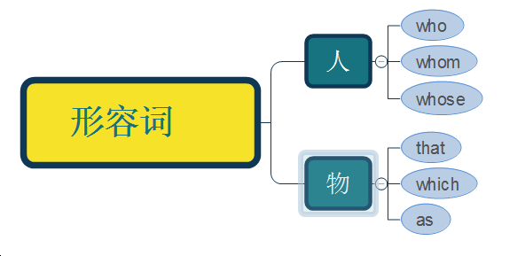

《6天搞定英语所有语法》



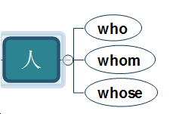This is the man who saved my life. This is the man whom I saved.

This is the man whose life was saved by me.

《6天搞定英语所有语法》



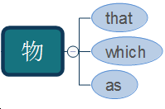This is the book that I read.

This is the book which is very popular.

You always work hard, as everybody knows.

1. I like climbing mountains, is good for my health.
2. This is the room, in I spent my whole childhood.

《6天搞定英语所有语法》



注意事项

as的用法

1. as不可指代具体的某个词，一般指某件事，其引导的定语从句可以置于句首

（其他定语从句不可以），也可以置于句末。

As is planned, we got there before eight.

正如计划，我们在八点前到那了。

They won the game, as we had expected.

他们赢得了比赛，正如我们预料的那样。

1. 当句子中出现such/the same 时，用as。

He is not such a fool as he looks.

他并没有看上去那么傻。

《6天搞定英语所有语法》





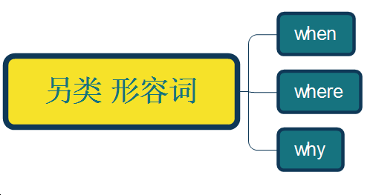

I can never forget the day when I met her.

I can never forget the place where I met her.

I can never forget the reason why she dumped me.

 《6天搞定英语所有语法》



《6天搞定英语所有语法》



巩固练习

请用who, whom, whose, that, which, as, when, where, why 填空

* 1. The man is speaking at the meeting is a worker.
  2. These are the trees were planted last year.
  3. The woman they wanted to visit is a teacher.
  4. I know the girl mother is a teacher.
  5. I have a friend likes listening to classical music.

《6天搞定英语所有语法》



1. The man who/that is speaking at the meeting is a worker.
2. These are the trees that/which were planted last year.
3. The woman whom they wanted to visit is a teacher.
4. I know the girl whose mother is a teacher.
5. I have a friend who/that likes listening to classical music.

《6天搞定英语所有语法》



巩固练习

请用who, whom, whose, that, which, as, when, where, why 填空

1. The speed at you drive your car mustn’t be too high.
2. The man to I talked is Mr. Li.
3. I don’t like the way in you speak to her.
4. Is this the library from you borrow books?
5. The wolf by the sheep was killed was shot.

《6天搞定英语所有语法》



* 1. The speed at which you drive your car mustn’t be too high.
  2. The man to whom I talked is Mr. Li.
  3. I don’t like the way in which you speak to her.
  4. Is this the library from which you borrow books?
  5. The wolf by which the sheep was killed was shot.

《6天搞定英语所有语法》

巩固练习



请用who, whom, whose, that, which, as, when, where, why 填空

* 1. He is such a nice person is popular.
  2. It is such a beautiful picture attracted many people.
  3. you’ve pointed out, he proves to be the best student here.
  4. we all know, the earth is round.

《6天搞定英语所有语法》



1. He is such a nice person as is popular.
2. It is such a beautiful picture as attracted many people.
3. As you’ve pointed out, he proves to be the best student here.
4. As we all know, the earth is round.

《6天搞定英语所有语法》

巩固练习



请用who, whom, whose, that, which, as, when, where, why 填空

1. I’ll never forget the days we spent together.
2. I’ll never forget the day I joined the league.
3. This is the house I lived two years ago.
4. Do you know the reason she was late.

《6天搞定英语所有语法》



1. I’ll never forget the days that/which we spent together.
2. I’ll never forget the day when I joined the league.
3. This is the house where I lived two years ago.
4. Do you know the reason why she was late.

《6天搞定英语所有语法》



注意事项

含有way/time 的定语从句

1. 当way和time做先行词时，关系词常常省略。

I don't like the way (that/ in which) he treated me.

The way (that/ in which) he explained to us is quite simple. This is the first time (that) I come here.

This is the last time (that) I shall give you a lesson.

《6天搞定英语所有语法》



### 六. 副词性从句的起源与本质

——状语从句详解

《6天搞定英语所有语法》

##### 什么叫做副词？



* 1. 我深深地爱着你。 I love you deeply.
  2. 你足够漂亮。 You are beautiful enough.
  3. 我每天吃早饭。 I have breakfast every day.

那些修饰动词, 形容词和整个句子的可有可无的成分叫做副词。

《6天搞定英语所有语法》



##### 小结：

1. 副词就是状语，状语就是副词。

2. 那些修饰动词, 形容词和整个句子的可有可无的成分叫做副词，也叫

做状语。

3. 除去五大基本概念和定语后剩下的成分就是副词，就是状语。

4. 说明地点、时间、原因、目的、结果、条件、方向、程度、方式和伴

随状况等

《6天搞定英语所有语法》



请判断下列句子中的副词成分

① The boy needs a pen ~~very much.~~  （程度）

② The boy ~~really~~ needs a pen. （程度）

③ He went ~~there~~ ~~yesterday~~. （地点+时间）

④ It ~~suddenly~~ rained. （方式）

⑤ I ~~often~~ read English ~~loudly in the morning.~~ (频率+程度+时间）

⑥ I ~~seldom~~ go to the movies.（频率）

《6天搞定英语所有语法》



请判断下列句子中的副词成分

⑦ We have worked ~~for 5 days~~*.* （时间）

⑧ Dark clouds hung ~~overhead~~. （地点）

~~⑨ Gradually~~ a smile appeared ~~on her face~~. （方式+地点）

⑩ He is smiling ~~all over his face~~. （地点）

《6天搞定英语所有语法》



请判断下列句子中的副词成分

⑪ I did ~~well in English~~*.* （程度+地点）

⑫ He talked ~~loudly in the classroom yesterday.~~ （程度+地点+时间）

⑬ People ~~all over the world~~ speak English. （地点）

⑭ He is having dinner ~~at home now~~*.* （地点+时间）

《6天搞定英语所有语法》



### 为什么会出现副词性从句？

《6天搞定英语所有语法》

我爱你.

I love you.

我非常爱你.

I love you very much.



我像老鼠爱大米一样爱你.

《6天搞定英语所有语法》



我爱你。 I love you.

我非常爱你。 I love you very much.

我像老鼠爱大米一样爱你。 I love you **as** a mouse loves rice**.**

连词 完整的句子

“一个句子做了副词的功能就叫做副词性从句”

《6天搞定英语所有语法》



##### 完整句子1 + 连词 +完整句子2

状语从句**/**副词性从句

##### I love you as a mouse loves rice.

《6天搞定英语所有语法》



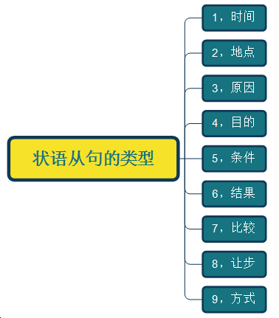

《6天搞定英语所有语法》



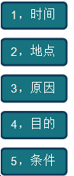**After** I finish my homework,I will play games with you.

You should have put the book **where** you found it.

I didn't come to work **because** I was ill.

He looked down **so that** she could not see his eyes.

**If** plastics are burned ,they give off poisonous gases.

《6天搞定英语所有语法》



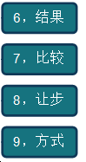I didn't sleep well last night,**so** I feel sleepy this morning.

You look younger **than** you are.

**Although** he studied hard,he didn't pass the examination.

You must try to hold the tool **as** I do.

《6天搞定英语所有语法》





《6天搞定英语所有语法》



巩固练习

请分析下面句子的结构，并找出其中的连词。

1. While/When/As John was watching TV, his wife was cooking.
2. You’d better think twice before you make your decision.
3. It is a month since I met him last time.
4. It has been five years since I taught English.

《6天搞定英语所有语法》



巩固练习

请分析下面句子的结构，并找出其中的连词。

1. While/When/As John was watching TV, his wife was cooking.
2. You’d better think twice before you make your decision.
3. It is a month since I met him last time.
4. It has been five years since I taught English.

《6天搞定英语所有语法》



巩固练习

请分析下面句子的结构，并找出其中的连词。

1. I found the world was amazing after I went abroad.
2. I waited until he came.
3. I didn’t have a boyfriend until I was 17 years old.
4. Whenever a visitor comes into a house, he is served with a cup of tea.

《6天搞定英语所有语法》



巩固练习

请分析下面句子的结构，并找出其中的连词。

1. I found the world was amazing after I went abroad.
2. I waited until he came.
3. I didn’t have a boyfriend until I was 17 years old.
4. Whenever a visitor comes into a house, he is served with a cup of tea.

《6天搞定英语所有语法》



巩固练习

请分析下面句子的结构，并找出其中的连词。

1. Each time I went there I saw him working.
2. Every time I listened to your advice I got into trouble.
3. By the time he was taken to the hospital he was almost dead.

《6天搞定英语所有语法》



巩固练习

请分析下面句子的结构，并找出其中的连词。

1. Each time I went there I saw him working.
2. Every time I listened to your advice I got into trouble.
3. By the time he was taken to the hospital he was almost dead.

《6天搞定英语所有语法》



巩固练习

请分析下面句子的结构，并找出其中的连词。

1. Next time you come to class, please remember to take your notes.
2. The first time I saw you I fell in love with you.
3. He didn’t tell me the news the last time I saw him.

《6天搞定英语所有语法》



巩固练习

请分析下面句子的结构，并找出其中的连词。

1. Next time you come to class, please remember to take your notes.
2. The first time I saw you I fell in love with you.
3. He didn’t tell me the news the last time I saw him.

《6天搞定英语所有语法》

巩固练习



请分析下面句子的结构，并找出其中的连词。

1. People check messages as soon as we wake up.
2. The children ran away from the garden the moment they saw the guard.
3. I want to see him the minute he arrives.
4. Once he arrives we can start.

《6天搞定英语所有语法》

巩固练习



请分析下面句子的结构，并找出其中的连词。

1. People check messages as soon as we wake up.
2. The children ran away from the garden the moment they saw the guard.
3. I want to see him the minute he arrives.
4. Once he arrives we can start.

《6天搞定英语所有语法》

巩固练习



请分析下面句子的结构，并找出其中的连词。

1. Hardly had he reached the school gate when the bell rang.
2. I had no sooner arrived home than it began to rain.

《6天搞定英语所有语法》

巩固练习



请分析下面句子的结构，并找出其中的连词。

1. Hardly had he reached the school gate when the bell rang.
2. I had no sooner arrived home than it began to rain.

《6天搞定英语所有语法》



小结：

时间状语连词在英文中特别重要，大家一定要熟记这些连词。

* 1. 常见的简单时间状语连词：

when/while/as/before/after/since/till/until/

2. “一…就…”系列：

as soon as/ (the moment/minute/second)/once/

hardly…when/no sooner…than/

3. Time系列：

every time/each time/next time/the last time/the first time/by the time

《6天搞定英语所有语法》

巩固练习



请分析下面句子的结构，并找出其中的连词。

1. Generally, air will be heavily polluted where there are factories.
2. Wherever you go, you should work hard.
3. Where there is no rain, farming is difficult or impossible.

《6天搞定英语所有语法》

巩固练习



请分析下面句子的结构，并找出其中的连词。

1. Generally, air will be heavily polluted where there are factories.
2. Wherever you go, you should work hard.
3. Where there is no rain, farming is difficult or impossible.

《6天搞定英语所有语法》

巩固练习



请分析下面句子的结构，并找出其中的连词。

1. My friends dislike me because I’m handsome and successful.
2. Now that everybody has come, let’s begin our conference. (高级)
3. The higher income tax is harmful in that it may discourage people from trying to earn more. (高级)

《6天搞定英语所有语法》

巩固练习



请分析下面句子的结构，并找出其中的连词。

1. My friends dislike me because I’m handsome and successful.
2. Now that everybody has come, let’s begin our conference. (高级)
3. The higher income tax is harmful in that it may discourage people from trying to earn more. (高级)

《6天搞定英语所有语法》

巩固练习



请分析下面句子的结构，并找出其中的连词。

1. The teacher uses simple examples so that his students could understand him.
2. He got up so early that he caught the first bus.
3. It’s such a good chance that we must not miss it.

《6天搞定英语所有语法》

巩固练习



请分析下面句子的结构，并找出其中的连词。

1. The teacher uses simple examples so that his students could understand him.
2. He got up so early that he caught the first bus.
3. It’s such a good chance that we must not miss it.

《6天搞定英语所有语法》

巩固练习



请分析下面句子的结构，并找出其中的连词。

1. We’ll start our project if the president agrees.
2. You will certainly succeed as long as you keep on trying.

《6天搞定英语所有语法》

巩固练习



请分析下面句子的结构，并找出其中的连词。

1. We’ll start our project if the president agrees.
2. You will certainly succeed as long as you keep on trying.

《6天搞定英语所有语法》

巩固练习



请分析下面句子的结构，并找出其中的连词。

1. The old man always enjoys swimming even though the weather is bad.
2. No matter how hard he tried, she could not change her mind.
3. He won’t listen whatever you may say.
4. I will support you whichever you choose.

《6天搞定英语所有语法》

巩固练习



请分析下面句子的结构，并找出其中的连词。

* 1. The old man always enjoys swimming even though the weather is bad.
  2. No matter how hard he tried, she could not change her mind.
  3. He won’t listen whatever you may say.

= He won’t listen no matter what you may say.

* 1. I will support you whichever you choose.

= I will support you no matter which you choose.

《6天搞定英语所有语法》



### 七. 长难句必杀技一

——左二右六原则

《6天搞定英语所有语法》



### 中英文的最大区别是什么？

《6天搞定英语所有语法》



我喜欢那个聪明的漂亮的会做饭的而且英语说得很流利的女孩。

I like the clever and beautiful girl who can cook and speak fluent English.

《6天搞定英语所有语法》



形容词的位置不一样

《6天搞定英语所有语法》



1. 已经存在的形容词放在名词前面
2. 人为创造的形容词放在名词后面

《6天搞定英语所有语法》



左二右六

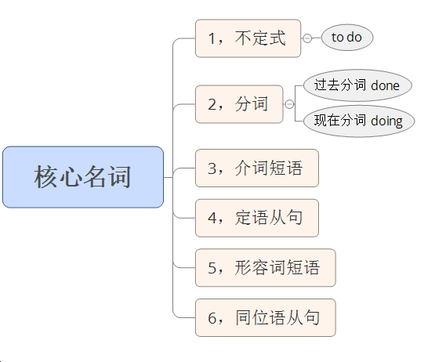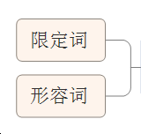

《6天搞定英语所有语法》

什么叫做限定词？



语法：限定词是指在名词词组中对中心名词起特指，类指及表示确定数量和非确定数量作用的词表。

* + 冠词： a, an, the
  + 形容词性代词：my, your, his, her, its, their
  + 量词：a number of , a plenty of, some.....

《6天搞定英语所有语法》



The beautiful girl is Angelababy.

The beautiful girl to get married is Angelababy.

不定式

The beautiful girl wearing sunglasses is Angelababy. The beautiful girl hugged by HXM is Angelababy.

现在分词

过去分词

The beautiful girl in blue jeans is Angelababy.

介词短语

The beautiful girl who is the leading actress in running man is Angelababy.

定语从句

The beautiful girl slim enough is Angelababy.

形容词短语

The question whether the beautiful girl is Angelababy has an answer.

同位语从句

《6天搞定英语所有语法》



巩固练习

请用“左二右六”原则分析下面的句子结构，找出人为创造出来的形容词。

1. I have many letters to write.
2. The letter to be written is to my father.
3. We have made a plan to learn from Lei Feng.
4. He made a promise to come here on time tomorrow.
5. We got the order to leave the city.

《6天搞定英语所有语法》



巩固练习

请用“左二右六”原则分析下面的句子结构，找出人为创造出来的形容词。

1. I have many letters ~~to write.~~
2. The letter ~~to be written~~ is to my father.
3. We have made a plan ~~to learn from Lei Feng~~.
4. He made a promise ~~to come here on time tomorrow~~.
5. We got the order ~~to leave the city.~~

《6天搞定英语所有语法》

巩固练习



请用“左二右六”原则分析下面的句子结构，找出人为创造出来的形容词。

1. The dog lying on the ground is mine.
2. People exercising ever day live longer.
3. They built a road leading into the mountains.
4. We met a group of pupils returning from school.
5. Surely, someone passing by would see it.

《6天搞定英语所有语法》

巩固练习



请用“左二右六”原则分析下面的句子结构，找出人为创造出来的形容词。

1. The dog ~~lying on the ground~~ is mine.
2. People ~~exercising ever day~~ live longer.
3. They built a road ~~leading into the mountains~~.
4. We met a group of pupils ~~returning from school.~~
5. Surely, someone ~~passing by~~ would see it.

《6天搞定英语所有语法》

巩固练习



请用“左二右六”原则分析下面的句子结构，找出人为创造出来的形容词。

1. This is a film directed by Feng Xiaogang.
2. What is the language spoken in Spain?
3. People got water by dropping a bucket (木桶) tied to a rope.
4. The reading time spent on them is getting longer.
5. He told me to watch the circles created by the stone.

《6天搞定英语所有语法》

巩固练习



请用“左二右六”原则分析下面的句子结构，找出人为创造出来的形容词。

1. This is a film ~~directed by Feng Xiaogang.~~
2. What is the language ~~spoken in Spain~~?
3. People got water by dropping a bucket (木桶) ~~tied to a rope~~.
4. The reading time ~~spent on them~~ is getting longer.
5. He told me to watch the circles ~~created by the stone~~.

《6天搞定英语所有语法》

巩固练习



请用“左二右六”原则分析下面的句子结构，找出人为创造出来的形容词。.

1. The bird on the tree flied away.
2. The road to the school is not wide.
3. The basic idea behind the festival remains the same.
4. We know China is a country with a large population.
5. Questions about the competition can be emailed to [51@qq.com.](mailto:51@qq.com)

《6天搞定英语所有语法》

巩固练习



请用“左二右六”原则分析下面的句子结构，找出人为创造出来的形容词。.

1. The bird ~~on the tree~~ flied away.
2. The road ~~to the school~~ is not wide.
3. The basic idea ~~behind the festival~~ remains the same.
4. We know China is a country ~~with a large population~~.
5. Questions ~~about the competition~~ can be emailed to [51@qq.com.](mailto:51@qq.com)

《6天搞定英语所有语法》

巩固练习



请用“左二右六”原则分析下面的句子结构，找出人为创造出来的形容词。.

1. Italian is a language very difficult to learn.
2. He looked at her eyes full of tears.
3. I know the actor suitable for the role.
4. I know it is a city famous for kites.
5. I know now that I am not the only one uncertain about future studies.

《6天搞定英语所有语法》

巩固练习



请用“左二右六”原则分析下面的句子结构，找出人为创造出来的形容词。.

1. Italian is a language ~~very difficult to learn~~.
2. He looked at her eyes ~~full of tears~~.
3. I know the actor ~~suitable for the role~~.
4. I know it is a city ~~famous for kites.~~
5. I know now that I am not the only one ~~uncertain about future studies~~.

《6天搞定英语所有语法》

巩固练习



请用“左二右六”原则分析下面的句子结构，找出人为创造出来的形容词。.

1. The fact that she didn't like me really hurts me..
2. The general gave the order that the soldiers should cross the

river at once.

1. I received the message that he won’t be able to see me tomorrow.
2. The suggestion that the plan should be delayed will be discussed tomorrow.

《6天搞定英语所有语法》

巩固练习



请用“左二右六”原则分析下面的句子结构，找出人为创造出来的形容词。.

1. The fact ~~that she didn't like me~~ really hurts me..
2. The general gave the order ~~that the soldiers should cross the~~

~~river at once.~~

1. I received the message ~~that he won’t be able to see me tomorrow~~.
2. The suggestion ~~that the plan should be delayed~~ will be discussed tomorrow.

《6天搞定英语所有语法》

巩固练习



请用“左二右六”原则分析下面的句子结构，找出人为创造出来的形容词。.

1. The news that our team has won the game is true.
2. They expressed the hope that they would come to visit Beijing again.
3. Many British parents hold the view that teenagers shouldn’t spend too much time online.
4. We’ll discuss the problem whether the sports meeting will be held on time.

《6天搞定英语所有语法》

巩固练习



请用“左二右六”原则分析下面的句子结构，找出人为创造出来的形容词。.

1. The news ~~that our team has won the game~~ is true.
2. They expressed the hope ~~that they would come to visit Beijing again~~.
3. Many British parents hold the view ~~that teenagers shouldn’t spend~~

~~too much time online.~~

1. We’ll discuss the problem ~~whether the sports meeting will be held on~~

~~time.~~

《6天搞定英语所有语法》

综合练习



In the video, young people from 20 countries along the Belt and Road(一带一路) routes were asked to name great inventions that had influenced their lives in China.



《6天搞定英语所有语法》

综合练习



In the video, young people ~~from 20 countries along the Belt~~ and Road(一带一路) routes were asked to name great inventions ~~that had influenced their lives in China.~~



《6天搞定英语所有语法》

综合练习



People’s knowledge and ideas about Scotsmen wearing these funny kilts come from films and television.

《6天搞定英语所有语法》

综合练习



People‘s knowledge and ideas ~~about Scotsmen~~ ~~wearing these~~

~~funny kilts~~ come from films and television.

《6天搞定英语所有语法》

综合练习



This book can give you the answers to the questions most often

asked by parents, teachers and students themselves.



《6天搞定英语所有语法》

综合练习



This book can give you the answers ~~to the questions~~ ~~most often~~ ~~asked by parents, teachers and students themselves.~~



《6天搞定英语所有语法》

综合练习



.

一辆车撞了那个男人 = A car hit the man.

扩写句子： 一辆价值200万元的豪华轿车撞了那个 在路边乞讨的男人。

《6天搞定英语所有语法》

综合练习



一辆车撞了那个男人 = A car hit the man.

扩写句子： 一辆价值200万元的豪华轿车撞了那个 在路边乞讨的男人。

A fancy car worth two million yuan hit the man begging on the street.

《6天搞定英语所有语法》



### 八、长难句必杀技二

——悬挂结构

《6天搞定英语所有语法》



### 悬挂结构的表现形式：

**X , SVO** 或 **SVO , X**

《6天搞定英语所有语法》



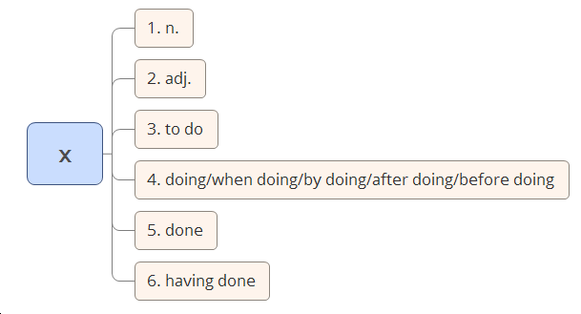

《6天搞定英语所有语法》



#### n. + svo

⚫The summer palace, **the park** is beautiful.

⚫I like **the Great Wall**, one of the eight wonders in the world.

《6天搞定英语所有语法》



#### adj + svo

⚫Mindful of the danger, **we** stopped climbing.

⚫Beautiful as Fan Bingbing, **the girl** is the most welcomed one in her school.

《6天搞定英语所有语法》



#### to do + svo

⚫To become beautiful, **Vic** is losing weight.

⚫To improve English, **I** choose to learn from Allen.

《6天搞定英语所有语法》



#### doing + svo

* + - Standing on the top of the mountain, **I** saw the whole Beijing.
    - **He** sat under the tree, reading a book.
    - **The song is sung all over the country,** making it the most

popular song.

《6天搞定英语所有语法》



#### when doing + svo

* When doing homework, **I** felt sleepy.
* When crossing the bridge, **I** saw Wu Yanzu.

《6天搞定英语所有语法》



#### by doing + svo

⚫By learning the cooking skill, **she** can cook now.

⚫By studying English from Allen, **I** improved it.

《6天搞定英语所有语法》



#### 5、done + svo

Built in 1979, **our shool** is an old school.

⚫ **He** entered the room, followed by his dog.

《6天搞定英语所有语法》



#### 6、Having done+ svo

⚫Having handed in the paper, **he** left the room.

⚫Having been given a map, **we** found our way easily.

 《6天搞定英语所有语法》



#### X, SVO

《6天搞定英语所有语法》



巩固练习

请用“悬挂结构” 分析下面的句子中悬挂部分和主干的关系。

1. She sent Henry, the eldest son, to school.
2. I'm He Wei, an exchange student from China.
3. Lin Tao, a 14-year-old schoolboy, still didn't show up at school.
4. Recently The Reader, a very popular TV program, is staged in the form of reading.
5. C919 is developed by COMAC ,a Chinese aircraft company.

《6天搞定英语所有语法》



巩固练习

请用“悬挂结构” 分析下面的句子中悬挂部分和主干的关系。

1. She sent Henry, the eldest son, to school.
2. I'm He Wei, an exchange student from China.
3. Lin Tao, a 14-year-old schoolboy, still didn't show up at school.
4. Recently The Reader, a very popular TV program, is staged in the form of reading.
5. C919 is developed by COMAC ,a Chinese aircraft company.

《6天搞定英语所有语法》



巩固练习

请用“悬挂结构” 分析下面的句子中悬挂部分和主干的关系。

1. In this video, the little girl wore a qipao, a kind of traditional Chinese dress.
2. Tong Xiaojun, a director from a university, told CCTV “we need support from the whole society to solve the problems.”
3. Lucy is on her way to Harvard, one of the eight world-famous universities in the eastern US.

《6天搞定英语所有语法》



巩固练习

请用“悬挂结构” 分析下面的句子中悬挂部分和主干的关系。

1. In this video, the little girl wore a qipao, a kind of traditional Chinese dress.
2. Tong Xiaojun, a director from a university, told CCTV “we need support from the whole society to solve the problems.”
3. Lucy is on her way to Harvard, one of the eight world-famous universities in the eastern US.

《6天搞定英语所有语法》



巩固练习

请用“悬挂结构” 分析下面的句子中悬挂部分和主干的关系。

1. I went home, tired and exhausted.
2. I play tennis with my best friend, happy and excited
3. Confident of the victory, the players are fighting hard.
4. To deal with this problem, the Chinese government worked out a draft regulation in January this year.

《6天搞定英语所有语法》



巩固练习

请用“悬挂结构” 分析下面的句子中悬挂部分和主干的关系。

1. I went home, tired and exhausted.
2. I play tennis with my best friend, happy and excited
3. Confident of the victory, the players are fighting hard.
4. To deal with this problem, the Chinese government worked out a draft regulation in January this year.

《6天搞定英语所有语法》



巩固练习

请用“悬挂结构” 分析下面的句子中悬挂部分和主干的关系。

1. To continue the production, the company plants more bamboo than it cuts.
2. Having the will, he always found the way.
3. Feeling sorry for the chrysalis(蛹), the man decides to help.
4. He also writes articles, hoping that more people will join in protecting natural ecosystems.

《6天搞定英语所有语法》



巩固练习

请用“悬挂结构” 分析下面的句子中悬挂部分和主干的关系。

1. To continue the production, the company plants more bamboo than it cuts.
2. Having the will, he always found the way.
3. Feeling sorry for the chrysalis(蛹), the man decides to help.
4. He also writes articles, hoping that more people will join in

protecting natural ecosystems.

《6天搞定英语所有语法》



巩固练习

请用“悬挂结构” 分析下面的句子中悬挂部分和主干的关系。

1. The helmet(头盔) can be folded almost completely flat, making it

easier to carry.

1. He worked as a border keeper while keeping some sheep to support his family.
2. She swept floors and picked up trash again in the afternoon, before diving (跳水) into her studies in the evenings.

《6天搞定英语所有语法》



巩固练习

请用“悬挂结构” 分析下面的句子中悬挂部分和主干的关系。

1. The helmet(头盔) can be folded almost completely flat, making it

easier to carry.

1. He worked as a border keeper while keeping some sheep to

support his family.

1. She swept floors and picked up trash again in the afternoon, before diving (跳水) into her studies in the evenings.

《6天搞定英语所有语法》



巩固练习

请用“悬挂结构” 分析下面的句子中悬挂部分和主干的关系。

1. After saying that, the student threw the potato away.
2. The water taxi can run for a day after being recharged(充电).
3. By making bamboo bikes, the company offers jobs to the local people.
4. By calming down and going slowly, you give your brain a

chance to think about what it has already received.

《6天搞定英语所有语法》



巩固练习

请用“悬挂结构” 分析下面的句子中悬挂部分和主干的关系。

1. After saying that, the student threw the potato away.
2. The water taxi can run for a day after being recharged(充电).
3. By making bamboo bikes, the company offers jobs to the local people.
4. By calming down and going slowly, you give your brain a

chance to think about what it has already received.

《6天搞定英语所有语法》



巩固练习

请用“悬挂结构” 分析下面的句子中悬挂部分和主干的关系。

1. He hurried to the hall, followed by two guards..
2. The film star got off the train, surrounded by her fans.
3. The old woman walked slowly to the lift, assisted by her son.
4. The president went into the lobby, accompanied by the high

officials and reporters.

《6天搞定英语所有语法》



巩固练习

请用“悬挂结构” 分析下面的句子中悬挂部分和主干的关系。

* 1. He hurried to the hall, followed by two guards..
  2. The film star got off the train, surrounded by her fans.
  3. The old woman walked slowly to the lift, assisted by her son.
  4. The president went into the lobby, accompanied by the high

officials and reporters.

《6天搞定英语所有语法》



巩固练习

请用“悬挂结构” 分析下面的句子中悬挂部分和主干的关系。

* 1. Having worked hard all day, I went to bed early.
  2. Having experienced quite a few earthquakes, I didn’t take much notice.

1. Having lost all my old friends, I felt lonely at the new school.
2. Having succeeded in exam, he became more confident.

《6天搞定英语所有语法》



巩固练习

请用“悬挂结构” 分析下面的句子中悬挂部分和主干的关系。

1. Having worked hard all day, I went to bed early.
2. Having experienced quite a few earthquakes, I didn’t take much notice.
3. Having lost all my old friends, I felt lonely at the new school.
4. Having succeeded in exam, he became more confident.

《6天搞定英语所有语法》



实战演练

《6天搞定英语所有语法》





A girl smiles after receiving winter clothes and toys at Dadang Primary School in Yongshan county, Yunnan province, on Dec 12. The school's 179 pupils, many of whom live in poverty, were given winter clothes donated by charity organizations.

《6天搞定英语所有语法》



wipe [waɪp] v. 擦

comfort v.安慰

gymnastics [dʒɪm'næstɪks] n. 体操

A coach wipes away tears and comforts a girl who was feeling tired during gymnastics lessons at the Shanghai Yangpu Youth Amateur Athletic School in Shanghai, May 4, 2016.

 《6天搞定英语所有语法》

anchor ['æŋkə(r)] n. 主持人

award v. 奖 励celebrity n.名人，明星worth adj. 值得的



A 22-year-old online anchor Xiaomili cries after her company awards her with a prize. She won an online celebrity training course worth 500,000 yuan. She was born in a village and started out working as a waitress.

After the professional training course, she could become the next big thing

and lead a very different life.

《6天搞定英语所有语法》



orphanage ['ɔrfənɪdʒ] n. 孤儿院

Liu Shichang (left), Feng Xue (center) and Ma Lujun, all grew up in an orphanage in Zhaoxian, Hebei province, and gave up their well-paid jobs to work in the orphanage as teachers. The institution has offered aid to 157 orphans since it opened 16 years ago.

《6天搞定英语所有语法》



### 九、那些年我们经历过的痛

— 15个最常见介词的深层次含义

《6天搞定英语所有语法》



#### 英文中15个最常见的介词

in / on / at / of / for / by /with / from / to as / about / around / off / through / over

《6天搞定英语所有语法》



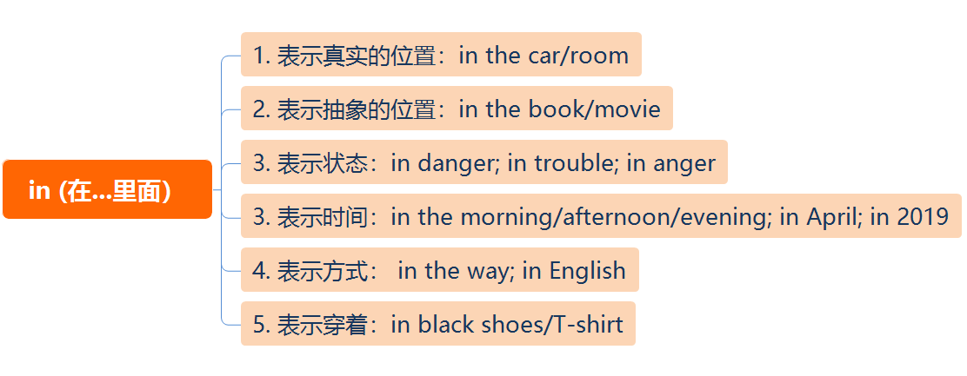

《6天搞定英语所有语法》



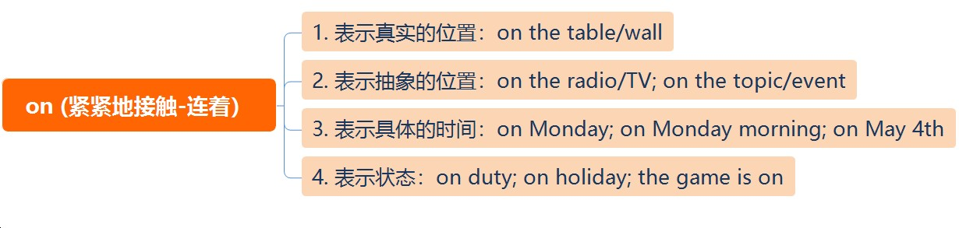

《6天搞定英语所有语法》



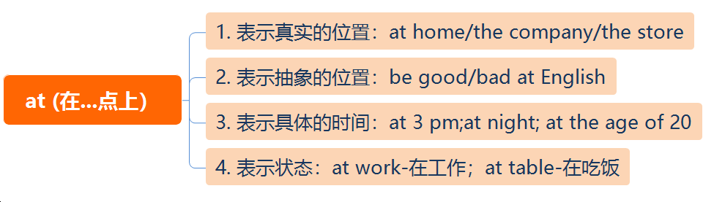

《6天搞定英语所有语法》



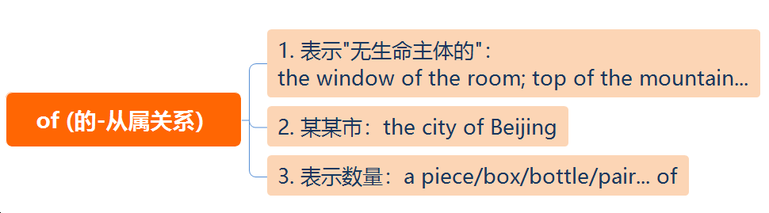

《6天搞定英语所有语法》



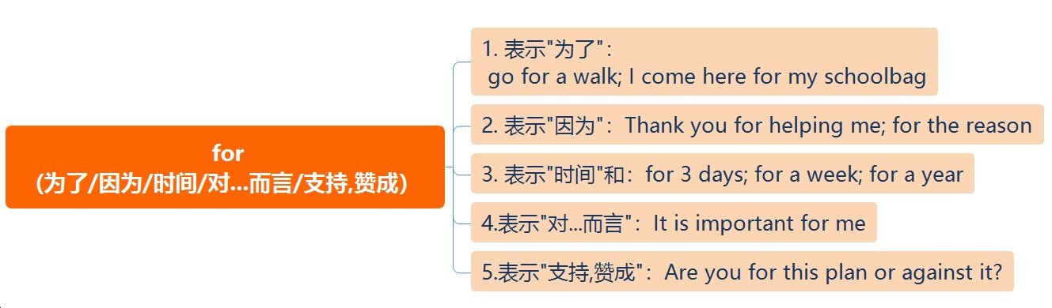

《6天搞定英语所有语法》



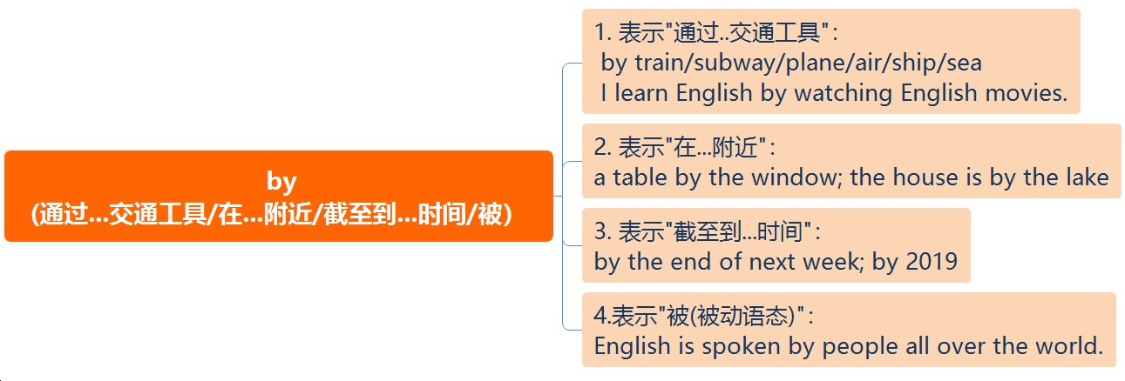

《6天搞定英语所有语法》



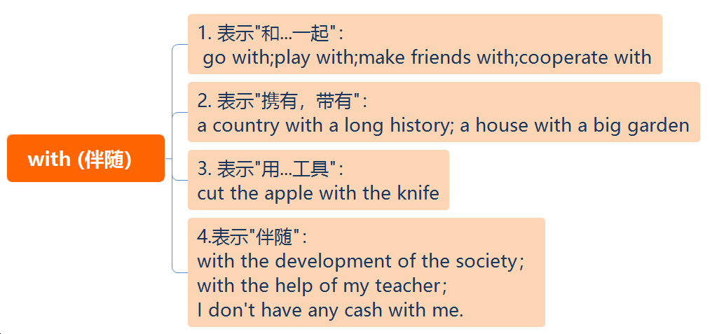

《6天搞定英语所有语法》



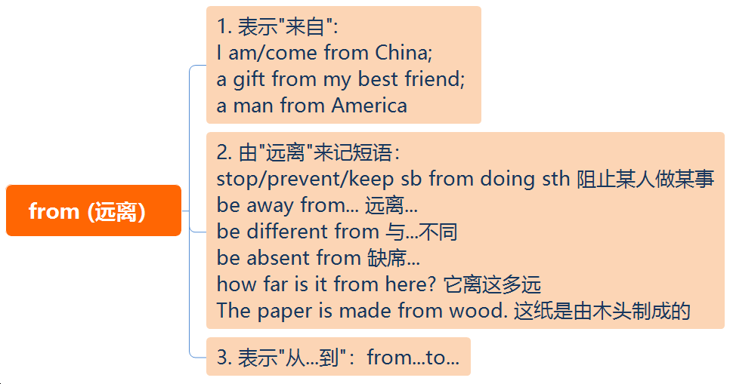

《6天搞定英语所有语法》



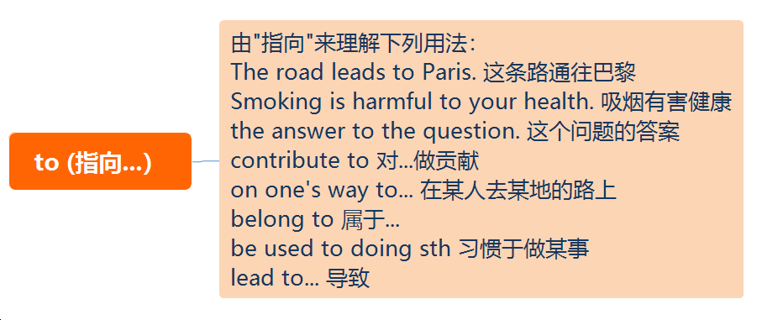

《6天搞定英语所有语法》



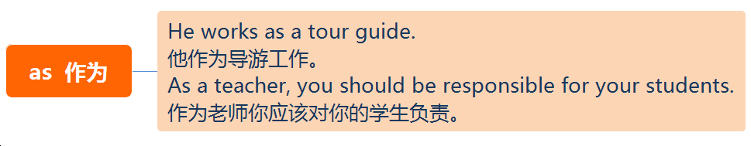

《6天搞定英语所有语法》



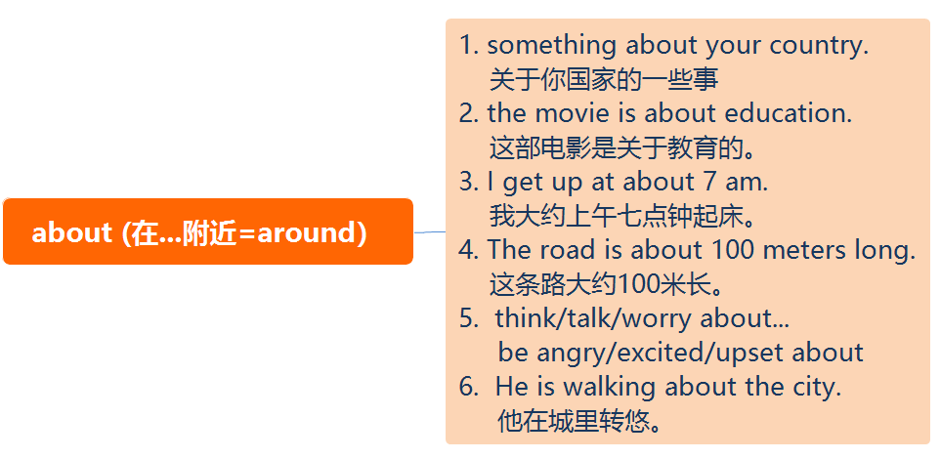

《6天搞定英语所有语法》



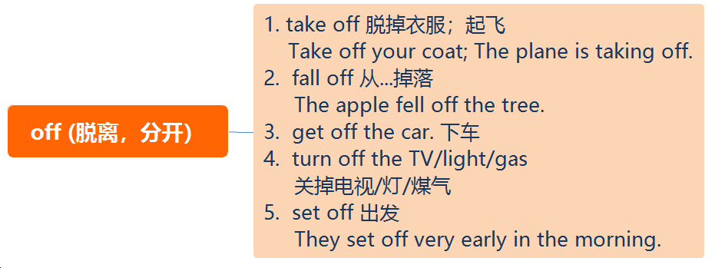

《6天搞定英语所有语法》



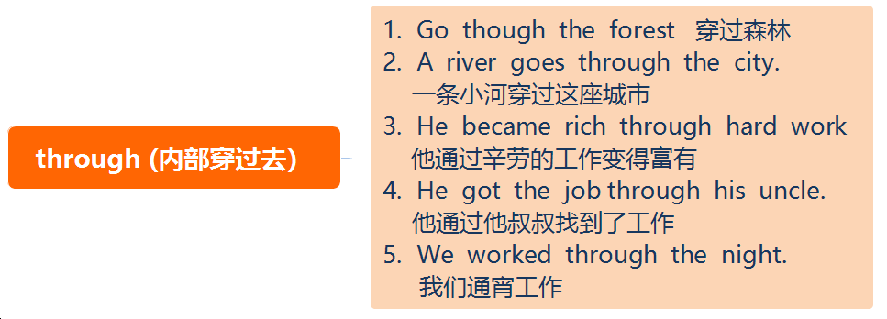

《6天搞定英语所有语法》



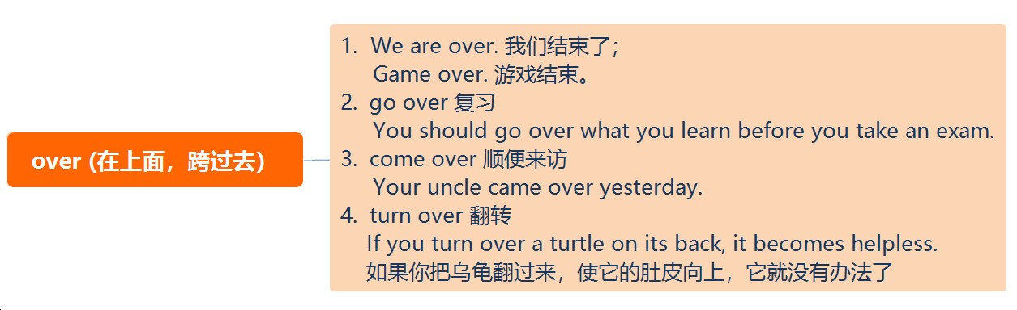

《6天搞定英语所有语法》



# 十、四大特殊句型

《6天搞定英语所有语法》



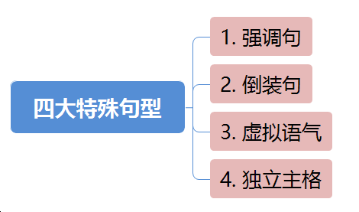

《6天搞定英语所有语法》



## 为什么会有强调句？

《6天搞定英语所有语法》



##### It is/was+强调部分+that/who +其他部分

* They will have a meeting in the hall tomorrow.
* It is they that/who will have a meeting in the hall tomorrow.
* It is a meeting that they will have in the hall tomorrow.
* It is in the hall that they will have a meeting tomorrow.
* It is tomorrow that they will have a meeting in the hall.

《6天搞定英语所有语法》



1. It is the ability to do the job matters, not where you come from or what you are.
   1. which B. that C. what D. who
2. It was not until midnight they reached the camp site.
   1. that B. when C. while D. as
3. was very that little Jim wrote the letter.
   1. It; careful B. It; carefully C. He; careful D. He; carefully

《6天搞定英语所有语法》



1. It is the ability to do the job matters, not where you come from or what you are.
   1. which B. that C. what D. who
2. It was not until midnight they reached the camp site. A. that B. when C. while D. as
3. was very that little Jim wrote the letter.
   1. It; careful B. It; carefully C. He; careful D. He; carefully

《6天搞定英语所有语法》





《6天搞定英语所有语法》



## 为什么会有倒装句？

《6天搞定英语所有语法》



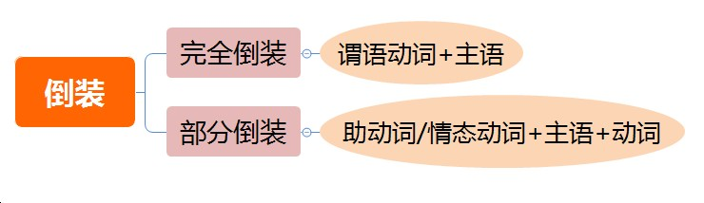

《6天搞定英语所有语法》



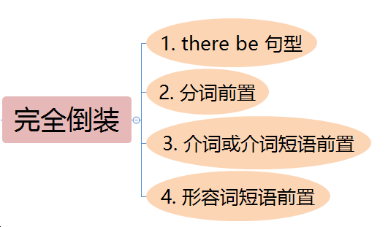

《6天搞定英语所有语法》



1, There be 结构。另外，在此结构中可以用来代替be动词的动词有

exist, appear, stand等。

* There stood a dog.
* There exist different opinions on this question.

2，分词前置

* Standing beside the desk was a teacher.
* Seated on the ground are a group of young people.

《6天搞定英语所有语法》



3, 介词或者介词短语

In came the teacher.

Out rushed the boy. **VS** Out he rushed. At the foot of the hill lies a beautiful lake.

Under the tree was lying a wounded soldier.

4, 形容词短语

Present at the meeting were Mr White and many other guests.

《6天搞定英语所有语法》



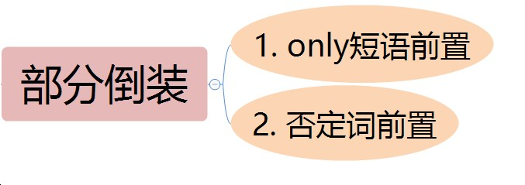

《6天搞定英语所有语法》



1, only 短语前置

* **Only** in this way can you learn English well.

2，Not until 短语前置 (属于否定词前置）

⚫He didn't finish his homework until his mother came back.

* **Not** until his mother came back did he finish his homework.

⚫ The mother didn't leave the room until the child fell asleep.

* **Not** until the child fell asleep did the mother leave the room

《6天搞定英语所有语法》



3，否定词前置

* + **Never** have I seen such a beautiful place.
  + **Seldom** do I go to the cinema.
  + **Not** a single mistake did he make at the exam yesterday.

《6天搞定英语所有语法》



1. –Do you know Jim quarreled with his brother?

--I don’t know; .

* 1. nor don’t I care B. nor do I care

C. I don’t care neither D. I don’t care also

1. – Here ! Where is David?

--There .

* 1. comes the bus; is he B. comes the bus; he is

C. the bus comes; is he D. the bus comes; he is

《6天搞定英语所有语法》



1. –Do you know Jim quarreled with his brother?

--I don’t know; .

* 1. nor don’t I care B. nor do I care

C. I don’t care neither D. I don’t care also

1. – Here ! Where is David?

--There .

* 1. comes the bus; is he B. comes the bus; he is

C. the bus comes; is he D. the bus comes; he is

《6天搞定英语所有语法》



1. Never in my life such a thing.
   1. I have heard or have seen
   2. have I heard or seen
   3. I have heard or seen
   4. did I hear or see
2. Little about his own health though he was very ill.
   1. he cared B. did he care

C. he cares D. does he care

《6天搞定英语所有语法》



1. Never in my life such a thing.
   1. I have heard or have seen B. have I heard or seen

C. I have heard or seen

D. did I hear or see

1. Little about his own health though he was very ill.
   1. he cared B. did he care

C. he cares D. does he care

《6天搞定英语所有语法》





《6天搞定英语所有语法》



## 为什么会有虚拟语气？

《6天搞定英语所有语法》



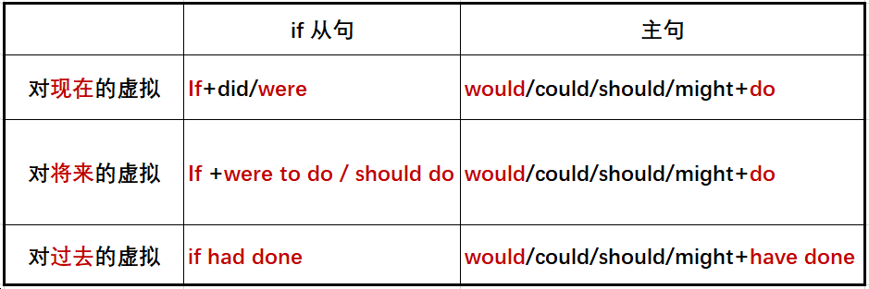

《6天搞定英语所有语法》



1. If I were you, I would accept his advice.

如果我是你，我会接受他的建议。

= Were I you, I would accept his advice.

1. If it were to rain tomorrow, I would stay at home.

如果明天下雨，我将会待在家里。

= Should it rain/Were it to rain tomorrow, I would stay at home.

1. If I had studied harder before, I would have passed the exam.

如果我以前更努力地学习，我会通过考试。

= Had I studied harder before, I would have passed the exam.

《6天搞定英语所有语法》

注意事项



在suggest, demand, order, insist等动词之后的宾语从句中用虚拟语气，即 “(should)+动词原形”

1. He suggested that we (should) set about doing the work at once.
2. I insist that she (should) do her work alone.
3. The leader ordered that the army (should) set off at once.

《6天搞定英语所有语法》



1. You didn’t let me drive. If we in turn, you so tired.
   1. drove; didn’t get B. drove; wouldn’t get
   2. were driving; wouldn’t get D. had driven; wouldn’t have got
2. I did not see your sister at the meeting. If she , she would have met my brother.
   1. has come B. did come C. had come D. came

《6天搞定英语所有语法》



1. You didn’t let me drive. If we in turn, you so tired.
   1. drove; didn’t get B. drove; wouldn’t get
   2. were driving; wouldn’t get D. had driven; wouldn’t have got
2. I did not see your sister at the meeting. If she , she would have met my brother.
   1. has come B. did come C. had come D. came

《6天搞定英语所有语法》



1. —It rained cats and dogs this morning. I’m glad we took an umbrella.

—Yeah, we would have got wet all over if we .

* 1. hadn’t B. haven’t C. didn’t D. don’t

1. If he had spent more time practicing speaking English before, he

able to speak it much better now.

* 1. will be B. would be C. has been D. would have been

《6天搞定英语所有语法》



1. —It rained cats and dogs this morning. I’m glad we took an umbrella.

—Yeah, we would have got wet all over if we . A. hadn’t B. haven’t C. didn’t D. don’t

1. If he had spent more time practicing speaking English before, he

able to speak it much better now.

* 1. will be B. would be C. has been D. would have been

《6天搞定英语所有语法》



1. I’m really very busy; otherwise, I there with you.
   1. would go B. will go C. go D. gone
2. —Do you think George has passed the driving test?

---No. If so, he his car to our college yesterday.

* 1. would drive B. drove

C. would have driven D. had driven

《6天搞定英语所有语法》



1. I’m really very busy; otherwise, I there with you.
   1. would go B. will go C. go D. gone
2. —Do you think George has passed the driving test?

---No. If so, he his car to our college yesterday.

* 1. would drive B. drove

C. would have driven D. had driven

《6天搞定英语所有语法》



1. Don’t handle the vase as if it made of steel.
   1. is B. were C. has been D. had been
2. We lost our way in that small village, otherwise we more places of interest yesterday.
   1. visited B. had visited

C. would visit D. would have visited

《6天搞定英语所有语法》



1. Don’t handle the vase as if it made of steel.
   1. is B. were C. has been D. had been
2. We lost our way in that small village, otherwise we more places of interest yesterday.
   1. visited B. had visited

C. would visit D. would have visited

《6天搞定英语所有语法》



1. I through that bitter period without your generous help.
   1. couldn’t have gone B. didn’t go

C. wouldn’t go D. hadn’t gone

1. We John’s name on the race list yesterday but for his

recent injury.

* 1. will put B. will have put

C. would put D. would have put

《6天搞定英语所有语法》



1. I through that bitter period without your generous help. A. couldn’t have gone B. didn’t go

C. wouldn’t go D. hadn’t gone

1. We John’s name on the race list yesterday but for his

recent injury.

* 1. will put B. will have put

C. would put D. would have put

《6天搞定英语所有语法》



1. My mom suggests that we eat out for a change this weekend.
   1. should B. might C. could D. would
2. Eye doctors recommend that a child’s first eye exam at the age of six months old.
   1. as B.be C. were D. is.

《6天搞定英语所有语法》



1. My mom suggests that we eat out for a change this weekend.
   1. should B. might C. could D. would
2. Eye doctors recommend that a child’s first eye exam at the age of six months old.
   1. as B.be C. were D. is.

《6天搞定英语所有语法》





《6天搞定英语所有语法》



## 独立主格结构是什么？

《6天搞定英语所有语法》



* Standing on the top of the mountain, I saw the whole Beijing.
* Built in 1979 ,our shool is an old school.

独立主格结构

* The girl staring at him, he didn't know what to say.
* The problem solved, we went home.

独立主格结构和悬挂结构的区别：

独立主格结构中有自己的独立的逻辑主语！

《6天搞定英语所有语法》



1. It is a beautiful village with a mountain it.
   1. surrounds B. surrounded.

C. surrounding D. having surrounded.

1. I couldn't do my homework with all that noise .
   1. going on B. goes on C. went on D. to go on
2. All his work , he left his office at ease.
   1. finished B. had been finished C. finishing D. to finish

《6天搞定英语所有语法》



1. It is a beautiful village with a mountain it.
   1. surrounds B. surrounded.

C. surrounding D. having surrounded.

1. I couldn't do my homework with all that noise .
   1. going on B. goes on C. went on D. to go on
2. All his work , he left his office at ease.
   1. finished B. had been finished C. finishing D. to finish

注意： with=逗号

《6天搞定英语所有语法》



十一、宇哥时态轴

——英语时态的秘密

《6天搞定英语所有语法》

1. 过去将来时 (would do)
2. 过去将来进行时(would be doing)
3. 过去将来完成时(would have done)
4. 过去将来完成进行时 (would have been doing)
   1. 一般现在时（do/be)
5. 过去

进行时

e+doing)

（was/wer

1. 过去完成时

（had+done)

11.过去完成进行时

（had+been+doing)

* 1. 现在进行时

（be+doing)

7.现在完成时

（have+done) 10.现在完成进行时

（have+been+doing)

1. 将来进行时

（will+be+doing)

1. 将来完成时

（will +have+done)

1. 将来完成进行时

（will+have+been+doing)



* 1. 一般过去时(did/was/were) 4.一般过去时(will do/be going to do)

《6天搞定英语所有语法》



* + 1. 一般现在时（do/be)

《6天搞定英语所有语法》



1. 一般现在时（do/is am are)

① I get up at 6 o’clock everyday.

② Beijing is the capital of China.

③ Do you get up at 6 o’clock everyday?

④ Is Beijing the capital of China?

⑤ When do you get up everyday?

⑥ Which city is the capital of China?

《6天搞定英语所有语法》

* 1. 一般现在时（do/be)
  2. 现在进行时

（be+doing)

* 1. 一般过去时(did/was/were)



* 1. 一般过去时(will do/be going to do)

《6天搞定英语所有语法》



* + 1. 现在进行时 (is/am/are/be +doing)

① I am doing homework now.

② He is playing basketball at the moment.

③ Are you doing homework now?

④ Is he playing basketball at the moment?

⑤ What are you doing now?

⑥ What is he doing at the moment?

《6天搞定英语所有语法》



* + 1. 一般过去时（did/was/were)

① I watched a movie last Sunday.

② I was a salesman 2 years ago.

③ Did you watch a movie last Sunday?

④ Were you a salesman 2 years ago?

⑤ What did you do last Sunday?

⑥ What were you 2 years ago?

《6天搞定英语所有语法》



* + 1. 一般将来时（is/are going to do/will do)

① He is going to get married next month.

② I will marry you when I grow up.

③ Is he going to get married next month?

④ Will you marry me when you grow up?

⑤ What is he going to do next month?

⑥ Who will you marry when you grow up?

《6天搞定英语所有语法》

* + - 1. 一般现在时（do/be)
    1. 过去进行时

（was/were+doing)

1. 现在进行时

（be+doing)

* 1. 将来进行时

（will+be+doing)

* + 1. 一般过去时(did/was/were)



* + 1. 一般过去时(will do/be going to do)

《6天搞定英语所有语法》



* + 1. 过去进行时 (was/were +doing)

① I was doing homework at this time yesterday.

② He was playing basketball yesterday afternoon.

③ Were you doing homework at this time yesterday?

④ Was he playing basketball yesterday afternoon?

⑤ What were you doing at this time yesterday?

⑥ What was he doing yesterday afternoon?

《6天搞定英语所有语法》



* + 1. 将来进行时 (will be doing)

① I will be sitting on the train to GZ at this time tomorrow.

② She will be having a meeting tomorrow morning.

③ Will you be sitting on the train to GZ at this time tomorrow?

④ Will she be having a meeting tomorrow morning?

⑤ What will you be doing at this time tomorrow?

⑥ What will she be doing tomorrow morning?

《6天搞定英语所有语法》

* + - 1. 一般现在时（do/be)

5.过去进行时

（was/were+doing)

* + - 1. 现在进行时

（be+doing)

* + - * 1. 将来进行时

（will+be+doing)



一般过去时(did/was/were) 4.一般过去时(will do/be going to do)

《6天搞定英语所有语法》

一般现在时（do/be)

5.过去进行时

（was/were+doing)

2.现在进行时

（be+doing)

6.将来进行时

（will+be+doing)

7.现在完成时

（have+done)

1. 一般过去时(did/was/were)



1. 一般过去时(will do/be going to do)

《6天搞定英语所有语法》



* 1. 现在完成时 (have/has done)

① I have finished my homework.

② She has been an English teacher for 6 years.

③ Have you finished your homework?

④ Has she been an English teacher for 6 years?

⑤ When have you finished your homework?

⑥ What has she been for 6 years?

《6天搞定英语所有语法》

* + 1. 一般现在时（do/be)

5.过去进行时

（was/were+doing)

1. 现在进行时

（be+doing)

* 1. 将来进行时

（will+be+doing)

8.过去完成时

（had+done)

* 1. 现在完成时

（have/has+done)

9.将来完成时

（will +have+done)



2.一般过去时(did/was/were) 3.一般过去时(will do/be going to do)

《6天搞定英语所有语法》



* 1. 过去完成时 (had+done)

① By the end of last week, he had learned English for 6 years.

② She had been an English teacher before she got married.

③ Had he learned English for 6 years by the end of last week?

④ Had she been an English teacher before she got married?

⑤ How long had he learned English by the end of last week?

⑥ What had she been before she got married ?

《6天搞定英语所有语法》



* 1. 将来完成时 (will have +done)

① By the end of next week, he will have learned English for 6 years.

② They will have been married for 20 years next Monday.

③ Will he have learned English for 6 years by the end of last week?

④ Will they have been married for 20 years next Monday?

⑤ How long will he have learned English by the end of next week?

⑥ How long will they have been married next Monday?

《6天搞定英语所有语法》

* + 1. 一般现在时（do/be)

5.过去进行时

（was/were+doing)

8.过去完成时

（had+done)

* + 1. 现在进行时

（be+doing)

7.现在完成时

（have+done)

* 1. 现在完成进行时

（have+been+doing)

6.将来进行时

（will+be+doing)

1. 将来完成时

（will +have+done)

* 1. 一般过去时(did/was/were)



* 1. 一般过去时(will do/be going to do)

《6天搞定英语所有语法》



* + 1. 现在完成进行时 (have/has been doing)

① I have been learning English for 5 hours.

② It has been raining for a week.

③ Have you been learning English for 5 hours?

④ Has it been raining for a week?

⑤ How long have you been learning English?

⑥ How long has it been raining?

《6天搞定英语所有语法》

* + - 1. 一般现在时（do/be)

5.过去进行时

（was/were+doing)

8.过去完成时

（had+done)

* + 1. 过去完成进行时

（had+been+doing)

2.现在进行时

（be+doing)

7.现在完成时

（have+done)

10.现在完成进行时

（have+been+doing)

6.将来进行时

（will+be+doing)

9.将来完成时

（will +have+done)

1. 将来完成进行时

（will+have+been+doing)

* 1. 一般过去时(did/was/were)



* 1. 一般过去时(will do/be going to do)

《6天搞定英语所有语法》



* + 1. 过去完成进行时 (had been doing)

① I had been learning English for 5 hours before my mum came back.

② It had been raining for a week before I got here.

③ Had you been learning English for 5 hours before your mum came back?

④ Had it been raining for a week before you got here?

⑤ How long had you been learning English before my mum came back?

⑥ How long had it been raining before you got here?

《6天搞定英语所有语法》



* + 1. 将来完成进行时 (will have been doing)

① I will have been living in BJ for 3 years by this time next month.

② He will have been working on the program for 5 days by Friday.

③ Will you have been living in BJ for 3 years by this time next month?

④ Will he have been working on the program for 5 days by Friday?

⑤ How long will you have been living in BJ by this time next month?

⑥ How long will he have been working on the program by Friday?

《6天搞定英语所有语法》

* + 1. 过去将来时 (would do)
    2. 过去将来进行时(would be doing)
    3. 过去将来完成时(would have done)
    4. 过去将来完成进行时 (would have been doing)
       1. 一般现在时（do/be)

5.过去

进行时

e+doing)

（was/wer

8.过去完成时

（had+done)

11.过去完成进行时

（had+been+doing)

* + - 1. 现在进行时

（be+doing)

7.现在完成时

（have+done) 10.现在完成进行时

（have+been+doing)

6.将来进行时

（will+be+doing)

9.将来完成时

（will +have+done)

1. 将来完成进行时

（will+have+been+doing)



3.一般过去时(did/was/were) 4.一般过去时(will do/be going to do)

《6天搞定英语所有语法》



1. 过去将来时 (would do; was/were going to do)

① He said he would love me forever.

② She said she were going to have a meeting the next Friday.

1. 过去将来进行时 (would be doing)

① He said he would be living in BJ one day.

② She told me that she would be studying at Peking University.

《6天搞定英语所有语法》



1. 过去将来完成时 (would have done)

① He said he would have lived in BJ for 5 years by the end of 2017.

② She told me she would have worked here for 5 years by May, 2017.

1. 过去将来完成进行时 (would have been doing)

① He said he would have been living in BJ for 5 years by the end of 2017.

② She told me she would have been working here for 5 years by May, 2017