

|  |
| --- |
| **NEW YORK CITY AIRBNB**  **DATA ANALYSIS REPORT** |
| (2019) |
| June 21  Written by: Afolayan Yinka Tosin |

TABLE OF CONTENTS

LIST OF FIQURES iii

INTRODUCTION 1

Overview of Airbnb NYC 1

Problem Statement 1

Objectives 2

REASEARCH QUESTIONS 3

DATASET INFORMATION 4

Overview 4

Data source 4

Data Columns 4

Calculated Columns 5

KEY FINDINGS 6

DATA VISUALIZTAION 7

Geographic Analysis 7

Room Types Analysis 9

Pricing Analysis 10

Host Analysis 11

DATA VISUALISATION 12

CONCLUSION 13

RECOMMENDATIONS 14

# LIST OF FIQURES

Figure 1: Airbnb Listing by Neighbourhood Groups 8

Figure 2: Top Five Neighbourhoods 9

Figure 3: Room Types 10

Figure 4: Avg. Price of Room Types in Airbnb NYC Neighbourhood Groups 11

Figure 5: Top Hosts 12

Figure 6: NYC Airbnb Dashboard 12

# INTRODUCTION

## Overview of Airbnb NYC

Airbnb in New York City is a vibrant and dynamic market. It is a short-term rental system where people (Hosts) can rent out their homes or properties for a short period usually ranging from a few days to a few weeks. New York City offers a unique Airbnb experience for travelers. These experiences may not be available through traditional hotels.

This report explores the Airbnb NYC dataset to analyze trends and patterns that can offer valuable insights into the market dynamics and inform decision-making processes.

## Problem Statement

The rise of short-term rental platforms like Airbnb has significantly transformed the hospitality industry. A comprehensive analysis of the Airbnb dataset is essential to optimize pricing strategies, improve guest satisfaction, and enhance the availability of properties. This analysis will help in identifying key factors that influence the performance and popularity of listings.

## Objectives

This analysis aims to extract actionable insights from the Airbnb dataset to understand the factors influencing listing performance and guest satisfaction. The specific objectives are:

1. To analyze the distribution and pricing of Airbnb listings across different neighborhoods.
2. To identify the relationship between property characteristics (e.g., room type, availability) and pricing.
3. To examine the impact of reviews on Airbnb listings.
4. To examine host performance metrics and trends.

# REASEARCH QUESTIONS

1. What are the most popular neighborhoods in New York for Airbnb bookings compared to others?
2. What are the characteristics of highly rated Airbnb rentals in New York City?
3. How does the price of Airbnb listings vary across different neighborhoods in New York City?
4. How does number of reviews impact the booking rate of Airbnb rentals in New York City?
5. Is there any correlation between the frequency of reviews and the total number of listings for New York City Airbnb Hosts?

# DATASET INFORMATION

## Overview

The Airbnb NYC dataset describes the listings and performance metrics for the year 2019. The dataset provides all the information required to delve into the hosts details, locations, availability and important metrics for analysis.

## Data source

The data used for this analysis was sourced from Kaggle which contains detailed information about listings, including the property details, host information, geographic location, pricing, and user reviews.

## Data Columns

The original dataset consists of 16 columns and 48,896 rows.

1. Id: A unique identifier for each Airbnb listing in the dataset.
2. Name: The name of the Airbnb listing.
3. Host_id: A unique identifier for each host on Airbnb.
4. Host_name: The name of the host who manages the Airbnb listing.
5. Neighbourhood_group: The broader geographical region or group within which the neighbourhood is located.
6. Neighbourhood: The specific neighbourhood or area where the Airbnb property is situated.
7. Latitude: The geographic latitude coordinate of the Airbnb listing's location.
8. Longitude: The geographic longitude coordinate of the Airbnb listing's location.
9. Room_type: The type of room or accommodation offered by the Airbnb listing (Entire home/apt, Private room, Shared room).
10. Price: The nightly rental price for the Airbnb listing
11. Minimum_nights: The minimum number of nights required for booking the Airbnb listing.
12. Number_of_reviews: The total number of reviews left by guests who have stayed at the Airbnb listing.
13. Last_review: The date of the most recent guest review for the Airbnb listing.
14. Reviews_per_month: The average number of reviews received per month for the Airbnb listing.
15. Calculated_host_listings_count: The count of listings managed by the host, including the current one, in the Airbnb platform.
16. Availability_365: The number of days in a year that the Airbnb listing is available for booking.

# DATA CLEANING AND PREPROCESSING

The dataset was cleaned in Microsoft Excel to remove errors and inconsistencies. This is necessary to ensure that the data is accurate and ready for analysis. The following operations were carried out before loading the dataset into Power BI for further analysis:

* A table was Inserted and headings were changed to proper case using the PROPER function.
* All the datasets contained in each column were transformed into the appropriate datatypes.
* The blank cells in the ‘Name’ column were replaced with ‘Unknown’.
* The blank cells in the ‘Host_Name’ column was replaced with ‘Anonymous’.
* The blank cells in the ‘Last_Review’ column was replaced with ‘No review’.
* The blank cells in the ‘Last_Review­_Year’ column was replaced with ‘No review’.
* The ‘#NAME?’ cell in the ‘Host_Name’ column was replaced with ‘Anonymous’.
* The ‘#NAME?’ cells in the ‘Name’ column were replaced with ‘Unknown’.

## Calculated Column

Last_Review_Year: A new column that contains the year of the last review date was added to the dataset. The year was extracted from the Last_review column using the YEAR function.

# KEY FINDINGS

The following are the key findings gotten from the analysis of the New York City Airbnb 2019 dataset.

* There were 37,457 unique hosts
* There were 349,305 total listings.
* The average price for the room types is $152.72.
* The average price per stay for Airbnb in New York City is $21.38.
* The dataset contains 221 neighbourhoods.
* The most common room type is the “Entire Home/Apt”.
* Sonder (NYC) emerged as the top host.

# DATA ANALYSIS

## Geographic Analysis

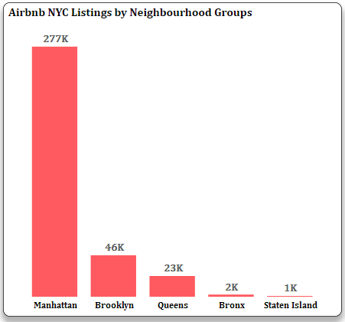

Figure 1: Airbnb Listing by Neighbourhood Groups

The analysis reveals that Manhattan has the highest number of Airbnb listings, followed by Brooklyn. This is likely due to Manhattan being a hotspot for tourists, thriving business hubs, and dynamic cultural activities.

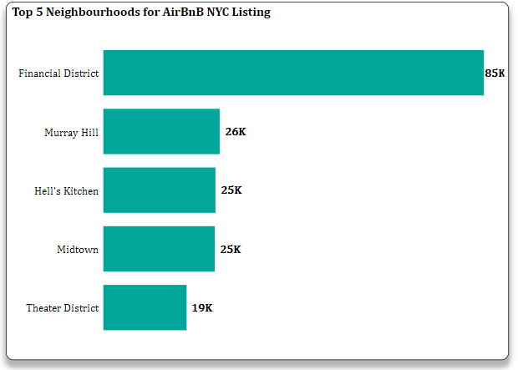

Figure 2: Top Five Neighbourhoods

Financial Districts, Murray Hill, Hell’s Kitchen, Midtown and Theater District are the top five neighbourhoods based on the total listings in the dataset. The popularity of these areas is likely due to increase in Airbnb properties and higher demand by tourists and business travelers.

## Room Types Analysis

|  |  |
| --- | --- |
| Figure 3: Room Types |  |

The analysis shows that the “Entire Home/Apt” is the most available and top listed Airbnb property with about 78% of the total listings in 2019. This might suggest that travelers or tourists prefer renting entire residential spaces for their stays.

## Pricing Analysis

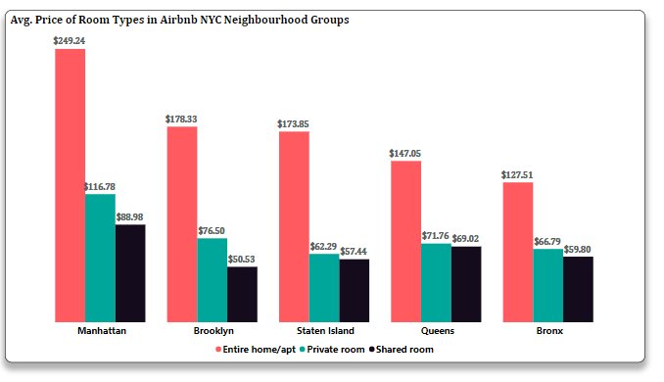

Figure 4: Avg. Price of Room Types in Airbnb NYC Neighbourhood Groups

From the analysis, the average prices of room types across neighbourhood groups, it is evident that “Entire home/apt” maintains a higher average price across all the neighbourhood groups which could have been due to the higher demand of “Entire home/apt”.

Furthermore, when the other room types, Private room and Shared room are closely evaluated, Manhattan stands out as the top-priced neighbourhood group. Bronx had the most affordable Airbnb listings, this can be attributed to various factors such as location, demand, amenities offered in the Airbnb and the standard of living in the area.

## Host Analysis

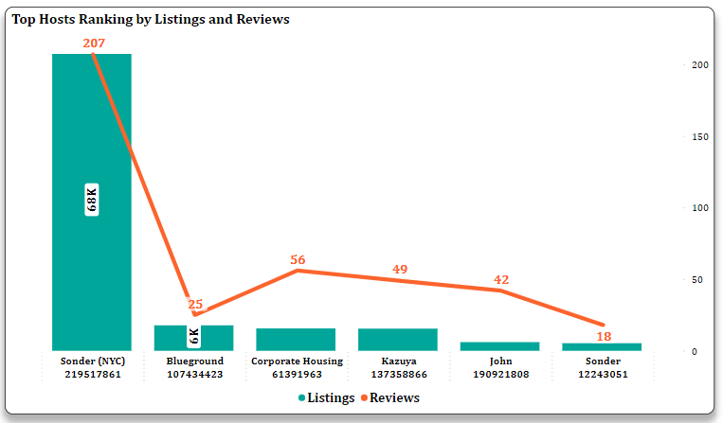

Figure 5: Top Hosts

The report shows that Sonder (NYC) is the top host with the highest number of Airbnb listings and reviews. The host “Blueground” had the second highest listings but a relatively low number of reviews this could be due to various factors. It is possible that “Blueground” and other hosts did not receive reviews for each listing, leading to a discrepancy between the total number of listings and total reviews. This lack of correlation highlights the complexity of the host performance metrics, therefore there is a need to consider other variables for further analysis.

# DATA VISUALISATION

Below is a snapshot of New York City Airbnb 2019 dashboard which shows the key metrics and general analysis.

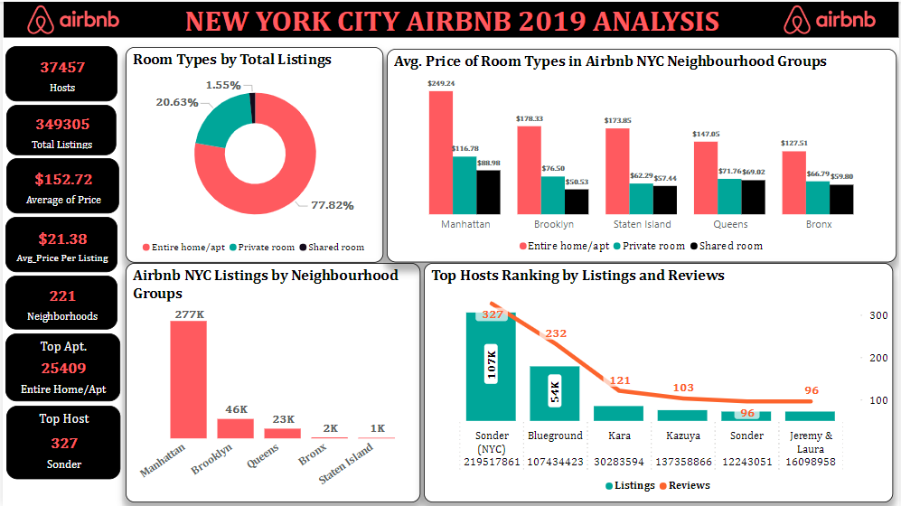

Figure 6: NYC Airbnb Dashboard

# CONCLUSION

In conclusion, this analysis has provided key and valuable insights into the Airbnb market trends in New York City. It was discovered that Manhattan is the top neighbourhood group in terms of Airbnb listings followed by Brooklyn. The dominance of Manhattan in the Airbnb market is due its high demand as a center for tourism, business, and culture. Financial Districts had the highest listings which implies that there are more Airbnb properties and higher demand by tourists and business travelers in the area.

Furthermore, Entire home/apt is the most preferred by Airbnb users which also turned out to be the most expensive room type across all the neighbourhood groups.

Finally, Sonder (NYC) stands out as the leading host with the most listings and reviews, although the frequency of reviews may have not influenced listing rates by the hosts. This analysis provides a comprehensive overview of New York City Airbnb market performance. It highlights valuable insights and key metrics influencing performance and popularity of listings of Airbnb in New York City.

# RECOMMENDATIONS

Based on the insights gathered from this analysis, the following recommendations are suggested:

1. Hosts should actively engage with the guests by offering personalized experiences to enhance their listing performance. Personalized experiences for guests can include welcome notes or gifts, themed decorations and local experiences to make their stay memorable and unique.
2. A new review mechanism can be introduced that can motivate guests to share their stories and feedbacks. This can help in providing an accurate representation of the host’s services which in return will lead to increased listing.