**Pace University**

**Seidenberg School of Computer Science and Information Systems**

**CS 361 Programming Languages and Implementation**

**HW 4**

**11/5/2018**

**Krutika Wadhwa**

**Yunting Yin**

## Grammars

*Due on 12/5*

The work has to be done in a group of 2 students.

A hard copy is required. Professional presentation is important.

100 points

**Exercise 1:**

We consider the BNF grammar below:

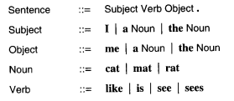

1. Show that **I like the cat.** is recognized by this BNF grammar using a rightmost derivation and, then, a parse tree.

**Answer:**

Rightmost derivation:

Sentence → Subject Verb Object → Subject Verb the Noun → Subject Verb the cat → Subject like the cat → I like the cat

Parse Tree:

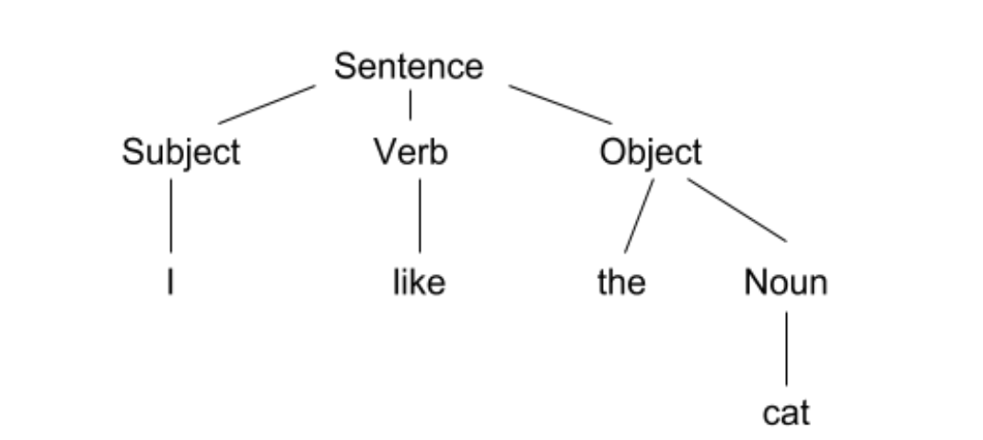

1. Provide an expression that is NOT recognized by the grammar.

She loves him

**Exercise 2:**

We consider the following grammar:

EXPRESSION ::= NUMERAL | ( EXPRESSION OPERATOR EXPRESSION )

NUMERAL ::= 0 | 1 | 2 | 3 | 4 | 5 | 6 | 7 | 8 | 9

OPERATOR ::= + | -

Show that (4 - (3 + 2)) is a legal EXPRESSION using a leftmost derivation, and,then, a parse tree.

**Answer:**

Leftmost derivation:

EXPRESSION → (EXPRESSION OPERATOR EXPRESSION) → (NUMERAL OPERATOR EXPRESSION) → (4 OPERATOR EXPRESSION) → (4 - EXPRESSION) → (4 - (EXPRESSION OPERATOR EXPRESSION)) → (4 - (NUMERAL OPERATOR EXPRESSION)) → (4 - (3 OPERATOR EXPRESSION)) → (4 - (3 + EXPRESSION)) → (4 - (3 + NUMERAL)) → (4 - (3 + 2))

Parse Tree:

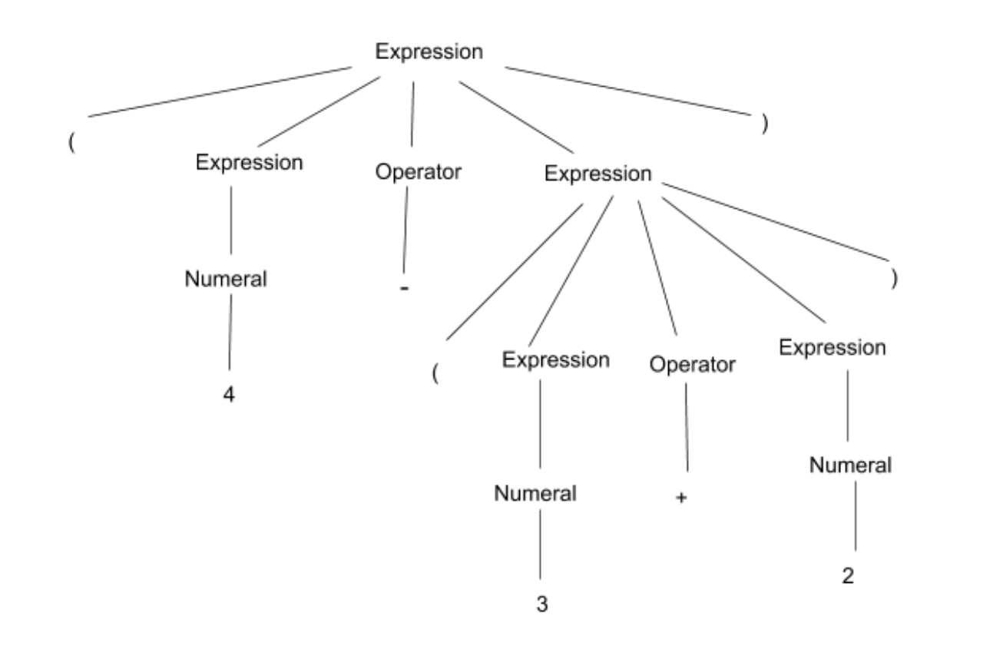

**Exercise 3:**

Show that the following grammar is ambiguous:

X -> a | bX | bXcX

where a,b,c are terminals.

**Answer:**

The expression bbaca can be shown using two parse trees.

Parse Tree 1:

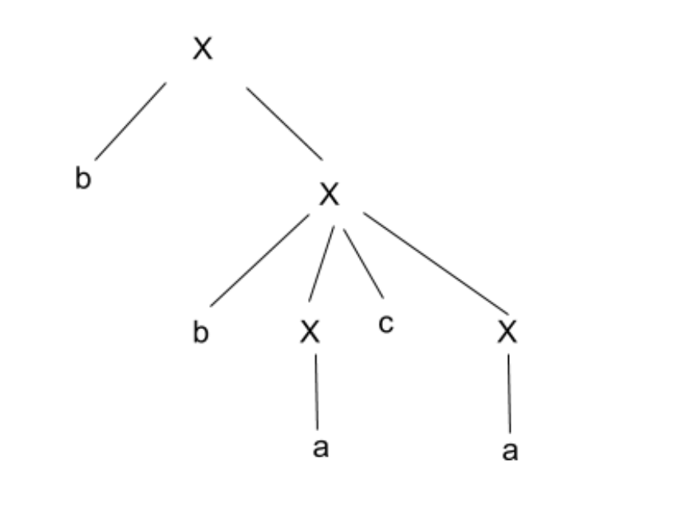

Parse Tree 2:

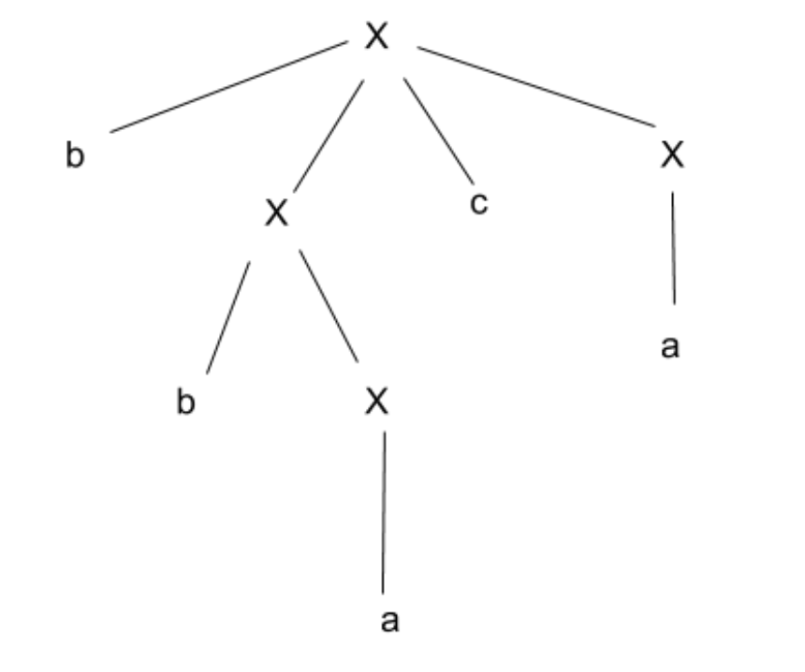

**Exercise 4:**

1. Design a BNF grammar that recognizes expressions of the form Ai where A is in {a,b,c} and i is a digit.

**Answer:**

expression → letter digit

letter → a | b| c

digit → 0 | 1 | 2 | 3 | ….|9

1. Design a BNF grammar that recognizes lists of the form A0, A1, A2, A3, …, An. Use question a).

**Answer:**

expression → letter digit

letter → a | b| c

digit → 0 | 1 | 2 | 3 | ….|9

1. Write a BNF grammar and a regular expression that describes the structure of US telephone numbers, which can either be (xxx)xxx-xxxx or xxx-xxxx, where x is a digit from 0 to 9.

**Answer:**

BNF:

expression → ( num) num - last | num last

num → digit digit digit

last → digit digit digit digit

digit → 0 | 1 | 2 | 3|..|9

Regular expression:

(?[0-9][0-9][0-9])?[0-9]?[0-9]?[0-9]?-[0-9][0-9][0-9][0-9]

**Exercise 5:**

Do the online exercises here: <https://regex.sketchengine.co.uk/> and report your answers.

**Answer:**

Exercise 1: .*p.t.*

Exercise 2: .*ap.?t.*

Exercise 3: .*af+g.?k.*

Exercise 4: [a-z" "']+[.?!')][" "')][A-Za-z" "]+

**Exercise 6:**

1. Write a JAY program that computes the sum of the *n* first numbers with a loop.

void main{

int n;

int count=0;

while(n>0)

{

count=count+n;

n=n-1;

}

}

1. Write a JAY program that assigns the minimum of two numbers in a variable called min.

void main{

int a;

int b;

int min;

if(a<b){

min=a;

}

else{

min=b;

}

}

1. Provide 2 examples of lexical errors in JAY.

$ , ~

1. Provide 2 examples of JAY programs with 2 different syntax errors.

Example 1:

void main() // Missing curly brace

int a;

}

Example 2:

void main (){

for () {

}// a for loop

}

1. Provide 2 examples of JAY programs with errors that are neither detected during the lexical analysis nor during the syntactic analysis.

Example 1:

void main (){

int a;

a = false;

}

Example 2:

void main (){

int i;

j=3;

}