**Python**

**Exercises**

The code must be submitted under your name in GitHub in a repository called Python. Work individually.

Create one file with all your work and name it: cs361python.py or cs 631python.py.

Do not commit code that does not compile. The code that you commit should have been tested. -10 points for each exercise for code that does not compile on the top of your grade.

You will provide a hardcopy with your code to Dr. Scharff on 12/17.

**Exercise 1**

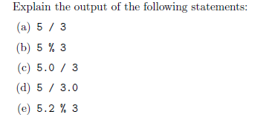

**Exercise 2**

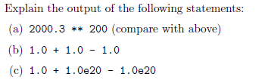

**Exercise 3**

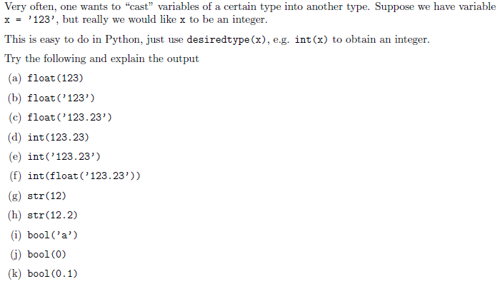

**Exercise 4**

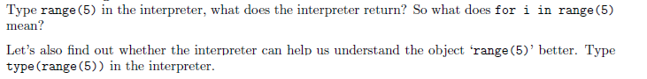

**Exercise 5**

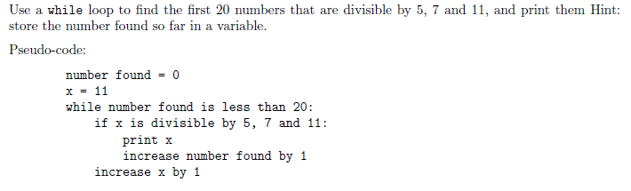

**Exercise 6**

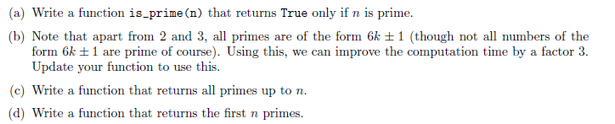

**Exercise 7**

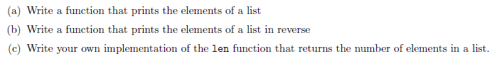

**Exercise 8**



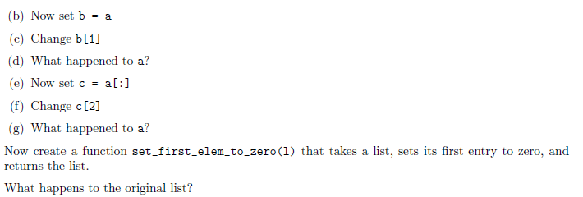

**Exercise 9**



**Exercise 10**

Use mathplotlib

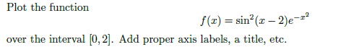

**Exercise 11**



**Exercise 12**

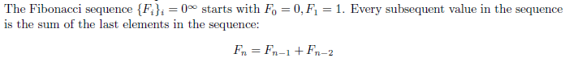

**Exercise 13**

Write a Python program that extracts the email addresses of a file. An email file emails.txt is provided to test your program.

<http://rubular.com/> is a site that can be useful to get familiar with regular expressions.

**References**

Stanford courses on Python <https://web.stanford.edu/~schmit/cme193/exercises.html>