

Internet of Things Engineering Practices

Course Report

Title : Storage environment monitoring system

Group number : Group 04

|  |  |  |
| --- | --- | --- |
| Name | Class | BUPT number |
| 李胤泽 Li Yinze | 2016215122 | 2016213609 |
| 姚远 Yao Yuan | 2016215122 | 2016213610 |
| 王鹏然 Wang Pengran | 2016215122 | 2016213611 |

2019.12

1. **Originality of application system**

The IoT storage environment monitoring system we designed is mainly used to monitor the environmental conditions of various warehouses. At present, the system mainly implements temperature and humidity monitoring. Systems that use sensors to monitor temperature and humidity are more common in today's warehouse management. The innovation of the system we designed are some additional functions which are based on the environmental monitoring.

In the project, while monitoring the temperature and humidity of the environment, the system can also alarm according to the set temperature and humidity warning lines (alarm lights will light up to remind users to pay attention). In addition, users can customize the temperature and humidity warning line values in the UI to respond to different use environments. For example, in cold chain storage, users can lower the temperature line to zero to ensure a low temperature storage environment to prevent economic losses caused by rising temperatures. In the same way, this function can also be applied to the insulation function.

At the same time, the user can also adjust the frequency of data packets sent by the sensor on the UI interface. When the system is deployed in a large area, many temperature and humidity sensors will be connected, and many data packets will be uploaded. In order to avoid waste of resources and energy, users can change the upload frequency through this function. For example, in areas where monitoring is important, users can increase the upload frequency (once every 10ms), but in other areas they can reduce the frequency (once every 5s). This will save a lot of resources and energy.

# Related technology

In the project, we mainly use the related technology of WSN and NB-IoT technology. In order to monitor indoor and outdoor environmental information, sensors are definitely needed to acquire these data, so WSN-related technologies are bound to be used. And WSN has low power, low cost, distributed style and many advantages such as self-organization are ideal for large-scale deployment in a warehouse environment. In the project, we used temperature and humidity sensors to obtain data. Using these technologies, the system can continuously receive temperature and humidity data from the deployed location.

At the same time, the technology of NB-IoT was used in the project. NB-IoT technology has many characteristics, one is flexible deployment, the other is suitable for application scenarios with weak mobility support, and the third is the advantages of low cost and high capacity. And based on this, the A9 intelligent module is used. Through serial communication technology, Arduino sends instructions to A9, and then A9 and OneNET use TCP connection with each other. Then users can upload the data sent by the sensor to the corresponding data stream on the OneNET platform.

# System function

**Requirements analysis：**

Nowadays, in the physical manufacturing industry and the logistics industry and other industries, we will definitely encounter the problem of warehouse management, and the monitoring of the warehouse environment is an important part of it. Especially in cold chain storage, chemical storage, and other storage methods that have more stringent requirements on the storage environment, a viable wireless sensor network based IoT storage environment monitoring system becomes particularly important. Warehouse management personnel can obtain the storage environment information through the monitoring system in real time. Whenever the storage environment parameters exceed the safe range, sensors in areas with abnormal parameters can immediately warn and alert the storage management personnel. At the same time, in order to cope with different deployment environments, the environmental monitoring system should allow users to change parameters in the UI interface, such as adjusting the temperature and humidity warning line value to meet different deployment requirements or adjusting the frequency of uploading data packets to reasonably save the energy of the sensor. Bandwidth occupancy and reduced wait latency. According to the above user requirements, we have developed an IoT warehouse environment monitoring system based on WSN and NB-IoT.

**Functions analysis：**

This system is mainly used to monitor the temperature and humidity data of the storage environment. The main function is to obtain temperature and humidity data of the deployed area through sensors. In the project, we developed a complete software system to facilitate the operation and use of users. In the system UI interface, users can directly see the real-time humidity and temperature information of the environment in which the sensors are deployed, and when the storage temperature and humidity exceed the set temperature and humidity warning line, the LED lights will flash alarm.

In addition, users can also adjust system parameters through the UI software. First, the user can adjust the temperature and humidity warning lines for alarms. Users can set different alert lines according to their respective storage scenarios, and do not need to change in the source code, which increases the friendliness of the product. At the same time, the user can also adjust the data packet upload frequency of the temperature and humidity sensor in the software system UI interface. For areas that require focused monitoring and management, users can increase the upload frequency of sensors in the area to achieve close monitoring of the area. For sub-primary storage areas, the upload frequency of low-temperature humidity data packets can be reduced, which not only achieves monitoring of the storage environment, but also saves sensor energy and reduces channel occupation.

# Design and Implementation of system

**Overall model design:**

The whole system is divided into two parts, one is the A9 model, which is designed to sense the current temperature and humidity and put this perceived information and the current time interval to the LCD screen. Once the temperature and humidity are over the cordon, the LCD screen will show "Warning!!!" and the light will be turned on, when the temperature and humidity return to normal, the screen display information and the state of the lamp return to the original state.

We also use it to upload these data to OneNET platform and form a change trend graph. The other part is the Java control system, which can get the environment information showing to the user. He can quickly set the temperature, humidity cordon and the refresh time according to his demands.

For example, the temperature warning line can be lowered when storing goods with a lower temperature. At present, this system is only a detection function. After expansion, it can be linked with the greenhouse adjustment equipment. Once it is found that the temperature is higher than the boundary, the air conditioner will be increased in time. Export air volume to achieve constant good storage of goods. Humidity control can be linked with the humidifier. In this way, it is convenient to store different types of goods, and to adapt to storage under different circumstances. When the circulation of goods such as Double Eleven is large, and the environment changes greatly, the detection cycle can be shortened in time to reduce the possibility of conditions Sex. All detected data and the alert lines set by the administrator in different situations will be stored in a file for subsequent management. These processes are all realized by serial communication.

**System physical distribution:**

Install the A9 module in a relatively stable location in the warehouse to prevent the goods from interfering with the sensor information collection to a greater extent during transportation management. Connect the A9 module to the computer in the monitoring room with a serial communication cable and use the program on the computer to control various information.

**Key code explanation：**

* Ja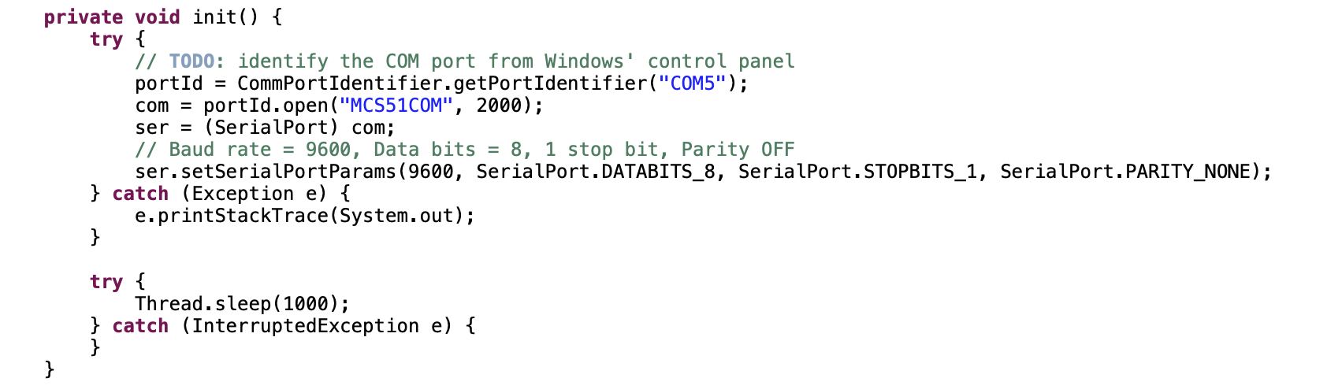va part

Connect to serial communication so that you can communicate with the A9 module from the Java console.

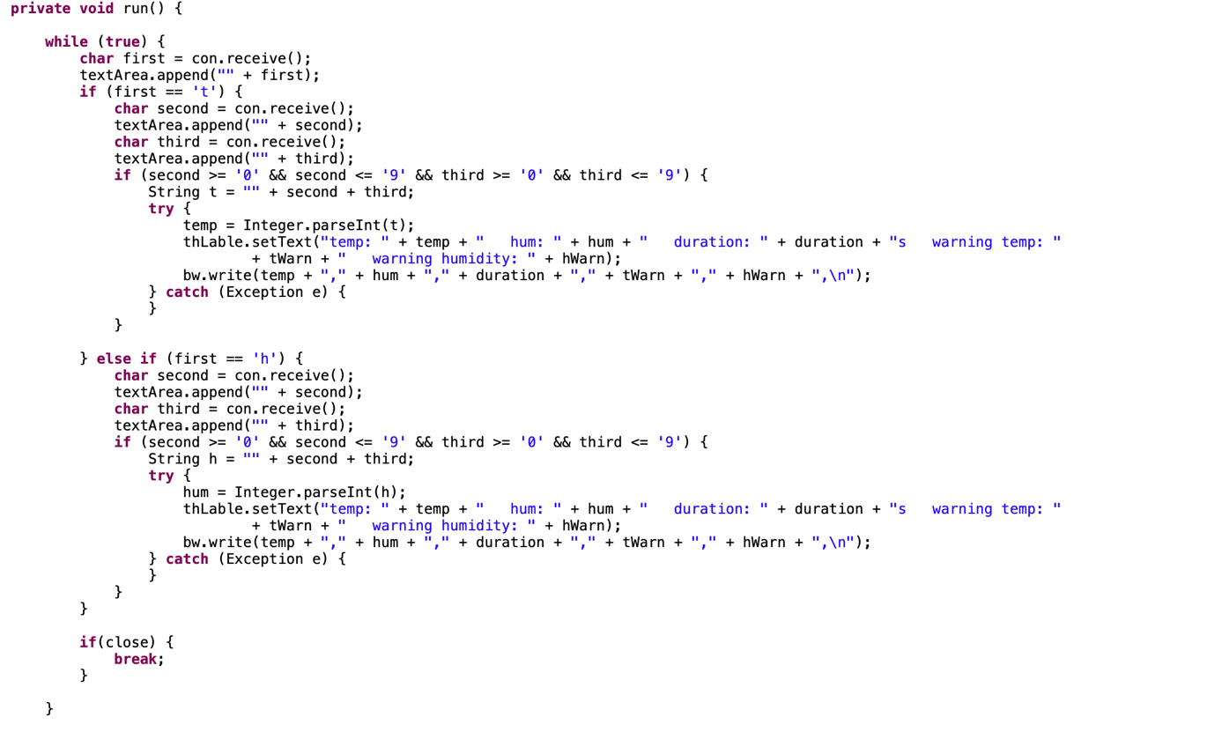Send and receive data using the serial port.

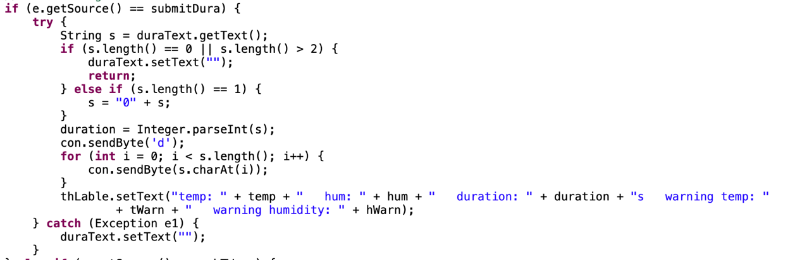We classify the information in serial communication. The symbol in front of the temperature information is 't', the symbol in front of the humidity is 'h', the symbol in front of the time interval is h, and the symbol in front of the time interval is 'd'. So, after obtaining the information, classify it according to the previous different identification symbols and write it to the console.

When the user sets a new alert line and time interval on the console, the system will add the corresponding identifier and send it to the serial buffer area.

Write the information to a file.

* 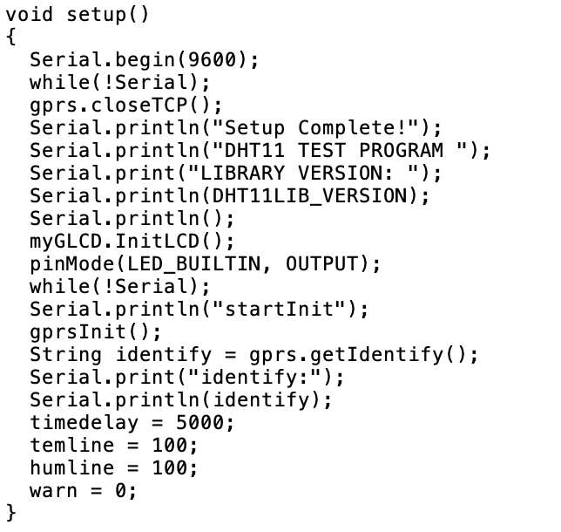A9 part

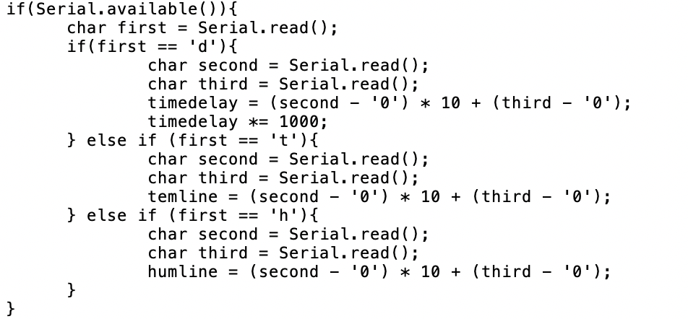During the setup phase, including the network access test and initial value setting, the default temperature and humidity warning line is 100 and the time interval is 5s when the system is first run.

Monitor the data of the serial port and determine which data the manager wants to control based on the data identifier.

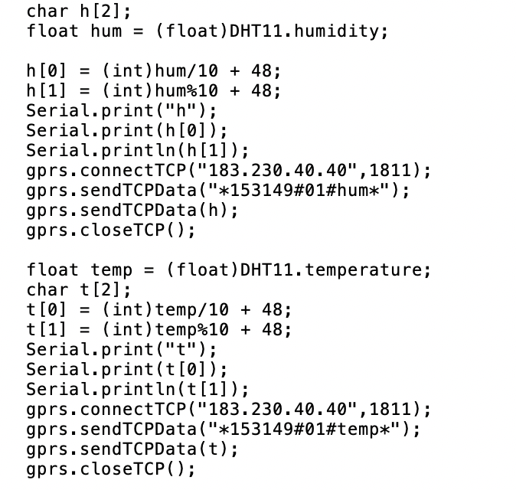

Obtain the data detected by the sensor and add the corresponding identification symbol, and send it to the serial port and OneNET

We set a variable warn to detect whether the temperature and humidity exceed the standard. Set the value of warn to 0 at the beginning of each loop. Because there is only one identifiable lamp on A9, when the temperature and humidity exceed the standard, the value of warn will add one. The value of warn will be detected at the end of each cycle. If the value of warn is greater than 0, the light is on and the corresponding information is displayed on the LCD图片包含 文字

# Extension of the system

The project can have some expansibility.

1. At the current stage, only one set of temperature and humidity sensors are added to the project, but after the project is actually put into use, in a large-scale storage environment, multiple sets of temperature and humidity sensors can be added for partition or sub-warehouse monitoring. Warehouse managers can use the UI interface of the software system to view the data of multiple groups of sensors. When the environmental information of an area or a sub-warehouse is abnormal, the manager can immediately know the specific location where the exception occurred.
2. At the current stage, only temperature and humidity sensors are referenced in the project, and only temperature and humidity can be monitored. Later, more types of sensors can be introduced, such as air pressure, oxygen content, etc. to deal with more professional and complex storage types. The principle of adding other sensors and temperature and humidity is the same, and it does not affect the original code logic at all.
3. In the subsequent expansion, some intelligent mechanisms can be added to enable multiple systems to cooperate, such as the sensor monitoring that the temperature of the storage environment exceeds the boundary value, and the excessive temperature is not conducive to cold chain. In this case, the system should control the air-conditioning system to reduce the temperature at the same time as it informs the management personnel, to process in the shortest time and to minimize the loss. This can make the entire warehouse management more convenient and intelligent, greatly reducing the burden on the management staff.

# Analysis of Internet of Things technology

What our team does is a warehouse monitoring system based on the Internet of Things technology, which uses sensor technology and NB-IoT related technologies. Sensor technology is responsible for sensing the surrounding environmental information and uploading data information. NB-IoT technology processes data and alerts based on abnormal values and uploads the data to the OneNET platform.

Through this project, we all deeply understand how the Internet of Things technology connects various things through information sensing equipment and systems. It can connect things to each other like the Internet, exchange information and communicate and realize intelligent identification, positioning, tracking, monitoring and management of items. An IoT project usually consists of perception, network and application. In the project, we use temperature and humidity sensors for sensing, the serial port is used for transmission, and the UI interface is written in Java to make the application system. We also realized that the Internet of Things technology uses sensor technology on a large scale and relies on the Internet to accurately and accurately transmit information about objects in real time.

Moreover, the Internet of Things can also be combined with artificial intelligence technology to analyze and process the massive data obtained from the sensors to meet the needs of different users and environments, making the Internet of Things systems more capable of sensing.