**Technical report**

|  |  |
| --- | --- |
| API Route | Description |
| /bigbank/customer/<branch> | This API processes all the customer requests in a specific branch, which is mainly for onsite operation, including: (1) Get queue number of different counter types. (2) Check queuing status. (3) Cancel queuing. |
| /bigbank/customeronline | This API processes all the customer requests online and customer should choose a branch. The requests include: (1) Get queue number of different counter types. (2) Check queuing status. (3) Cancel queuing. |
| /bigbank/counter/<branch>/<counter> | This API includes all the operations of a certain counter in a certain branch, including (1) Call next customer (2) Hold missing customer (3) Re-schedule for missing customer (4) Change counter-type for serving different type of queues. (5) Send messages to the next 3 customers in queue. |
| /bigbank/cro | This API includes all the operations of the CRO, including: (1) Stop and start a/all type of queue(s) of a/all branch(es). (2) Reinitiate a/all type of queue(s) of a/all branch(es). (3) View the queue status of a certain queue type and a certain branch. |
| /bigbank/display/<branch> | This API includes all the methods for displaying different information on the screen of a specific branch, including: (1) Display the next 3 customers in each type of queue. (2) Display the missing customers’ ID in each type of queue. (3) Display the current customer’s ID in each counter. |

# **Non-technical report**

# Overview

Our team made 5 single page web applications (SPA) with a backend server to deal with the bank’s queuing solutions.

## Customer Page

The Customer SPA supports queue management both offline, enabling three domains business, personal and priority clients to:

* Get the queue number in the queue for its corresponding domain – get queue function
* Check their position in the current queueing – check queue function
* Cancel their queue in the current queueing – cancel queue function

*Customer (*[*http://localhost:1219/bigbank/customer/jurong*](http://localhost:1219/bigbank/customer/jurong)*)*

*Figure 1-1: Consumer Page*

## Customer Online Page

The Customer Online SPA supports queue management both online, enabling the same functions as offline for all three domain clients.

*Customer Online (*[*http://localhost:1219/bigbank/customeronline/*](http://localhost:1219/bigbank/customeronline/)*)*

*Figure 1-2: Customer Online Page*

## Counter Page

The Counter SPA support the counter staff to:

* Call for the next customer to the respective counter with – next function
* Hold certain queue number as ‘missed queue number’ – hold function
* Re-schedule 'missed queue number' to be served after next 2 – reschedule function
* Send SMS notification service to consumers when they are the 3rd subsequent customer in the queue

*Counter (*[*http://localhost:1219/bigbank/counter/jurong/6/*](http://localhost:1219/bigbank/counter/jurong/6/) *)*

*Figure 1-3: Counter Page*

## CRO Page

The CRO SPA enables customer relationship officer (CRO) to:

* View the entire queue list for the respective domain – view function
* Re-initiate the taking of queue number for selected domain – reinitiate function
* Stop/continue the taking of queue number for selected domain – stop function

*CRO (*[*http://localhost:1219/bigbank/cro/*](http://localhost:1219/bigbank/cro/)*)*

*Figure 1-4: CRO Page*

## Display Page

The Display SPA provides continuous real-time update for:

* Customers who are served currently with the corresponding counter
* Next three customers who are to be served
* Customers who have missed their number

*Display board (*[*http://localhost:1219/bigbank/display/jurong/*](http://localhost:1219/bigbank/display/jurong/) *)*

*Figure 1-5: Display Board Page*

# User Guide

This section we are keen to illustrate the functionality of the application with examples to help users better understand how to perform specific tasks.

## Customer

1. GET QUEUE

* The branch is “jurong” selected by administrant
* On the left side (get queue) section, customer could choose their domain from the drop lists, input their name and phone number, click GET QUEUE button at the bottom
* The notification of its queue number as well as current position will display in the upper corner of the screen
* For example, we choose “business” domain, input name “HKT” and phone number “12345678”, then click GET QUEUE to record my queue number request and get my number

*Figure2-1: Customer – Get Queue Function*

1. CHECK QUEUE

* To check the queueing status, choose the counter type on the left side, input either queue number or phone number on the right side, click CHECK QUEUE
* The notification of the current position in the queue as well as estimated waiting time will show in the upper corner of the screen
* For example, we input Queue number “b8” (not case sensitive) and click CHECK QUEUE; “B8” is the queue number we just got in the previous operation
* Client will be informed that "Invalid search, please check the information!" if the input information is wrong.

*Figure 2-2: Consumer – Check Queue Function*

1. CANCEL QUEUE

* Same as checking the queueing status, choose the counter type on the left side, input either queue number or phone number on the right side, click CANCEL QUEUE
* For example, client input Queue number “p12” (not case sensitive) and click CANCEL QUEUE; “p12” will be deleted from the queueing system.
* Client will be informed that "Invalid search, please check the information!" if the input information is wrong.

*Figure 2-3: Consumer – Cancel Queue Function*

## Consumer Online

* The three functions get, check, and cancel queue are same as the Consumer page for offline clients, except that client need to choose the branch from the drop list instead of setting by administrant.
* For example, we choose the branch “Jurong”, choose counter type “personal”, input client name “LYQ” and leave the phone number black, click GET QUEUE.

*Figure 2-4: Customer Online*

## Counter

1. NEXT

* Branch and counter number are set by administrant
* For example, ZYY is one of the business counter staffs serving counter 6 in Jurong branch, he is starting to work. By clicking Next button, the current number will show below the NEXT button. At the same time, the notification show “Next customer called!”

*Figure 2-5: Counter – Next Function*

1. HOLD

* Assuming the business counter staff presses NEXT continuously to call the customer in the business queue, then B5’s (Client “HKT” recorded above) turn comes.

*Figure 2-6: Counter – HOLD Function Figure 1*

* Now the counter is calling B5, it’s time when only having 3 people (B5, B6,B7) before HKT, which can be seen in the display board.

*Figure 2-7: Display Board Figure 1*

* His phone receives SMS message notifying there are 3 people before him, the SMS message sample is shown below. He will totally receive 3 messages while each one person before him completes their service.

*Figure 2-8: SMS notification*

* After 3 people completed their services, it’s time to service B8. But B8 client HKT didn’t appear, he missed his turn. The counter staff presses HOLD button to add missing number into the hold list. ID.

*Figure 2-9: Counter – HOLD Function Figure 2*

* The display board shows B8 in the MISSING ID

*Figure 2-10: Display Board Figure 2*

1. RESCHEDULE

* When client B8 HKT rushes into the bank, by seeing the notification (“Missing number please proceed to any counter to reschedule!”) on the display board, he will ask for one of the counter staffs for help.
* Then the counter staff filles in HKT’s queue number B8 (not case-sensitive), presses RESCHEDULE button, the notification shows “Customer B8 found! Successfully rescheduled!”

*Figure 2-11: Counter-Reschedule Function*

* In the display board his number is scheduled in the third position in current business queue, which is before B12.

*Figure2-12: Display Board Figure 3*

* When is close to get off work, all types of counters should complete all customers in the queue.
* For example, the current number will show “None” when there is no customer in the business queue.

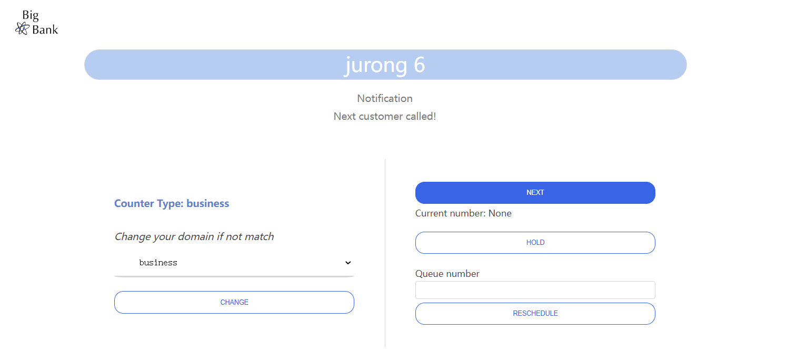

*Figure 2-13: Counter – Cleaning Queue*

1. CHANGE DOMAIN

* Counter staff could change its counter type by choosing from the drop list in the left side.
* For example, as the business counter staff completed their services, according to the number of people in current personal queue, CRO dispatches 1 business counter staff ZYY (mentioned before) to help the personal services
* He changes the counter domain to personal which shows in the notification “Domain changed successfully!” and counter type changes from “business” to “personal”. Jurong counter 6 now can serve customers from personal queue.

*Figure2-14: Counter – Change Domain Function*

## CRO

1. VIEW

* The CRO needs to choose the branch and domain, then click the VIEW button to have a look of the certain.
* For example, CRO chooses “Jurong” branch and “personal” domain. The notification on the right side shows that the personal queue in Jurong branch still has many people waiting to serve.
* Please choose only one branch (not “all” option) and one domain (not “all” option) for View function.

*Figure 2-15: CRO – View Function*

1. STOP

* CRO could stop the taking of queue number for selected domain
* CRO could stop queues of all domains (choose “all” domain option) in all branches (choose “all” branch options) at once.
* For example, CRO selects branch “Jurong” and selects “personal” domain from the drop list, then click STOP/CONTINUE button. Notification of “Queue personal in jurong branch now stops queueing!” displays on the right side.

*Figure 2-16: CRO – Stop Function*

* Client can’t get the new queue number in a stopped queue. For example, if client tries to get queue number for “person” service in “Jurong” branch, which is stopped by CRO. He will be informed that the “personal” service is stopped, as shown below:

*Figure 2-17: Get queue for stopped service*

1. CONTINUE

* Similarly, CRO could continue the taking of queue number for selected domain
* CRO could continue queues of all domains (choose “all” domain option) in all branches (choose “all” branch options) at once.
* For example, if all queueing’s are stopped previously and CRO selects branch “all” and selects “all” domain from the drop list, then click STOP/CONTINUE button. Notification of “Now all queues in all branches continues queueing!” displays in the notification section.

*Figure 2-18: CRO-Continue Function*

1. REINITIATE

* A busy day is over, the CRO selects all branches and presses the reinitiate button, all branches’ queuing information are gone.

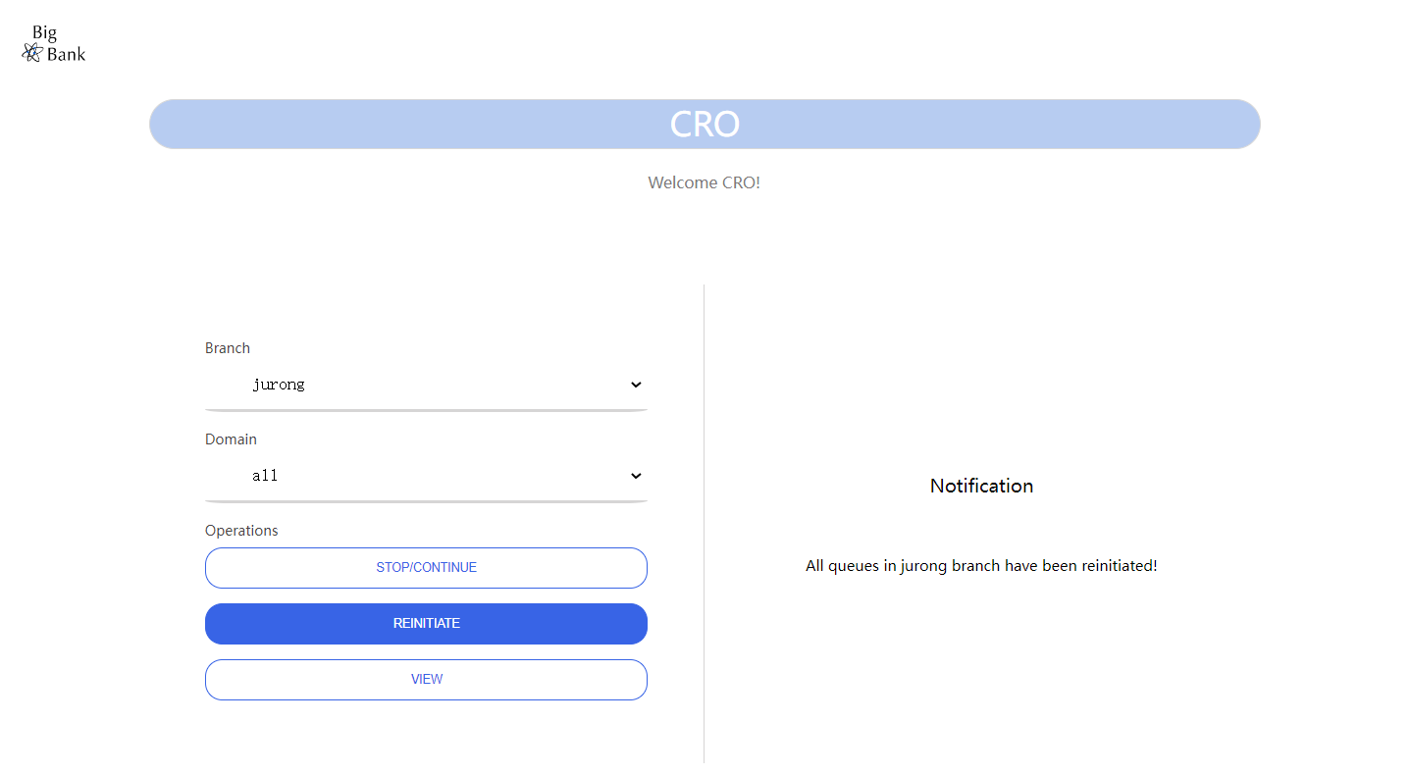

*Figure 2-19: CRO-Reinitiate Function*