Readme

This section provides an overview of the required packages and files for the implementation of the bank queuing system.

Introduction of files

The primary component of the system is the "Project_final.py" file which performs the backend application. The system also requires two additional folders, namely the "static" folder for storing front-end design files and brand logos and the "templates" folder that holds the HTML files for each single-page application (SPA).

徽标

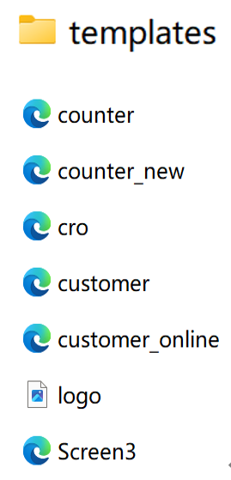

Package Installation

The installation process of the required packages can be performed by the "install()" function. This function checks if the packages "flask," "flask_table," and "twilio" are installed on the system. In case they are not installed, the function uses the pip package manager and the "subprocess" module to install them. The following imports are required for the backend application: "flask," "request," and "render_template" from "flask," "Table" and "Col" from "flask_table," "Client" from "twilio.rest," and "random" and "string."

Applications

The bank queuing system consists of five single-page applications with a backend server. Each SPA requires a unique URL for activation and access.

**Display Screen:** The display screen URL requires the input of an existing branch name at the end of the URL. Notice: please do not insert branch name that does not exist, following sentence will display, “Cannot find the branch or counterid you entered, please check again”.

The URL would be in the following format: "http://localhost:1219/bigbank/display/<branch>".

**CRO SPA:** The CRO SPA has a fixed URL, which can be accessed by typing "<http://localhost:1219/bigbank/cro/>."

图形用户界面

**Counter SPA**: The counter SPA URL requires the input of an existing branch name and counter number. In case the entered branch or counter ID cannot be found, a message "Cannot find the branch or counterid you entered, please check again" will be displayed. The URL format would be as follows:

"http://localhost:1219/bigbank/<branch>/<counter>/".

**Customer SPA**: The bank offers two types of customer checking systems: online and offline. The URL for the online system is fixed and can be accessed by typing "<http://localhost:1219/bigbank/customeronline/>". The URL for the offline system is <http://localhost:1219/bigbank/ntu/.>

