**Assignment:** QBIO7008 research proposal

**Supervisors:** Celine Frere & Katrina McGuigan

**Name:** Yiqian Li

**Student ID:** 45186455

**Title:** The impact of yellow fungus disease (*Nannizziopsis sp.*) on within individual variations in social thermoregulatory behaviours in the eastern water dragon (*Intellagama lesueurii*)

**Abstract (229 words):**

Body temperature is critical for the survival, performance, and fitness of ectothermic reptiles. Many reptiles have evolved thermoregulatory behaviour to actively control their body temperature, where the skins of the animals are important for detecting and maintaining the surrounding heat. Fungi under the genus *Nannizziopsis* are lethal pathogen to many reptiles mostly found in captive environment. They are known to infect through the skins of these animals causing yellow coloured lesions named yellow fungus disease (YFD), however, the mode transmission of these fungi between individuals, and to what extent YFD would impact on the behaviour and physiology (e.g. body temperature) of the infected individual in a wild population is currently understudied. Our research aimed to fill in this gap by using a 10-year records of behaviour and physiology data on a wild population of eastern water dragon *Intellagama lesueurii* found in Brisbane, Queensland, Australia. The main focus of our research will be on the how the body temperature of the dragons would change at a within individual level through time when the YFD was involved. We will also determine how YFD would interact with other behaviour, physiological and environmental variables to impact on the body temperature of the dragons. Our results will have important implications for the conservation of the dragons, and for the understanding of the effect of fungal induced thermoregulatory disease and behaviour-disease interactions in ectothermic reptiles.

**Main texts (1823 words):**

**Background**:

Body temperature is one of the most important physiological variables in ectotherms, as it directly impacts on the behaviour and the performance of the animals (Angilletta *et al.* 2002). For most ectotherms, there is a narrow range of body temperature where their performance can be maximized (Angilletta *et al.* 2002). The maintenance of the body temperature within this optimal range is therefore important and is directly relevant to the fitness and the survival of the ectotherms, thus many ectotherms have developed thermoregulation techniques both physiologically and behaviourally (Herczeg *et al.* 2006; Angilletta *et al.* 2002). However, thermoregulation usually at a cost, and the optimal body temperature is not always achievable due to environmental constraints, the physiological conditions of individuals or the availability of the resources, which varies from case to case (Herczeg *et al.* 2006; Angilletta *et al.* 2002; Khan *et al.* 2010). For many ectothermic reptiles, even within the same species, their body temperature can vary between populations, between individuals, and within individual over time (Seebacher 2005; Khan *et al.* 2010). The most effective heat source for most reptiles is the solar radiation, where their skin is the first receiving end of the heat (Bogert 1949). The skins of the many reptile species also contain thermoreceptors, which are deterministic to how the reptiles will perceive and react to ambient temperatures (Tattersall *et al.* 2006).

The fungi under the genus *Nannizziopsis* are the causative agent of the commonly known yellow fungus disease (YFD) (Paré & Sigler 2016). In reptiles, YFD may lead to deep granulomatous dermatomycosis and become lethal to infected individuals, where the skin of these individuals become necrotic and their internal organs become inflamed (Paré & Sigler 2016). Even if not being directly killed by YFD, infected individuals rarely recover, and usually end up in a state of dehydration, starvation, or secondary infections (Peterson *et al.* 2020). While there is currently no evidence of *Nannizziopsis* *sp.* directly causing thermoregulatory issues in reptiles, *Nannizziopsis* *sp.* was found to be growing optimally under certain temperature, and individuals with weakened immune system are more susceptible YFD due to their inability to regulate their body temperature (Schilliger *et al.* 2023; Peterson *et al.* 2020). We speculate that YFD will lead to a positive feedback loop in infected individuals due to the damage it may cause on their skins.

The YFD was mostly found in captive environment, however, there have been an increase in reports of wild infected individuals in the recent decades, with the earliest record in Australia dating back only to 2013 (Peterson *et al.* 2020). The exact mode of transmission and pathogenesis of *Nannizziopsis* *sp.* are poorly understood, but the transmission rate is likely to be host density dependent (Fisher *et al.* 2012; Tacey *et al.* 2023). Some *Nannizziopsis* *sp.* have been found to be non-host specific, giving them a higher chance to persist in the environment by jumping between host species (Gentry *et al.* 2023).

The eastern water dragon *Intellagama lesueurii* can be found across Queensland, Australia. The population in Brisbane, Queensland in particular was the first to be identified as YFD infected in the wild and was found to have more than 30% of the individuals being infected through repeated surveys (Tacey *et al.* 2023; Peterson *et al.* 2020). *I. lesueurii* are particularly at risk, as the most severely infected individuals were found to be more likely to socialize with others, speeding up the transmission of the pathogen (Tacey *et al.* 2023), this would likely be exacerbated when their basking sites were limited resources where individuals were more likely to aggregate as seen in other dragon species (Khan *et al.* 2010). The social behaviours of *I. lesueurii* quantified as conspecifics have also been found to be sex dependent, but both sexes tended to social associate more when the population density was high, which might create more opportunities for the transmission of YFD (Strickland & Frère 2019; Tacey *et al.* 2023). While lethal pathogen may not be spread across the entire population easily under standard scenario as infected individuals do not persist long in the population, the increased socialization of YFD infected *I. lesueurii* may not follow this rule, and may actually drive population into local extinction (Fisher *et al.* 2012)

Some reptiles have been found to display behavioural induced fever to up-regulate their body temperature and fight off fungal infections, this can be achieved by utilising the micro-environment available around them, such as basking more under sunlight, as *Nannizziopsis* *sp.* will struggle to grow when the temperature is above 37 C° (McCoy *et al.* 2017; Burns *et al.* 1996; Paré *et al.* 2021). It is currently unclear whether *I. lesueurii* will respond in such way to YFD, however, we do know that *I. lesueurii* could adjust their social behaviours throughout their life history based on their environment and physiological conditions both among and within individuals within the same population (Strickland & Frère 2019). Nevertheless, the potential response of *I. lesueurii* to YFD may be ineffective, as there may be risk of UV from basking causing subcutaneous tissue damages due to the lack of skin covering, which may feed into a positive feedback loop to promote the growth of the fungus (Adkins *et al.* 2003). The potential need for long-term basking for diseased dragon individuals due to their poor skin conditions may also come as a trade-off to their feeding, reproduction, and predation avoidance, which may reduce their fitness elsewhere (Seebacher 2005). It worth noting that many factors have been identified to be correlated to body temperature variability in *I. lesueurii*, such as sex and location (ambient temperature and resource availability) (Gardiner *et al.* 2014), so determining whether YFD is one of the major causes of their body temperature variability is difficulty due to potential interaction of YFD with these known terms both physiologically and behaviourally, and this will be the focus of my research project.

This research project will address the body temperature of the *I. lesueurii* among and within individuals in a population collected at Roma Street Parkland, Brisbane. In particular, we aimed to determine how YFD would interact with other physiological and environmental variables to contribute to the mean and variability in the body temperature. The within individual variability in body temperature will be our major focus, as it has not been studied on this species in relations to YFD before.

**Methods:**

*Data collection:*

In this study, a population of *I. lesueurii* around Brisbane were monitored for their body temperature, behaviour and *Nannizziopsis* disease status for 10 years. The disease status was determined by visual examination of the skin lesions and/or through qPCR sequencing of the skin swabs. Other physiological information such as sex, length and weight were also recorded for each observation. All data were geographically located, and the number of dragons that were within the home range of each recorded individual was then calculated as “conspecific”. Only individuals with more than 20 observations across the years are used in the following analysis.

*Data clean up and processes:*

Data is merged and cleaned up using the “tidyverse” package in R, disease statuses are classified as diseased (symptomatic or asymptomatic) and healthy. Individuals could have their disease status changed over time, and these individuals were specially noted. Diseased and Healthy individuals are also made into subset and will be analysed separately to compare their body temperature variability.

*Modelling and statistical choices:*

We plan to utilise the double-hierarchical generalized linear models (Cleasby *et al.* 2015) and Bayesian statistical tools such as the “brm” package in R (Buerkner 2017), which will allow us to explore the complex interactions between our physiological and behavioural data (Hertel *et al.* 2020). By using these approaches, we will be able to obtain information on the variation in means as well as the variation in variances and to compare between the diseased and healthy individuals, this will be achievable with our massive repeatedly measured dataset.

Hypotheses:

1. We hypothesized that YFD would have a statistically significant impact on the mean body temperature on *I. lesueurii*. A full DHGLM model with the disease status interacting with every other measured variable is outlined below (model will be simplified if excluding some interactions will improve the outputs). The only random effect here are the individuals. As stated in the background information, Sex, Location and Feeding (which assumed to be directly correlated to weight to length ratio) and Conspecific (assumed to be correlated to social behaviours) would all interact with the YFD either directly or indirectly, while they were also correlated to the mean body temperature of the dragons.

**Body temp ~ Disease +Sex + Location + Weight to Length ratio + Conspecific + Number of sighting per individual + Disease*Sex + Disease *Location + Disease *Weight to Length ratio + Disease*Conspecific + Disease * Number of sighting per individual + (1|Individual name) + residual**

1. We hypothesized that YFD diseased individuals would have a higher within individual variability in their body temperature compares to those from the healthy individuals. This is due to their inconsistency in behaviours and reduced in thermoregulatory ability to be expected by the infections, despite they may attempt to use behavioural induced fever to compensate for the body temperature loss, they may still be outcompeted in resources such as basking sites by the healthy individuals. For this analysis, we will use the subsets of diseased and healthy individual separately. We will not include disease status as a fixed effect in our models but assume it will be taken account to in the residuals. In this model, the residuals will contain the information on (1| Number of sighting per individual:Individual name), since each individual was repeatedly measured, where we assume a large part of variability throughout these measurements will be explained by the disease status. We will then compare the residuals from the model outputs of the diseased and heathy individuals using Bayesian credibility intervals.

**Body temp ~ Sex + Location + Weight to Length ratio + Conspecific +** **Number of sighting per individual + (1|Individual name) + residual**

**Proposed schedule:**

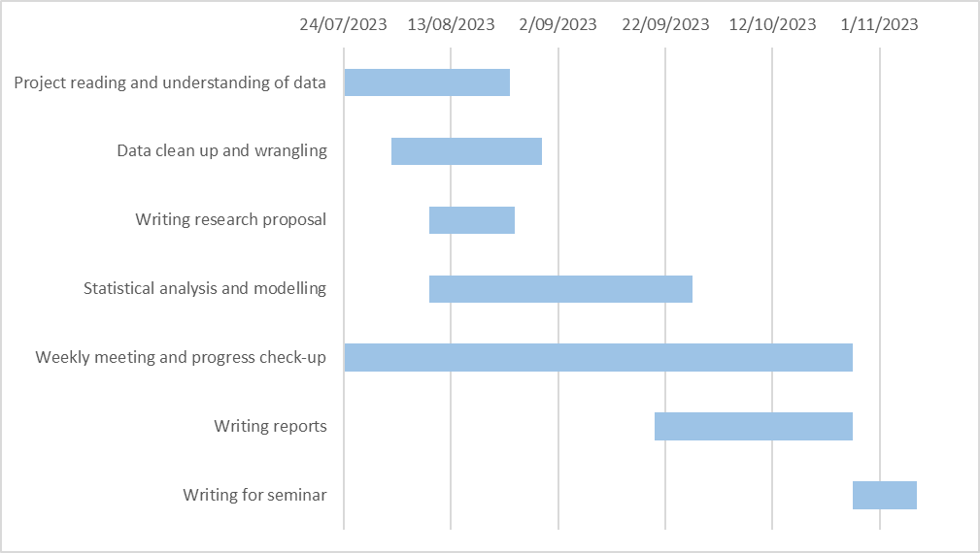

**Proposed outcomes and deliverables:**

We expect to have answered both the hypotheses listed in the method part by the due date of the written report. As the research project is exploratory, we also expect to discover unexpected outcome and form new hypothesis, which we may directly address in our report or leave them for further research. All data given will be tidied up, and every code used will be reproducible and made available on GitHub. The report will contain visual elements such as tables, graphs, and details of the model outputs to facilitate the discussion. The report will be made with journal publishable standard in mind.

Not many analyses have been done so far as there are some back and forth in tidying up and gathering of the necessary data. But here are some example graphs to showcase what graphs will be expected in the final report (the data is still subject to changes).

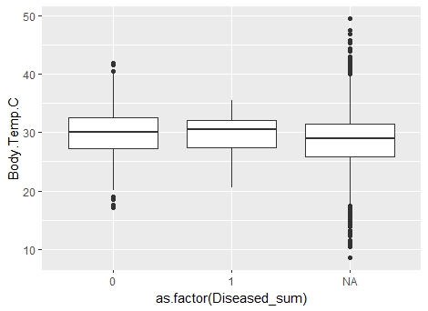

**Figure 1. The disease status against body temperature plot (0 = healthy, 1 = diseased).** The mean temperatures do not seem to be differ much between diseased and heathy individuals. However, the data has not been fully categorised and cleaned up at this stage, there could be some NA being moved to the other columns, and diseased will be further categorised into symptomatic and asymptomatic, which will likely change the results.

**Figure 2. The Weight to Length ratio regression line to body temperature.** Again not clean pattern is seen in this graph, but this may change when the term is used as a fixed effect with interaction in the full model.

**References:**

Adkins, E., Driggers, T., Ferguson, G., Gehrmann, W., Gyimesi, Z., May, E., Ogle, M., Owens, T., & Klaphake, E. (2003). Ultraviolet Light and Reptiles, Amphibians. *Journal of Herpetological Medicine and Surgery*, 13(4): 27–37. doi: https://doi.org/10.5818/1529-9651.13.4.27

Angilletta, M. J., Niewiarowski, P. H., & Navas, C. A. (2002). The evolution of thermal physiology in ectotherms. *Journal of Thermal Biology*, 27(4), 249–268. https://doi.org/10.1016/S0306-4565(01)00094-8

Bogert, C. M. (1949). Thermoregulation in Reptiles, A Factor in Evolution. *Evolution*, 3(3), 195–211. https://doi.org/10.1111/j.1558-5646.1949.tb00021.x

Buerkner, P. C. (2017). brms: An R package for Bayesian multilevel models using Stan. *Journal of Statistical Software*, 80(1), 1–28. https://doi.org/10.18637/jss.v080.i01

Burns, G., Ramos, A., & Muchlinski, A. (1996). Fever Response in North American Snakes. *Journal of Herpetology*, 30(2), 133–139. https://doi.org/10.2307/1565503

Cleasby, I. R., Nakagawa, S., Schielzeth, H., & Hadfield, J. (2015). Quantifying the predictability of behaviour: statistical approaches for the study of between‐individual variation in the within‐individual variance. *Methods in Ecology and Evolution*, 6(1), 27–37. https://doi.org/10.1111/2041-210X.12281

Fisher, M. C., Henk, D. A., Briggs, C. J., Brownstein, J. S., Madoff, L. C., McCraw, S. L., & Gurr, S. J. (2012). Emerging fungal threats to animal, plant and ecosystem health. *Nature (London)*, 484(7393), 186–194. https://doi.org/10.1038/nature10947

Gardiner, R. Z., Doran, E., Strickland, K., Carpenter-Bundhoo, L., & Frère, C. (2014). A face in the crowd: A non-invasive and cost effective photo-identification methodology to understand the fine scale movement of eastern water dragons. *PloS One*, 9(5), e96992–e96992. https://doi.org/10.1371/journal.pone.0096992

Gentry, S., Lorch, J. M., Lankton, J. S., & Pringle, A. (2023). A Cross-Inoculation Experiment Reveals that Ophidiomyces ophiodiicola and Nannizziopsis guarroi Can Each Infect Both Snakes and Lizards. *Applied and Environmental Microbiology*, 89(5), e0216822–e0216822. https://doi.org/10.1128/aem.02168-22

Herczeg, G., Gonda, A., Saarikivi, J., & Merilä, J. (2006). Experimental Support for the Cost-Benefit Model of Lizard Thermoregulation. *Behavioral Ecology and Sociobiology*, 60(3), 405–414. https://doi.org/10.1007/s00265-006-0180-6

Hertel, A. G., Hertel, A. G., Niemelä, P. T., Dingemanse, N. J., Mueller, T., & Mueller, T. (2020). A guide for studying among-individual behavioral variation from movement data in the wild. *Movement Ecology*, 8(1), 1–30. https://doi.org/10.1186/s40462-020-00216-8

Khan, J. J., Richardson, J. M., & Tattersall, G. J. (2010). Thermoregulation and aggregation in neonatal bearded dragons (Pogona vitticeps). *Physiology & Behavior*, 100(2), 180–186. https://doi.org/10.1016/j.physbeh.2010.02.019

McCoy, C. M., Lind, C. M., & Farrell, T. M. (2017). Environmental and physiological correlates of the severity of clinical signs of snake fungal disease in a population of pigmy rattlesnakes, Sistrurus miliarius. *Conservation Physiology*, 5(1), cow077–cow077. https://doi.org/10.1093/conphys/cow077

Paré, J. A., & Sigler, L. (2016). An Overview of Reptile Fungal Pathogens in the Genera Nannizziopsis, Paranannizziopsis, and Ophidiomyces. *Journal of Herpetological Medicine and Surgery*, 26(1-2), 46–53. https://doi.org/10.5818/1529-9651-26.1-2.46

Paré, J. A., Wellehan, J., Perry, S. M., Scheelings, T. F., Keller, K., & Boyer, T. (2021). Onygenalean Dermatomycoses (Formerly Yellow Fungus Disease, Snake Fungal Disease) in Reptiles. *Journal of Herpetological Medicine and Surgery*, 30(4), 198–209. https://doi.org/10.5818/19-12-221.1

Peterson, N. R., Rose, K., Shaw, S., Hyndman, T. H., Sigler, L., Kurtböke, D. İpek, Llinas, J., Littleford-Colquhoun, B. L., Cristescu, R., & Frère, C. (2020). Cross-continental emergence of Nannizziopsis barbatae disease may threaten wild Australian lizards. *Scientific Reports*, 10(1), 20976. https://doi.org/10.1038/s41598-020-77865-7

Schilliger, L., Paillusseau, C., François, C., & Bonwitt, J. (2023). Major Emerging Fungal Diseases of Reptiles and Amphibians. *Pathogens (Basel)*, 12(3), 429. https://doi.org/10.3390/pathogens12030429

Seebacher, F. (2005). review of thermoregulation and physiological performance in reptiles: what is the role of phenotypic flexibility. *Journal of Comparative Physiology. B, Biochemical, Systemic, and Environmental Physiology*, 175(7), 453–461. https://doi.org/10.1007/s00360-005-0010-6

Strickland, K., & Frère, C. H. (2019). Individual Variation in the Social Plasticity of Water Dragons. *The American Naturalist*, 194(2), 194–206. https://doi.org/10.1086/704089

Tacey, J., Class, B., Delmé, C., Powell, D., & Frère, C. H. (2023). Impacts of fungal disease on dyadic social interactions in a wild agamid lizard. *Animal Behaviour*, 200, 125–136. https://doi.org/10.1016/j.anbehav.2023.04.002

Tattersall, G. J., Cadena, V., & Skinner, M. C. (2006). Respiratory Cooling and Thermoregulatory Coupling in Reptiles. *Respiratory Physiology & Neurobiology*, 154(1), 302–318. https://doi.org/10.1016/j.resp.2006.02.011