**Assignment:** QBIO7008 final research report

**Name:** Yiqian Li

**Student ID:** 45186455

**Word Count:**

**Title:** The impact of yellow fungus disease (*Nannizziopsis sp.*) on within individual variations in social thermoregulatory behaviours in the eastern water dragon (*Intellagama lesueurii*)

**Abstract:**

Body temperature is critical for the survival, performance, and fitness of ectothermic reptiles. Many reptiles have evolved thermoregulatory behaviour to actively control their body temperature, where the skins of the animals are important for detecting and maintaining the surrounding heat. Fungi under the genus *Nannizziopsis* are lethal pathogen to many reptiles mostly found in captive environment. They are known to infect through the skins of these animals causing yellow coloured lesions named yellow fungus disease (YFD), however, the mode transmission of these fungi between individuals, and to what extent YFD would impact on the behaviour and physiology (e.g. body temperature) of the infected individual in a wild population is currently understudied. Our research aimed to fill in this gap by using a 10-year records of behaviour and physiology data on a wild population of eastern water dragon *Intellagama lesueurii* found in Brisbane, Queensland, Australia. The main focus of this project was to investigate how the body temperature of the dragons would change at a within individual level through time when the YFD was involved. The results we got were inconclusive due to the many limitations of the models and needed further research.

**Main text:**

**Introduction:**

Body temperature is one of the most important physiological variables in ectotherms, as it directly impacts on the behaviour and the performance of the animals (Angilletta *et al.* 2002). For most ectotherms, there is a narrow range of body temperature where their performance can be maximized (Angilletta *et al.* 2002). The maintenance of the body temperature within this optimal range is therefore important and is directly relevant to the fitness and the survival of the ectotherms, thus many ectotherms have developed thermoregulation techniques both physiologically and behaviourally (Herczeg *et al.* 2006; Angilletta *et al.* 2002). However, thermoregulation usually at a cost, and the optimal body temperature is not always achievable due to environmental constraints, the physiological conditions of individuals or the availability of the resources, which varies from case to case (Herczeg *et al.* 2006; Angilletta *et al.* 2002; Khan *et al.* 2010). For many ectothermic reptiles, even within the same species, their body temperature can vary between populations, between individuals, and within individual over time (Seebacher 2005; Khan *et al.* 2010). The most effective heat source for most reptiles is the solar radiation, where their skin is the first receiving end of the heat (Bogert 1949). The skins of the many reptile species also contain thermoreceptors, which are deterministic to how the reptiles will perceive and react to ambient temperatures (Tattersall *et al.* 2006).

The fungi under the genus *Nannizziopsis* are the causative agent of the commonly known yellow fungus disease (YFD) (Paré & Sigler 2016). In reptiles, YFD may lead to deep granulomatous dermatomycosis and become lethal to infected individuals, where the skin of these individuals become necrotic and their internal organs become inflamed (Paré & Sigler 2016). Even if not being directly killed by YFD, infected individuals rarely recover, and usually end up in a state of dehydration, starvation, or secondary infections (Peterson *et al.* 2020). While there is currently no evidence of *Nannizziopsis* *sp.* directly causing thermoregulatory issues in reptiles, *Nannizziopsis* *sp.* was found to be growing optimally under certain temperature, and individuals with weakened immune system are more susceptible YFD due to their inability to regulate their body temperature (Schilliger *et al.* 2023; Peterson *et al.* 2020). We speculate that YFD will lead to a positive feedback loop in infected individuals due to the damage it may cause on their skins.

The YFD was mostly found in captive environment, however, there have been an increase in reports of wild infected individuals in the recent decades, with the earliest record in Australia dating back only to 2013 (Peterson *et al.* 2020). The exact mode of transmission and pathogenesis of *Nannizziopsis* *sp.* are poorly understood, but the transmission rate is likely to be host density dependent (Fisher *et al.* 2012; Tacey *et al.* 2023). Some *Nannizziopsis* *sp.* have been found to be non-host specific, giving them a higher chance to persist in the environment by jumping between host species (Gentry *et al.* 2023).

The eastern water dragon *Intellagama lesueurii* can be found across Queensland, Australia. The population in Brisbane, Queensland was the first to be identified as YFD infected in the wild and was found to have more than 30% of the individuals being infected through repeated surveys (Tacey *et al.* 2023; Peterson *et al.* 2020). *I. lesueurii* are particularly at risk, as the most severely infected individuals were found to be more likely to socialize with others, speeding up the transmission of the pathogen (Tacey *et al.* 2023), this would likely be exacerbated when their basking sites were limited resources where individuals were more likely to aggregate as seen in other dragon species (Khan *et al.* 2010). The social behaviours of *I. lesueurii* quantified as conspecifics have also been found to be sex dependent, but both sexes tended to social associate more when the population density was high, which might create more opportunities for the transmission of YFD (Strickland & Frère 2019; Tacey *et al.* 2023). While lethal pathogen may not be spread across the entire population easily under standard scenario as infected individuals do not persist long in the population, the increased socialization of YFD infected *I. lesueurii* may not follow this rule, and may actually drive population into local extinction (Fisher *et al.* 2012)

Some reptiles have been found to display behavioural induced fever to up-regulate their body temperature and fight off fungal infections, this can be achieved by utilising the micro-environment available around them, such as basking more under sunlight, as *Nannizziopsis* *sp.* will struggle to grow when the temperature is above 37 C° (McCoy *et al.* 2017; Burns *et al.* 1996; Paré *et al.* 2021). It is currently unclear whether *I. lesueurii* will respond in such way to YFD, however, we do know that *I. lesueurii* could adjust their social behaviours throughout their life history based on their environment and physiological conditions both among and within individuals within the same population (Strickland & Frère 2019). Nevertheless, the potential response of *I. lesueurii* to YFD may be ineffective, as there may be risk of UV from basking causing subcutaneous tissue damages due to the lack of skin covering, which may feed into a positive feedback loop to promote the growth of the fungus (Adkins *et al.* 2003). The potential need for long-term basking for diseased dragon individuals due to their poor skin conditions may also come as a trade-off to their feeding, reproduction, and predation avoidance, which may reduce their fitness elsewhere (Seebacher 2005). It worth noting that many factors have been identified to be correlated to body temperature variability in *I. lesueurii*, such as sex and location (ambient temperature and resource availability) (Gardiner *et al.* 2014), so determining whether YFD is one of the major causes of their body temperature variability is difficulty due to potential interaction of YFD with these known terms both physiologically and behaviourally, and this will be the focus of my research project.

This research project will address the body temperature of the *I. lesueurii* among and within individuals in a population collected at Roma Street Parkland, Brisbane. In particular, we aimed to determine how YFD would interact with other physiological and environmental variables to contribute to the mean and variability in the body temperature. The within individual variability in body temperature will be our major focus, as it has not been studied on this species in relations to YFD before.

**Approach and Methods:**

*Data collection:*

In this study, a population of *I. lesueurii* around Brisbane were monitored for their body temperature, behaviour and *Nannizziopsis* disease status for 10 years. The final dataset contains 459 unique individuals. The health status was determined by visual examination of the skin lesions when captured and/or through qPCR sequencing of the skin swabs (every entry has a visual examination result but may not have a qPCR result). Other physiological information such as sex, length and weight were also recorded for each observation. All data were geographically located, and the number of dragons that were within the home range of each recorded individual was then calculated as “conspecific density”. Only individuals with more than 20 observations across the years are used in the following analysis.

*Data clean up and processes:*

A major part of this project is focused on tidying up and making sense of the data. Data is merged and cleaned up using the “tidyverse” package in R. The body temperature of the overall data was checked to be normally distributed before proceeding further. The health statuses are classified as diseased (symptomatic or asymptomatic) and healthy based on the combined results from visual examination and qPCR, the classification of overall disease status can be seen in the table 1 below, note that overall there are more healthy data entries (29032 entries) compared to diseased data entries (3848 entries). Individuals could have their health status changed over time, and these individuals were specially noted, there were 95 individuals belong to this category. Considering these is a relatively high number, the diseased and healthy individuals are also made into subset and will be analysed separately to compare their body temperature variability. To further reduce sampling bias, I added a predictor variable called “number of sighting per individual” to each data entry, which counted how many times the individual was present in the entire dataset.

Some data entries had missing weight and location or 0 weight and length value, they were dropped from the dataset for the analysis. Since the body temperature of *I. lesueurii* is heavily influence by the ambient temperature thus may be correlated to seasons, the outlier entries had body temperature out of ± 1.5 interquartile range in respective to each season were dropped from the analysis. Interquartile range were chosen instead of mean ± 3 standard deviations, as there were extremely high and low body temperature data either due to faulty of the recording device or human error, which might skew the cut-off. To further standardize the data since individuals might vary hugely in their sizes, I used “weight to length ratio” that was calculated by dividing logged weight with length, then the outliers outside of mean ± 3 standard deviations were removed. Finally, to standardize the scales between the predictors, each numerical predictor was mean centred around 0 with division of 1 standard deviation.

**Table 1. the table of determining the overall health status of an individual based on the combined visual and qPCR results.**

|  |  |  |
| --- | --- | --- |
| **Health Status** | **Visual Examination** | **qPCR result** |
| Healthy | Healthy | Healthy/NA |
| Asymptomatic | Healthy | Diseased |
| Symptomatic | Diseased | Healthy/NA/Diseased |

I plotted the correlation matrix between the numerical predictors of interests before the modelling in case high correlation causing problems such as multicollinearity. The correlation between them were lower than 80% (figure 1), so I decided to include them all.

**Figure 1. the correlation matrix between the 3 numerical predictors - Weight to Length ratio (W_to_L_ratio),** **Conspecific Density (density50_per_season) and Number of sighting per individual (number_of_sighting).** All 3 of them have low correlations.

*Modelling and statistical analysis:*

Hypotheses:

1. We hypothesized that YFD would have a statistically significant impact on the mean body temperature on *I. lesueurii*. As stated in the background information, Sex, Location, Feeding (which assumed to be directly correlated to weight to length ratio) and Conspecific Density (assumed to be correlated to social behaviours) would all interact with the YFD either directly or indirectly, while they were also correlated to the mean body temperature of the dragons.

For this hypothesis, I used the double-hierarchical generalized linear models with the “brms” package in R (Buerkner 2017), and partially followed the modelling techniques from Hertel *et al.* 2020. The model parameters were set as the following as suggested by unpublished *I. lesueurii* paper by Frere *et al.* on predictability, where a default uninformative prior, 4 chains and 4 thinning, 1000 warmups, 5000 iteration univariate model was able to provide them with reasonably high fit to the data. I seeded the model with the seed 12345, so that the result could be reproducible. The health status was chosen to interact with all the other predictors as it was the major interest of this project. Individua name and name nested within seasons were added as random effect, alongside with residual. Due to the time constraint, some technical difficulties and my limited knowledge on predictor tweaking and prior setting, only one final model was fitted (took 17 hours for it to run successfully, several simpler models were fitted beforehand but they did not improve the result significantly or answer the questions I was interested in), as outlined below:

**Body temp ~ Health Status + Sex + Location + Weight to Length ratio + Conspecific Density + Number of sighting per individual + Season + Health Status*Sex + Health Status*Location + Health Status*Weight to Length ratio + Health Status*Conspecific Density + Health Status* Number of sighting per individual + Health Status*Season + (1|Individual Name) + (1|Season: Individual Name)**

1. We hypothesized that YFD diseased individuals would have a higher within individual variability in their body temperature compares to those from the healthy individuals. This is due to their inconsistency in behaviours and reduced in thermoregulatory ability to be expected by the infections, despite they may attempt to use behavioural induced fever to compensate for the body temperature loss, they may still be outcompeted in resources such as basking sites by the healthy individuals.

For this hypothesis, I used the subsets of diseased and healthy individual separately and tested them in lme4 package with linear mixed effect models (since I found limited success with brms). I did not include health status as a fixed effect in our models but assume it would be taken account to in the residuals. In this model, the residuals will contain the information on (1| Number of sighting per individual:Individual Name), since each individual was repeatedly measured, where we assume a large part of variability throughout these measurements will be explained by the health status. The residuals from the 2 models were compared using Wilcoxon rank-sum test, without the assumption of normal distribution or equal variances. The models are outlined as below (same model for diseased and healthy subset):

**Body temp ~ Sex + Location + Weight to Length ratio + Conspecific Density + Number of sighting per individual + Season + (1|Individual name) + (1|Season:Individual Name) + residual**

**Results:**

From table 2, out of all the brm model predictors, the LocationBBabs, Health_StatusDiseased and LocationBBabs interaction term and Health_StatusNo and LocationBBabs interaction term had the smallest R-hat value of 1.08, which is still larger than the standard cut-off value of 1.05, indicating that the model was not able to converge. Most of the 95% credible interval were also ranged across 0, indicating they may positively or negatively impact on body temperature, which leaves the results indecisive. The model output suggested to set an informative prior to improve the model, but after a few trial and error I was unable to find a proper prior for better fit to improve the run time of the model, so I decided to showcase the default full complex model instead.

**Table 2. The brm model output with 95% credible interval range (CI.low and CI high).** The health status – asymptomatic is being used as the baseline reference, as it came in first in the alphabetical order.Out of all the predictors, only the 3 random effects have consistent positive significant confidence interval showing their contribution towards the body temperature (coloured in yellow below). The model seemed to be performing poorly overall (Bayesian R-Squared: 0.15), as plotting them did not show trace values with the pattern of “hairy caterpillar” convergence in the fixed effect predictors.

|  |  |  |  |  |  |
| --- | --- | --- | --- | --- | --- |
| **Effect Type** | **Term** | **estimate** | **std.error** | **CI.low** | **CI.high** |
| Fixed | (Intercept) | 4.957503 | 31.51264 | -54.0632 | 35.75025 |
| Health_StatusDiseased | 24.68562 | 31.62378 | -6.00162 | 83.5144 |
| Health_StatusNo | 25.76441 | 31.54048 | -5.24049 | 84.86494 |
| Sex_from_sightingsMale | 0.290902 | 0.344874 | -0.37182 | 0.973346 |
| LocationBBabs | -0.62685 | 1.209326 | -2.84343 | 1.766555 |
| LocationBroms | -187.194 | 800.4915 | -1909.09 | 1305.233 |
| LocationLake | -2.51314 | 0.691545 | -3.71657 | -1.17161 |
| LocationPground | -0.56691 | 0.640252 | -1.62439 | 0.788033 |
| LocationRforest | -2.11187 | 0.696013 | -3.39545 | -0.66329 |
| LocationSpec | -0.72024 | 0.646495 | -1.87144 | 0.597586 |
| W_to_L_ratio | 0.17027 | 0.221843 | -0.29137 | 0.56847 |
| density50_per_season | 0.262928 | 0.27588 | -0.21418 | 0.842604 |
| Season4 | -1138.13 | 1838.911 | -5408.74 | 1020.788 |
| Season5 | 793.9087 | 771.2903 | -483.415 | 2321.043 |
| Season7 | 266.572 | 254.1699 | -134.079 | 804.9771 |
| Season8 | 168.7442 | 428.237 | -926.414 | 942.2745 |
| Season9 | 274.8732 | 466.9155 | -581.828 | 935.8684 |
| Season10 | 25.77799 | 31.88058 | -5.4323 | 85.32977 |
| Season11 | 25.45355 | 31.82711 | -5.21425 | 84.80353 |
| Season12 | 24.88644 | 31.79042 | -5.95645 | 84.2318 |
| Season13 | 24.11483 | 31.82453 | -6.26573 | 83.66529 |
| number_of_sighting | 0.323153 | 0.182965 | -0.02523 | 0.672608 |
| Health_StatusDiseased:Sex_from_sightingsMale | -0.38247 | 0.399431 | -1.18124 | 0.455165 |
| Health_StatusNo:Sex_from_sightingsMale | -0.32401 | 0.347414 | -0.97289 | 0.378306 |
| Health_StatusDiseased:LocationBBabs | 0.618749 | 1.307513 | -2.01941 | 2.832505 |
| Health_StatusNo:LocationBBabs | 0.230144 | 1.251684 | -2.22805 | 2.526378 |
| Health_StatusDiseased:LocationBroms | 187.2686 | 800.4702 | -1305.28 | 1909.608 |
| Health_StatusNo:LocationBroms | 186.1139 | 800.4876 | -1305.88 | 1908.106 |
| Health_StatusDiseased:LocationLake | 1.521558 | 0.83263 | -0.05575 | 3.104878 |
| Health_StatusNo:LocationLake | 0.63329 | 0.685738 | -0.65512 | 1.825939 |
| Health_StatusDiseased:LocationPground | 0.081228 | 0.765243 | -1.62566 | 1.528026 |
| Health_StatusNo:LocationPground | -0.61982 | 0.652061 | -2.01713 | 0.480683 |
| Health_StatusDiseased:LocationRforest | -0.69922 | 0.814905 | -2.53608 | 0.767182 |
| Health_StatusNo:LocationRforest | -0.50833 | 0.69333 | -1.9572 | 0.822727 |
| Health_StatusDiseased:LocationSpec | 0.450197 | 0.765376 | -1.06273 | 1.994597 |
| Health_StatusNo:LocationSpec | -0.09952 | 0.65386 | -1.36031 | 1.082389 |
| Health_StatusDiseased:W_to_L_ratio | -0.09363 | 0.252663 | -0.56735 | 0.410286 |
| Health_StatusNo:W_to_L_ratio | -0.13263 | 0.232216 | -0.5457 | 0.351957 |
| Health_StatusDiseased:density50_per_season | -0.12753 | 0.310795 | -0.82251 | 0.371543 |
| Health_StatusNo:density50_per_season | 0.027584 | 0.283511 | -0.56557 | 0.494246 |
| Health_StatusDiseased:Season4 | -5059.94 | 9016.494 | -28679.1 | 12123.9 |
| Health_StatusNo:Season4 | 1139.006 | 1838.852 | -1019.88 | 5409.961 |
| Health_StatusDiseased:Season5 | 23565.84 | 46412.51 | -4923.02 | 158584.5 |
| Health_StatusNo:Season5 | -793.346 | 771.2624 | -2321.13 | 483.3902 |
| Health_StatusDiseased:Season7 | -266.31 | 254.1512 | -804.812 | 135.0731 |
| Health_StatusNo:Season7 | -266.545 | 254.2051 | -804.958 | 134.1265 |
| Health_StatusDiseased:Season8 | -170.123 | 428.0325 | -944.58 | 925.1069 |
| Health_StatusNo:Season8 | -171.002 | 428.3025 | -944.721 | 924.4064 |
| Health_StatusDiseased:Season9 | -274.765 | 466.9848 | -935.04 | 581.2654 |
| Health_StatusNo:Season9 | -275.428 | 466.9125 | -936.869 | 581.2095 |
| Health_StatusDiseased:Season10 | -24.7827 | 31.96746 | -84.0684 | 6.203787 |
| Health_StatusNo:Season10 | -25.5304 | 31.97353 | -85.3124 | 6.039243 |
| Health_StatusDiseased:Season11 | -24.8397 | 31.91217 | -84.1082 | 5.972925 |
| Health_StatusNo:Season11 | -25.9672 | 31.87908 | -85.5249 | 4.839905 |
| Health_StatusDiseased:Season12 | -25.5562 | 31.82599 | -84.5052 | 5.384814 |
| Health_StatusNo:Season12 | -26.3387 | 31.85022 | -85.6766 | 4.799386 |
| Health_StatusDiseased:Season13 | -25.3875 | 31.87983 | -84.438 | 5.296664 |
| Health_StatusNo:Season13 | -26.1148 | 31.88427 | -85.9886 | 4.432003 |
| Health_StatusDiseased:number_of_sighting | -0.25285 | 0.195862 | -0.58779 | 0.144482 |
| Health_StatusNo:number_of_sighting | -0.25499 | 0.184906 | -0.59573 | 0.115004 |
| Random | sd__(Intercept) Name | 0.626074 | 0.05249 | 0.521703 | 0.730506 |
| sd__(Intercept) Season:Name | 0.650267 | 0.036581 | 0.574537 | 0.716683 |
| sd__Observation Residual | 3.649227 | 0.013401 | 3.624227 | 3.674637 |

The posterior predictive were checked using the brms package function. The result shows a relatively well fit of the posterior prediction (figure 2), it is a questionable result considering how weak those predictors in the model were.

**Figure 2. the posterior predictive check plot.** The number of random draws was set to 100. The prediction is relatively well fit.

From the linear mixed effect models that utilised the 2 subsets of the whole data (diseased and healthy), the conditional R-squared value for both are low (diseased model: 0.13, healthy model: 0.15) indicating the fixed and random effects alone were unable to explain the data well enough. The quantile-quantile plot of the 2 models residuals showed that they were normally distributed (figure 3). The Wilcoxon rank-sum test result between the 2 residuals, however, was not significant (p-value: 0.57).

1. A graph of a graph

   Description automatically generatedA graph of a graph

   Description automatically generated **b.**

**Figure 3. the quantile-quantile plot of the diseased (a) and healthy (b) linear mixed effect models.** Both model residual predictions closely follow the observed residual.

**Discussion:**

The lower predictability (Bayesian R-Squared: 0.15) brm model did not have any significant fixed effect predictor, in fact the health status was among some of the worst predictors (table 2). If we assume the brm result to be the truth, only the random effects of individual name and names nested within the season had a consistent positive impact on the body temperature, which means there is individual variability in body temperature regulation, but variability is not dependent on the health status regarding the YFD, and this contradicts with the ideas combined from the available literatures regarding the disease and the dragon. Since asymptomatic is used as a reference level in the model, the estimation of symptomatic (shown as the “diseased” status) and healthy (shown as the “no” status) from table 2 also do not make sense logically, as both of them trended towards the positive side compared to the asymptomatic baseline, despite being the polar opposite. The linear mixed effect models somewhat agreed with this result, while excluding health status from these model and getting very low R-square may be an indication that something in the residuals (e.g. health status) might have impacted on the body temperature of *I. lesueurii*, the comparison between the diseased and healthy residual opposed this idea (figure 3). Overall, while there is no major finding from the result, and the hypotheses were both not proven to be correct, they might not have been disproven either due to the many limitations of this project, which I will discuss in the following paragraphs.

For the brm model, I could have chosen the wrong regression type due to the many levels of categorical predictors (group levelled characters and factors), as some of the posterior data showed a bimodal trend depending on the predictor which can be seen in the supplementary figures. The posterior predictive check result from figure 2 looked fine, but when combined with the result in table 2 where not a single predictor was tested to be significant made me question the model was hit by chance. My understanding is that it might have been an issue with the model overfitting the data or the model being overly complex resulting in good fit of the data but unable to be interpret one by one as predictors i.e. the behind the model blind box, something was fundamentally wrong. These might have been caused by wrongly assumed prior for those predictors, where the default was normal distribution for all predictors even the categorical ones.

Furthermore, I was able to extract the data of individuals that have had their health status changed over time, while some of it might have been real changes in reality (healthy individuals got infected, or diseased individuals recovered), some might have been due to how the criteria (table 1) was set and in combination of human error, which might have been resulted in wrongly assumed health status and skewed some of the results (e.g. No and NA recording might have been used interchangeably). Due to the time constraint, I was unable to figure out a way to model these data independently.

The conclusion of this project is inconclusive due to the models being poorly fit to the data. It also needs a lot of extra works on tweaking the model parameters and variables (e.g. providing informative prior, selecting more suitable regression type, selecting more suitable link function family) to confidently say that YFD did not have an effect on the body temperature regulation of *I. lesueurii*.

**Supplementary figures:**

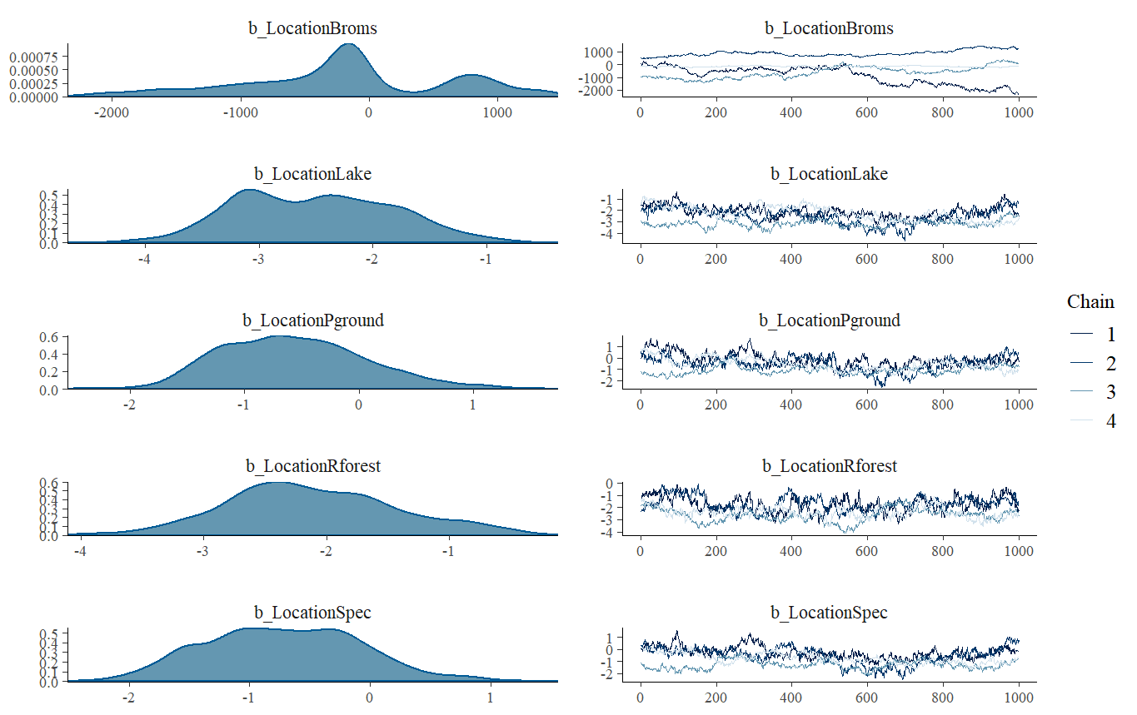

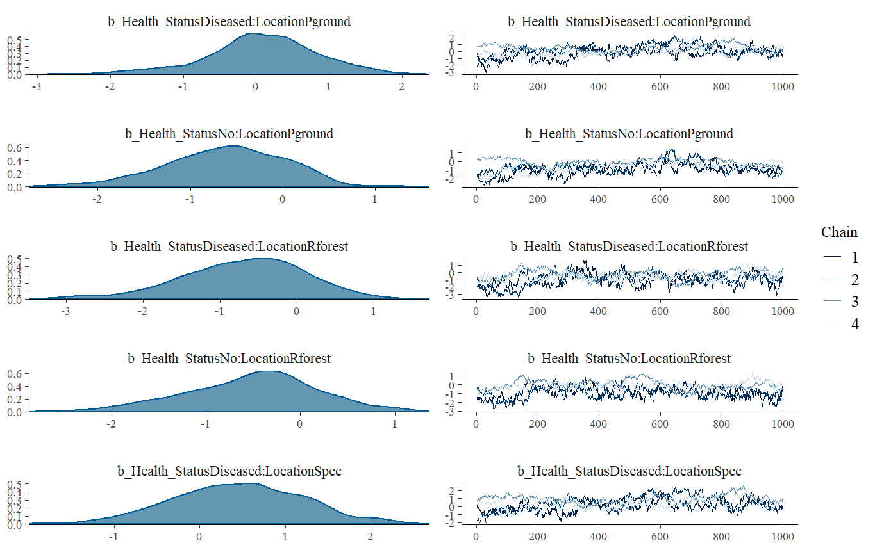

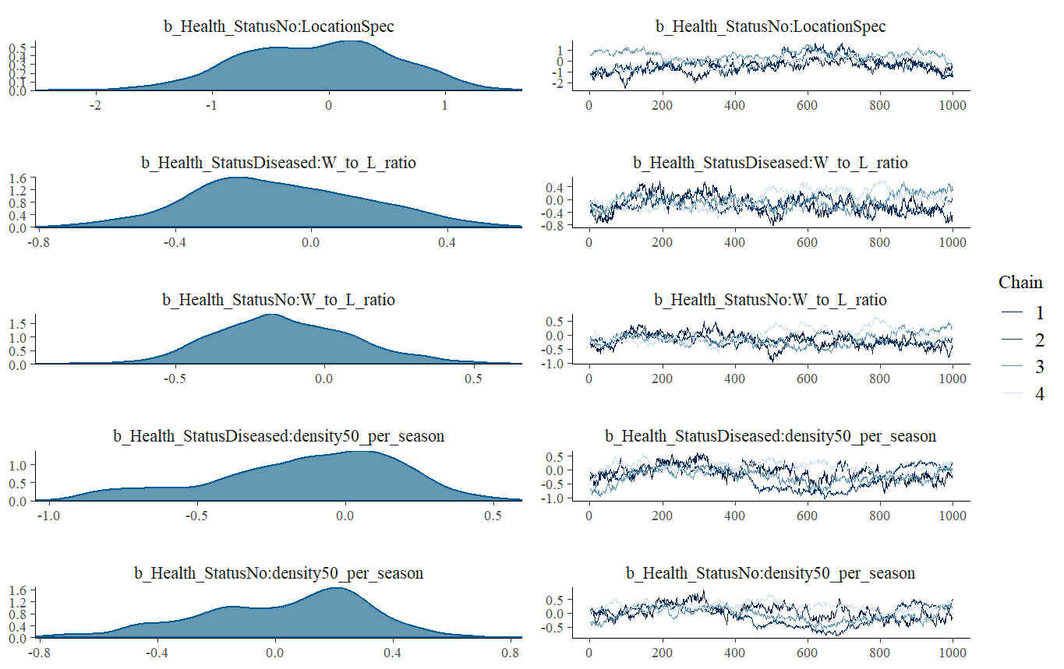

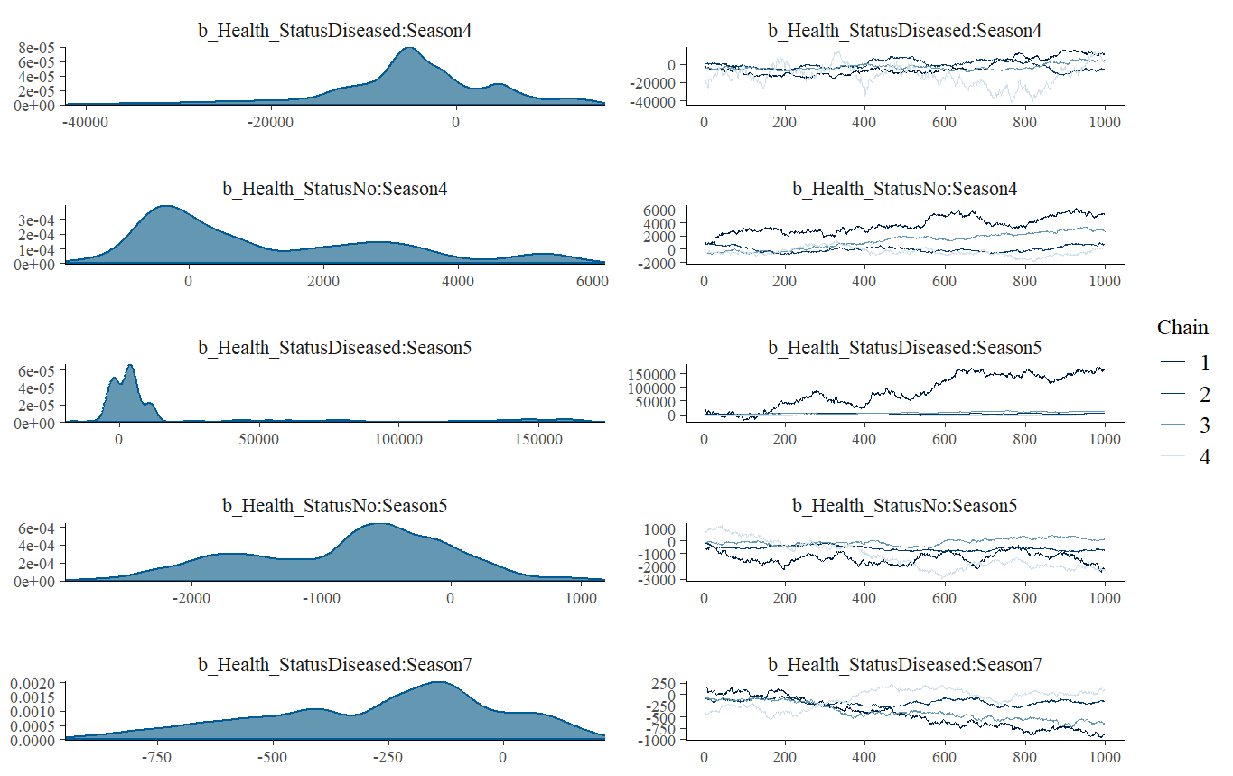

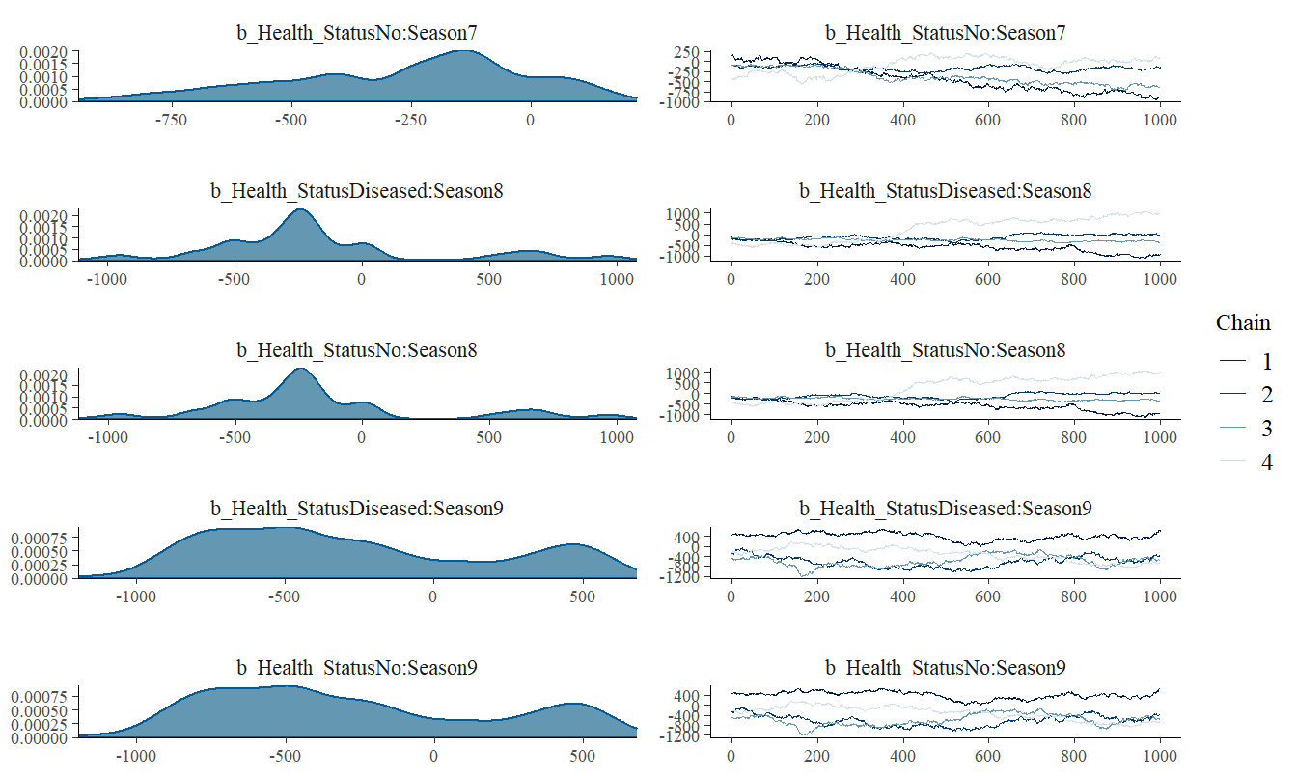

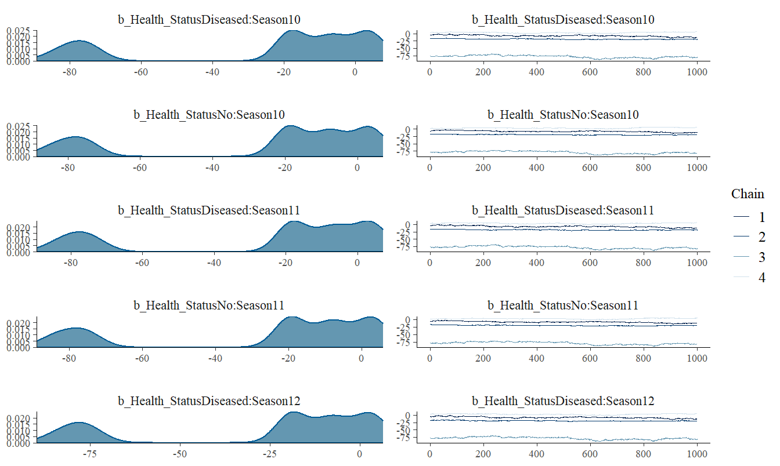

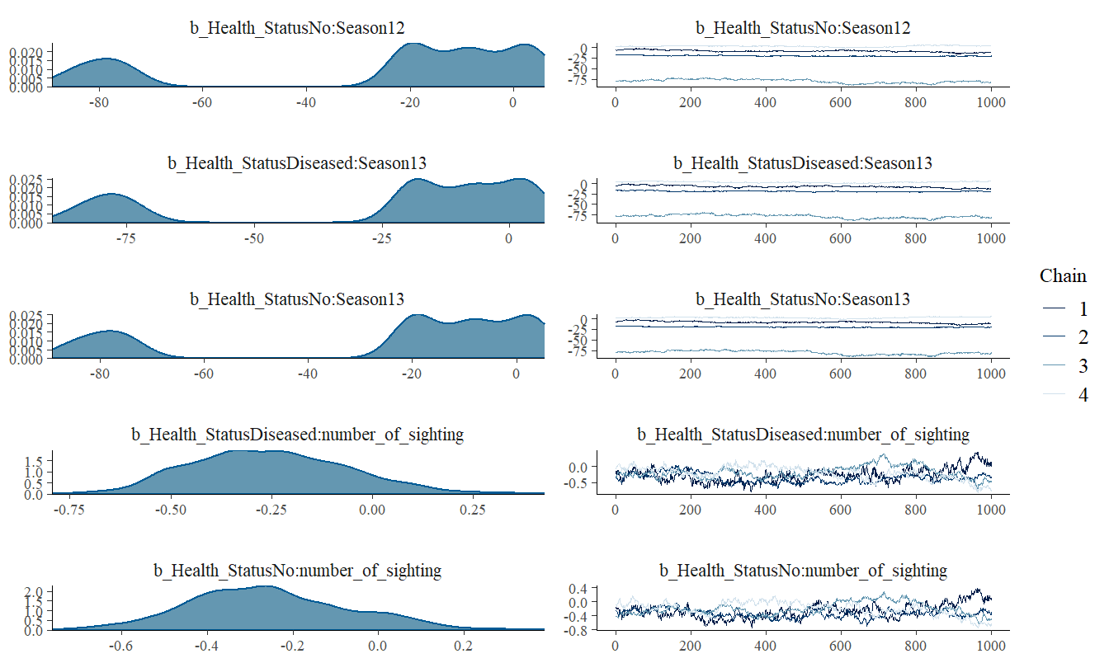

**Acknowledgements:**

Huge thank you my supervisors Professor Celine Frere and Professor Katrina McGuigan for helping me through out this project, including explaining the dataset to me in details, guiding me through the basics of analysis, helping me trouble shoot the data and models as well as giving feedbacks to my progress and proposal. Special thanks to Doctor Nicola Jackson for helping me categorising and extracting the data from a massive dataset, and giving me a helping hand on calculating certain variables such as conspecific density. Despite the results not being ideal at the end, I still learnt quite a lot.

**Data and Code Availability:**

All the reproducible codes, models, and the working progression of this project can be found under this github depository:

**References:**

Adkins, E., Driggers, T., Ferguson, G., Gehrmann, W., Gyimesi, Z., May, E., Ogle, M., Owens, T., & Klaphake, E. (2003). Ultraviolet Light and Reptiles, Amphibians. *Journal of Herpetological Medicine and Surgery*, 13(4): 27–37. doi: https://doi.org/10.5818/1529-9651.13.4.27

Angilletta, M. J., Niewiarowski, P. H., & Navas, C. A. (2002). The evolution of thermal physiology in ectotherms. *Journal of Thermal Biology*, 27(4), 249–268. https://doi.org/10.1016/S0306-4565(01)00094-8

Bogert, C. M. (1949). Thermoregulation in Reptiles, A Factor in Evolution. *Evolution*, 3(3), 195–211. https://doi.org/10.1111/j.1558-5646.1949.tb00021.x

Buerkner, P. C. (2017). brms: An R package for Bayesian multilevel models using Stan. *Journal of Statistical Software*, 80(1), 1–28. https://doi.org/10.18637/jss.v080.i01

Burns, G., Ramos, A., & Muchlinski, A. (1996). Fever Response in North American Snakes. *Journal of Herpetology*, 30(2), 133–139. https://doi.org/10.2307/1565503

Fisher, M. C., Henk, D. A., Briggs, C. J., Brownstein, J. S., Madoff, L. C., McCraw, S. L., & Gurr, S. J. (2012). Emerging fungal threats to animal, plant and ecosystem health. *Nature (London)*, 484(7393), 186–194. https://doi.org/10.1038/nature10947

Gardiner, R. Z., Doran, E., Strickland, K., Carpenter-Bundhoo, L., & Frère, C. (2014). A face in the crowd: A non-invasive and cost effective photo-identification methodology to understand the fine scale movement of eastern water dragons. *PloS One*, 9(5), e96992–e96992. https://doi.org/10.1371/journal.pone.0096992

Gentry, S., Lorch, J. M., Lankton, J. S., & Pringle, A. (2023). A Cross-Inoculation Experiment Reveals that Ophidiomyces ophiodiicola and Nannizziopsis guarroi Can Each Infect Both Snakes and Lizards. *Applied and Environmental Microbiology*, 89(5), e0216822–e0216822. https://doi.org/10.1128/aem.02168-22

Herczeg, G., Gonda, A., Saarikivi, J., & Merilä, J. (2006). Experimental Support for the Cost-Benefit Model of Lizard Thermoregulation. *Behavioral Ecology and Sociobiology*, 60(3), 405–414. https://doi.org/10.1007/s00265-006-0180-6

Hertel, A. G., Hertel, A. G., Niemelä, P. T., Dingemanse, N. J., Mueller, T., & Mueller, T. (2020). A guide for studying among-individual behavioral variation from movement data in the wild. *Movement Ecology*, 8(1), 1–30. https://doi.org/10.1186/s40462-020-00216-8

Khan, J. J., Richardson, J. M., & Tattersall, G. J. (2010). Thermoregulation and aggregation in neonatal bearded dragons (Pogona vitticeps). *Physiology & Behavior*, 100(2), 180–186. https://doi.org/10.1016/j.physbeh.2010.02.019

McCoy, C. M., Lind, C. M., & Farrell, T. M. (2017). Environmental and physiological correlates of the severity of clinical signs of snake fungal disease in a population of pigmy rattlesnakes, Sistrurus miliarius. *Conservation Physiology*, 5(1), cow077–cow077. https://doi.org/10.1093/conphys/cow077

Paré, J. A., & Sigler, L. (2016). An Overview of Reptile Fungal Pathogens in the Genera Nannizziopsis, Paranannizziopsis, and Ophidiomyces. *Journal of Herpetological Medicine and Surgery*, 26(1-2), 46–53. https://doi.org/10.5818/1529-9651-26.1-2.46

Paré, J. A., Wellehan, J., Perry, S. M., Scheelings, T. F., Keller, K., & Boyer, T. (2021). Onygenalean Dermatomycoses (Formerly Yellow Fungus Disease, Snake Fungal Disease) in Reptiles. *Journal of Herpetological Medicine and Surgery*, 30(4), 198–209. https://doi.org/10.5818/19-12-221.1

Peterson, N. R., Rose, K., Shaw, S., Hyndman, T. H., Sigler, L., Kurtböke, D. İpek, Llinas, J., Littleford-Colquhoun, B. L., Cristescu, R., & Frère, C. (2020). Cross-continental emergence of Nannizziopsis barbatae disease may threaten wild Australian lizards. *Scientific Reports*, 10(1), 20976. https://doi.org/10.1038/s41598-020-77865-7

Schilliger, L., Paillusseau, C., François, C., & Bonwitt, J. (2023). Major Emerging Fungal Diseases of Reptiles and Amphibians. *Pathogens (Basel)*, 12(3), 429. https://doi.org/10.3390/pathogens12030429

Seebacher, F. (2005). review of thermoregulation and physiological performance in reptiles: what is the role of phenotypic flexibility. *Journal of Comparative Physiology. B, Biochemical, Systemic, and Environmental Physiology*, 175(7), 453–461. https://doi.org/10.1007/s00360-005-0010-6

Strickland, K., & Frère, C. H. (2019). Individual Variation in the Social Plasticity of Water Dragons. *The American Naturalist*, 194(2), 194–206. https://doi.org/10.1086/704089

Tacey, J., Class, B., Delmé, C., Powell, D., & Frère, C. H. (2023). Impacts of fungal disease on dyadic social interactions in a wild agamid lizard. *Animal Behaviour*, 200, 125–136. https://doi.org/10.1016/j.anbehav.2023.04.002

Tattersall, G. J., Cadena, V., & Skinner, M. C. (2006). Respiratory Cooling and Thermoregulatory Coupling in Reptiles. *Respiratory Physiology & Neurobiology*, 154(1), 302–318. https://doi.org/10.1016/j.resp.2006.02.011