An Analysis of road accidents in victoria

Name: Yiqun Cheng

# User Guide

## Introduction page

When you click on the link of this website, the scheme will be shown as below as an introduction page. To tell both the name and the aim of this project.

Scrolling down from the introduction page, or simply click on the ‘About’ button on the top of the page will lead to the ‘About’ of this project.

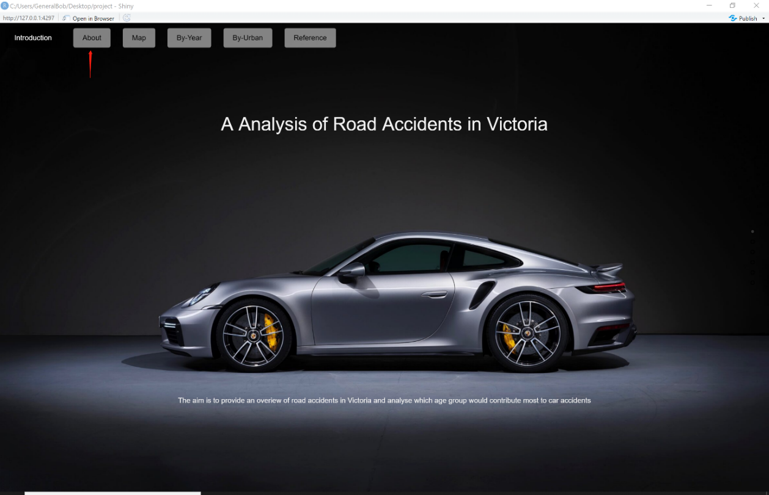

## About page

The formation of the about page is shown as below, when leading to the next page, scroll down or click ‘Map’ on the top of the page.

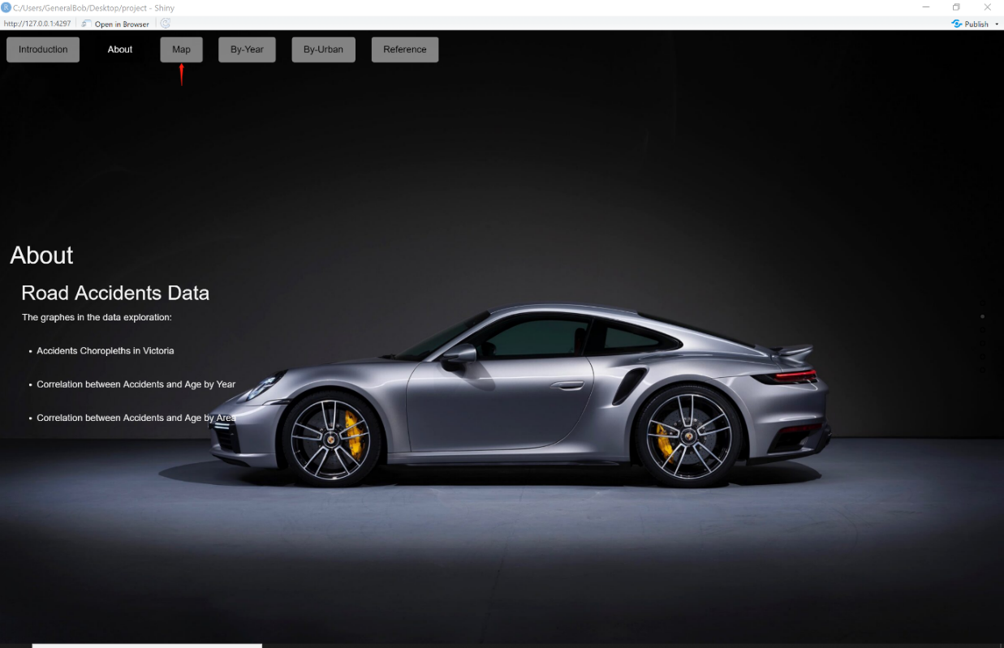

Other than scrolling down or clicking on the specified button, this point on the right-hand side is also used as navigation purpose.

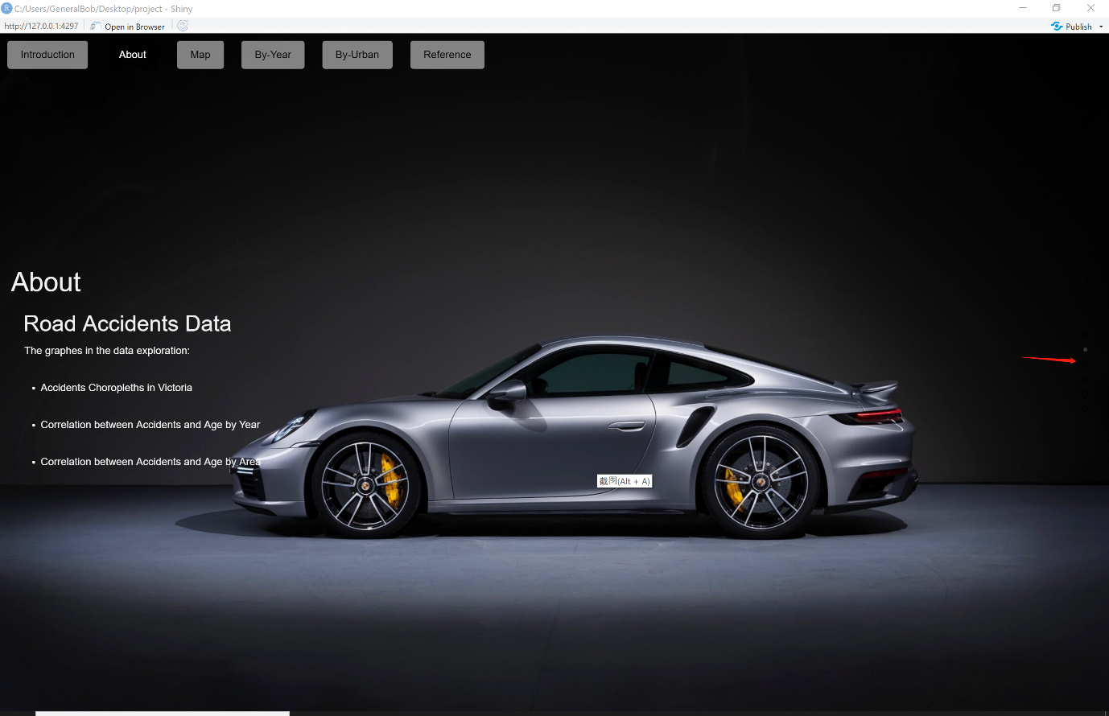

## Map page

The Accidents Choropleths in Victoria and Number of accidents by age group will be shown on the ‘Map’ page, where users can select their specified city to see the details.

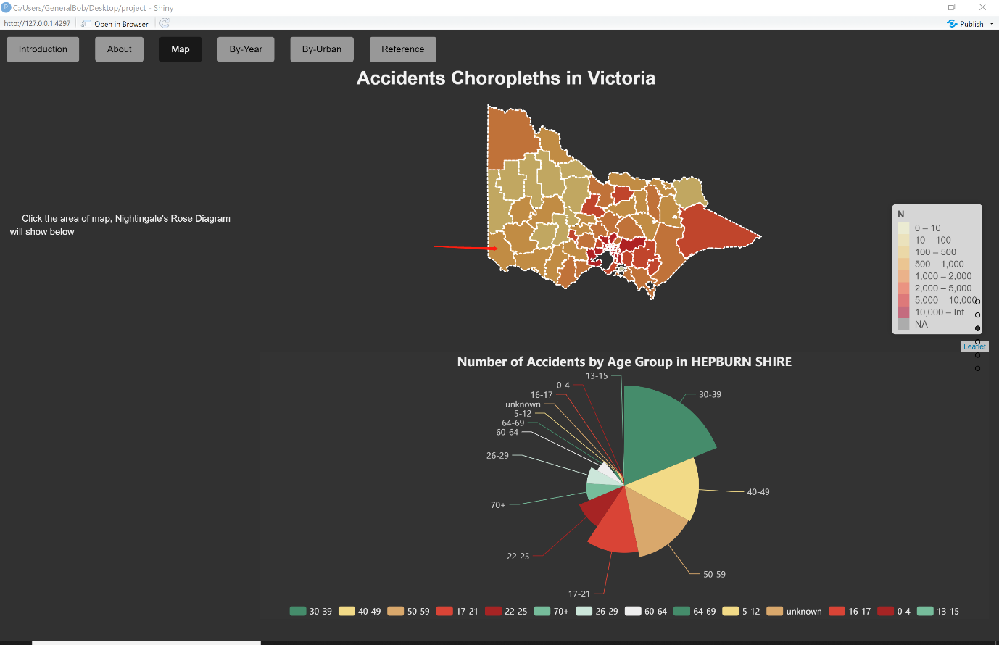

Users can always zoom in, zoom out and drag to select their wanted city council, and hover over to see the correspondent number of accidents.

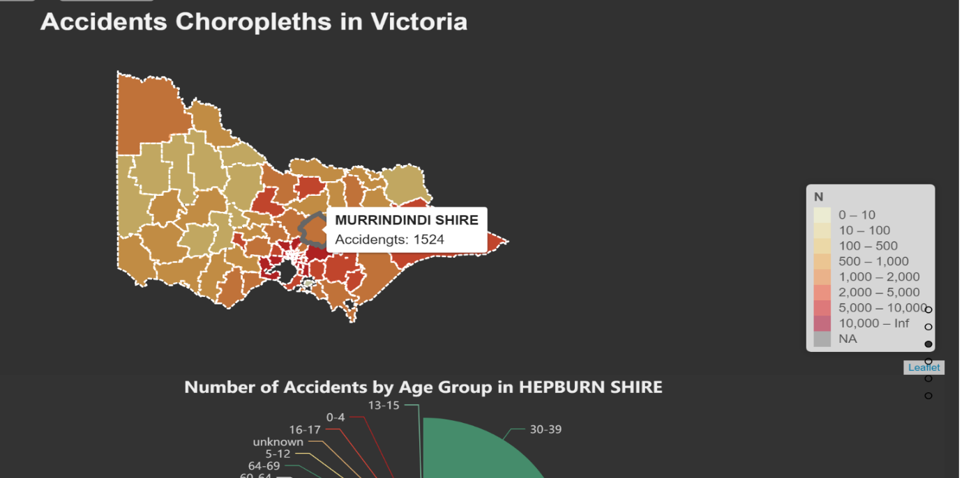

Users can also hover to the Number of Accidents chart and hover over to see the different number of accidents caused by different age groups with number figures and overall percentage.

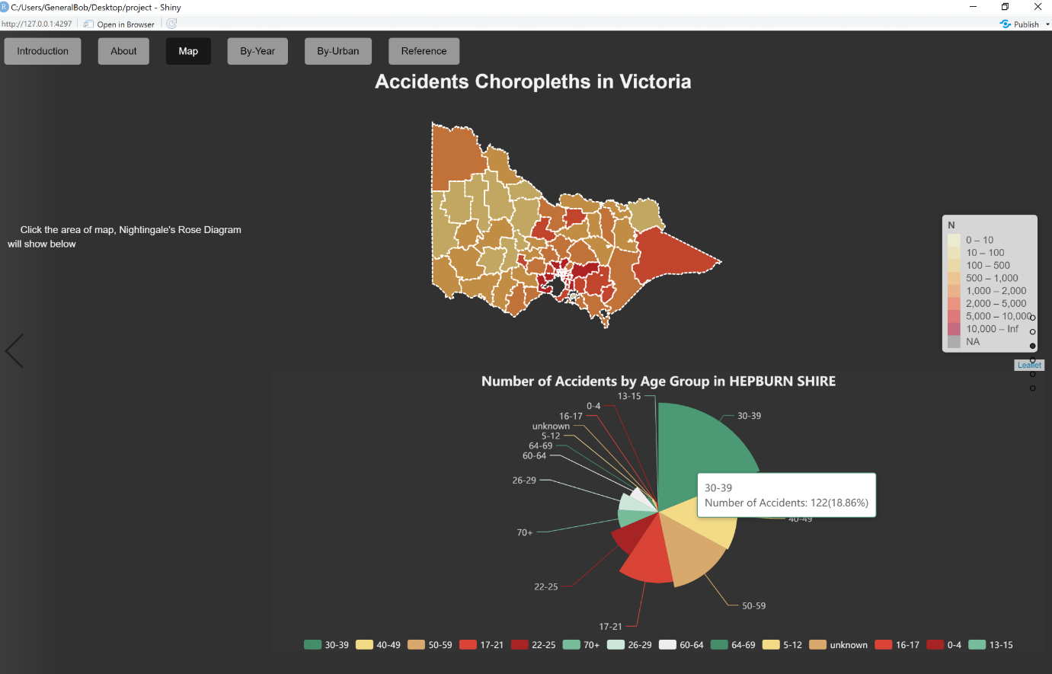

## By Year page

Users can select different year they want to see the correlation between accidents and age by gender in different years.

Users can also select to see Female, Male or both by selection in the gender section, and hover to see the specified number in the correlation chart.

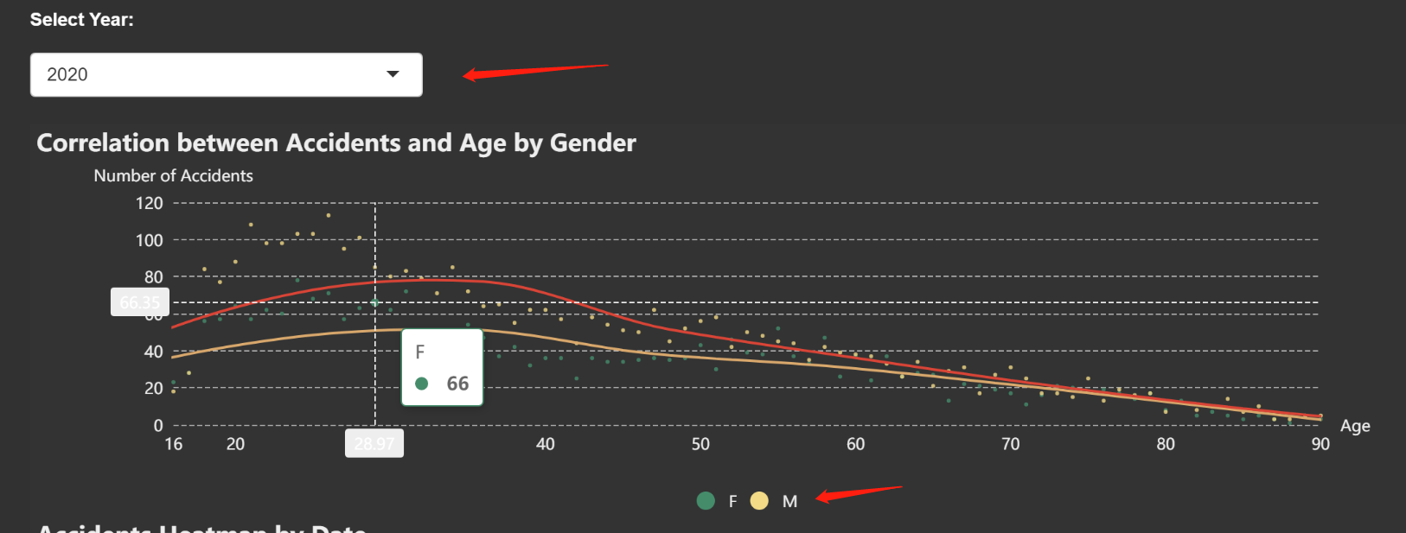

On this page, users can see the Accidents Heatmap by Date chart, and change and specify their wanted range of number of accidents on the heatmap. Since the data set is not complete in 2020, there are some white spaces.

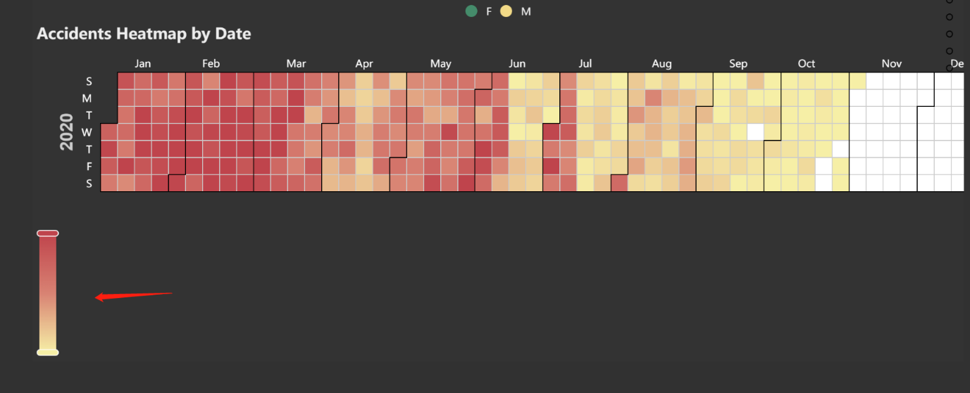

## By Area page

As it is instructed in the By Area page, users can also select different locations to observe data source, and hover over to see the specified number figure over the correlation chart.

Users can also see the Number of Accidents by Injury Level chart among different city locations, and hover over to monitor the detailed data.

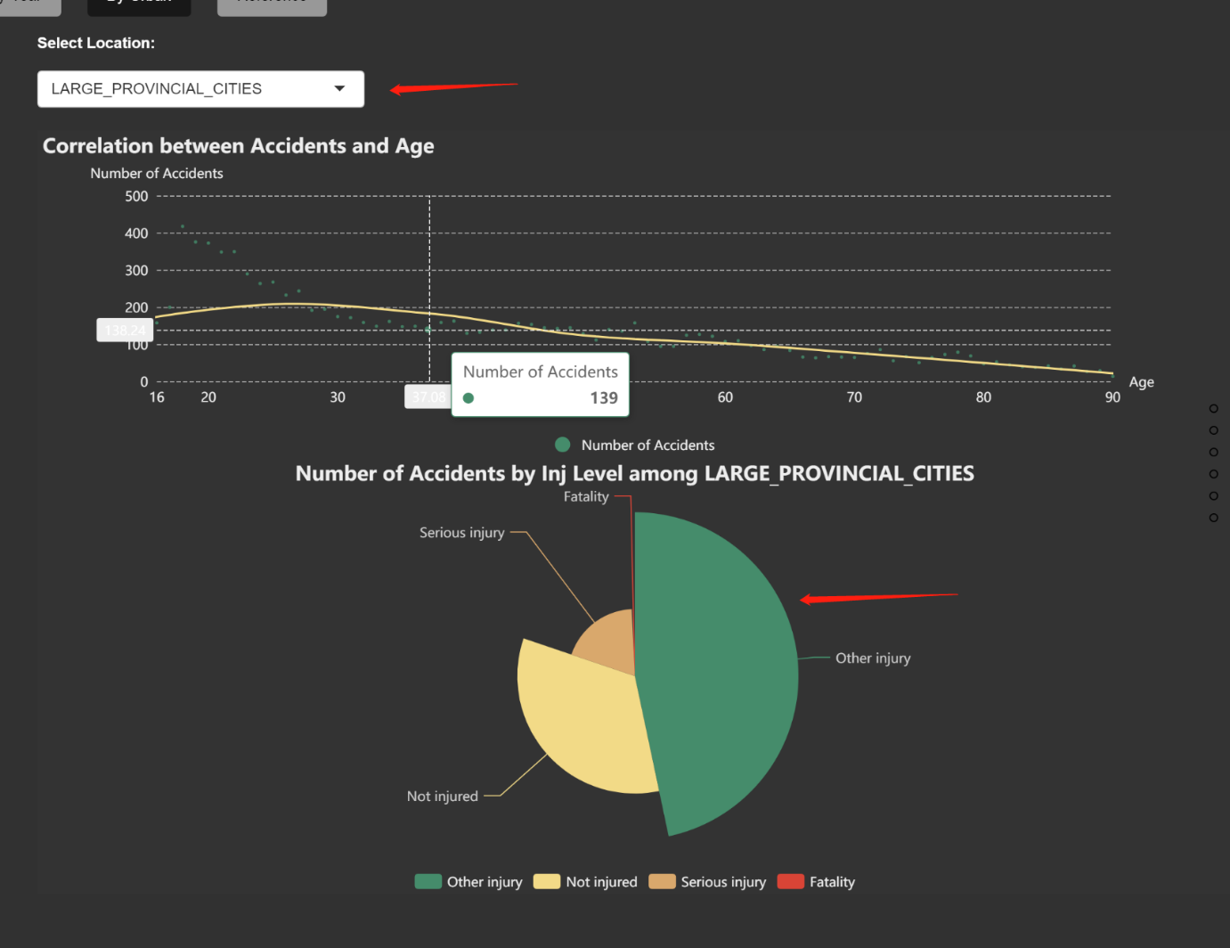

## Reference page

The data collection source will be shown in this page, where the referral webpage of VicRoad and RACV is listed.

