M2 UI functional test report
Product | Yira Clinics
Organisation | YIRA HEALTH TECH PVT LTD
Milestone | M2
Report type | UI functional test (run type ui)
Document id | FT-M2
Version | 1.1
Release date | 2026-10-30
Confidential. Aadhaar, ABHA and mobile numbers are masked, and the report holds no credential, token or OTP.

Contents
Open in Word and update fields to build the contents.

Document control
Document title | M2 UI functional test report
Document id | FT-M2
Version | 1.1
Prepared by | Manikanta N, Tester
Reviewed by | Not yet reviewed
Approved by | Not yet approved
Released by | Not yet released
Release date | 2026-10-30

Change history
Version | Date | By | Change
1.0 | 2026-10-29 | Manikanta N | First issue
1.1 | 2026-10-30 | Manikanta N | Product name corrected from ClinicX to Yira Clinics

Distribution
Name | Organisation | Role
Manikanta N | YIRA HEALTH TECH PVT LTD | Tester

Executive summary
Measure | All cases | Mandatory
Cases in NHA's sheet | 13 | 13
Applicable to this integrator | 13 | 13
Tested | 13 | 13
Passed | 13 | 13
Conditional pass | 0 | 0
Failed | 0 | 0
Blocked | 0 | 0
Not tested | 0 | 0
Not applicable | 0 | 0
Cases in NHA's sheet: Every case in the workbook.
Applicable to this integrator: The cases less those not applicable to a private entity.
Tested: Run to a result: passed, conditional pass or failed.
Passed: The Expected Result was seen.
Conditional pass: The Expected Result was seen, with a gap beside it, listed with its condition.
Failed: The Expected Result was not seen in three passes.
Blocked: Started, then waiting for a tester, a device or test data.
Not tested: Applicable and not run yet, NA on a mandatory case NHA has not agreed to, or an unknown status.
Not applicable: Not for this entity type as the sheet's groups mark it, run or not; or NA agreed or optional.
Ready for sandbox exit.

ABDM details
Entity name | YIRA HEALTH TECH PVT LTD
Product name | Yira Clinics
Category | HMIS
Role | HIP
Entity type | private
Milestone | M2
API version | V3
Run type | ui, UI functional test
Test execution dates | 2026-10-28 to 2026-10-29
Number of days for testing | 2
Most passes any case took | 3
Test executed by | Manikanta N
Recordings | None

Results summary

Results by function
Function | Cases | Passed | Conditional pass | Failed | Blocked | Not tested | Not applicable
Health Record Creation | 1 | 1 | 0 | 0 | 0 | 0 | 0
HIP Initiated Health Record Linking Using Demographic Auth | 3 | 3 | 0 | 0 | 0 | 0 | 0
User Initiated Health Record Linking | 7 | 7 | 0 | 0 | 0 | 0 | 0
Sending Notification for deep link workflow | 1 | 1 | 0 | 0 | 0 | 0 | 0
Data transfer & share | 1 | 1 | 0 | 0 | 0 | 0 | 0

Scope and limitations
Application | URL
Yira Clinics web (HIP IN3610001937, Ocimum dentistry) | http://localhost:4200/
Workbook | M2_BUILDING_HIP_TEST_CASES.xlsx
Tabs | Building HIP
Limitations | The results hold for the build and configuration tested from 2026-10-28 to 2026-10-29. The build under test ran on a local machine; ABDM callbacks reached it through a Cloudflare quick tunnel registered as the bridge URL. The tunnel was replaced twice during the run after the machine slept, and the bridge URL re-registered each time (run log). The build does not store the bodies of its outbound replies and pushes (on-discover, on-init, on-confirm, on-notify, on-request, data push, notify); their content is shown by the code and by ABDM accepting them and by what followed. ABDM sandbox: one on-discover was answered with 'Runtime Error', and twice no health-information request followed a granted consent (USER_INIT_LINK_607 passes 1 and 2). Extra checks outside the set (count mismatch ABDM-1037, wrong OTP, consent revocation) were not run. HIP_INIT_SHARE_CARECONTEXT was re-run on 2026-10-29 on backend db30fa2 / frontend feb708f, after a read-only Consents view was added. Backend changes since 85ae1bd are only that view (0326320, db30fa2) and a hospital-role check on the staff ABDM patient routes (a5a4dca); the linking, data-flow, FHIR, gateway and crypto code the other 12 cases ran on is unchanged. Frontend feb708f adds the view to the ABDM Records tab and also carries the M1/M3 commits merged at 00:13 on 2026-10-29 (HIU record request pages and the shared calendar), none of which touches the ABDM Records tab or the linking screens. The quick tunnel was replaced and the bridge URL re-registered for the re-run. The product's name is Yira Clinics. Its screens still show the working name ClinicX in places, so screenshots and screen messages quoted in this report can carry that name.

Flow details
Flow | ABHA address used | HI types created or tested
HIP initiated linking by demographic details | xxx0319@sbx | Prescription, WellnessRecord, OPConsultation, Invoice
User initiated linking | xxx0606@sbx | Prescription
SMS notify with deep link |  | Prescription
Data transfer and share | xxx0319@sbx, xxx0606@sbx | Prescription, WellnessRecord, OPConsultation

Test environment and tools
Tool | Version or value
Browser | Google Chrome (headed, driven through the Playwright MCP server)
Browser version | 156.0.8078.48
Playwright | @playwright/mcp 0.0.83
PHR app | ABDM sandbox PHR app
PHR app version | Not recorded
Emulator | None: the tester's Android phone
Model that ran the agent | claude-opus-5-5
backend_build | Clinicx-Backend ABHABang-26-10 at 85ae1bd; HIP_INIT_SHARE_CARECONTEXT re-run at db30fa2
frontend_build | Clinicx-Frontend at ab5a8a0; HIP_INIT_SHARE_CARECONTEXT re-run at feb708f
callback_route | Cloudflare quick tunnel to the local backend, registered as the bridge URL

Test team
Name | Role | Qualifications
Manikanta N | Tester

Approach and methodology
Runner | An agent ran each case with the module's test skill and wrote the result into the workbook.
Passes | At most three per case. Iterations is the number of passes a case took.
Approvals | A person gave every OTP, consent and approval as the case needed it. The agent kept no OTP.
PHR app | A case through the PHR app is proved by one PHR app screenshot of the consent or the record.
Run type | ui: Playwright drove the screens, with a screenshot per step.
Request IDs | A fresh one on every call. Look each up in the gateway's own record.

Test data
Item | Value
ABHA address, HIP initiated linking and share (patient HOSP11-2026-0032) | xxx0319@sbx
ABHA address, user initiated linking (patient OCM123-2026-0013, registered without ABHA) | xxx0606@sbx
Mobile for user initiated linking and the SMS deep link | XXXXXX5506
HIP id | IN3610001937

Evidence

Health Record Creation

Health_RECORD_CREATION_101: Creation of Health Records
Result | PASS, 1 pass. Marking: Mandatory.
Expected result | 1. ABDM mandates only the sharing of digital health records in FHIR format. 2. Kindly ensure to implement SNOMED CT/ LOINC Codes. Refer to following link to know more: https://sandbox.abdm.gov.in/sandbox/v3/toolkit
Observed | All 8 HI types are created as NRCES document bundles stored against care contexts, with SNOMED CT and LOINC codes.
Request IDs | None in the manifest
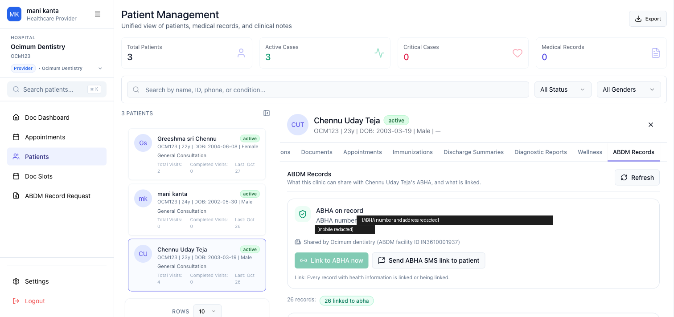
Figure 1, step 1
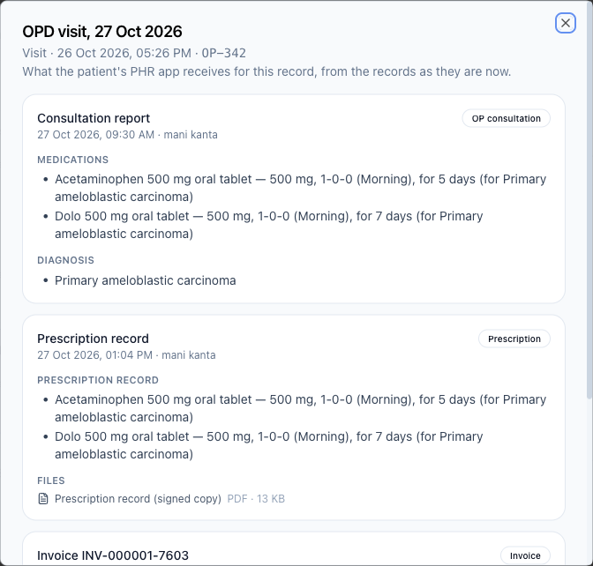
Figure 2, step 2

HIP Initiated Health Record Linking Using Demographic Auth

HIP_INTI_LINK_504: Generate Link Token
Result | PASS, 1 pass. Marking: Mandatory.
Expected result | 1. A new linking token should be created. Before generating a new token, check if an existing token is already available for the same patient. If it is still valid, reuse the same token for linking. Currently, the token is valid for 6 months
Observed | A record save requests a link token when none is held, stores it for six months, and reuses it for the next link.
Request IDs | 00c8e3d1-4aa8-4e21-937f-fe692f88708a, eb698f25-663b-46ca-9e84-6ef145db724f, 47926fe3-8e13-4b75-ab53-b9b5baceed3a
Step | Result | Note
1 | PASS | token requested and received, requestId matched
2 | PASS | stored against patient and ABHA address, 6 months
3 | PASS | reused for WR-5, no second generate-token
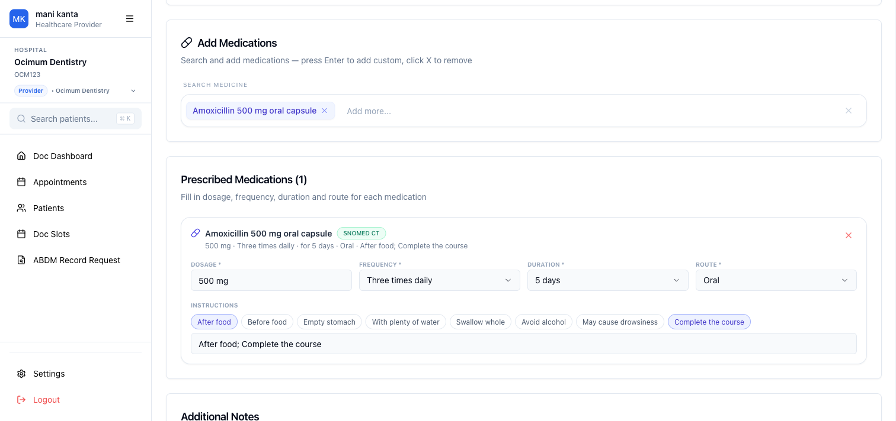
Figure 3, step 1
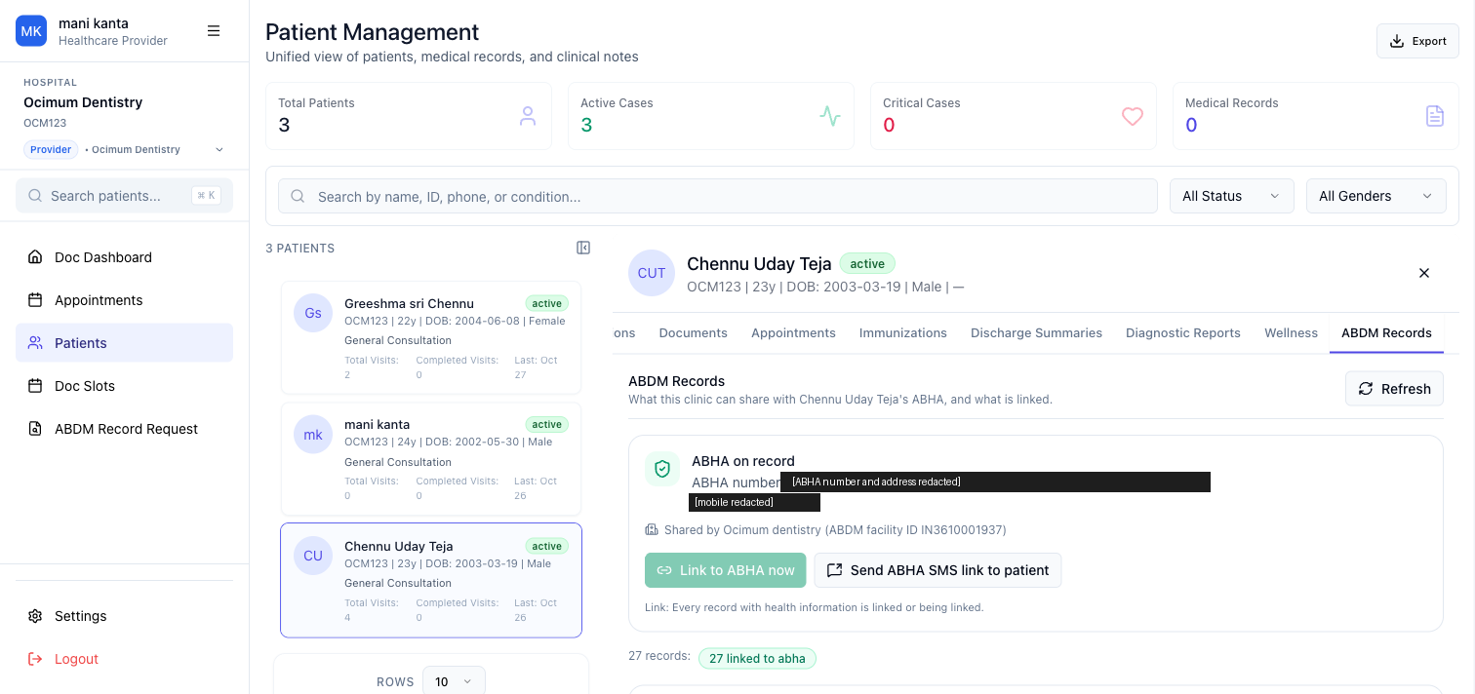
Figure 4, step 2
Figure 5, step 3

HIP_INTI_LINK_505: Linking of Health Records
Result | PASS, 1 pass. Marking: Mandatory.
Expected result | 1. Linking of care context initiated using the token. 2. User can pull linked health records via PHR app. Note: Linking of health records should be done automatically once records have been saved at HIP end.
Observed | Care contexts link automatically on save, and a record added to a linked visit sends the context notify (SUCCESS).
Request IDs | eb698f25-663b-46ca-9e84-6ef145db724f, 47926fe3-8e13-4b75-ab53-b9b5baceed3a, 800ed08d-86d7-46b8-8fd5-aed664ab5b4c
Step | Result | Note
1 | PASS | link initiated with the token on save, Successfully Linked care context
2 | PASS | records pulled and visible in the PHR app (tester screenshots), context notify SUCCESS
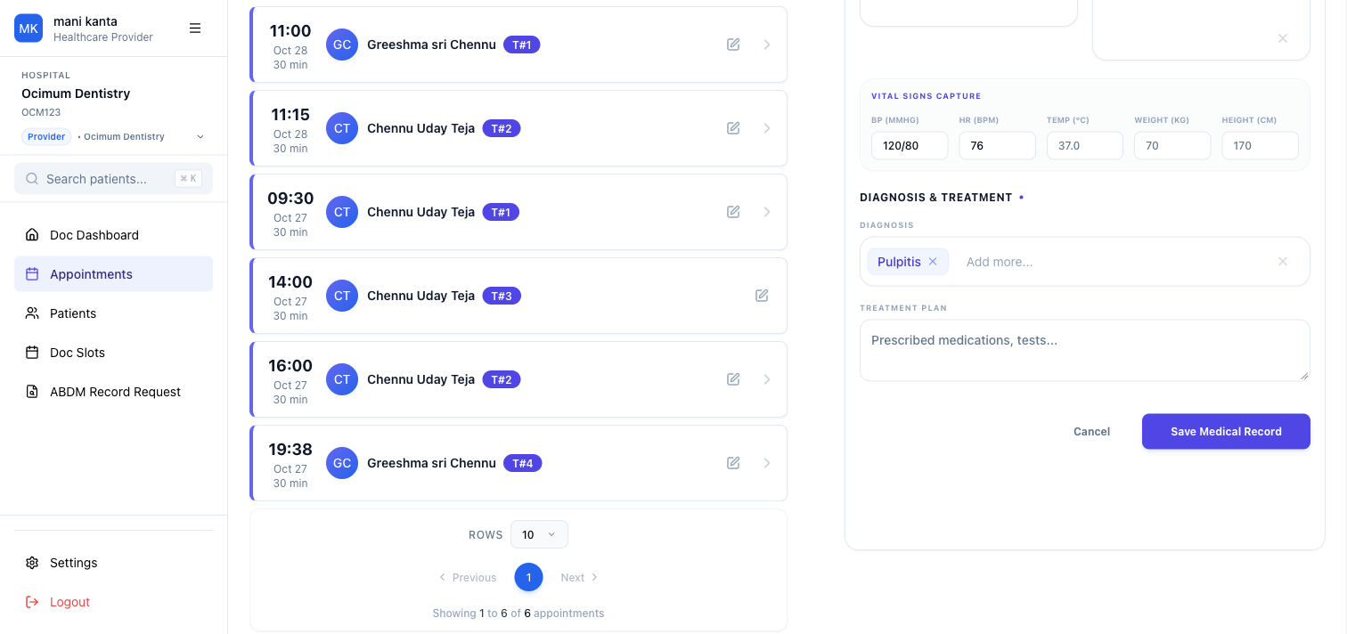
Figure 6, step 1
Figure 7, step 2
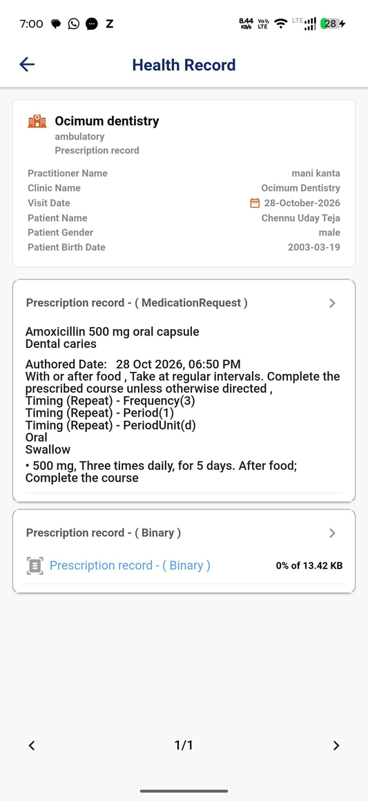  Figure 8, step 3 | 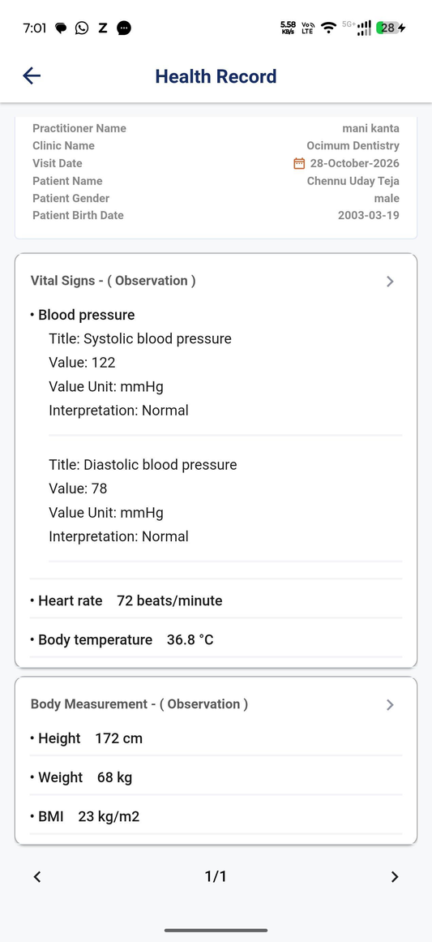  Figure 9, step 4 | 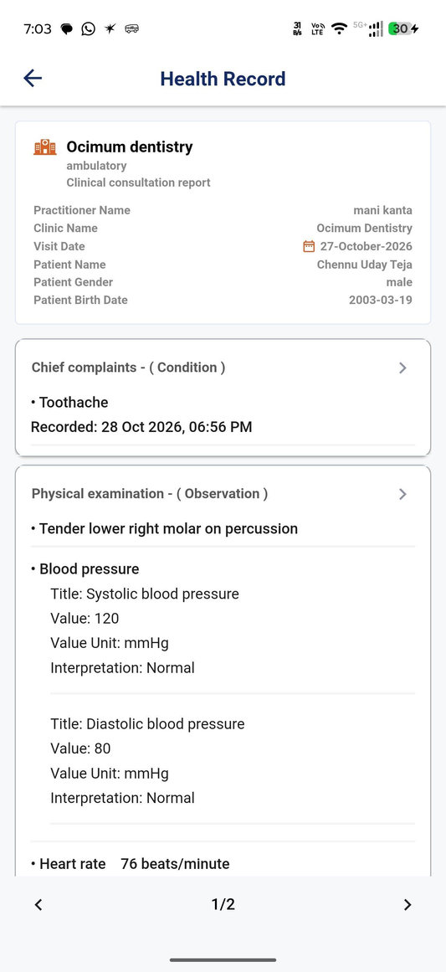  Figure 10, step 5
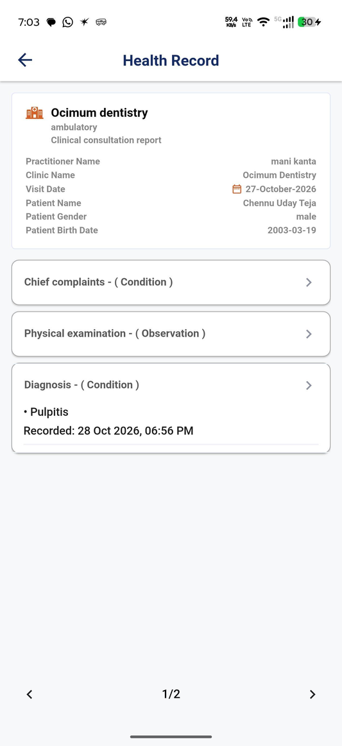
Figure 11, step 6

HIP_INTI_LINK_506: Pull Records
Result | PASS, 1 pass. Marking: Mandatory.
Expected result | 1. Linked records can be pulled using the "Pull Records" button in the PHR app.
Observed | The linked records were pulled and shown in the PHR app.
Request IDs | 2dbace9a-b69d-4153-bb15-a7177b585b17, 1534304c-8baa-47bd-b123-a43fe5ecafd2, a535f7b1-1e96-4100-9c64-10935e640c06
Figure 12, step 1 | Figure 13, step 2 | Figure 14, step 3
Figure 15, step 4

User Initiated Health Record Linking

USER_INIT_LINK_601: Login into PHR App
Result | PASS, 1 pass. Marking: Mandatory.
Expected result | 1. User should be able to successfully log in to the PHR app.
Observed | The tester logged in to the PHR app with the second ABHA.
Request IDs | None in the manifest

USER_INIT_LINK_602: Search for Facility/ HIP
Result | PASS, 1 pass. Marking: Mandatory.
Expected result | 1. User should be able to search and select the desired health provider (HIP).
Observed | Ocimum dentistry is found and selected in the PHR app.
Request IDs | 17df06aa-b95d-4f33-b2d0-5ba9cbf0677b
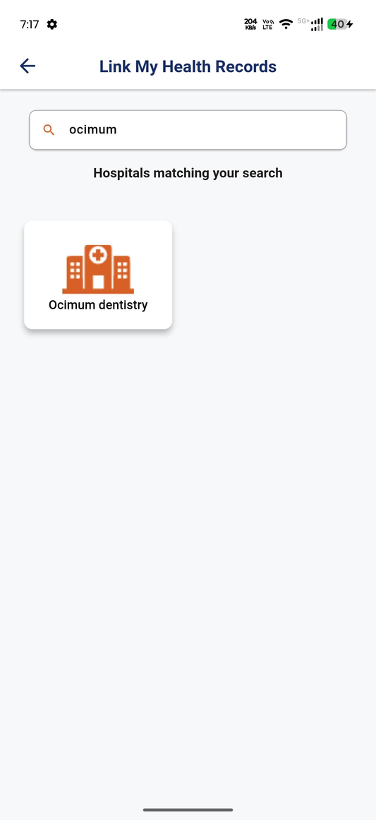
Figure 16, step 1

USER_INIT_LINK_603: Share User Profile Details with HIP
Result | PASS, 1 pass. Marking: Mandatory.
Expected result | 1. The Gateway send the request to the HIP to identify the patient in th HIP System. 2. The Facility/ HIP will receive the User's profile details. HIP searches their records for any of the verified identifers; search with Mobile number. On mobile number match HIP to do a fuzzy logic match on matched records. 3. Proceed with sharing the health records for linking.
Observed | The discover reaches the HIP with the transaction id, patient id and verified identifiers.
Request IDs | 17df06aa-b95d-4f33-b2d0-5ba9cbf0677b

USER_INIT_LINK_606: Validate Request
Result | PASS, 1 pass. Marking: Mandatory.
Expected result | 1. HIP send the matching record to the patient (PHR App)
Observed | The patient is matched by mobile, with gender and year of birth agreeing.
Request IDs | 17df06aa-b95d-4f33-b2d0-5ba9cbf0677b

USER_INIT_LINK_604: Fetch Health Records
Result | PASS, 1 pass. Marking: Mandatory.
Expected result | 1. If health records are available at the HIP, the user receives the list of available records and selects the records to proceed with linking.
Observed | Only unlinked care contexts are returned, and the person selects one to link.
Request IDs | 17df06aa-b95d-4f33-b2d0-5ba9cbf0677b, 764fd0a5-cd3f-4b0d-8e1c-038a56341033
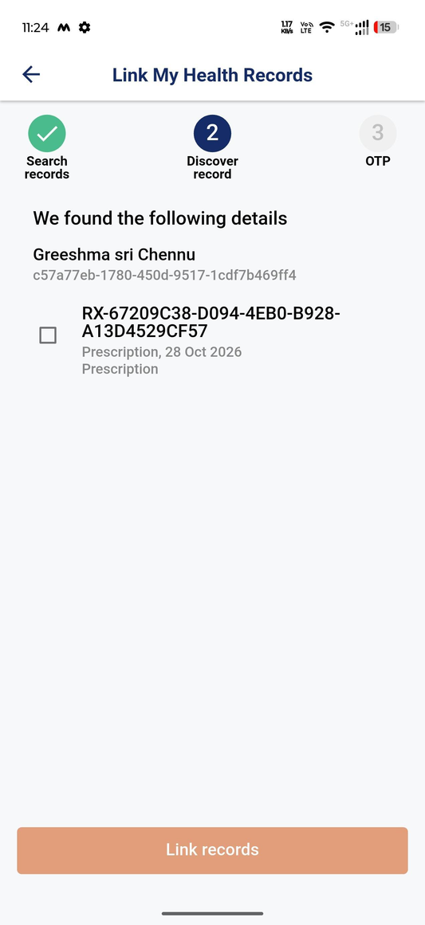
Figure 17, step 1

USER_INIT_LINK_605: Provide Consent for Health Record Linking
Result | PASS, 1 pass. Marking: Mandatory.
Expected result | 1. If OTP is valid, selected health records are linked with the ABHA. 2. Linked health record should be visible under the “Linked Facilities” section in the PHR app.
Observed | The HIP sends the OTP, verifies it on confirm and links only the selected care context.
Request IDs | 764fd0a5-cd3f-4b0d-8e1c-038a56341033, 44b6d7d6-9720-4573-b350-b65c8cf57e9d
Step | Result | Note
1 | PASS | init received, on-init DIRECT/MOBILE with link reference
2 | PASS | OTP sent by the HIP, confirm with matching linkRefNumber and token
3 | PASS | on-confirm with the selected care context only, record visible under the linked facility
Figure 18, step 1 | 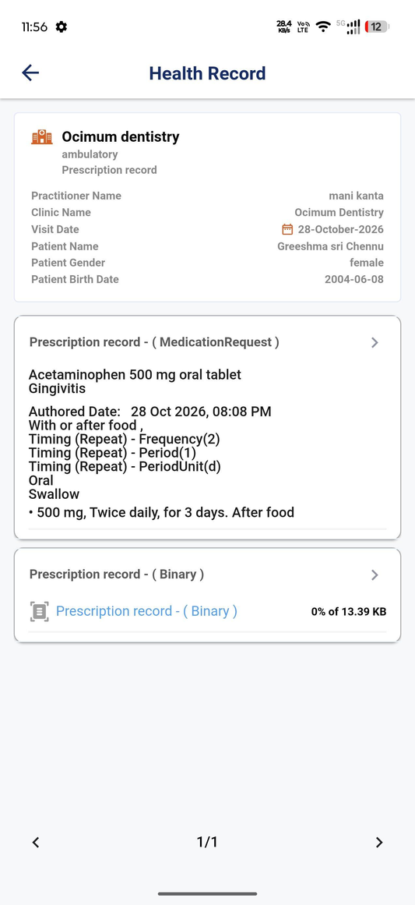  Figure 19, step 2

USER_INIT_LINK_607: Pull Records
Result | PASS, 3 passes. Marking: Mandatory.
Expected result | 1. Health record linking is completed. 2. User can now pull linked records in their PHR app.
Observed | The linked prescription was pulled into the PHR app on the third pass; ABDM sent no data request on the first two.
Request IDs | 188f3727-eeac-44a9-b3ad-c57214b083df, cfd114d3-02d2-4a4c-bc1a-a354ed3b479c, 1ddc08b0-a32f-45a2-8684-80efc33070c3, 20ae5b76-ded9-4738-8b0f-5a46676b28a5
Figure 20, step 1

Sending Notification for deep link workflow

HIP_INIT_NOTIFY_HIECM: Sending Notification to Patient with Deep Link
Result | PASS, 1 pass. Marking: Mandatory.
Expected result | 1. SMS with deep link is sent to the patient’s mobile.
Observed | A new record for a patient without ABHA sends sms/notify2 on its own, and the SMS with the deep link arrives.
Request IDs | ee33aa71-2e46-4704-8472-d823408f26bf
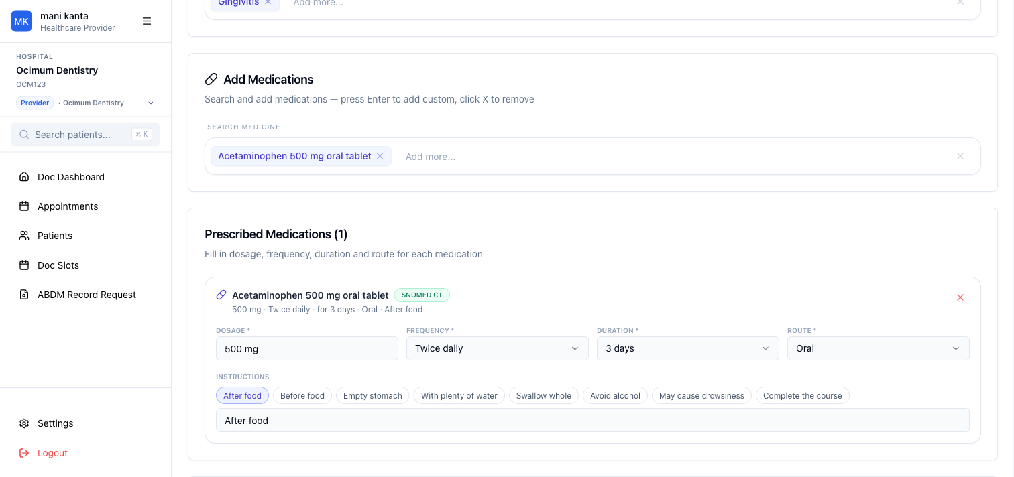
Figure 21, step 1
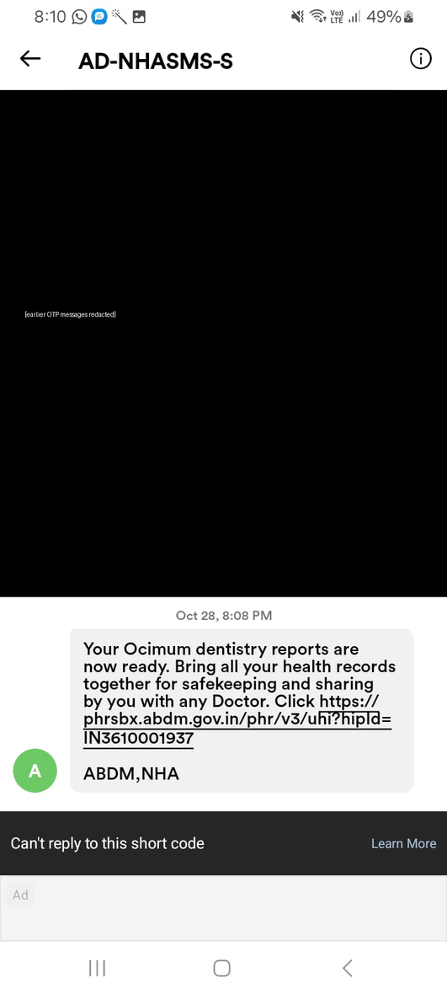
Figure 22, step 2

Data transfer & share

HIP_INIT_SHARE_CARECONTEXT: HIP must share health records associated with care context on request
Result | PASS, 2 passes. Marking: Mandatory.
Expected result | 1. Health records will be successfully received in the PHR app 2. Health records must be properly decryptable using the HIP public key and nonce. 3. Health records shared/ transferred must be in proper FHIR formats defined by NrCes.
Observed | Records are shared encrypted on request and shown in the PHR app, and Yira Clinics shows each stored consent against the patient with its HI types, date range, purpose and expiry.
Request IDs | 8b0b8f8b-2d65-4296-9c59-6865556cd787, 7a34c022-ec56-46d6-a0dc-2fc139eb86c6
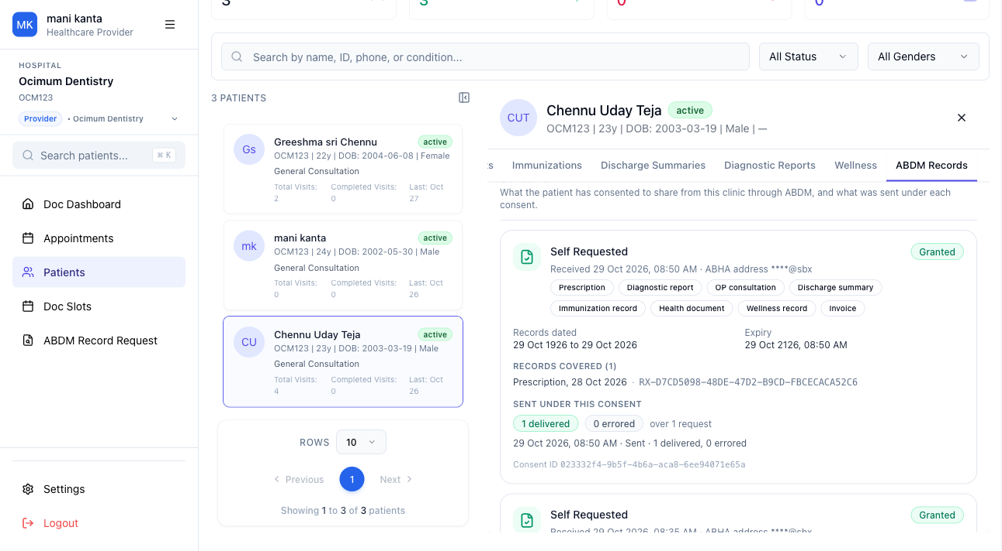
Figure 23, step 1
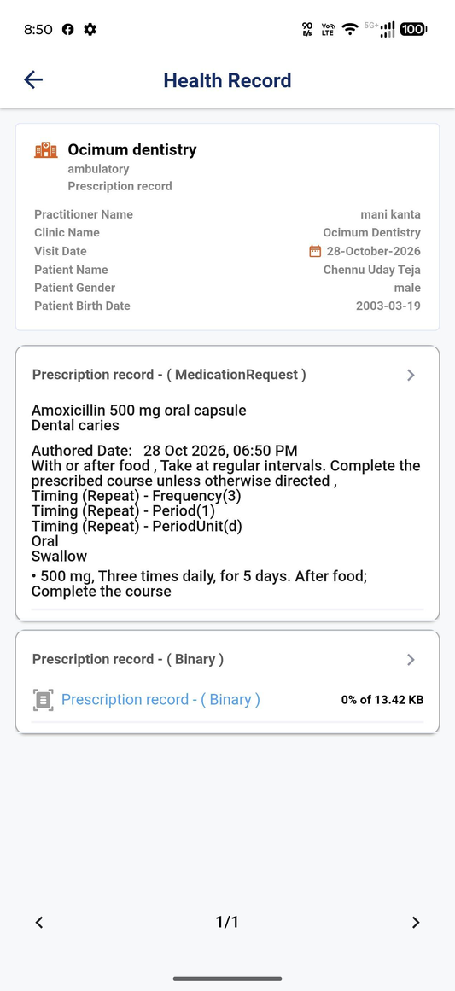
Figure 24, step 2

Failures and iterations log
No case failed, is blocked or passed with a condition.

Conclusion and sign-off
Ready for sandbox exit.
Sign-off | Name | Date | Signature
Prepared by | Manikanta N, Tester
Reviewed by | Not yet reviewed
Approved by | Not yet approved

Annexures
Recording | Link
Annexure | File
Completed workbook | M2_BUILDING_HIP_TEST_CASES.xlsx
REQUEST-ID manifest | m2-20261028-1847.json
Full size screenshots | abdm-ft/evidence, each figure listed in report-m2-screenshots.json

