# Step 1. Reserve edition time slot

Go to the shared file: “G:\Shared drives\SUMO Seattle Simulation Model\Edit time reservation-Winter 2020” and reserve [edition time slots](https://docs.google.com/spreadsheets/d/1Eb4geE6LPX1WNfP2gi6EKV-6FOqDGE5CDeEjKUodQeQ/edit#gid=0).

# Step 2. Locate the working folder

Open conda prompt (or system console with python installed), change direction to the shared drive folder: “G:\Shared drives\SUMO Seattle Simulation Model\Seattle Network\Bigger Seattle\Network_check_Ped\”.

# Step 3. Run the SUMO simulation

In the system console, type “python main_program_Bigger_Seattle_ped.py”. The program will generate the pedestrian demand based on the O-D (on TAZ level) file. After that, the program will open the SUMO GUI and run the simulation automatically.

# Step 4. Check the error and resolve it

The simulation may stop due to errors. Check the error message (highlighted with red color at the bottom of the GUI) and resolve it. There might be different types of errors:

## Scenario 1. Pedestrians cannot be generated on the origin edge

This indicates the origin edge does not allow pedestrians. One way to address it is to remove it from the origin TAZ: open the file “*Seattle02262021_veh_ped.net*” by the **NetEdit** software, and load additional file “*Taz_bigger_Seattle_all_ped.add*” 🡪 find the origin edge using the “locate” function in NetEdit:

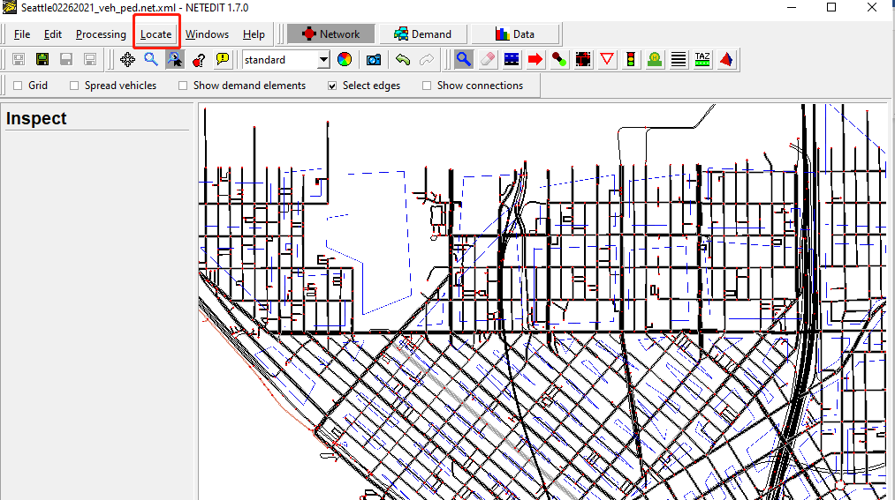

Click *Locate Edges* under the  icon, copy the origin edge ID shown in the error message and “enter”, use ‘Select/deselect’ and ‘Center’ to find the edges.

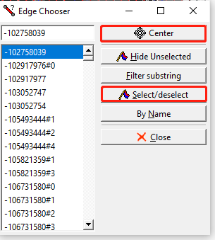

click the TAZ icon (), click the TAZ border (the blue-line) around the origin edge to find the TAZ that includes the origin edge (the edges included in a specific TAZ will be highlighted if you click that TAZ). Once found, click the origin edge, it will not be highlighted anymore. Click “Save changes” on the left. Then, **save the additional file by overwriting** “Taz_bigger_Seattle_all_ped.add” (Notice: you will need to save the additional file, using ‘ctrl+S’ only saves the network). 🡪 go to Step 3 to correct other errors.

## Scenario 2. No connection found between origin edge and destination edge for a person

There is no connected route for the person who wants to travel from the origin edge to the destination edge. The connection errors usually occur around the origin or the destination edge.

Open the file “Seattle02262021_veh_ped.net” by the NetEdit software, and load additional file “Taz_bigger_Seattle_all_ped.add” 🡪 find the origin edge using the “locate” function in NetEdit: copy the origin edge ID shown in the error message and “enter” 🡪 check the connections around the origin edge 🡪 if there is no connection error around the origin edge, find the destination edge and check the connections around it 🡪 if there is also no error around the destination edge, the connection error locates at the intermediate edges, you will have to manually check the connections of possible routes use the route icon () to check if there are missing routes from the origin edges to the destination edges. If the route looks file, try to check if there are missing crossings using the crossing icons (), a pedestrian cannot cross an intersection (whether it’s a cross intersection/T intersection) without crossings sometime. (if you cannot resolve such error, please let Yiran or Qiangqiang know)🡪 save the network (it is not necessary to save the additional TAZ file) 🡪 double click “Bigger_Seattle.sumocfg” to run SUMO GUI directly, and re-do Step 4.