Project Requirements

* Scenario
  + The following is a sample scenario describing a customer reserving table for party from a Restaurant Booking System.
    - It’s Friday afternoon and Joe wants to hold a party tomorrow so he needs to invite friends and booking a table for it.
    - He calls his friends and counts the numbers of party.
    - He runs the Booking System and searches for a table suit on party.
    - He reserves a table with 6 seats.
    - He finds that more people would come than his expect.
    - So, he changes the table to a 8 seats one.
  + General event
  + i.e. RecordBooking
    - input date
    - System shows all booking in current date
    - Accept a new booking sheet (include table no. donated by system)
    - System takes booking sheet and update new booking info
  + Optional event flow (no available table)
  + i.e. RecordBooking
    - input date
    - System shows all booking in current date
    - No available table today
    - end use case
  + Exceptional event flow (table are too small)
  + i.e. RecordingBooking
    - input date
    - System shows all booking in current date
    - input a new booking sheet
    - system shows no available table to take enough seats
      * Respond No: End case
      * Respond Yes: Keep recording the booking sheet but set a warning mark.
* Roles identified (Undefined)
* Use case
  + A booking System should:
    - Record a new booking information (also called booking sheet)
    - Cancel a booking information
    - Record arrival of a customer
    - Table transfer
  + 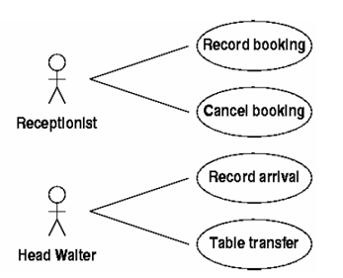
  + Also, system should collect those info:
    - Name, Phone number and covers. (on booking sheet)
    - For each booking, occupies an available table.
    - Record walk-ins and booking but not taking table customers. (only for counting, no phone number and name record)
    - Update the information on booking sheet
    - Whether has changed the table
    - Whether arrived or not
    - Cancellation
  + So, the basic functions are:
    - Record booking
    - Updating booking sheet (on time)
* Customer
  + Make bookings (receives booking confirmation if reference number)
  + Cancel bookings
  + Change bookings (Reschedule or change size of party)
* Staff (Front of house/Receptionist)
  + Log in to system
  + Can do everything a customer can do
  + Checking customers in or out
* Manager
  + Can do everything the staff can do
  + Print up to date list of bookings
  + Creating seating plan
  + Modify seating plan

Optional Additions

* Customer
  + Choose a table
  + Pre-order food
* Staff
  + Submit food orders