Final Project Report Kunshan Cultural Interactive Map
Duke Kunshan University | INFOSCI 301 | Autumn 2026
Instructor Prof Luyao Zhang
Team 6 | Yihong Lin yl999 | Yiran Zheng yz1011 | Sitong Chang sc972 | Final commit f43801f
Abstract. Kunshan Cultural Interactive Map explores how a bilingual website can help visitors, students, newcomers, and interested residents discover local culture and plan a cultural route. The final version brings together 82 records, 67 documented relationships, and 13 source collections. It links five views: a category overview, a relationship network, a map, record-level source details, and a comparison of three route ideas. Figures 1–3 show these views, the software structure, and the user task. Following Munzner’s validation model, we separated four questions: whether the proposed community need is real, whether the data represent it well, whether users can read the views, and whether the code works as claimed. Peer feedback led us to simplify the entrance, explain cultural links, repair route saving, standardize map markers, and replace straight lines with road-shaped routes where the routing service responds. The project is intended to support SDG 11.4 by improving access to heritage information. It does not yet prove learning, community benefit, or heritage protection. The next step is a task-based review with local visitors and cultural workers.
Keywords: cultural heritage visualization; Human-Centered Spatiotemporal Intelligence; Kunshan community; SDG 11.4
1 Project Frame and Contribution
1.1 Question user task and local context
Our question is: how can a bilingual interface help a visitor find a Kunshan cultural record, understand why it is connected to another record, and compare possible routes? At the Shanghai Science and Technology Museum, we saw visitors spend time with hands-on exhibits. At the Jinxi Intangible Cultural Heritage Museum on 18 September 2026, we saw objects presented with images and short explanations. These observations suggested that interaction and context could make cultural information easier to approach. They did not show that Kunshan residents need our website. That need is still a hypothesis. We have not yet consulted local cultural workers, site staff, older visitors, disabled visitors, or regular public-transport users.
1.2 Evidence supported claim and boundary
The artifact lets a user inspect 82 curated records, compare five category counts, trace 67 documented relationships, open cited sources, and compare three route modes. These statements describe implemented functions and dataset coverage. They do not establish that the dataset is complete, that relations represent cultural importance, that routes are optimal, or that the interface improves learning, participation, heritage protection, or SDG outcomes.
1.3 Project contribution
Five linked views support one route-building task. A user can first see what the dataset contains, then inspect a place and its sources, follow a recorded cultural connection, save stops, and compare route ideas. Figure 1 places the evidence and main limit beside each view.
Figure 1. Five actual visualization idioms in commit f43801f. Each panel states the supported task and its evidence boundary.
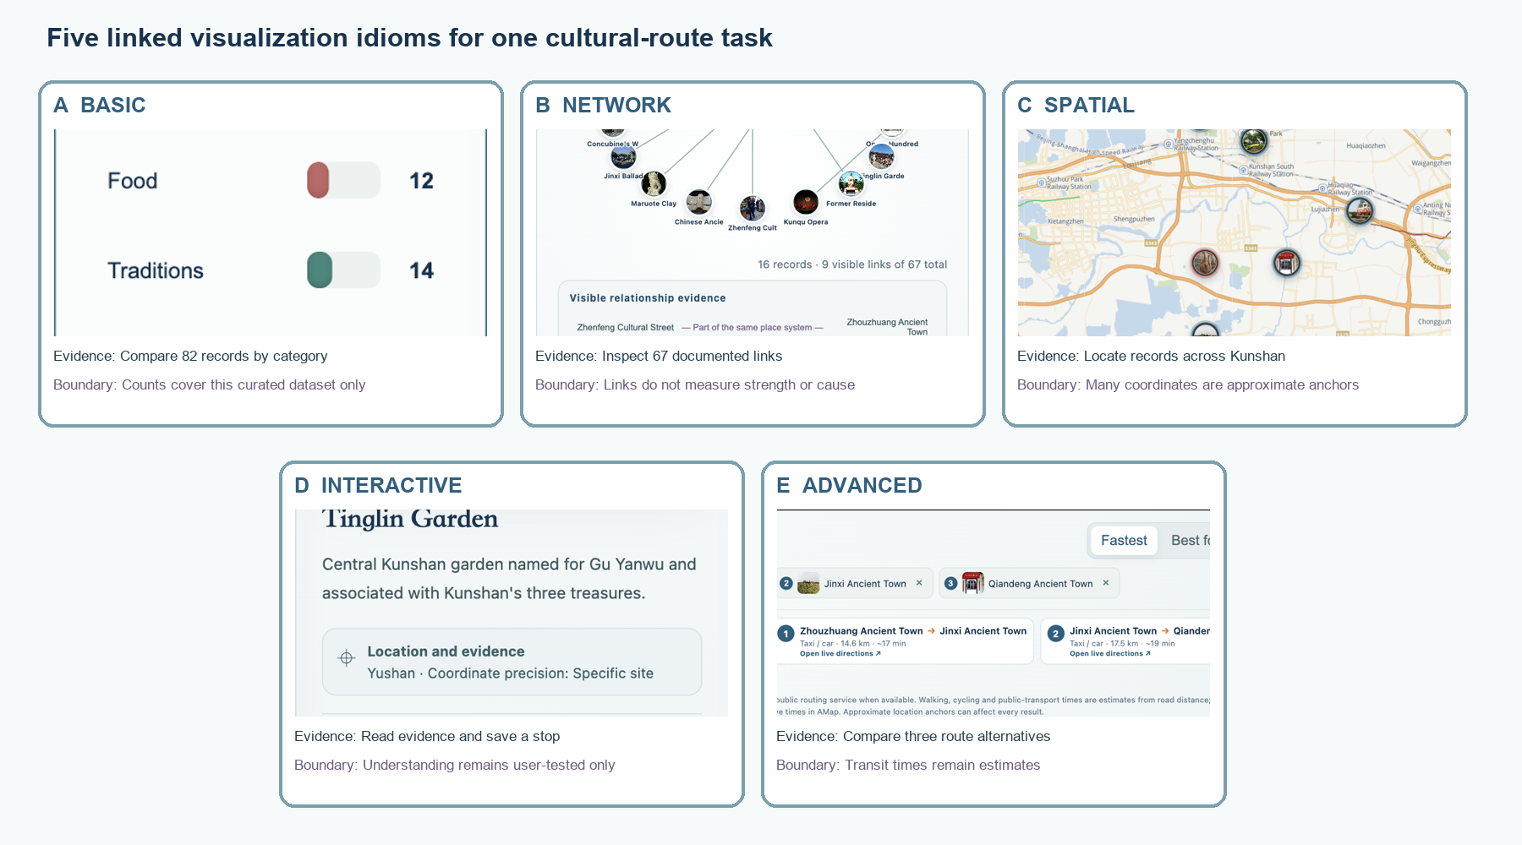
Representation | Task served | Input or interaction | Evidence and boundary
Basic overview | See what the dataset contains. | Select a category bar. | Counts describe this 82-record collection, not all Kunshan culture.
Relationship network | Understand one recorded cultural link. | Select a node or related record. | 67 links have listed sources; line length is not importance, distance, or cause.
Spatial map | Find approximate cultural locations. | Pan, zoom, filter, and open a marker. | Coordinates are mixed-precision anchors, not surveyed entrances.
Interactive details | Inspect a record before saving it. | Search, open sources, add or remove a stop. | The interface exposes evidence; user understanding is not yet established.
Route comparison | Compare three possible route rules. | Save at least two stops and generate. | Road results depend on OSRM; transit time is estimated and must be checked in AMap.

2 Design Capability
2.1 Design pipeline
Domain. The real-world problem is helping people explore Kunshan culture without presenting our selection as a complete or official account. Data and task. Users search, filter, inspect, connect, save, and order 82 bilingual records supported by 67 relationships and 13 source collections. Idiom. Category bars show coverage, a node-link view shows recorded relationships, a Leaflet map shows approximate locations, detail panels expose sources, and route cards compare three planning rules. Algorithm. JavaScript keeps the views synchronized and clusters nearby markers. The route feature orders saved stops using visible rules. When OSRM responds, it returns road geometry and driving distance; the public-transport option provides an estimate and opens AMap for a current route check.
Table 1. End-to-end design pipeline.
Domain | Data and task | Idiom | Algorithm
Kunshan cultural discovery for visitors and residents. | 82 records; 67 links; find, inspect, compare, save, sequence. | Overview, network, map, evidence detail, route comparison. | Filtering, clustering, route rules, OSRM roads, AMap live links and fallback.

2.2 Four validation levels
Table 2. Four-level validation summary.
Level | Current evidence | Main threat | Next test and owner
Domain | Implemented bilingual visitor task. | Need inferred; missing local voices. | Interview visitors and cultural stewards; Sitong.
Data and task | 82 records, 67 links, 13 source collections. | Coverage, rights, translations and coordinates vary. | Record audit and correction log; Yihong.
Idiom | Five linked views and visible boundaries. | Interpretation and accessibility are under-tested. | Think-aloud and keyboard path; Yiran and Sitong.
Algorithm | Road geometry, estimates, fallback and smoke checks. | Transit is estimated; anchors may shift routes. | Compare with live AMap and field travel; team.

2.3 Implementation architecture accessibility and fallback
The submitted version uses browser-compatible HTML, CSS, JavaScript, Leaflet, local JSON files, and local media. It does not require a backend, npm build, Python service, or environment variable. Source and coordinate-precision labels are visible in the interface. The site also provides bilingual text, keyboard focus, alternative text, responsive layouts, loading feedback, a route-service fallback, and reduced-motion behavior. These features are present in the code, but a full screen-reader and cross-browser accessibility study has not been completed. The built-in smoke check verifies the 82 records, five linked views, two languages, and three route modes. Figure 2 shows the actual files and services.
Figure 2. Actual repository paths, browser logic, external services, deployment, checks, and fallback for commit f43801f. Text equivalent follows in Appendix B.
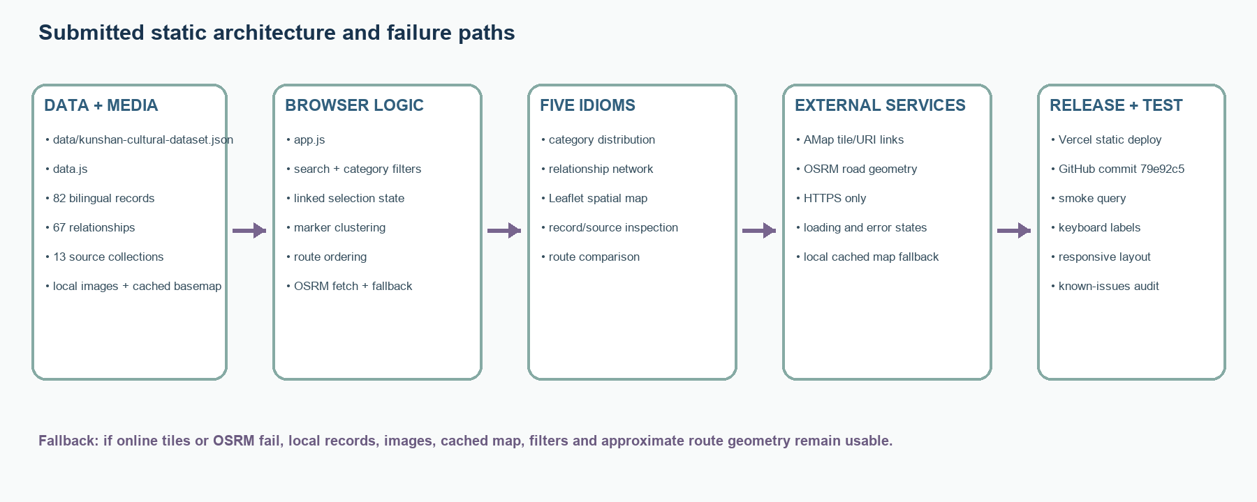
Architecture record | Data and provenance | Transform and store | Logic and views | Deploy test and fallback
Repository path | data/kunshan-cultural-dataset.json; assets/ | data.js static browser copy | app.js; index.html; map.html | README.md; Vercel; FINAL_SYSTEM_AUDIT.md
Input and output | 82 records, 67 links, sources, coordinates, media | JSON is copied into data.js; no hidden server transform | Filters, details, network, map, route comparison | Smoke URL checks counts, languages, five views, and three routes
Failure path | Missing or uncertain values remain labelled | Local data and images still load | OSRM failure returns an approximate route notice | Cached basemap and local files support degraded-network use

DIRECT LINKS Working artifact: https://kunshan-cultural-interactive-map.vercel.app/ Repository and commit: https://github.com/YiranZheng0206/Kunshan-Cultural-Interactive-Map/commit/f43801f Poster: https://github.com/YiranZheng0206/Kunshan-Cultural-Interactive-Map/blob/main/ Team6_INFOSCI301_FinalProject_Poster.pptx Final paper: https://github.com/YiranZheng0206/Kunshan-Cultural-Interactive-Map/blob/main/Team6_INFOSCI301_Final_Project_Paper.docx Demo video: https://github.com/YiranZheng0206/Kunshan-Cultural-Interactive-Map/blob/main/Team6_INFOSCI301_DemoVideo.mp4

3 Interdisciplinary Contribution
3.1 Three emerging frontiers
Table 3. Frontier-to-design contribution.
Emerging frontier | Contribution and evidence | Visible design consequence | Current limit
Open Science Data Governance and Responsible AI | Source IDs, precision labels, credits, limits, and public correction path. | Evidence panel and source register remain visible during exploration. | Third-party images are used for educational and non-commercial purposes, subject to their respective usage terms.
Scientific Communication for Emerging Technologies | Bilingual tutorial and linked explanations turn records into an inspectable sequence. | Users move from overview to relation, place, evidence, then route. | Learning and comprehension are not demonstrated.
Human-Centered Spatiotemporal Intelligence primary | Cultural records and relations are connected to approximate geographic context. | Photo markers, clustering, filters, linked network, and routes. | Positions are anchors; live accessibility and transit are external.

3.2 Research to design change
Munzner’s nested model changed an important part of our design. Earlier versions treated a polished map as the main result. The model asked us to check four different things: the real situation, the data and task, the visual form, and the implementation. We therefore added limits beside the claims, labels for coordinate precision, a source register, and plain-language route assumptions. We also gave each level a separate next test in Table 2. Dimara and Perin’s study of interaction helped us keep controls that change what users can inspect—filtering, selecting, opening evidence, saving stops, and comparing routes—instead of adding interaction only for visual effect.
4 Community Rooted Global Leadership
4.1 Local community service
The intended users are visitors, students, newcomers, and interested residents in Kunshan. Our course visits gave us observations, not community permission, endorsement, or co-design. Our need hypothesis is that a bilingual map with visible sources may make scattered cultural information easier to explore. Important voices are still missing, including cultural workers, museum and site staff, residents of the towns shown, people with mobility needs, and public-transport users. Before making a public-service claim, we should invite these groups to correct records, question how culture is represented, and test the proposed routes. We can return a bilingual correction summary and revised dataset to participants. GitHub Issues currently serves as a channel for corrections, while more structured local engagement and feedback mechanisms could be explored in future development.
4.2 SDG goal exact target and bounded contribution
Accountability field | Current evidence | Limit or next check
Need hypothesis and missing voices | A bilingual, source-linked map may make scattered cultural information easier to explore. | Ask cultural workers, residents, disabled visitors, and transit users whether this is useful or needs to change.
Permission and public sharing | Official pages support factual links. The Tinglin Garden and Sock-Bottom Pastry images are team photographs used with the photographer's permission; no private participant records are published. | Future development should prioritize verifying the sources, usage rights, and accuracy of third-party images to improve the reliability of visual content.
Return and correction | The public repository offers an issue channel for corrections. | Return a bilingual correction summary and revised dataset; appoint a local contact and response schedule.
SDG 11 target 11.4 | The website provides access to sourced heritage information. | Access is not safeguarding impact. Test with local users and cultural workers.

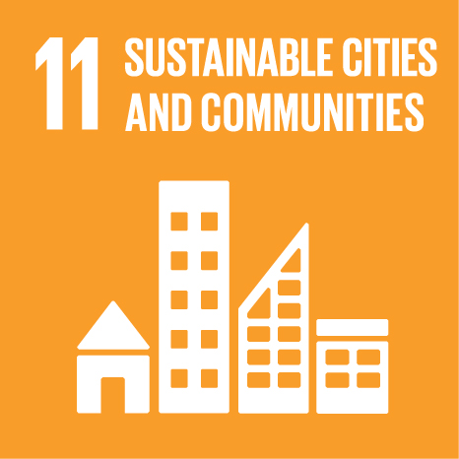
Our project is intended to contribute to SDG 11, target 11.4, by supporting access to sourced local heritage information. The current artifact demonstrates an interface and dataset, not protection or safeguarding outcomes.
Table 4. Path from technology to a measurable local check.
Digital technology | Data or visual mechanism | Possible community use | Observable indicator
Static bilingual web application with linked map and network views. | 82 records, 67 sourced links, record details, correction route, and route comparison. | Visitors inspect sources and cultural workers identify missing or incorrect records. | Task completion, correctly explained link, corrections submitted, and changes returned to reviewers.

This chain keeps our SDG statement testable. The website can make records and sources easier to reach, but access alone is not preservation. A useful next study would ask local visitors to find and explain one cultural link, then ask a cultural worker to identify omissions or incorrect wording. We would record task completion, interpretation errors, proposed corrections, and whether those corrections appear in the next public version. These measures are modest, but they connect the interface to an observable local result without claiming that a student prototype has already safeguarded heritage.

5 Interactive Evaluation and Evidence Based Revision
5.1 Activity 1 Interactive Demonstration
The demonstration follows one 90-second path. The user reads the bilingual tutorial, enters the map, opens a record and its source, switches to Patterns to inspect one recorded relationship, saves at least two stops, and compares route modes. Earlier versions made the starting point and route-saving action hard to find. The final build adds a shorter tutorial, keeps Map and Patterns as the two main entrances, repairs save and remove actions, and shows loading and fallback messages. When OSRM responds, the route follows roads instead of drawing a straight line.
5.2 Activity 2 Peer Evaluation user study
On 29 September, Michelle Clark, Andi Wan, Jiaxin Wang, and Tingyi Xiao reviewed selection, operating steps, relationship evidence, network value, and route saving. On 13 October, Zhixin Liu and Yixuan Chen reviewed how the project separated cultural evidence from route recommendations. These classmates acted as visitor proxies, not Kunshan community representatives. The sessions guided revision but did not produce standardized timing or error-rate data.
5.3 Activity 3 Response to Peers
We kept map-based discovery and selection. We revised the entrance with a bilingual tutorial and simpler Map/Patterns navigation; revised links with summaries, sources, and a line-meaning note; and repaired save/remove behavior. The October review led us to separate evidence from route claims and label the routes as planning aids rather than verified live navigation. The whole team conducted the formative study. Next we will test whether first-time users understand these limits and compare selected estimates with AMap and field travel.
Figure 3. Four-state walkthrough of the submitted task. Formative peer evidence prompted clearer onboarding, relation explanations, route saving, road geometry and explicit limits; broad usability remains untested.
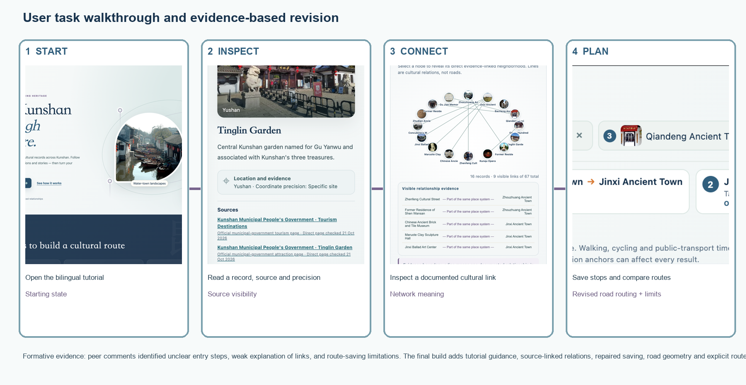
Study record | User and task | Start and action | System response | Observed evidence | Decision and next test
Formative peer review | Six classmate proxies contributed across two course dates; the team conducted the study together. | Landing page; open map, inspect source, save stops, generate. | Details, relation summary, and three route cards appear. | Concerns: save eligibility, unclear steps, relationship evidence, network value, and evidence/route separation. No consistent timing data. | Revise documented concerns; next test with local visitors and a cultural worker.
Evidence boundary | Peers were not community representatives. | No formal consented study dataset or performance measure. | Implemented behavior was checked, not learning or community benefit. | Broad usability, accessibility, route accuracy, and SDG impact remain untested. | Sitong: think-aloud task. Yihong: AMap and field route comparison.

5.4 What the evidence does not establish
The peer sessions do not establish usability for all visitors, comprehension, accessibility, cultural appropriateness, local benefit, route accuracy under live conditions, or progress toward SDG 11.4.
6 Results Limitations and Next Validation
Claim or task | Current evidence | Main limitation | Next test and owner
Inspect culture and evidence | 82 records, 67 links, bilingual details and sources. | Curated and uneven coverage. | Steward source audit; Yihong and Sitong.
Build and compare a route | Three modes, road geometry, per-leg estimates and AMap links. | Approximate anchors and non-live transit estimate. | Five-user route task plus field comparison; team.

7 Bounded Contribution and Current Conclusion
Our strongest current contribution is a working, reproducible website in which five linked views support one understandable task. It brings together cultural records, places, relationships, sources, and route limits without claiming that the dataset is complete or that a recommended route is objectively best. The project combines information visualization, interaction design, source tracking, and local cultural content. Its intended SDG contribution is better access to heritage information, not demonstrated heritage protection. The next step is a documented task study with local visitors and cultural workers, followed by a correction round and a maintained release.
Acknowledgements
We thank Prof. Luyao Zhang for course instruction and feedback; Michelle Clark, Andi Wan, Jiaxin Wang, and Tingyi Xiao for the 29 September review; and Zhixin Liu and Yixuan Chen for the 13 October review. Visits to Tencent’s Shanghai Office, Shanghai Science and Technology Museum, Jinxi Intangible Cultural Heritage Museum, and China Ancient Brick and Tile Museum informed interaction and contextual explanation but do not imply endorsement or co-design. We credit Leaflet, OpenStreetMap, AMap, OSRM, Kunshan municipal sources, UNESCO, and image creators named in the dataset under their recorded terms. Yihong Lin took the Tinglin Garden and Sock-Bottom Pastry photographs and permitted their use in this project.
AI and human responsibility. ChatGPT and Codex assisted with drafting, code alternatives, debugging, source organization, layout, and tests. The team chose the question and claims, checked links and commits, corrected images and wording, and remains responsible for the submission.
References
Munzner, T. (2009). A nested model for visualization design and validation. IEEE TVCG, 15(6), 921–928. https://doi.org/10.1109/TVCG.2009.111
Dimara, E., & Perin, C. (2020). What is interaction for data visualization? IEEE TVCG, 26(1), 119–129. https://doi.org/10.1109/TVCG.2019.2934283
United Nations. Goal 11: Sustainable Cities and Communities, Target 11.4. https://sdgs.un.org/goals/goal11
Kunshan Municipal People’s Government. Tourism Destinations. https://www.ks.gov.cn/kss/Tourism/enlist_tt_hd.shtml
Kunshan Municipal People’s Government. Sixth batch of representative intangible cultural heritage. https://www.ks.gov.cn/kss/c112598/202406/154c05692c0e41e4b9503059cd0614b9.shtml
Kunshan Municipal People’s Government. Third batch of Wu-culture protected place names. https://www.ks.gov.cn/kss/c112598/202411/f07e2e41857040d7a1920a6353aeb24c.shtml
Kunshan Municipal People’s Government. Cultural relic protection overview. https://www.ks.gov.cn/kss/c113206pu/202206/c405f8247cc64b2bb8b1e10d1dd01433.shtml
Kunshan Municipal People’s Government. Sixth batch of cultural relic units and second batch of controlled buildings. https://data.ks.gov.cn/kss/whzc/202003/5cb76caf7f674f2ab395fcbdcc5dbe9b.shtml
Kunshan Municipal People’s Government. Traditional village protection programme. https://data.ks.gov.cn/kss/ghjh/202406/7392d5f1b13144459869fbec5c2a5a54/files/c725f479bee54e6faa6e5762d66630d3.pdf
Kunshan Municipal People’s Government. Five award-winning Kunshan foods. https://www.ks.gov.cn/kss/ttxw/202407/da6fe60d561c49deadce176ec2019bfb.shtml
Kunshan Municipal People’s Government. A bowl of bubble wontons. https://www.ks.gov.cn/kss/lvzx/202003/dc569bd8c1a346e8b8fa07b6deabc0fc.shtml
Kunshan Municipal People’s Government. 2024 Kunshan food fair. https://www.ks.gov.cn/kss/ksyw/202412/8808d9156d0f420695061e4a929cc296.shtml
Kunshan Municipal People’s Government. Tourism and cultural development plan. https://www.ks.gov.cn/kss/c112598/201802/84e9f12b86e34c67940e35753455e343.shtml
Kunshan Municipal People’s Government. Opera Hundred Plays Museum. https://www.ks.gov.cn/kss/xqbxxwdt/202401/7f3243057f1e415b8f4530a40de5d3cc.shtml
Kunshan Municipal People’s Government. Tinglin Garden. https://www.ks.gov.cn/kss/zmjd/202403/8aa3e3aef8c74680805e7679031b5ab3.shtml
UNESCO. Kun Qu Opera. https://ich.unesco.org/en/RL/kun-qu-opera-00004
Leaflet contributors. Leaflet 1.9.4. https://leafletjs.com/ BSD-2-Clause.
OpenStreetMap contributors. Copyright and license. https://www.openstreetmap.org/copyright ODbL.
AutoNavi. AMap URI API route guide. https://lbs.amap.com/api/uri-api/guide/travel/route
Project OSRM. Route service API. https://project-osrm.org/docs/v5.24.0/api/#route-service
Wikimedia Commons contributors. Kunqu performer image and item-level license record. https://commons.wikimedia.org/wiki/File:Kunqu_-_Dan.jpg
Team 6. Kunshan Cultural Interactive Map, commit f43801f. https://github.com/YiranZheng0206/Kunshan-Cultural-Interactive-Map/commit/f43801f

Appendix A Evidence Map and Version History
Table A1. Evidence and revision history.
Stage | Version or evidence | Change and reason | Current location
Early repository baseline | cf6d13e (README revision) | Recorded an early project description; this commit is not evidence of the final system. | Repository history.
Integrated prototype | 2eab8b7; 82 records; 67 links | Expanded bilingual data, imagery, map and routes. | Repository history.
Peer feedback | Named reviewers; formative comments | Simplified navigation; explained links; repaired route saving. | README and Appendix D.
Final release | f43801f; 21 Oct 2026 | Verified images/sources; uniform markers; OSRM roads; AMap links; animation; audit. | Current main branch.

Table A2. Four validation levels.
Level | Current evidence | Main threat | Next test and owner
Domain | Named task and candidate audiences. | Need is still a hypothesis. | Local interview; Sitong.
Data and task | 82/67/13 integrated records. | Incomplete coverage and uneven provenance. | Record audit; Yihong.
Idiom | Five linked views. | Meaning and accessibility under-tested. | Think-aloud and keyboard test; Yiran/Sitong.
Algorithm | Road service, fallback and estimates. | Anchors and transit assumptions. | AMap and field comparison; team.

Appendix B Data Governance and Reproducibility
Table B1. Dataset and governance record.
Data record | Exact source and use | Risk or restriction | Verification
Primary integrated dataset | data/kunshan-cultural-dataset.json; 82 records and 67 relations; municipal and UNESCO sources. | Curated, not exhaustive; no blanket open-data license. | Source IDs and access notes visible; checked 21 Oct 2026.
Spatial data and maps | Record coordinates; AMap tiles/URI; cached map fallback. | Mixed precision; map-service terms; anchors are not surveyed entrances. | Every record carries a precision label.
Images | Local files with source, credit and role metadata; two record-specific photographs were taken by Yihong Lin. | The two team photographs are cleared for this project; third-party images are included for educational and non-commercial purposes, with source attribution provided where available. | IMAGE_AUDIT.md; the incorrect images were replaced with team photographs.
Route output | OSRM road geometry/driving time; distance-based walk/cycle/transit estimates. | Public OSRM availability; transit is not live; no fares/accessibility. | Fallback and AMap live links tested.

Table B2. Reproducibility and release record.
Field | Record
Repository and artifact URLs | https://github.com/YiranZheng0206/Kunshan-Cultural-Interactive-Map | https://kunshan-cultural-interactive-map.vercel.app/
Tagged version or commit | f43801f
Architecture | Figure 2; data.js → app.js → five linked views → Vercel; OSRM/AMap with fallback.
Environment | Static browser; HTML/CSS/JavaScript; Leaflet; HTTPS resources only.
Run steps | Open index.html or serve repository statically; enter map.html; add two stops; generate routes.
Tests | node --check app.js; git diff --check; browser smoke query; bilingual and route interaction checks.
Known issues | Approximate coordinates; incomplete rights audit; public OSRM dependency; live transit external.
License and correction | Repository license and third-party terms apply separately; use GitHub Issues for corrections.

Appendix C User Experience Protocol and Evidence
Table C1. User-experience session record.
Field | Record
Participant role and notice | Six named classmates contributed feedback across two dates: Michelle Clark, Andi Wan, Jiaxin Wang, and Tingyi Xiao on 29 September; Zhixin Liu and Yixuan Chen on 13 October. They were visitor proxies, not community partners. The team conducted the sessions together.
Exact task and starting state | From landing page: enter map, find two records, inspect a source and relation, save stops, compare route modes.
Success criterion and measures | Explain one supported relation and choose a route while recognizing data and route limits; observe completion, hesitation and recovery.
Observed evidence | 29 September notes document save eligibility, unclear steps, relationship validation, and uncertainty about the network’s value. The 13 October review focused on separating evidence from route recommendations. No consistent timing or error-count record is available.
System response and revision | Added bilingual tutorial, focused Map/Patterns switch, source-linked relation summaries, repaired route controls, road geometry and visible limits.
Accessibility barrier | Keyboard, screen-reader, color and mobile checks remain incomplete.
Evidence boundary | Formative peer evidence only; no broad usability, learning, community-benefit or SDG inference.
Next validation | Five local visitors plus one cultural worker; the team repeats the same task, records completion and interpretation consistently, and includes keyboard and mobile checks.

Privacy and evidence handling
The paper reports roles and task observations rather than identifying participant behavior. Public materials should include only authorized reviewer names and redacted summaries. Raw notes, if retained, should remain in the team’s course storage with access limited to the team and instructor. No audio, image, or quotation should be released without permission.

Appendix D Feedback and Response Log
Table D1. Progress activities and Week 7 feedback-to-revision record.
Activity or ID | Evidence received | Decision and reason | Change or next test and owner | Artifact or commit
29 Sep Michelle Clark | Map and connections supported discovery; some selected records could not enter a route. | Keep discovery; Revise save eligibility and precision explanation. | Anchored records are saveable; precision and route caveats are visible. Retest: Yihong. | app.js; 2eab8b7; f43801f
29 Sep Andi Wan | Selection was engaging, but operating steps were unclear. | Keep selection; Revise guidance. | Bilingual tutorial and simpler Map/Patterns navigation. Owner: Yihong/Yiran. | index.html; map.html; 2eab8b7
29 Sep Jiaxin Wang | Related records were inspectable, but the basis of relationships was unclear. | Revise evidence visibility; Investigate comprehension. | Relation summaries, source IDs, and network boundary. Owner: Yiran/Yihong. | app.js; data.js; 2eab8b7
29 Sep Tingyi Xiao | Random discovery worked; questioned node-link value and steps. | Keep discovery; Revise guidance; Investigate network value. | Network/tutorial retained; future test compares network with text. Owner: team. | 29 Sep response; 2eab8b7
13 Oct Zhixin Liu and Yixuan Chen | Review concerned whether users could distinguish cultural evidence from route recommendation. Exact wording needs comparison with the review sheet. | Revise claim boundary; Investigate comprehension. | Separate evidence text from route cards; label estimates and external live check. Owner: team. | README; app.js; Figure 3; f43801f
Professor review | Align final artifact, paper, evidence figures, credits, and bounded claims. | Keep and Revise: make evidence traceable. | Figures 1–3, source audit, direct links, and separate AI disclosure. Owner: team. | Final paper and README; f43801f

Appendix E Poster and Demo Evidence
Table E1. Poster preflight.
Check | Evidence or location
Descriptive title and bounded claim | Required in the redesigned poster; use the wording from Sections 1.2 and 7.
Question users task data and five views | Required: shorten Section 1 and reuse Figure 1.
Architecture | Required: reuse a legible simplified Figure 2.
Walkthrough and revision | Required: reuse Figure 3 and the verified feedback record.
Frontiers and validation | Required: summarize the primary frontier and four validation levels.
Local service and SDG | Required: official SDG 11 icon, Target 11.4, and the untested-impact statement.
URLs and credits | Required: final paper, poster, artifact, repository, video, source, and acknowledgement links.

Table E2. Demo storyboard and transcript map.
Time | Segment | Content and evidence
0:00–0:20 | Introduction | Project goal, intended users, and cultural discovery task.
0:20–0:50 | Start and exploration | Updated interface, entrance animation, cultural categories, search, and map exploration.
0:50–1:20 | Cultural information | Jinxi Ancient Town, record details, verified images, and visible source references.
1:20–1:50 | Patterns and connections | Category comparison, cultural relationship network, source register, and Evidence Boundary.
1:50–2:30 | Route planning | Save stops, Generate animation, OSRM road routing, travel-time estimates, and AMap reference.
2:30–2:57 | Evidence-based revision and conclusion | Peer feedback, interface improvements, source transparency, route improvements, and project goal.

Table E3. Professional reference artifacts.
Reference | What we used | Course extension
CHI Interactive Demos | Concise working-system explanation and walkthrough. | Added evidence boundaries and reproducible paths.
SIGCHI video guide | Readable captions and visible interaction sequence. | Kept course demo below 2:59.
Munzner 2009 | Nested validation levels. | Assigned threats, tests and owners.

Appendix F Team Contribution and AI Assistance
Table F1. Named team contributions.
Member | Roles and concrete contributions | Evidence or commit | Design element the member can defend
Yiran Zheng yz1011 | Built the website, implemented functions, and contributed to the paper. Participated in the user study with the full team. | Final website files, functions, and paper sections; Final poster; commit f43801f. | Website structure, implemented interactions, and functional behavior.
Sitong Chang sc972 | Produced the demo video and participated in the user study with the full team. | Team6_INFOSCI301_DemoVideo.mp4 and public demo link. | Demonstration sequence, captions, and how the video represents the submitted task.
Yihong Lin yl999 | Prepared and checked data, led iteration and UI/UX design, and contributed to the paper. Participated in the user study with the full team. | Dataset, source/image audits, interface revisions, paper, and commit f43801f. | Data provenance, design iterations, route limits, and UI/UX decisions.

Table F2. AI assistance and human verification.
Field | Disclosure
Tool dates | OpenAI ChatGPT and Codex; September–October 2026.
Material assistance | Drafting, language support, code alternatives, debugging, data/source organization, document layout and test generation.
Accepted output | Selected interface code, bounded descriptions, architecture summary and formatting support.
Human verification | Team reviewed code, source links, images, coordinates, claims, route labels, commits and rendered paper.
Corrections | Incorrect images, unclear labels, straight-line routes, unsupported wording and incomplete source visibility were revised.
Excluded claims | AI output was not treated as evidence for community need, cultural impact, user behavior, route optimality or SDG impact.

Team responsibility statement
We designed and verified the submitted work, distinguished evidence from inference, credited reused resources and contributions, protected private or restricted material, and can explain the project’s question, data, design, implementation, evidence, limitations, local-community contribution, and SDG connection.
Typed names: Yihong Lin ____________________ Yiran Zheng ____________________ Sitong Chang ____________________ Date: 21 October 2026

