TEST RESULT FOR JWT AUTHENTICATION
BASE URL: http://127.0.0.1:8000/api/auth/
REGISTER A USER
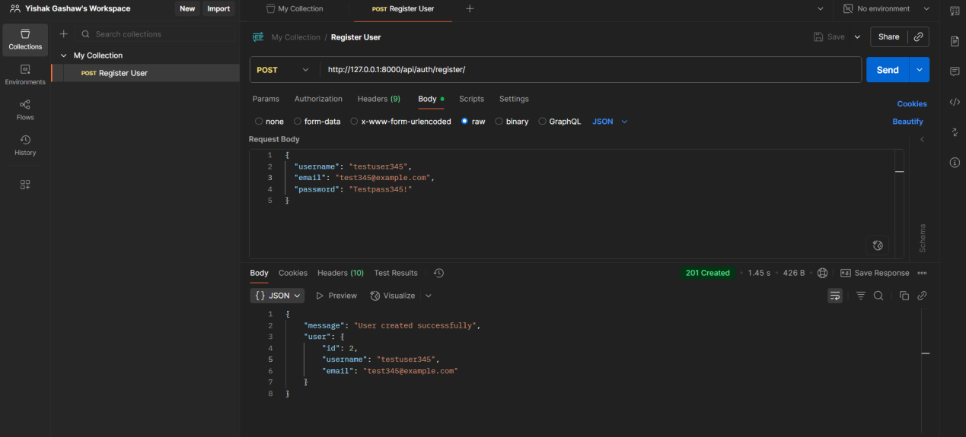
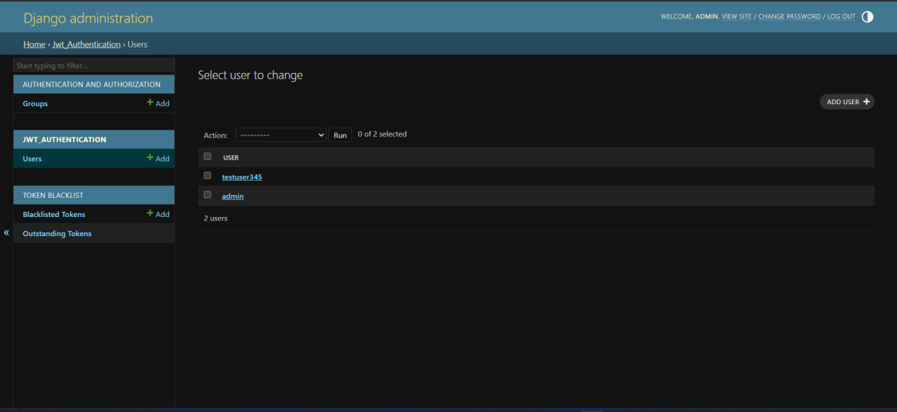
LOGIN A USER
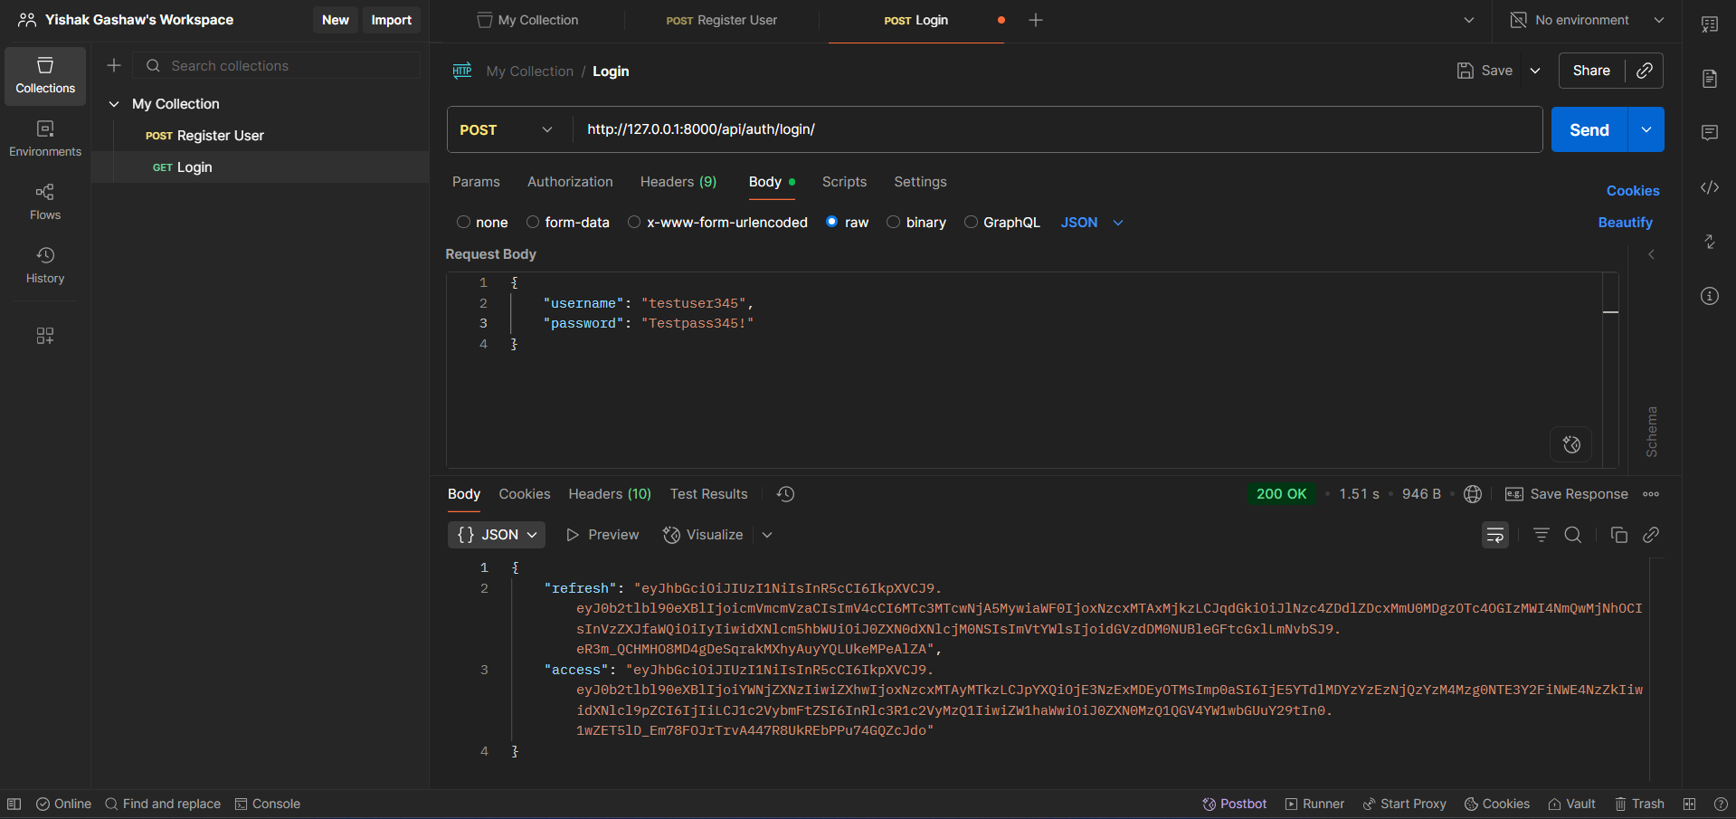
GET PROFILE
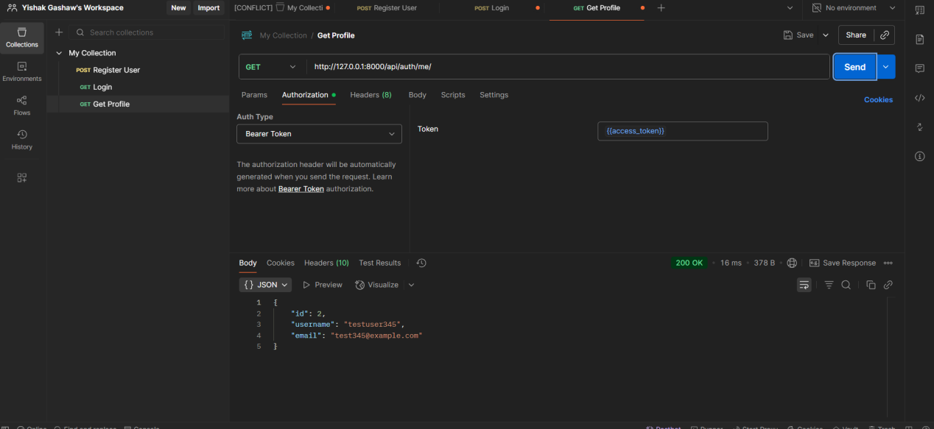
REFRESH TOKEN
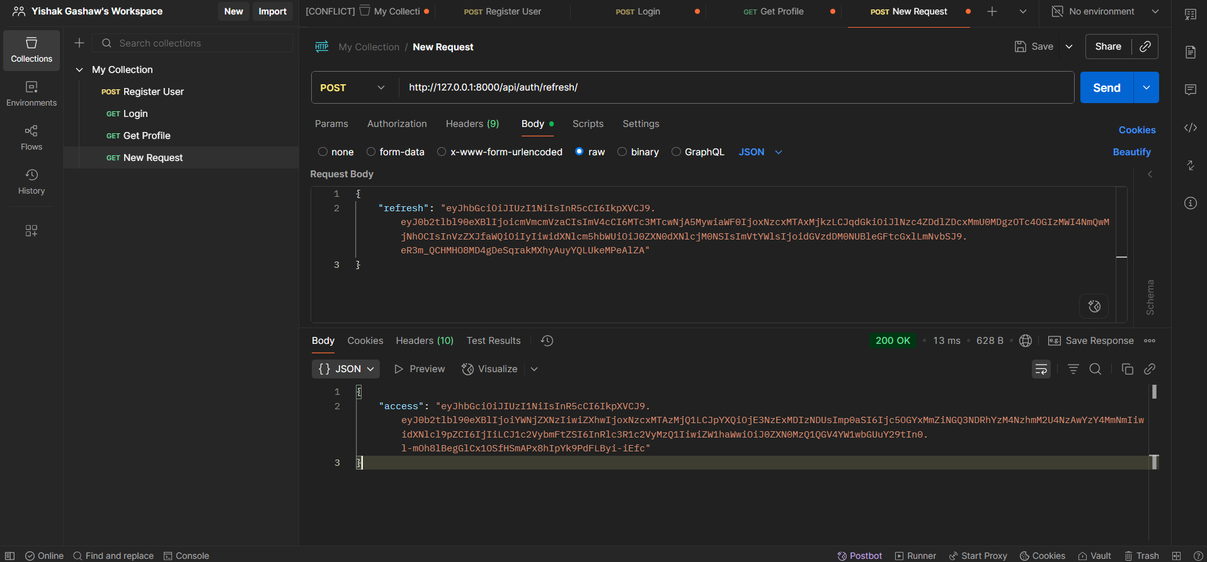
LOGOUT
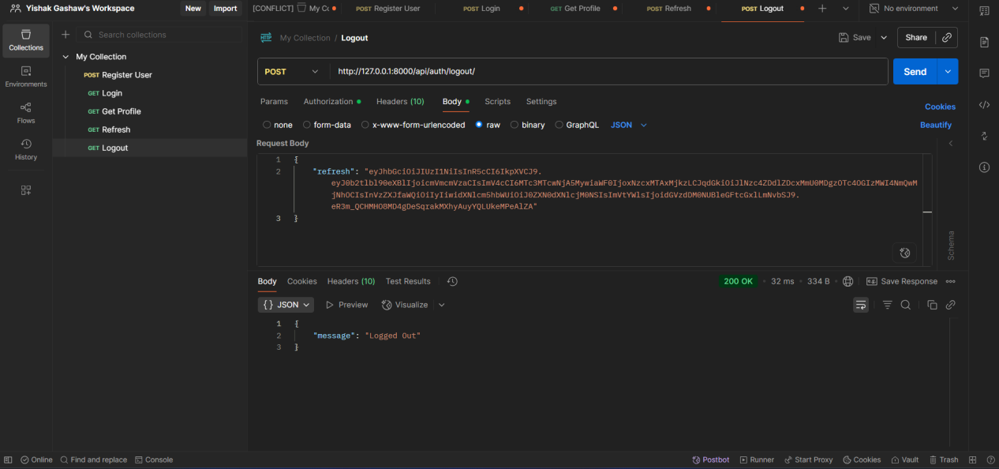
REFRESH FAILS AFTER LOGIN
