Smart Mall
E-Commerce Platform
Complete Technical Documentation

Document Version 2.0
May 2026
smartmall.unaux.com

Prepared for academic submission

Table of Contents

Part I: Project Overview

1. Introduction
Smart Mall is a full-stack e-commerce platform developed using PHP and MySQL, designed to serve the Ethiopian market with multi-currency support (USD and ETB). The platform supports the complete online retail lifecycle: product catalog management, customer registration and authentication, a server-side shopping cart, order processing with real-time stock validation, and payment processing through the Chapa payment gateway. A companion Capacitor mobile application wraps the web experience for Android deployment.
This document provides a comprehensive technical reference for every component in the Smart Mall codebase. Each file is documented with its exact file path, purpose, dependencies, database interactions, and integration points with other components.

2. Technology Stack
Layer | Technology | Version / Notes
Backend Language | PHP | 8.0+, with PDO, cURL, MySQLi extensions
Database | MySQL / MariaDB | MySQL 5.7+ / MariaDB 10.3+
Database Access | PDO | Prepared statements with ERRMODE_EXCEPTION
Web Server | Apache | mod_rewrite, XAMPP-compatible
Frontend | HTML5 + CSS3 + JavaScript | Vanilla JS, CSS custom properties
Payment Gateway | Chapa API | https://api.chapa.co/v1 (test mode)
Exchange Rates | ExchangeRate-API | https://open.er-api.com/v6/latest/USD
Mobile App | Capacitor (WebView) | v8, wraps the web app for Android
PWA | manifest.json + Service Worker | Installable web app
Doc Generation | docx (npm) | Node.js 18+ for .docx output

3. Directory Structure
The project root is at /reference/ (under the web server document root at /opt/lampp/htdocs/). Every PHP file in the root directory serves as an independent page or handler. The includes directory holds shared components. The admin directory contains store management tools.

reference/
├── config.php # Application bootstrap
├── index.php # Homepage (product grid, categories)
├── product.php # Product detail page
├── search.php # Search results page
├── cart.php # Shopping cart management
├── checkout.php # Checkout + Chapa payment initiation
├── order_confirmation.php # Payment verification + confirmation
├── orders.php # Customer order history
├── login.php # User login
├── register.php # User registration
├── logout.php # Session destruction
├── forgot_password.php # Password reset request
├── reset_password.php # Password reset token validation
├── about.php # About page with store statistics
├── contact.php # Contact form
├── download.php # Mobile app download page
├── set_currency.php # Currency switch handler
├── add_to_cart.php # AJAX add-to-cart endpoint
├── check_schema.php # Schema introspection tool
├── protect.php # Password-gated access
├── manifest.json # PWA manifest
├── includes/
│ ├── db.php # PDO connection + CSRF helpers
│ ├── currency.php # Multi-currency engine
│ ├── header.php # Shared HTML header + nav
│ └── footer.php # Shared HTML footer + scripts
├── admin/
│ ├── dashboard.php # Admin dashboard with stats
│ ├── add_product.php # Add/Edit product form
│ ├── delete_product.php # Product deletion handler
│ ├── manage_orders.php # Order management + status updates
│ └── manage_categories.php # Category CRUD + slide images
├── api/
│ └── search.php # JSON search API
├── chapa_pay/
│ └── chapa-config.php # Chapa API credentials
├── uploads/ # Product images (auto-created)
├── assets/images/ # Logo and static images
├── docs/ # Documentation hub
└── smartmall-app/ # Capacitor mobile app

4. Request Lifecycle
Every page request follows a consistent bootstrap sequence:
- The web server (Apache) routes the HTTP request to the target PHP file (e.g., index.php, product.php).
- The target file requires config.php, which starts the output buffer (ob_start), initializes the session, detects the base URL from the server environment, then requires includes/db.php (PDO connection) and includes/currency.php (exchange rate engine).
- config.php emits security headers (X-Content-Type-Options: nosniff, X-Frame-Options: SAMEORIGIN).
- The page file processes any POST form submissions (with CSRF verification) before including header.php, ensuring header() redirects remain available.
- header.php sets cache-control headers, determines the current page for navigation highlighting, queries the cart count for the badge, and renders the <head> and <body> opening tags with navigation.
- The page renders its main content between header.php and footer.php.
- footer.php closes the HTML structure and includes JavaScript assets.
For AJAX requests (add_to_cart.php, api/search.php), the bootstrap is minimal: the output buffer is still started, but no header or footer is rendered. These endpoints return JSON.

Part II: Database Schema

5. Schema Overview
The Smart Mall database (smartmall_db) consists of eight tables. The engine is InnoDB (enforced by PDO's MySQL driver) with UTF-8 MB4 character encoding. Foreign keys enforce referential integrity with ON DELETE CASCADE on cart entries and ON DELETE RESTRICT on order-related tables.

5.1 Entity Relationship Summary
Table | Rows Ref'd | Foreign Keys | Purpose
users | — | — | Customer & admin accounts
categories | — | — | Product categories with slide images
products | categories | category_id | Product inventory
cart | users, products | user_id, product_id | Shopping cart items
orders | users | user_id | Placed orders with shipping
order_items | orders, products | order_id, product_id | Order line items
payments | orders | order_id | Payment transactions
password_resets | — | — | Password reset tokens

5.2 Table: users
Column | Type | Constraints | Notes
id | INT(11) | PRIMARY KEY, AUTO_INCREMENT | Unique user identifier
name | VARCHAR(100) | NOT NULL | User's full name
email | VARCHAR(100) | NOT NULL, UNIQUE | Login identifier
phone | VARCHAR(20) | DEFAULT NULL | Contact number
password | VARCHAR(255) | NOT NULL | bcrypt hash (PASSWORD_BCRYPT)
role | ENUM('customer','admin') | DEFAULT 'customer' | Authorization level
address | TEXT | DEFAULT NULL | Default shipping address
created_at | TIMESTAMP | DEFAULT CURRENT_TIMESTAMP | Account creation time

5.3 Table: categories
Column | Type | Constraints | Notes
id | INT(11) | PRIMARY KEY, AUTO_INCREMENT | Unique category ID
name | VARCHAR(255) | NOT NULL | Display name
slug | VARCHAR(255) | DEFAULT NULL | URL-friendly name
image1 | VARCHAR(255) | DEFAULT NULL | Slide image 1
image2 | VARCHAR(255) | DEFAULT NULL | Slide image 2
image3 | VARCHAR(255) | DEFAULT NULL | Slide image 3
created_at | TIMESTAMP | DEFAULT CURRENT_TIMESTAMP | Creation time

5.4 Table: products
Column | Type | Constraints | Notes
id | INT(11) | PRIMARY KEY, AUTO_INCREMENT | Unique product ID
category_id | INT(11) | FOREIGN KEY → categories(id) | Product category
name | VARCHAR(255) | NOT NULL | Product name
description | TEXT | DEFAULT NULL | Product description
price | DECIMAL(10,2) | NOT NULL | Price in USD
image | VARCHAR(255) | DEFAULT NULL | Primary product image
images | LONGTEXT | DEFAULT NULL | JSON array of additional images
video | VARCHAR(255) | DEFAULT NULL | Product video filename
stock | INT(11) | NOT NULL DEFAULT 0 | Available quantity
created_at | TIMESTAMP | DEFAULT CURRENT_TIMESTAMP | Creation time

5.5 Table: cart
The cart table uses ON DELETE CASCADE on both foreign keys, so deleting a user or a product automatically removes their cart entries.
Column | Type | Constraints | Notes
id | INT(11) | PRIMARY KEY, AUTO_INCREMENT | Unique cart entry ID
user_id | INT(11) | FOREIGN KEY → users(id) ON DELETE CASCADE | Cart owner
product_id | INT(11) | FOREIGN KEY → products(id) ON DELETE CASCADE | Added product
quantity | INT(11) | NOT NULL DEFAULT 1 | Quantity selected
created_at | TIMESTAMP | DEFAULT CURRENT_TIMESTAMP | When added

5.6 Table: orders
Column | Type | Constraints | Notes
id | INT(11) | PRIMARY KEY, AUTO_INCREMENT | Unique order ID
user_id | INT(11) | FOREIGN KEY → users(id) | Ordering customer
total_price | DECIMAL(10,2) | NOT NULL | Total (subtotal + 10% VAT)
status | ENUM('pending','processing','paid','shipped','delivered','cancelled') | DEFAULT 'pending' | Order lifecycle state
first_name | VARCHAR(100) | DEFAULT NULL | Shipping first name
last_name | VARCHAR(100) | DEFAULT NULL | Shipping last name
email | VARCHAR(255) | DEFAULT NULL | Shipping email
address | TEXT | DEFAULT NULL | Street address
city | VARCHAR(100) | DEFAULT NULL | City
state | VARCHAR(100) | DEFAULT NULL | State/region
zip | VARCHAR(20) | DEFAULT NULL | Postal code
country | VARCHAR(100) | DEFAULT 'Ethiopia' | Country
payment_method | VARCHAR(50) | DEFAULT 'chapa' | chapa / bank_transfer / cash_on_delivery
created_at | TIMESTAMP | DEFAULT CURRENT_TIMESTAMP | Order placement time

5.7 Table: order_items
Order items preserve a snapshot of the price at the time of purchase, so that price changes to products do not affect historical orders.
Column | Type | Constraints | Notes
id | INT(11) | PRIMARY KEY, AUTO_INCREMENT | Unique item ID
order_id | INT(11) | FOREIGN KEY → orders(id) | Parent order
product_id | INT(11) | FOREIGN KEY → products(id) | Purchased product
quantity | INT(11) | NOT NULL | Quantity purchased
price | DECIMAL(10,2) | NOT NULL | Price snapshot at purchase time

5.8 Table: payments
Column | Type | Constraints | Notes
id | INT(11) | PRIMARY KEY, AUTO_INCREMENT | Unique payment ID
order_id | INT(11) | FOREIGN KEY → orders(id) | Related order
method | VARCHAR(50) | NOT NULL | Payment method used
status | ENUM('pending','paid','failed') | DEFAULT 'pending' | Payment state
amount | DECIMAL(10,2) | NOT NULL | Amount charged
currency | VARCHAR(10) | NOT NULL DEFAULT 'USD' | Currency (USD or ETB)
tx_ref | VARCHAR(100) | DEFAULT NULL | Chapa transaction reference
chapa_response | LONGTEXT | DEFAULT NULL | Full Chapa API JSON response
paid_at | DATETIME | DEFAULT NULL | When payment confirmed
created_at | DATETIME | NOT NULL | Record creation time

5.9 Table: password_resets
Column | Type | Constraints | Notes
id | INT(11) | PRIMARY KEY, AUTO_INCREMENT | Unique record ID
email | VARCHAR(100) | NOT NULL | User's email address
token | VARCHAR(64) | NOT NULL | 64-char hex token (32 random bytes)
expires_at | DATETIME | NOT NULL | Token expiration (1 hour)
created_at | TIMESTAMP | DEFAULT CURRENT_TIMESTAMP | Record creation

Part III: Component Reference

This section documents every file in the Smart Mall codebase. Each entry lists the exact file path, the component's purpose, its dependencies (files it includes or requires), the database tables it interacts with, its key functions or features, and the other components it integrates with.

6. Bootstrap & Configuration

6.1 config.php
File Path: /reference/config.php
Purpose: Application bootstrap — executes before every page request
Dependencies: includes/db.php, includes/currency.php
Database Tables: None directly (includes db.php which connects)
Key Features:
- Starts output buffering (ob_start) to catch accidental BOM/whitespace
- Initializes the PHP session if not already active
- Auto-detects the base URL: parses HTTP_HOST and SCRIPT_NAME to determine the subfolder (e.g., /reference) and constructs absolute URLs
- Defines the global variable $base_url used by all pages
- Defines the redirect() helper: takes a path, prepends $base_url if not already absolute, and issues a Location header
- Emits security headers: X-Content-Type-Options: nosniff, X-Frame-Options: SAMEORIGIN
- NO closing PHP tag (?>) to prevent accidental whitespace output
Called By: Every page file (index.php, product.php, cart.php, etc.) via require_once

6.2 includes/db.php
File Path: /reference/includes/db.php
Purpose: PDO database connection and CSRF token helpers
Dependencies: None (standalone; currency.php is required at the end)
Database Tables: All (provides the $pdo connection object)
Key Features:
- PDO connection with DSN mysql:host=localhost;dbname=smartmall_db;charset=utf8mb4
- PDO options: ERRMODE_EXCEPTION for error handling, FETCH_ASSOC for fetch style, emulated prepares OFF (real prepared statements)
- getDB(): returns the global $pdo connection for use in all page files
- CSRF token generation: bin2hex(random_bytes(32)) produces a 64-character hex token, idempotent per session
- csrf_field(): outputs a hidden HTML input with the token
- csrf_verify(): compares submitted token to session token using hash_equals(), terminates with HTTP 403 on mismatch
- get_product_image_url($path): resolves image paths — returns external URLs as-is, prepends uploads/ for local files, adjusts for admin subfolder context
- get_product_video_url($path): same logic for video files
- Requires currency.php at the end of the file
Called By: Every page that needs database access

6.3 includes/currency.php
File Path: /reference/includes/currency.php
Purpose: Multi-currency engine — USD base, live ETB exchange rates
Dependencies: None (standalone helper library)
Database Tables: None
Key Functions:
- smartmall_supported_currencies(): returns ['USD', 'ETB']
- smartmall_selected_currency(): reads $_SESSION['currency'], defaults to 'USD'
- smartmall_set_selected_currency($currency): validates and sets the session currency
- smartmall_exchange_cache_path(): returns sys_get_temp_dir() + '/smartmall_exchange_usd.json'
- smartmall_fetch_exchange_rates(): calls open.er-api.com/v6/latest/USD via cURL (with file_get_contents fallback), validates result and base_code, writes rates to cache file with LOCK_EX
- smartmall_exchange_data(): returns cached rates if not expired, otherwise fetches fresh; falls back to stale cache or empty rates on API failure
- smartmall_exchange_rate($currency): returns the rate for USD or ETB (1.0 for USD)
- smartmall_convert_money($amountUsd, $currency): converts USD to target currency
- smartmall_format_money($amountUsd, $currency): formats as '$X.XX' for USD or 'ETB X.XX' for ETB
- smartmall_currency_is_converted(): boolean check if displaying in non-USD
Constants: SMARTMALL_BASE_CURRENCY='USD', SMARTMALL_EXCHANGE_API_URL='https://open.er-api.com/v6/latest/USD'
Called By: header.php (display), checkout.php (price display + ETB conversion for Chapa), product.php, cart.php, order_confirmation.php, api/search.php

6.4 chapa_pay/chapa-config.php
File Path: /reference/chapa_pay/chapa-config.php
Purpose: Chapa payment gateway configuration constants
Dependencies: None
Key Features:
- CHAPA_SECRET_KEY: 'CHASECK_TEST-aF7ZWVLHJRP8rFpNG4V7rpDveopvXt2D' (test mode)
- CHAPA_API_URL: 'https://api.chapa.co/v1'
Called By: checkout.php, order_confirmation.php

7. Authentication System

7.1 login.php
File Path: /reference/login.php
Purpose: User login with email/password
Dependencies: includes/db.php, config.php
Database Tables: users
Key Features:
- POST handler processes login before header.php is included (to allow redirects)
- CSRF verification via csrf_verify()
- Prepared statement: SELECT id, name, email, password, role FROM users WHERE email = :email
- Password verification: password_verify($password, $user['password'])
- Session fixation prevention: session_regenerate_id(true) on successful login
- Session variables set: user_id, user_name, user_email, user_role
- Redirect parameter sanitization: preg_match('/^[a-zA-Z0-9_...]+\.php$/', $redirect)
- session_write_close() before redirect to force write
Called By: User navigation from any page
Interacts With: header.php (displays login/logout link based on session)

7.2 register.php
File Path: /reference/register.php
Purpose: New user registration with password policy enforcement
Dependencies: config.php
Database Tables: users
Key Features:
- CSRF verification on POST
- Name validation: min 2 characters
- Email validation: filter_var with FILTER_VALIDATE_EMAIL + duplicate email check
- Password policy — four separate preg_match checks:
- strlen($password) >= 8
- preg_match('/[A-Z]/', $password) — at least one uppercase
- preg_match('/[a-z]/', $password) — at least one lowercase
- preg_match('/[0-9]/', $password) — at least one digit
- preg_match('/[^A-Za-z0-9]/', $password) — at least one special character
- Password confirmation matching
- Hashing: password_hash($password, PASSWORD_BCRYPT)
- Role defaults to 'customer'
- On success: sets session success flash, redirects to login.php
Interacts With: login.php (redirect after success), header.php

7.3 logout.php
File Path: /reference/logout.php
Purpose: Session destruction and redirect to homepage
Key Features:
- session_unset() followed by session_destroy() for complete cleanup
- Redirects to index.php
Called By: User clicking Logout in navigation

7.4 forgot_password.php
File Path: /reference/forgot_password.php
Purpose: Password reset request initiation
Dependencies: config.php
Database Tables: password_resets
Key Features:
- CSRF verification on POST
- Email validation + checks if user exists (without revealing existence)
- Token generation: bin2hex(random_bytes(32)) — 64-character hex string
- Token stored in password_resets table with email and expires_at (1 hour)
- Reset link stored in session as $_SESSION['reset_link'] for display
- Reset link logged to file: sys_get_temp_dir() . '/smartmall_reset_links.txt'
- Attempts email via PHP mail() function
Interacts With: reset_password.php

7.5 reset_password.php
File Path: /reference/reset_password.php
Purpose: Validate reset token and set new password
Dependencies: config.php
Database Tables: password_resets, users
Key Features:
- Validates token from GET or POST parameter
- Prepared statement: SELECT email, expires_at FROM password_resets WHERE token = :token
- Checks strtotime($reset['expires_at']) > time() for expiration
- Re-applies the same password policy as register.php
- Updates user password with password_hash($password, PASSWORD_BCRYPT)
- Deletes used token from password_resets table
Interacts With: forgot_password.php, login.php (redirect after success)

8. Product Catalog

8.1 index.php
File Path: /reference/index.php
Purpose: Homepage — product grid with categories, search, and slideshow
Dependencies: config.php, header.php, footer.php
Database Tables: products, categories
Key Features:
- LEFT JOIN query: products LEFT JOIN categories ON p.category_id = c.id
- Optional category filtering via $_GET['category'] parameter
- Search query support via $_GET['query'] parameter (LIKE search on name and description)
- ORDER BY p.created_at DESC with LIMIT for pagination
- INNER JOIN with order_items for best-selling products display
- Category slideshow with up to 3 images per category
- Price display via smartmall_format_money() in both USD and ETB
Interacts With: product.php (links to detail pages), cart.php (add-to-cart links), search.php (search form POST)


8.2 product.php
File Path: /reference/product.php
Purpose: Single product detail view with image gallery and related products
Dependencies: config.php, header.php, footer.php
Database Tables: products, categories
Key Features:
- Product loaded by ID from $_GET['id'] parameter
- Full product details: name, description, price, stock, images, video
- Image gallery with previous/next navigation arrows
- Related products query: same category, excluding current product, LIMIT 4
- Multi-image support via images column (JSON array)
- Video display support
- Stock indicator (in stock / out of stock)
Interacts With: add_to_cart.php (AJAX add-to-cart button), cart.php
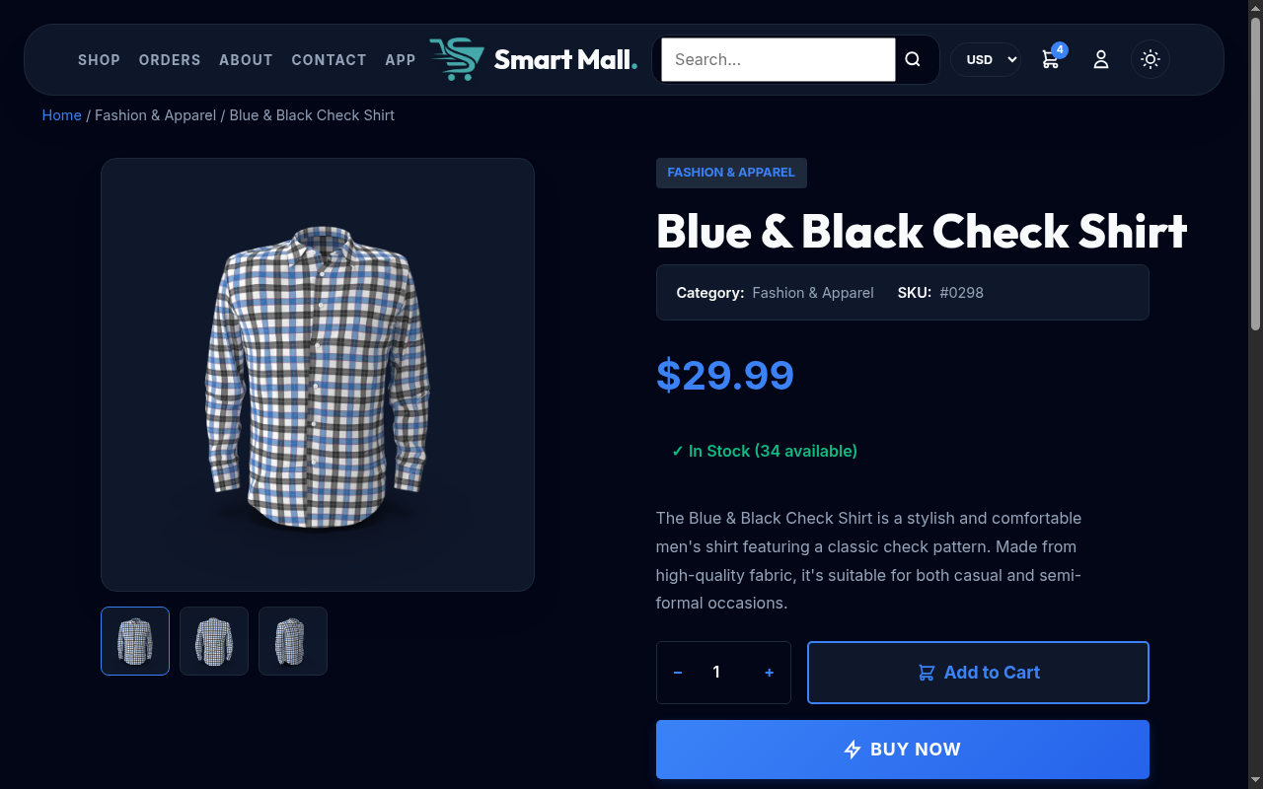

8.3 api/search.php
File Path: /reference/api/search.php
Purpose: JSON search autocomplete API
Dependencies: config.php (for DB and currency)
Database Tables: products
Key Features:
- Content-Type: application/json
- Parameter: $_GET['q'] — search query string
- LIKE search on name and description, LIMIT 6 results
- Results formatted with image_url and display_price (via smartmall_format_money)
- External URLs kept as-is; local paths prefixed with /uploads/
Called By: header.php search bar via JavaScript fetch/AJAX

9. Shopping Cart

9.1 cart.php
File Path: /reference/cart.php
Purpose: Full shopping cart management page
Dependencies: config.php, header.php, footer.php
Database Tables: cart, products
Key Features:
- Requires login: redirects to login.php?redirect=cart.php if not authenticated
- Remove item: POST handler with csrf_verify(), verifies cart ownership before DELETE
- Update quantity: POST handler verifies ownership AND checks stock limit
- Stock enforcement: joins cart with products to compare c.quantity against p.stock
- Cart items loaded with JOIN: SELECT c.id, c.quantity, p.id, p.name, p.price, p.stock, p.image FROM cart c JOIN products p
- Price totals calculated in PHP: subtotal, 10% VAT, grand total
- Sticky cart notification bar in footer showing item count
- Cache-control: no-store headers via header.php
Interacts With: add_to_cart.php (add items), checkout.php (proceed to checkout)
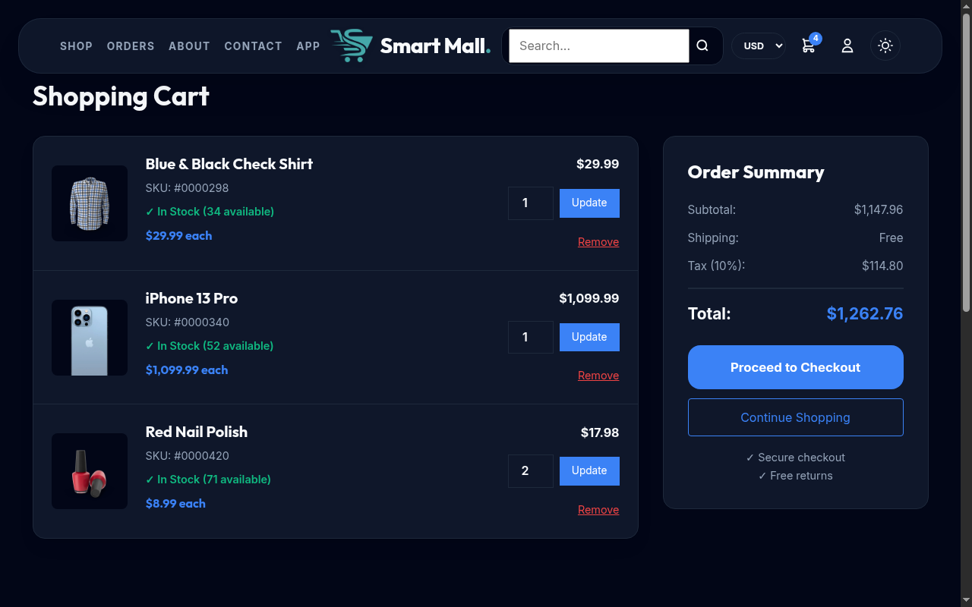

9.2 add_to_cart.php
File Path: /reference/add_to_cart.php
Purpose: AJAX JSON endpoint for adding products to cart
Dependencies: config.php
Database Tables: cart, products
Key Features:
- Content-Type: application/json response
- Accepts POST with product_id and quantity
- Requires authentication (returns JSON error if not logged in)
- Stock validation: checks products.stock >= requested quantity
- Quantity capping: if quantity > stock, sets to stock max
- UPSERT logic: if product already in user's cart, UPDATE quantity; otherwise INSERT
- Returns JSON: {success, message, cart_count, new_quantity}
- cart_count is summed via SELECT COALESCE(SUM(quantity), 0) FROM cart
Called By: index.php, product.php (via JavaScript fetch on button click)

10. Checkout & Payment

10.1 checkout.php
File Path: /reference/checkout.php
Purpose: Order placement with Chapa payment initiation
Dependencies: config.php, includes/currency.php, chapa_pay/chapa-config.php
Database Tables: cart, products, orders, order_items, payments
Key Features:
- POST handler processes order before header.php for redirect capability
- Requires login: redirects to login.php?redirect=checkout.php
- Three payment methods: chapa (online), bank_transfer, cash_on_delivery
- PDO Transaction: beginTransaction(), commit() for atomicity
- Row-level locking: SELECT stock FROM products WHERE id = :id FOR UPDATE
- Stock validation per item — rolls back entire transaction on shortage
- 10% VAT calculation: $tax = $total_price * 0.1
- Chapa ETB conversion: uses smartmall_exchange_rate('ETB') and smartmall_convert_money()
- Order inserted with shipping details: first_name, last_name, email, address, city, state, zip, country
- Payment record inserted regardless of method (cash_on_delivery → 'paid'; Chapa → 'pending')
- Order items inserted with price snapshot
- Stock deducted: UPDATE products SET stock = stock - :qty
- Chapa flow:
- TxRef generated: 'ORD-' + order_id + '-' + YYYYMMDD
- Updates payments.tx_ref
- POST to https://api.chapa.co/v1/transaction/initialize with JSON payload
- Authorization: Bearer CHAPA_SECRET_KEY header
- On success (200 + status=success): commits transaction, redirects to Chapa checkout_url
- On failure: displays HTTP code, cURL error, and raw response for debugging
- Cart NOT cleared for Chapa payments (cleared after verification callback)
- Cart cleared immediately for non-Chapa payments
Interacts With: cart.php (source of items), order_confirmation.php (confirmation page), chapa_pay/chapa-config.php (API config)
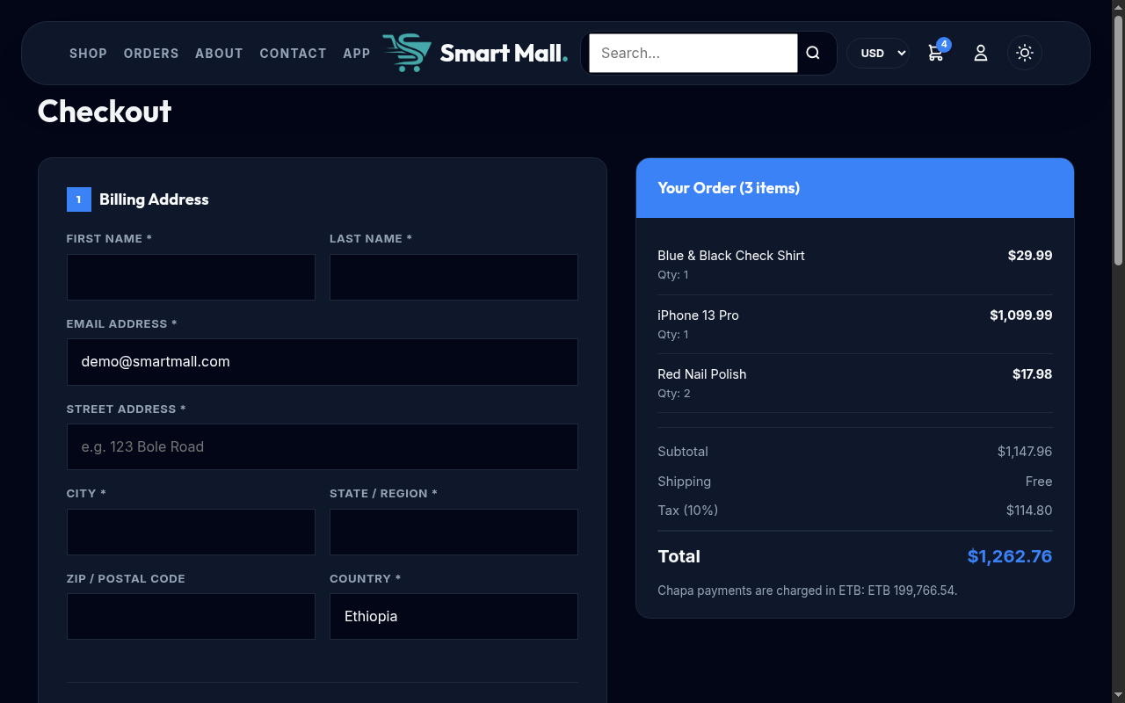

10.2 order_confirmation.php
File Path: /reference/order_confirmation.php
Purpose: Post-payment verification, order display, and payment state machine
Dependencies: config.php, chapa_pay/chapa-config.php
Database Tables: orders, payments, order_items, products, cart
Key Features:
- Payment state machine with three branches:
- ALREADY PAID: skips verification, shows confirmation page directly
- PENDING + CHAPA: triggers immediate Chapa verification API call
- PENDING + NON-CHAPA: handled as per payment method
- Chapa verification: GET https://api.chapa.co/v1/transaction/verify/{tx_ref}
- Verification success requires both top-level status='success' AND data.status='success'
- Test mode fallback: if CHAPA_SECRET_KEY contains 'TEST' and verification fails, assumes success
- Test mode writes synthetic success response to chapa_response column
- On success: updates payments.status='paid', payments.paid_at=NOW(), orders.status='processing', clears cart
- On failure: updates payments.status='failed', orders.status='cancelled', restores product stock
- Stock restoration: loops through order_items and UPDATE products SET stock = stock + :qty
- Loading page with 3-second auto-countdown while payment is pending
- Ownership check: verifies $_SESSION['user_id'] matches order's user_id
- Displays order items with product names, images, quantities, and prices
Interacts With: checkout.php (receives order), chapa_pay/chapa-config.php (API credentials)
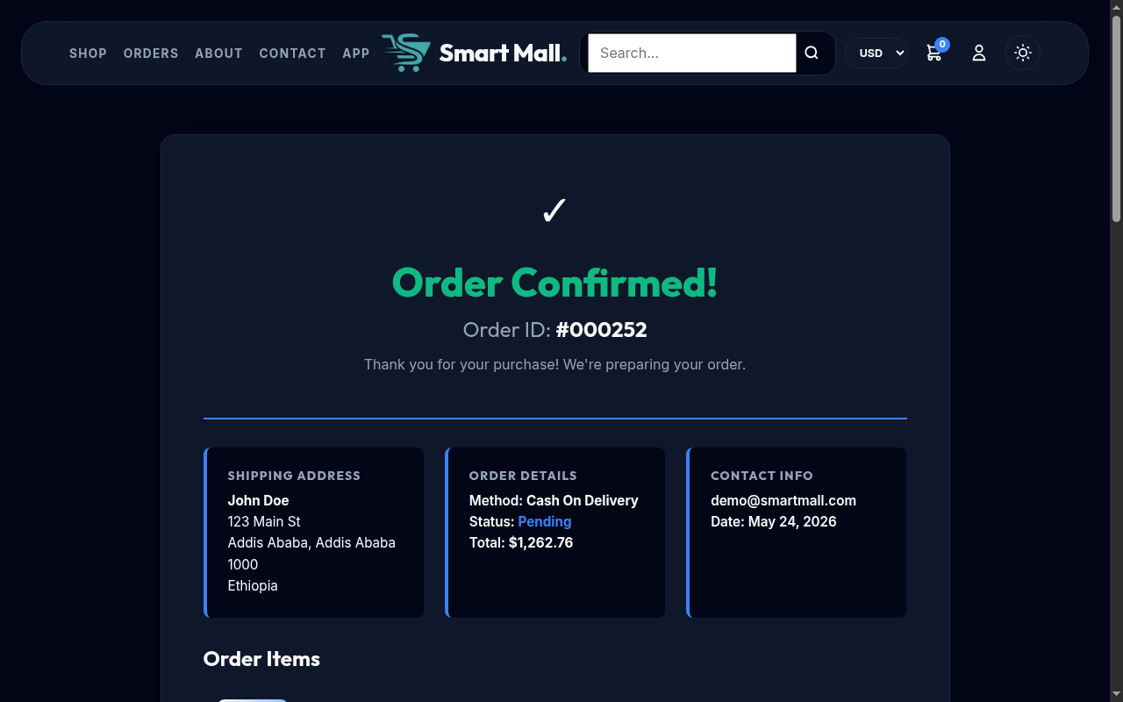

11. Order Management

11.1 orders.php
File Path: /reference/orders.php
Purpose: Customer order history page
Dependencies: config.php, header.php, footer.php
Database Tables: orders, payments, order_items
Key Features:
- Requires login (redirects if not authenticated)
- Fetches orders for current user: SELECT FROM orders WHERE user_id = :user_id ORDER BY created_at DESC
- Joins with payments for payment status
- Displays order items with quantities via order_items table
- Order cancelation: POST handler with csrf_verify(), updates status to 'cancelled'
- Cancelation restores stock: UPDATE products SET stock = stock + :qty
- Price display via smartmall_format_money()
Interacts With: order_confirmation.php (linked from order rows), checkout.php
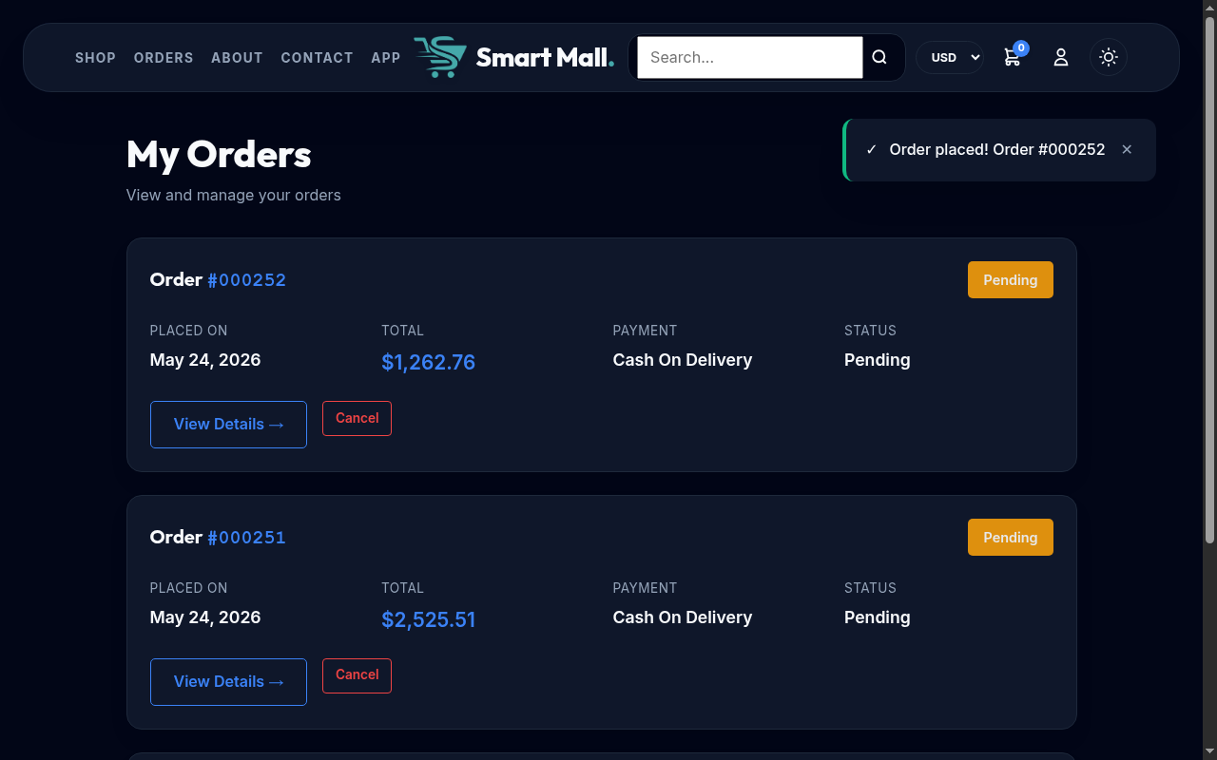

12. Admin Panel

12.1 admin/dashboard.php
File Path: /reference/admin/dashboard.php
Purpose: Admin dashboard with store statistics and product management
Dependencies: config.php, header.php, footer.php
Database Tables: products, categories, orders
Key Features:
- Admin gate: checks $_SESSION['user_role'] !== 'admin', redirects to ../index.php
- Statistics queries:
- COUNT(*) FROM products
- SUM(stock) FROM products
- COUNT(*) FROM orders
- SUM(total_price) FROM orders
- COUNT(*) FROM categories
- Products table with edit/delete actions, LEFT JOIN with categories
- Links to manage orders, manage categories, add product pages
Interacts With: add_product.php (edit links), delete_product.php (delete links), manage_orders.php, manage_categories.php
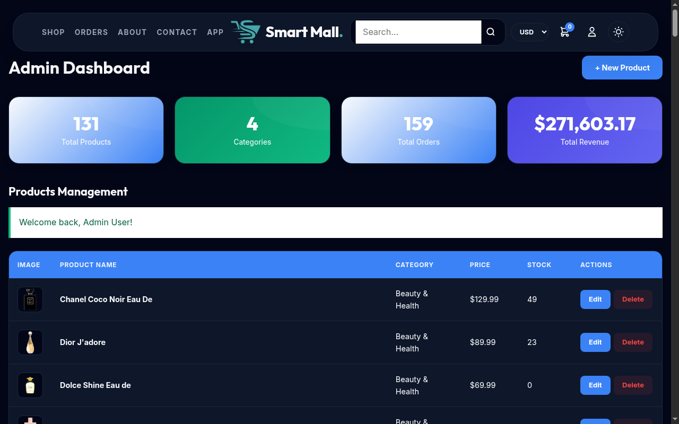

12.2 admin/add_product.php
File Path: /reference/admin/add_product.php
Purpose: Add and edit product form with image upload
Dependencies: includes/db.php (manually required, not config.php)
Database Tables: products, categories
Key Features:
- Dual-mode: add (no ?id) or edit (?id=N)
- Admin gate: checks $_SESSION['user_role']
- File upload validation: checks file type, size (max 5 MB), and upload errors
- Supported formats: JPEG, PNG, GIF, WebP
- Multi-image support with JSON array in images column
- Video upload support
- Media deletion: individual image/video deletion via POST action=delete_media
- Category dropdown loaded from categories table
- Price, stock, name, description fields
Interacts With: dashboard.php (navigates back), uploads/ directory
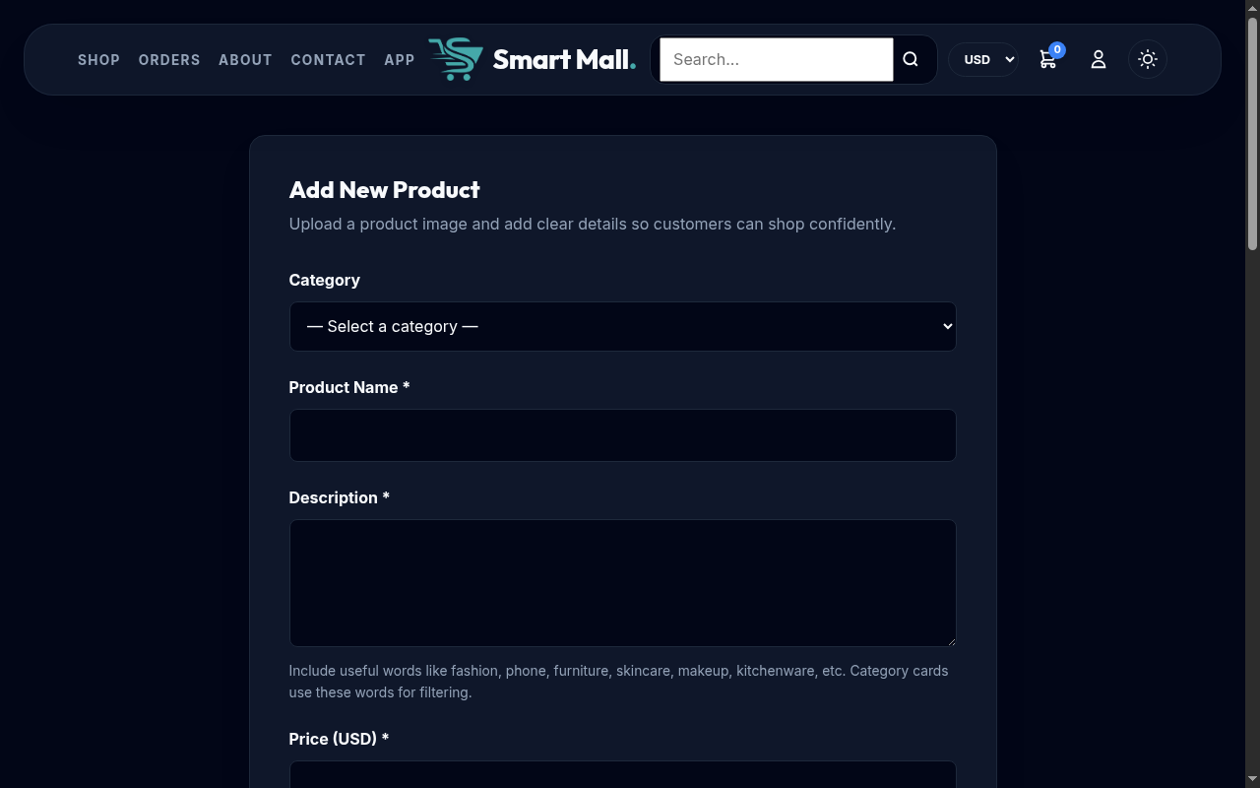

12.3 admin/delete_product.php
File Path: /reference/admin/delete_product.php
Purpose: Product deletion handler (POST only)
Dependencies: includes/db.php
Database Tables: products
Key Features:
- POST-only: rejects GET requests
- CSRF verification before deletion
- Fetches product image path, deletes image file from uploads/ using unlink()
- DELETE FROM products WHERE id = :id
- Redirects to dashboard.php with success/error flash
Interacts With: dashboard.php (product delete button)

12.4 admin/manage_orders.php
File Path: /reference/admin/manage_orders.php
Purpose: Order management with status updates
Dependencies: config.php, header.php, footer.php
Database Tables: orders, users, payments, order_items, products
Key Features:
- Paid orders displayed first: CASE WHEN pay.status='paid' THEN 1 ELSE 2 END ORDER
- Status update via POST: csrf_verify(), UPDATE orders SET status = :status
- Items data aggregated via GROUP_CONCAT with product name, image, quantity, price
- JOIN: orders LEFT JOIN users, LEFT JOIN payments, LEFT JOIN order_items, LEFT JOIN products
- Order details include: ID, customer name, items, total, status, date, payment method
Interacts With: order_confirmation.php (view order details)
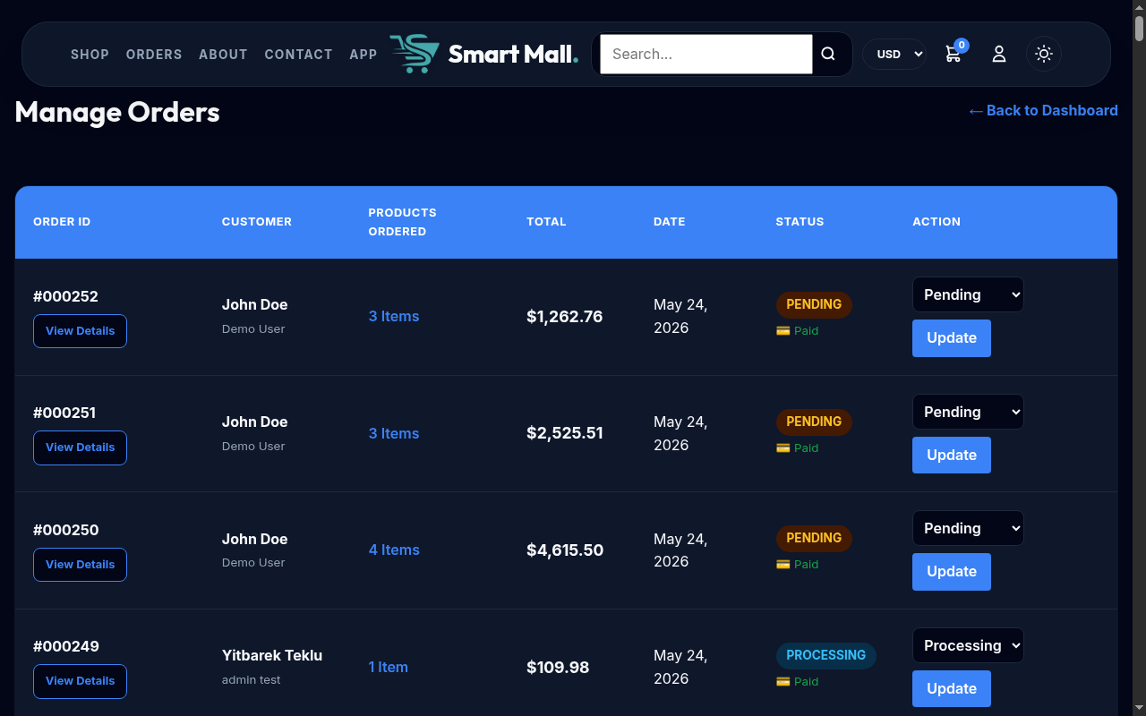

12.5 admin/manage_categories.php
File Path: /reference/admin/manage_categories.php
Purpose: Category CRUD with up to 3 slide images per category
Dependencies: config.php, header.php, footer.php
Database Tables: categories
Key Features:
- View all categories with slide image previews
- Add new category with name and up to 3 slide images
- Edit existing categories with image replacement
- Delete categories (with slide image cleanup from uploads/)
- Image upload via handle_category_upload() helper: generates unique names (cat_****.ext)
- Individual slide deletion via POST action=delete_category_slide
Interacts With: index.php (category slideshow on homepage), uploads/ directory
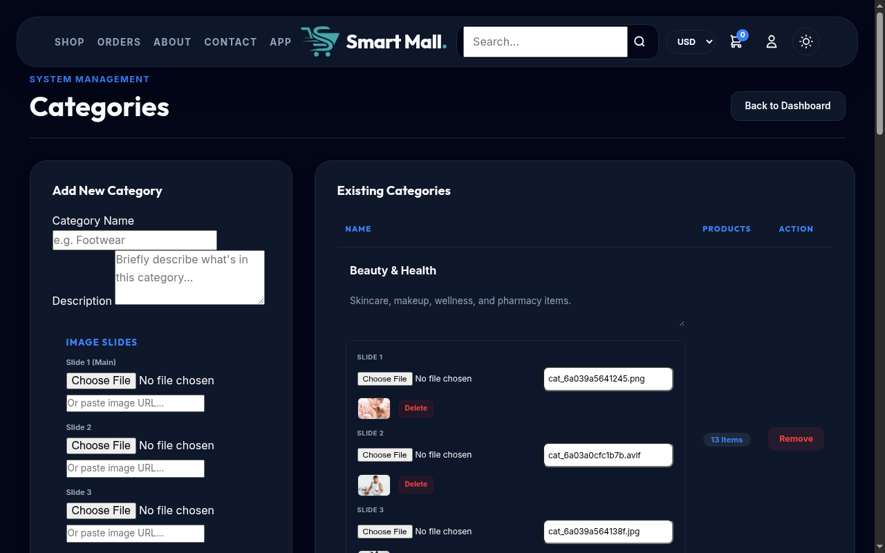

13. Additional Pages

13.1 about.php
File Path: /reference/about.php
Purpose: About page with live store statistics
Database Tables: products, orders, users, categories
Key Stats Displayed: Total products, total orders, registered customers, categories count

13.2 contact.php
File Path: /reference/contact.php
Purpose: Contact form page
Note: Client-side form; no backend email handler (static contact form)

13.3 download.php
File Path: /reference/download.php
Purpose: Mobile app download page with app store badges and QR code
Features: Google Play badge, App Store badge, QR code display

13.4 set_currency.php
File Path: /reference/set_currency.php
Purpose: Currency switch handler (called when user toggles USD/ETB)
Key Features:
- Accepts POST or GET with 'currency' parameter
- Calls smartmall_set_selected_currency() to persist choice in session
- Validates redirect URL: parses HTTP_REFERER, rejects cross-origin URLs
- Sanitizes redirect: strips newlines, ensures relative path starts with /
Called By: Currency toggle in header.php navigation

13.5 check_schema.php
File Path: /reference/check_schema.php
Purpose: Development utility — outputs product table column names as JSON
Output: JSON array of column names from DESCRIBE products

13.6 protect.php
File Path: /reference/protect.php
Purpose: Password-gated page protection
Credentials: Password is 'smartmalltest!' (defined as $SECRET)
Key Features:
- Session-based unlock: sets $_SESSION['unlocked'] = true on correct password
- Mobile-responsive password form with gradient design
Called By: Included at top of pages that need protection

14. Shared Layout Components

14.1 includes/header.php
File Path: /reference/includes/header.php
Purpose: Shared HTML <head>, navigation bar, and opening <body> tags
Dependencies: includes/currency.php
Key Features:
- Cache-control: no-store, no-cache headers for session pages
- Dark theme applied via JavaScript before page renders (localStorage 'smartmall-theme', respects prefers-color-scheme)
- Cart count badge: SELECT COALESCE(SUM(quantity), 0) FROM cart WHERE user_id = :user_id
- Current page detection via basename($_SERVER['PHP_SELF'])
- Navigation: Home, Shop, About, Contact, Cart (with badge), My Orders, Download App, Admin (if role=admin)
- Currency dropdown: USD/ETB toggle via set_currency.php
- PWA: manifest.json link, apple-touch-icon, theme-color meta
- Mobile hamburger menu drawer

14.2 includes/footer.php
File Path: /reference/includes/footer.php
Purpose: Shared footer with JavaScript assets and closing tags
- Sticky cart notification bar at bottom of page
- Toast notification system (showToast function)
- Search autocomplete JavaScript (calls api/search.php)
- Slideshow/carousel JavaScript for homepage
- Dark theme toggle JavaScript

15. Progressive Web App

15.1 manifest.json
File Path: /reference/manifest.json
Purpose: PWA manifest enabling installable web app
- Display: standalone (full-screen, no browser chrome)
- Theme color: #007AFF
- Background color: #FFFFFF
- Name: 'Smart Mall'
- Icons: logo-icon.png

16. Capacitor Mobile App

16.1 Capacitor Project (smartmall-app/)
Project Root: /reference/smartmall-app/
Framework: Capacitor v8 (NOT Flutter)

capacitor.config.json
Key Configuration:
- webDir: 'www' (the web app root)
- server.url: 'https://smartmall.unaux.com'
- appId: 'com.example.smartmall'
- appName: 'Smart Mall'

www/app.js
File Path: /reference/smartmall-app/www/app.js
Purpose: Capacitor app entry point — native back button and deep link handling
- StatusBar.hide() — hides status bar on app launch
- SplashScreen.hide() — hides splash screen on app launch
- backButton listener: if canGoBack, calls window.history.back(); otherwise App.exitApp()
- appUrlOpen listener: intercepts URLs containing 'smartmall.unaux.com/' and navigates in-app

Part IV: Data Flows

17. Add to Cart Flow
The add-to-cart flow is entirely AJAX-driven, providing instant feedback without page reload:
- User clicks 'Add to Cart' on a product card or product detail page.
- JavaScript in the page sends a POST request to add_to_cart.php with product_id and quantity as FormData.
- add_to_cart.php checks authentication: if no user_id in session, returns JSON {error: 'Please login first'}.
- If authenticated, validates stock: SELECT stock FROM products WHERE id = :id. Caps quantity at stock if exceeded.
- Checks for existing cart entry: SELECT id, quantity FROM cart WHERE user_id = :uid AND product_id = :pid.
- If exists: UPDATE cart SET quantity = :qty WHERE id = :cid. If not: INSERT INTO cart (user_id, product_id, quantity).
- Recalculates cart count: SELECT COALESCE(SUM(quantity), 0) FROM cart WHERE user_id = :uid.
- Returns JSON: {success: true, message, cart_count, new_quantity}.
- JavaScript updates the cart count badge and shows a success toast.
This entire flow takes under 500ms on a local development environment.

18. Checkout & Payment Flow
The checkout process involves a PDO transaction, a Chapa API call for online payments, and a post-return verification step:
- User reviews cart on cart.php and clicks 'Proceed to Checkout'.
- checkout.php loads cart items via JOIN with products and calculates subtotal + 10% VAT.
- User fills in billing/shipping form and selects payment method (Chapa / Bank Transfer / Cash on Delivery).
- On form POST: csrf_verify() is called first. Then a PDO transaction begins.
- Row-level stock check: SELECT stock FROM products WHERE id = :id FOR UPDATE for every item.
- Order INSERT with shipping details. Payment INSERT with method and status.
- Order items INSERT for each product. Stock UPDATE: stock = stock - quantity.
- For Chapa payments:
- Generate tx_ref = 'ORD-' + order_id + '-' + date('Ymd'). Update payments row.
- POST JSON to https://api.chapa.co/v1/transaction/initialize with amount (ETB), currency, tx_ref, callback_url, return_url.
- On success: commit transaction, redirect user to Chapa checkout page.
- Cart is NOT deleted yet (preserved until payment callback).
- For non-Chapa: commit transaction, clear cart immediately, redirect to order_confirmation.php.

19. Payment Verification Flow
After a Chapa payment, the user returns to order_confirmation.php which handles verification:
- User arrives at order_confirmation.php?order_id=X after Chapa redirect.
- System checks payment status: if 'paid', display confirmation immediately.
- If 'pending' and method is 'chapa':
- Fetch tx_ref from payments table.
- GET https://api.chapa.co/v1/transaction/verify/{tx_ref} with Bearer token auth.
- Parse response. Success requires: status='success' AND data.status='success'.
- If verification succeeds: UPDATE payments SET status='paid', paid_at=NOW() — UPDATE orders SET status='processing'. DELETE FROM cart WHERE user_id = :uid.
- If verification fails AND key contains 'TEST': assume success (test mode fallback). Writes synthetic response.
- If verification fails and NOT test mode: UPDATE payments SET status='failed'. UPDATE orders SET status='cancelled'. Restore stock for each order_item.
- Redirect to self with ?verified=1 to prevent form resubmission.

20. Currency Conversion Flow
The currency system converts USD prices (stored in the database) to ETB for display and Chapa payments:
- User selects ETB from the currency dropdown in the header.
- set_currency.php receives the request, calls smartmall_set_selected_currency('ETB'), persists to $_SESSION['currency'], and redirects back.
- On subsequent page loads, header.php reads smartmall_selected_currency() which returns 'ETB' from session.
- Formatting functions (smartmall_format_money) detect the active currency and exchange rate.
- smartmall_exchange_data() checks file cache at {sys_temp_dir}/smartmall_exchange_usd.json.
- If cached rates are valid (within expires_at), they are used immediately.
- If expired or missing, smartmall_fetch_exchange_rates() calls open.er-api.com/v6/latest/USD via cURL.
- The API response is validated (result=success, base_code=USD, rates.ETB exists).
- Rates are cached to disk with LOCK_EX and a next_update timestamp.
- If the API call fails, stale cache is used. If no cache exists, rates default to 0.0 (USD-only fallback).
- smartmall_format_money applies the rate: ETB X.XX = $USD * rate.

21. Password Reset Flow
The password reset process uses a token-based approach with one-hour expiration:
- User navigates to forgot_password.php and enters their email.
- A 64-character hex token is generated: bin2hex(random_bytes(32)).
- The token, email, and expires_at (now + 1 hour) are INSERTed into password_resets.
- A reset link is constructed: {base_url}/reset_password.php?token={token}.
- The link is saved to {sys_temp_dir}/smartmall_reset_links.txt for dev access, and stored in $_SESSION['reset_link'].
- PHP mail() is called with the reset link (delivery depends on server mail configuration).
- User navigates to the reset link. reset_password.php validates the token:
- SELECT email, expires_at FROM password_resets WHERE token = :token.
- Checks strtotime(expires_at) > time().
- If valid, user sets a new password (same policy as registration: 8+ chars, upper, lower, digit, special).
- Password is hashed with PASSWORD_BCRYPT and UPDATE users SET password = :hash WHERE email = :email.
- The reset token is DELETEd from password_resets to prevent reuse.

Part V: Security

22. Security Measures

22.1 CSRF Protection
All state-changing operations require CSRF token verification. Tokens are generated in includes/db.php using bin2hex(random_bytes(32)), producing a 64-character hexadecimal string stored in $_SESSION['csrf_token']. Verification uses PHP's hash_equals() function to prevent timing attacks. Forms include the token via csrf_field() and handlers call csrf_verify(), which terminates with HTTP 403 on mismatch.
Files using CSRF: login.php, register.php, checkout.php, cart.php, add_to_cart.php, orders.php, forgot_password.php, reset_password.php, admin/dashboard.php (product delete), admin/manage_orders.php, admin/manage_categories.php, admin/delete_product.php

22.2 SQL Injection Prevention
All database queries use PDO prepared statements with named parameters (:param) or positional placeholders (?). PDO::ATTR_EMULATE_PREPARES is set to false, ensuring real prepared statements are sent to MySQL. The charset is explicitly set to utf8mb4 in the DSN. No raw string interpolation or concatenation is used in any SQL query across the entire codebase.

22.3 XSS Prevention
All user-controlled data rendered in HTML is escaped with htmlspecialchars($value, ENT_QUOTES, 'UTF-8'). This applies to product names, descriptions, form field values, error messages, and any other dynamic content displayed on pages. Session success/error messages are also escaped before display.

22.4 Password Security
Passwords are hashed using PASSWORD_BCRYPT (PHP's bcrypt implementation) via password_hash(). Verification uses password_verify(), which is timing-safe. The minimum cost factor is 10 (PHP default). The password policy enforced at registration and password reset requires: minimum 8 characters, at least one uppercase letter, at least one lowercase letter, at least one digit, and at least one special character. This is enforced server-side through four separate preg_match() calls.

22.5 Session Security
- Session fixation prevention: session_regenerate_id(true) on login
- Session cleanup: session_unset() + session_destroy() on logout
- Cache-control: no-store, no-cache headers on session pages
- HTTP-only cookies (PHP default for sessions)
- No session ID in URLs

22.6 File Upload Security
The admin product form (admin/add_product.php) validates file uploads using PHP's upload error constants (UPLOAD_ERR_OK, etc.). Files are checked for size (server upload limits), and extensions are validated. Images are stored in the uploads/ directory with original filenames prefixed with unique identifiers for categories (cat_****.ext). Deletion handlers clean up associated files from the filesystem.

22.7 HTTP Security Headers
config.php emits two security headers on every request:
- X-Content-Type-Options: nosniff — prevents MIME-type sniffing
- X-Frame-Options: SAMEORIGIN — prevents clickjacking by restricting framing to same origin

Part VI: Appendices

23. Complete DDL
The following DDL statements define all eight tables in the Smart Mall database schema:

CREATE TABLE users (
id INT(11) PRIMARY KEY AUTO_INCREMENT,
name VARCHAR(100) NOT NULL,
email VARCHAR(100) NOT NULL UNIQUE,
phone VARCHAR(20) DEFAULT NULL,
password VARCHAR(255) NOT NULL,
role ENUM('customer','admin') DEFAULT 'customer',
address TEXT DEFAULT NULL,
created_at TIMESTAMP DEFAULT CURRENT_TIMESTAMP
);

CREATE TABLE categories (
id INT(11) PRIMARY KEY AUTO_INCREMENT,
name VARCHAR(255) NOT NULL,
slug VARCHAR(255) DEFAULT NULL,
image1 VARCHAR(255) DEFAULT NULL,
image2 VARCHAR(255) DEFAULT NULL,
image3 VARCHAR(255) DEFAULT NULL,
created_at TIMESTAMP DEFAULT CURRENT_TIMESTAMP
);

CREATE TABLE products (
id INT(11) PRIMARY KEY AUTO_INCREMENT,
category_id INT(11) DEFAULT NULL,
name VARCHAR(255) NOT NULL,
description TEXT DEFAULT NULL,
price DECIMAL(10,2) NOT NULL,
image VARCHAR(255) DEFAULT NULL,
images LONGTEXT DEFAULT NULL,
video VARCHAR(255) DEFAULT NULL,
stock INT(11) NOT NULL DEFAULT 0,
created_at TIMESTAMP DEFAULT CURRENT_TIMESTAMP,
FOREIGN KEY (category_id) REFERENCES categories(id)
);

CREATE TABLE cart (
id INT(11) PRIMARY KEY AUTO_INCREMENT,
user_id INT(11) NOT NULL,
product_id INT(11) NOT NULL,
quantity INT(11) NOT NULL DEFAULT 1,
created_at TIMESTAMP DEFAULT CURRENT_TIMESTAMP,
FOREIGN KEY (user_id) REFERENCES users(id) ON DELETE CASCADE,
FOREIGN KEY (product_id) REFERENCES products(id) ON DELETE CASCADE
);

CREATE TABLE orders (
id INT(11) PRIMARY KEY AUTO_INCREMENT,
user_id INT(11) NOT NULL,
total_price DECIMAL(10,2) NOT NULL,
status ENUM('pending','processing','paid','shipped','delivered','cancelled') DEFAULT 'pending',
first_name VARCHAR(100) DEFAULT NULL,
last_name VARCHAR(100) DEFAULT NULL,
email VARCHAR(255) DEFAULT NULL,
address TEXT DEFAULT NULL,
city VARCHAR(100) DEFAULT NULL,
state VARCHAR(100) DEFAULT NULL,
zip VARCHAR(20) DEFAULT NULL,
country VARCHAR(100) DEFAULT 'Ethiopia',
payment_method VARCHAR(50) DEFAULT 'chapa',
created_at TIMESTAMP DEFAULT CURRENT_TIMESTAMP,
FOREIGN KEY (user_id) REFERENCES users(id)
);

CREATE TABLE order_items (
id INT(11) PRIMARY KEY AUTO_INCREMENT,
order_id INT(11) NOT NULL,
product_id INT(11) NOT NULL,
quantity INT(11) NOT NULL,
price DECIMAL(10,2) NOT NULL,
FOREIGN KEY (order_id) REFERENCES orders(id),
FOREIGN KEY (product_id) REFERENCES products(id)
);

CREATE TABLE payments (
id INT(11) PRIMARY KEY AUTO_INCREMENT,
order_id INT(11) NOT NULL,
method VARCHAR(50) NOT NULL,
status ENUM('pending','paid','failed') DEFAULT 'pending',
amount DECIMAL(10,2) NOT NULL,
currency VARCHAR(10) NOT NULL DEFAULT 'USD',
tx_ref VARCHAR(100) DEFAULT NULL,
chapa_response LONGTEXT DEFAULT NULL,
paid_at DATETIME DEFAULT NULL,
created_at DATETIME NOT NULL,
FOREIGN KEY (order_id) REFERENCES orders(id)
);

CREATE TABLE password_resets (
id INT(11) PRIMARY KEY AUTO_INCREMENT,
email VARCHAR(100) NOT NULL,
token VARCHAR(64) NOT NULL,
expires_at DATETIME NOT NULL,
created_at TIMESTAMP DEFAULT CURRENT_TIMESTAMP
);

24. Component Dependency Map
The following table summarizes how every file depends on includes/db.php (for the PDO connection and CSRF helpers) and includes/currency.php (for the multi-currency engine):

File | config.php | db.php | currency.php | Database Tables Used
config.php | — | Yes (require) | Yes (require) | None directly
index.php | Yes | via config | via config | products, categories
product.php | Yes | via config | via config | products, categories
cart.php | Yes | via config | via config | cart, products
checkout.php | Yes | via config | via config | cart, products, orders, order_items, payments
order_confirmation.php | Yes | via config | via config | orders, payments, order_items, products, cart
orders.php | Yes | via config | via config | orders, payments, order_items
login.php | No | Yes (require) | No | users
register.php | Yes | via config | via config | users
logout.php | No | No | No | None
forgot_password.php | Yes | via config | via config | password_resets
reset_password.php | Yes | via config | via config | password_resets, users
add_to_cart.php | Yes | via config | via config | cart, products
api/search.php | Yes | via config | via config | products
about.php | Yes | via config | via config | products, orders, users, categories
set_currency.php | Yes | via config | via config | None
admin/dashboard.php | Yes | via config | via config | products, categories, orders
admin/add_product.php | No | Yes (require) | No | products, categories
admin/delete_product.php | No | Yes (require) | No | products
admin/manage_orders.php | Yes | via config | via config | orders, users, payments, order_items, products
admin/manage_categories.php | Yes | via config | via config | categories

25. Deployment Checklist
To deploy the Smart Mall platform to a production server:

- Ensure PHP 8.0+ with PDO, cURL, and MySQL extensions enabled.
- Create a MySQL database (e.g., smartmall_db) and execute the DDL statements in Appendix 23 to create all eight tables.
- Copy all files to the web server's document root, preserving the directory structure (uploads/, includes/, admin/, chapa_pay/, etc.).
- Update database credentials in includes/db.php: set $host, $db_user, $db_pass, and $db_name for the production environment.
- Configure the Chapa production secret key in chapa_pay/chapa-config.php (replace CHASECK_TEST-* with the live key).
- Ensure the uploads/ directory is writable by the web server process (chmod 755 or 775).
- For the mobile app: update server.url in smartmall-app/capacitor.config.json to the production domain, then build with 'npx cap sync android'.
- Configure cron for abandoned order cleanup if desired (30-minute interval recommended).
- Enable HTTPS (required by Chapa API for production callbacks).
- Test the full payment flow: registration, product browsing, add to cart, checkout with Chapa (sandbox), and order confirmation.

