Enhancing Thermal Imaging via Multi-Frame Fusion

Yiwei Wang, Yufei Xi, Carissa Wu

## Background & Motivation

High-resolution thermal cameras are valuable tools in applications like equipment diagnostics, human temperature monitoring, and autonomous navigation. Despite wide application of thermal cameras, their cost is creating a barrier for end-users. The following table summarizes the price for thermal camera models from FLIR, a leading manufacturer in thermal imaging. The cost increases rapidly for finer resolution, with a 6 times price from 160 x 120 to 320 x 240, and about 8 times price from 320 x 240 to 640 x 480.

| Model | Resolution | Price |
| --- | --- | --- |
| FLIR TG268 | 160 x 120 | $499.00 |
| FLIR E6 PRO | 240 x 180 | $1739.13 |
| FLIR E8 PRO | 320 x 240 | $2999.00 |
| FLIR T560 | 640 x 480 | $23529.00 |

Table 1. Summary of thermal camera pricing

Attempts have been made to tackle the problem of enhancing thermal cameras. [A multi-image super-resolution algorithm applied to thermal imagery](https://link.springer.com/article/10.1007/s12518-019-00253-y) utilizes slightly displaced low resolution thermal images to reconstruct a higher resolution image. However, the algorithm was based on known fixed displacement between images, which is hard to achieve without precise motion control. [Other researchers](https://openaccess.thecvf.com/content_CVPRW_2020/papers/w6/Chudasama_TherISuRNet_-_A_Computationally_Efficient_Thermal_Image_Super-Resolution_Network_CVPRW_2020_paper.pdf) employed machine learning techniques to estimate the missing pixels. Although these algorithms produce visually acceptable results, the upscaled images are “deduced” with the same information as the lower resolution image and hence bear the possibility of losing critical details.

Regular cameras have also benefited greatly from software-driven image enhancement. HDR imaging — now standard in smartphones — captures multiple frames and combines them to create more detailed images. [Hand-held Multiframe Super Resolution](https://doi.org/10.48550/arXiv.1905.03277), as proposed by Google, implemented a hand-held multi-frame super-resolution algorithm that uses optical flow to align adjacent frames.

Inspired by this idea, we explore using multi-frame super-resolution on thermal images. Instead of exposure differences, we capture small shifts between frames using natural hand motion. A pi camera tracks this motion using a visual tracking algorithm, allowing us to align and combine multiple low-resolution thermal frames from an MLX90640 thermal sensor into a sharper composite image offering a low-cost path to higher-resolution thermal imaging.

## High Level Design

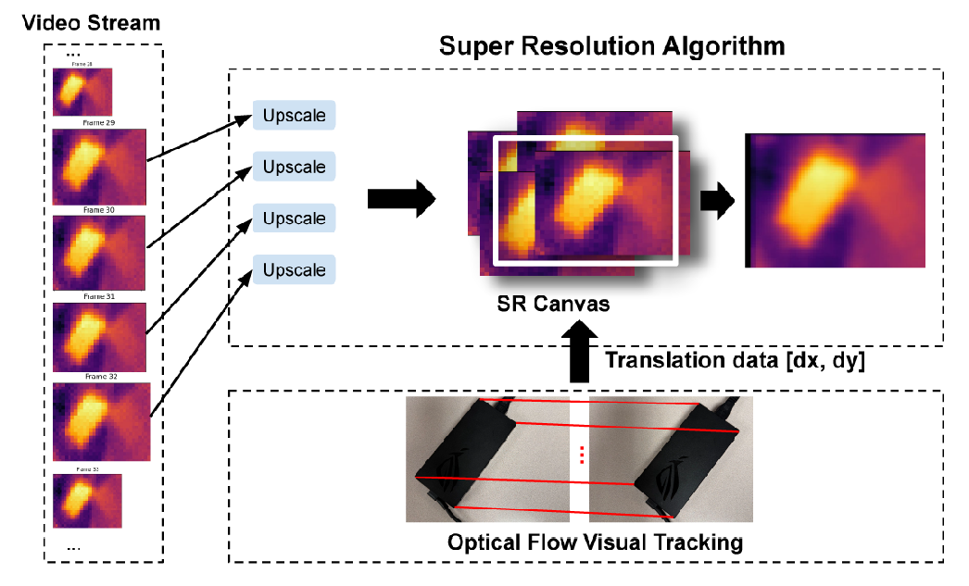

Figure 1. SR algorithm overview

Our design includes creating a super resolution algorithm using multiple frames. We have a video stream that collects multiple images in real time using our thermal camera, as shown on the left, each one upscaled using bilinear interpolation. Meanwhile, we simultaneously use our pi camera to collect translation data, which shows the number of pixels shifted for each image frame in both the horizontal and vertical directions. We use that information in our final result, when overlapping our images as shown on the right according to how many pixels that had been translated, and averaging the pixel values to then create a smooth, consistent, effect.

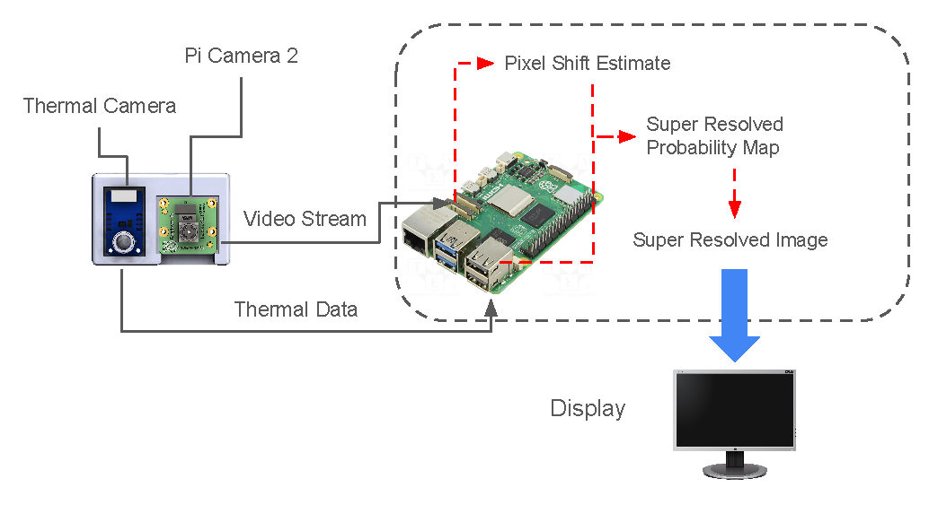

Figure 2. Hardware overview

Our design for the project consisted of multiple hardware components. We used a MLX90640 thermal camera to collect thermal image data, which is the data that we needed to create a high resolution thermal image. The thermal camera sends the image data to the raspberry pi, which is where we ran our super resolution algorithms on. At the same time, we also used Pi Camera 2 to collect translation data which is also sent to the raspberry pi for optical flow tracking and estimating the pixel shifts between images. Once we combine both the optical flow data and the thermal image data for a super resolved image, we send that information to a laptop display, which shows a comparison of the original, bilinear upscaling, and super resolved images.

## Important Technical Issues

A technical issue we have encountered included our low frame rate. In the end, we were only able to achieve a frame rate of 8Hz, when we had previously expected it to be 16Hz. A possible explanation for this was that there was an issue with i2C (connection between the raspberry pi and the thermal camera). A potential solution is to connect the thermal camera to the teensy first, and connect teensy to the raspberry pi, where we would be able to capture images at a higher frame rate.

## System Testing & Validation

The system was tested with a rectangular shaped laptop power supply for testing super resolution of straight edges. The original low resolution thermal image is shown on the right. The super resolution image is compared with the original image, as well as another super resolved image generated by bicubic interpolation between neighboring pixels as a baseline algorithm.

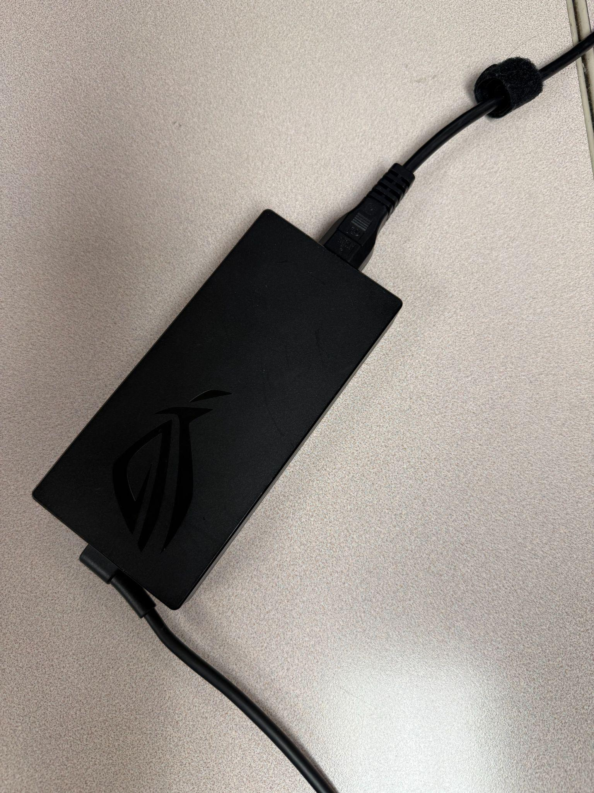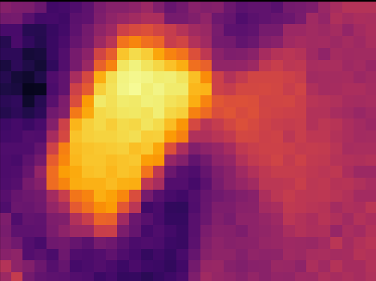

Figure 3. Power supply & corresponding thermal image

In addition to the power supply, a human hand is also used to test the algorithm’s behavior on complex shaped objects.

1. **Results & Discussion**

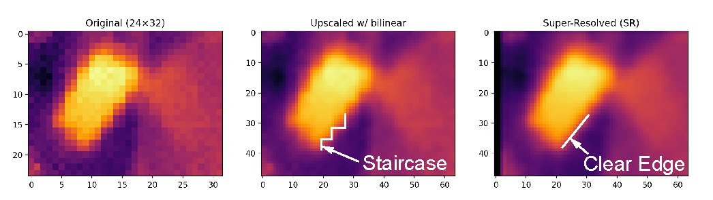

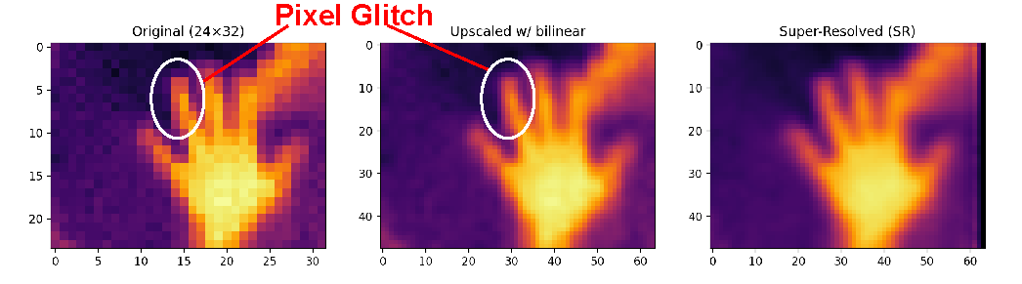

Figure 4. SR results & comparison with baseline algorithm

On the left, we have the original image, which is the one directly taken from our thermal camera, while the other two images are an upscaled image of the original using bilinear interpolation for an image that is double the original height and width, and the super resolution image created using multiple images, also an upscaled version of the original image. As you can see, the original image, which is low resolution enlarged to match the upscaled versions, is the worst quality due to it looking pixelated and chunky. The bilinear upscaling made the original image slightly better by smoothing the edges, but there is still a clear staircase effect nonetheless, while our super resolution algorithm is able to produce clear and smooth edges, and represents the best quality out of the three options.

1. **Future Work**

For future work, we plan on making improvements to our super resolution algorithm, as well as making the final image a higher resolution. Currently our final image after the algorithm is 64 x 48 pixels, which is still lacking compared to the higher resolution cameras in Table 1. We will aim for the final image to be 320 x 240, thus being competitive for real life cameras. To do this, we will make several improvements to our super resolution algorithm, including using a pre-trained machine learning model with known parameters. We would find datasets of preexisting thermal images to train the model on, before getting all the right parameters and then using that model in real time thermal image capture.