The user can customize the brush's size, color, amount, and other properties in a digital painting application by selecting from a variety of brush options. The parameters in the application that the user can change to acquire the desired brush settings are shown in Figure 6.1.1.1. The **“Water Brush”** toggle switches between a water-only and pigment-carrying brush. The color of the paint carried by the brush can be changed by modifying the **“Brush Color”** option. 12 colors are available for selection in this application. The brush stroke size is controlled by the **“Brush Size”** setting. The size of the brush represents the radius of the brush because the brush has a circular form. To regulate the amount of pigment used every stroke, **“Pig Per Stroke”** (pigments per stroke) is employed. **“Pig Drop Rate”** (pigment drop rate) is used to hold the rate of paint drop per stroke since in reality, paint on the brush gradually transfers to the paper when it is applied to the canvas. Finally, **“Water Amount”** governs how much water is on the brush, which has an impact on how the pigments are distributed.

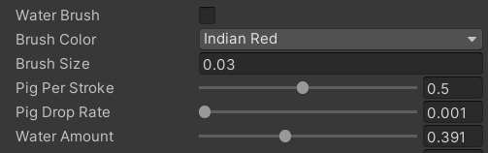

*Figure 6.1.1.1. Parameters that control brush settings.*

Figure 6.1.1.2 shows dots and strokes by different brush sizes. The rows from top to bottom display strokes drawn with the pixel width of canvas texture multiplied by 1, 5, 10, and 20 as the radius of brushes. The pixel width is formulated as 1.0 / (texture width), since the pixel position in the texture is located from 0 to 1 in the uv coordinates. The first column contains dots drawn by brush without water so that the actual size of brush can be shown. The second and third columns contain dots and line segments drawn by brush with 0.5 of water amount. Different brush sizes provide the user with the ability to paint different levels of watercolor. The size of the brush affects the amount of paint and water used in a stroke, because the larger the brush, the larger the area covered by paint and water, and the greater the spread of color.

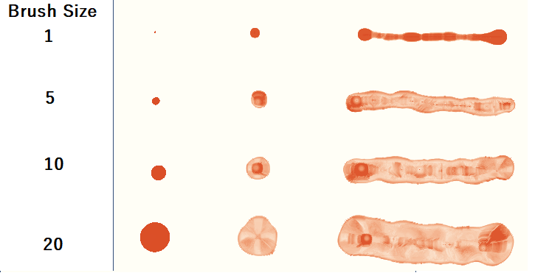

*Figure 6.1.1.2. Dots and strokes by different brush size*