# Chapter 1 Introduction

## 1.1 Problem Statement

**Watercolor is one of the well-known styles of art painting. It involves mixing a water-based solution before applying the pigments to the canvas.** The liquid mixture of the pigmented water-based solution is dispersed and spread on the canvas. Afterwards, the excess water solution is absorbed and evaporated, leaving only traces of pigment on the canvas. It is the combination of these traces of pigment that makes up a watercolor painting. These traces are translucent patterns of pigment, formed by the flow of the pigment-water solution along the grooves of the watercolor canvas. These traces cannot be completely controlled or manipulated, which is the beauty of watercolor. Due to this randomness, it is difficult for artists to reproduce the same watercolor effect, which makes each watercolor painting unique. In addition, the flowing motion of the pigment-watercolor is completely different on dry and wet canvases. Figure 1 shows the watercolor effect of wet in dry (wet brush drawing on dry canvas) and wet in wet (wet brush drawing on wet canvas). Many people, including myself, are fascinated by the characteristics of these watercolors. I am particularly interested in studying and reproducing the mechanisms behind the use of computer graphics techniques to create watercolor paintings.

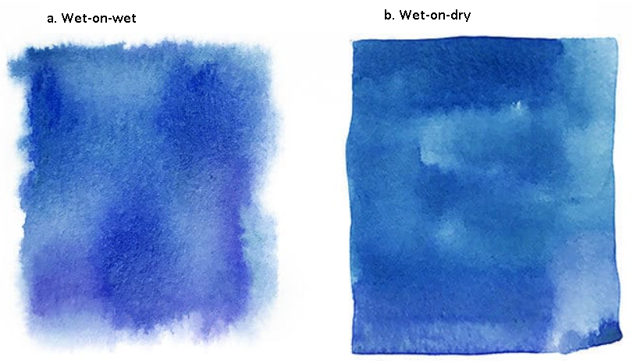

Figure 1. Wet brush with pigment on canvas of different wetness. (a) wet-on-wet (wet brush with pigment drawing on wet canvas); (b) wet-on-dry (wet brush with pigment drawing on dry canvas).

**Current research on watercolor simulation is concentrated in two fields: watercolor stylization and digital watercolor painting.** Watercolor stylization involves converting the input image to a watercolor style and rendering the anime scene in a watercolor style [[1]–[4]](https://www.zotero.org/google-docs/?NIqhdd). Figure 2 illustrates the watercolor stylization results from Curtis *et al.* [[3]](https://www.zotero.org/google-docs/?4ZqMBO) and Bousseau *et al.* [[4]](https://www.zotero.org/google-docs/?tTZgLG). While this stylization provides users with the ability to convert from regular images to watercolor, it lacks the creativity of user control. I, however, am interested in the second research area of watercolor simulation, digital watercolor painting application. It offers artists and watercolor enthusiasts the convenience of being able to create watercolor paintings anytime, anywhere.

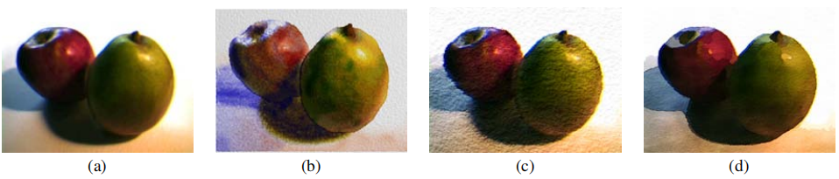

Figure 2. Comparison of results from Curtis *et al.* [[3]](https://www.zotero.org/google-docs/?EKAyHS) and Bousseau *et al.* [[4]](https://www.zotero.org/google-docs/?oLega6). (a) original image, (b) Curtis *et al.* result, (c, d) Bousseau *et al.* result

**In the history of the development of painting, from painting on cave walls to colored pottery, on silk, and on paper, the material media of painting has always evolved along with the development of time.** With the development of technology and the advent of the digital and graphic age, digital painting has become a new art form derived from the fusion of modern computer technology and the art of painting [[5]](https://www.zotero.org/google-docs/?7v80bK). In the field of digital painting, paper models are designed and constructed as an alternative to painting bearers, and pressure sensitive board and pressure sensitive pen have replaced painting tools.

**Compared to traditional watercolor painting with paints, water solutions and brushes on watercolor paper, digital watercolor, painting on digital devices such as computers and tablets, gives the artist many benefits that traditional painting cannot offer.** Based on computer graphics algorithms all required tools are integrated and accessible via a single machine, such as a tablet or smartphone, thus saving the space taken up by painting tools. Because of the benefits of the digital platform, painters are not afraid of damaging or soiling paper or canvas, or of not being able to replicate previous brushstrokes, as they can easily delete or copy them from their operational history [[5], [6]](https://www.zotero.org/google-docs/?Ptkq6i). In addition, with the help of the Internet, completed electronic paintings can be easily and quickly disseminated, shared, and brought to public attention, which may help artists attain recognition. Digital watercolors also benefit from these advantages.

**Digital watercolor simulation consists of two main tasks: building a physical model of the watercolor painting and rendering the image based on the information from the physical model.** Since conventional watercolor painting is done on canvas, where all physical phenomena, including diffusion, absorption, and evaporation of the pigment-water solution, occur, a major approach to simulating watercolor effects is to model the physical properties of watercolor and render the final effect image on canvas. Small *et al.* introduced a basic model to simulate a watercolor canvas using cellular automata [[7]](https://www.zotero.org/google-docs/?SXqEGs). In their work, they divided the simulation of watercolor painting into three parts. First, pigments and water are applied to the paper in different ways. The properties of the paper, as well as environmental factors such as humidity and gravity, are taken into account. Second, the mobility of the pigment and water in discrete time steps to various pressures is calculated. Finally, depending on the simulated state of the discrete time, images can be produced in various ways. In order to reproduce watercolors effectively, not only the physical characteristics of the medium but also the phenomenological characteristics that make watercolors so popular among artists must be studied, approximated, simulated.

**Compared to studies on watercolor stylization, there are not many studies on digital watercolor simulation, but there is some basis for inquiry.** Small *et al.* proposed to use Cellular Automata to simulate the watercolor painting canvas and its effects [[7]](https://www.zotero.org/google-docs/?0Al7TY). Curtis *et al.* improved Small’s model with a more sophisticated three-layer canvas model, more complex shallow water simulation and Kubelka-Munk model to calculate the resulting color for every pixel [[3]](https://www.zotero.org/google-docs/?WLB12u). Van Laerhoven and Van Reeth made a trade-off between “real-time” and the simulation complexity, and employed a semi-Lagrangian method for faster simulation [[6]](https://www.zotero.org/google-docs/?i1b8g9). Chu and Tai present a physically-based method for simulating ink dispersion in absorbent, using the Lattice Boltzmann equations to simulate ink dispersion [[8]](https://www.zotero.org/google-docs/?bZXZLL). Oh *et al.* proposed a new watercolor painting system that may be used on low-power computing devices like tablets [[9]](https://www.zotero.org/google-docs/?IYX54k). DiVerdi *et al.* introduced a watercolor simulation system with a particle-based model for pigment flow and vector-based strokes representation for rendering at arbitrary resolution [[10]](https://www.zotero.org/google-docs/?q6bo8B).

## 1.2 Goal

**In order to construct a real-time digital watercolor painting application, the aim of this project is to research various existing watercolor simulation methods and implement a suitable solution.** The platform for this application's implementation is Unity3D. On the basis of user input from the canvas, such as brush size, color, and movement, the application created for this project simulates watercolor effects in real time. The software also reproduces watercolor painting styles including wet-on-dry, wet-on-wet, darker edges, and color glazing. The program may even replicate watercolor painting settings that cannot be met in actual artwork by tweaking multiple variables. The program simulates fluid flow using the Lattice-Boltzmann equation, and it renders pigmented layers using the Kubelka-Monk reflectance model. By programming the application on the GPU, we have improved the efficiency of the simulation and achieved an almost real-time simulation.

## 1.3 Report Structure

The project report is structured as follows. In Chapter 2, we examine the existing related work. Chapter 3 discusses the technologies used in this project, and the design of the solution. Chapter 4 describes the detailed implementation steps. Chapter 5 discusses the parameters that affect the simulation and evaluates the rendering results and performance. Chapter 6 is the conclusion and future work. We summarize the achievements and shortcomings of this project and suggest possible improvements.