# Chapter 5 Result and Evaluation

All tests in this project were performed on the Unity platform implementing the model. All results were rendered in real- time with configurable control parameters.

The success of this project will be assessed based on the following four criteria:

1. Flexibility: The user should be able to configure rendering results.
2. Performance: The watercolor painting stroke rendered by the project should be in real time.
3. Characteristic: The watercolor stroke rendered by the project should contain the basic watercolor effects, including wet-on-dry, edge darkening, and color glazing.
4. User-specific conditions: Watercolor paint simulation should be examined under different conditions. While painting, painting parameters, including the color of the pigment on the brush, the amount of pigment on the brush, and the size of brush, will affect the rendering result. In addition, the properties of paper, and environmental conditions, such as evaporation rate, and water density, have influence on the simulation of watercolor patterns.

We'll provide programmable control settings in this chapter so that you can tweak the rendering outcomes to get the aesthetic you want and discuss the rendering outcomes under various circumstances. In addition, we will evaluate the rendering outcomes using the previously given standards.

## 5.1 Control Parameters

(adding screenshots of the parameters/conditions from Unity Editor, explain the meaning of the parameters.)

Painting parameters:

* Brush size
* Brush color
* Amount of pigment on brush
* Pigment drop rate

Paper properties:

* Paper height upper bound
* Paper height lower bound

Environmental conditions:

* Evaporation rate
* Initial water density
* Water relaxation rate

## 5.2 Rendering Result

1. Single stroke, comparing with the online real watercolor stroke
2. Two strokes intersected with the same color.



1. Two strokes intersected with different colors.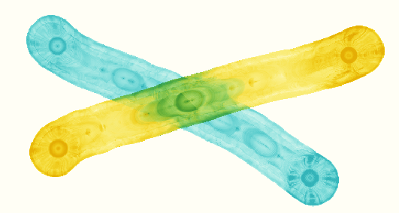
2. Strokes with 3 or 4 colors



1. Water stroke

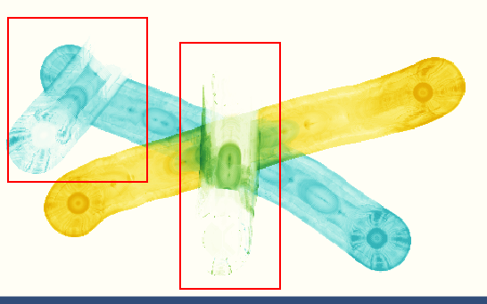

1. Watercolor painting produced by the application.

## 5.3 Evaluation