# Chapter 6 Result and Evaluation

In this chapter, we will present the parameters available for user configuration, and all rendering results. In addition, we will evaluate these results based on the specifications defined in Chapter 3.

The success of this project will be assessed based on the following four criteria:

1. Flexibility: The user should be able to configure rendering results.
2. Performance: The watercolor painting stroke rendered by the project should be in real time.
3. Characteristic: The watercolor stroke rendered by the project should contain the basic watercolor effects, including wet-on-dry, edge darkening, and color glazing.
4. User-specific conditions: Watercolor paint simulation should be examined under different conditions. While painting, painting parameters, including the color of the pigment on the brush, the amount of pigment on the brush, and the size of brush, will affect the rendering result. In addition, the properties of paper, and environmental conditions, such as evaporation rate, and water density, have influence on the simulation of watercolor patterns.

## 6.1 Results

The outcomes based on a comparison of user-controlled parameters, such as brush parameters, paper simulation parameters, and watercolor simulation parameters, will be shown first. Additionally, many watercolor patterns will be showcased and contrasted with watercolor patterns observed in the actual world.

### 6.1.1 Brush Parameters

The user can customize the brush's size, color, amount, and other properties in a digital painting application by selecting from a variety of brush options. The parameters in the application that the user can change to acquire the desired brush settings are shown in Figure 5.1.1.1. The **“Water Brush”** toggle switches between a water-only and pigment-carrying brush. The color of the paint carried by the brush can be changed by modifying the **“Brush Color”** option. 12 colors are available for selection in this application. The brush stroke size is controlled by the **“Brush Size”** setting. The size of the brush represents the radius of the brush because the brush has a circular form. To regulate the amount of pigment applied to the canvas pixel, **“Pigment Amount”** is employed. **“Pig Drop Rate”** (pigment drop rate) is used to hold the rate of paint drop per stroke since in reality, paint on the brush gradually transfers to the paper when it is applied to the canvas. Finally, **“Water Amount”** governs how much water is on the brush, which has an impact on how the pigments are distributed.

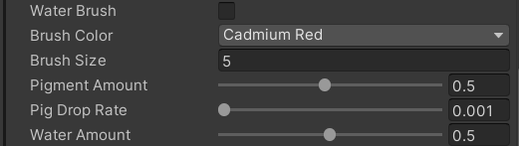

*Figure 6.1.1.1. Parameters that control brush settings.*

Figure 6.1.1.2 shows dots and strokes by different brush sizes. The rows from top to bottom display strokes drawn with the pixel width of canvas texture multiplied by 1, 5, 10, and 20 as the radius of brushes. The pixel width is formulated as 1.0 / (texture width), since the pixel position in the texture is located from 0 to 1 in the uv coordinates. The first column contains dots drawn by brush without water so that the actual size of brush can be shown. The second and third columns contain dots and line segments drawn by brush with 0.5 of water amount. Different brush sizes provide the user with the ability to paint different levels of watercolor. The size of the brush affects the amount of paint and water used in a stroke, because the larger the brush, the larger the area covered by paint and water, and the greater the spread of color.

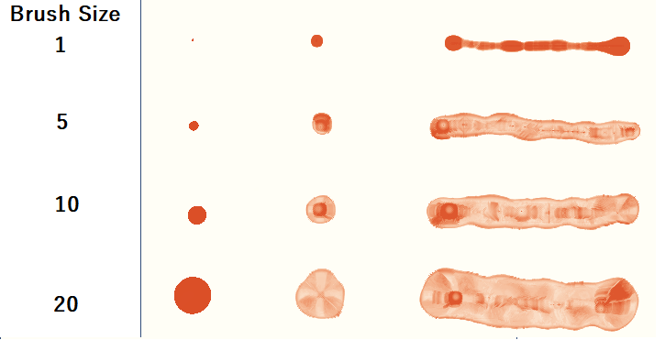

*Figure 6.1.1.2. Dots and strokes by different brush size*

Figure 6.1.1.3 shows strokes with different amounts of pigments on the brush. “Pigment Amount” is the parameter that changes in this experiment, which represents the amount of pigments received by a pixel of the canvas when the brush is drawn on the canvas. The value of “Pigment Amount” ranges from 0.05 to 1 unit, since the maximum amount of paint a pixel can receive is 1 unit. From top to bottoms, strokes were drawn with 0.05, 0.1, 0.5, and 1 unit of pigments. The amount of pigment affects the shade of a stroke. The shade of a stroke is a visual representation of how much pigment is gathered together. The stroke with 0.05 units of pigment transferred to each canvas pixel touched shows a lighter color than other strokes because the distribution of pigment in this stroke is more widely dispersed than in a stroke with more pigment for the same amount of water.

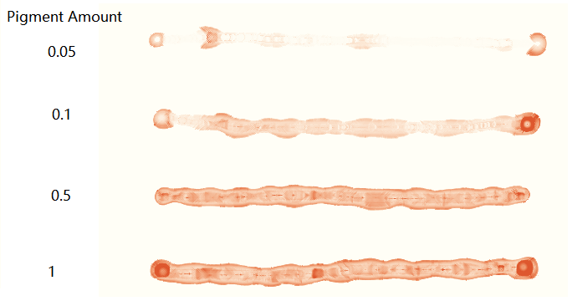

*Figure 6.1.1.3. Strokes with different amounts of pigments on a brush.*

Figure 6.1.1.5 illustrates the strokes with different amounts of water on the brush. From top to bottom, these strokes are drawn with 0.0001, 0.1, 0.5, and 1 unit of water. The "Water Amount" represents the volume of water each pixel receives when the brush comes in contact with the paper, and the maximum amount of water a pixel can hold is 1 unit. The amount of water on the brush affects the ability of the brush to spread and the time used to dry the brush. Group (a) in Figure 6.1.1.5 was taken while some parts of the brush were still wet. Strokes with 1 unit of water on the brush dries more slowly than other strokes with less water on the brush. Group (b) was taken after all strokes were dried. The brush with 0.1 units of water shows the most severe edge darkening effect because with less water, the edges of the brush dried faster and the pigment in that area could not flow to any other area, leading to pigment deposition. Compared to strokes with 0.5 units of water, strokes with 1 unit of water spread over a larger area because there is more water available for diffusion versus more time available for pigment flow.

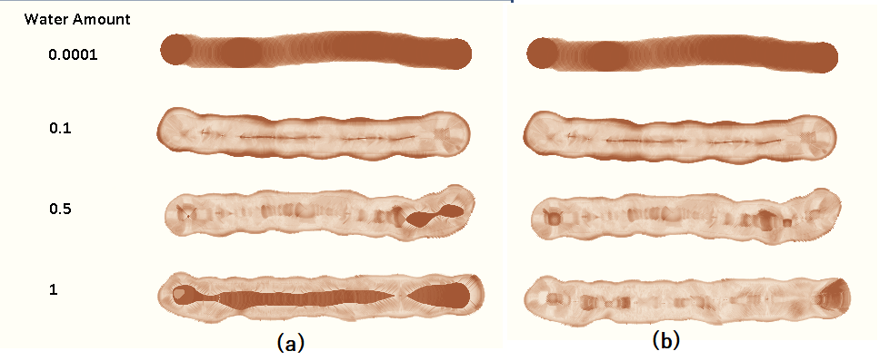

*Figure 6.1.1.5. Strokes with different amounts of water. Group (a) is taken while some parts of the stroke are still wet and group (b) is taken when all strokes are dried out.*