Xidian University
Chinese-American class
experiment report


Course name: Comprehensive Management of International Enterprises Experiment
classes : 223402
name: Liu Yiwen
Student ID: 22061300016
Group: MZSLL
Date of submission: 2025.4.18
Catalogue
I Letter to Shareholders 3
1. Company profile 3
2.Company mission 4
3.Company business overview 4
4.Company advantages and future development potential 5
II Corporate strategic planning 8
1.strategic objective 8
2.Company strategy decomposition 13
1. Financial strategy: 13
2. Marketing strategy: 14
Production strategy: 15
4．R&D strategy: 16
3.Target market strategy 18
Target market : 18
Secondary target market: 18
Alternative target markets: 18
III Financial performance review 20
1.Analysis of financial indicators 20
2.Analysis of itemized costs 23
3.Analysis of cumulative shareholder return rate 26
IV Discussion and analysis of operation management 30
1.Global market conditions 30
2.Product portfolio 35
3. Research and Development 38
4.Market share 42
5.Production decisions 50
V Analysis of competitors 55
VI Outlook for business prospects 60
VII Simulate learning outcomes and suggestions for course teaching 61
1.Simulating learning outcomes (building the body of knowledge required for simulation and analysing one's own situation) 61
2.Teaching Recommendations of this course 61

I Letter to Shareholders
- Company profile
As a leading global automotive manufacturer, our company is committed to an innovation-driven development strategy. We continuously work in the fields of hybrid, electric, and hydrogen energy technologies, with the goal of becoming an industry leader. Our commitment extends beyond simply offering efficient and environmentally friendly automotive products. We are also dedicated to promoting the development of green mobility and intelligent transportation solutions through continuous technological research and development, as well as expanding our market presence globally.
Our company’s philosophy is rooted in the belief that the automotive industry must evolve to meet the growing demands for sustainability, energy efficiency, and environmental responsibility. To this end, we have placed significant focus on developing cutting-edge technologies that not only reduce emissions but also enhance the overall driving experience for our consumers. This forward-thinking approach allows us to stay ahead of the curve as the industry shifts towards cleaner and smarter mobility solutions. Our ongoing investment in innovation has led us to establish a firm presence in key global markets, with a commitment to long-term sustainability and continued growth.
We understand the immense responsibility that comes with being a key player in the automotive sector, and we are constantly working to balance business growth with environmental stewardship. Our success is a result of our ability to adapt to changing market conditions while maintaining a clear focus on the future of mobility.

2.Company mission
Our mission is to accelerate the green transformation of the global automotive industry through the development of innovative powertrains and sustainable production methods. We aim to provide consumers with high-quality, high-performance intelligent mobility solutions that are not only functional but also environmentally conscious. This mission reflects our dedication to promoting sustainable development for both society and the environment.
Our approach is centered around creating products that contribute to a greener, low-carbon future while offering superior performance and cutting-edge technology. This includes advancing electric vehicles, hybrid powertrains, and hydrogen fuel cell technology, which will play an essential role in reducing the global carbon footprint. Through these efforts, we are helping to drive the global transition to cleaner energy and paving the way for a more sustainable future for urban mobility.
We also strive to create innovative products that seamlessly integrate into smart cities and provide solutions for both urban and rural transportation needs. Our focus on intelligent mobility means that we are also working on autonomous driving systems, advanced safety technologies, and connectivity features that will enhance the driving experience for consumers while optimizing energy usage and reducing environmental impact.
Ultimately, we envision a future where our vehicles are integral to reducing global emissions, promoting energy transformation, and contributing to the development of more sustainable urban transport systems. We are committed to achieving these objectives while ensuring that our operations remain sustainable and that we continue to create value for our shareholders.
3.Company business overview
At present, our product portfolio covers hybrid, combustion engine, and electric vehicles. We have firmly established our market presence in several key regions across the globe, particularly in Europe and China, where we have achieved a significant market share. This success can be attributed to our outstanding technology, performance-driven products, and strong consumer demand for sustainable and innovative transportation solutions.
As technology continues to evolve, the production costs for electric vehicles are steadily decreasing, allowing us to further enhance our competitive edge in the market. Our R&D teams are focused on improving battery technology, energy efficiency, and vehicle performance to make electric vehicles more accessible to a wider consumer base. Additionally, hydrogen fuel technology, which has long been seen as a promising solution for the future of clean mobility, is now beginning to see breakthroughs that could revolutionize the automotive industry. We are actively involved in hydrogen technology development and aim to be a leader in this space as the global demand for hydrogen-powered vehicles continues to rise.
To support our global expansion strategy, we have significantly increased our investment in manufacturing facilities. This includes establishing state-of-the-art production plants in key markets such as China, where we are increasing our electric vehicle production capacity to meet the growing demand for clean energy vehicles. As part of our commitment to sustainability, these new facilities are designed with green technologies to minimize environmental impact while maximizing production efficiency.
Our global presence also extends to the development of strategic partnerships and collaborations with key industry players, governments, and research institutions. These partnerships enable us to share knowledge, leverage the latest technological advancements, and drive innovation across our product lines. We believe that a collaborative approach will be essential in driving the transformation of the automotive industry and accelerating the adoption of sustainable transportation solutions.
In addition to our product development and manufacturing strategies, we are vigorously promoting our Environmental, Social, and Governance (ESG) strategy to ensure that we remain at the forefront of sustainable development in the automotive industry. ESG principles are integrated into every aspect of our business, from how we design and manufacture our vehicles to how we interact with our employees, suppliers, and communities.
MZSLL ESG strategy is particularly prominent in the European market, where our commitment to green product development, energy efficiency, and sustainable manufacturing practices has helped us grow our brand influence. In this region, we have successfully aligned our business goals with the continent’s environmental regulations and sustainability targets, positioning ourselves as a leader in the green mobility space.
We continue to invest in advanced manufacturing technologies, such as electric vehicle production lines, smart factory automation, and sustainable supply chain practices. These investments are designed not only to reduce our environmental footprint but also to improve operational efficiency and reduce costs in the long term.
MZSLL’s commitment to ESG principles also extends to our social and governance practices. We are dedicated to promoting diversity and inclusion within our workforce, ensuring fair labor practices, and maintaining transparency in our corporate governance. We strive to create a positive impact on society by supporting local communities, promoting clean energy initiatives, and reducing our environmental footprint.
Looking ahead, we will continue to invest in technological innovation, expand our production capacity, and strengthen our commitment to sustainability. We are confident that, by focusing on these core pillars, we will remain a leader in the automotive industry and continue to provide value to our shareholders while contributing to the transition towards a more sustainable and low-carbon global economy.
4.Company advantages and future development potential
1. Leading Technological Research and Development Capabilities
We have a strong research and development (R&D) team specializing in hybrid, electric, and hydrogen energy technologies, and we maintain close cooperation with world-renowned research institutes. This collaboration enables us to continuously innovate and refine our technologies, ensuring that we stay at the forefront of the automotive industry. Through our ongoing technological advancements, we not only improve the performance of our products but also reduce production costs, allowing us to maintain a leading technological position in the global market. Our R&D efforts focus on optimizing battery technology, improving energy efficiency, and advancing hydrogen fuel cell systems, all of which contribute to our ability to offer cutting-edge, sustainable solutions for our customers.
2. Globalisation
Our strategic expansion into major global markets such as Europe, China, and the United States is progressing steadily. By combining self-built manufacturing plants with outsourced production, we have developed a flexible production model that enhances production efficiency and effectively reduces costs. This flexible approach allows us to meet the growing demand for sustainable transportation while optimizing our supply chain. In the Chinese market, our electric vehicle products have received a warm reception from consumers, demonstrating significant market potential. The growing interest in electric vehicles, along with favorable government policies and investments, positions China as a key market for our continued expansion. Similarly, in Europe and the U.S., we are making significant strides in establishing a strong presence in the clean energy sector, further solidifying our global footprint.
3. Solid ESG Strategy
We firmly believe in the importance of corporate social responsibility and are dedicated to improving our environmental, social, and governance (ESG) performance. Our commitment to ESG principles is an integral part of our strategy, ensuring that we not only focus on profitability but also take into account the long-term impact of our operations on the environment and society. In the European market, our ESG strategy has received widespread recognition, with our strong environmental management practices and transparent corporate governance earning us the trust and loyalty of consumers. By continuously working to improve our environmental footprint, social engagement, and governance standards, we are building a brand that consumers trust and respect, which in turn strengthens our position in the market.
4. Strong Brand Effect
In the early stages of our development, we made significant investments in advertising and marketing, successfully establishing a high-end brand image. This strategic approach has laid a solid foundation for the future market penetration of our products. As our brand continues to grow and gain recognition, we anticipate further market share expansion and increased customer loyalty. The brand’s strong association with quality, innovation, and sustainability will be key to driving customer retention and attracting new consumers, particularly in the highly competitive global automotive market. By continuing to strengthen our brand presence, we will remain a leading force in the industry and capitalize on emerging trends in sustainable transportation.
5. Future Development Potential
Looking ahead, we are committed to continuing our investment in the research and development of electric vehicles and hydrogen energy technology, particularly in key markets such as China and the United States. These regions are crucial to the global transformation of the energy landscape, and we are well-positioned to play a leading role in this shift. Our ongoing R&D efforts will focus on enhancing the efficiency and performance of our electric vehicles while exploring new applications for hydrogen energy. Additionally, we are vigorously promoting automation and intelligence in our production processes to further enhance capacity and production efficiency. By integrating advanced manufacturing technologies, we will continue to improve product quality, reduce production costs, and accelerate time-to-market for new innovations.
At the same time, as consumer demand for environmentally friendly and sustainable products increases, we will continue to strengthen our ESG strategy. Our ongoing commitment to ESG principles will not only enhance our brand value but also ensure that we remain competitive in an increasingly eco-conscious market. By maintaining a strong focus on sustainability, we are not only meeting the demands of today’s consumers but also preparing for the future of mobility.
In conclusion, we are confident that our continued investments in technology, market expansion, ESG practices, and brand development will propel us to even greater heights. With a clear vision and commitment to sustainability, we are well-positioned to lead the automotive industry in the transition to a greener, smarter, and more sustainable future.

II Corporate strategic planning
1.strategic objective
The company's short-term strategy (round 1-4):
(I) Strategic Objectives
During the initial stages of the company's development (Rounds 1-4), the short-term strategic objectives of MZSLL primarily focus on three areas: market expansion and brand building, production capacity enhancement and supply chain optimization, and financial stability and risk control.
1.1Market Expansion and Brand Building:
Capitalize on the increased market demand driven by economic recovery, particularly the significant growth in the Chinese market, to rapidly open up the market and enhance the company's visibility. Invest heavily in advertising, which will have a cumulative effect on future product sales, build brand equity, and attract high-stickiness customers.
In response to the high level of ESG focus in the European market, actively cooperate to improve ESG standards to enhance brand image and market competitiveness.
1.2Production Capacity Enhancement and Supply Chain Optimization:
Construct new factories in Asia, especially in the Chinese market, to increase production capacity and meet market demand. At the same time, adopt a self-production strategy to ensure product quality and supply stability.
Focus on technological costs. While electric technology costs are high, hybrid technology is relatively mature and can be promoted as the main production technology.
1.3Financial Stability and Risk Control:
Under relatively stable financial conditions, manage funds reasonably to ensure financial stability. Utilize the advantage of abundant funds to repay long-term loans in advance and reduce interest expenses.
Pay attention to market changes, such as news events that may affect US outsourcing, and adjust strategies promptly to reduce potential risks.
(II) Decision-making Analysis:
Round 1: In the context of economic recovery and rising market demand, the company decided to open up the market and enhance its visibility. Cooperate with the European market to improve ESG standards, while constructing new factories in Asia to increase production capacity.
Round 2: In response to unchanged US growth, slowing European growth, and accelerating Chinese growth, the company continued to build new factories, increase production capacity, and raise prices across the board to achieve high profits. At the same time, it conducted share repurchases to increase the return on equity for shareholders.
Round 3: Facing the situation of decreasing marketing returns but increasing hybrid market, the company decided to increase promotion investment, strengthen brand equity, and stop investing in factories, shifting focus to continuous ESG investment and hybrid fuel production.
Round 4: In the context of continuously decreasing marketing returns and peak European demand, the company basically followed the strategy of the previous round, while repaying long-term loans to reduce interest expenses and transferring internal manufacturing capacity mainly to China, cutting the number of US factories.
(III) Implementation Effects:
Through the implementation of short-term strategies, the company successfully opened up the market, enhanced its visibility, and established stable production capacity in the Asian market. At the same time, it maintained financial stability, controlled risks appropriately, had no short-term loans, and laid a solid foundation for the company's medium and long-term development.
The company's mid-term strategy (round 5-8 ):
(II) Decision-making Analysis:
Round 1: In the context of economic recovery and rising market demand, the company decided to open up the market and enhance its visibility. Cooperate with the European market to improve ESG standards, while constructing new factories in Asia to increase production capacity.
Round 2: In response to unchanged US growth, slowing European growth, and accelerating Chinese growth, the company continued to build new factories, increase production capacity, and raise prices across the board to achieve high profits. At the same time, it conducted share repurchases to increase the return on equity for shareholders.
Round 3: Facing the situation of decreasing marketing returns but increasing hybrid market, the company decided to increase promotion investment, strengthen brand equity, and stop investing in factories, shifting focus to continuous ESG investment and hybrid fuel production.
Round 4: In the context of continuously decreasing marketing returns and peak European demand, the company basically followed the strategy of the previous round, while repaying long-term loans to reduce interest expenses and transferring internal manufacturing capacity mainly to China, cutting the number of US factories.
(III) Implementation Effects:
Through the implementation of short-term strategies, the company successfully opened up the market, enhanced its visibility, and established stable production capacity in the Asian market. At the same time, it maintained financial stability, controlled risks appropriately, had no short-term loans, and laid a solid foundation for the company's medium and long-term development.
The company's long-term strategy (round 9-12 ):
(I) Strategic Objectives:
In the long-term stage (Rounds 9-12), the company's strategic objectives focus on three areas: market transformation and technological innovation, global layout and supply chain optimization, and sustainable development and brand building.
1.1Market Transformation and Technological Innovation:
Increase outsourcing of electric technology to reduce production costs and improve market response speed. At the same time, continue to research and develop new features of electric technology and new hydrogen energy technologies to enhance the company's technological level and product competitiveness.
In response to the background of rising Chinese market demand for electric technology, the company decided to cut the number of Chinese factories and optimize the global production layout.
1.2Global Layout and Supply Chain Optimization:
Pay attention to changes in global market demand, especially the trends of declining European market demand and increasing US market interest in hydrogen energy technology. Optimize the global supply chain layout through outsourcing production and other methods to improve market response speed.
At the same time, pay attention to changes in transportation costs, tariff policies, etc., and adjust supply chain strategies promptly to reduce potential risks.
1.3Sustainable Development and Brand Building:
In the context of declining global ESG focus, the company continues to adhere to sustainable development strategies and improve ESG standards. Enhance brand image and market competitiveness by fulfilling social responsibilities, complying with relevant regulations, etc.
At the same time, pay attention to changes in consumer environmental awareness and launch products and services that meet environmental protection requirements to meet market demand.
(II) Decision-making Analysis:
Round 9: Facing the background of rising Chinese electric demand and infrastructure expansion, the company decided to increase electric outsourcing, cut Chinese factories, repurchase shares, and reduce electric product prices to increase sales.
Round 10: In the context of a significant drop in overall EU demand and China's retreat in hydrogen technology, the company decided to increase electric outsourcing, cut Chinese factories, repurchase shares, reduce electric product prices to increase sales, and start researching and developing new features of electric power and new hydrogen power technologies.
Round 11: In response to the background of function frenzy stabilizing to a more reasonable level and the continuous decline of internal combustion engines and hybrids, the company decided to comprehensively reduce prices to gain competitiveness, reduce promotion investment, cut Chinese factories, issue dividends, and continue to research and develop new features of electric power and new hydrogen power technologies.
Round 12: In the context of European demand recovery and a stable financial environment, the company decided to follow the previous round and not consider selling hydrogen energy vehicles.
(III) Implementation Effects:
Through the implementation of long-term strategies, the company successfully achieved breakthroughs in market transformation and technological innovation, optimized global production layout and supply chain strategies. At the same time, it adhered to sustainable development strategies and improved brand image and market competitiveness. Ultimately, the company achieved remarkable results in the global market and realized its long-term development goals.
The relationship between the company's short, medium and long term strategies:
The company's short-term, medium-term, and long-term strategies are closely logically connected and mutually influential.
(I)The short-term strategy lays the foundation for the medium-term strategy.
Through measures such as market expansion, production capacity enhancement, and financial stability, it provides support for technological upgrading, market adjustment, and financial optimization in the medium-term strategy.
1.1Market expansion and brand building in the short-term strategy provide market demand support for technological upgrading and product development in the medium-term strategy.
1.2Production capacity enhancement and supply chain optimization in the short-term strategy provide production guarantees for market adjustment and structural optimization in the medium-term strategy.
1.3Financial stability and risk control in the short-term strategy provide a financial foundation for financial optimization and capital operation in the medium-term strategy.
(II) The medium-term strategy further deepens on the basis of the short-term strategy.
Through measures such as technological upgrading, market adjustment, and financial optimization, it provides direction for market transformation, technological innovation, and sustainable development in the long-term strategy.
2.1Technological upgrading and product development in the medium-term strategy provide technological support for market transformation and technological innovation in the long-term strategy.
2.2Market adjustment and structural optimization in the medium-term strategy provide a market foundation for global layout and supply chain optimization in the long-term strategy.
2.3Financial optimization and capital operation in the medium-term strategy provide financial guarantees for sustainable development and brand building in the long-term strategy.
(III) The long-term strategy is the continuation and sublimation of short-term and medium-term strategies.
Through measures such as market transformation, technological innovation, and sustainable development, it realizes the company's long-term development goals.
3.1Market transformation and technological innovation in the long-term strategy are the concentrated embodiment of the results of short-term and medium-term strategies.
3.2Global layout and supply chain optimization in the long-term strategy are the deepening and expansion of short-term and medium-term strategic measures.
3.3Sustainable development and brand building in the long-term strategy are the ultimate sublimation of short-term and medium-term strategic objectives.
2.Company strategy decomposition

1. Financial strategy:
Strategic Core Positioning:
Focus on enhancing Return on Equity (ROE) as the core objective, achieving capital appreciation and controllable risks through dynamic capital management.
Phased Implementation Path:
1.1Early Capital Accumulation Phase (Rounds 1-5)：
Adopt aggressive investment strategy: Utilize abundant cash flow for factory expansion, technology introduction, and brand promotion to form economies of scale. Directly increase shareholder equity ratio through share repurchases.
Debt management: Prepay long-term loans to reduce interest expenses and optimize financial structure.
1.2Strategic Transformation Phase (Rounds 6-10)：
Shift technology investment: Allocate R&D funds to electric technology and independently develop new electric functions. Implement outsourcing production model to reduce transformation risks.
Capacity optimization: Reduce idle production capacity in Chinese factories, convert fixed costs into variable costs, and improve financial flexibility.
1.3Value Realization Phase (Rounds 11-12)：
Maximize capital returns: Increase market share through comprehensive product price reductions, coupled with dividend distributions to create stock price catalytic effects.
Liquidity management: Maintain strategic reserves to address potential market risks and preserve financial safety margins.
Key Decision-Making Logic:
ROE Tripartite Balance: Achieve ROE improvement through three-dimensional linkage of net profit margin, asset turnover rate, and equity multiplier (ROE = Net Profit Margin × Asset Turnover Rate × Equity Multiplier).
Option Thinking Application: Implement phased investment method in electric technology investment, setting technological breakthroughs as subsequent investment trigger conditions (locking in future opportunities with smaller initial investments while controlling risks).
- Marketing strategy:
Strategic Core Positioning:
Construct a dual-wheel drive model of brand premium and market share to maximize customer lifetime value.
Hierarchical Implementation Strategy:
2.1Brand Building Period (Rounds 1-3)：
High-profile strategy: Heavily invest in advertising budgets, focusing on European and Chinese markets to establish "technology leadership" perception.
Pricing strategy: Adopt skimming pricing method to form a high-end brand image.
2.2Market Expansion Period (Rounds 4-7)：
Precision advertising placement: Tilt advertising budgets toward the Chinese market, leveraging tariff reduction policies to achieve sales breakthroughs.
2.3Value Deepening Period (Rounds 8-12)：
Value marketing transformation: Reduce promotion investments and achieve organic growth through product word-of-mouth dissemination.
Key Decision-Making Logic:
Brand Equity Securitization: Convert accumulated brand value into pricing power.
Market Cycle Matching: Pre-judge market demand inflection points and initiate emerging market layouts in advance.

Production strategy:
Strategic Core Positioning:
Establish a global supply chain response system to achieve dynamic alignment between production capacity and demand.
Analysis Methodology:
Our team (MZSLL) developed a multiple linear regression model based on three rounds of practice data to quantify the impact of key variables on sales volume. This enables precise demand forecasting and provides robust data support for production and investment decisions.
3. Capacity Layout Evolution:
3.1Regional Concentration Phase (Rounds 1-5)：
Asia-centric Strategy: Aggressively construct new factories in China to leverage cost advantages for large-scale production.
Flexible Manufacturing Retrofit: Invest in modular production lines to shorten line adjustment time.
3.2Global Optimization Phase (Rounds 6-9)：
Capacity Relocation: Strategically reduce China's capacity share to mitigate trade risks.
Outsourcing Synergy: Activate outsourcing during demand fluctuations.
3.3Lean Management Phase (Rounds 10-12)：
Zero-Inventory Management: Enhance inventory turnover through demand forecasting.
Carbon Footprint Integration: Link ESG investments with capacity planning to reduce carbon emissions per unit output.
Key Decision Logic:
Capacity Option Mechanism: Maintain redundant capacity as a strategic buffer against demand growth. Gradually reduce excess capacity in later stages to cut costs and risks.
Life-Cycle Costing: Adopt full life-cycle cost calculations in factory investment decisions.

4．R&D strategy:
Core Strategic Positioning:
The core of MZSLL's R&D strategy is positioned to establish a dual innovation mechanism that integrates technological leadership with cost controllability, aiming to cultivate generational technological advantages. This positioning closely aligns with the company's overall business development strategy, ensuring R&D activities not only generate stable market returns but also maintain flexibility in responding to evolving market demands. Through effective integration of external collaborations and internal independent R&D, the company rapidly elevates its technological capabilities to secure market leadership positions while strictly controlling R&D costs to maximize the efficiency of every investment.
Technological Evolution Pathway:
4.1 Independent Breakthrough Phase (Rounds 1-5):
During the initial phase, MZSLL concentrates resources on independent R&D of combustion technologies. Through significant investments and external partnerships, the company rapidly enhances its technological capabilities to establish a relatively leading market position. While maintaining steady autonomous R&D efforts, the company proactively manages R&D timelines to align technological outcomes with market strategies. However, in the medium term, to align with fuel price reductions and electric transition strategies, new feature developments for fuel-powered vehicles are discontinued.
4.2 Open Innovation Phase (Rounds 6-9):
Entering the open innovation phase, MZSLL begins adjusting its R&D focus. While combustion technology R&D remains stable, hybrid power technologies emerge as new R&D directions. For hybrid technologies, due to initial resource allocation prioritizing combustion technology R&D, progress was relatively slow. Subsequently, through continuous autonomous investments, the company achieves hybrid technology feature levels slightly above market averages. During this phase, the company emphasizes market interactions and leverages external resources and technologies to accelerate innovation. However, starting from Round 6, in preparation for corporate transformation and low-price strategy requirements, hybrid vehicles are no longer prioritized in R&D efforts.
4.3 Ecosystem Construction Phase (Rounds 10-12):
In the ecosystem construction phase, MZSLL fully shifts its R&D focus to electric technologies. Due to concentrated electric technology R&D efforts since the medium term, the company enters the market with feature accumulation slightly above market levels. Over the subsequent three rounds, the company allocates all personnel to autonomous R&D in this technology, continuously increasing feature quantities. As market demands shift and corporate strategies adjust, electric technology becomes critical to the company's future competitiveness. The company fully commits to autonomous R&D in electric technologies, continuously increasing feature quantities to cultivate generational technological advantages in the electric technology domain.
Key Decision-Making Logic:
MZSLL's R&D decisions consistently revolve around the company's overall strategy and market changes. Firstly, the company emphasizes alignment with overall business development strategies to ensure R&D activities deliver tangible benefits. Secondly, the company proactively manages R&D timelines by analyzing market technological features and competitors' R&D activities to determine appropriate pacing, ensuring targeted and effective R&D efforts. Furthermore, the company demonstrates flexibility in adjusting R&D priorities based on market shifts and strategic needs, such as timely cessation of new combustion technology features to reallocate resources to electric technologies. The company exhibits high flexibility in R&D resource allocation, ensuring future market competitiveness through optimized resource configuration.
In summary, MZSLL's R&D activities align with the company's overall business development strategy, fundamentally meeting evolving R&D demands and maintaining relatively stable return rates.
3.Target market strategy

Target market :
Hybrid Electric Vehicle (HEV) Market (Rounds 1-12):
Our company will maintain a steadfast focus on hybrid electric vehicle technology throughout Rounds 1 to 12, with continuous sales of HEVs in European, Chinese, and U.S. markets. Hybrid technology remains our core strategic pillar. Sustained sales across major markets will enable gradual market share penetration, enhance brand recognition, and further solidify our competitive positioning in the automotive sector.

Secondary target market:
Conventional Internal Combustion Engine (ICE) Vehicle Market (Rounds 1-7):
During Rounds 1-7, while prioritizing HEVs, we will concurrently distribute ICE vehicles in Europe, China, and the U.S. Our existing significant market share in ICE vehicles ensures stable profit contributions. Consistent ICE sales preserve our competitiveness in traditional markets while generating capital and resources for future new energy transitions.
New Energy Vehicle (NEV) Market (Rounds 8-12):
Beginning in Round 8, we initiate a strategic pivot toward NEVs. Focusing on hybrid and battery electric vehicle (BEV) offerings, we target European and Chinese markets where NEV adoption rates and policy support are robust. Through innovative product development and R&D investments, we aim to capture growing NEV market shares.

Alternative target markets:
Hydrogen Fuel Cell Technology Development (Rounds 10-12):
Though hydrogen fuel cell R&D commences in Round 10, commercial production remains a high-risk proposition. During this phase, we intensify technical research to assess market potential and prepare for future expansion. Upon technological maturation, we plan to launch hydrogen-powered vehicle production and sales in the U.S. market.

III Financial performance review
1.Analysis of financial indicators
1.1 Asset Structure and Its Link to Strategy
During the 12-round simulation, our asset structure changed in response to our strategic decisions. Here we focus on fixed assets, inventory, and cash, and explain how these shifts supported—or sometimes limited—our operations and transformation.
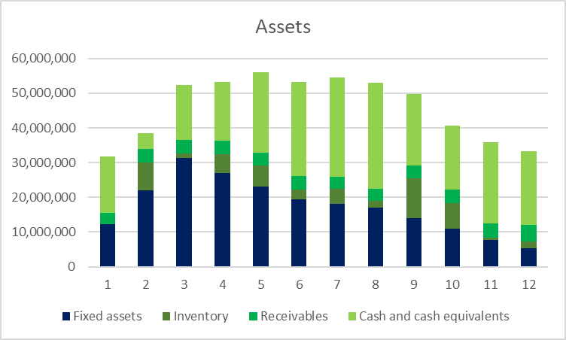
1.1.1 Fixed Assets
In rounds 1 to 3, we followed a “build first, expand fast” strategy. We invested heavily in factories, especially in China, and our fixed assets quickly grew from about $12 million to over $31 million. At that stage, we preferred building our own capacity instead of outsourcing to maintain control and lower long-term costs.
In rounds 4 to 7, as production capacity became sufficient, we started closing underused factories in the U.S. and focused on China. Fixed assets slightly decreased, showing we were managing cost and capacity more carefully.
Starting in round 8, we shifted to electric vehicles. Since EV production was mostly outsourced, and hybrid sales dropped, our factories were underused. We began reducing our assets in China, and fixed assets declined significantly.
These changes show our move from expansion to optimization. While early investments supported growth, later they became a burden. The asset reduction helped lower costs but also made us more dependent on external suppliers.
1.1.2 Inventory
From round 1 to 7, our sales and production matched well. Inventory levels stayed low, meaning we avoided large stockpiles and unnecessary costs.
After round 8, we shifted to a mix of electric and hybrid products. EV demand didn’t grow as fast as expected, while production continued. Inventory started to build up, especially for EVs.
We reacted quickly with discounts and promotions to reduce stock. It worked, but also hurt our profit margins.
Summary: The inventory problem showed we overestimated new product demand. Our quick response helped, but it came at a cost. Better demand forecasting is needed for smoother product transitions.
1.1.3 Cash Flow
In rounds 1 to 3, cash dropped fast due to heavy investment in factories and R&D. We faced short-term pressure and used small short-term loans.
From round 4 to 7, cash flow improved as factory building slowed and sales increased. Operations became healthier.
In the later rounds, even though spending was reduced, our lower profits and slower growth in EV sales put pressure on cash again. We didn’t need more loans, but our ability to invest further became limited.
Overall Takeaway
Our asset decisions mostly matched our strategies: early investment supported growth, mid-stage optimization controlled costs, and later flexibility reduced risks. But we also faced problems like underused assets, excess inventory, and cash flow limits in the transition phase. To stay competitive long-term, we need not just flexibility, but better planning ahead of each major shift.

1.2 Capital Structure and Financing Overview
Throughout the simulation, we followed a cautious and stable financing strategy. Instead of relying on debt, we mainly used our profits to support expansion and transformation. In this section, we focus on three areas—equity, short-term debt, and long-term debt—and explain how they changed and what they meant for our business performance.
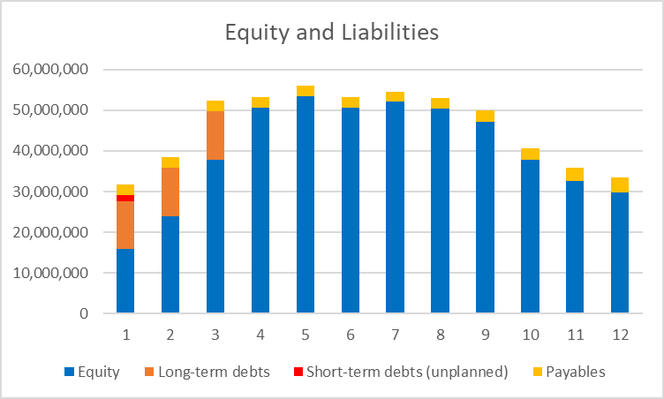
1.2.1 Equity
In the first 7 rounds, we kept generating profit and reinvested it back into the business. As a result, our equity kept increasing, and by round 7, shareholder equity accounted for over 90% of our total assets—a very solid capital structure. During this time, we paid off all long-term debt and operated with zero leverage. This “low debt, high equity” model gave us strong risk resistance and financial independence.
However, from round 8 onwards, our transition to electric vehicles led to lower profits and weaker hybrid sales. We also reduced factory assets, which slightly reduced our equity and reflected the pressure on our capital base during this adjustment period.
Summary: We built a strong equity base early on, but the pressure from lower profits in the transition phase made it hard to keep growing. If we want to expand in the future, we may need to find new profit sources or more flexible ways to manage capital.
1.2.2 Short-term Debt
We only used a small amount of short-term debt in rounds 1–2, mostly to support factory construction and early operations in China. From round 3 onward, we didn’t take on any new short-term loans, and we had no urgent need for cash, which shows that our internal cash flow was strong enough to support operations. This also means we had good planning and didn’t face liquidity problems.
Summary: Our short-term debt stayed very low, and we managed our working capital well. This helped us stay financially stable even during large investments.
1.2.3 Long-term Debt
In rounds 1–3, we borrowed around $11.9 million in long-term debt to help fund our factory expansion and early market entry.
By round 4, with profits and cash improving, we paid off the entire loan at once, which helped us save interest costs and reduce risk. This also increased our equity ratio and improved our capital structure, which later supported our stock performance and shareholder return.
Summary: We used long-term debt carefully, at a time when we really needed it, and then exited quickly. This reduced our financial burden and made our structure more efficient.
Overall Takeaway
Our capital structure stayed healthy, low-risk, and flexible throughout the simulation. We used a mix of early profits and limited borrowing to fund expansion. Even during the later transition period, we didn’t take on new debt, which shows that our finances were well under control. Looking forward, if we want to invest more in technology or expand globally, we may consider bringing in more funding—while still keeping a balance between efficiency and risk.
2.Analysis of itemized costs
Throughout the simulation, our cost structure changed along with production layout, product transitions, and market strategy. Below we analyze six major types of costs—variable cost, fixed cost, outsourcing cost, transportation & tariffs, R&D, and promotion—and explain how they changed across different phases and how these changes supported our strategy.
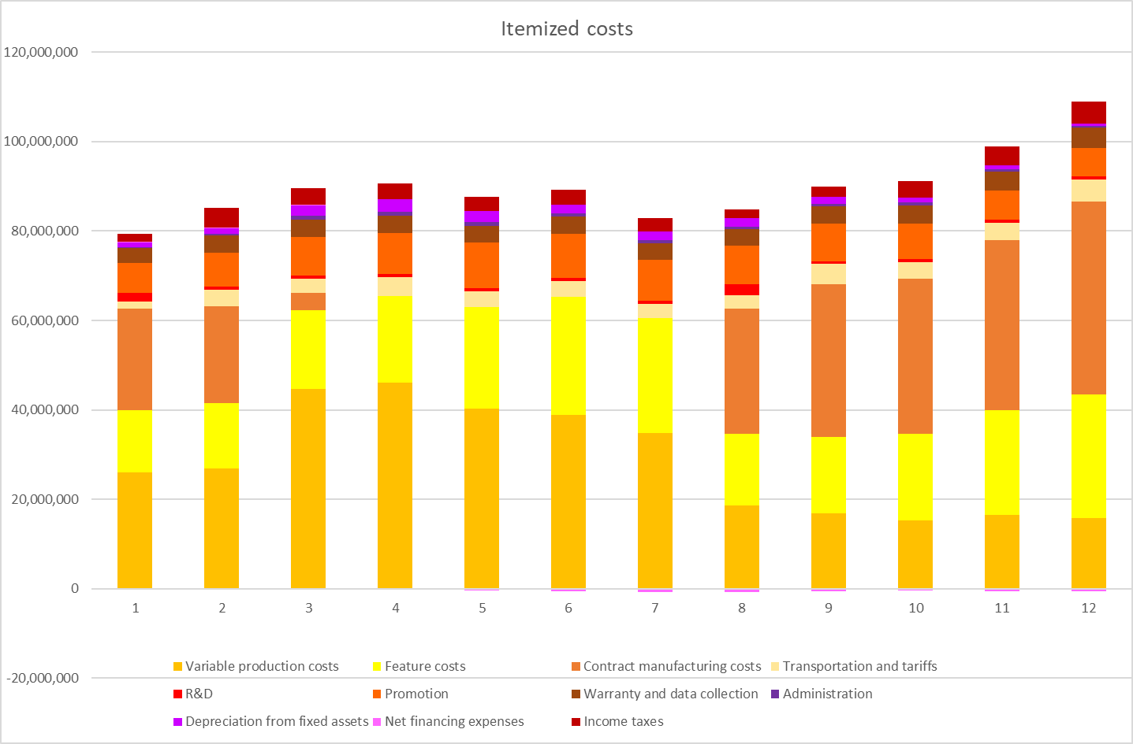
2.1 Variable Cost
In the early rounds, we focused on building up production in our China factories and gradually shifted from outsourcing to in-house production. At this stage, we mainly produced combustion and hybrid vehicles. As demand increased, we scaled up production, which led to a sharp rise in variable costs due to higher output. We saw this as a necessary cost, since higher capacity helped us lower per-unit fixed costs and build a stable supply chain. Although costly at first, it laid a solid foundation for our mid-term operations.
By round 4, our factory setup was nearly complete. Hybrid models became our core product, and with stable demand and improved efficiency, we were able to keep production steady without relying on outsourcing. As processes improved and waste was reduced, variable cost growth slowed, even though total spending remained high. This period showed that high in-house output helped us maintain cost control and reliable delivery.
After round 8, we entered the EV transition. Our own capacity couldn’t keep up with rising EV demand, so we started outsourcing again. At the same time, hybrid sales dropped and we began closing some factories in China, reducing our in-house production. As a result, variable costs declined round by round. This shift from full in-house to a mixed model helped ease spending pressure in the short term, but we also gave up some control over cost structure.
2.2 Fixed Cost
In rounds 1–3, we were in the middle of large-scale factory expansion in China. Equipment purchases and construction drove up depreciation costs quickly. We also increased admin spending to support growing operations, and continued investing in product features. All of this pushed fixed costs up fast—expected during rapid expansion, but it did add pressure later on.
During the mid-phase (rounds 4–7), our factory buildout ended. Although we made no new investments, we still had to cover high depreciation and management costs. Hybrid remained our main product line, and we maintained a high level of feature configuration. With all capacity in use, fixed costs stayed high and could not be reduced quickly.
After round 8, as we transitioned to EVs, we closed some underperforming factories to reduce unnecessary spending. However, we still invested in EV features and brand image, which made it hard to cut fixed costs. Some idle factories continued to generate depreciation, so fixed costs actually went back up after round 10.
2.3 Outsourcing Cost
In the first three rounds, since our factories weren’t fully built, we outsourced part of the production for combustion and hybrid models to meet demand. This helped us ensure delivery but came with high per-unit costs. Without scale, outsourcing was not the most cost-efficient option.
By round 4, our main lines in China were ready, and we switched entirely to in-house production. This gave us full control over cost and delivery. Outsourcing costs dropped to zero. While this simplified our cost structure, it also made us more dependent on fixed assets.
In round 8, we started launching EVs, but our own lines weren’t ready, so we returned to outsourcing. We built local outsourcing channels in China and the U.S. This helped us respond quickly to market needs, though the rising share of outsourcing also increased unit costs, becoming a major part of our cost in the transition.
2.4 Transportation and Tariff Cost
In rounds 1–7, we used a centralized production model—producing everything in China and exporting to overseas markets. This helped us manage production and lower unit costs, but also created high transportation and tariff expenses. The burden was especially heavy in Europe due to ESG and carbon tax policies.
In rounds 8–12, to handle delivery during the EV shift, we set up outsourced production in both China and the U.S., enabling localized delivery. This reduced long-distance shipping, and transportation and tariff costs dropped significantly. Though outsourcing coordination became more complex, this move clearly improved overall cost efficiency.
2.5 R&D Cost
During the first seven rounds, we kept R&D spending steady at about $670,000 per round, focused mainly on improving combustion and hybrid vehicles. While not a large amount, this regular investment helped keep our products competitive during the early and mid-phase.
In round 8, we transitioned to electric vehicles. To support the launch, we purchased five EV product features, leading to a sharp rise in R&D costs. Though this added short-term cost pressure, it was a key part of supporting the shift and improving product competitiveness.
In the final four rounds, we returned to normal R&D spending levels. Since core EV features were already in place, we didn’t need further large investments. R&D pressure eased, and spending stayed stable again.
2.6 Promotion Cost
In the first ten rounds, we were in the early stages of brand building and faced intense market competition. To increase brand awareness and open markets in multiple regions, we maintained high promotion spending across advertising, product launches, and distribution. Especially in China and Europe, our rivals entered the hybrid and EV markets earlier, so we had to act fast to win over customers. As a result, we kept raising our promotion budget and reached a peak of $10.2 million in round 10. Although this increased costs, it also gave us strong brand visibility and helped maintain market share during the transition phase.
From round 11 onward, our brand was already well-established, especially for hybrid models. As the market became more mature, the return on promotion investment started to decline. So we scaled down promotion spending and shifted focus to brand maintenance and customer retention. Despite lower spending, market response remained stable, showing that earlier promotion efforts had paid off and we could now manage the brand more efficiently.
Summary
Our cost structure changed clearly with our strategic phases: high investment and in-house focus during expansion, followed by outsourcing, selective promotion, and focused R&D during the EV transition. While cost pressure was significant in the middle, we managed to optimize in the later rounds, improving overall efficiency. This “stage-driven cost strategy” supported both our operations and long-term transformation goals.
3.Analysis of cumulative shareholder return rate
In this simulation, Total Shareholder Return (TSR) was one of the most important financial indicators, as it reflects the overall value created for shareholders and directly affects the final ranking. To better understand our TSR performance, we analyzed two closely related indicators: Return on Capital Employed (ROCE) and Return on Equity (ROE). Together, these help explain how well we used our capital and turned profits into shareholder value.
3.1 ROCE and ROE Trend Analysis
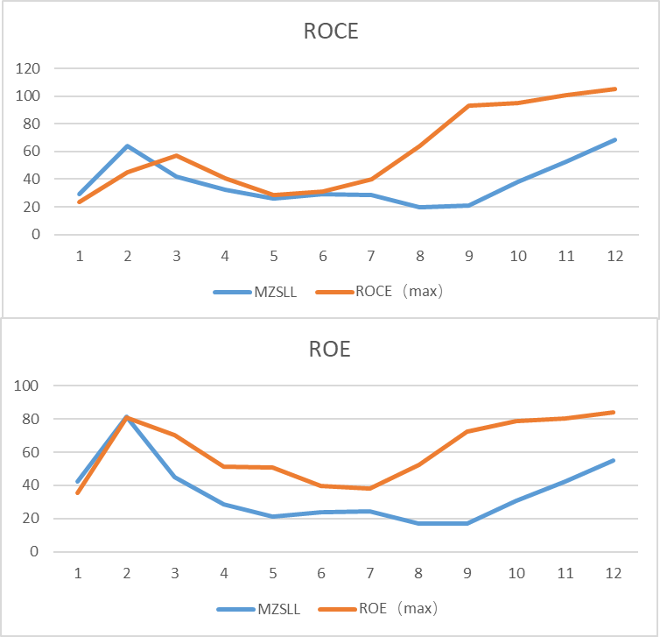
Rounds 1–2: Fast expansion brought high returns
At the start, we invested heavily in production and quickly launched products. This allowed us to grow revenue fast and use our capital efficiently. ROCE jumped from 29.2% to 63.8%, showing strong returns on investment. At the same time, ROE rose from 42.2% to 81.2%, partly because profits increased quickly and our equity base was still small. This was a great early result, driven by smart investment and strong market response.
Rounds 3–5: Growth slowed, capital became more stable
By this stage, most of our factory expansion was done. We paid off our long-term debt, and our equity share went above 90%. While this made our capital structure more stable, it also lowered ROE because the equity base grew faster than profit. ROE dropped to the 21%–45% range, and ROCE also fell to 26%–41%, as our new investments didn’t bring the same high return as before. Overall, our financial performance stayed healthy but started to slow down.
Rounds 6–9: Transition started, but efficiency dropped
As we began shifting to electric vehicles, our competitors moved faster and gained an early lead. Although we used outsourcing to support EV production, our profits declined, and unused factory capacity reduced ROCE to the 20%–30% range. ROE stayed around 17%–24%, as our capital structure remained low-debt but also less flexible. We were still profitable, but the return on our capital was clearly weaker.
Rounds 10–12: Operations improved, but not enough to lift returns
Later on, our sales improved and costs were better controlled. Both ROCE and ROE rose again, reaching 52.7% and 42.3% respectively. However, this improvement came too late to change market perception. The financial recovery didn’t fully turn into shareholder gains, which shows the gap between internal improvement and market reaction.
Summary: Our capital usage and return were strong in the early stages, but slowed during the transition. Although we saw some recovery in later rounds, the delay in strategic adjustment reduced our ability to turn profits into shareholder value.
3.2 TSR Trend and Why We Fell Behind
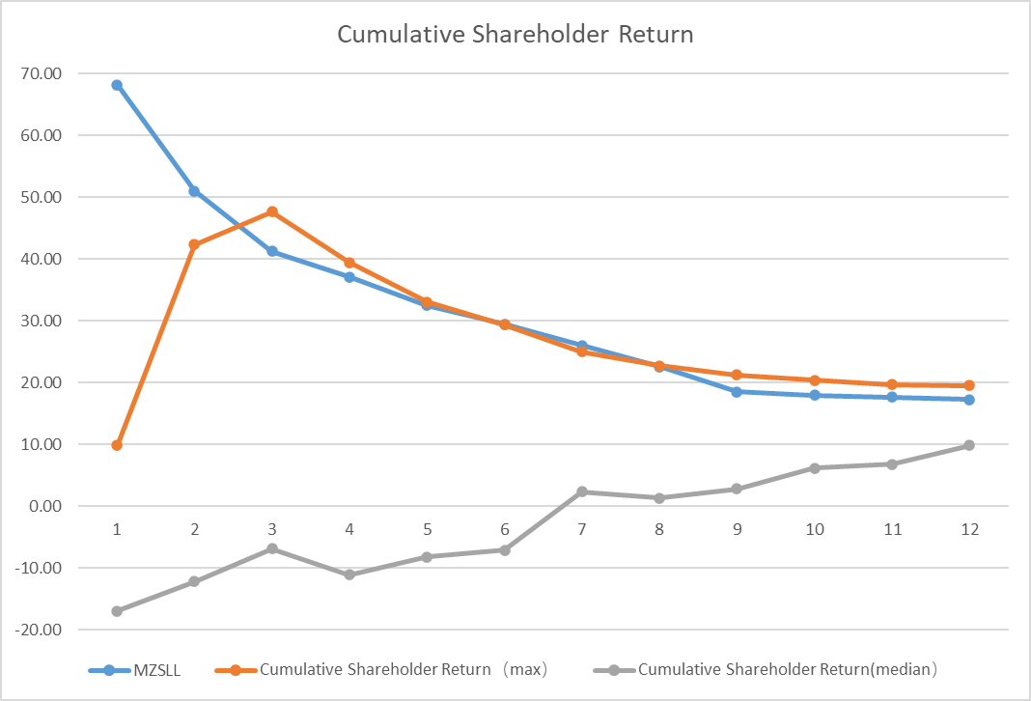
TSR shows how much value we created for shareholders through stock price and dividends. In this simulation, our TSR started strong but kept dropping as we moved through the rounds. Here’s how and why it changed.
Round 1: Strong start and market leadership
We launched quickly, priced products well, and matched capacity with demand. This gave us a TSR of 68.2%, the highest among all teams. Our business and financial results were well aligned, and market confidence was high.
Rounds 2–7: Rising competition, slow transition
While we stayed focused on hybrids, other teams like Goldman and Spider entered the electric and hydrogen markets early. They locked in growth opportunities while we hesitated. Our sales began to level off, and even though we kept spending heavily on promotion, the effect became weaker. Profits and expectations both dropped, and TSR fell to 32.4%.
Rounds 8–12: Missed timing and weak investor response
We finally launched electric vehicles in round 8, using outsourcing to catch up. But by then, competitors already had brand recognition and market share. In the U.S., we had completely stopped selling combustion cars, while others kept offering them and even added hydrogen models, giving them more stable revenue. Although we tried to support shareholder return through stock buybacks and dividends, weak profits and unclear market signals held back our stock price. By round 12, our TSR had dropped to 18.5%.
Summary: Our TSR went through a typical pattern—strong start, mid-game drop, and weak recovery. The main reasons were late action on product strategy, conservative market choices, and lack of strong financial signals to boost investor confidence. In future cases like this, we need to act earlier on technology trends, stay flexible in different markets, and make sure strategy and financial value move together.

IV Discussion and analysis of operation management
1.Global market conditions
1.1 Market Size Trends
During the simulation, the three main regional markets—Europe, China, and the United States—showed very different patterns of growth. These differences had a clear impact on how we allocated our resources and designed our product strategies. Below is a breakdown of each market’s capacity changes, the key reasons behind them, and how we responded.
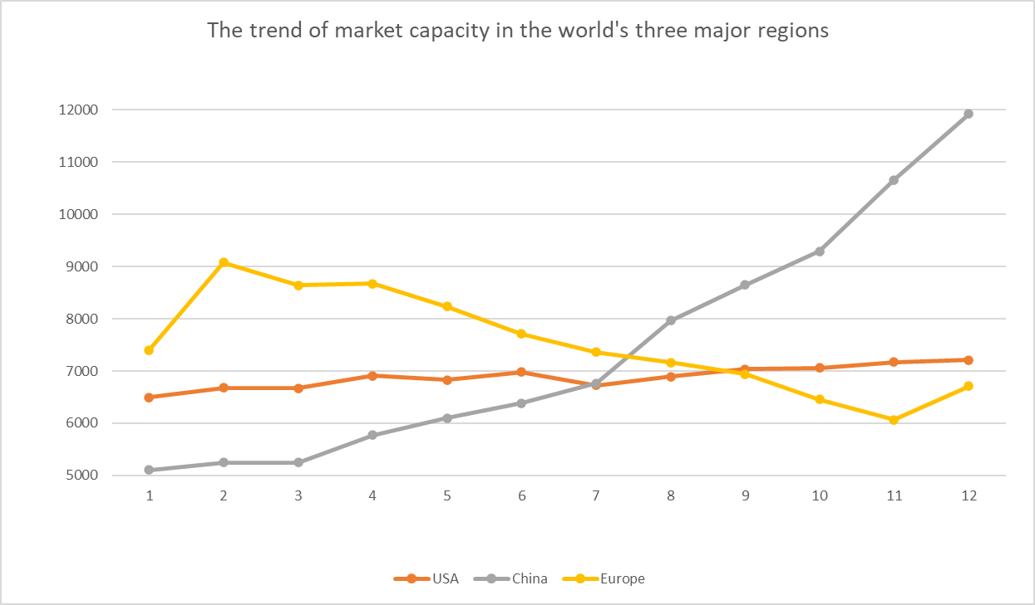
1.1.1 United States market
The U.S. market was the most stable of the three. From Round 1 to Round 12, its size grew slowly from 6,494 to 7,395 thousand units. Although it didn’t show strong growth, it remained reliable. There was a slight dip in the middle rounds, possibly due to economic factors like rising labor costs or interest rate changes. In later rounds, the market recovered slightly, helped by new trade deals and government support for hydrogen vehicles.
In terms of product preferences, U.S. consumers still preferred combustion and hybrid cars. EVs didn’t take off as quickly as in China. However, after Round 10, hydrogen vehicles started gaining attention, and one competitor (Spider) used hydrogen products to gain a clear advantage.
We, on the other hand, exited the combustion market in the U.S. too early and focused on EVs instead. But due to weak demand, this move didn’t bring good results. Looking ahead, the U.S. should be treated as a “profit support” market. We should keep offering stable, mature products and closely watch hydrogen policy changes. There may be a future opportunity to test hydrogen technologies here.
1.1.2 China market
In Round 1, China had the smallest market size at only 5,103 thousand units. But it quickly started growing, especially after Round 5. By Round 12, China’s market had jumped to 9,510 thousand units, surpassing Europe and becoming the largest in the simulation.
This rapid growth was likely driven by strong government support for electric vehicles and fast development of infrastructure. In response, we began shifting more of our production and market efforts to China. We built factories, optimized pricing, and adjusted product features to better match local preferences.
These moves helped us lower costs and improve delivery efficiency, giving us an advantage in the second half of the game. Going forward, China should remain a top priority, especially for EV strategy. We should continue developing EV products, strengthen our local supply chain, and stay flexible in adjusting to policy and consumer changes.
Summary
Each market showed a unique pattern: Europe started strong but slowed down; China grew quickly and became the main battleground; the U.S. remained stable but offered tech potential. Our early focus on Europe and later shift to China was mostly correct, but we missed some opportunities in the U.S. due to aggressive product changes. Moving forward, we should apply a more flexible, region-specific approach—invest where growth is strong, maintain where the market is stable, and explore where new tech may rise.
1️.1.3 Europe market
In the first few rounds (Rounds 1–4), Europe had the largest market size globally, reaching a peak of 9,081 thousand units. Because of this, we chose to focus our early strategy on Europe. We invested heavily in branding, ESG efforts, and high-feature product development to win over customers who care about sustainability and premium quality. This worked well at first—our sales and profits in Europe were strong in the early stage.
However, from Round 5 onward, the European market began to shrink, dropping to 6,685 thousand units by Round 11. This is a typical sign of a saturated market where demand slows down even as competition increases. In Round 12, there was a small rebound to 7,379 thousand units, which might be due to a 10% “hidden growth” suggested by the platform—possibly triggered by new policies supporting green consumption.
Although we reduced investment in Europe after Round 6, we still kept a strong presence. Looking back, our early focus on Europe was reasonable, but we could have shifted more resources earlier to faster-growing markets. In the future, Europe should remain important but shift from being our growth engine to a region for brand maintenance and stable returns.
1.2 Technology Distribution Trends
As the global automotive industry moves toward cleaner energy and sustainability, different markets are taking very different paths when it comes to powertrain technologies. Throughout the 12 rounds of simulation, we observed clear regional differences in how combustion, hybrid, electric, and hydrogen vehicles were adopted. This section looks at how each of the three major markets—the United States, China, and Europe—shifted their preferences, and how well our team’s product strategy matched those changes.
1.2.1 United State market
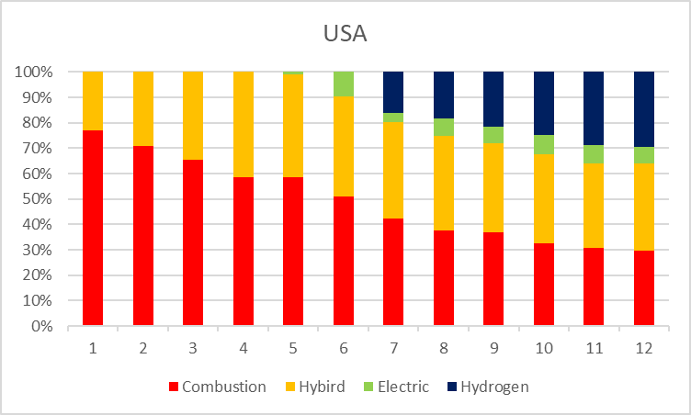
In the U.S., traditional fuel cars declined gradually over time but still held a noticeable share even in the final rounds. This shows that American consumers continued to favor familiar technologies, and the switch to alternatives was relatively slow. Because of this, our early decision to keep offering combustion cars was well-aligned with market demand and helped us maintain sales and profit.
Hybrid vehicles played an important transitional role. They grew quickly in the mid-game and then stabilized. We kept hybrids in our product line throughout, which matched the ongoing market need for in-between options.
Electric vehicles, on the other hand, struggled in the U.S. Even though the platform often highlighted EV advancements and global promotion, the EV market share in the U.S. stayed low and grew slowly. This matched the platform’s background information, which mentioned weak charging infrastructure and a national focus on hydrogen. Our team started offering EVs in Round 8, which was forward-looking, but didn’t fit the local demand at the time, so the results were disappointing.
What stood out most was the rise of hydrogen vehicles. Once introduced, they quickly gained market share and became a leading alternative in later rounds. This shift was clearly policy-driven, combined with the appeal of new tech. Unfortunately, we didn’t offer any hydrogen models, which meant we missed a major opportunity during this late-stage growth. Overall, our U.S. strategy leaned toward stability and tradition, but we reacted too slowly to new trends like hydrogen. For the future, we should pay more attention to emerging technologies and consider early-stage investment or testing.
1.2.2 China market
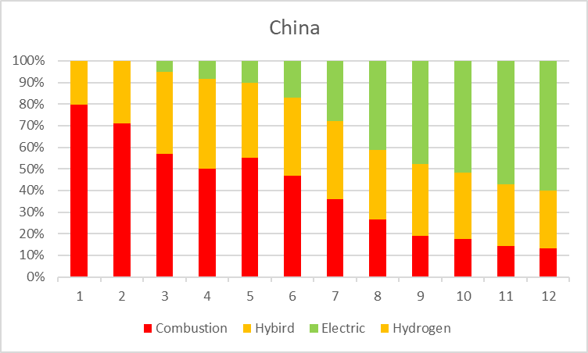
China went through one of the fastest energy transitions in the simulation. Starting from a fuel-based structure, the market quickly moved through a hybrid phase and into a strong dominance of electric vehicles. Combustion cars dropped off sharply after Round 5 and were nearly gone by the end. This shift reflected strong government policies, expanding infrastructure, and growing consumer demand for cleaner vehicles. We continued offering combustion vehicles early on, which was reasonable, but didn’t shift away from them quickly enough.
Hybrids helped bridge the gap in the early and mid-game. We kept investing in hybrids, which made sense at first. But as EVs took over, the hybrid market got squeezed, and their long-term role became limited.
EVs clearly became the star product in China. From the moment they entered the market, their share grew rapidly and soon made up more than half of total demand. This trend matched the platform’s descriptions of government support and strong charging infrastructure. However, our team only started offering EVs in Round 8, which was two or three rounds later than ideal. By that time, much of the early market share had already been taken by competitors.
In short, our strategy in China was generally steady and well-timed in the mid-game, but our EV rollout was delayed. Going forward, we should react earlier to clear policy signals and shift our product line before the market fully changes. Early action helps secure competitive advantages in fast-moving markets like China.
1.2.3 Europe market
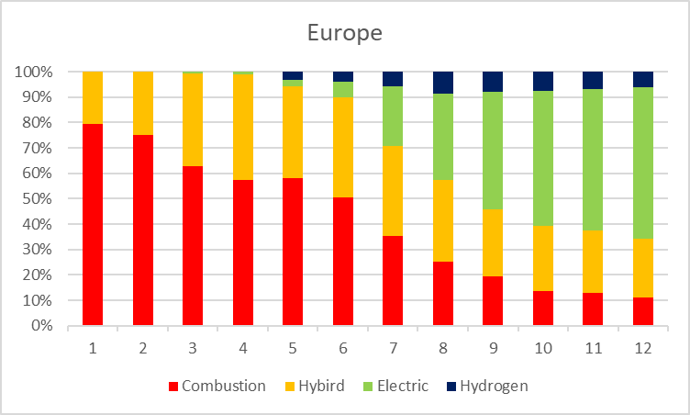
Europe was the first region to fully embrace green technology. Starting from Round 3, electric vehicles began growing rapidly, and by Round 6, they had become the market leader. EVs maintained over 50% of market share for the rest of the simulation. In contrast, combustion vehicles declined quickly and held only a very small share by the final rounds. Europe clearly moved away from fossil fuel cars earlier than any other region.
Hybrids played a mid-stage role. They saw some early growth but eventually lost space to EVs. Still, they remained a small but stable part of the product mix, showing that some consumers still preferred them as a more affordable or familiar option.
Our team continued offering combustion and hybrid models in Europe during the early rounds. This matched the market at the time but became a mismatch later on. We didn’t launch EVs until Round 8—two or three rounds behind the curve. Meanwhile, the platform had made it clear that Europe had raised carbon taxes and was offering strong green incentives. Our late entry into the EV space cost us a chance to lead in one of the most environmentally conscious markets.
Hydrogen vehicles did appear relatively early in Europe, but their growth stayed slow. Even by the end of the simulation, their market share was still small. This suggests the technology is still in testing stages, and current policy support is not yet enough to make hydrogen mainstream. Our choice not to invest in hydrogen for Europe seems reasonable under current conditions.
Overall, Europe was the first to show clear demand for electric vehicles. Our team responded too slowly, which made it hard to catch up later. In future markets with strict ESG goals and green-focused consumers, we should prepare electric or low-emission options early and move faster to take advantage of timing and policy support.
2.Product portfolio
As the global automotive industry enters a new phase focused on energy transformation and sustainable development, significant differences emerge in the evolution paths of traditional fuel, hybrid, electric, and hydrogen technologies across various regions. Each market’s characteristics are shaped not only by policy, infrastructure, and consumer preferences but also by technological developments and industry transformation trends. In this context, based on data from the 12 rounds of simulation platforms and the market background for each round, the following analysis focuses on the product mix trends in the three core markets—The U.S., China, and Europe—while evaluating the alignment with our team’s actual deployment strategy, highlighting areas for optimization.
I. U.S. Market: Slow Transition, Hydrogen “Late but Fast"
The U.S. market is characterized by a relatively slow transition, with consumers' reliance on traditional fuel cars and slow adoption of new technologies. The market’s distinct characteristics contribute to a different pattern of adoption for new energy vehicles compared to other regions.
- Combustion Vehicles: Fuel car market shows a continuous downward trend, but even in the last round, fuel cars still hold a significant share, reflecting U.S. consumers' inertia toward traditional models and the slow pace of replacement. This is closely linked to the market’s infrastructure and traditional consumer habits.
- Hybrid Vehicles: Hybrid cars show a significant rise in market share during the earlier rounds, stabilizing after reaching a peak. This indicates that hybrid vehicles serve as a transitional technology in the shift from fuel to new energy cars.
- Electric Vehicles: Despite the platform’s mid-term indications of mature technology and promotion, the electric vehicle market in the U.S. remains relatively small and grows slowly. This can be attributed to the lack of infrastructure and a slower pace of consumer acceptance.
- Hydrogen Vehicles: Once hydrogen vehicles appear, they quickly gain market share, becoming a major alternative energy option besides electric cars. The fast growth of hydrogen vehicles reflects the combined effects of policy support and technological advancements.
In terms of the team's deployment strategy, the focus was on deploying fuel and hybrid vehicles during rounds 1-7, and transitioning to hybrid and electric vehicles in rounds 8-12. Comparing this with market trends, despite the decline in the fuel vehicle market, it still holds a considerable market share, making the early-stage deployment of fuel vehicles a reasonable choice. The hybrid vehicle market has gradually stabilized, and continued investment in hybrids aligns well with the evolving market demand. In contrast, the electric vehicle market remains weak, and introducing electric vehicles in round 8 seems somewhat aggressive. Furthermore, the hydrogen vehicle market has been growing rapidly, but our team missed this opportunity, leading to a loss of potential market share.
II. China Market: Rapid Transformation Driven by Electrification
China is one of the fastest-transforming markets for electric vehicles, driven by strong policy support, the development of electric infrastructure, and high market demand. Compared to the U.S. market, China’s transition to electric vehicles is much faster, and electric vehicles are becoming the dominant force in the market.
- Fuel Vehicles: Fuel vehicle sales are rapidly declining and are nearly replaced by electric vehicles in the later rounds, reflecting the strong push from policies, improved infrastructure, and growing consumer awareness of electric vehicles.
- Hybrid Vehicles: Hybrid vehicles rise rapidly in the early stages but are gradually marginalized as electric vehicles emerge. However, they still maintain some market share as a balanced solution for price and functionality.
- Electric Vehicles: Electric vehicles grow rapidly from the moment they appear, quickly capturing over half of the market share in a short time, indicating strong demand in China’s electric vehicle market and aggressive governmental policies promoting new energy vehicles.
- Hydrogen Vehicles: Hydrogen vehicles do not appear within the 12 rounds, indicating that hydrogen vehicles do not yet have the conditions for promotion in China, possibly due to insufficient policy support and infrastructure.
In the team’s deployment strategy, the approach began with a focus solely on fuel vehicles in Round 1. From Rounds 2 to 7, both fuel and hybrid vehicles were deployed, followed by a shift towards hybrid and electric vehicles in Rounds 8 to 12.

When comparing this strategy to market trends, the fuel vehicle market is shrinking rapidly, and while the early deployment of fuel vehicles was reasonable, it should have been adjusted sooner to align with the market shift. The electric vehicle market is growing quickly and is on track to dominate, but the introduction of electric vehicles only by Round 8 appears to be somewhat delayed. Hybrid vehicles continue to maintain some market share in the mid-term, making their ongoing deployment a reasonable strategy. As for hydrogen vehicles, they are not yet a significant factor in the Chinese market, meaning there is no immediate need for deployment in this area.
III. Europe Market: Electric Priority, Green Transition Leader
Europe has long been a leader in green transformation, with electric vehicles and green technologies being strongly supported by policies. Compared to other regions, Europe demonstrates a high level of maturity in the popularization of electric vehicles and green transition.
- Fuel Vehicles: Similar to China, Europe shows a significant decline in fuel vehicles, eventually holding only a small share of the market. Due to stringent policy guidance and environmental regulations, Europe is the earliest region to relinquish the dominance of fuel vehicles.
- Hybrid Vehicles: Hybrid vehicles perform steadily, showing growth in the mid-early stages before declining. Hybrid vehicles still have some market value as a transitional technology but are gradually replaced by electric vehicles.
- Electric Vehicles: Electric vehicles quickly rise in Europe, becoming dominant by mid-term and maintaining over half of the market share throughout the simulation, reflecting the strong policy support for green technologies in Europe.
- Hydrogen Vehicles: Although hydrogen vehicles entered the market early, their growth was slow, and they never became dominant, indicating that hydrogen technology is still in the exploration stage.
Team Deployment Strategy Review:
- Rounds 1-7: Deployment of fuel and hybrid vehicles.
- Rounds 8-12: Deployment of hybrid and electric vehicles.
Comparison with Market Trends:
- Electric Vehicles: Europe is the first market to show a demand for electric vehicles, with electric cars becoming mainstream from round 3. The team didn’t start deploying electric vehicles until round 8, missing 2-3 rounds of opportunities.
- Hydrogen Vehicles: Hydrogen vehicles grow slowly but remain marginal, making it acceptable to defer deployment.
- Research and Development
From the company’s research and development strategy and management perspective, the investment and progress in combustion technology, hybrid technology, electric technology, and hydrogen technology fully reflect the company’s strategic choices and market positioning in different technological fields. These four R&D strategies show that the company started with traditional combustion technology and gradually transitioned to hybrid and electric technologies, with hydrogen technology also becoming one of the key R&D areas after the company’s transformation. These strategic choices not only reflect the company’s adaptation to industry development trends but also align with the overall technological trends in the industry. This is especially true in the Chinese market, where the competition between fuel and electric technologies is intensifying, while hydrogen technology is gradually emerging as a potential future technology.
In the above report, we have analyzed the company’s progress in different technological fields, with the charts providing more visual data support. It is important to note that while the company applies the same production and R&D strategy across multiple markets, we have chosen the Chinese market as the case for visual analysis here. The Chinese market is the company's primary market and has broad demand and competition in combustion, hybrid, electric, and hydrogen technologies. Therefore, by using data from the Chinese market for visualization, we can clearly observe the company’s technological R&D progress and market positioning. These charts provide a better understanding of the relationship between the company’s R&D strategy and market demand, helping to illustrate the dynamic adjustments and innovative directions of the company in technological fields.
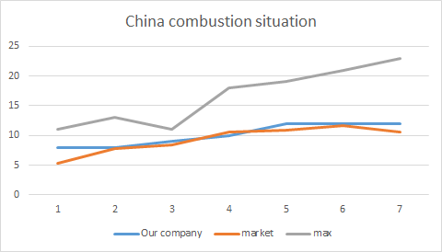
Combustion technology marks the initial phase of the company’s R&D efforts. The data charts show that in the first round, the company significantly increased its R&D investment, rapidly advancing its combustion technology, surpassing market levels, and achieving a leading position. This success is attributed to the company’s continuous investment in combustion technology and its close collaboration with external partners. Through this combination of external collaboration and in-house R&D, the company not only enhanced its combustion technology features but also quickly gained a technological lead.
However, as fuel prices declined and the electric transformation strategy gained momentum, the company’s R&D focus began to shift. Mid-term data indicates that as fuel prices continued to fall and the electric transformation trend took hold, the company started reducing its investment in combustion technology, gradually reallocating R&D resources to other fields. This indicates that once the company reached the market average in combustion technology, further investment was scaled down, and the company began focusing more on electric technology R&D.
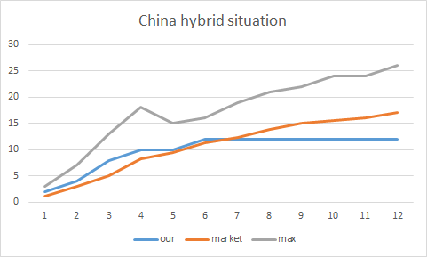

In hybrid technology, during the early stages, the company’s resources were largely concentrated on combustion technology, which led to slower progress in hybrid technology development. The data charts show that although hybrid technology gradually gained importance in the company’s overall strategy, it did not become the primary area for R&D investment.
Starting from the second round, as the company adjusted its resources, hybrid technology began to receive more attention. Through continuous in-house research, the company achieved a technical level slightly above the market average in hybrid technology, gradually establishing itself in the field. However, from the sixth round onward, given the demand for electrification and the implementation of a low-price strategy, hybrid technology was no longer considered a primary R&D focus, with more resources being allocated to the development of electric technology. At this point, hybrid technology became more of a transitional technology, gradually diminishing under the larger trend toward electrification.
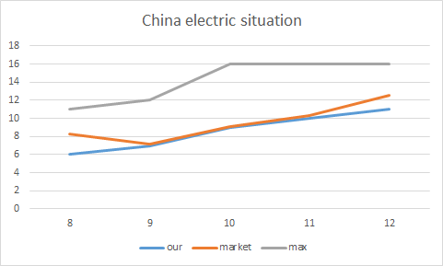
Electric technology became the focal point of the company’s future development. Starting from the mid-term, the data clearly shows that the company’s investment in electric technology rapidly increased. The company concentrated all its R&D resources on electric technology, consistently increasing the number of technical features, and gradually surpassing the market average in technological levels.
From the sixth round onward, with the gradual implementation of the company’s transformation strategy, electric technology became the core of the company’s R&D efforts. Through large-scale R&D investments and technological accumulation, the company achieved significant breakthroughs in electric technology, gradually leading the market.
Hydrogen technology became another key area of R&D focus after the company’s transformation. Although, due to calculations showing that hydrogen technology’s market return would not cover its development costs, the company decided not to start selling hydrogen-powered vehicles in the final rounds, it still continued to push forward the development of hydrogen-powered vehicles. This decision reflects the company’s belief that, as the market and technology continue to develop, hydrogen technology may become an essential part of the automotive industry in the future, especially given the shift toward sustainable energy solutions. Hydrogen technology, as a clean energy solution, still holds significant market potential.
Thus, while the company did not immediately launch hydrogen-powered vehicles, it continued the R&D work on hydrogen technology. This effort laid the groundwork for possible future production schemes, preparing the company for future technological developments in case the market demands hydrogen-powered vehicles.
In summary, MZSLL’s R&D strategy is highly aligned with its business development. In combustion technology, the company maintained stable development and kept a competitive edge through continuous in-house research and external collaboration. However, with the decline in fuel prices and the implementation of an electric transformation strategy, the company gradually shifted its focus to hybrid and electric technologies. Although hybrid technology development started slower, the company ultimately gained a competitive advantage in this area through sustained R&D efforts. In electric technology, the company acted decisively, quickly leading the market in terms of technological advancements.
In hydrogen technology, despite not launching hydrogen-powered vehicles immediately, the company continued R&D work, preparing for potential future production schemes. This strategy positions the company well for future energy transformations, providing it with more options in its future market strategy.
MZSLL’s flexible adjustment of R&D focus and resource allocation ensured continuous innovation in key technologies. This flexible and efficient R&D strategy not only meets the company’s current technological needs but also provides strong technical support for future market competition. Overall, the company’s R&D return rate remains stable, its technological accumulation continues to increase in value, and its market competitiveness is enhanced.
4.Market share
4.1 Global Market Share Trends
Throughout the simulation, our global market share followed a clear pattern that reflected the pace of our product adjustments and technology shift. From strong performance in the early game to a drop during transition, and finally a gradual recovery, our market position went through four distinct stages. Below is an overview of each phase and how our product strategy played a role in shaping the outcome.
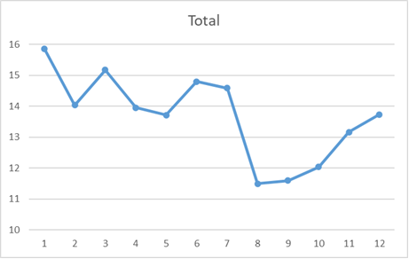
Round 1: Strong start with well-matched product strategy
In the first round, we entered the market quickly and captured a strong position, reaching a global market share of 15.85%, one of the highest among all teams. This success was driven by a product strategy that matched the early market needs—we offered both combustion and hybrid vehicles across the U.S., China, and Europe. Our hybrid products were supported by strong R&D investment right from the beginning, and we combined this with competitive pricing and decent promotion. These efforts helped us gain fast recognition and acceptance.
This early success also showed that our team made the right call by focusing on traditional powertrains instead of rushing into electric vehicles too soon. Our consistency in product lineup and marketing across different markets gave us a solid base to build from. Looking back, Round 1 was a textbook example of aligning product, market timing, and execution—setting us up well for what came next.
Rounds 2–7: Market share stays steady as traditional strength holds
Between Rounds 2 and 7, our market share stayed in a fairly stable range between 13% and 15%, with only slight ups and downs. During this time, competition increased as other teams started launching electric and hydrogen vehicles more aggressively. In response, we decided to hold our position by sticking with combustion and hybrid models, which still had steady demand in most regions.
This more cautious approach helped us maintain our base, especially in Europe, where customers still preferred high-feature hybrid models. However, behind this stability, there were early signs that our slower move toward new technologies could hurt us later. While we avoided big risks during this time, we also missed the chance to be first in the EV race.
Overall, this phase showed that our strategy was conservative but stable. We managed to protect our market share while preparing for a future shift. But in hindsight, we may have waited too long to begin that shift, especially as policy and consumer trends started changing faster.
Round 8: Major product shift causes short-term market drop
Round 8 marked a turning point in our product strategy. We officially exited the combustion segment and switched to a “hybrid + electric” lineup. This decision was based on the clear growth trend for EVs, especially in China and Europe. However, this shift also brought new challenges.
Our EV technology wasn’t fully ready, and customer acceptance was still building. Meanwhile, our competitors had already moved into the EV space earlier, gaining first-mover advantages. As a result, our market share dropped significantly this round. We also faced issues with cost and delivery, as we relied more on outsourcing before internal production could catch up.
This drop was a classic example of "transition pain"—a dip caused by big changes made a little too late. While the direction was correct, our speed and preparation weren’t enough. A smoother and earlier shift could have reduced the impact.
Rounds 9–12: Recovery through gradual optimization
After the initial shock of our transition, we started improving our product and pricing strategy. We adjusted EV prices through multiple rounds of reductions, making them more attractive to consumers. We also increased our use of outsourcing to improve efficiency and cut costs. At the same time, we kept hybrid products available in markets where demand still existed, helping us hold a solid base.
These changes helped our market share begin to recover after Round 9. By Round 12, we had reached a new stable position within the EV-focused landscape. Although we didn’t return to the peak share we had in Round 1, we successfully adapted to the new market direction and regained competitiveness.
This phase showed that, even if a strategy shift comes late, it's still possible to catch up with the right execution. However, it also reminded us that the timing of a transition matters just as much as the direction. For future decisions, starting earlier and breaking big changes into smaller steps could help us manage risks better.
4.2 Performance Review by Powertrain Technology
During the simulation, our team, MZSLL, introduced four key powertrain types: combustion, hybrid, electric, and hydrogen. At different stages, we made adjustments based on global market trends and regional needs. We followed a strategic path of “stability – transition – forward planning,” aligning our decisions with product life cycles and market fit. Below is an analysis of how each type performed in the overall market and how well our strategy matched each phase.
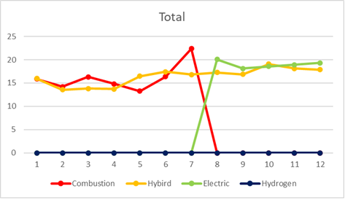
4.2.1 Combustion Technology
In the first seven rounds, we actively offered combustion vehicles as one of our main products. Most other teams began shifting to electric or hydrogen early, which meant less direct competition in the traditional segment. This gave us an unexpected advantage—our combustion cars gained steady sales and even increased market share in some areas, especially in the U.S., where demand stayed strong.
We used this strategy to support our early cash flow and hold a firm position in the market. Even in markets like China and Europe, where combustion demand dropped faster, we kept limited offerings to maintain coverage.
Starting in Round 8, we made a clear move to exit the combustion product line, driven by rising ESG pressure and the need to shift toward cleaner technology. While this change brought some short-term losses, it showed our long-term focus and commitment to sustainability.
Overall, our timing was solid. We used combustion products effectively in the early game, then exited before the risks became too high. This helped us avoid penalties and shift resources to newer technologies at the right moment.
4.2.2 Hybrid Technology
Hybrid vehicles were a key part of our lineup from Round 1 through Round 12. We developed and sold them consistently across regions. Hybrids offered a good balance between traditional stability and cleaner operation, making them widely accepted in most markets.
In the first half of the game, our hybrids saw steady sales growth, especially in Europe, where customers liked the mix of fuel efficiency and performance. As electric vehicles grew in popularity later on, the hybrid market did shrink slightly, but it still stayed relevant.
We continued investing in hybrid products, keeping them updated and available. This helped us avoid sudden sales drops and supported our financial performance even as we started shifting to electric.
Strategically, hybrids worked as our “cash cow”—stable, profitable, and low-risk. Even with the rise of EVs, hybrid models still played a role in our sales mix, and they can continue to be used in markets that need flexible, cost-friendly options.
4.2.3 Electric Technology
We officially launched electric vehicles in Round 8, marking a full shift in our technology strategy. At first, our EVs didn’t gain strong market share—mainly because we entered late and our pricing and features needed fine-tuning. But from Round 9 onward, we started improving.
We lowered EV prices, increased outsourcing to reduce production costs, and targeted markets like China and Europe where EV demand was already high. These changes helped us build stable market share over time, and by Round 12, our EVs became core products in several regions.
Although we missed some early benefits by entering late, our mid-to-late adjustments were effective. EVs became the center of our strategy, and their future potential remains strong. To stay competitive, we should continue investing in EV development, pricing strategies, and brand visibility.
4.2.4 Hydrogen Technology
Hydrogen technology showed some growth in the U.S. market, especially after Round 10. However, we chose not to launch any hydrogen models during the simulation. Instead, we made small R&D investments starting in Round 8 to build up technical know-how, without committing to full-scale production.
Our decision was based on several factors: high production costs, unclear commercial potential, and weak infrastructure. Also, since our EV line had just launched, we didn’t want to stretch resources too thin. By focusing on electric first, we avoided major risks linked to hydrogen.
That said, we did miss an early opportunity in the U.S. hydrogen market. Some other teams used hydrogen products to gain market share late in the game. While our cautious approach avoided losses, it also meant we weren’t part of this growth phase.
Looking forward, if hydrogen becomes more supported by policy or infrastructure improves, we should consider testing it in smaller markets. Starting with a trial run could give us flexibility without too much risk.
4.3 Regional Performance in the U.S., China, and Europe
Throughout the simulation, our team, MZSLL, developed different strategies for each region based on market characteristics, policy direction, and technology trends. By reviewing our market share changes across the three major markets—the United States, China, and Europe—we can evaluate how well our decisions matched each region’s needs and how the market responded.
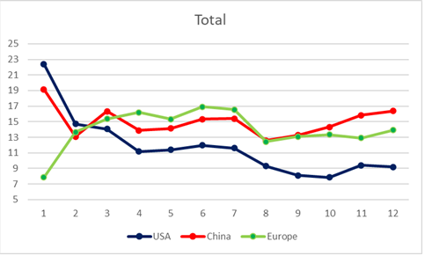
4.3.1 United States Market
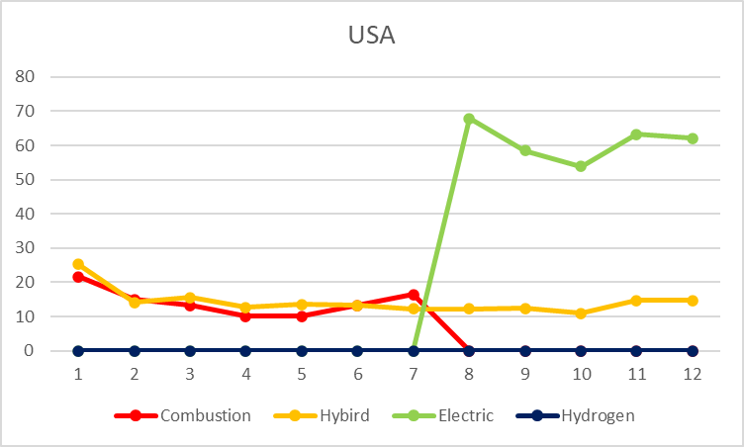
In the first seven rounds, the U.S. was never our strongest market. Our market share in this region stayed behind China and Europe, and although we offered combustion and hybrid models, we invested less in marketing and brand-building. As a result, our share remained low, with no major growth during this period.
This was mainly due to our low-cost strategy in the U.S.—we tried to cover the market with minimum resources. But because local demand for combustion cars was still strong and our brand recognition was weak, we couldn’t gain a solid position. In Round 8, when we stopped selling combustion cars and focused only on electric models, our share dropped quickly. U.S. customers were not ready to fully switch to EVs, and without any hydrogen models either (which started growing in the U.S. around this time), our presence in the region weakened even more.
Looking back, our U.S. strategy was too passive. We didn’t invest enough in the early rounds and didn’t localize our transition approach later on. While our switch to EVs was right for some regions, it didn’t fit the U.S. market at that time. In the future, for mature but slow-changing markets like this, we should offer a more flexible product mix and avoid one-size-fits-all strategies.
4.3.2 China Market
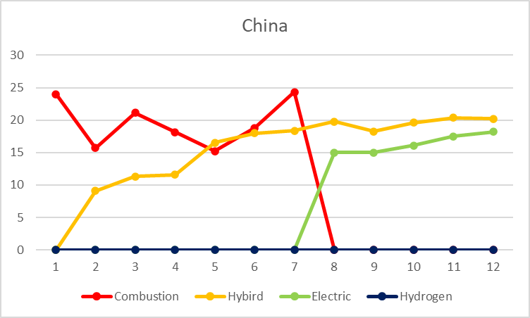
During the first seven rounds, China was a stable market for us, usually ranked second in terms of our market share. We focused on a mix of combustion and hybrid models, controlling costs while slowly improving product features. This helped us build a brand base, but we didn’t push EVs early, so our share stayed steady without major growth.
After Round 8, we shifted more focus to electric vehicles and started offering lower prices and increased outsourcing to improve cost efficiency. These changes, combined with strong EV demand in China, helped our share grow quickly. By Round 11, China overtook Europe to become our top regional market in terms of share.
China’s rise in our market share was closely tied to how quickly we adjusted our strategy. While our early EV response was a bit slow, our later actions were timely and effective. For fast-growing markets like China, we should consider even earlier pilot tests and flexible launch plans to catch growth windows and stay ahead of the curve.
4.3.3 Europe Market
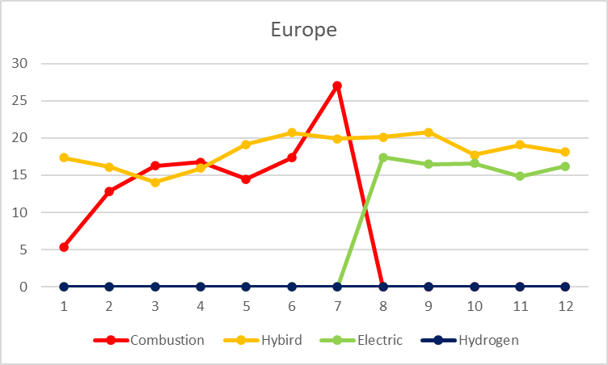
From Rounds 1 to 7, Europe was our main market. We had the highest share here, supported by strong early investments in ESG efforts, branding, and high-feature hybrids. Customer demand for eco-friendly products and brand value helped us build a solid position during this phase.
In Round 8, as we transitioned from combustion to EVs, our European share dropped slightly. Although the region was highly supportive of EVs, we entered the electric space a bit later than competitors. This delay cost us some early opportunities. However, from Round 9 onward, we improved EV pricing and product features, and our market share in Europe gradually returned to earlier levels.
Overall, even though our European share faced some setbacks during the transition, we responded quickly and were able to rebuild our position. In regions that move fast on green trends, we need to be better
5.Production decisions
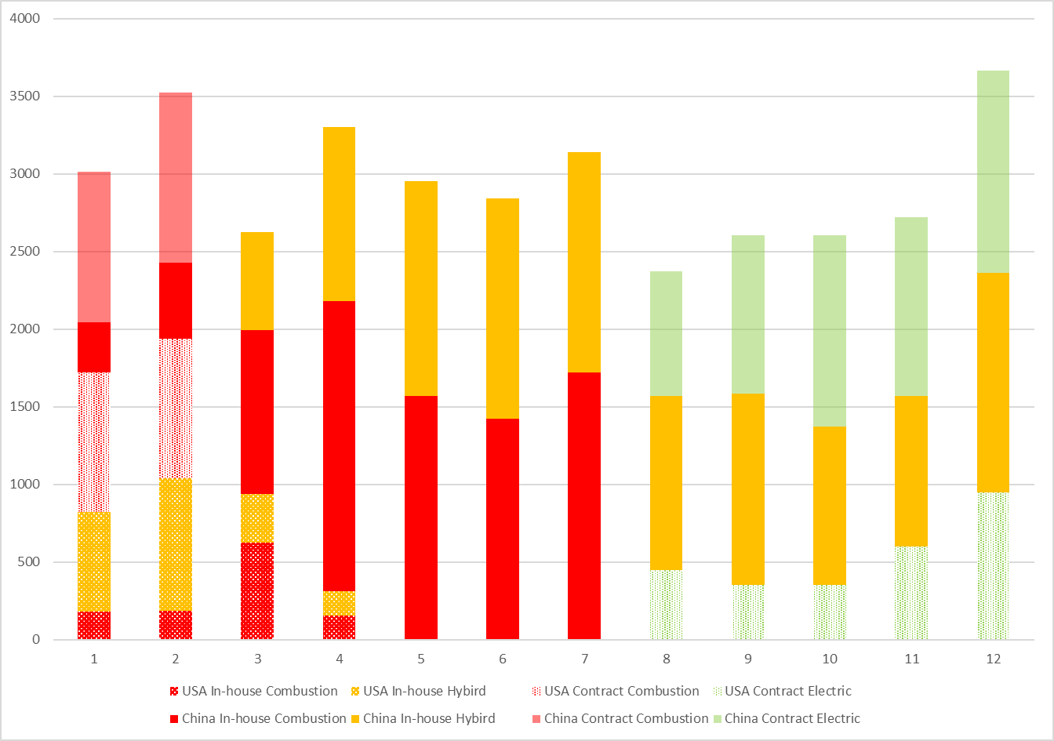
Stage-by-Stage Optimization of Capacity Layout and Flexible Adjustment
In this simulation, the MZSLL team developed a clear capacity configuration strategy around the core idea of "gradual centralization + flexible outsourcing," and continuously adjusted and optimized the production plan based on data analysis to maximize market demand fulfillment and production efficiency. By simulating multiple rounds, the team gradually evolved from a phase of parallel in-house production and outsourcing to centralizing production in China, and then back to an outsourcing-driven strategy.
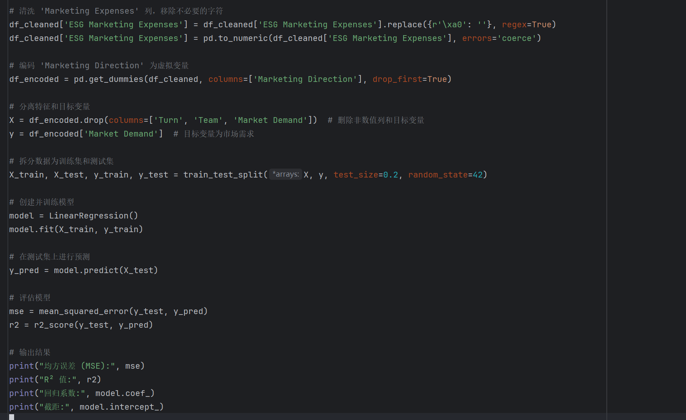
Through the construction of a multiple linear regression model, the team predicted market demand for each round and used this data to guide factory production capacity arrangements. Additionally, by analyzing the cost differences between production in China and the U.S., the team chose to expand production capacity in China to achieve cost control and improve overall production efficiency. The following is a detailed analysis of each stage:
I. Rounds 1-2: Capacity Constraints, Parallel Outsourcing and Factory Construction
In the initial phase of the simulation, the MZSLL team faced capacity shortages. Especially with a diverse product line (fuel + hybrid) and market coverage, the existing in-house factories could not meet market demand. To address this, the team adopted a "parallel outsourcing + factory construction" strategy to quickly ensure the supply capacity.
- Outsourcing to Address "Initial Capacity Anxiety": Outsourcing proved to be an effective solution to the initial capacity shortage. By outsourcing the production of some fuel and hybrid products, the team could quickly increase delivery capacity and focus resources on core markets and future capacity planning.
- Factory Construction in China, Low Cost and Market Proximity: With the increasing demand in China, the team decided to set up production facilities there. Compared to the U.S., China’s production costs were significantly lower, and its proximity to the market allowed for faster response times. Establishing production facilities in China also provided a solid foundation for future large-scale production.
Key Strategy Points:
- Outsourcing resolves the initial capacity bottleneck and ensures stable production and delivery.
- Prioritize factory construction in China to optimize capacity with low costs and geographical advantages.
II. Rounds 3-4: Gradual Capacity Improvement, Transition to Full In-House Production
As the Chinese factory gradually completed its construction, the team achieved sufficient in-house production capacity starting in round 3. By round 4, the team fully transitioned to in-house production, marking a significant upgrade in their capacity strategy.
- In-house Production, Enhanced Delivery Control: At this stage, the team no longer relied on outsourcing but achieved full in-house production. By concentrating resources on the construction and capacity expansion of the Chinese factory, the team could better control production progress and quality, improving response speed to market demand.
- Factory Layout Optimization, Begin "Withdrawal from U.S., Transition to China": To reduce management costs and fixed asset burdens, the team gradually downsized the U.S. factories and shifted most of the production capacity to China. This strategy not only improved production efficiency but also reduced overall cost structure, enhancing the team’s competitiveness in the Chinese market.
Key Strategy Points:
- Achieve in-house production and improve control over production progress and quality.
- Optimize factory layout by shifting capacity from the U.S. to China to reduce fixed and management costs.
III. Rounds 5-7: Centralized Production in China, Efficient Low-Cost Operations
By rounds 5-7, the MZSLL team successfully completed the exit from U.S. factories, with all products (mainly hybrid) being produced in China. This phase marked the highest efficiency and optimal cost structure, resulting in stable operations and the most consistent profit contribution.
- Full Transition to Chinese Production, Reducing Unit Manufacturing Costs: With large demand and low production costs in China, the team fully transitioned to production in China. Through efficient production management and large-scale production processes, unit manufacturing costs were significantly reduced. The production efficiency in China also made the entire production process more streamlined and effective.
- Accurate Matching of Product Demand and Capacity Distribution, Stable Operations: During this stage, the product mix remained heavily focused on hybrids, and the capacity configuration met market demand precisely without any significant resource redundancy or idleness. By optimizing capacity distribution and production scheduling, the team maintained high operational efficiency, ensuring timely market demand response.
Key Strategy Points:
- Centralize capacity in China, fully utilizing cost advantages and production efficiency.
- Precisely match product demand and capacity distribution, avoiding resource waste.
IV. Rounds 8-12: Electric Transformation Drives the Return to Outsourcing, Capacity Restructuring and Adjustment
With the introduction of electric products in round 8, the team reassessed the capacity layout. Due to the shorter development cycle and higher production costs for electric vehicles, in-house production lines lacked scale advantages, prompting the team to reintroduce outsourcing to meet delivery demands.
- Electric Products Outsourced, Saving Early Transformation Investment: In the early phase of the electric vehicle transformation, outsourcing was the best option. Given the high production costs and long development cycles for electric vehicles, in-house production lines were unable to achieve scale effects early, so outsourcing helped save on transformation costs while ensuring timely delivery of electric vehicles.
- Capacity Mismatch Exposed, Adjust Chinese Factory Size in Time: As electric vehicles began to capture some of the market share, the hybrid vehicle sales decreased, leading to an oversupply of hybrid capacity. To address this, the team began to gradually reduce the size of Chinese factories starting from round 9, reclaiming resources and controlling costs to optimize capacity structure.
Key Strategy Points:
- Outsource electric vehicle production to avoid early capital investments.
- Address capacity mismatch by adjusting Chinese factory scale in response to market demand.
Mathematical Model Support for Capacity Optimization
Throughout the production strategy development process, the MZSLL team made extensive use of a multiple linear regression model, predicting market demand for each round based on historical data, and adjusting production capacity accordingly. This approach enabled the team to maintain efficient production operations despite the challenges posed by a complex market environment.
Through continuous optimization of the model, the team successfully predicted market demand fluctuations and adjusted production plans accordingly. Additionally, the team found that setting up production facilities in China could effectively reduce production costs and improve market response speed. This analytical result provided a scientific basis for decision-making, ensuring optimal capacity configuration and cost minimization.
Conclusion and Recommendations
Through flexible capacity layout and continuous optimization of production plans, the MZSLL team successfully transitioned from early reliance on outsourcing to full in-house production, and later to outsourcing-driven strategies during the electric transformation. Going forward, the team should continue to monitor market demand changes and technological advancements, maintain flexibility in capacity adjustments, and respond promptly to changes in market demand. Additionally, strengthening production cost and efficiency management will ensure that the company maintains a competitive edge in the fierce market competition.

V Analysis of competitors
During the simulation, our team MZSLL performed well across key areas such as market share, profitability, and strategy execution. In terms of Cumulative Total Shareholder Return (TSR), we finished with a result of 17.26%, placing third out of ten teams. The only two teams ahead of us were Goldman (19.51%) and Fuxi Street Spider (19.21%), while the fourth-place team was much further behind. This means Goldman and Spider were not only our closest competitors in final performance but also the most relevant teams to compare in terms of overall strategy and execution.
From a strategic point of view, Goldman was our main competitor in the early rounds (Rounds 1–5). During that time, our teams shared many similarities in product structure, capacity planning, and market timing. However, starting in Round 6, Goldman made a clear shift toward new technologies, focusing heavily on electric and hydrogen vehicles, which was quite different from our more balanced approach. As a result, they were no longer a direct strategic match.
At the same time, Fuxi Street Spider gradually became our closest competitor in the second half (Rounds 6–12). Their strategy was highly aligned with ours in terms of production, R&D focus, and product rollout. In many rounds, we followed a nearly identical development path, leading to a more direct and meaningful comparison.
Because of both the final results and the strategic similarities, we chose Goldman and Fuxi Street Spider as our two key competitors for this analysis. The following sections will compare their approaches with ours in terms of business strategy, market performance, and shareholder return, to better understand what we did well and where we could improve.
1. MZSLL vs. Goldman (Rounds 1–5)
During the first half of the simulation, Goldman was our team’s main competitor. While both teams shared some similarities in product strategy and market layout, Goldman quickly adapted and improved their approach, eventually overtaking us in key performance areas like shareholder return. This section analyzes our competition in three aspects: strategic similarity, performance comparison, and the reasons why we couldn’t outperform Goldman in TSR.
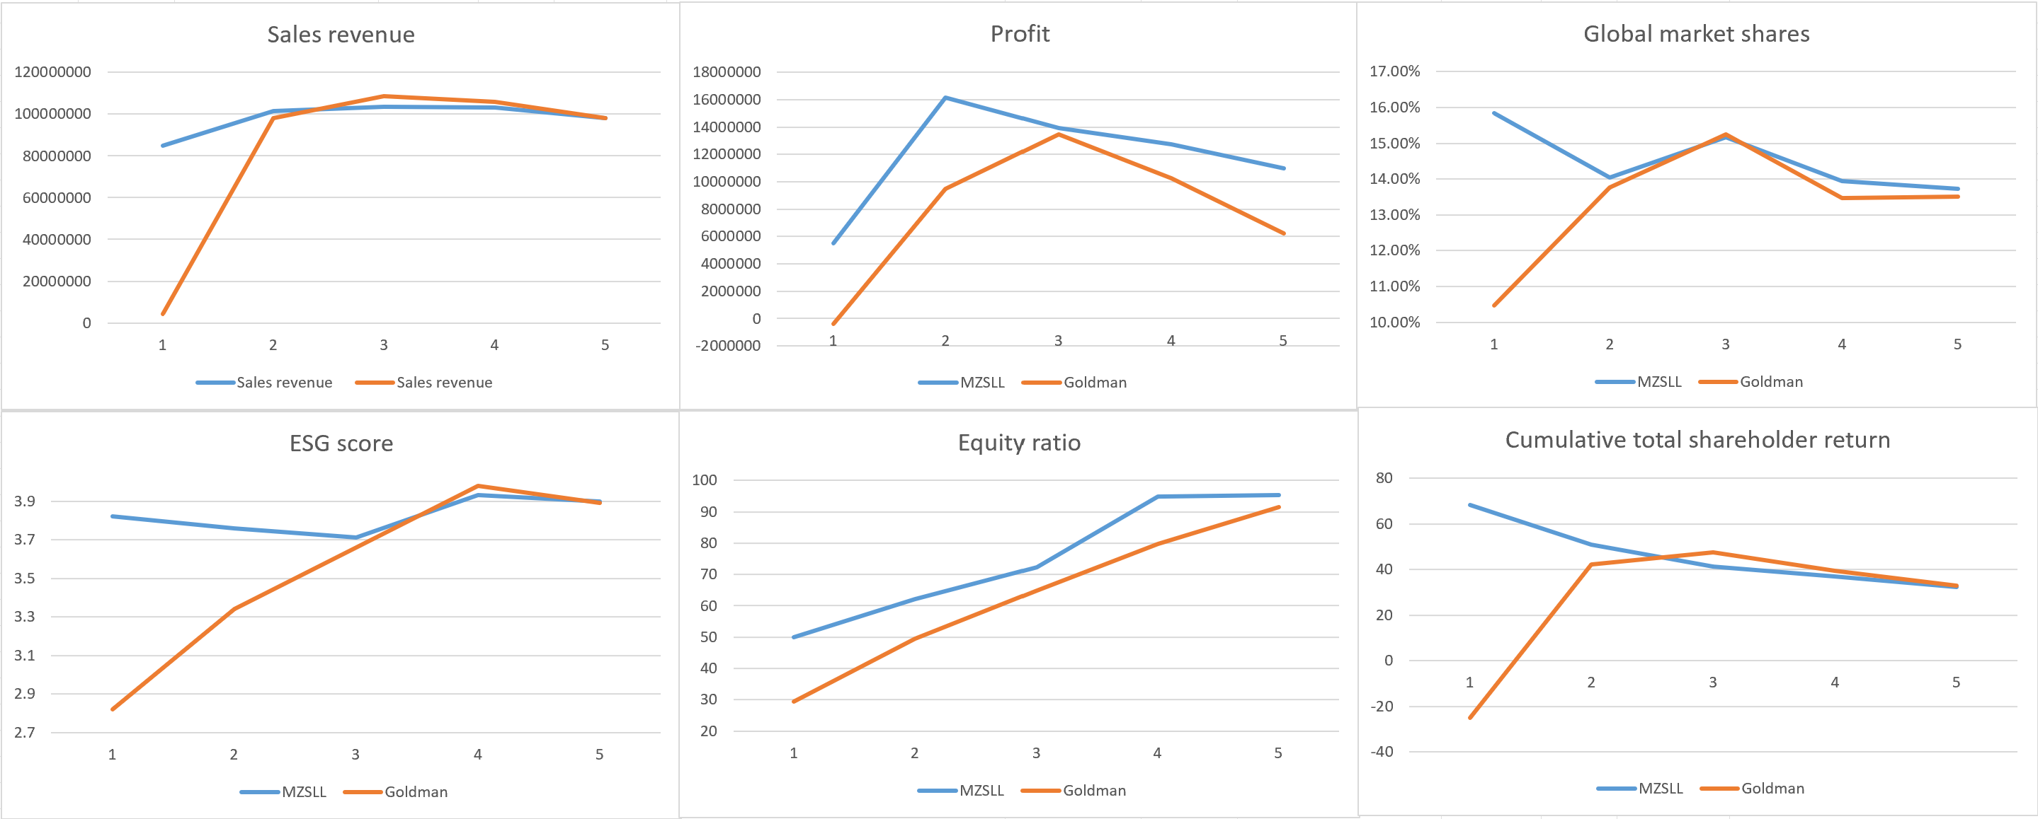
(1). Strategic Similarity: Focus on hybrids, ESG, and steady expansion
In the early rounds, both MZSLL and Goldman focused on selling combustion and hybrid vehicles. Especially in hybrid technology, we directly competed with each other. In Round 1, our team performed strongly, with higher sales and ESG scores. Goldman followed with a more cautious approach but soon adjusted their strategy.
Both teams invested in branding and sustainability and covered all three main markets (U.S., China, and Europe). Neither team rushed into electric or hydrogen vehicles in the first five rounds. Instead, we both adopted a step-by-step approach, focusing on stability and market acceptance. Our strategies looked similar from the outside, but the key differences came down to timing and execution.
(2). Performance Comparison: From clear lead to being overtaken
In Round 1, MZSLL was clearly ahead. We had the highest sales revenue, a strong market share, and the best ESG score among competitors. This was thanks to our early investment in hybrid R&D and factory setup. Goldman, in contrast, had a slow start and lower performance across all metrics.
However, from Round 2 onward, Goldman quickly adjusted. They copied many of our strategies—strengthening their hybrid lineup, increasing ESG efforts, and investing in branding. By Round 3, they were closing the gap, and by Round 5, their sales and ESG score had overtaken ours. While we stayed consistent, Goldman’s faster reaction helped them rise rapidly.
This phase shows that Goldman was highly efficient in learning and adapting. Their ability to react quickly and reorganize helped them move from behind to ahead in just a few rounds.
(3). Why We Fell Behind in Shareholder Return
Although our operations remained stable and profitable, we never managed to surpass Goldman in Total Shareholder Return (TSR). There are three main reasons:
First, Goldman moved faster in transitioning to new technology. Before Round 5, they had already started investing in electric and hydrogen vehicles. We didn’t begin this shift until after Round 6, which meant we missed early growth opportunities and investor attention.
Second, Goldman used a more flexible production model. They focused on outsourcing instead of building factories, which helped them stay light and flexible. We, on the other hand, invested heavily in factory construction early on. While this increased profits mid-game, it became a burden during the transition when our extra capacity led to higher adjustment costs.
Third, ESG performance played a key role. Although we led in ESG in the early game, Goldman caught up quickly and passed us by Round 5. Their improved ESG score helped boost investor confidence and brand image, which likely had a positive impact on their stock value and TSR.
In summary, while MZSLL had a strong and steady strategy, Goldman’s faster decision-making, flexible structure, and better timing allowed them to pull ahead. Their high-speed, high-flexibility style of transformation offers useful lessons for us. If we want to win long-term, we’ll need to improve both our response speed and our ability to make proactive changes in structure and technology.
2. MZSLL vs. Fuxi Street Spider (Rounds 6–12)
In the second half of the simulation, Fuxi Street Spider gradually replaced Goldman as our main competitor. Unlike Goldman, who had a clearly different strategy, Spider’s overall approach was very similar to ours. This created a kind of "shadow competition," where both teams followed similar strategies in production, product structure, and transition speed. However, despite these similarities, Spider eventually outperformed us in sales, profit, and total shareholder return (TSR). This makes it important to look deeper into the differences that led to this outcome.
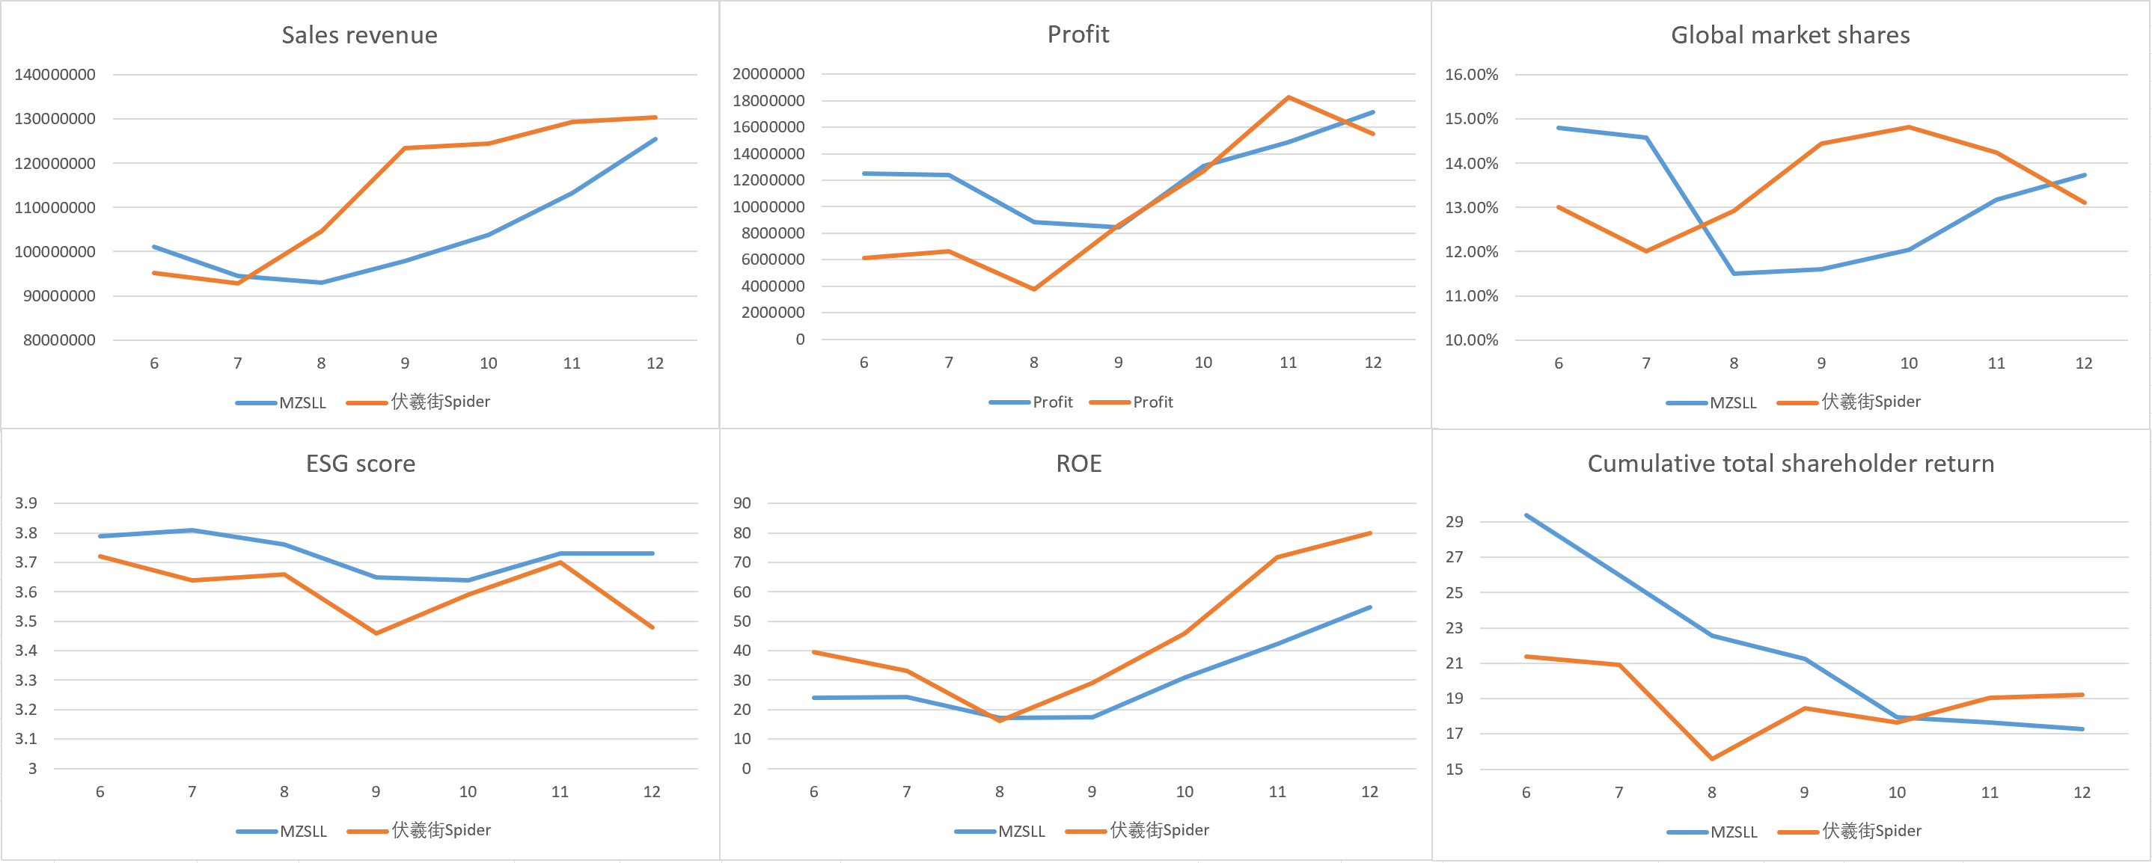

(1). Strategy Similarities: Parallel moves, similar direction
From Rounds 6 to 10, our team and Spider followed nearly identical strategies. Both companies invested heavily in factory construction early on, especially in China, to build up capacity at a lower cost. In R&D, both teams focused on fuel and hybrid technologies first, then shifted to electric in Round 6, with full EV product launches by about Round 8.
Our product lines were also very similar. Both of us shifted away from fuel toward a hybrid + electric mix. However, one small but important difference was that we completely stopped selling fuel cars in Round 8, while Spider continued offering them in the U.S. market. This created a more flexible structure for Spider and gave them an advantage later on.
Although the overall direction was the same, it was the smaller strategic decisions—like how fast to exit fuel products and where to test new ideas—that made a big difference in the end.
(2). Competitive Differences: Small choices, big impact
Even with similar frameworks, Spider made more flexible decisions that helped them pull ahead in the later rounds. After we exited the fuel market, we offered EVs in the U.S., but local customers weren’t ready for a full switch. Because of this, our U.S. market share dropped quickly. Meanwhile, Spider continued selling fuel vehicles in that market, capturing steady sales and profits, which gave them a big advantage in total revenue.
In Round 11, Spider also became the first team to enter the hydrogen vehicle market. Even though the impact was small at first, the U.S. was showing early policy support for hydrogen, and Spider’s move gave them an extra growth path. Our team had invested in hydrogen R&D but never brought it to market, which left us stuck competing in the very crowded hybrid and EV segments.
Another key difference was brand and ESG performance. We had a strong ESG image early on, and our brand was recognized for being responsible and sustainable. But Spider gradually caught up, putting more effort into ESG improvements, employee training, and supply chain management. By the end, their ESG score matched ours, and our brand advantage was mostly gone, reducing our pricing power in higher-end segments.
(3). Why TSR Stayed Behind: Three main reasons
Even though our operations remained solid, our total shareholder return (TSR) never caught up with Spider’s. The reasons came down to three major areas:
First, Spider kept fuel products in the U.S. and took advantage of existing customer demand. We, on the other hand, exited too early and tried to push EVs in a market that wasn’t ready, leading to lower sales and weaker cash flow.
Second, Spider moved faster on hydrogen. They used policy signals to test a new product, while we waited too long and missed the chance to lead in a new technology. This gave them a unique growth curve and set them apart from competitors stuck in hybrid/EV battles.
Third, our early ESG and brand advantages disappeared over time. While we started strong, Spider invested steadily and eventually matched us. This leveled the playing field and made it harder for us to justify premium pricing or win investor attention.
In summary, even though our overall strategy was solid, Spider’s flexible and timely actions helped them convert their plans into better market results. When facing competitors with nearly the same strategy, it’s the small differences—speed, local adaptation, and risk-taking—that really decide who wins. For the future, we should focus not just on doing the right thing, but on doing it fast, locally, and with better timing.

VI Outlook for business prospects
Based on our full analysis of performance, technology paths, and competitive trends during the simulation, we believe that MZSLL’s future strategy should focus on electric vehicles as our main direction, while also actively entering the hydrogen market to prepare for the next wave of innovation.
Electric vehicle (EV) technology has already become a mainstream trend globally, especially in China and Europe, where demand is strong and growing fast. In the later rounds of the simulation, we gained solid experience in EV development and sales, giving us a good foundation to build on. Going forward, we plan to keep improving our EV product lineup, speed up the launch of new models, and strengthen our brand influence and pricing competitiveness in key markets. At the same time, we should invest more in channels, after-sales service, and smart features to improve user loyalty and create more value.
In addition, we recognize that hydrogen technology, although still in the early stages, is showing early potential—especially in the U.S. market, where policies and interest are starting to grow. While we didn’t launch any hydrogen products during this simulation, we believe it’s important to start now. In the future, we should choose a few test markets to launch small-scale hydrogen trials. This would allow us to enter the hydrogen field carefully, control risk, and still stay ahead on future technologies. Hydrogen could be our way to break into high-end or commercial segments and open a second growth track for the company.
In terms of regional strategy, China should remain our main growth engine, with a strong focus on electric vehicles. In Europe, we will strengthen our image as a sustainable, high-quality brand. And in the U.S., we should rebuild a more flexible product mix, possibly combining hybrid, electric, and small-scale hydrogen products to improve overall coverage.
Overall, under the strategy of “EV-first, hydrogen-ready,” MZSLL will continue to improve our technology flexibility, market speed, and strategic adaptability—aiming to achieve breakthrough growth in the next round of global competition.

VII Simulate learning outcomes and suggestions for course teaching

1.Simulating learning outcomes (building the body of knowledge required for simulation and analysing one's own situation)
In the Cesim Business Simulation Competition course, my primary responsibilities included taxation, tariffs, investment and share buybacks. Through this simulation, I developed a deeper understanding of corporate financial decision-making in a competitive market environment.
One thing is that I learned how tax strategy works dealing with different tax situations, impacting profitability and cash flow, optimizing tax planning to maximize net income.
The other is that I learnt the importance of tariff management. Understanding the effects of import/export tariffs on supply chain costs and pricing strategies in international trade.
Initially, I struggled with balancing tax payments and reinvestment strategies, leading to liquidity issues in early rounds.
Later, by adjusting tariff-influenced procurement strategies and optimizing share buyback timing, I improved financial stability and shareholder returns.
The simulation helped me recognize the importance of data-driven decision-making and cross-functional collaboration (e.g., aligning tax strategies with overall corporate finance and operations).
2.Teaching Recommendations of this course
Enhancing pre-simulation training:
Although there is a pdf document which illustrate the basic information, it would still be better to describe the work shall be done.
- Provide more specific introductory workshops on key concepts like tax optimization, tariff impacts, and corporate finance (e.g., share buybacks vs. dividends).
- Offer case studies (written form instead of oral explanations) from previous competitions to illustrate best practices and common pitfalls during endings of each term. To keep on track of every term we've completed, including real time guidance and feedbacks.

