**Robot Boxing Web Game**

**Project Files:**

index.html

indexStyle.css

play.html

indexStyle.css

rule.html

rps.go

lhd.go

main.go

**Use Cases: Robot Boxing Game (Basic application flow)**

1. Initialize page (an entertaining home page, may add functionality in the future)
2. Random selecting play character (for player and computer)
   1. The functionality where the player selecting the character for himself is not available for the current delivered version.
3. Player entering phase 1
4. Player chooses one option between ROCK, PAPER, and SCISSOR
5. System compares the player’s selection with computer’s selection and determine the winner. The loser loses one health bar
6. Phase 1 completion
7. Player entering phase 2
8. Player chooses one option between LIGHT ATTACK, HEAVY ATTACK, and DEFENSE
9. System compares the player’s selection with computer’s selection and determine the winner. The loser loses one health bar
10. Phase 2 completion
11. Player repeats the phase 1 and 2 until one wins the game (Means one of the players loses all his 5-health bar)
12. Play round terminates

**Basic UML:**

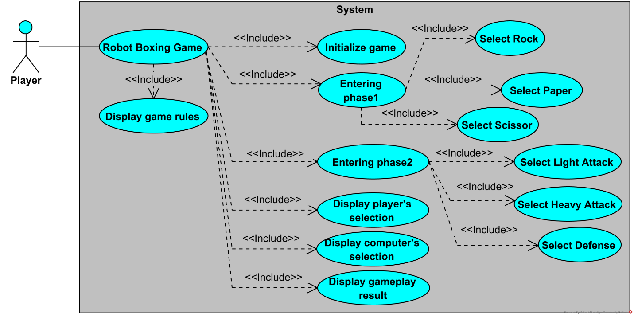

**Sequence Diagrams:**

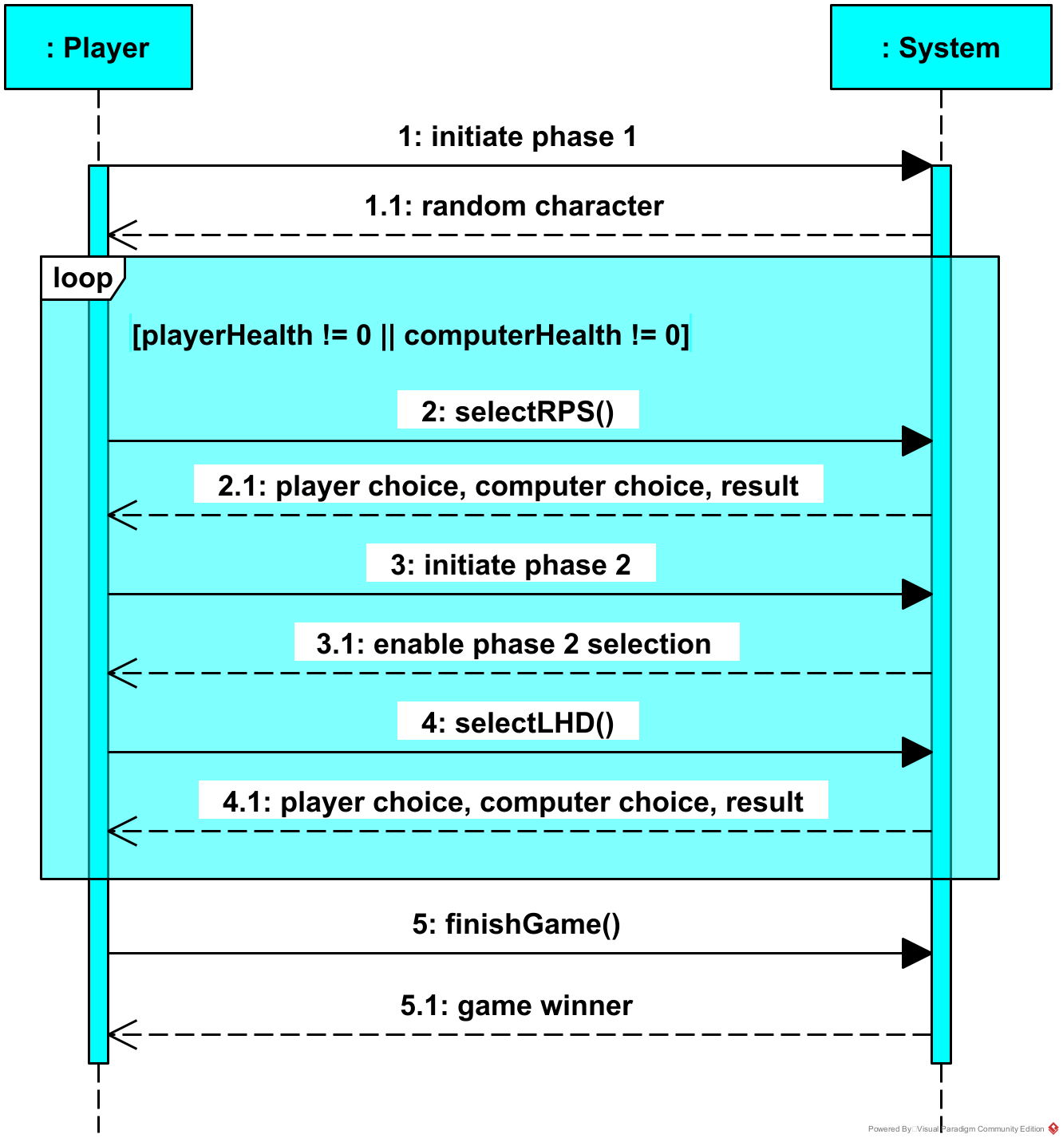

**Note*:**

Use Case “Entering Phase 1” and “Entering Phase 2” are two separate Use Case. However, the Phase 2 depends on Phase 1. The player must finish Phase 1 in order to access Phase 2. Also, the action of accessing Phase 1 and Phase 2 is placed in a loop because the player will be repeating Phase 1 and Phase 2 until he wins or loses. Therefore, those two Use Cases cannot be represented in two different sequence diagrams because it will breaks the loop container.