Exercise 3:

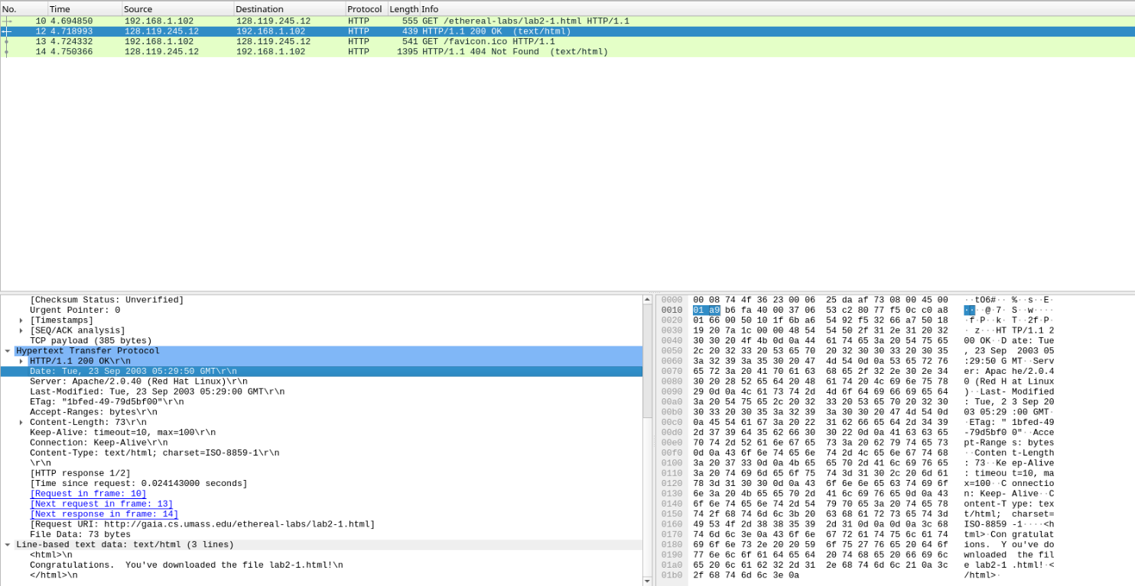

Q1: The status code is 200,  The phrase is HTTP/1.1 200 OK

Q2: Last modified on: Tue, 23 Sep 2003 05:29:00 GMT

         Under DATE header: Tue, 23 Sep 2003 05:29:50 GMT

         Where the last modified date is the last modified date of the Website/server, but the date under DATE header is the time the client received the information sent back from the server.

Q3: The connection established between the browser and the server is persistent, it can be found under KEEP-ALIVE header and CONNECTION header, it was said the connection status is "keep alive" which means the connection is persistent.

Q4: We can find there are 73 bytes content was sent back to the client from the server.

Q5: The data contained inside the HTTP response packet is a text/html object, whose contents are:

"Congratulations. You've downloaded the file lab2-1.html!\n"

Exercise 4:

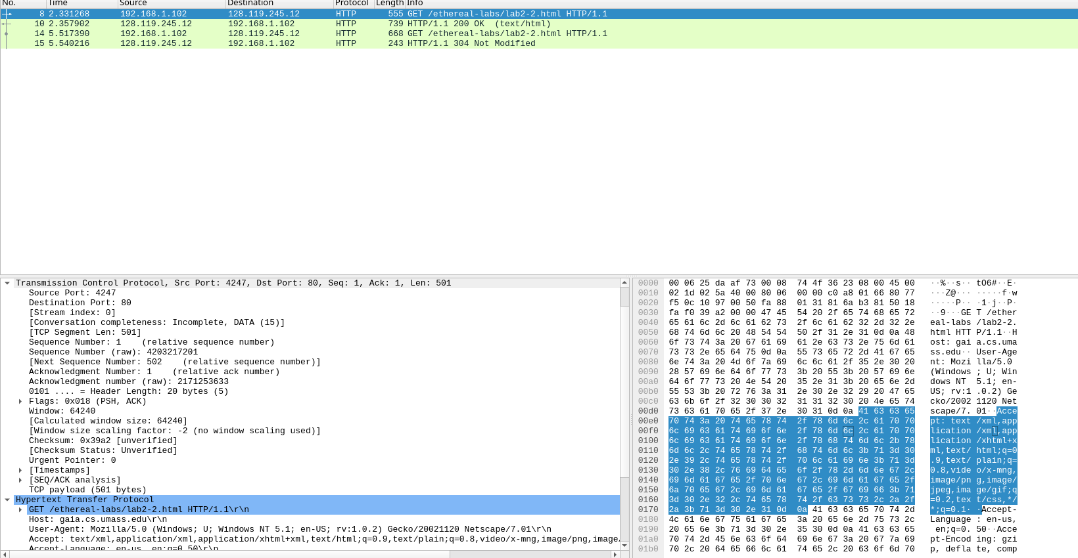

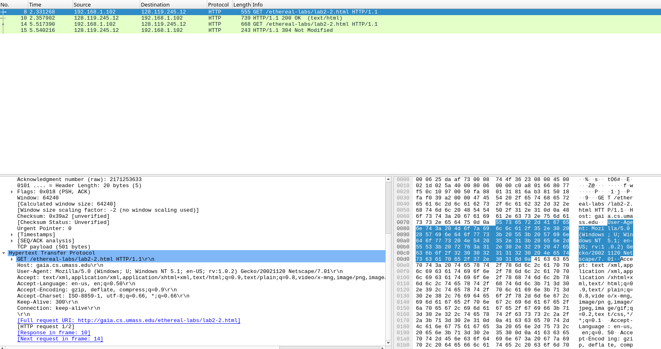

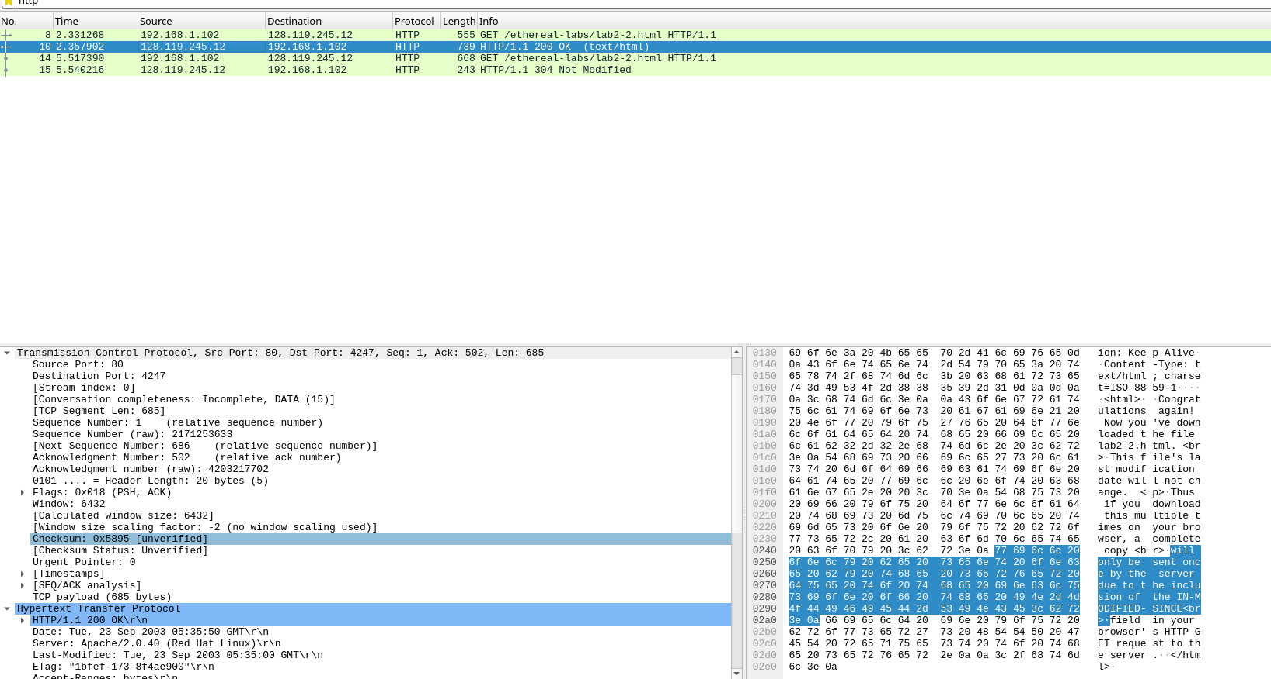

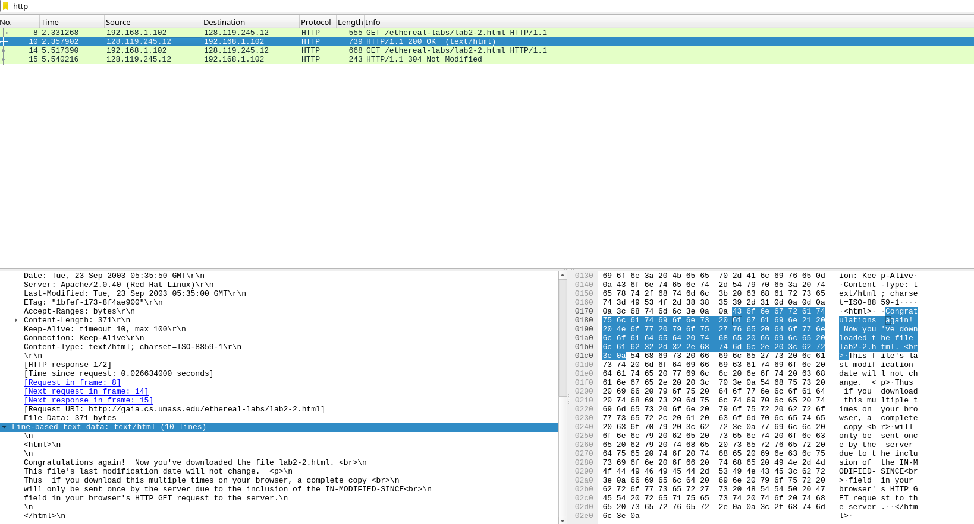

Q1: There is no “IF-MODIFIED-SINCE” line in the HTTP GET, this is because the local cache is not deleted yet.

Q2: Yes, it was shown under Last-Modified header which is: Tue,23 Sep 2003 05:35:00

Q3: Yes, there is an If-Modified-Since header and an If-None-Match header.

Under the If-Modified-Since header, it contains the date and time that last modification time.

Under the If-None-Match header contains the same value of Etag, It is a unique identifier assigned by a web server to a specific version of a resource.

Q4: The HTTP code is 304 not modified. The server didn’t return the contents, it means that the file doesn’t change since the last modified date, which means the version of the file will be stored on the proxy server and the last version of file will be sent by the proxy server. Therefore, there is no need to send it again since the whole version is already stored in proxy server.

Q5: The Etag value is “1bfef-173-8f4ae900”. It is a unique identifier assigned by a web server to a specific version of a resource, not changed since the first response.

Exercise 5:

ping to 127.0.0.1, seq = 32334, rtt = 74 ms

ping to 127.0.0.1, seq = 32335, rtt = time out

ping to 127.0.0.1, seq = 32336, rtt = 163 ms

ping to 127.0.0.1, seq = 32337, rtt = 189 ms

ping to 127.0.0.1, seq = 32338, rtt = 27 ms

ping to 127.0.0.1, seq = 32339, rtt = 107 ms

ping to 127.0.0.1, seq = 32340, rtt = 92 ms

ping to 127.0.0.1, seq = 32341, rtt = 189 ms

ping to 127.0.0.1, seq = 32342, rtt = time out

ping to 127.0.0.1, seq = 32343, rtt = 70 ms

ping to 127.0.0.1, seq = 32344, rtt = 8 ms

ping to 127.0.0.1, seq = 32345, rtt = 196 ms

ping to 127.0.0.1, seq = 32346, rtt = 25 ms

ping to 127.0.0.1, seq = 32347, rtt = 150 ms

ping to 127.0.0.1, seq = 32348, rtt = 58 ms

minimum = 8 ms, maximum = 196 ms, average = 103.69 ms

