Exercise 1:

***Question 1***. What is the IP address of gaia.cs.umass.edu? On what port number is it sending and receiving TCP segments for this connection? What are the IP address and TCP port numbers used by the client computer (source) that is transferring the file to gaia.cs.umass.edu? 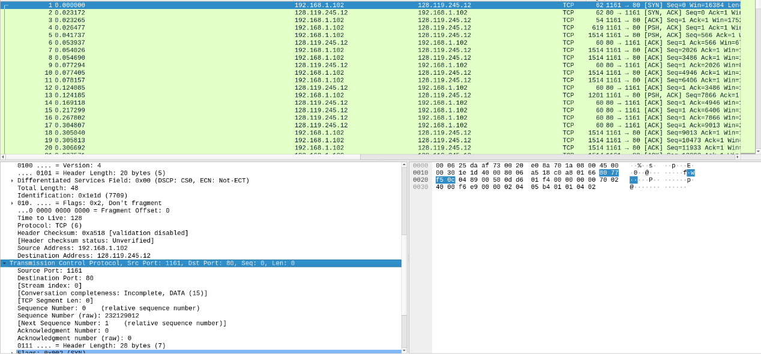

The IP address of gaia.cs.umass.edu should be the destination IP address which is given by 128.119.245.12. The corresponding port number is used for this connection is 80.

The IP address of client computer is the source address which is given by 192.168.1.102  this is a private IP address, and the corresponding port number used is 1161.

***Question 2****.*What is the sequence number of the TCP segment containing the HTTP POST command?

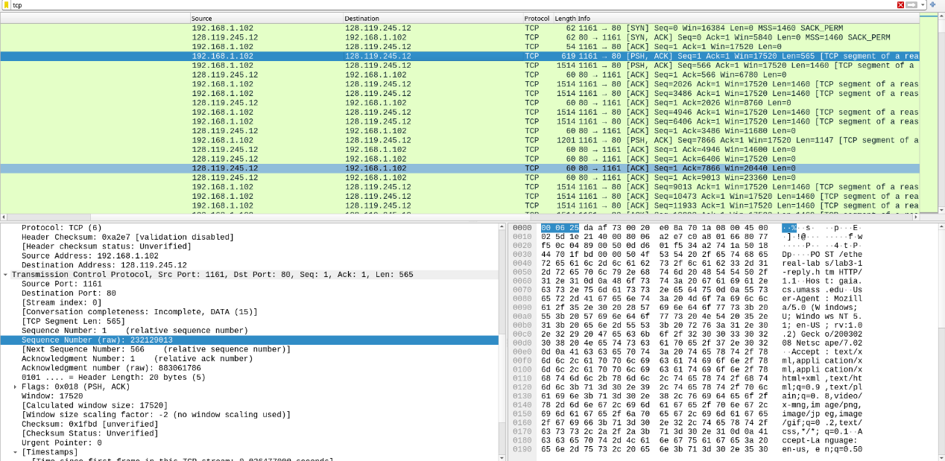

The fourth segment of the trace is the first TCP segment containing the HTTP POST command where you can find in the right.

The sequence number is 232129013

***Question 3.***Consider the TCP segment containing the HTTP POST as the first segment in the TCP connection.

(a) What are the sequence numbers of the first six segments in the TCP connection (including the segment containing the HTTP POST) sent from the client to the webserver (Do not consider the ACKs received from the server as part of these six segments)?

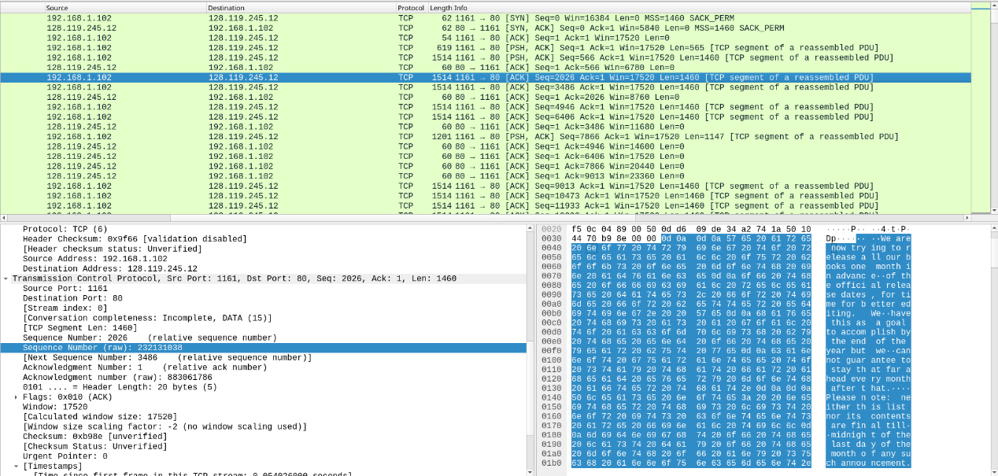

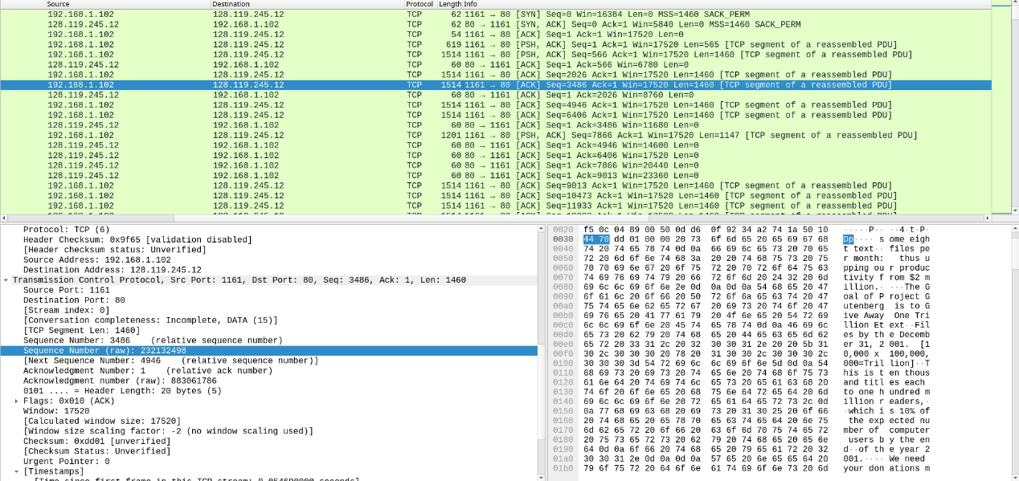



The sequence numbers are:  232129013   232129578  232131038  232132496  232132498 and 232135418

(b) At what time was each segment sent? When was the ACK for each segment received? Given the difference between when each TCP segment was sent and when its acknowledgement was received, what is the RTT value for each of the six segments?

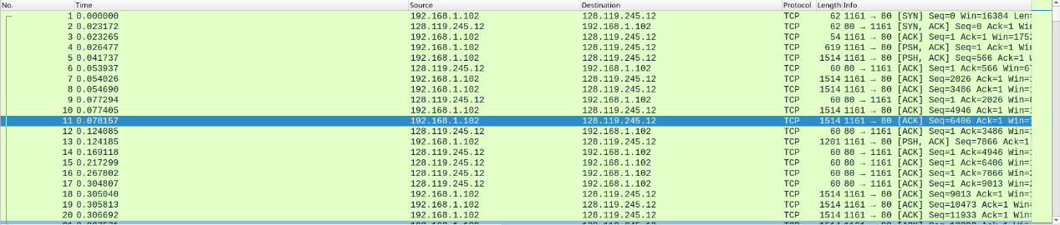

The segments were sent at time 0.026477 0.041737 0.054026 0.054690 0.077405 0.078157

The ACKs were received at time  0.053937 0.077294 0.124085 0.169118 0.217299 0.267802

RTT value can be calculated by taking the difference shown in the following table

(c) What is the *EstimatedRTT*value (see relevant parts of Section 3.5 or lecture slides) after receiving each ACK? Assume that the initial value of *EstimatedRTT*is equal to the measured RTT ( *SampleRTT*) for the first segment and then is computed using the *EstimatedRTT*equation for all subsequent segments. Set alpha to 0.125.

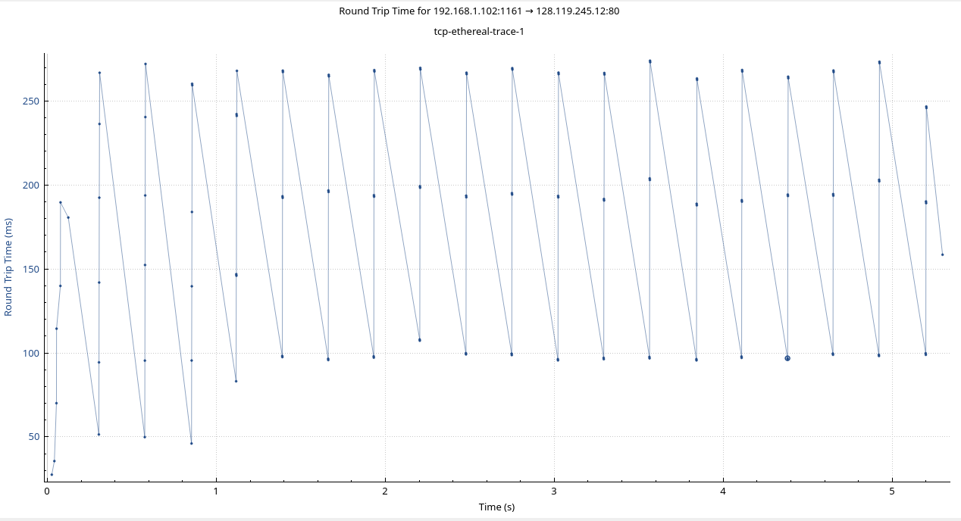

|  |  |  |  |  |  |
| --- | --- | --- | --- | --- | --- |
| Sequence Number | Segment sent time | ACK receive time | RTT | EstimatedRTT | Length |
| 232129013 | 0.026477 | 0.053937 | 0.027460 | 0.027460 | 565 |
| 232129578 | 0.041737 | 0.077294 | 0.035557 | 0.028472 | 1460 |
| 232131038 | 0.054026 | 0.124085 | 0.070059 | 0.033670 | 1460 |
| 232132496 | 0.054690 | 0.169118 | 0.114428 | 0.043765 | 1460 |
| 232132498 | 0.077405 | 0.217299 | 0.139894 | 0.055781 | 1460 |
| 232135418 | 0.078157 | 0.267802 | 0.189645 | 0.072514 | 1460 |

Estimated RTT  =  (1 - alpha) * Estimated RTT + alpha *  SampleRTT

*(d)*What is the length of each of the first six TCP segments?

The lengths are: 565 1460 1460 1460 1460 1460 correspondingly

***Question 4.***What is the minimum amount of available buffer space advertised at the receiver for the entire trace? Does the lack of receiver buffer space ever throttle the sender?

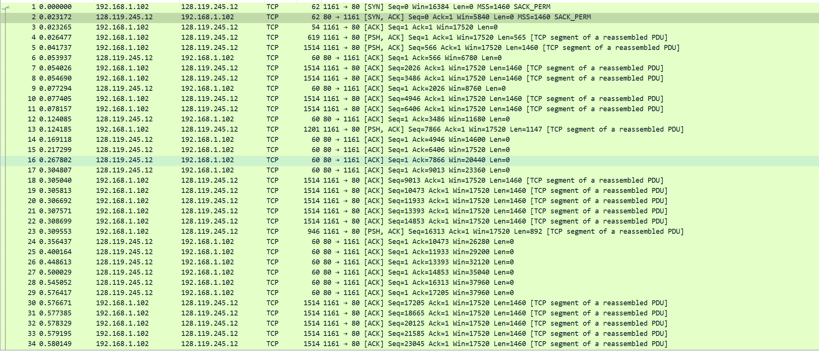

The minimum window size is 5840 bytes during the entire trace, the maximum buffer space is 62780 bytes. It is not likely to throttle the sender, as the buffer space is much bigger than the actual segment size.

***Question 5.***Are there any retransmitted segments in the trace file? To answer this question, what did you check for (in the trace)?

The sequence number kept increasing all the time, therefore, no retransmitted segments.

***Question 6.***How much data does the receiver typically acknowledge in an ACK? Can you identify cases where the receiver is ACKing every other received segment (recall the discussion about delayed acks from the lecture notes or Section 3.5 of the text)?

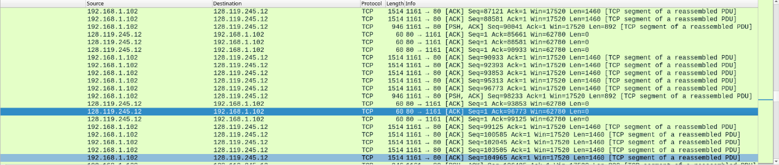

The receiver typically acknowledges 1460 bytes of data in an ACK, as we can see the length of the data sent by the sender is mostly 1460 bytes. In the picture above. We can find that Seq 95313 and seq 96773 are combined in the Acknowledgement 96773 sent from the receiver.

***Question 7.***What is the TCP connection's throughput (bytes transferred per unit of time during the connection)?

We can find that the total amount of data transmitted is 164090 bytes

Total time used to transfer the data is 5.455830-0.026477 = 5.429353s (from the HTTP POST request to the time finish the transmission)

Throughput = amount of data transmitted/ time used = 164090/5.429353 = 30222.75 bytes/s

Exercise 2:

***Question 1*.**What is the sequence number of the TCP SYN segment that is used to initiate the TCP connection between the client computer and server?

2818463618

***Question 2.***What is the sequence number of the SYNACK segment sent by the server to the client computer in reply to the SYN? What is the value of the Acknowledgement field in the SYNACK segment? How did the server determine that value?

Sequence number of the SYNACK segment sent by the server is 1247095790, the Acknowledgement field is 2818463619, which is the sequence number from the sender add 1 bit of SYN segment

***Question 3*.**What is the sequence number of the ACK segment sent by the client computer in response to the SYNACK? What is the value of the Acknowledgment field in this ACK segment? Does this segment contain any data?

Sequence number of the ACK segment sent by the client computer in response to the SYNACK is 2818463619, the value of the Acknowledgment field in this ACK segment is 1247095791. It contains 2818463652 – 2818463619 = 33 bytes of the data

***Question 4*.**Who has done the active close? Is it the client or the server? How you have determined this? What type of closure has been performed? 3 Segment (FIN/FINACK/ACK), 4 Segment (FIN/ACK/FIN/ACK) or Simultaneous close?

Both the client and server did the active close, in No 304 and 305, we can find both client and server sent a FIN ACK segment to other side while the sequence number and Ack number correspond to each other.

***Question 5*.**How many data bytes have been transferred from the client to the server and from the server to the client during the whole duration of the connection? What relationship does this have with the Initial Sequence Number and the final ACK received from the other side?

The amount of data transferred can be determined by the difference of first sequence number and the last ACK number.

Client: 2818463652 – 2818463619 = 33bytes

Server: 1247095831 – 1247095791 = 40 bytes

The Initial Sequence Number + 2 + total data transferred = final ACK received from the other side. Where the extra 2 is the SYN bit and FIN bit.