Describing three-dimensional structures with spherical and Cartesian coordinates
The geometry of a geologic structure is expressed in terms of angles: a plane’s orientation is described by its strike and dip, and a line’s attitude is given as its trend and plunge. It is clear that directional information — the strike of a plane, and the trend of a line — is inherently “circular”, as we measure these quantities with a compass. The dip and plunge are also circular, describing angles that sweeps downward from horizontal. As pairs, the strike and dip or the trend and plunge define the three dimensional geometry of a geologic structure. So, these data are expressed using spherical coordinates.
Spherical coordinates are convenient for recording and representing linear and planar data, but calculations relating and operating on these data can often be better handled by converting to a different representation — what are called Cartesian (north, east, down) coordinates.
Let’s start with a line that plunges to the northeast. This could represent a lineation, or it could represent the pole to a plane (dealing with poles to planes in Cartesian coordinates is simpler than with the planes themselves). First, let’s take a look at this line from above, as though we were measuring its trend with a compass (left figure; 3D perspective view on right):
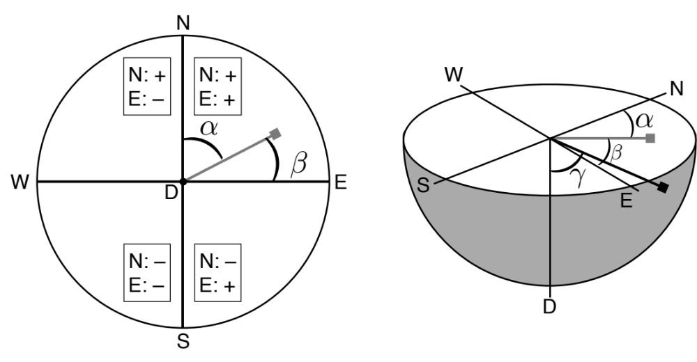
At the top and right sides of this compass face, we see a familiar N and E, denoting north and east, respectively. At the center of the compass face, we see a D, showing the trace of the “down” axis (it points straight down, into the earth). The gray line is the linear feature of interest projected upward to the compass face (a line of zero plunge). Keep in mind, however, that the linear feature itself is actually plunging (see right figure).
The angles α, β, and γ represent the angles made between the linear feature with the North, East, and Down axes, respectively. While the spherical coordinates of the linear feature are described as angles with respect to north and horizontal, the Cartesian coordinates can be expressed as linear units that are trigonometric functions of those angles. First, we can relate the trend and plunge to the depicted angles as:
- α = trend
- β = (90–trend)
- γ = (90–plunge) (the plunge is expressed with respect to the horizontal, whereas γ is the angle expressed with respect to the down axis, which is vertical).

To define the Cartesian coordinates, we want to find out the vector components of the linear feature along the N, E, and D axes:
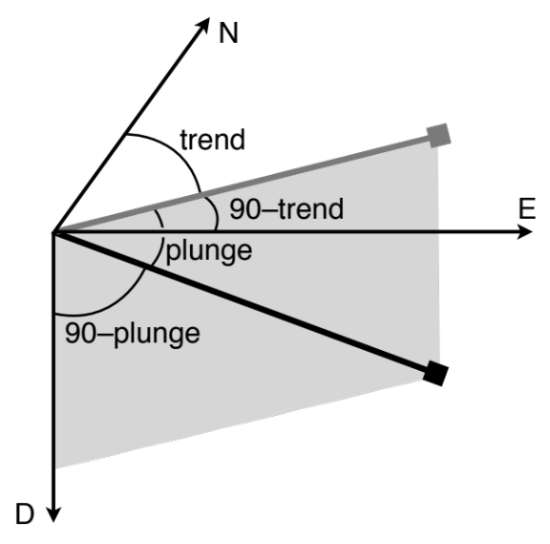
We treat the linear feature as a unit vector (bold black line) with length = 1 and direction given by its trend and plunge. First, let’s determine the D component of the vector:
D = cos(γ) = cos(90–plunge) = sin(plunge).
Note from the figure above that the D component of the vector, treating the vector itself as the hypotenuse of a right triangle within the gray vertical plane, is just the sine of the plunge (recall that the vector is of length = 1). Similarly, we can express the projection of the vector onto a horizontal plane as the cosine of the plunge (i.e., the “adjacent” limb of the right triangle we just used).
Using this horizontal projection of the plunging line (the gray vector on the diagram above), we can determine the vector components along the N and E axes:
N = cos(α) = cos(plunge)*cos(trend)
E = cos(β) = cos(plunge)*cos(90–trend) = cos(plunge)*sin(trend).
Poles to planes
We generally describe the geometry of a plane using its strike and dip, but we could alternatively uniquely describe its orientation using the pole to the plane. As noted above, in carrying out mathematical operations that relate multiple planes, it is often simpler to describe those planes using the trend and plunge of their poles as opposed to the strike and dip of the planes themselves. The trend of a plane’s pole is the dip direction of that plane: 90º to the strike of the plane, pointing in the direction of dip. The plunge of a pole to a geologic plane is 90º to the dip of the plane.
Using the same relationships described above, the N, E, D components of the unit vector defining the pole to a plane can be defined in terms the plane’s strike and dip as:
N = cos(α) = sin(strike)*sin(dip)
E = cos(β) = –cos(strike)*sin(dip)
D = cos(γ) = cos(dip).
Application: Determining rake
A linear structure appearing within a plane — for example, a slickenline marking the direction of fault slip — can be characterized by measuring its trend and plunge directly, or by measuring its rake within the plane. What the rake represents is the angle between the linear feature and a line defining the strike of the plane, that is, a line whose trend is the strike and whose plunge is zero. When the lineation’s trend and plunge are measured, the rake can be determined easily using Cartesian coordinates and the concept of a dot product, or scalar product.
The dot product multiplies the magnitude of two vectors. The dot product of two vectors, U and V, each defined by N, E, D components can be thought of as the magnitude (length) of U times the length of V projected onto U. This projection is achieved by multiplying the length of U times the length of V times the cosine of the angle between the vectors, θ. In our example, this angle is what we want to know: the rake. Expressed mathematically, the dot product U⋅V is given as:
U⋅V = |U||V|cos θ = U_{N}V_{N} + U_{E}V_{E} + U_{D}V_{D}.
That is, the dot product can be calculated as the sum of the products of the Cartesian components of the two vectors.
To return to our original problem, we could determine the rake of a lineation by calculating the Cartesian components of vector U, the strike line, and vector V, the lineation.
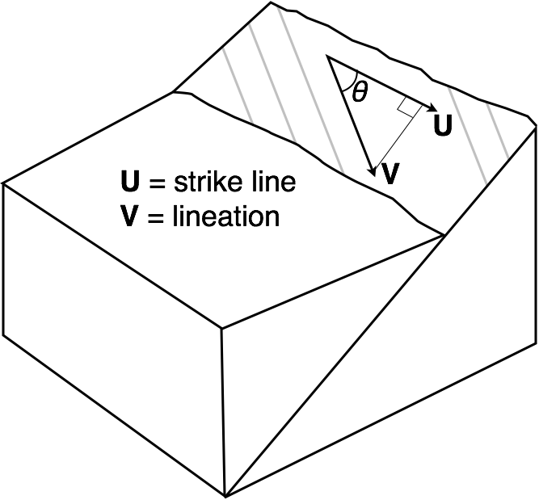
We can then determine the rake, θ, by rearranging the above equation:
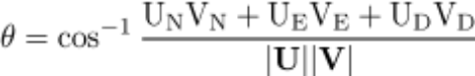
Because we use unit vectors to describe the information, the lengths of the vectors, |U| and |V| are both 1.
Application: Determining apparent dip
The dip of a plane is maximum slope of that plane, and the dip direction is always 90º to the strike of the plane. If you were to construct a geologic cross section in a plane perpendicular to strike (i.e., in the dip direction), then the beds would appear in that cross section at their dip angle. However, if the cross section is drawn in any other plane, not perpendicular to strike, then the beds appear in the cross section with what is called an apparent dip.
An alternate way of thinking about this is as follows. The intersection between two planes — in this case, a bedding plane and the plane depicting the cross section — is a line. This line can of course be described with a trend and plunge. In our example, the trend of this line is equal to the strike of the cross section plane, and the plunge of the line gives the apparent dip of the bedding plane. The apparent dip is always less than the true dip, but we need to determine what that value is in order to depict the bedding planes in the cross section.
Converting the two planes of interest — again, the bedding plane and the cross section plane — into vectors described by Cartesian coordinates provides a straightforward approach for determining apparent dip. The first step is to determine the poles to our two planes. The second step is to express the pole vectors in Cartesian coordinates. (Alternatively — and this is how we will proceed — we can use the formulae above that give the N, E, D components directly in terms of strike and dip.) The third step involves the calculation of a cross product, or vector product. The output of the cross product defines the N, E, D components of a vector that is perpendicular to two input vectors. This is exactly what we want. Think about this carefully: if the input vectors are poles to planes, they are perpendicular to those planes. Therefore, a third vector that is perpendicular to both poles lies within (is contained by) both planes. The only vector to lie within both planes defines the intersection between those planes. As discussed above, it is this vector whose plunge describes the apparent dip of a given bedding plane within a given cross-section plane.
The cross product can be visualized using your right hand. Point the fingers of your right hand in the direction of the first vector, below called U. Now curl your fingers in the direction pointing to the other vector, V, within the plane defined by the two vectors (in this case, a horizontal plane). The cross product, U×V is the vector in the direction your thumb points. Note that U×V = – V×U.
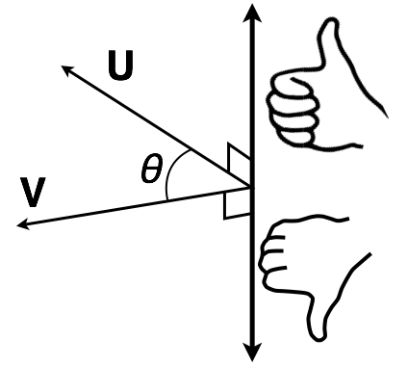
Specifically for vectors in the N, E, D coordinate system, the [N, E, D] components of the cross product are defined as:
U×V = [U_{E}V_{D}–U_{D}V_{E} , U_{D}V_{N}–U_{N}V_{D} , U_{N}V_{E}–U_{E}V_{N}].
With this vector’s Cartesian components calculated, the final step is to convert the N, E, D components of a unit vector along the intersection line back to spherical coordinates to give its plunge, and hence the apparent dip of the bedding plane in the cross-section plane. This is done using some straightforward trigonometry:
Trend = tan⁻¹(E/N)
Plunge = tan⁻¹(D/sqrt(E²+N²))
(Consult the diagram on Page 2 to see these relationships). Note that if the cross-product vector defines the pole to a plane, the strike and dip of the plane can be easily determined.

