# http://localhost:8080/v1/services

curl -i -XPOST http://localhost:8080/v1/services -H "Content-Type: application/json" -d '{

"ID": "fool",

"Service": "fool"

"Name": "foo1",

"Port": "8123",

"Address": "192.168.0.42"

"EnableTagOverride": true

}'

# config.json

-config-file="../config.json"

E:\workspace\yh\OpenBridge-passos-proxy\open-falcon\src\git.yihecloud.com\PaaS

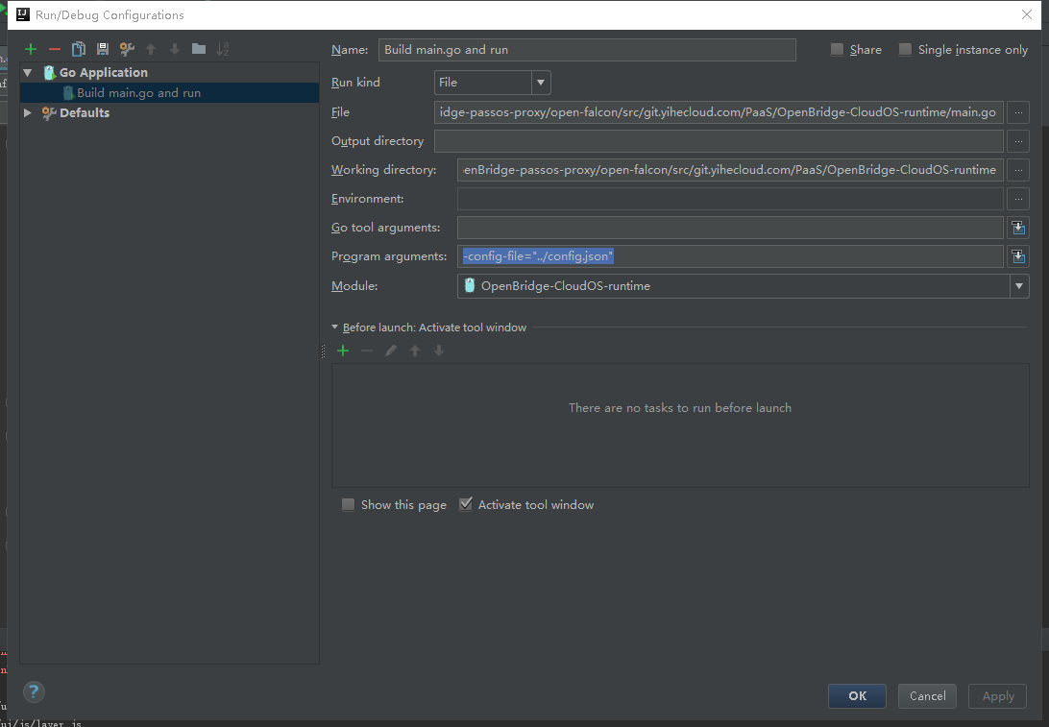

# Consul api put srv_config

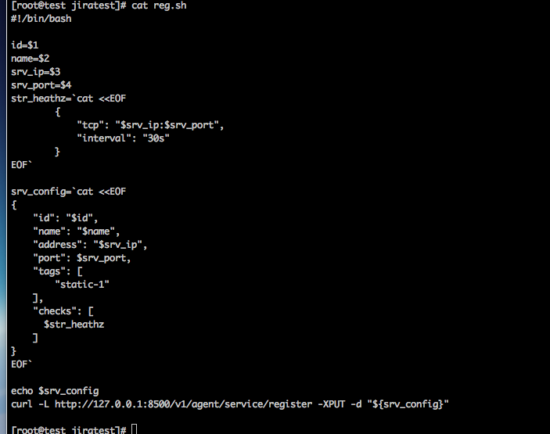

# Consul自带的UI

http://192.168.31.240:8500/ui/#/dc1/kv/runtime/config/ntp-server/edit