# jconsole

## 输入参数

127.0.0.1:7777/jolokia/read/java.lang:type=Runtime/InputArguments http://127.0.0.1:7777/jolokia/read/java.lang:type=Runtime/InputArguments

{

* **request**:

{

* + **mbean**: "java.lang:type=Runtime",
  + **attribute**: "InputArguments",
  + **type**: "read"

},

* **value**:

[

* + "-agentlib:jdwp=transport=dt_socket,suspend=y,address=localhost:53353",
  + "-javaagent:jolokia-jvm-1.3.5-agent.jar=port=7777,host=localhost",
  + "-Dfile.encoding=UTF-8"

],

* **timestamp**: 1492394831,
* **status**: 200

}

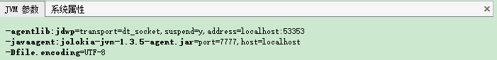

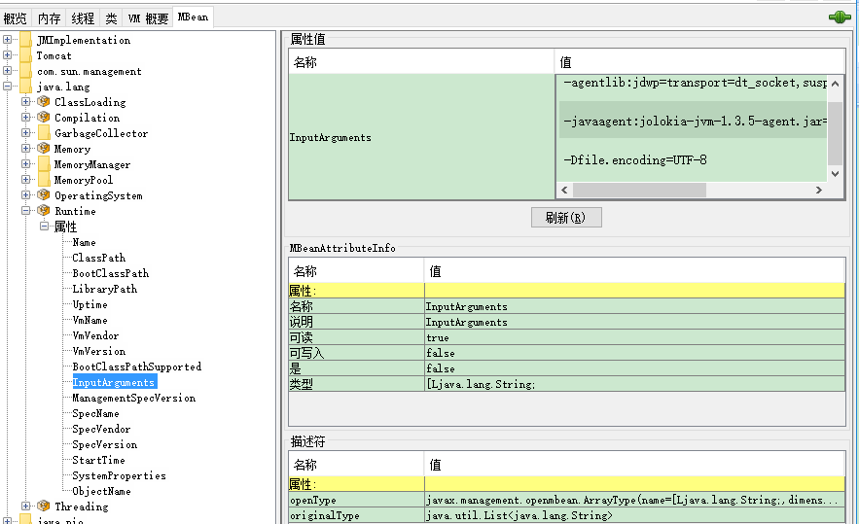

## 系统属性

http://127.0.0.1:7777/jolokia/read/java.lang:type=Runtime/SystemProperties

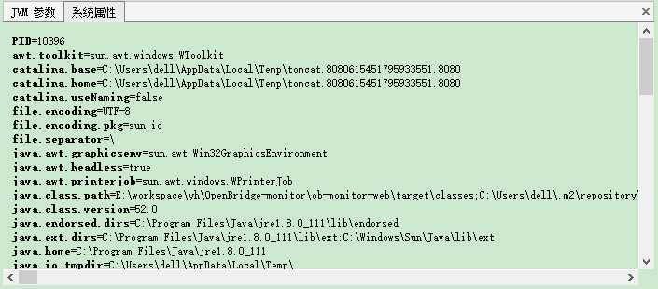

## 内存使用

http://127.0.0.1:7777/jolokia/read/java.lang:type=Memory/HeapMemoryUsage/used

{

* **request**:

{

* + **mbean**: "java.lang:type=Memory",
  + **attribute**: "HeapMemoryUsage",
  + **type**: "read"

},

* **value**:

{

* + **init**: 134217728,
  + **committed**: 434110464,
  + **max**: 1884815360,
  + **used**: 383785024

},

* **timestamp**: 1492395225,
* **status**: 200

}

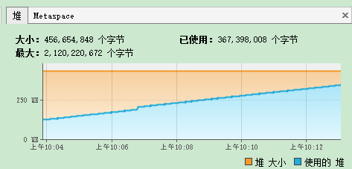

元数据

http://127.0.0.1:7777/jolokia/read/java.lang:type=Memory

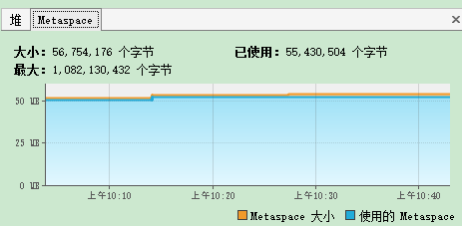

## 内加载

http://127.0.0.1:7777/jolokia/read/java.lang:type=ClassLoading

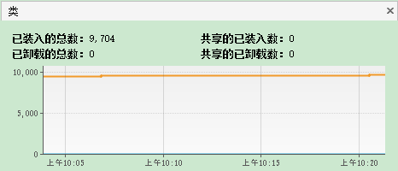

## 线程

http://127.0.0.1:7777/jolokia/read/java.lang:type=Threading

