## Query

## curl -XPOST localhost:9966/graph/history

curl -XPOST localhost:9966/graph/history -H "Content-Type: application/json" -d '{

"start": 1470900343,

"end": 1470910343,

"cf": "AVERAGE",

"endpoint_counters": [

{

"endpoint": "192.168.1.82",

"counter": "container.cpu.usage.busy/id=9406e2933cfaed3dabbe456dc124e90e3664634080a5d83537c32c2054bc3553"

},

{

"endpoint" : "192.168.1.82",

"counter" : "container.cpu.usage.system/id=9406e2933cfaed3dabbe456dc124e90e3664634080a5d83537c32c2054bc3553"

},

{

"endpoint" : "192.168.1.82",

"counter" : "container.cpu.usage.user/id=9406e2933cfaed3dabbe456dc124e90e3664634080a5d83537c32c2054bc3553"

},

{

"endpoint" : "192.168.1.82",

"counter" : "container.net.if.out.bytes/id=77a83fd61450923d2266fd3807d1796ef261027d3420623fea8d39a8ac74130d"

}

]

}

'| python -m json.tool

### 查询单个graph

graph_http.go

http.HandleFunc("/graph/history", **func**(w http.ResponseWriter, r *http.Request) {

result, err := graph.QueryOne(request)

### 容器监控项

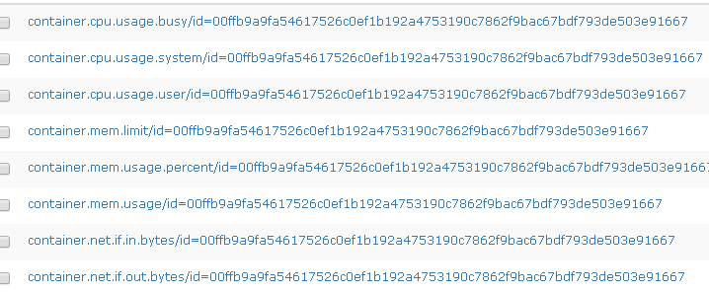

### graph/graph.go 调用rrd查询Graph.Query

rpc调用获取结果

err := rpcConn.Call("Graph.Query", para, resp)

### counter/all

http://192.168.1.135:9966/counter/all

### graph/info

<http://192.168.1.135:9966/graph/info>

[{"endpoint": "192.168.1.82","counter": "container.cpu.usage.busy/id=9406e2933cfaed3dabbe456dc124e90e3664634080a5d83537c32c2054bc3553"}]

[

{

"endpoint": "192.168.1.82",

"counter": "container.cpu.usage.busy/id=9406e2933cfaed3dabbe456dc124e90e3664634080a5d83537c32c2054bc3553",

"consolFun": "GAUGE",

"step": 60,

"filename": "/opt/install-alarm/data/graph/6070/19/1928daf1972cf57aecb2584ae05a61da_GAUGE_60.rrd",

"addr": "127.0.0.1:6070"

}

]

### graph/last根据cpu.usage.busy获取容器数据

http://192.168.0.179:9966/graph/last

[{

"endpoint": "192.168.0.184",

"counter": "container.cpu.usage.busy/id=ef86a87f89631c4b3766c8ab9ae84f10a7600146eea82177c61819f378b0fd28"}

]

[

{

"endpoint": "192.168.0.184",

"counter": "container.cpu.usage.busy/id=ef86a87f89631c4b3766c8ab9ae84f10a7600146eea82177c61819f378b0fd28",

"value": {

"timestamp": 1473049260,

"value": 0.054944

}

}

]

### graph/last获取容器数据例子

http://192.168.1.135:9966/graph/last

[{"endpoint": "192.168.1.82","counter": "container.cpu.usage.busy/id=9406e2933cfaed3dabbe456dc124e90e3664634080a5d83537c32c2054bc3553"}]

[

{

"endpoint": "192.168.1.82",

"counter": "container.cpu.usage.busy/id=9406e2933cfaed3dabbe456dc124e90e3664634080a5d83537c32c2054bc3553",

"value": {

"timestamp": 1470903120,

"value": 0.044965

}

}

]

http://192.168.0.179:9966/graph/last

[{"endpoint": "192.168.0.184","counter": "container.cpu.usage.busy/id=9994e186bfe4fc715d9478dbb5eed252754c8f14c65dcc0ca3533a6471b55702"}]

### graph/last/raw

http://192.168.1.135:9966/graph/last/raw

[{"endpoint": "192.168.1.82","counter": "container.cpu.usage.busy/id=9406e2933cfaed3dabbe456dc124e90e3664634080a5d83537c32c2054bc3553"}]

[

{

"endpoint": "192.168.1.82",

"counter": "container.cpu.usage.busy/id=9406e2933cfaed3dabbe456dc124e90e3664634080a5d83537c32c2054bc3553",

"value": {

"timestamp": 1470903060,

"value": 0

}

}

]

### graph/history

http://192.168.1.135:9966/graph/history

{

"start": 1470900343,

"end": 1470910343,

"cf": "AVERAGE",

"endpoint_counters": [

{

"endpoint": "192.168.1.82",

"counter": "container.cpu.usage.busy/id=9406e2933cfaed3dabbe456dc124e90e3664634080a5d83537c32c2054bc3553"

},

{

"endpoint" : "192.168.1.82",

"counter" : "container.cpu.usage.system/id=9406e2933cfaed3dabbe456dc124e90e3664634080a5d83537c32c2054bc3553"

},

{

"endpoint" : "192.168.1.82",

"counter" : "container.cpu.usage.user/id=9406e2933cfaed3dabbe456dc124e90e3664634080a5d83537c32c2054bc3553"

},

{

"endpoint" : "192.168.1.82",

"counter" : "container.net.if.out.bytes/id=77a83fd61450923d2266fd3807d1796ef261027d3420623fea8d39a8ac74130d"

}

]

}

# /graph/history

## df.bytes.free.percent/fstype=ext4,mount=/boot

[df.bytes.free.percent/fstype=ext4,mount=/boot](javascript:void(0);)

curl -XPOST localhost:9966/graph/history -d '{

"start": 1484622700,

"end":1484623700,

"cf": "AVERAGE",

"endpoint_counters": [

{

"endpoint": "192.168.110.115",

"counter": "df.bytes.free.percent/fstype=ext4,mount=/boot"

}

]

}

'| python -m json.tool

## df.bytes.free.percent/fstype=ext4,mount=/

curl -XPOST localhost:9966/graph/history -d '{

"start": 1484622700,

"end":1484623700,

"cf": "AVERAGE",

"endpoint_counters": [

{

"endpoint": "192.168.110.115",

"counter": "df.bytes.free.percent/fstype=ext4,mount=/"

}

]

}

'| python -m json.tool

# /graph/history/accurate

E:\workspace\yh\OpenBridge-passos-proxy\open-faclon\src\query\http\graph_http.go

## Bug graph/history有值，graph/history/accurate无值

curl -XPOST localhost:9966/graph/history -d '{

"start": 1484622700,

"end":1484625127,

"cf": "AVERAGE",

"step": 60,

"endpoint_counters": [

{

"endpoint": "192.168.110.115",

"counter": "df.bytes.free.percent/fstype=ext4,mount=/boot"

}

]

}

'| python -m json.tool

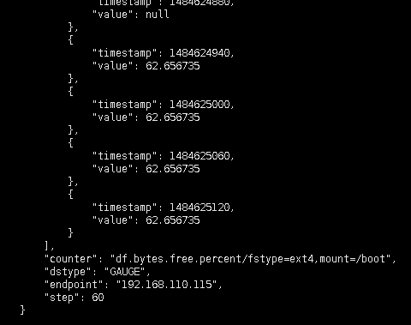

curl -XPOST localhost:9966/graph/history/accurate -d '{

"start": 1484622700,

"end":1484625127,

"cf": "AVERAGE",

"step": 60,

"endpoint_counters": [

{

"endpoint": "192.168.110.115",

"counter": "df.bytes.free.percent/fstype=ext4,mount=/boot"

}

]

}

'| python -m json.tool

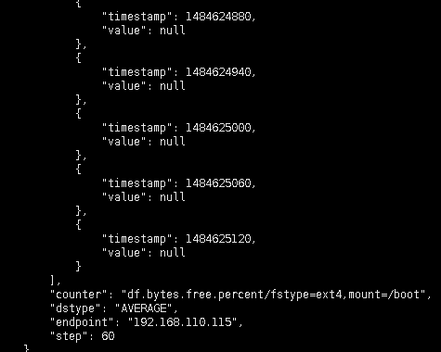

## df.bytes.free.percent/fstype=ext4,mount=/boot

curl -XPOST localhost:9966/graph/history/accurate -d '{

"start": 1484622700,

"end":1484625228,

"cf": "AVERAGE",

"step": 60,

"endpoint_counters": [

{

"endpoint": "192.168.110.115",

"counter": "df.bytes.free.percent/fstype=ext4,mount=/boot"

}

]

}

'| python -m json.tool

curl -XPOST localhost:9966/graph/history/accurate -d '{

"start": 1484622700,

"end":1484625127,

"cf": "AVERAGE",

"step": 60,

"endpoint_counters": [

{

"endpoint": "192.168.110.115",

"counter": "df.bytes.free.percent/fstype=ext4,mount=/boot"

}

]

}

'| python -m json.tool

## AccurateQueryOne

E:\workspace\yh\OpenBridge-passos-proxy\open-faclon\src\query\graph\graph.go