# 1 图表接口

## 1.1 节点图表：

<https://paas.dev.yihecloud.com/os/manager/monitor/nodeInfo?nodeurl=192.168.0.181>

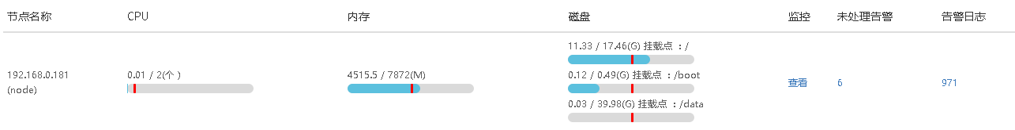

## 1.2 部署图表：

https://paas.dev.yihecloud.com/os/monitor/alarm/page/deploy?deployId=72kd20aaixvdhq5yf7fdn5kp8vdfzs

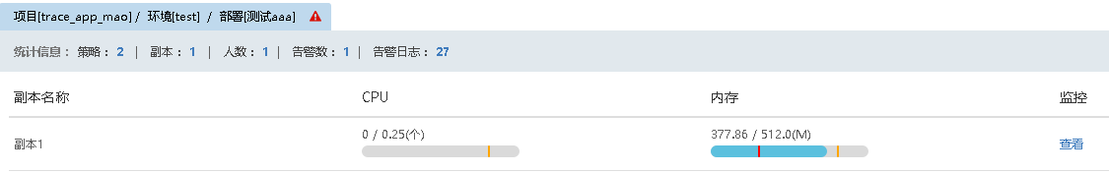

# 2 数据接口

<POST>：https://paas.demo.yihecloud.com/monitor/apps/monitors/data

## 2.1 获取主机磁盘信息

{

"start":1484895907,//历史数据起始时间，UNIX时间戳2017-01-20 15:05:07

"step":60,//必填，汇报周期，默认为60s

"timeLength":2,//可选，如果不设置start，则按（当前时间-timeLength * 60 * 60 * 1000）为起始时间

"endpointCounters":[

{

"endpoint": "192.168.110.115",//主机名

"counter": "df.bytes.free.percent/fstype=ext4,mount=/boot" //挂载点空闲率使用率

},

{

"endpoint": "192.168.110.115",

"counter": "df.bytes.used.percent/fstype=xfs,mount=/" //挂载点使用率

},

{

"endpoint": "192.168.110.115",

"counter": "disk.io.read_bytes/device=sda" //sda磁盘读取速度

}

]

}

## 2.2 获取主机网络信息

{

"start":1484895907,

"step":60,

"timeLength":2,

"endpointCounters":[

{

"endpoint": "192.168.110.115",

"counter": "net.if.in.bytes/iface=eno16777984" //下载流量

},

{

"endpoint": "192.168.110.115",

"counter": "net.if.out.bytes/iface=eno16777984" //上传流量

}

]

}

## 2.3 获取主机内存信息

{

"start":1484895907,

"step":60,

"timeLength":2,

"endpointCounters":[

{

"endpoint": "192.168.110.115",

"counter": "mem.memtotal" //内存重量

},

{

"endpoint": "192.168.110.115",

"counter": "mem.memused" //内存使用情况

},

{

"endpoint": "192.168.110.115",

"counter": "mem.memused.percent" //内存使用率

}

]

}

## 2.4 获取主机CPU信息

{

"start":1484895907,

"step":60,

"timeLength":2,

"endpointCounters":[

{

"endpoint": "192.168.110.115",

"counter": "cpu.busy" //CPU使用情况

},

{

"endpoint": "192.168.110.115",

"counter": "cpu.system" //CPU系统使用情况

},

{

"endpoint": "192.168.110.115",

"counter": "cpu.user" //CPU用户使用情况

}

]

}

## 2.5 获取容器CPU信息

{

"start":1484895907,

"step":60,

"timeLength":2,

"endpointCounters":[

{

"endpoint": "192.168.110.115",

"counter": "container.cpu.usage.busy/deploy_id=72kd20aaixvdhq5yf7fdn5kp8vdfzs,id=68b27faf06571b205f8d4be0e5a95f6b884e92847960fd74f68ef34985ec855e" //CPU使用情况

},

{

"endpoint": "192.168.110.115",

"counter": "container.cpu.usage.system/deploy_id=72kd20aaixvdhq5yf7fdn5kp8vdfzs,id=68b27faf06571b205f8d4be0e5a95f6b884e92847960fd74f68ef34985ec855e" //CPU系统使用情况

},

{

"endpoint": "192.168.110.115",

"counter": "container.cpu.usage.user/deploy_id=72kd20aaixvdhq5yf7fdn5kp8vdfzs,id=68b27faf06571b205f8d4be0e5a95f6b884e92847960fd74f68ef34985ec855e" //CPU用户使用情况

}

]

}

## 2.7 获取容器内存信息

{

"start":1484895907,

"step":60,

"timeLength":2,

"endpointCounters":[

{

"endpoint": "192.168.110.115",

"counter": "container.mem.limit/deploy_id=72kd20aaixvdhq5yf7fdn5kp8vdfzs,id=68b27faf06571b205f8d4be0e5a95f6b884e92847960fd74f68ef34985ec855e"

},//内存总量

{

"endpoint": "192.168.110.115",

"counter": "container.mem.usage/deploy_id=72kd20aaixvdhq5yf7fdn5kp8vdfzs,id=68b27faf06571b205f8d4be0e5a95f6b884e92847960fd74f68ef34985ec855e"

},//内存使用情况

{

"endpoint": "192.168.110.115",

"counter":"container.mem.usage.percent/deploy_id=72kd20aaixvdhq5yf7fdn5kp8vdfzs,id=68b27faf06571b205f8d4be0e5a95f6b884e92847960fd74f68ef34985ec855e"

}//内存使用率

]

}

## 2.8 获取容器网络信息

{

"start":1484895907,

"step":60,

"timeLength":2,

"endpointCounters":[

{

"endpoint": "192.168.110.115",

"counter": "container.net.if.in.bytes/id=d4c6faf431dea01c2fc6b2a8912c4127dab21ca1d6ef00704f6a92c6b6b8b708"

},

{

"endpoint": "192.168.110.115",

"counter": "container.net.if.out.bytes/id=d4c6faf431dea01c2fc6b2a8912c4127dab21ca1d6ef00704f6a92c6b6b8b708"

}

]

}

# 3 告警设置

## 3.1 读取告警设置

https://paas.dev.yihecloud.com/monitor/groups/891/templates?type=alarm

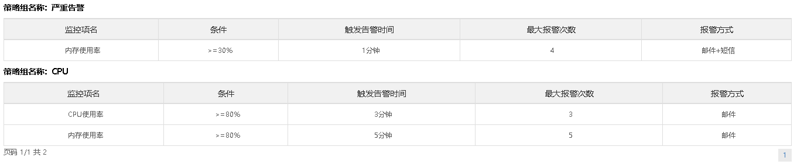

## 3.2 维护告警设置

<https://paas.dev.yihecloud.com/os/monitor/strategy/265>

