# Scrape_path

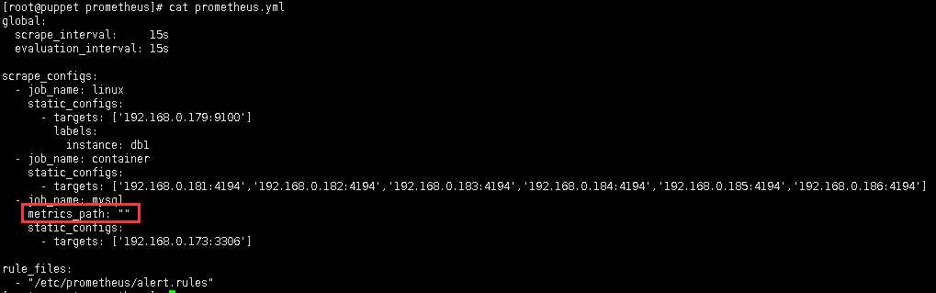

# prometheus\prometheus\config\testdata\conf.good.yml

E:\workspace\go\prometheus\prometheus\vendor\github.com\

prometheus\prometheus\config\testdata\conf.good.yml

*# my global config***global:  
 scrape_interval:** 15s  
 **evaluation_interval:** 30s  
 *# scrape_timeout is set to the global default (10s).* **external_labels:  
 monitor:** codelab  
 **foo:** bar  
  
**rule_files:**- "first.rules"  
- "/absolute/second.rules"  
- "my/*.rules"  
  
**remote_write:** - **url:** http://remote1/push  
 **write_relabel_configs:** - **source_labels:** [__name__]  
 **regex:** expensive.*  
 **action:** drop  
 - **url:** http://remote2/push  
  
**scrape_configs:**- **job_name:** prometheus  
  
 **honor_labels:** true  
 *# scrape_interval is defined by the configured global (15s).  
 # scrape_timeout is defined by the global default (10s).  
  
 # metrics_path defaults to '/metrics'  
 # scheme defaults to 'http'.* **file_sd_configs:** - **files:** - foo/*.slow.json  
 - foo/*.slow.yml  
 - single/file.yml  
 **refresh_interval:** 10m  
 - **files:** - bar/*.yaml  
  
 **static_configs:** - **targets:** ['localhost:9090', 'localhost:9191']  
 **labels:  
 my:** label  
 **your:** label  
  
 **relabel_configs:** - **source_labels:** [job, __meta_dns_name]  
 **regex:** (.*)some-[regex]  
 **target_label:** job  
 **replacement:** foo-${1}  
 *# action defaults to 'replace'* - **source_labels:** [abc]  
 **target_label:** cde  
 - **replacement:** static  
 **target_label:** abc  
 - **regex:  
 replacement:** static  
 **target_label:** abc  
  
 **bearer_token_file:** valid_token_file  
  
  
- **job_name:** service-x  
  
 **basic_auth:  
 username:** admin_name  
 **password:** admin_password  
  
 **scrape_interval:** 50s  
 **scrape_timeout:** 5s  
  
 **sample_limit:** 1000  
  
 **metrics_path:** /my_path  
 **scheme:** https  
  
 **dns_sd_configs:** - **refresh_interval:** 15s  
 **names:** - first.dns.address.domain.com  
 - second.dns.address.domain.com  
 - **names:** - first.dns.address.domain.com  
 *# refresh_interval defaults to 30s.* **relabel_configs:** - **source_labels:** [job]  
 **regex:** (.*)some-[regex]  
 **action:** drop  
 - **source_labels:** [__address__]  
 **modulus:** 8  
 **target_label:** __tmp_hash  
 **action:** hashmod  
 - **source_labels:** [__tmp_hash]  
 **regex:** 1  
 **action:** keep  
 - **action:** labelmap  
 **regex:** 1  
 - **action:** labeldrop  
 **regex:** d  
 - **action:** labelkeep  
 **regex:** k  
  
 **metric_relabel_configs:** - **source_labels:** [__name__]  
 **regex:** expensive_metric.*  
 **action:** drop  
  
- **job_name:** service-y  
  
 **consul_sd_configs:** - **server:** 'localhost:1234'  
 **services:** ['nginx', 'cache', 'mysql']  
 **scheme:** https  
 **tls_config:  
 ca_file:** valid_ca_file  
 **cert_file:** valid_cert_file  
 **key_file:** valid_key_file  
 **insecure_skip_verify:** false  
  
 **relabel_configs:** - **source_labels:** [__meta_sd_consul_tags]  
 **separator:** ','  
 **regex:** label:([^=]+)=([^,]+)  
 **target_label:** ${1}  
 **replacement:** ${2}  
  
- **job_name:** service-z  
  
 **tls_config:  
 cert_file:** valid_cert_file  
 **key_file:** valid_key_file  
  
 **bearer_token:** avalidtoken  
  
- **job_name:** service-kubernetes  
  
 **kubernetes_sd_configs:** - **role:** endpoints  
 **api_server:** 'https://localhost:1234'  
  
 **basic_auth:  
 username:** 'myusername'  
 **password:** 'mypassword'  
  
- **job_name:** service-marathon  
 **marathon_sd_configs:** - **servers:** - 'https://marathon.example.com:443'  
  
 **tls_config:  
 cert_file:** valid_cert_file  
 **key_file:** valid_key_file  
  
- **job_name:** service-ec2  
 **ec2_sd_configs:** - **region:** us-east-1  
 **access_key:** access  
 **secret_key:** secret  
 **profile:** profile  
  
- **job_name:** service-azure  
 **azure_sd_configs:** - **subscription_id:** 11AAAA11-A11A-111A-A111-1111A1111A11  
 **tenant_id:** BBBB222B-B2B2-2B22-B222-2BB2222BB2B2  
 **client_id:** 333333CC-3C33-3333-CCC3-33C3CCCCC33C  
 **client_secret:** nAdvAK2oBuVym4IXix  
 **port:** 9100  
  
- **job_name:** service-nerve  
 **nerve_sd_configs:** - **servers:** - localhost  
 **paths:** - /monitoring  
  
- **job_name:** 0123service-xxx  
 **metrics_path:** /metrics  
 **static_configs:** - **targets:** - localhost:9090  
  
- **job_name:** 測試  
 **metrics_path:** /metrics  
 **static_configs:** - **targets:** - localhost:9090  
  
- **job_name:** service-triton  
 **triton_sd_configs:** - **account:** 'testAccount'  
 **dns_suffix:** 'triton.example.com'  
 **endpoint:** 'triton.example.com'  
 **port:** 9163  
 **refresh_interval:** 1m  
 **version:** 1  
 **tls_config:  
 cert_file:** testdata/valid_cert_file  
 **key_file:** testdata/valid_key_file  
  
**alerting:  
 alertmanagers:** - **scheme:** https  
 **static_configs:** - **targets:** - "1.2.3.4:9093"  
 - "1.2.3.5:9093"  
 - "1.2.3.6:9093"