# SNMP Monitoring with Prometheus | Robust Perception

https://www.robustperception.io/snmp-monitoring-with-prometheus/

[SNMP Monitoring with Prometheus](https://www.robustperception.io/snmp-monitoring-with-prometheus/)

[***Brian Brazil***](https://www.robustperception.io/author/brian/)***February 3, 2016***

[**Prometheus**](http://prometheus.io/)**isn’t limited to monitoring just machines and applications, it can provide insight for any system you can get metrics out of. That includes network devices, so let’s look at how to monitor SNMP.**

**First off, let’s install and run the**[**SNMP exporter**](https://github.com/prometheus/snmp_exporter)**:**

**wget https://github.com/prometheus/snmp_exporter/releases/download/v0.1.0/snmp_exporter-0.1.0.linux-amd64.tar.gz**

**tar -xzf snmp_exporter-0.1.0.linux-amd64.tar.gz**

**cd snmp_exporter-0.1.0.linux-amd64/**

**./snmp_exporter**

**If you visit**[**http://localhost:9116**](http://localhost:9116/)**you can verify it’s running.**

**Next let’s configure Prometheus to scrape it:**

**wget https://s3-eu-west-1.amazonaws.com/downloads.robustperception.io/prometheus/prometheus-linux-amd64-nightly.tar.gz**

**tar -xzf prometheus-linux-amd64-nightly.tar.gz**

**cd prometheus-\***

**cat <<'EOF' > prometheus.yml**

**global:**

**scrape_interval: 10s**

**evaluation_interval: 10s**

**scrape_configs:**

**- job_name: 'snmp'**

**metrics_path: /snmp**

**params:**

**module: [default]**

**static_configs:**

**- targets:**

**- 192.168.1.2 # SNMP device - add your IPs here**

**relabel_configs:**

**- source_labels: [__address__]**

**target_label: __param_target**

**- source_labels: [__param_target]**

**target_label: instance**

**- target_label: __address__**

**replacement: 127.0.0.1:9116 # SNMP exporter.**

**EOF**

**./prometheus &**

**If you wait a bit for some scrapes to happen, you can then visit**[**http://localhost:9090/consoles/snmp.html**](http://localhost:9090/consoles/snmp.html)**to see interface statistics.**

**The SNMP exporter was deployed at**[**FOSDEM**](https://fosdem.org/)**last weekend, and we were able to produce a variety of useful dashboards in**[**Grafana**](http://www.robustperception.io/setting-up-grafana-for-prometheus/)**covering things like bandwidth and WiFi usage.**

**[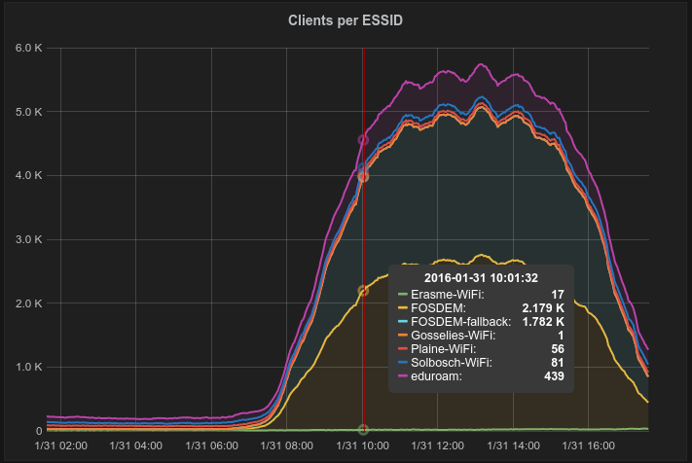](http://www.robustperception.io/wp-content/uploads/2016/02/Screenshot-030216-135014.png)**

**ESSID usage during FOSDEM**

[**prometheus**](https://www.robustperception.io/tag/prometheus/)**,**[**snmp**](https://www.robustperception.io/tag/snmp/)