/github.com/prometheus/prometheus/vendor/k8s.io/client-go/rest/request.go:803

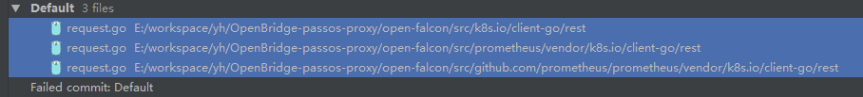

tr := &http.Transport{  
 TLSClientConfig: &tls.Config{InsecureSkipVerify: true},  
}  
client := &http.Client{Transport: tr}